NHSRC
Maharashtra – Ahmad Nagar
Analysis: Apr 2009 – Mar 2010

Maharashtra-Ahmadnagar- Summary-Apr'09 to Mar'10
ANC
ANC Registration against Expected Pregnancies | 87% | TT1 given to Pregnant women against ANC Registration | 65%
3 ANC Check ups against ANC Registrations | 90% | 100 IFA Tablets given to Pregnant women against ANC Registration | 83%
Deliveries
Unreported Deliveries against Estimated Deliveries | 22.0% | HOME Deliveries( SBA& Non SBA) against Estimated Deliveries | 3.6%
Institutional Deliveries against Estimated Deliveries | 74.4% | HOME Deliveries( SBA& Non SBA) against Reported Deliveries | 4.7%
Institutional Deliveries against Reported Deliveries | 95.3% | C Section Deliveries against Institutional Deliveries( Pvt & Pub) | 5%
Births & Neonates Care
Live Births Reported against Estimated Live Births | 78% | New borns weighed against Reported Live Births | 91%
Still Births (Reported) | 900 | New borns weighed less than 2.5 kgs against newborns weighed | 7%
Sex Ratio at Birth | 813 | New borns breastfed within one hr of Birth against Reported live Births | 0%
Child Immunization( 0 to 11 months)
BCG given against Expected Live Births | 92% | Measles given against Expected Live Births | 89%
OPV3 given against Expected Live Births | 91% | Fully Immunized Children against Expected Live Births | 88%
DPT3 given against Expected Live Births | 92%
Family Planning
Family Planning Methods Users ( Sterilizations(Male &Female)+IUD+ Condom pieces/72 + OCP Cycles/13) | 75,307 | IUD Insertions against reported FP Methods | 27%
Sterilization against reported FP Methods | 29% | Condom Users against reported FP Methods | 27%
 |  | OCP Users against reported FP Methods | 18%
Other Services
OPD | 261,022 | Major Operations | 560
IPD | - | Minor Operations | 659
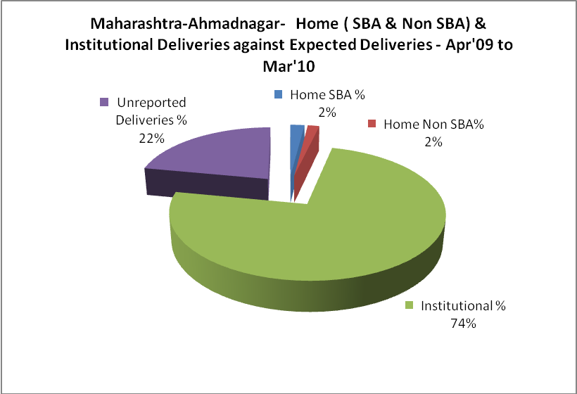
Maharashtra-Ahmadnagar- Deliveries Apr'09 to Mar'10
Total Population | 4,734,149 | Expected Deliveries |  | 86,139
Home SBA | Home Non SBA | Institutional | Total Deliveries Reported | Unreported Deliveries
1,734 | 1,409 | 64,069 | 67,212 | 18,927
Home SBA % | Home Non SBA% | Institutional % | Total Deliveries Reported % | Unreported Deliveries %
2% | 2% | 74% | 78% | 22%

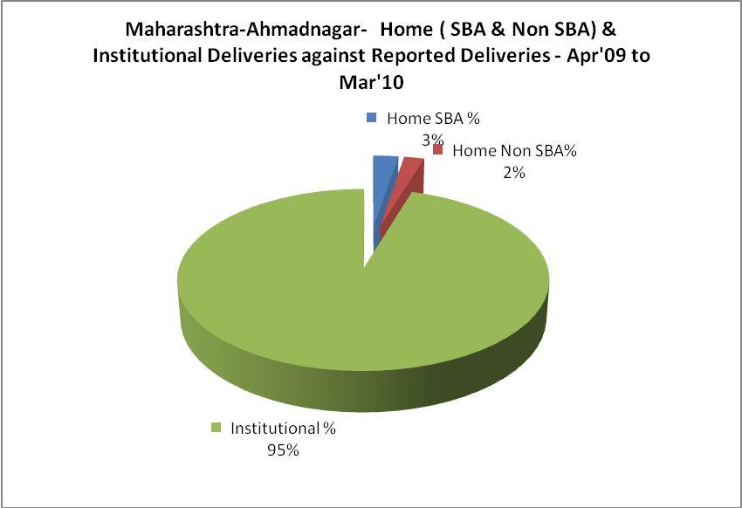

Maharashtra-Ahmadnagar- C sections & Complicated Deliveries Apr'09 to Mar'10
 | Institutional Deliveries (Public) | Institutional Deliveries (Pvt)
 | 14,770 | 49,299
C Section | 680 | 2,796
C Section% | 5% | 6%
Complicated Pregnancies attended | 1,572 | 620
Complicated Pregnancies attended % | 11% | 1%

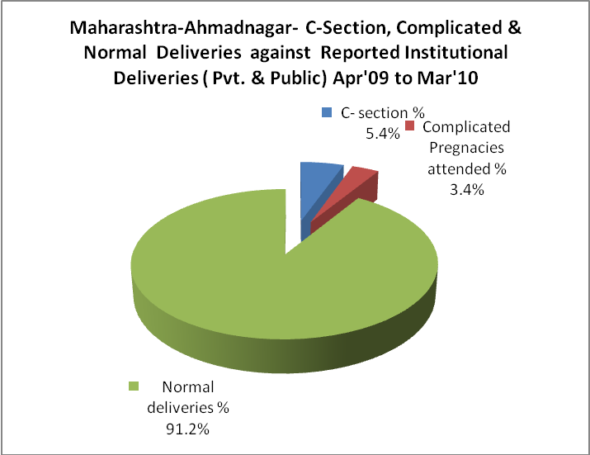

Maharashtra-Ahmadnagar- Complicated Pregnancies & Deliveries Treated - Apr'09 to Mar'10
Reported Deliveries |  |  | Reported ANC Reigtration
67,212 |  |  | 81,406
Complicated Pregnancies attended | Complicated Pregnancies Rate | C - Section Deliveries | PNC Maternal Complications | Abortions | Still Births
2,192 | 2% | 3,476 | - | 6,156 | 900
Complicated Deliveries Treated with |  |  |  | No Of Eclampsia cases Treated | No Of severe anemia cases treated
IV Antibiotics | IV antihypertensive/Magsulph injection | IV Oxytocis | Blood Transfusion | No Of Eclampsia cases Treated | No Of severe anemia cases treated
- | - | - | - | - | -

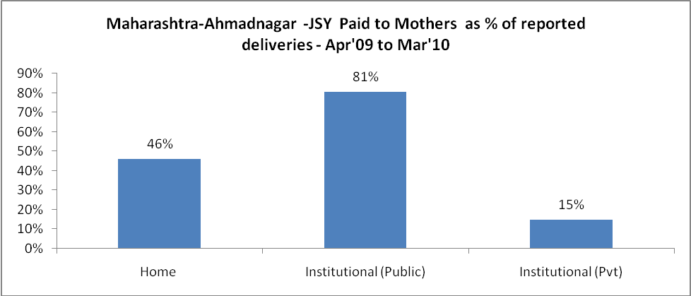

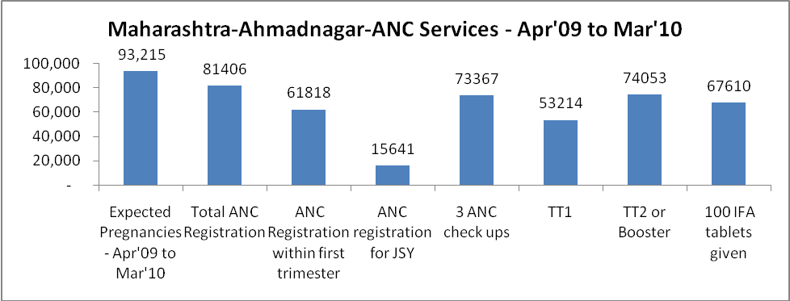

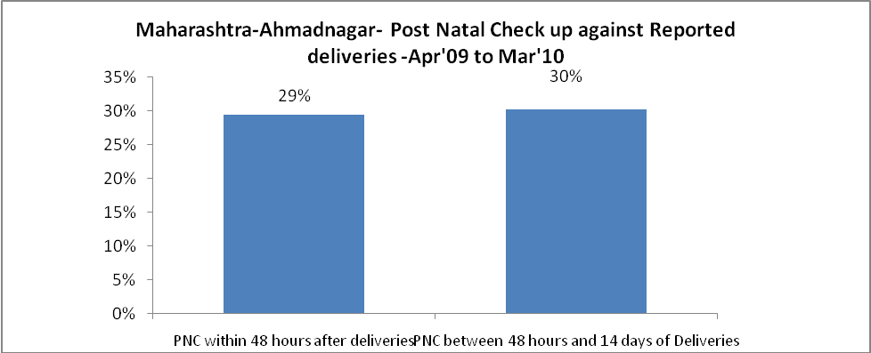

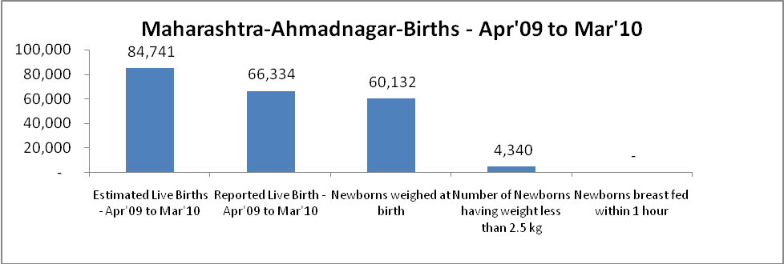

Maharashtra-Ahmadnagar - Births - Apr'09 to Mar'10
Live Birth - Males | Live Birth - females | Live Birth - Total | Sex Ratio at birth | Still Birth | Abortion( Induced/Spontaneous
36,590 | 29,744 | 66,334 | 813 | 900 | 6,156

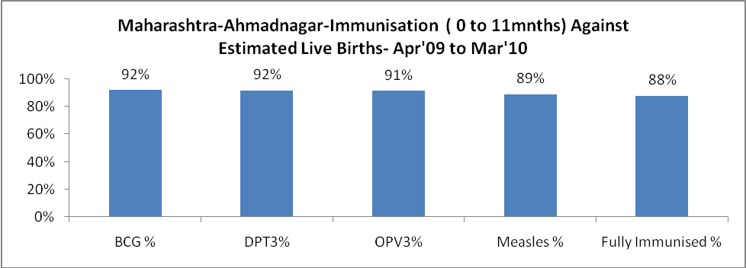

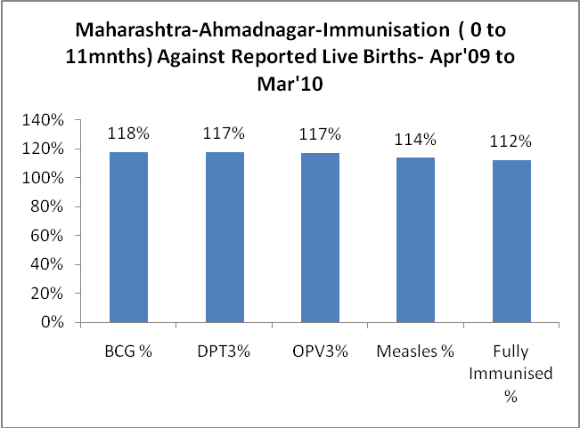

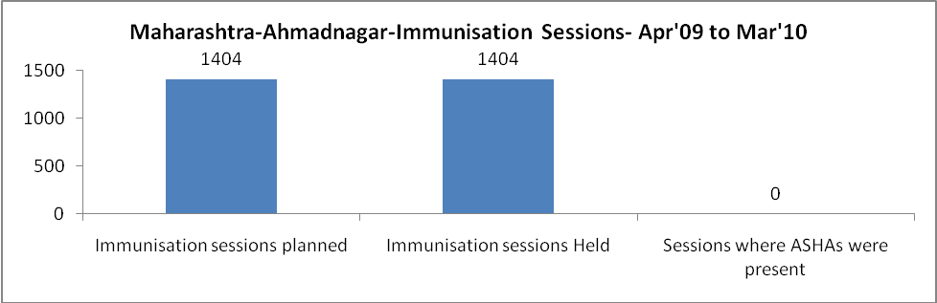

Maharashtra-Ahmadnagar- Apr'09 to Mar'10
Total Abortions | Abortion Rate
9,970 | 10.7%

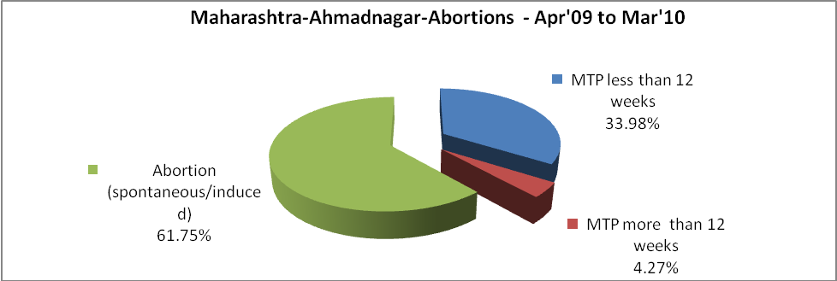

Maharashtra-Ahmadnagar- Apr'09 to Mar'10
Total OPD | Total RTI/STI cases
261,022 | 9,090

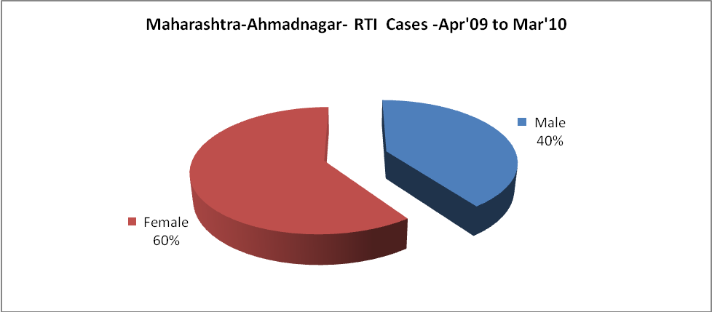

Maharashtra-Ahmadnagar-Sterilizations - Apr'09 to Mar'10
 | Reported | %age of Reported Sterilization
Total Sterilization | 21,464 | -
NSV | 165 | 1%
Laparoscopic | 6,152 | 29%
Mini Lap | 12,176 | 57%
Post Partum | 2,971 | 14%
Male Sterilization | 165 | 1%
Female Sterilization | 21,299 | 99%

Maharashtra-Ahmadnagar-FP Methods - Apr'09 to Mar'10
 | Reported | %age of All Reported FP Methods
Total Reported FP Method (All types) Users | 75,307 | -
Sterilizations | 21,464 | 29%
IUD | 20,204 | 27%
Condom Users | 20,002 | 27%
OCP Users | 13,637 | 18%
Limiting Methods | 21,464 | 29%
Spacing Methods | 53,843 | 71%
v

Maharashtra-Ahmadnagar- Service Delivery - Apr'09 to Mar'10
Operation major (General and spinal anaesthesia) | Operation minor (No or local anaesthesia) | AYUSH | Dental Procedures | Adolescent counselling services | Total OPD | Total IPD
560 | 659 | - | - | - | 261,022 | -
Operation major (General and spinal anaesthesia) as %ge of OPD | Operation minor (No or local anaesthesia)as %ge of OPD | AYUSH as %ge of OPD | Dental Procedures as %ge of OPD | Adolescent counselling services as %ge of OPD | IPD as percentage of OPD
0.2% | 0.3% | 0.0% | 0.0% | 0.0% | 0%

Maharashtra-Ahmadnagar- Lab Services - Apr'09 to Mar'10
Total OPD | Total HB tested | Total HIV Tested | Total Population
261,022 | - | - | 4,734,149
HB test conducted as %age of OPD | HB<7gm as %age of HB tested | HIV test conducted as %age of OPD | HIV positive as %age of HIV tested | Blood Smear Examined as % of Population
0.0% | 0.0% | 0.0% | 0.0% | 9.1%

Maharashtra-Ahmadnagar- Childhood Disease - Vaccine Preventable -Apr'09 to Mar'10
Diphtheria | Pertussis | Tetanus Neonatorum | Tetanus others | Polio | Measles
0 | 0 | 0 | 0 | 0 | 17
Maharashtra-Ahmadnagar-Childhood Disease - Others - Apr'09 to Mar'10
Diarrhoea and dehydration | Malaria | Number admitted with Respiratory Infections
300 | 1 | 218

Maharashtra-Ahmadnagar- Infant & Child Deaths - Apr'09 to Mar'10
Infant Deaths within 24 hrs of birth | Infant Deaths between 24hrs & under 1 week | Infant Deaths between 1 week & under 1 month | Child Deaths between 1 month & under 1 year | Child Deaths between 1yr under 5years | Total Deaths
184 | 70 | 15 | 63 | 33 | 365

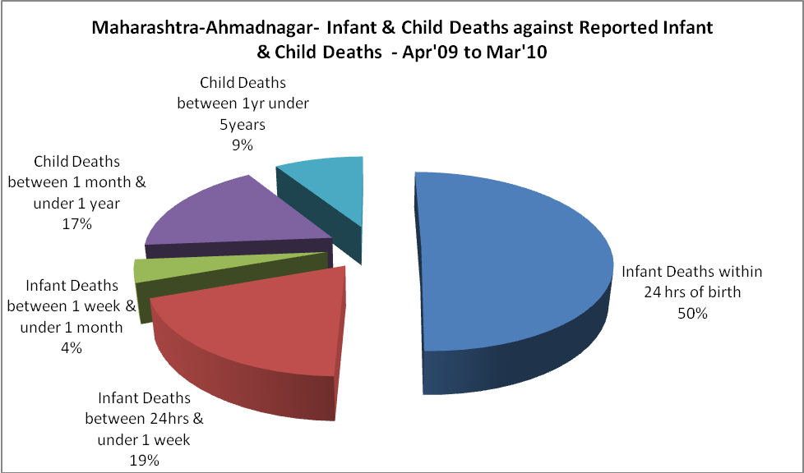

Maharashtra-Ahmadnagar- Causes of Infant & Child Deaths - Apr'09 to Mar'10
Sepsis |  |  | Asphyxia |  |  | LBW
Up to 1 Weeks of Birth | Between 1 week & 4 weeks of birth | Total | Up to 1 Weeks of Birth | Between 1 week & 4 weeks of birth | Total | Up to 1 Weeks of Birth | Between 1 week & 4 weeks of birth | Total
0 | 0 | 0 | 0 | 0 | 0 | 1 | 0 | 1
Pneumonia |  |  | Diarrhoea |  |  | Fever related
Between 1 month and 11 months | Between 1 year & 5 years | Total | Between 1 month and 11 months | Between 1 year & 5 years | Total | Between 1 month and 11 months | Between 1 year & 5 years | Total
0 | 0 | 0 | 0 | 0 | 0 | 0 | 0 | 0
Others |  |  | Measles |  |  | Others
Up to 1 Weeks of Birth | Between 1 week & 4 weeks of birth | Total | Between 1 month and 11 months | Between 1 year & 5 years | Total | Between 1 month and 11 months | Between 1 year & 5 years | Total
69 | 15 | 84 | 0 | 0 | 0 | 63 | 33 | 96

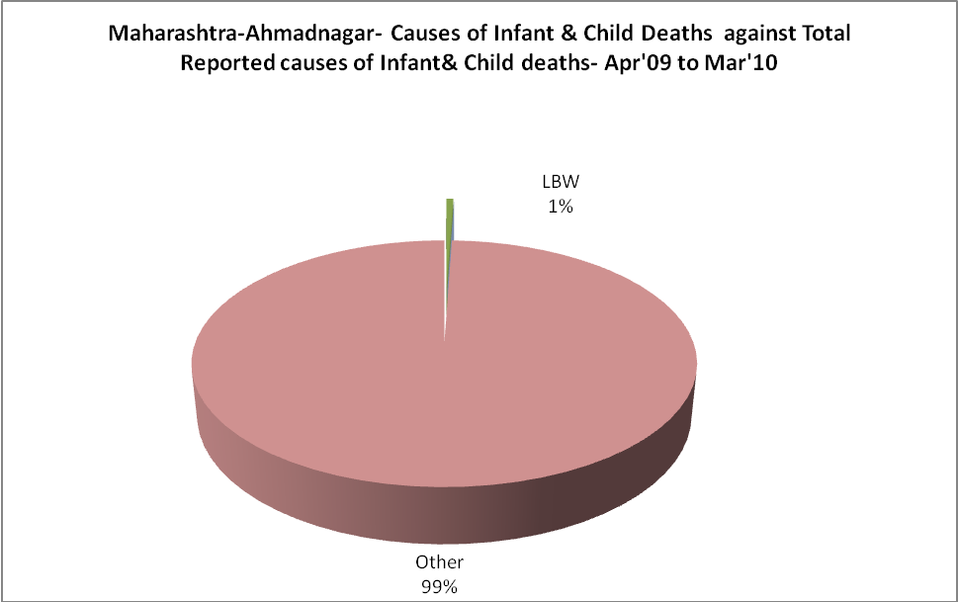

Maharashtra-Ahmadnagar-Causes of Deaths in 6 to 55yrs age group - Apr'09 to Mar'10
Diarrhoel Diseases |  |  |  | Tuberculosis |  |  |  | Respiratory Diseases( Other than TB)
6-14 yrs | 15-55 yrs. | Above 55yrs | Total | 6-14 yrs | 15-55 yrs. | Above 55yrs | Total | 6-14 yrs | 15-55 yrs. | Above 55yrs | Total
0 | 0 | 0 | 0 | 0 | 0 | 0 | 0 | 0 | 0 | 0 | 0
Malaria |  |  |  | Other fever Related |  |  |  | HIV/Aids
6-14 yrs | 15-55 yrs. | Above 55yrs | Total | 6-14 yrs | 15-55 yrs. | Above 55yrs | Total | 6-14 yrs | 15-55 yrs. | Above 55yrs | Total
0 | 0 | 0 | 0 | 0 | 0 | 0 | 0 | 0 | 0 | 0 | 0
Heart Disease/Hypertension related |  |  |  | Neurological Disease including strokes |  |  |  | Trauma/Accidents/ Burn Cases
6-14 yrs | 15-55 yrs. | Above 55yrs | Total | 6-14 yrs | 15-55 yrs. | Above 55yrs | Total | 6-14 yrs | 15-55 yrs. | Above 55yrs | Total
0 | 0 | 0 | 0 | 0 | 0 | 0 | 0 | 0 | 0 | 0 | 0
Suicide |  |  |  | Animal Bites & Stings
6-14 yrs | 15-55 yrs. | Above 55yrs | Total | 6-14 yrs | 15-55 yrs. | Above 55yrs | Total
0 | 0 | 0 | 0 | 0 | 0 | 0 | 0

