NHSRC
Maharashtra – Akola
Analysis: Apr 2009 – Mar 2010

`
Maharashtra-Akola- Summary-Apr'09 to Mar'10
ANC
ANC Registration against Expected Pregnancies | 87% | TT1 given to Pregnant women against ANC Registration | 65%
3 ANC Check ups against ANC Registrations | 78% | 100 IFA Tablets given to Pregnant women against ANC Registration | 65%
Deliveries
Unreported Deliveries against Estimated Deliveries | 49.6% | HOME Deliveries( SBA& Non SBA) against Estimated Deliveries | 6.7%
Institutional Deliveries against Estimated Deliveries | 43.6% | HOME Deliveries( SBA& Non SBA) against Reported Deliveries | 13.4%
Institutional Deliveries against Reported Deliveries | 86.6% | C Section Deliveries against Institutional Deliveries( Pvt & Pub) | 8%
Births & Neonates Care
Live Births Reported against Estimated Live Births | 69% | New borns weighed against Reported Live Births | 103%
Still Births (Reported) | 345 | New borns weighed less than 2.5 kgs against newborns weighed | 30%
Sex Ratio at Birth | 836 | New borns breastfed within one hr of Birth against Reported live Births | 53%
Child Immunization( 0 to 11 months)
BCG given against Expected Live Births | 81% | Measles given against Expected Live Births | 78%
OPV3 given against Expected Live Births | 96% | Fully Immunized Children against Expected Live Births | 56%
DPT3 given against Expected Live Births | 81%
Family Planning
Family Planning Methods Users ( Sterilizations(Male &Female)+IUD+ Condom pieces/72 + OCP Cycles/13) | 28,729 | IUD Insertions against reported FP Methods | 22%
Sterilization against reported FP Methods | 30% | Condom Users against reported FP Methods | 20%
 |  | OCP Users against reported FP Methods | 28%
Other Services
OPD | 279,820 | Major Operations | 1,136
IPD | 887 | Minor Operations | 458

Maharashtra-Akola- Deliveries Apr'09 to Mar'10
Total Population | 1,913,386 | Expected Deliveries |  | 34,815
Home SBA | Home Non SBA | Institutional | Total Deliveries Reported | Unreported Deliveries
1,554 | 788 | 15,190 | 17,532 | 17,283
Home SBA % | Home Non SBA% | Institutional % | Total Deliveries Reported % | Unreported Deliveries %
4% | 2% | 44% | 50% | 50%

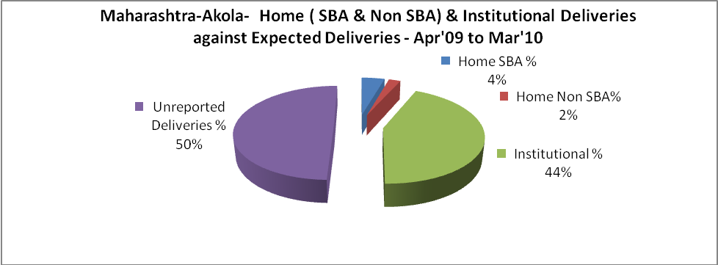

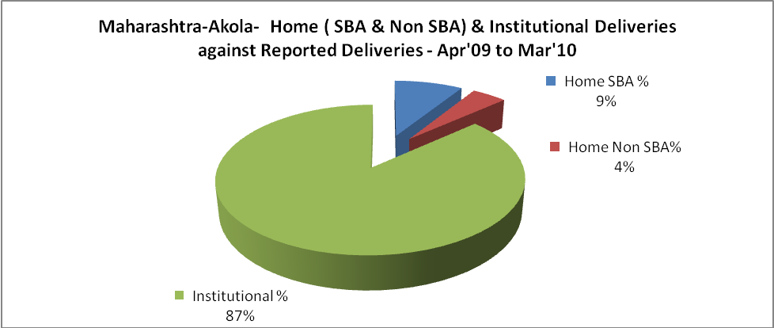

Maharashtra-Akola- C sections & Complicated Deliveries Apr'09 to Mar'10
 | Institutional Deliveries (Public) | Institutional Deliveries (Pvt)
 | 11,479 | 3,711
C Section | 1,128 | 137
C Section% | 10% | 4%
Complicated Pregnancies attended | 625 | 274
Complicated Pregnancies attended % | 5% | 7%

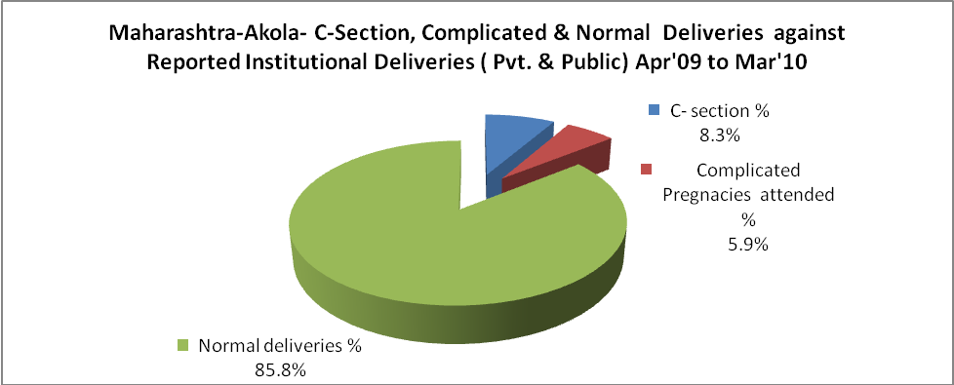

Maharashtra-Akola- Complicated Pregnancies & Deliveries Treated - Apr'09 to Mar'10
Reported Deliveries |  |  | Reported ANC Registration
17,532 |  |  | 32,877
Complicated Pregnancies attended | Complicated Pregnancies Rate | C - Section Deliveries | PNC Maternal Complications | Abortions | Still Births
899 | 2% | 1,265 | 2,357 | 870 | 345
Complicated Deliveries Treated with |  |  |  | No Of Eclampsia cases Treated | No Of severe anemia cases treated
IV Antibiotics | IV antihypertensive/Magsulph injection | IV Oxytocis | Blood Transfusion | No Of Eclampsia cases Treated | No Of severe anemia cases treated
8 | 4 | 8 | 54 | - | -

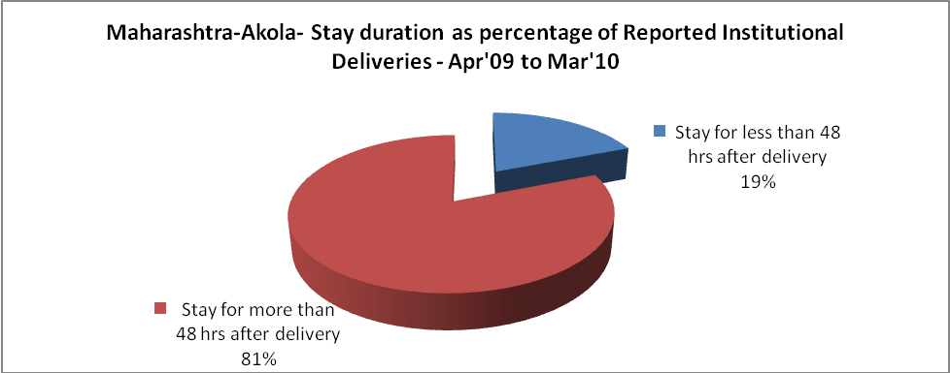

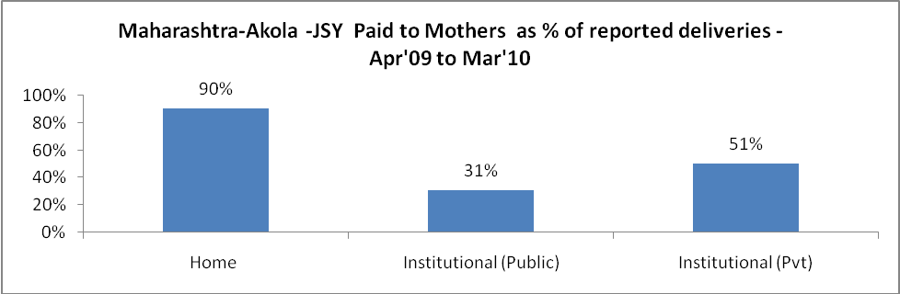

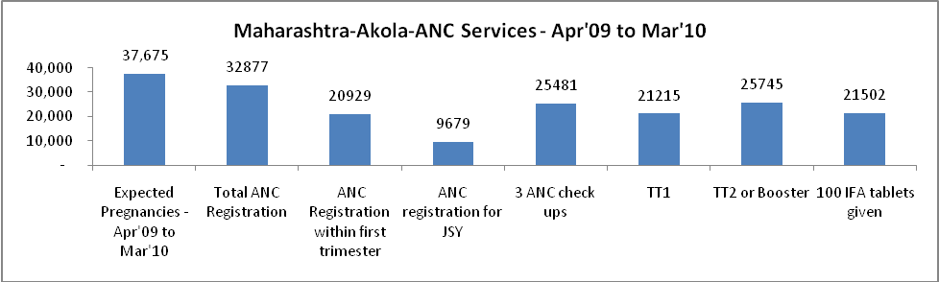

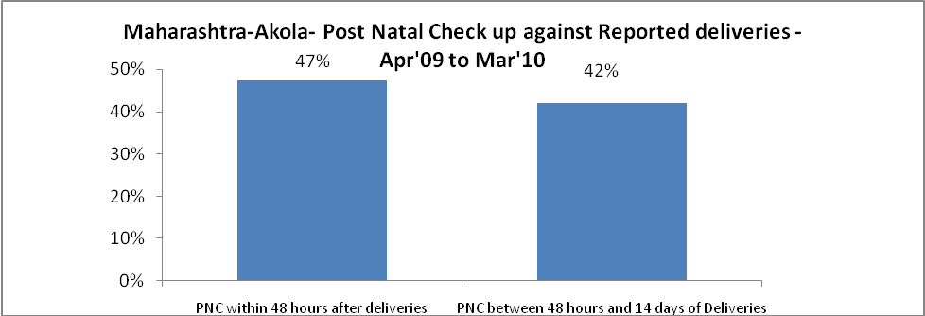

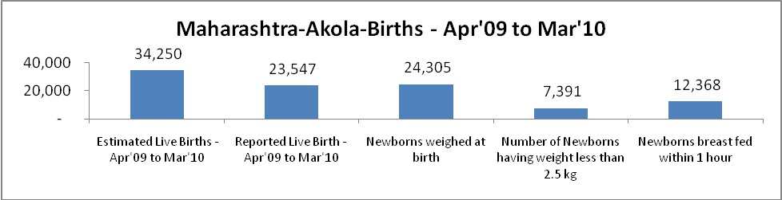

Maharashtra-Akola - Births - Apr'09 to Mar'10
Live Birth - Males | Live Birth - females | Live Birth - Total | Sex Ratio at birth | Still Birth | Abortion( Induced/Spontaneous
12,828 | 10,719 | 23,547 | 836 | 345 | 870

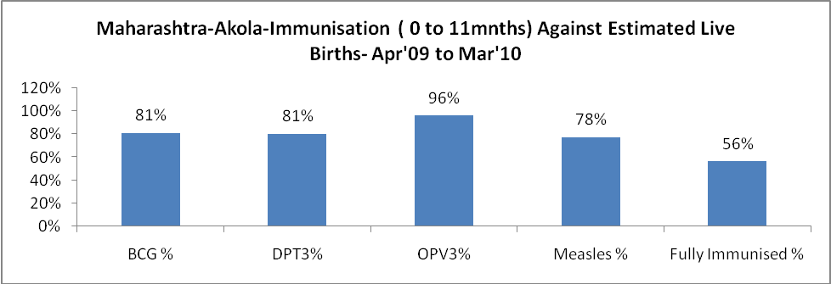

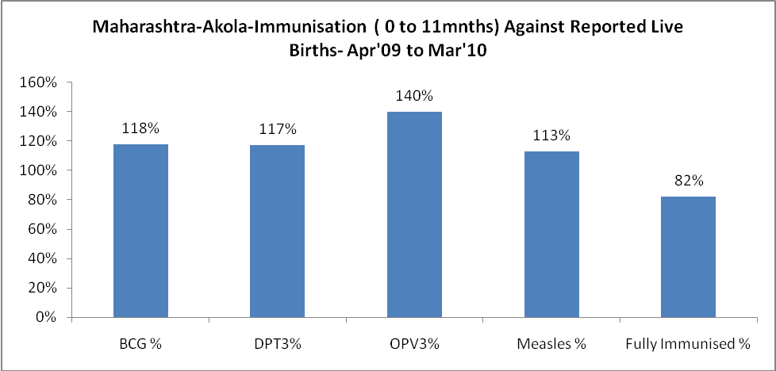

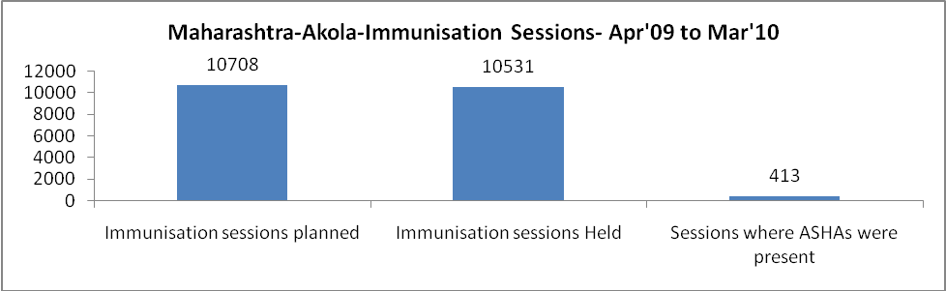

Maharashtra-Akola- Apr'09 to Mar'10
Total Abortions | Abortion Rate
2,187 | 5.8%

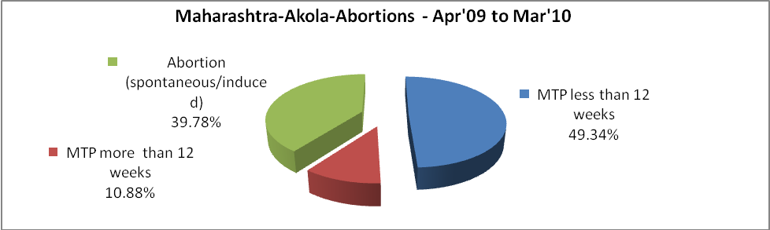

Maharashtra-Akola- Apr'09 to Mar'10
Total OPD | Total RTI/STI cases
279,820 | 2,771

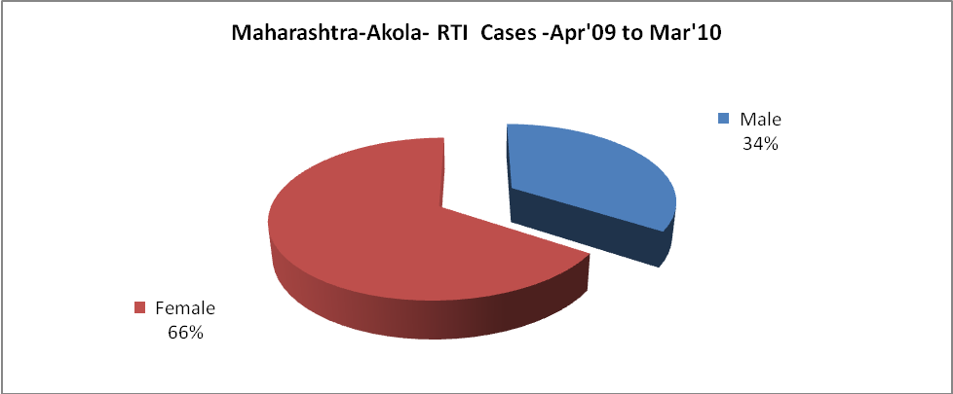

Maharashtra-Akola-Sterilizations - Apr'09 to Mar'10
 | Reported | %age of Reported Sterilization
Total Sterilization | 8,543 | -
NSV | 1,356 | 16%
Laparoscopic | 1,632 | 19%
Mini Lap | 5,269 | 62%
Post Partum | 286 | 3%
Male Sterilization | 1,356 | 16%
Female Sterilization | 7,187 | 84%

Maharashtra-Akola-FP Methods - Apr'09 to Mar'10
 | Reported | %age of All Reported FP Methods
Total Reported FP Method (All types) Users | 28,729 | -
Sterilizations | 8,543 | 30%
IUD | 6,346 | 22%
Condom Users | 5,691 | 20%
OCP Users | 8,149 | 28%
Limiting Methods | 8,543 | 30%
Spacing Methods | 20,186 | 70%

Maharashtra-Akola- Service Delivery - Apr'09 to Mar'10
Operation major (General and spinal anaesthesia) | Operation minor (No or local anaesthesia) | AYUSH | Dental Procedures | Adolescent counselling services | Total OPD | Total IPD
1,136 | 458 | 8 | 7 | 5 | 279,820 | 887
Operation major (General and spinal anaesthesia) as %ge of OPD | Operation minor (No or local anaesthesia)as %ge of OPD | AYUSH as %ge of OPD | Dental Procedures as %ge of OPD | Adolescent counselling services as %ge of OPD | IPD as percentage of OPD
0.4% | 0.2% | 0.0% | 0.0% | 0.0% | 0%

Maharashtra-Akola- Lab Services - Apr'09 to Mar'10
Total OPD | Total HB tested | Total HIV Tested | Total Population
279,820 | 84 | - | 1,913,386
HB test conducted as %age of OPD | HB<7gm as %age of HB tested | HIV test conducted as %age of OPD | HIV positive as %age of HIV tested | Blood Smear Examined as % of Population
0.0% | 6.0% | 0.0% | - | 11.8%

Maharashtra-Akola- Childhood Disease - Vaccine Preventable -Apr'09 to Mar'10
Diphtheria | Pertussis | Tetanus Neonatorum | Tetanus others | Polio | Measles
4 | 5 | 8 | 4 | 4 | 5
Maharashtra-Akola-Childhood Disease - Others - Apr'09 to Mar'10
Diarrhoea and dehydration | Malaria | Number admitted with Respiratory Infections
243 | 34 | 63

Maharashtra-Akola- Infant & Child Deaths - Apr'09 to Mar'10
Infant Deaths within 24 hrs of birth | Infant Deaths between 24hrs & under 1 week | Infant Deaths between 1 week & under 1 month | Child Deaths between 1 month & under 1 year | Child Deaths between 1yr under 5years | Total Deaths
187 | 131 | 752 | 8297 | 16670 | 26037

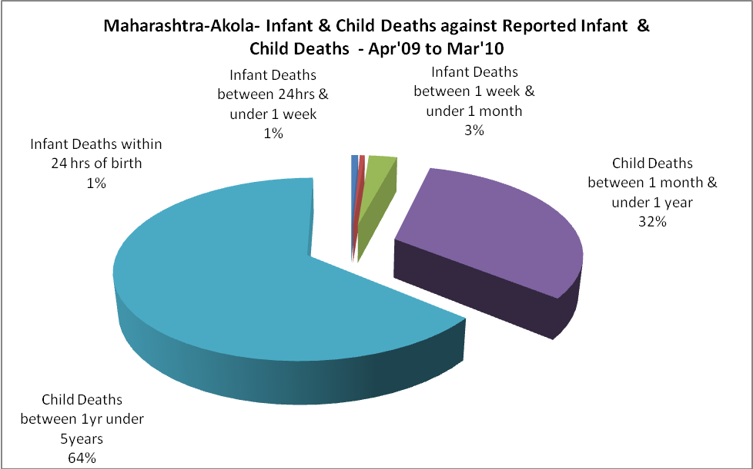

Maharashtra-Akola- Causes of Infant & Child Deaths - Apr'09 to Mar'10
Sepsis |  |  | Asphyxia |  |  | LBW
Up to 1 Weeks of Birth | Between 1 week & 4 weeks of birth | Total | Up to 1 Weeks of Birth | Between 1 week & 4 weeks of birth | Total | Up to 1 Weeks of Birth | Between 1 week & 4 weeks of birth | Total
12 | 91 | 103 | 13 | 16 | 29 | 93 | 512 | 605
Pneumonia |  |  | Diarrhoea |  |  | Fever related
Between 1 month and 11 months | Between 1 year & 5 years | Total | Between 1 month and 11 months | Between 1 year & 5 years | Total | Between 1 month and 11 months | Between 1 year & 5 years | Total
463 | 1098 | 1561 | 999 | 10585 | 11584 | 6270 | 4465 | 10735
Others |  |  | Measles |  |  | Others
Up to 1 Weeks of Birth | Between 1 week & 4 weeks of birth | Total | Between 1 month and 11 months | Between 1 year & 5 years | Total | Between 1 month and 11 months | Between 1 year & 5 years | Total
13 | 133 | 146 | 559 | 469 | 1028 | 6 | 53 | 59
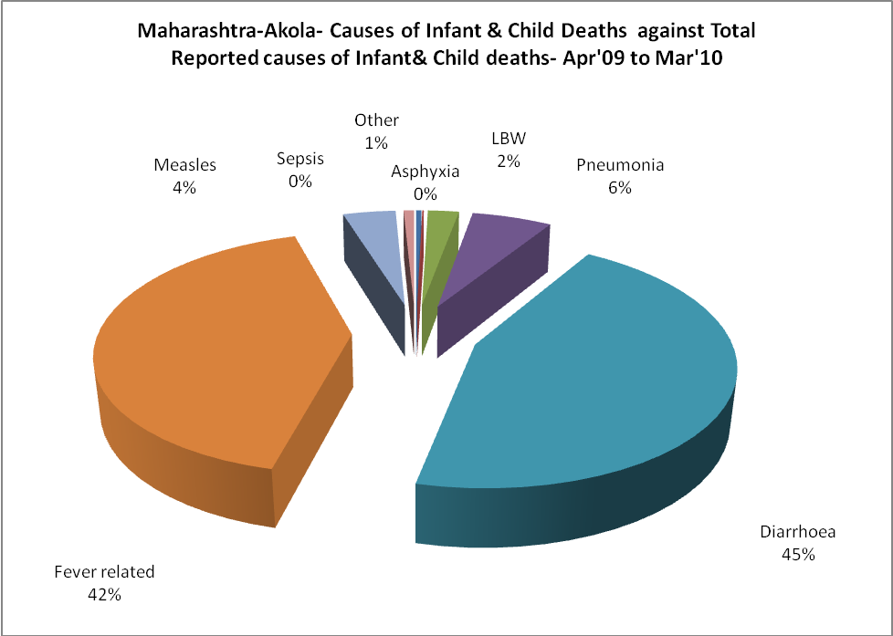

Maharashtra-Akola- Maternal Deaths & Causes - Apr'09 to Mar'10
Abortion |  |  | Obstructed/prolonged labour |  |  | Severe hypertesnion/fits
6-14 yrs | 15-55 yrs. | Total | 6-14 yrs | 15-55 yrs. | Total | 6-14 yrs | 15-55 yrs. | Total
0 | 4 | 4 | 0 | 48 | 48 | 0 | 52 | 52
Bleeding |  |  | High Fever |  |  | Other Causes
6-14 yrs | 15-55 yrs. | Total | 6-14 yrs | 15-55 yrs. | Total | 6-14 yrs | 15-55 yrs. | Total
0 | 12 | 12 | 0 | 63 | 63 | 0 | 4 | 4

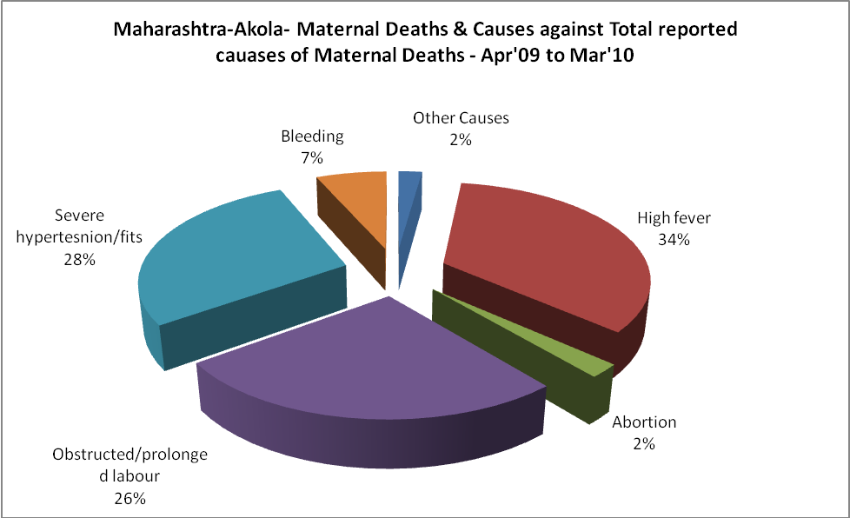
Maharashtra-Akola-Causes of Deaths in 6 to 55yrs age group - Apr'09 to Mar'10
Diarrhoel Diseases |  |  |  | Tuberculosis |  |  |  | Respiratory Diseases( Other than TB)
6-14 yrs | 15-55 yrs. | Above 55yrs | Total | 6-14 yrs | 15-55 yrs. | Above 55yrs | Total | 6-14 yrs | 15-55 yrs. | Above 55yrs | Total
11 | 89 | 0 | 100 | 89 | 55 | 0 | 144 | 553 | 4674 | 0 | 5227
Malaria |  |  |  | Other fever Related |  |  |  | HIV/Aids
6-14 yrs | 15-55 yrs. | Above 55yrs | Total | 6-14 yrs | 15-55 yrs. | Above 55yrs | Total | 6-14 yrs | 15-55 yrs. | Above 55yrs | Total
8 | 93 | 0 | 101 | 1441 | 1140 | 0 | 2581 | 170 | 5008 | 0 | 5178
Heart Disease/Hypertension related |  |  |  | Neurological Disease including strokes |  |  |  | Trauma/Accidents/ Burn Cases
6-14 yrs | 15-55 yrs. | Above 55yrs | Total | 6-14 yrs | 15-55 yrs. | Above 55yrs | Total | 6-14 yrs | 15-55 yrs. | Above 55yrs | Total
16 | 49 | 0 | 65 | 89 | 128 | 0 | 217 | 1879 | 16 | 0 | 1895
Suicide |  |  |  | Animal Bites & Stings
6-14 yrs | 15-55 yrs. | Above 55yrs | Total | 6-14 yrs | 15-55 yrs. | Above 55yrs | Total
23 | 53 | 0 | 76 | 12 | 12 | 0 | 24

