NHSRC
Maharashtra – Amravati
Analysis: Apr 2009 – Mar 2010

Maharashtra-Amravati- Summary-Apr'09 to Mar'10
ANC
ANC Registration against Expected Pregnancies | 86% | TT1 given to Pregnant women against ANC Registration | 57%
3 ANC Check ups against ANC Registrations | 87% | 100 IFA Tablets given to Pregnant women against ANC Registration | 80%
Deliveries
Unreported Deliveries against Estimated Deliveries | 26.7% | HOME Deliveries( SBA& Non SBA) against Estimated Deliveries | 9.0%
Institutional Deliveries against Estimated Deliveries | 64.3% | HOME Deliveries( SBA& Non SBA) against Reported Deliveries | 12.2%
Institutional Deliveries against Reported Deliveries | 87.8% | C Section Deliveries against Institutional Deliveries( Pvt & Pub) | 9%
Births & Neonates Care
Live Births Reported against Estimated Live Births | 77% | New borns weighed against Reported Live Births | 93%
Still Births (Reported) | 736 | New borns weighed less than 2.5 kgs against newborns weighed | 9%
Sex Ratio at Birth | 859 | New borns breastfed within one hr of Birth against Reported live Births | 14%
Child Immunization( 0 to 11 months)
BCG given against Expected Live Births | 87% | Measles given against Expected Live Births | 81%
OPV3 given against Expected Live Births | 84% | Fully Immunized Children against Expected Live Births | 79%
DPT3 given against Expected Live Births | 84%
Family Planning
Family Planning Methods Users ( Sterilizations(Male &Female)+IUD+ Condom pieces/72 + OCP Cycles/13) | 37,491 | IUD Insertions against reported FP Methods | 28%
Sterilization against reported FP Methods | 33% | Condom Users against reported FP Methods | 23%
 |  | OCP Users against reported FP Methods | 16%
Other Services
OPD | 349,856 | Major Operations | 5,619
IPD | 288 | Minor Operations | 7,643

Maharashtra-Amravati- Deliveries Apr'09 to Mar'10
Total Population | 3,059,916 | Expected Deliveries |  | 55,676
Home SBA | Home Non SBA | Institutional | Total Deliveries Reported | Unreported Deliveries
1,915 | 3,075 | 35,802 | 40,792 | 14,884
Home SBA % | Home Non SBA% | Institutional % | Total Deliveries Reported % | Unreported Deliveries %
3% | 6% | 64% | 73% | 27%

\
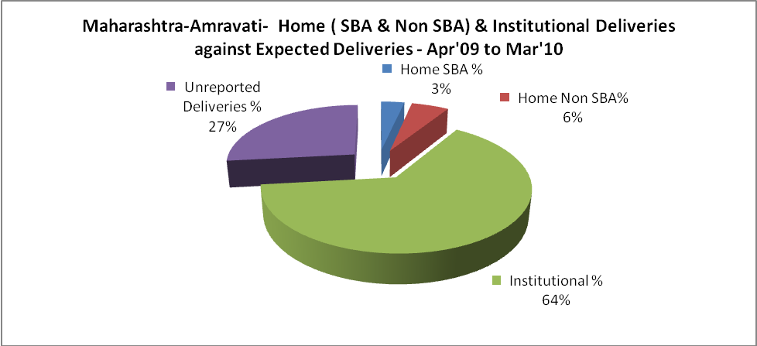

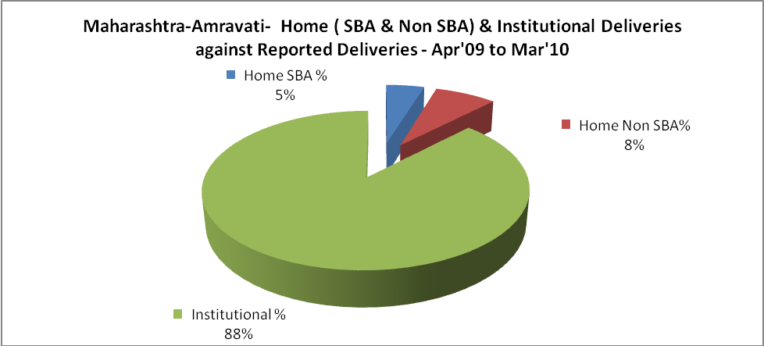

Maharashtra-Amravati- C sections & Complicated Deliveries Apr'09 to Mar'10
 | Institutional Deliveries (Public) | Institutional Deliveries (Pvt)
 | 22,735 | 13,067
C Section | 1,691 | 1,384
C Section% | 7% | 11%
Complicated Pregnancies attended | 3,404 | 936
Complicated Pregnancies attended % | 15% | 7%

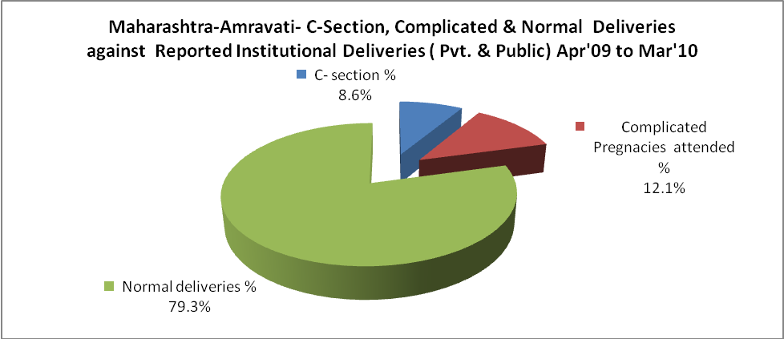

Maharashtra-Amravati- Complicated Pregnancies & Deliveries Treated - Apr'09 to Mar'10
Reported Deliveries |  |  | Reported ANC Registration
40,792 |  |  | 52,005
Complicated Pregnancies attended | Complicated Pregnancies Rate | C - Section Deliveries | PNC Maternal Complications | Abortions | Still Births
4,340 | 7% | 3,075 | 365 | 1,829 | 736
Complicated Deliveries Treated with |  |  |  | No Of Eclampsia cases Treated | No Of severe anemia cases treated
IV Antibiotics | IV antihypertensive/Magsulph injection | IV Oxytocis | Blood Transfusion | No Of Eclampsia cases Treated | No Of severe anemia cases treated
- | - | - | - | 2 | 175

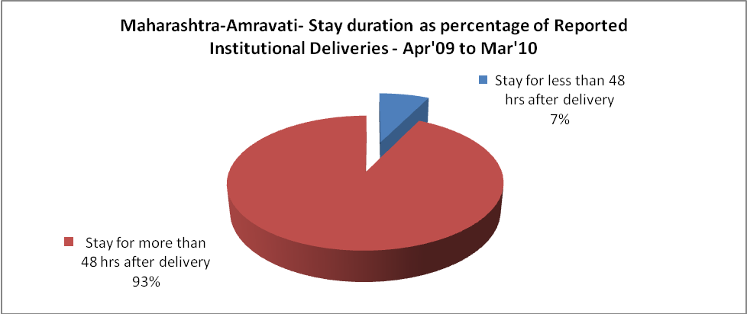

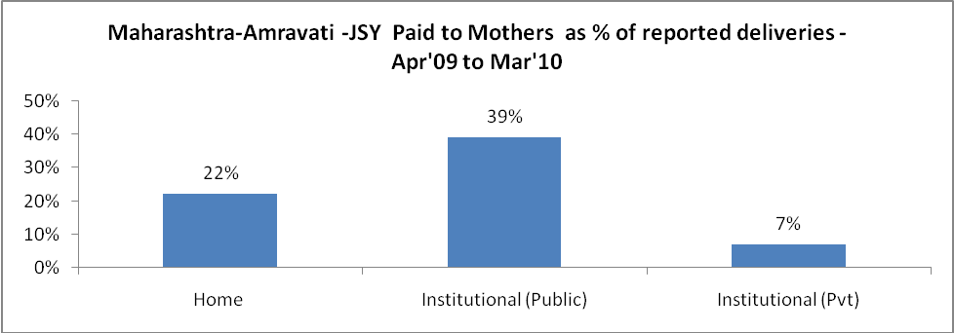

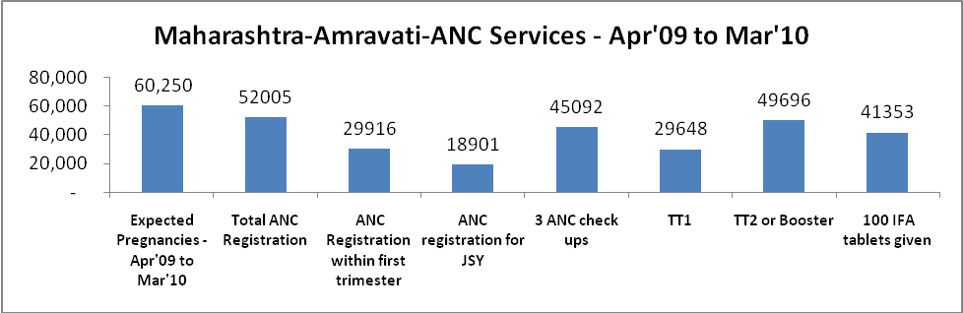

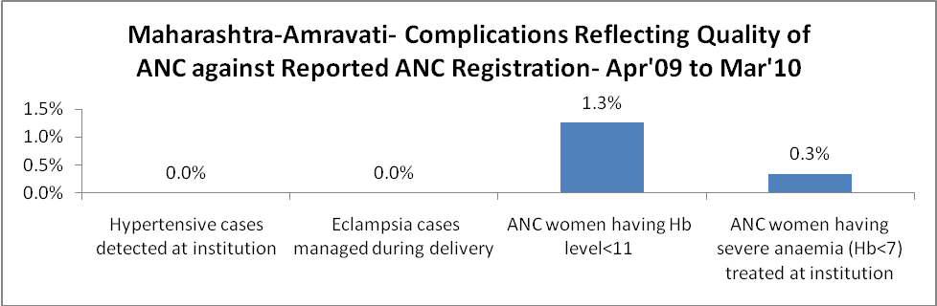

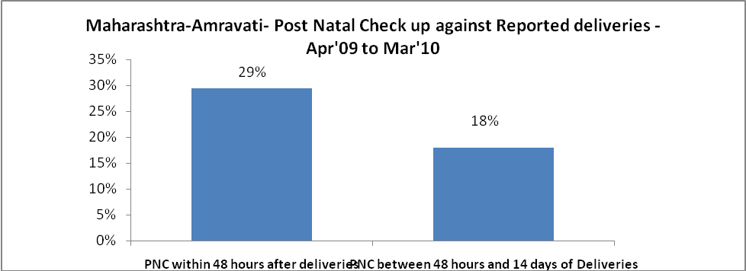

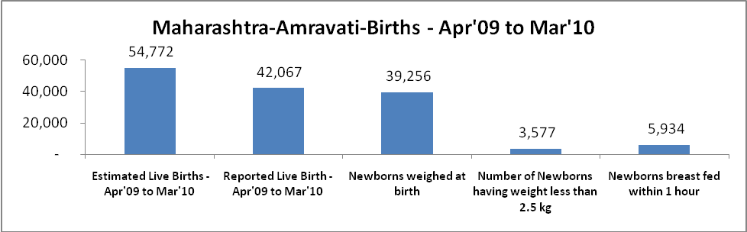`

Maharashtra-Amravati - Births - Apr'09 to Mar'10
Live Birth - Males | Live Birth - females | Live Birth - Total | Sex Ratio at birth | Still Birth | Abortion( Induced/Spontaneous
22,627 | 19,440 | 42,067 | 859 | 736 | 1,829

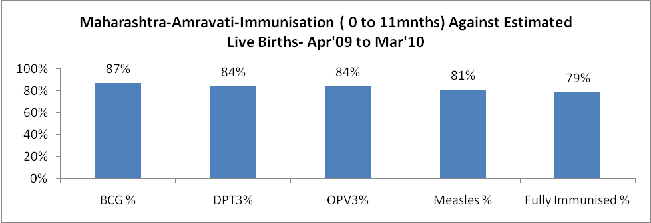

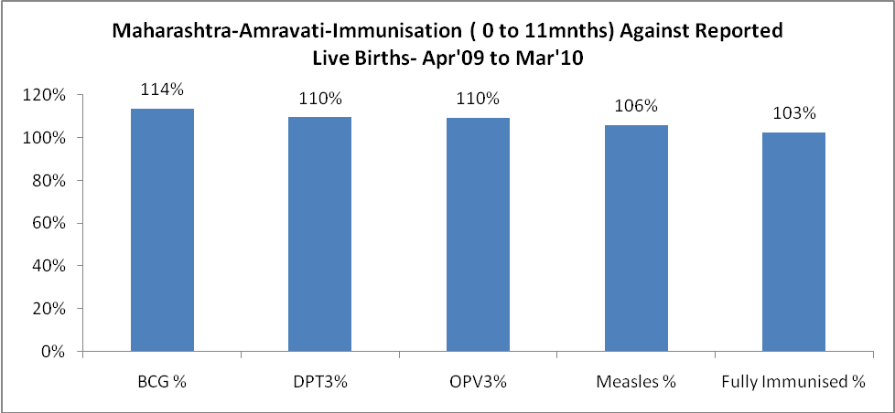

Maharashtra-Amravati- Apr'09 to Mar'10
Total Abortions | Abortion Rate
5,052 | 8.4%

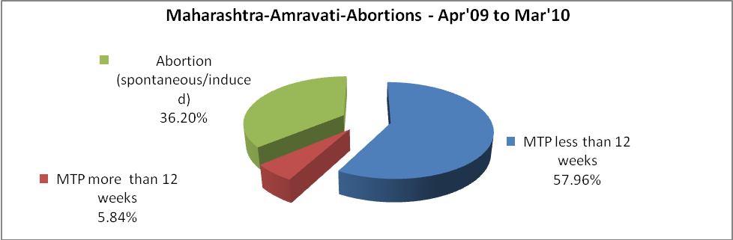

Maharashtra-Amravati- Apr'09 to Mar'10
Total OPD | Total RTI/STI cases
349,856 | 3,277

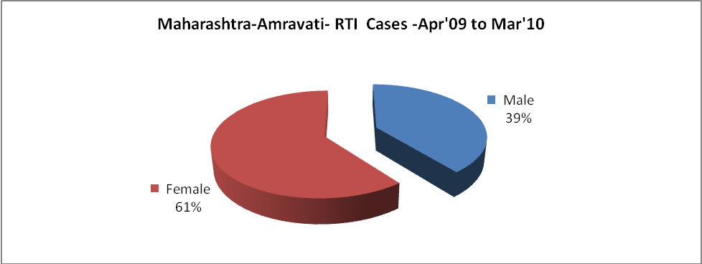

Maharashtra-Amravati-Sterilizations - Apr'09 to Mar'10
 | Reported | %age of Reported Sterilization
Total Sterilization | 12,479 | -
NSV | 2,680 | 21%
Laparoscopic | 1,447 | 12%
Mini Lap | 4,355 | 35%
Post Partum | 3,997 | 32%
Male Sterilization | 2,680 | 21%
Female Sterilization | 9,799 | 79%

Maharashtra-Amravati-FP Methods - Apr'09 to Mar'10
 | Reported | %age of All Reported FP Methods
Total Reported FP Method (All types) Users | 37,491 | -
Sterilizations | 12,479 | 33%
IUD | 10,379 | 28%
Condom Users | 8,716 | 23%
OCP Users | 5,916 | 16%
Limiting Methods | 12,479 | 33%
Spacing Methods | 25,012 | 67%

Maharashtra-Amravati- Service Delivery - Apr'09 to Mar'10
Operation major (General and spinal anaesthesia) | Operation minor (No or local anaesthesia) | AYUSH | Dental Procedures | Adolescent counselling services | Total OPD | Total IPD
5,619 | 7,643 | 1,397 | 154 | 61 | 349,856 | 288
Operation major (General and spinal anaesthesia) as %ge of OPD | Operation minor (No or local anaesthesia)as %ge of OPD | AYUSH as %ge of OPD | Dental Procedures as %ge of OPD | Adolescent counselling services as %ge of OPD | IPD as percentage of OPD
1.6% | 2.2% | 0.4% | 0.0% | 0.0% | 0%

Maharashtra-Amravati- Lab Services - Apr'09 to Mar'10
Total OPD | Total HB tested | Total HIV Tested | Total Population
349,856 | 35,070 | - | 3,059,916
HB test conducted as %age of OPD | HB<7gm as %age of HB tested | HIV test conducted as %age of OPD | HIV positive as %age of HIV tested | Blood Smear Examined as % of Population
10.0% | 18.5% | 0.0% | - | 12.8%

Maharashtra-Amravati- Childhood Disease - Vaccine Preventable -Apr'09 to Mar'10
Diphtheria | Pertussis | Tetanus Neonatorum | Tetanus others | Polio | Measles
0 | 0 | 0 | 0 | 0 | 3
Maharashtra-Amravati-Childhood Disease - Others - Apr'09 to Mar'10
Diarrhoea and dehydration | Malaria | Number admitted with Respiratory Infections
926 | 3 | 94

Maharashtra-Amravati- Infant & Child Deaths - Apr'09 to Mar'10
Infant Deaths within 24 hrs of birth | Infant Deaths between 24hrs & under 1 week | Infant Deaths between 1 week & under 1 month | Child Deaths between 1 month & under 1 year | Child Deaths between 1yr under 5years | Total Deaths
62 | 106 | 45 | 73 | 68 | 354

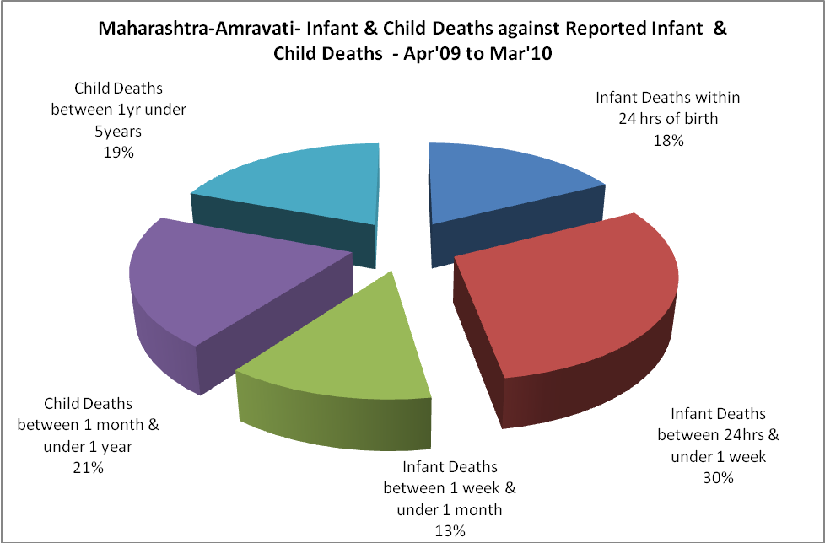

Maharashtra-Amravati- Causes of Infant & Child Deaths - Apr'09 to Mar'10
Sepsis |  |  | Asphyxia |  |  | LBW
Up to 1 Weeks of Birth | Between 1 week & 4 weeks of birth | Total | Up to 1 Weeks of Birth | Between 1 week & 4 weeks of birth | Total | Up to 1 Weeks of Birth | Between 1 week & 4 weeks of birth | Total
2 | 0 | 2 | 5 | 0 | 5 | 6 | 0 | 6
Pneumonia |  |  | Diarrhoea |  |  | Fever related
Between 1 month and 11 months | Between 1 year & 5 years | Total | Between 1 month and 11 months | Between 1 year & 5 years | Total | Between 1 month and 11 months | Between 1 year & 5 years | Total
0 | 0 | 0 | 0 | 0 | 0 | 0 | 0 | 0
Others |  |  | Measles |  |  | Others
Up to 1 Weeks of Birth | Between 1 week & 4 weeks of birth | Total | Between 1 month and 11 months | Between 1 year & 5 years | Total | Between 1 month and 11 months | Between 1 year & 5 years | Total
93 | 45 | 138 | 0 | 0 | 0 | 73 | 68 | 141

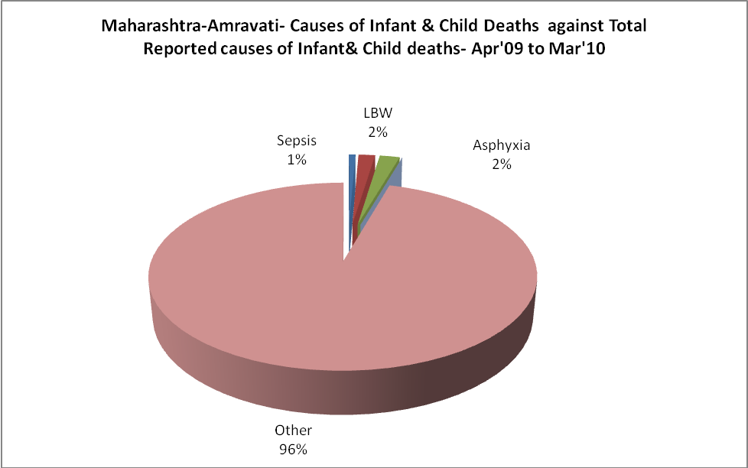

Maharashtra-Amravati- Maternal Deaths & Causes - Apr'09 to Mar'10
Abortion |  |  | Obstructed/prolonged labour |  |  | Severe hypertension/fits
6-14 yrs | 15-55 yrs. | Total | 6-14 yrs | 15-55 yrs. | Total | 6-14 yrs | 15-55 yrs. | Total
0 | 1 | 1 | 0 | 2 | 2 | 0 | 2 | 2
Bleeding |  |  | High Fever |  |  | Other Causes
6-14 yrs | 15-55 yrs. | Total | 6-14 yrs | 15-55 yrs. | Total | 6-14 yrs | 15-55 yrs. | Total
0 | 5 | 5 | 0 | 7 | 7 | 0 | 5 | 5

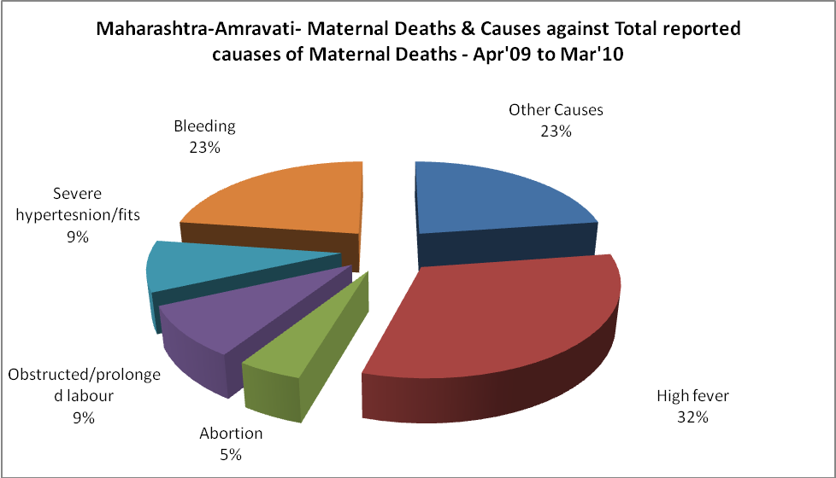

Maharashtra-Amravati-Causes of Deaths in 6 to 55yrs age group - Apr'09 to Mar'10
Diarrheal Diseases |  |  |  | Tuberculosis |  |  |  | Respiratory Diseases( Other than TB)
6-14 yrs | 15-55 yrs. | Above 55yrs | Total | 6-14 yrs | 15-55 yrs. | Above 55yrs | Total | 6-14 yrs | 15-55 yrs. | Above 55yrs | Total
0 | 0 | 0 | 0 | 0 | 0 | 0 | 0 | 0 | 0 | 0 | 0
Malaria |  |  |  | Other fever Related |  |  |  | HIV/Aids
6-14 yrs | 15-55 yrs. | Above 55yrs | Total | 6-14 yrs | 15-55 yrs. | Above 55yrs | Total | 6-14 yrs | 15-55 yrs. | Above 55yrs | Total
0 | 0 | 0 | 0 | 0 | 0 | 0 | 0 | 0 | 0 | 0 | 0
Heart Disease/Hypertension related |  |  |  | Neurological Disease including strokes |  |  |  | Trauma/Accidents/ Burn Cases
6-14 yrs | 15-55 yrs. | Above 55yrs | Total | 6-14 yrs | 15-55 yrs. | Above 55yrs | Total | 6-14 yrs | 15-55 yrs. | Above 55yrs | Total
0 | 0 | 0 | 0 | 0 | 0 | 0 | 0 | 0 | 0 | 0 | 0
Suicide |  |  |  | Animal Bites & Stings
6-14 yrs | 15-55 yrs. | Above 55yrs | Total | 6-14 yrs | 15-55 yrs. | Above 55yrs | Total
0 | 0 | 0 | 0 | 0 | 0 | 0 | 0

