NHSRC
Bihar- Araria
HMIS Analysis 2009-2010

NHSRC
25/08/2010

Bihar- Araria- Summary-Apr'09 to Mar'10
ANC
ANC Registration against Expected Pregnancies | 39% | TT1 given to Pregnant women against ANC Registration | 94%
3 ANC Checkups against ANC Registrations | 60% | 100 IFA Tablets given to Pregnant women against ANC Registration | 512%
Deliveries
Unreported Deliveries against Estimated Deliveries | 54.0% | HOME Deliveries( SBA& Non SBA) against Estimated Deliveries | 4.9%
Institutional Deliveries against Estimated Deliveries | 41.1% | HOME Deliveries( SBA& Non SBA) against Reported Deliveries | 10.7%
Institutional Deliveries against Reported Deliveries | 89.3% | C Section Deliveries against Institutional Deliveries( Pvt & Pub) | 0%
Births & Neonates Care
Live Births Reported against Estimated Live Births | 35% | New born weighed against Reported Live Births | 94%
Still Births (Reported) | 307 | New born weighed less than 2.5 kgs against newborns weighed | 7%
Sex Ratio at Birh | 1,009 | New born breastfed within one hr of Birth against Reported live Births | 82%
Child Immunisation( 0 to 11 months)
BCG given against Expected Live Births | 57% | Measles given against Expected Live Births | 53%
OPV3 given against Expected Live Births | 59% | Fully Immunised Children against Expected Live Births | 144%
DPT3 given against Expected Live Births | 60%
Family Plannng
Family Plannig Methods Users ( Sterilisations(Male &Female)+IUD+ Condom pieces/72 + OCP Cycles/13) | 20,487 | IUD Insertions against reported FP Methods | 28%
Sterilisation against reported FP Methods | 64% | Condom Users against reported FP Methods | 6%
 |  | OCP Users against reported FP Methods | 2%
Other Services
OPD | 5,31,891 | Major Operations | 432
IPD | 34,310 | Minor Operations | 1,133

Bihar- Araria- Deliveries Apr'09 to Mar'10
Total Population | 24,42,796 | Expected Deliveries |  | 74,034
Home SBA | Home Non SBA | Institutional | Total Deliveries Reported | Unreported Deliveries
3,483 | 158 | 30,416 | 34,057 | 39,977
Home SBA % | Home Non SBA% | Institutional % | Total Deliveries Reported % | Unreported Deliveries %
5% | 0% | 41% | 46% | 54%

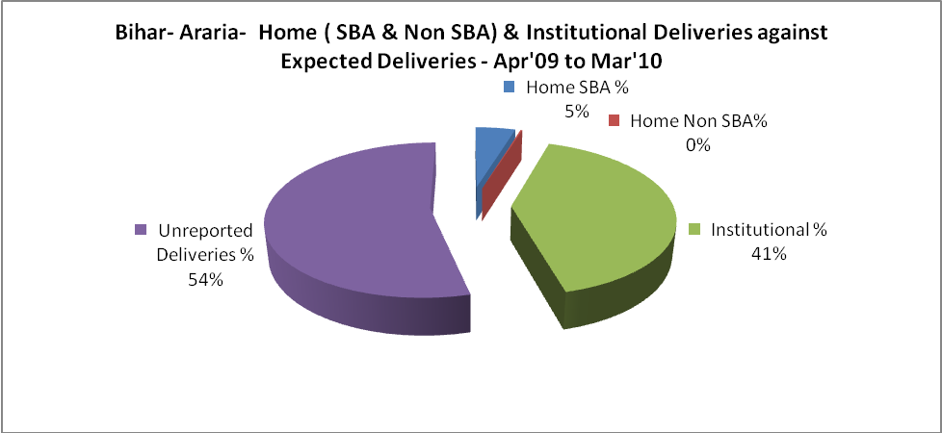

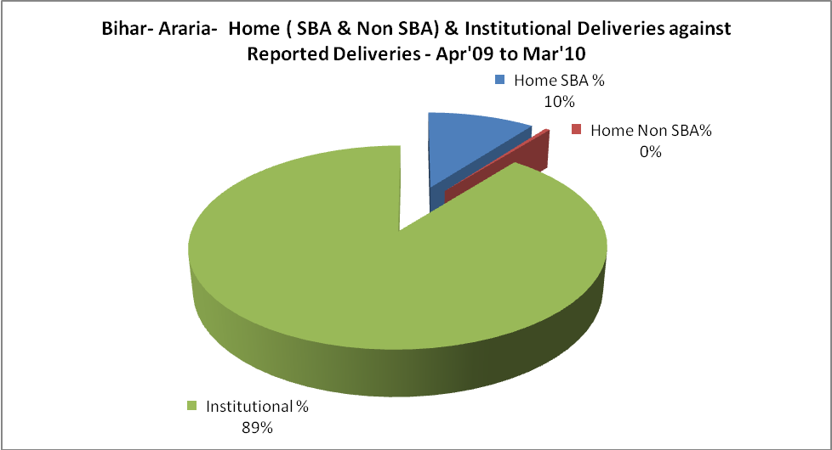

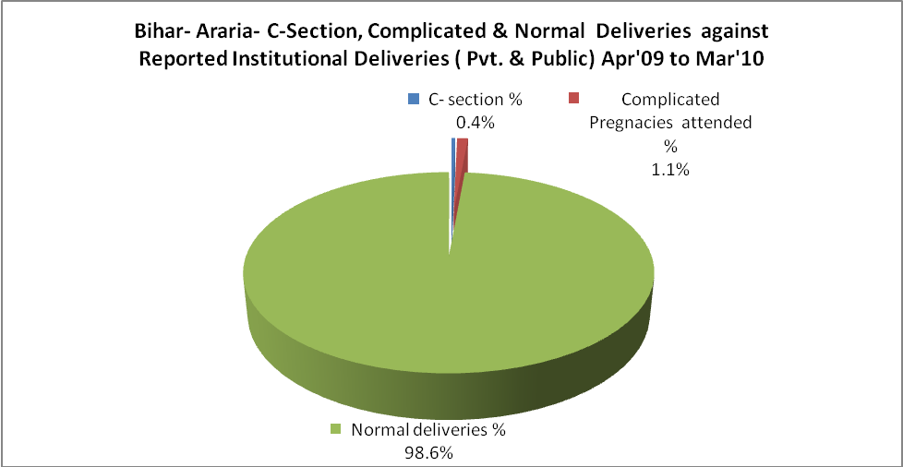

Bihar- Araria- Complicated Pregnancies & Deliveries Treated - Apr'09 to Mar'10
Reported Deliveries |  |  | Reported ANC Reigtration
34,057 |  |  | 30,759
Complicated Pregnancies attended | Complicated Pregnancies Rate | C - Section Deliveries | PNC Maternal Complications | Abortions | Still Births
324 | 0% | 112 | 183 | 17 | 307
Complicated Deliveries Treated with |  |  |  | No Of Eclampsia cases Treated | No Of severe anaemia cases treated
IV Antibiotics | IV antihypertensive/Magsulph injection | IV Oxytocis | Blood Transfusion | No Of Eclampsia cases Treated | No Of severe anaemia cases treated
913 | - | 1,047 | 206 | 318 | 444

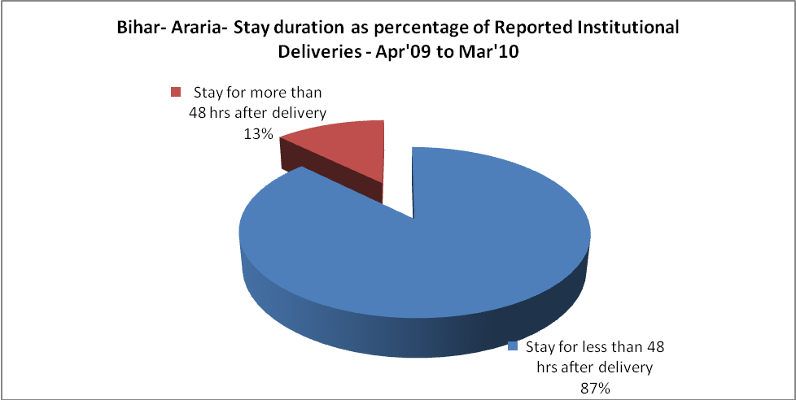

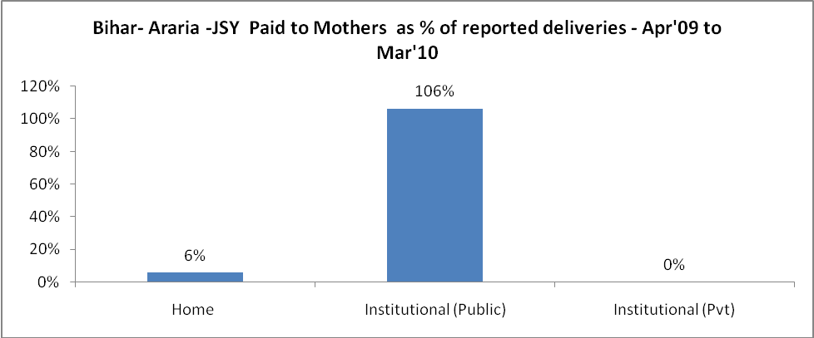
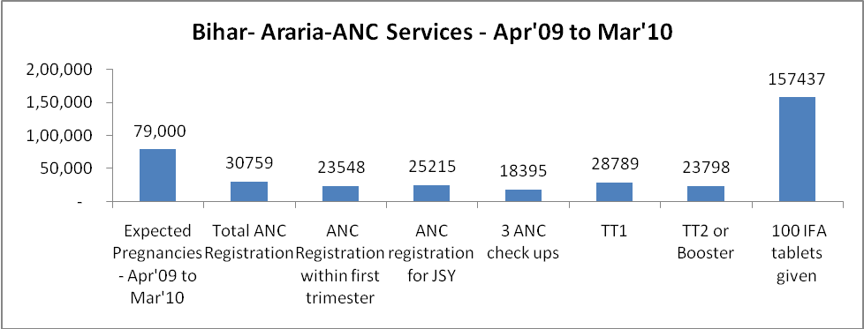

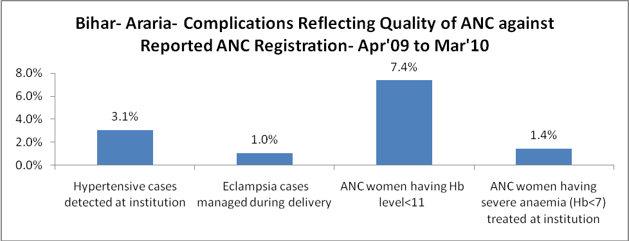

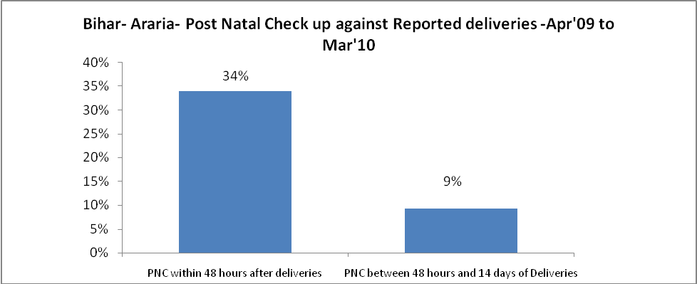

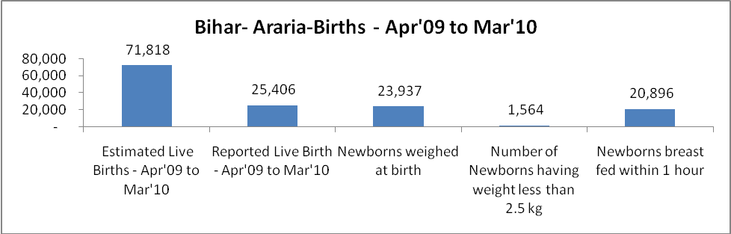

Bihar- Araria - Births - Apr'09 to Mar'10
Live Birth - Males | Live Birth - females | Live Birth - Total | Sex Ratio at birth | Still Birth | Abortion( Induced/Spontaneous
12,646 | 12,760 | 25,406 | 1,009 | 307 | 17

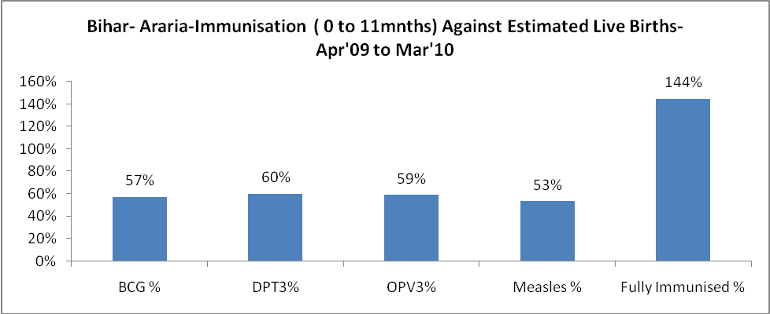

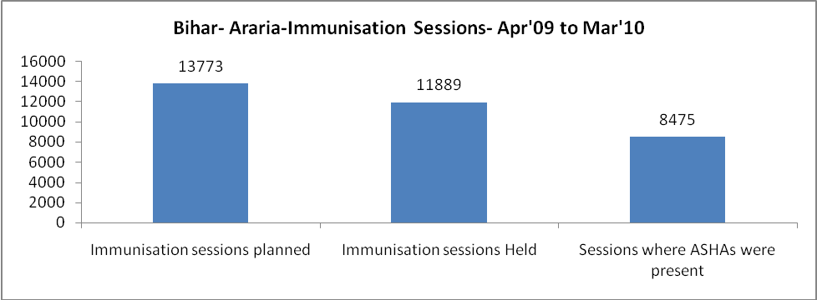

Bihar- Araria- Apr'09 to Mar'10
Total Abortions | Abortion Rate
1,827 | 2.3%

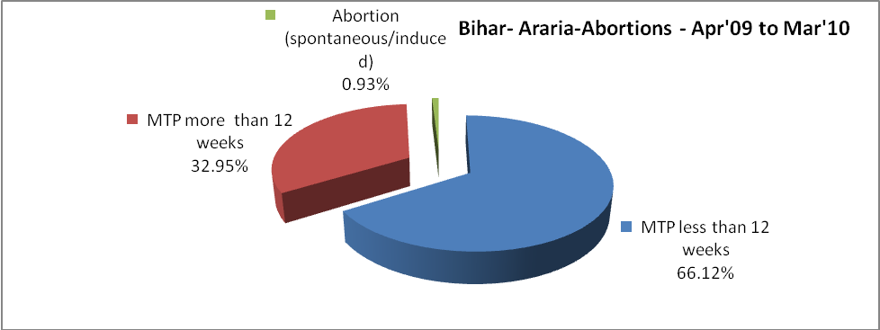

Bihar- Araria- Apr'09 to Mar'10
Total OPD | Total RTI/STI cases
5,31,891 | 4,899

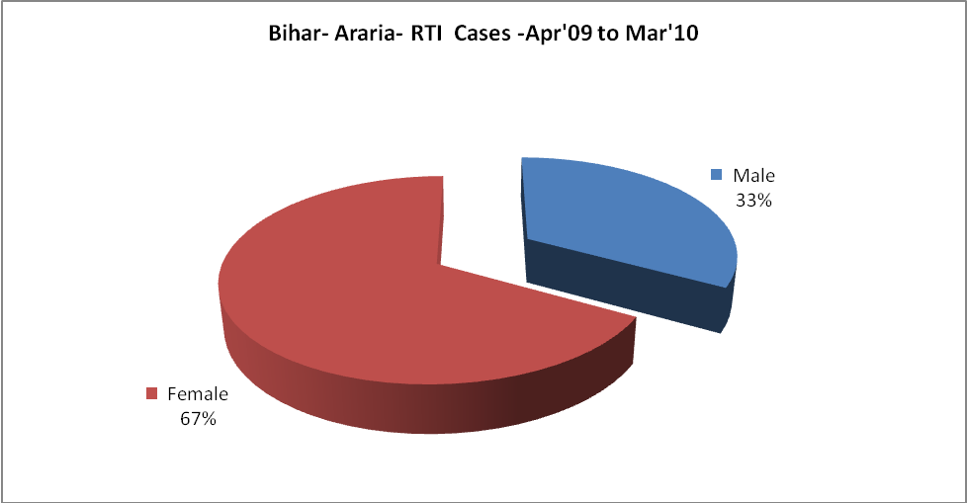
Bihar- Araria-Sterilisations - Apr'09 to Mar'10
 | Reported | %age of Reported Sterilisation
Total Sterilisation | 13,110 | -
NSV | 6,388 | 49%
Laproscopic | 646 | 5%
MiniLap | 3,934 | 30%
Post Partum | 2,142 | 16%
Male Sterilisation | 6,388 | 49%
Female Sterilisation | 6,722 | 51%

Bihar- Araria-FP Methods - Apr'09 to Mar'10
 | Reported | %age of All Reported FP Methods
Total Reported FP Methodd (All types) Users | 20,487 | -
Sterilisations | 13,110 | 64%
IUD | 5,691 | 28%
Condom Users | 1,239 | 6%
OCP Users | 447 | 2%
Limiting Methods | 13,110 | 64%
Spacing Methods | 7,377 | 36%

Bihar- Araria- Service Delivery - Apr'09 to Mar'10
Operation major (General and spinal anaesthesia) | Operation minor (No or local anaesthesia) | AYUSH | Dental Procedures | Adolescent counselling services | Total OPD | Total IPD
432 | 1,133 | 6 | 4 | 1 | 5,31,891 | 34,310
Operation major (General and spinal anaesthesia) as %ge of OPD | Operation minor (No or local anaesthesia)as %ge of OPD | AYUSH as %ge of OPD | Dental Procedures as %ge of OPD | Adolescent counselling services as %ge of OPD | IPD as percentage of OPD
0.1% | 0.2% | 0.0% | 0.0% | 0.0% | 6%

Bihar- Araria- Lab Services - Apr'09 to Mar'10
Total OPD | Total HB tested | Total HIV Tested | Total Population
5,31,891 | 1,112 | 1,077 | 24,42,796
HB test conducted as %age of OPD | HB<7gm as %age of HB tested | HIV test conducted as %age of OPD | HIV positive as %age of HIV tested | Blood Smear Examined as % of Population
0.2% | 6.5% | 0.2% | 0.6% | 0.0%

Bihar- Araria- Childhood Disease - Vaccine Preventable -Apr'09 to Mar'10
Diphtheria | Pertussis | Tetanus Neonatorum | Tetanus others | Polio | Measles
0 | 0 | 0 | 0 | 4 | 15
Bihar- Araria-Childhood Disease - Others - Apr'09 to Mar'10
Diarrhoea and dehydration | Malaria | Number admitted with Respiratory Infections
353 | 119 | 49

Bihar- Araria- Infant & Child Deaths - Apr'09 to Mar'10
Infant Deaths within 24 hrs of birth | Infant Deaths between 24hrs & under 1 week | Infant Deaths between 1 week & under 1 month | Child Deaths between 1 month & under 1 year | Child Deaths between 1yr under 5years | Total Deaths
1 | 0 | 0 | 0 | 5 | 6

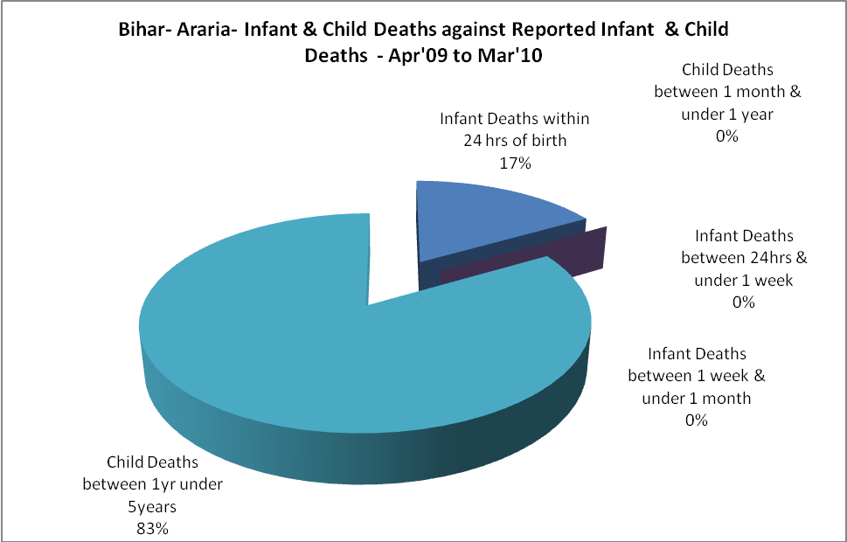

Bihar- Araria- Causes of Infant & Child Deaths - Apr'09 to Mar'10
Sepsis |  |  | Asphyxia |  |  | LBW
Up to 1 Weeks of Birth | Between 1 week & 4 weeks of birth | Total | Up to 1 Weeks of Birth | Between 1 week & 4 weeks of birth | Total | Up to 1 Weeks of Birth | Between 1 week & 4 weeks of birth | Total
0 | 0 | 0 | 0 | 0 | 0 | 0 | 0 | 0
Pneumonia |  |  | Diarrhoea |  |  | Fever related
Between 1 month and 11 months | Between 1 year & 5 years | Total | Between 1 month and 11 months | Between 1 year & 5 years | Total | Between 1 month and 11 months | Between 1 year & 5 years | Total
0 | 0 | 0 | 0 | 5 | 5 | 0 | 0 | 0
Others |  |  | Measles |  |  | Others
Up to 1 Weeks of Birth | Between 1 week & 4 weeks of birth | Total | Between 1 month and 11 months | Between 1 year & 5 years | Total | Between 1 month and 11 months | Between 1 year & 5 years | Total
0 | 0 | 0 | 0 | 0 | 0 | 0 | 0 | 0

Bihar- Araria- Maternal Deaths & Causes - Apr'09 to Mar'10
Abortion |  |  | Obstructed/prolonged labour |  |  | Severe hypertension / fits
6-14 yrs | 15-55 yrs. | Total | 6-14 yrs | 15-55 yrs. | Total | 6-14 yrs | 15-55 yrs. | Total
0 | 0 | 0 | 0 | 0 | 0 | 0 | 0 | 0
Bleeding |  |  | High Fever |  |  | Other Causes
6-14 yrs | 15-55 yrs. | Total | 6-14 yrs | 15-55 yrs. | Total | 6-14 yrs | 15-55 yrs. | Total
0 | 0 | 0 | 0 | 0 | 0 | 0 | 0 | 0

Bihar- Araria-Causes of Deaths in 6 to 55yrs age group - Apr'09 to Mar'10
Diarrhoel Diseases |  |  |  | Tuberculosis |  |  |  | Respiratory Diseases( Other than TB)
6-14 yrs | 15-55 yrs. | Above 55yrs | Total | 6-14 yrs | 15-55 yrs. | Above 55yrs | Total | 6-14 yrs | 15-55 yrs. | Above 55yrs |  | Total
8 | 4 | 0 | 12 | 6 | 137 | 0 | 143 | 8 | 3 | 0 |  | 11
Malaria |  |  |  | Other fever Related |  |  |  | HIV/Aids
6-14 yrs | 15-55 yrs. | Above 55yrs | Total | 6-14 yrs | 15-55 yrs. | Above 55yrs | Total | 6-14 yrs | 15-55 yrs. | Above 55yrs | Total
0 | 0 | 0 | 0 | 0 | 0 | 0 | 0 | 0 | 0 | 0 | 0
Heart Disease/Hypertenion related |  |  |  | Neurological Disease including strokes |  |  |  | Trauma/Accidents/ Burn Cases
6-14 yrs | 15-55 yrs. | Above 55yrs | Total | 6-14 yrs | 15-55 yrs. | Above 55yrs | Total | 6-14 yrs | 15-55 yrs. | Above 55yrs | Total
0 | 9 | 0 | 9 | 0 | 0 | 0 | 0 | 0 | 0 | 0 | 0
Suicide |  | Animal Bites & Stings
6-14 yrs | 15-55 yrs. | Above 55yrs | Total | 6-14 yrs | 15-55 yrs. | Above 55yrs | Total
0 | 0 | 0 | 0 | 16 | 8 | 0 | 24

