NHSRC
Bihar- Arwal
HMIS DATA ANALYSIS 2009-10

KUNAL
8/14/2010

Bihar- Arwal- Summary-Apr'09 to Mar'10
ANC
ANC Registration against Expected Pregnancies | 47% | TT1 given to Pregnant women against ANC Registration | 119%
3 ANC Checkups against ANC Reigtrations | 55% | 100 IFA Tablets given to Pregnant women against ANC Registration | 83%
Deliveries
Unreported Deliveries against Estimated Deliveries | 56.7% | HOME Deliveries( SBA& Non SBA) against Estimated Deliveries | 7.7%
Institutional Deliveries against Estimated Deliveries | 35.5% | HOME Deliveries( SBA& Non SBA) against Reported Deliveries | 17.9%
Institutional Deliveries against Reported Deliveries | 82.1% | C Section Deliveries against Institutional Deliveries( Pvt & Pub) | 0%
Births & Neonates Care
Live Births Reported against Estimated Live Births | 43% | New borns weighed against Reported Live Births | 91%
Still Births (Reported) | 182 | New borns weighed less than 2.5 kgs against newborns weighed | 17%
Sex Ratio at Birth | 973 | New borns breastfed within one hr of Birth against Reported live Births | 86%
Child Immunisation( 0 to 11 months)
BCG given against Expected Live Births | 70% | Measles given against Expected Live Births | 71%
OPV3 given against Expected Live Births | 73% | Fully Immunised Children against Expected Live Births | 92%
DPT3 given against Expected Live Births | 73%
Family Planning
Family Plannig Methods Users ( Sterilisations(Male &Female)+IUD+ Condom pieces/72 + OCP Cycles/13) | 6,659 | IUD Insertions against reported FP Methods | 20%
Sterilisation against reported FP Methods | 29% | Condom Users against reported FP Methods | 25%
 |  | OCP Users against reported FP Methods | 26%
Other Services
OPD | 2,30,310 | Major Operations | 242
IPD | 2,417 | Minor Operations | 2,848

Bihar- Arwal- Deliveries Apr'09 to Mar'10
Total Population | 7,00,282 | Expected Deliveries |  | 21,223
Home SBA | Home Non SBA | Institutional | Total Deliveries Reported | Unreported Deliveries
611 | 1,032 | 7,539 | 9,182 | 12,041
Home SBA % | Home Non SBA% | Institutional % | Total Deliveries Reported % | Unreported Deliveries %
3% | 5% | 36% | 43% | 57%

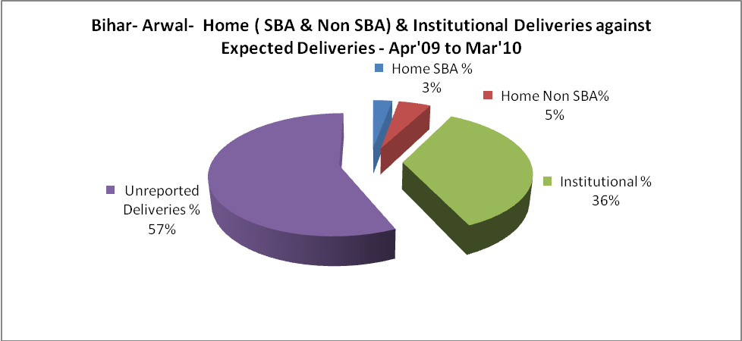

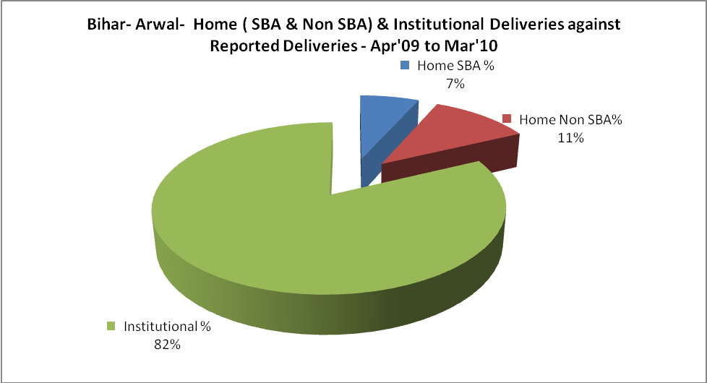

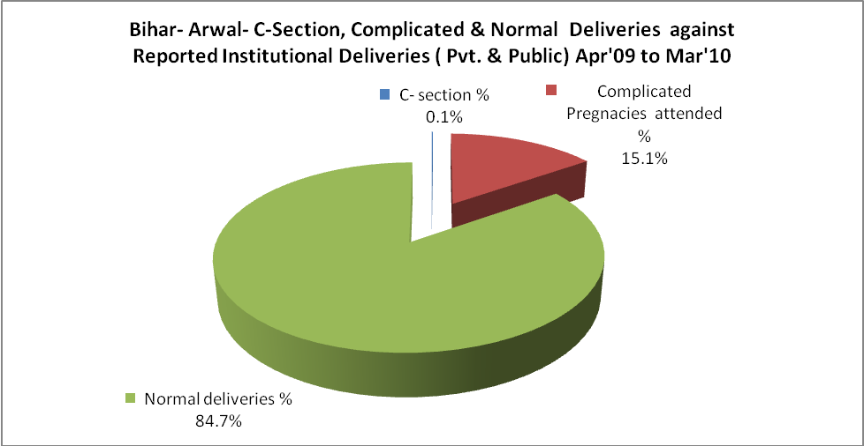

Bihar- Arwal- Complicated Pregnancies & Deliveries Treated - Apr'09 to Mar'10
Reported Deliveries |  |  | Reported ANC Reigtration
9,182 |  |  | 10,617
Complicated Pregnancies attended | Complicated Pregnancies Rate | C - Section Deliveries | PNC Maternal Complications | Abortions | Still Births
1,142 | 5% | 9 | - | - | 182
Complicated Deliveries Treated with |  |  |  | No Of Eclampsia cases Treated | No Of severe anemia cases treated
IV Antibiotics | IV antihypertensive/Magsulph injection | IV Oxytocis | Blood Transfusion | No Of Eclampsia cases Treated | No Of severe anemia cases treated
55 | 45 | 1,032 | - | 299 | 9

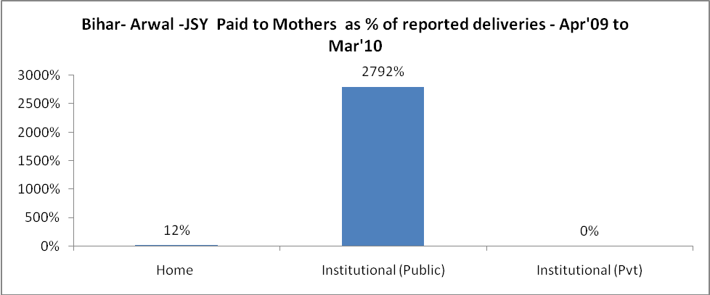

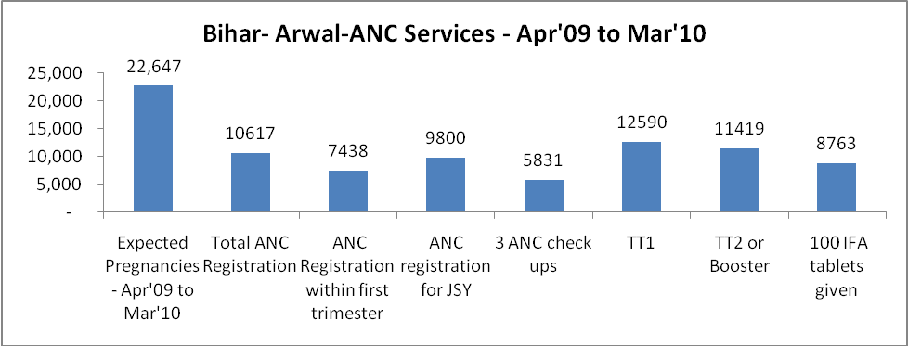

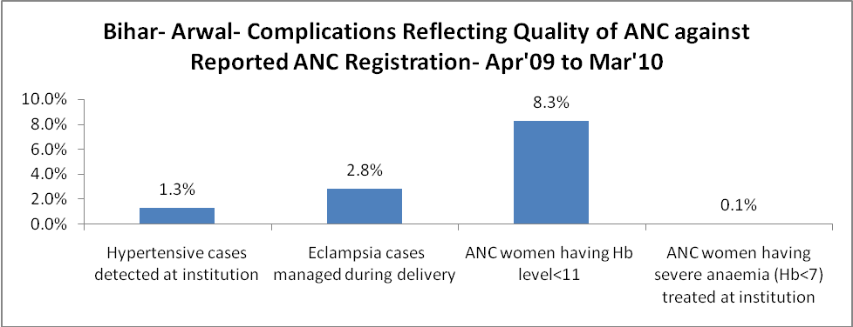

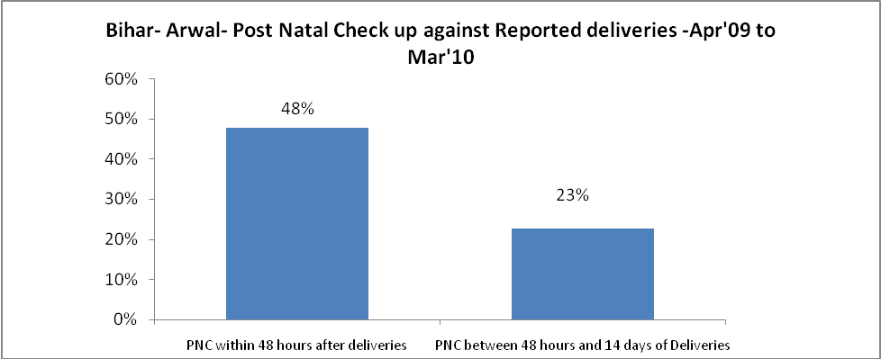

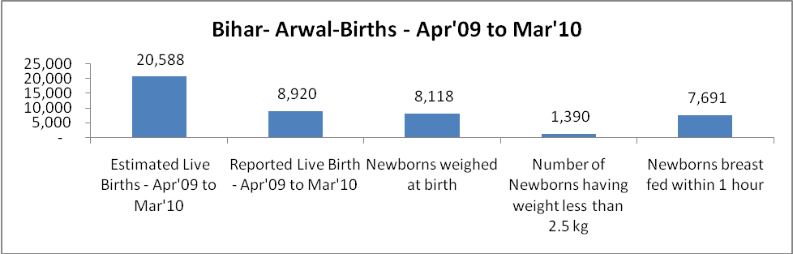
\

Bihar- Arwal - Births - Apr'09 to Mar'10
Live Birth - Males | Live Birth - females | Live Birth - Total | Sex Ratio at birth | Still Birth | Abortion( Induced/Spontaneous
4,522 | 4,398 | 8,920 | 973 | 182 | -

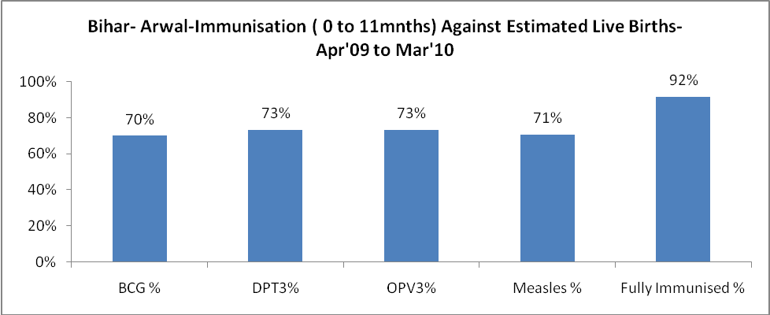

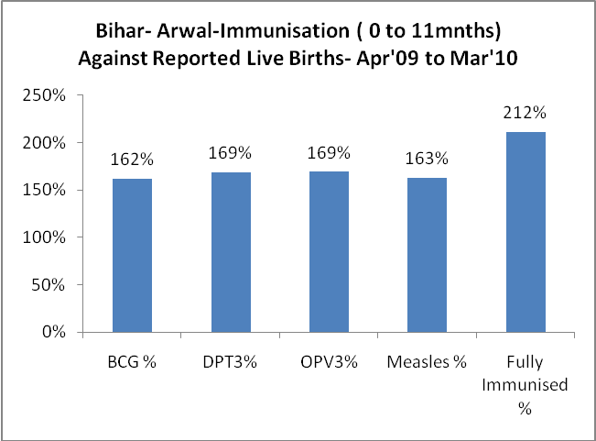

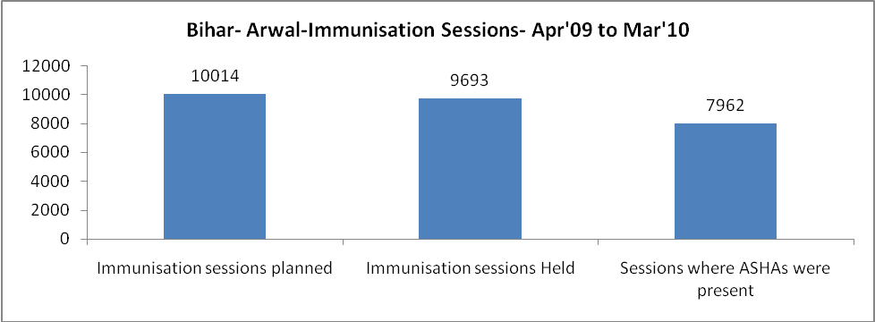

Bihar- Arwal- Apr'09 to Mar'10
Total Abortions | Abortion Rate
- | 0.0%

Bihar- Arwal- Apr'09 to Mar'10
Total OPD | Total RTI/STI cases
2,30,310 | 32

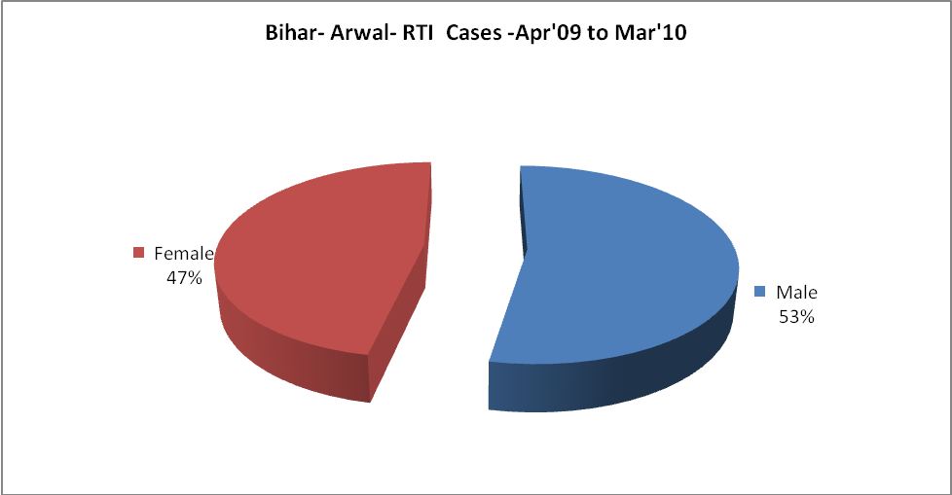

Bihar- Arwal-Sterilisations - Apr'09 to Mar'10
 | Reported | %age of Reported Sterilisation
Total Sterilisation | 1,901 | -
NSV | 37 | 2%
Laproscopic | - | 0%
MiniLap | 1,667 | 88%
Post Partum | 197 | 10%
Male Sterilisation | 37 | 2%
Female Sterilisation | 1,864 | 98%

Bihar- Arwal-FP Methods - Apr'09 to Mar'10
 | Reported | %age of All Reported FP Methods
Total Reported FP Methodd (All types) Users | 6,659 | -
Sterilisations | 1,901 | 29%
IUD | 1,338 | 20%
Condom Users | 1,659 | 25%
OCP Users | 1,761 | 26%
Limiting Methods | 1,901 | 29%
Spacing Methods | 4,758 | 71%

Bihar- Arwal- Service Delivery - Apr'09 to Mar'10
Operation major (General and spinal anaesthesia) | Operation minor (No or local anaesthesia) | AYUSH | Dental Procedures | Adolescent counselling services | Total OPD | Total IPD
242 | 2,848 | 398 | 1,235 | 630 | 2,30,310 | 2,417
Operation major (General and spinal anaesthesia) as %ge of OPD | Operation minor (No or local anaesthesia)as %ge of OPD | AYUSH as %ge of OPD | Dental Procedures as %ge of OPD | Adolescent counselling services as %ge of OPD | IPD as percentage of OPD
0.1% | 1.2% | 0.2% | 0.5% | 0.3% | 1%

Bihar- Arwal- Lab Services - Apr'09 to Mar'10
Total OPD | Total HB tested | Total HIV Tested | Total Population
2,30,310 | 279 | 2,592 | 7,00,282
HB test conducted as %age of OPD | HB<7gm as %age of HB tested | HIV test conducted as %age of OPD | HIV positive as %age of HIV tested | Blood Smear Examined as % of Population
0.1% | 0.0% | 1.1% | 0.4% | 0.0%

Bihar- Arwal- Childhood Disease - Vaccine Preventable -Apr'09 to Mar'10
Diphtheria | Pertussis | Tetanus Neonatorum | Tetanus others | Polio | Measles
0 | 0 | 0 | 0 | 0 | 4
Bihar- Arwal-Childhood Disease - Others - Apr'09 to Mar'10
Diarrhoea and dehydration | Malaria | Number admitted with Respiratory Infections
28 | 10 | 22

Bihar- Arwal- Infant & Child Deaths - Apr'09 to Mar'10
Infant Deaths within 24 hrs of birth | Infant Deaths between 24hrs & under 1 week | Infant Deaths between 1 week & under 1 month | Child Deaths between 1 month & under 1 year | Child Deaths between 1yr under 5years | Total Deaths
19 | 28 | 0 | 4 | 0 | 51

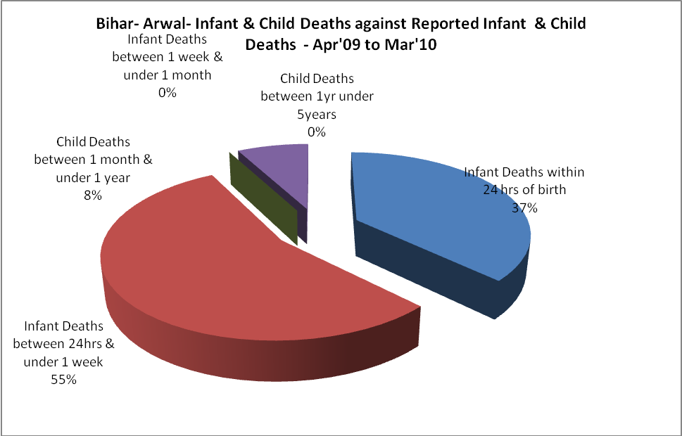

Bihar- Arwal- Causes of Infant & Child Deaths - Apr'09 to Mar'10
Sepsis |  |  | Asphyxia |  |  | LBW
Up to 1 Weeks of Birth | Between 1 week & 4 weeks of birth | Total | Up to 1 Weeks of Birth | Between 1 week & 4 weeks of birth | Total | Up to 1 Weeks of Birth | Between 1 week & 4 weeks of birth | Total
0 | 0 | 0 | 0 | 0 | 0 | 0 | 0 | 0
Pneumonia |  |  | Diarrhoea |  |  | Fever related
Between 1 month and 11 months | Between 1 year & 5 years | Total | Between 1 month and 11 months | Between 1 year & 5 years | Total | Between 1 month and 11 months | Between 1 year & 5 years | Total
0 | 0 | 0 | 0 | 0 | 0 | 0 | 0 | 0
Others |  |  | Measles |  |  | Others
Up to 1 Weeks of Birth | Between 1 week & 4 weeks of birth | Total | Between 1 month and 11 months | Between 1 year & 5 years | Total | Between 1 month and 11 months | Between 1 year & 5 years | Total
28 | 0 | 28 | 0 | 0 | 0 | 4 | 0 | 4

Bihar- Arwal- Maternal Deaths & Causes - Apr'09 to Mar'10
Abortion |  |  | Obstructed/prolonged labour |  |  | Severe hypertension/fits
6-14 yrs | 15-55 yrs. | Total | 6-14 yrs | 15-55 yrs. | Total | 6-14 yrs | 15-55 yrs. | Total
0 | 0 | 0 | 0 | 0 | 0 | 0 | 0 | 0
Bleeding |  |  | High Fever |  |  | Other Causes
6-14 yrs | 15-55 yrs. | Total | 6-14 yrs | 15-55 yrs. | Total | 6-14 yrs | 15-55 yrs. | Total
0 | 0 | 0 | 0 | 0 | 0 | 0 | 0 | 0

