NHSRC
Bihar- Begusarai
[Type the document subtitle]

KUNAL
8/14/2010

Bihar- Begusarai - Summary-Apr'09 to Mar'10
ANC
ANC Registration against Expected Pregnancies |  |  |  | 48% |  | TT1 given to Pregnant women against ANC Registraion |  |  | 99%
3 ANC Check ups against ANC Reigtrations |  |  |  | 58% |  | 100 IFA Tablets given to Pregnant women against ANC Registraion |  |  | 264%
Deliveries
Unreported Deliveries against Estimated Deliveries |  |  |  | 52.4% |  | HOME Deliveries( SBA& Non SBA) against Estimated Deliveries |  |  | 17.0%
Institutional Deliveries against Estimated Deliveries |  |  |  | 30.6% |  | HOME Deliveries( SBA& Non SBA) against Reported Deliveries |  |  | 35.8%
Institutional Deliveries against Reported Deliveries |  |  |  | 64.2% |  | C Section Deliveries against Institutional Deliveries( Pvt & Pub) |  |  | 0%
Births & Neonates Care
Live Births Reported against Estimated Live Births |  |  |  | 45% |  | New borns weighed against Reported Live Births |  |  | 54%
Still Births (Reported) |  |  |  | 3,008 |  | New borns weighed less than 2.5 kgs against newborns weighed |  |  | 25%
Sex Ratio at Birh |  |  |  | 724 |  | New borns breastfed within one hr of Birth against Reported live Births |  |  | 37%
Child Immunisation( 0 to 11 mnths)
BCG given against Expected Live Births |  |  |  | 58% |  | Measles given against Expected Live Births |  |  | 54%
OPV3 given against Expected Live Births |  |  |  | 67% |  | Fully Immunised Children against Expected Live Births |  |  | 132%
DPT3 given against Expected Live Births |  |  |  | 71%
Family Plannng
Family Plannig Methods Users ( Sterilisations(Male &Female)+IUD+ Condom pieces/72 + OCP Cycles/13) |  |  |  | 11,379 |  | IUD Insertions against reported FP Methods |  |  | 25%
Sterilisation against reported FP Methods |  |  |  | 62% |  | Condom Users against reported FP Methods |  |  | 7%
 |  |  |  |  |  | OCP Users against reported FP Methods |  |  | 5%
Other Services
OPD |  |  |  | 7,75,600 |  | Major Operations |  |  | 44
IPD |  |  |  | 45,459 |  | Minor Operations |  |  | 2,249
 | Bihar- Begusarai - Deliveries Apr'09 to Mar'10
 | Total Population | 26,93,600 | Expected Deliveries |  |  |  | 81,635
 | Home SBA | Home Non SBA | Institutional |  | Total Deliveries Reported |  | Unreported Deliveries
 | 11,560 | 2,341 | 24,976 |  | 38,877 |  | 42,758
 | Home SBA % | Home Non SBA% | Institutional % |  | Total Deliveries Reported % |  | Unreported Deliveries %
 | 14% | 3% | 31% |  | 48% |  | 52%

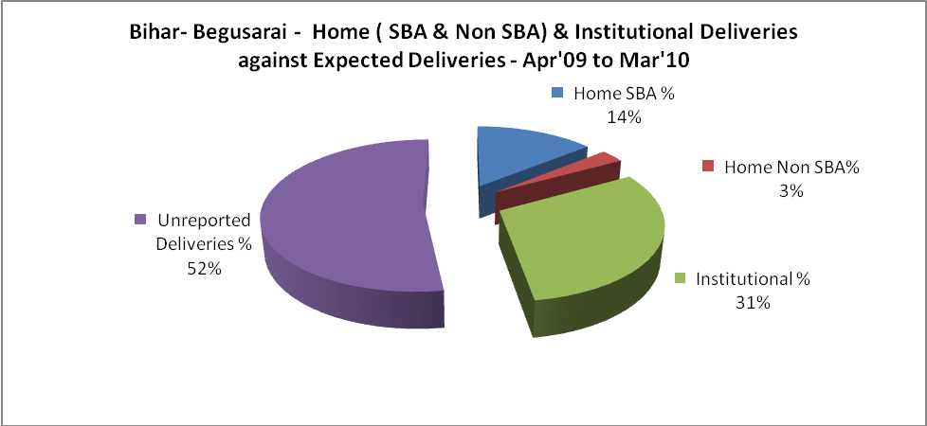

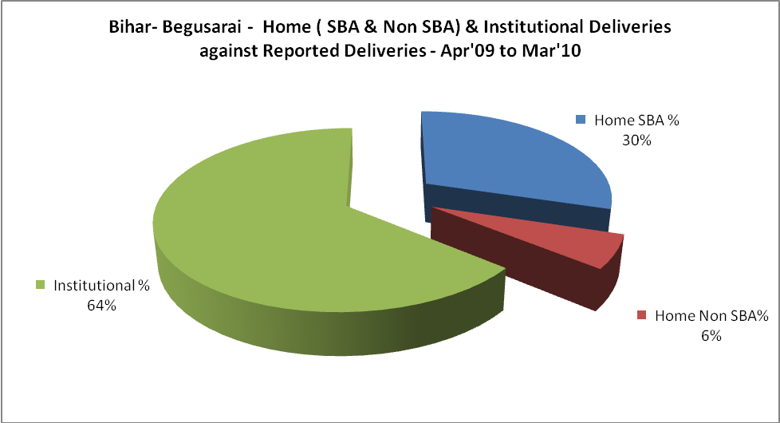
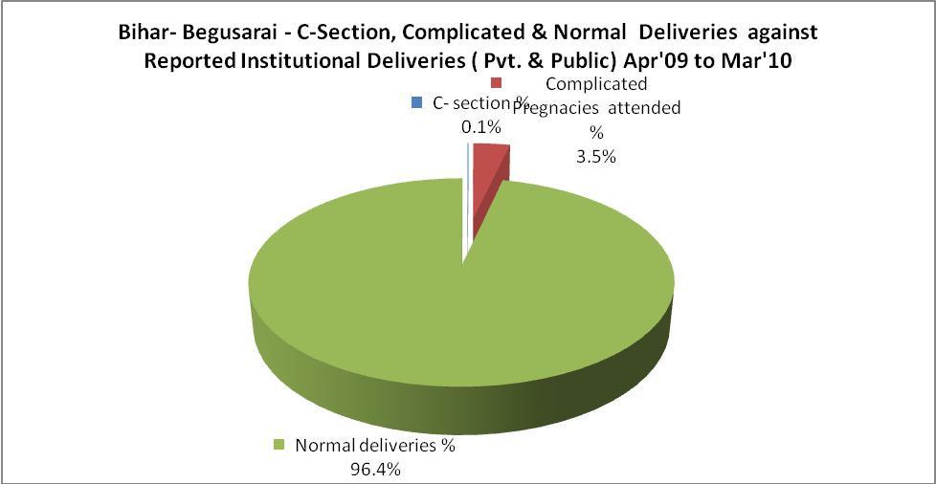
Bihar- Begusarai - Complicated Pregnancies & Deliveries Treated - Apr'09 to Mar'10
Reported Deliveries |  |  | Reported ANC Reigtration
38,877 |  |  | 41,746
Complicated Pregnancies attended | Complicated Pregnancies Rate | C - Section Deliveries | PNC Maternal Complications | Abortions | Still Births
870 | 1% | 20 | 44 | 25 | 3,008
Complicated Deliveries Treated with |  |  |  | No Of Eclampsia cases Treated | No Of severe anemia cases treated
IV Antibiotics | IV antihypertensive/Magsulph injection | IV Oxytocis | Blood Transfusion | No Of Eclampsia cases Treated | No Of severe anemia cases treated
5,687 | 824 | 5,062 | - | 946 | 1,458

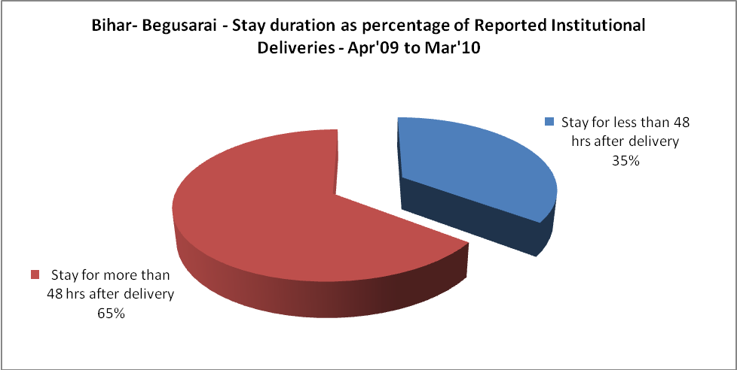
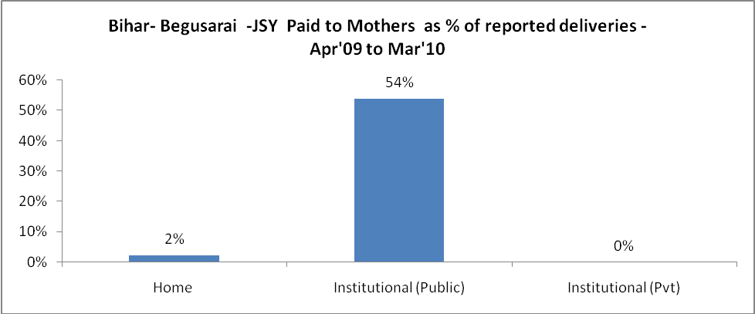
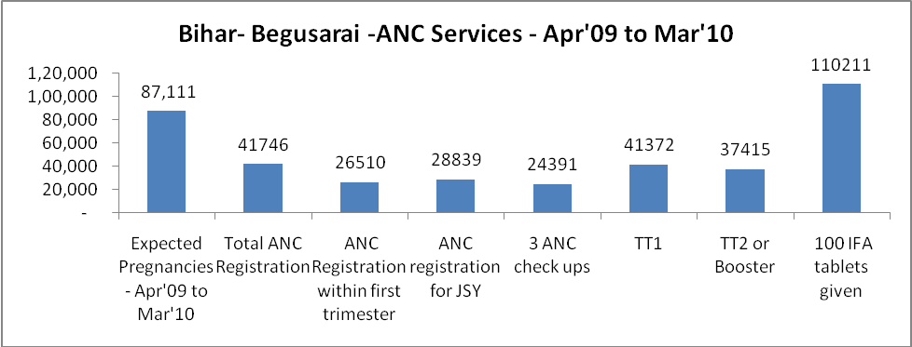
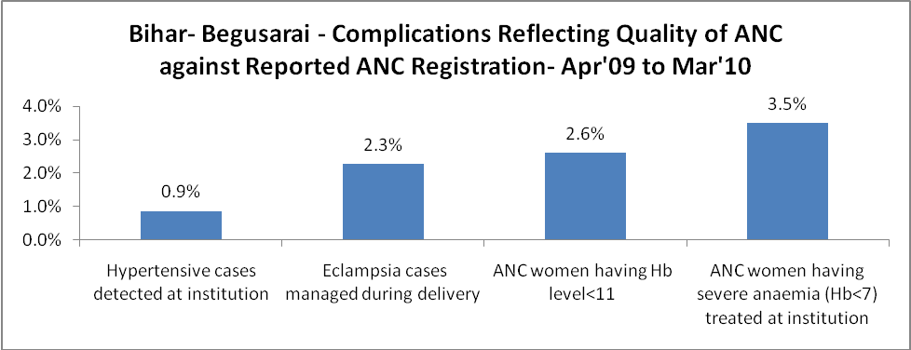
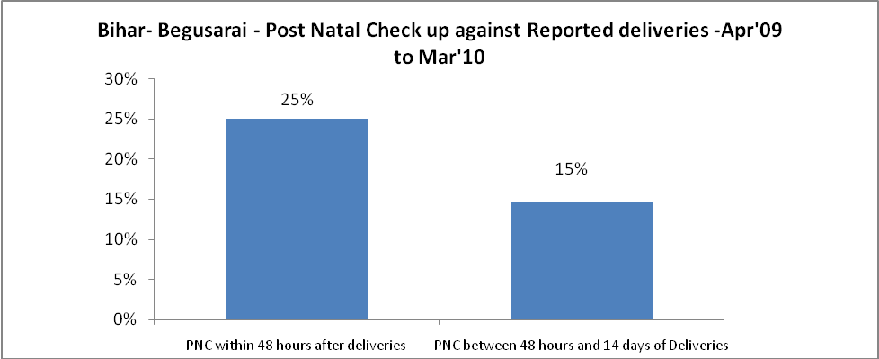
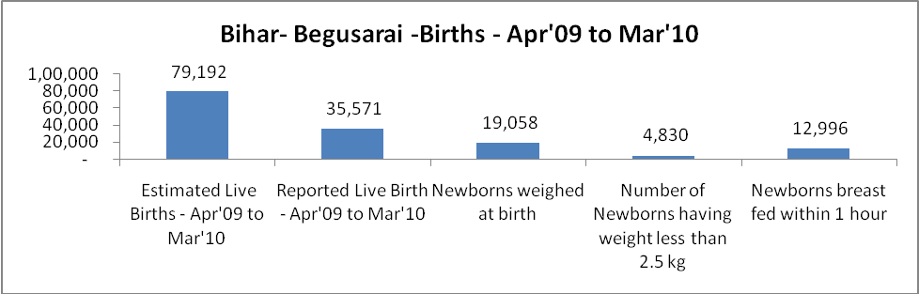
Bihar- Begusarai - Births - Apr'09 to Mar'10
Live Birth - Males | Live Birth - females | Live Birth - Total | Sex Ratio at birth | Still Birth | Abortion( Induced/Spontaneous
20,635 | 14,936 | 35,571 | 724 | 3,008 | 25

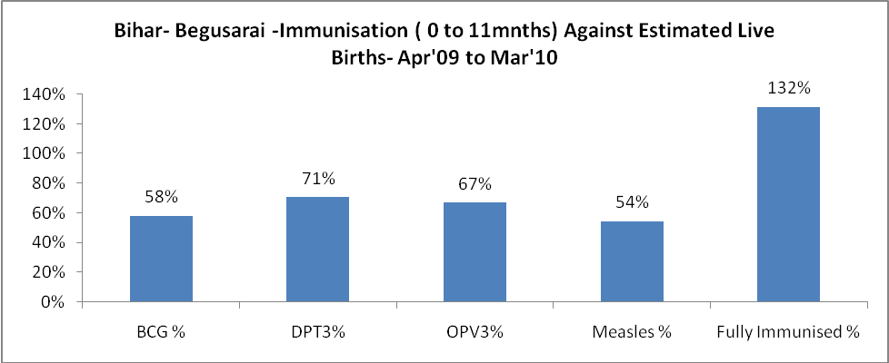

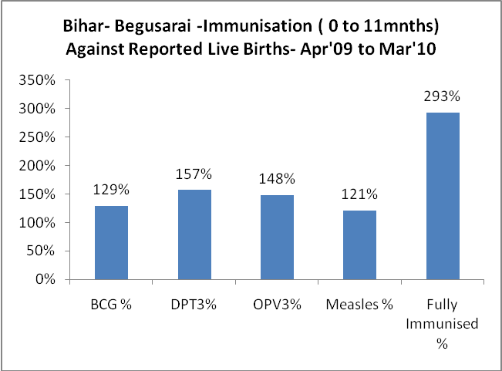
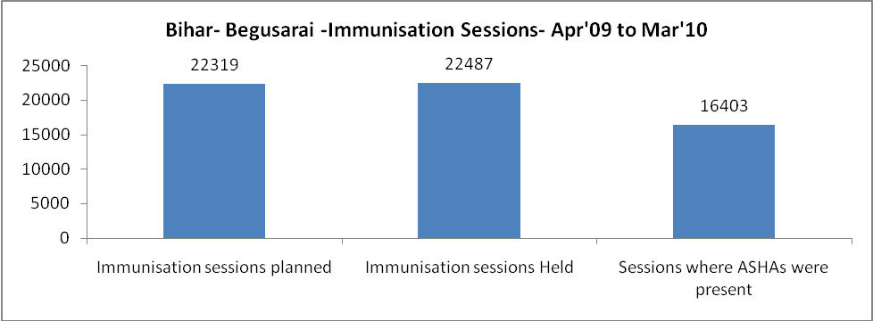
Bihar- Begusarai - Apr'09 to Mar'10
Total Abortions | Abortion Rate
1,021 | 1.2%

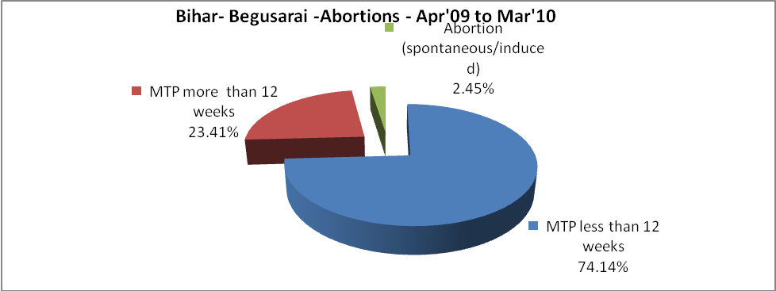

Bihar- Begusarai - Apr'09 to Mar'10
Total OPD | Total RTI/STI cases
7,75,600 | 348

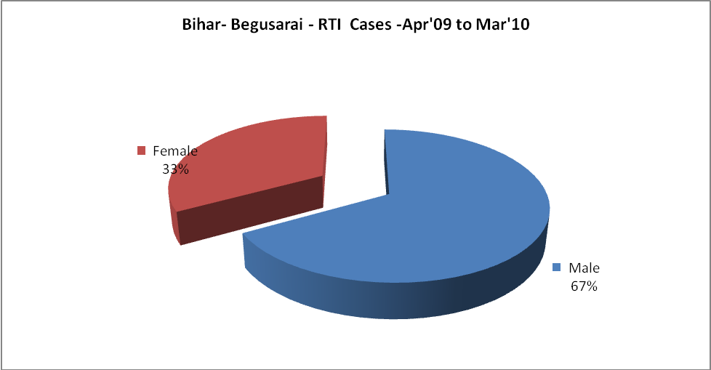

Bihar- Begusarai -Sterilisations - Apr'09 to Mar'10
 | Reported | %age of Reported Sterilisation
Total Sterilisation | 7,106 | -
NSV | 832 | 12%
Laproscopic | 157 | 2%
MiniLap | 5,751 | 81%
Post Partum | 366 | 5%
Male Sterilisation | 832 | 12%
Female Sterilisation | 6,274 | 88%

Bihar- Begusarai -FP Methods - Apr'09 to Mar'10
 | Reported | %age of All Reported FP Methods
Total Reported FP Methodd (All types) Users | 11,379 | -
Sterilisations | 7,106 | 62%
IUD | 2,876 | 25%
Condom Users | 784 | 7%
OCP Users | 614 | 5%
Limiting Methods | 7,106 | 62%
Spacing Methods | 4,273 | 38%

Bihar- Begusarai - Service Delivery - Apr'09 to Mar'10
Operation major (General and spinal anaesthesia) | Operation minor (No or local anaesthesia) | AYUSH | Dental Procedures | Adolescent counselling services | Total OPD | Total IPD
44 | 2,249 | 254 | 7,550 | 285 | 7,75,600 | 45,459
Operation major (General and spinal anaesthesia) as %ge of OPD | Operation minor (No or local anaesthesia)as %ge of OPD | AYUSH as %ge of OPD | Dental Procedures as %ge of OPD | Adolescent counselling services as %ge of OPD | IPD as percentage of OPD
0.0% | 0.3% | 0.0% | 1.0% | 0.0% | 6%

Bihar- Begusarai - Lab Services - Apr'09 to Mar'10
Total OPD | Total HB tested | Total HIV Tested | Total Population
7,75,600 | 1,280 | 1,649 | 26,93,600
HB test conducted as %age of OPD | HB<7gm as %age of HB tested | HIV test conducted as %age of OPD | HIV positive as %age of HIV tested | Blood Smear Examined as % of Population
0.2% | 3.8% | 0.2% | 4.5% | 0.0%

Bihar- Begusarai - Childhood Disease - Vaccine Preventable -Apr'09 to Mar'10
Diphtheria | Pertussis | Tetanus Neonatorum | Tetanus others | Polio | Measles
0 | 5 | 1 | 8 | 31 | 533
Bihar- Begusarai -Childhood Disease - Others - Apr'09 to Mar'10
Diarrhoea and dehydration | Malaria | Number admitted with Respiratory Infections
965 | 112 | 2,409

Bihar- Begusarai - Infant & Child Deaths - Apr'09 to Mar'10
Infant Deaths within 24 hrs of birth | Infant Deaths between 24hrs & under 1 week | Infant Deaths between 1 week & under 1 month | Child Deaths between 1 month & under 1 year | Child Deaths between 1yr under 5years | Total Deaths
31 | 0 | 0 | 0 | 11 | 42

Bihar- Begusarai - Causes of Infant & Child Deaths - Apr'09 to Mar'10
Sepsis |  |  | Asphyxia |  |  | LBW
Up to 1 Weeks of Birth | Between 1 week & 4 weeks of birth | Total | Up to 1 Weeks of Birth | Between 1 week & 4 weeks of birth | Total | Up to 1 Weeks of Birth | Between 1 week & 4 weeks of birth | Total
0 | 0 | 0 | 0 | 0 | 0 | 0 | 0 | 0
Pneumonia |  |  | Diarrhoea |  |  | Fever related
Between 1 month and 11 months | Between 1 year & 5 years | Total | Between 1 month and 11 months | Between 1 year & 5 years | Total | Between 1 month and 11 months | Between 1 year & 5 years | Total
0 | 0 | 0 | 0 | 11 | 11 | 0 | 0 | 0
Others |  |  | Measles |  |  | Others
Up to 1 Weeks of Birth | Between 1 week & 4 weeks of birth | Total | Between 1 month and 11 months | Between 1 year & 5 years | Total | Between 1 month and 11 months | Between 1 year & 5 years | Total
0 | 0 | 0 | 0 | 0 | 0 | 0 | 0 | 0

Bihar- Begusarai - Maternal Deaths & Causes - Apr'09 to Mar'10
Abortion |  |  | Obstructed/prolonged labour |  |  | Severe hypertesnion/fits
6-14 yrs | 15-55 yrs. | Total | 6-14 yrs | 15-55 yrs. | Total | 6-14 yrs | 15-55 yrs. | Total
0 | 0 | 0 | 0 | 0 | 0 | 0 | 0 | 0
Bleeding |  |  | High Fever |  |  | Other Causes
6-14 yrs | 15-55 yrs. | Total | 6-14 yrs | 15-55 yrs. | Total | 6-14 yrs | 15-55 yrs. | Total
0 | 2 | 2 | 0 | 0 | 0 | 0 | 0 | 0

Bihar- Begusarai -Causes of Deaths in 6 to 55yrs age group - Apr'09 to Mar'10
Diarrhoel Diseases |  |  |  | Tuberculosis |  |  |  | Respiratory Diseases( Other than TB)
6-14 yrs | 15-55 yrs. | Above 55yrs | Total | 6-14 yrs | 15-55 yrs. | Above 55yrs | Total | 6-14 yrs | 15-55 yrs. | Above 55yrs | Total
2 | 1 | 0 | 3 | 0 | 0 | 0 | 0 | 0 | 0 | 0 | 0
Malaria |  |  |  | Other fever Related |  |  |  | HIV/Aids
6-14 yrs | 15-55 yrs. | Above 55yrs | Total | 6-14 yrs | 15-55 yrs. | Above 55yrs | Total | 6-14 yrs | 15-55 yrs. | Above 55yrs | Total
0 | 0 | 0 | 0 | 0 | 0 | 0 | 0 | 0 | 0 | 1 | 1
Heart Disease/Hypertenion related |  |  |  | Neurological Disease including strokes |  |  |  | Trauma/Accidents/ Burn Cases
6-14 yrs | 15-55 yrs. | Above 55yrs | Total | 6-14 yrs | 15-55 yrs. | Above 55yrs | Total | 6-14 yrs | 15-55 yrs. | Above 55yrs | Total
0 | 0 | 1 | 1 | 0 | 0 | 0 | 0 | 0 | 0 | 0 | 0
Suicide |  |  |  | Animal Bites & Stings
6-14 yrs | 15-55 yrs. | Above 55yrs | Total | 6-14 yrs | 15-55 yrs. | Above 55yrs | Total
0 | 11 | 0 | 11 | 0 | 0 | 0 | 0

