NHSRC
Maharashtra – Bhandara
Data Analysis: Apr 2009 – Mar 2010

Maharashtra-Bhandara- Summary-Apr'09 to Mar'10
ANC
ANC Registration against Expected Pregnancies | 82% | TT1 given to Pregnant women against ANC Registration | 60%
3 ANC Check ups against ANC Registrations | 101% | 100 IFA Tablets given to Pregnant women against ANC Registration | 59%
Deliveries
Unreported Deliveries against Estimated Deliveries | 43.9% | HOME Deliveries( SBA& Non SBA) against Estimated Deliveries | 13.6%
Institutional Deliveries against Estimated Deliveries | 42.5% | HOME Deliveries( SBA& Non SBA) against Reported Deliveries | 24.2%
Institutional Deliveries against Reported Deliveries | 75.8% | C Section Deliveries against Institutional Deliveries( Pvt & Pub) | 17%
Births & Neonates Care
Live Births Reported against Estimated Live Births | 60% | New borns weighed against Reported Live Births | 74%
Still Births (Reported) | 407 | New borns weighed less than 2.5 kgs against newborns weighed | 24%
Sex Ratio at Birth | 934 | New borns breastfed within one hr of Birth against Reported live Births | 0%
Child Immunization( 0 to 11 months)
BCG given against Expected Live Births | 80% | Measles given against Expected Live Births | 69%
OPV3 given against Expected Live Births | 69% | Fully Immunized Children against Expected Live Births | 69%
DPT3 given against Expected Live Births | 69%
Family Planning
Family Planning Methods Users ( Sterilizations(Male &Female)+IUD+ Condom pieces/72 + OCP Cycles/13) | 16,592 | IUD Insertions against reported FP Methods | 18%
Sterilization against reported FP Methods | 31% | Condom Users against reported FP Methods | 32%
 |  | OCP Users against reported FP Methods | 19%
Other Services
OPD | 203,568 | Major Operations | 1,064
IPD | - | Minor Operations | 467

`
Maharashtra-Bhandara- Deliveries Apr'09 to Mar'10
Total Population | 1,333,420 | Expected Deliveries |  | 24,262
Home SBA | Home Non SBA | Institutional | Total Deliveries Reported | Unreported Deliveries
2,036 | 1,264 | 10,311 | 13,611 | 10,651
Home SBA % | Home Non SBA% | Institutional % | Total Deliveries Reported % | Unreported Deliveries %
8% | 5% | 42% | 56% | 44%

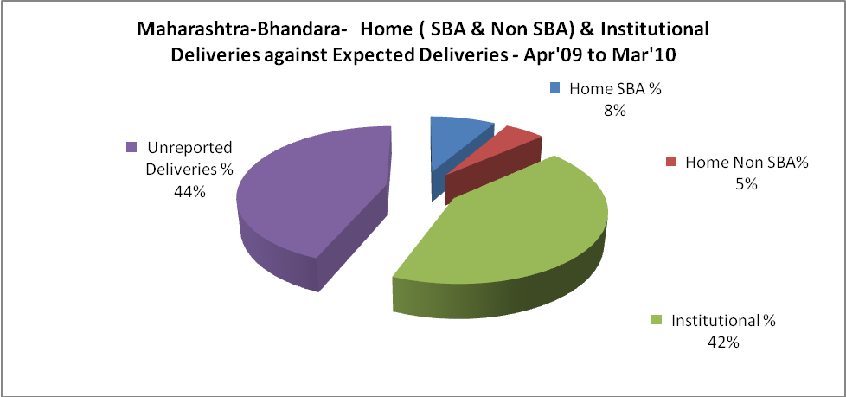

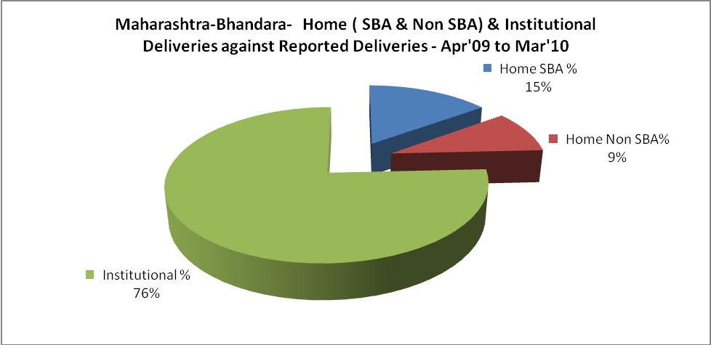

Maharashtra-Bhandara- C sections & Complicated Deliveries Apr'09 to Mar'10
 | Institutional Deliveries (Public) | Institutional Deliveries (Pvt)
 | 9,850 | 461
C Section | 1,504 | 263
C Section% | 15% | 57%
Complicated Pregnancies attended | 699 | -
Complicated Pregnancies attended % | 7% | 0%

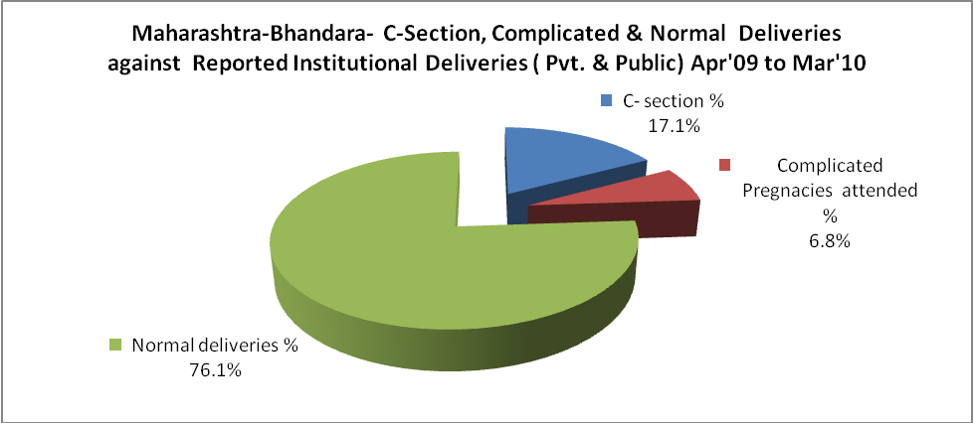

Maharashtra-Bhandara- Complicated Pregnancies & Deliveries Treated - Apr'09 to Mar'10
Reported Deliveries |  |  | Reported ANC Registration
13,611 |  |  | 21,541
Complicated Pregnancies attended | Complicated Pregnancies Rate | C - Section Deliveries | PNC Maternal Complications | Abortions | Still Births
699 | 3% | 1,767 | - | 591 | 407
Complicated Deliveries Treated with |  |  |  | No Of Eclampsia cases Treated | No Of severe anemia cases treated
IV Antibiotics | IV antihypertensive/Magsulph injection | IV Oxytocis | Blood Transfusion | No Of Eclampsia cases Treated | No Of severe anemia cases treated
- | - | - | - | - | -

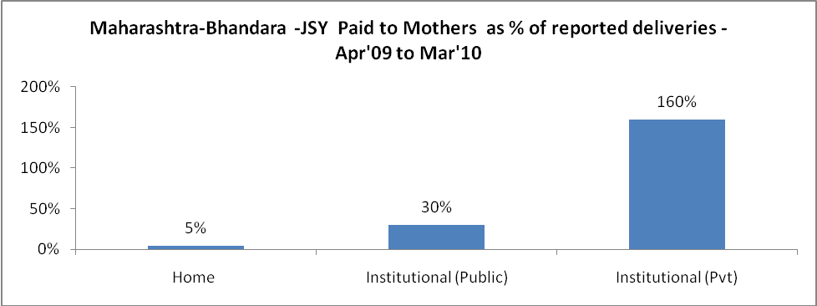

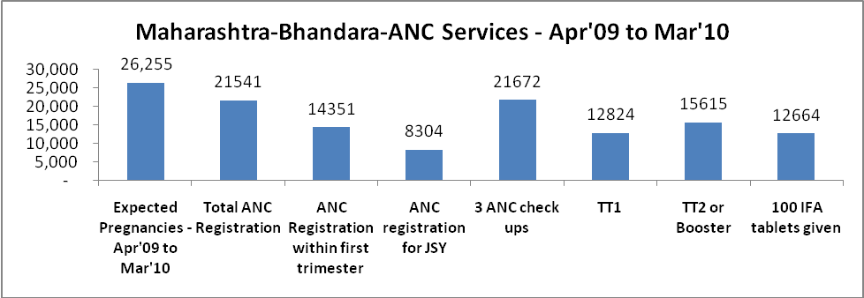

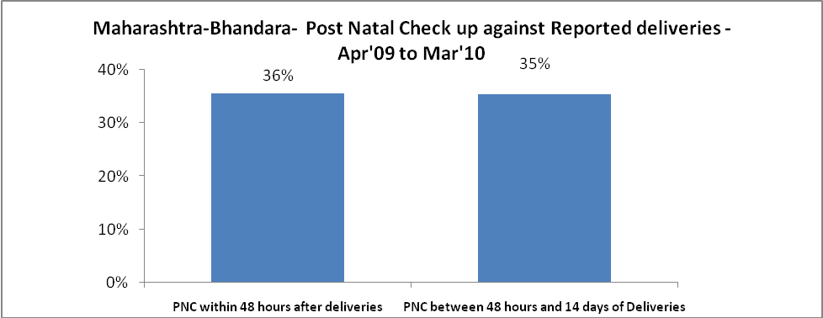

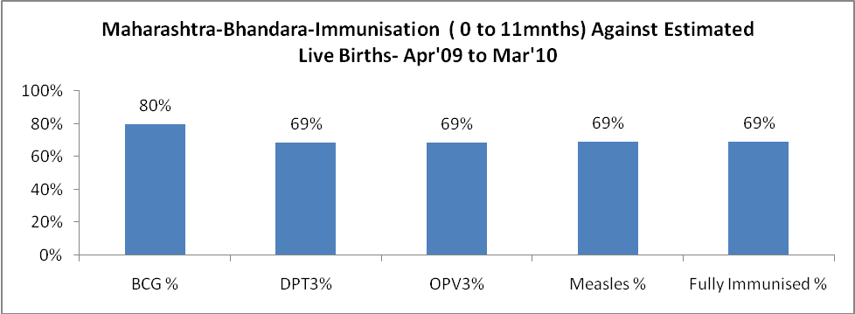

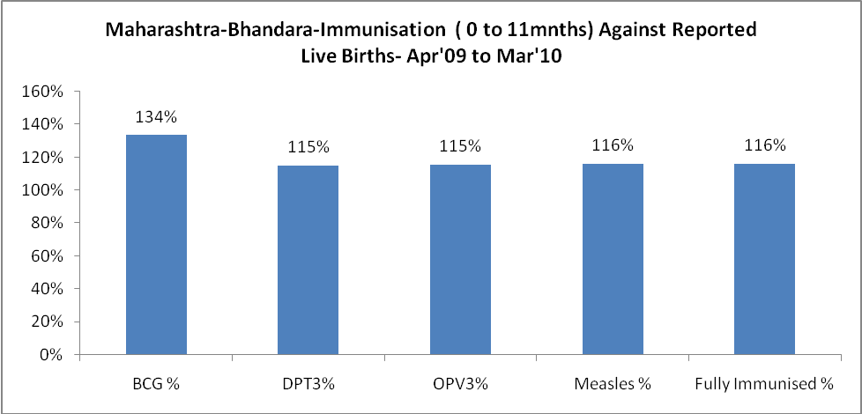

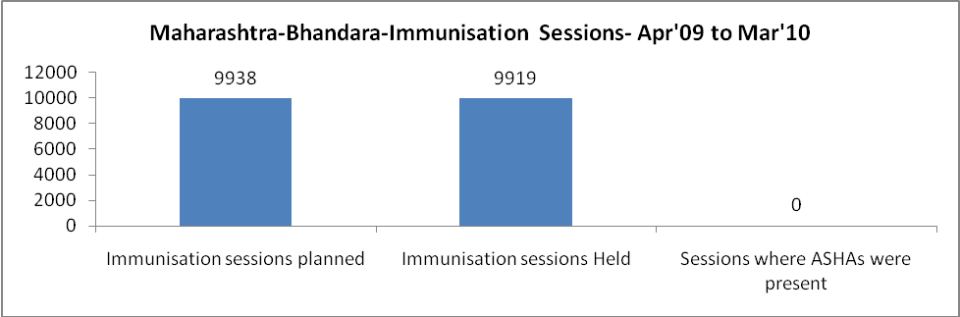

Maharashtra-Bhandara- Apr'09 to Mar'10
Total Abortions | Abortion Rate
791 | 3.0%

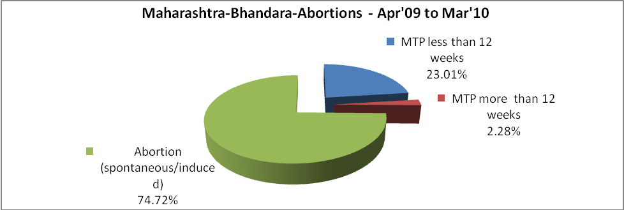

Maharashtra-Bhandara- Apr'09 to Mar'10
Total OPD | Total RTI/STI cases
203,568 | 5,113

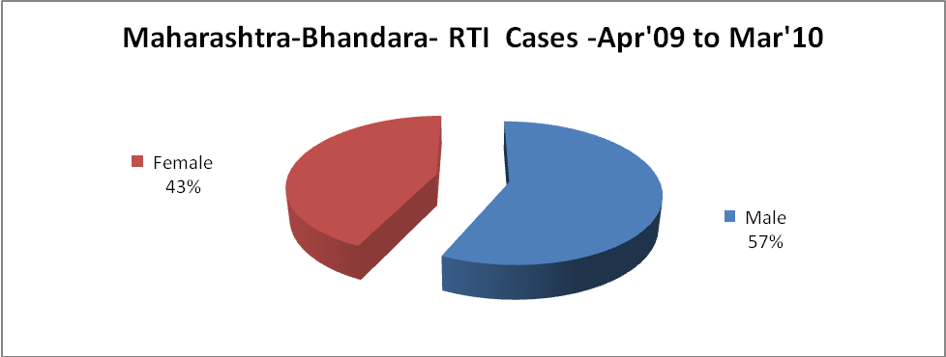

Maharashtra-Bhandara-Sterilizations - Apr'09 to Mar'10
 | Reported | %age of Reported Sterilization
Total Sterilization | 5,222 | -
NSV | 1,139 | 22%
Laparoscopic | 446 | 9%
Mini Lap | 2,022 | 39%
Post Partum | 1,615 | 31%
Male Sterilization | 1,139 | 22%
Female Sterilization | 4,083 | 78%

Maharashtra-Bhandara-FP Methods - Apr'09 to Mar'10
 | Reported | %age of All Reported FP Methods
Total Reported FP Method (All types) Users | 16,592 | -
Sterilizations | 5,222 | 31%
IUD | 2,981 | 18%
Condom Users | 5,233 | 32%
OCP Users | 3,156 | 19%
Limiting Methods | 5,222 | 31%
Spacing Methods | 11,370 | 69%

Maharashtra-Bhandara- Service Delivery - Apr'09 to Mar'10
Operation major (General and spinal anaesthesia) | Operation minor (No or local anaesthesia) | AYUSH | Dental Procedures | Adolescent counselling services | Total OPD | Total IPD
1,064 | 467 | - | - | - | 203,568 | -
Operation major (General and spinal anaesthesia) as %ge of OPD | Operation minor (No or local anaesthesia)as %ge of OPD | AYUSH as %ge of OPD | Dental Procedures as %ge of OPD | Adolescent counselling services as %ge of OPD | IPD as percentage of OPD
0.5% | 0.2% | 0.0% | 0.0% | 0.0% | 0%

Maharashtra-Bhandara- Lab Services - Apr'09 to Mar'10
Total OPD | Total HB tested | Total HIV Tested | Total Population
203,568 | - | - | 1,333,420
HB test conducted as %age of OPD | HB<7gm as %age of HB tested | HIV test conducted as %age of OPD | HIV positive as %age of HIV tested | Blood Smear Examined as % of Population
0.0% | - | 0.0% | - | 17.1%

Maharashtra-Bhandara- Infant & Child Deaths - Apr'09 to Mar'10
Infant Deaths within 24 hrs of birth | Infant Deaths between 24hrs & under 1 week | Infant Deaths between 1 week & under 1 month | Child Deaths between 1 month & under 1 year | Child Deaths between 1yr under 5years | Total Deaths
7 | 0 | 0 | 0 | 0 | 7

Maharashtra-Bhandara- Causes of Infant & Child Deaths - Apr'09 to Mar'10
Sepsis |  |  | Asphyxia |  |  | LBW
Up to 1 Weeks of Birth | Between 1 week & 4 weeks of birth | Total | Up to 1 Weeks of Birth | Between 1 week & 4 weeks of birth | Total | Up to 1 Weeks of Birth | Between 1 week & 4 weeks of birth | Total
0 | 0 | 0 | 0 | 0 | 0 | 0 | 0 | 0
Pneumonia |  |  | Diarrhoea |  |  | Fever related
Between 1 month and 11 months | Between 1 year & 5 years | Total | Between 1 month and 11 months | Between 1 year & 5 years | Total | Between 1 month and 11 months | Between 1 year & 5 years | Total
0 | 0 | 0 | 0 | 0 | 0 | 0 | 0 | 0
Others |  |  | Measles |  |  | Others
Up to 1 Weeks of Birth | Between 1 week & 4 weeks of birth | Total | Between 1 month and 11 months | Between 1 year & 5 years | Total | Between 1 month and 11 months | Between 1 year & 5 years | Total
0 | 0 | 0 | 0 | 0 | 0 | 0 | 0 | 0

Maharashtra-Bhandara- Maternal Deaths & Causes - Apr'09 to Mar'10
Abortion |  |  | Obstructed/prolonged labour |  |  | Severe hypertension/fits
6-14 yrs | 15-55 yrs. | Total | 6-14 yrs | 15-55 yrs. | Total | 6-14 yrs | 15-55 yrs. | Total
0 | 0 | 0 | 0 | 0 | 0 | 0 | 0 | 0
Bleeding |  |  | High Fever |  |  | Other Causes
6-14 yrs | 15-55 yrs. | Total | 6-14 yrs | 15-55 yrs. | Total | 6-14 yrs | 15-55 yrs. | Total
0 | 0 | 0 | 0 | 0 | 0 | 0 | 0 | 0

Maharashtra-Bhandara-Causes of Deaths in 6 to 55yrs age group - Apr'09 to Mar'10
Diarrhoel Diseases |  |  |  | Tuberculosis |  |  |  | Respiratory Diseases( Other than TB)
6-14 yrs | 15-55 yrs. | Above 55yrs | Total | 6-14 yrs | 15-55 yrs. | Above 55yrs | Total | 6-14 yrs | 15-55 yrs. | Above 55yrs | Total
0 | 0 | 0 | 0 | 0 | 0 | 0 | 0 | 0 | 0 | 0 | 0
Malaria |  |  |  | Other fever Related |  |  |  | HIV/Aids
6-14 yrs | 15-55 yrs. | Above 55yrs | Total | 6-14 yrs | 15-55 yrs. | Above 55yrs | Total | 6-14 yrs | 15-55 yrs. | Above 55yrs | Total
0 | 0 | 0 | 0 | 0 | 0 | 0 | 0 | 0 | 0 | 0 | 0
Heart Disease/Hypertension related |  |  |  | Neurological Disease including strokes |  |  |  | Trauma/Accidents/ Burn Cases
6-14 yrs | 15-55 yrs. | Above 55yrs | Total | 6-14 yrs | 15-55 yrs. | Above 55yrs | Total | 6-14 yrs | 15-55 yrs. | Above 55yrs | Total
0 | 0 | 0 | 0 | 0 | 0 | 0 | 0 | 0 | 0 | 0 | 0
Suicide |  |  |  | Animal Bites & Stings
6-14 yrs | 15-55 yrs. | Above 55yrs | Total | 6-14 yrs | 15-55 yrs. | Above 55yrs | Total
0 | 0 | 0 | 0 | 0 | 0 | 0 | 0

