NHSRC
Rajasthan-Bharatpur
Analysis: Apr 2009 – Mar 2010

Rajasthan- Bharatpur- Summary-Apr'09 to Mar'10
ANC
ANC Registration against Expected Pregnancies | 96% | TT1 given to Pregnant women against ANC Registration | 88%
3 ANC Checkups against ANC Registrations | 72% | 100 IFA Tablets given to Pregnant women against ANC Registration | 108%
Deliveries
Unreported Deliveries against Estimated Deliveries | 20.5% | HOME Deliveries( SBA& Non SBA) against Estimated Deliveries | 15.2%
Institutional Deliveries against Estimated Deliveries | 64.3% | HOME Deliveries( SBA& Non SBA) against Reported Deliveries | 19.1%
Institutional Deliveries against Reported Deliveries | 80.9% | C Section Deliveries against Institutional Deliveries( Pvt & Pub) | 2%
Births & Neonates Care
Live Births Reported against Estimated Live Births | 76% | New borns weighed against Reported Live Births | 79%
Still Births (Reported) | 1,053 | New borns weighed less than 2.5 kgs against newborns weighed | 24%
Sex Ratio at Birh | 882 | New borns breastfed within one hr of Birth against Reported live Births | 96%
Child Immunization( 0 to 11 months)
BCG given against Expected Live Births | 98% | Measles given against Expected Live Births | 95%
OPV3 given against Expected Live Births | 98% | Fully Immunised Children against Expected Live Births | 90%
DPT3 given against Expected Live Births | 98%
Family Planning
Family Plannig Methods Users ( Sterilisations(Male &Female)+IUD+ Condom pieces/72 + OCP Cycles/13) | 60,216 | IUD Insertions against reported FP Methods | 19%
Sterilisation against reported FP Methods | 16% | Condom Users against reported FP Methods | 45%
 |  | OCP Users against reported FP Methods | 20%
Other Services
OPD | 705,960 | Major Operations | 213
IPD | 24,344 | Minor Operations | 1,366

Rajasthan- Bharatpur- Deliveries Apr'09 to Mar'10
Total Population | 2,516,800 | Expected Deliveries |  | 71,392
Home SBA | Home Non SBA | Institutional | Total Deliveries Reported | Unreported Deliveries
9,666 | 1,196 | 45,903 | 56,765 | 14,627
Home SBA % | Home Non SBA% | Institutional % | Total Deliveries Reported % | Unreported Deliveries %
14% | 2% | 64% | 80% | 20%
`

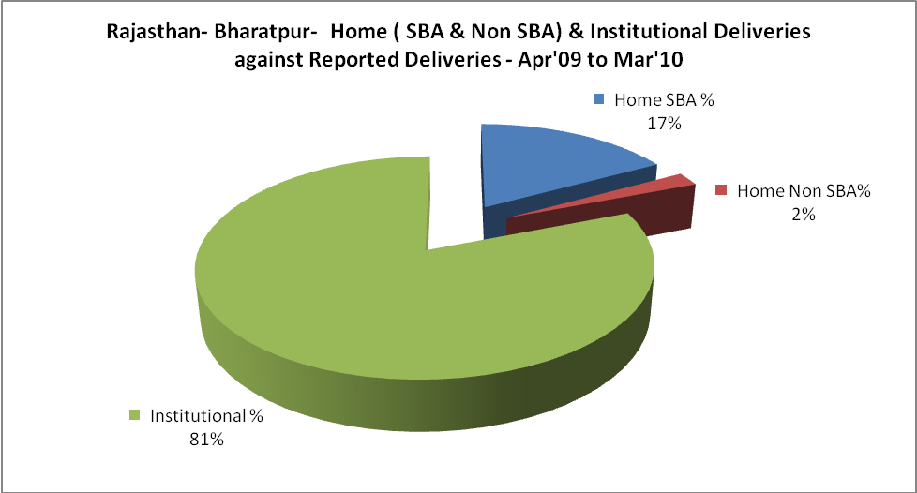

Rajasthan- Bharatpur- C sections & Complicated Deliveries Apr'09 to Mar'10
 | Institutional Deliveries (Public) | Institutional Deliveries (Pvt)
 | 43,392 | 2,511
C Section | 955 | 2
C Section% | 2% | 0%
Complicated Pregnacies attended | 357 | -
Complicated Pregnacies attended % | 1% | 0%

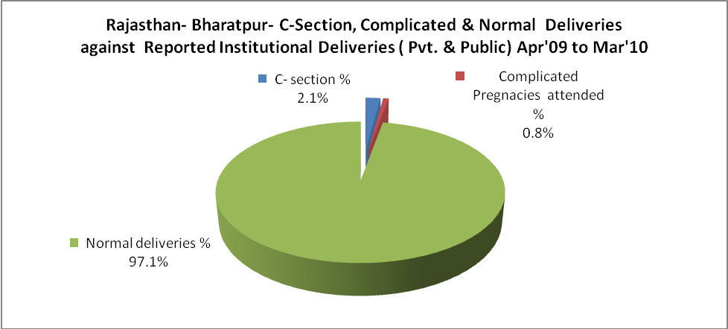

Rajasthan- Bharatpur- Complicated Pregnancies & Deliveries Treated - Apr'09 to Mar'10
Reported Deliveries |  |  | Reported ANC Reigtration
56,765 |  |  | 72,913
Complicated Pregnancies attended | Complicated Pregnancies Rate | C - Section Deliveries | PNC Maternal Complications | Abortions | Still Births
357 | 0% | 957 | 1,858 | 1,000 | 1,053
Complicated Deliveries Treated with |  |  |  | No Of Eclampsia cases Treated | No Of severe anemia cases treated
IV Antibiotics | IV antihypertensive/Magsulph injection | IV Oxytocis | Blood Transfusion | No Of Eclampsia cases Treated | No Of severe anemia cases treated
2,192 | 1,281 | 2,732 | 1,156 | 598 | 1,421

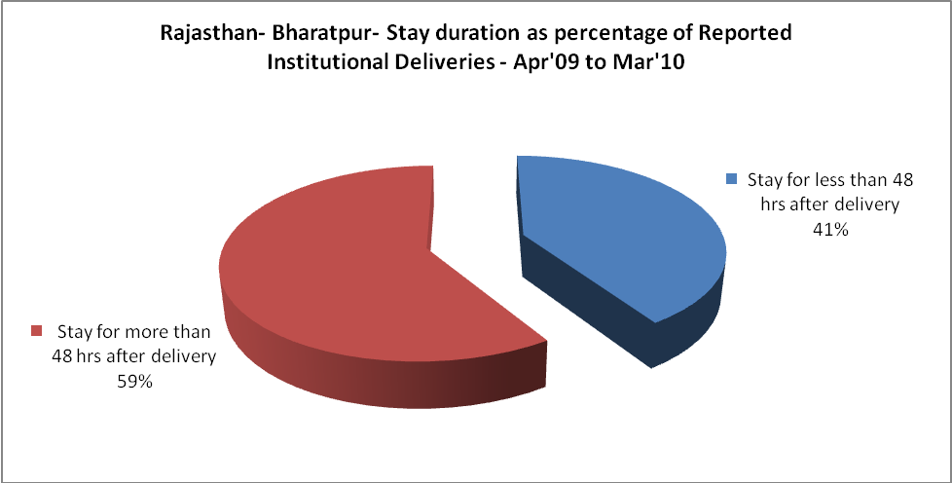

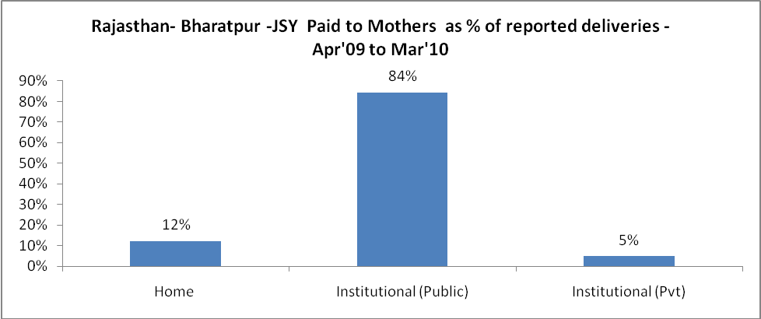

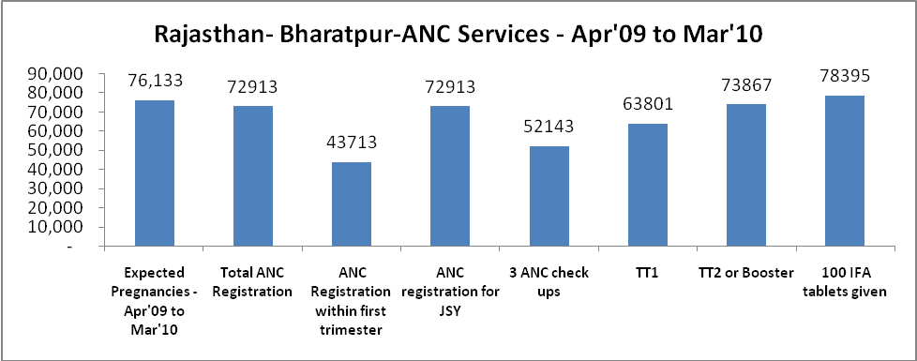

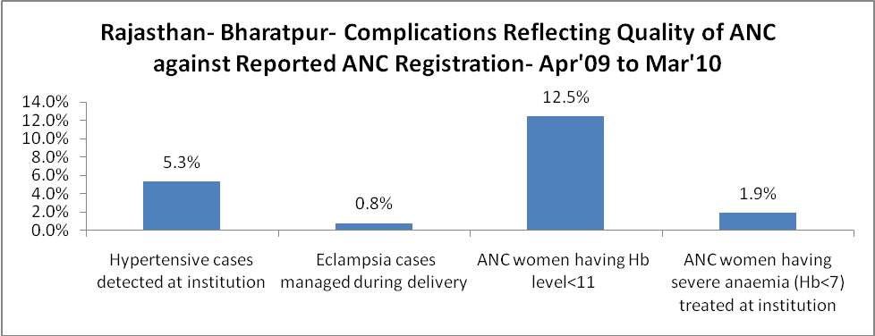

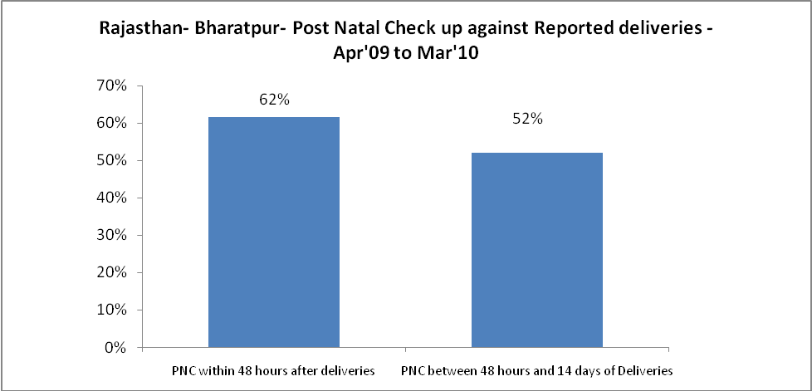

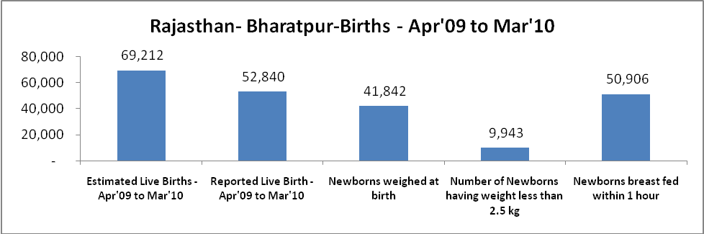

Rajasthan- Bharatpur - Births - Apr'09 to Mar'10
Live Birth - females | Live Birth - Total | Sex Ratio at birth | Still Birth | Abortion( Induced/Spontaneous
24,767 | 52,840 | 882 | 1,053 | 1,000

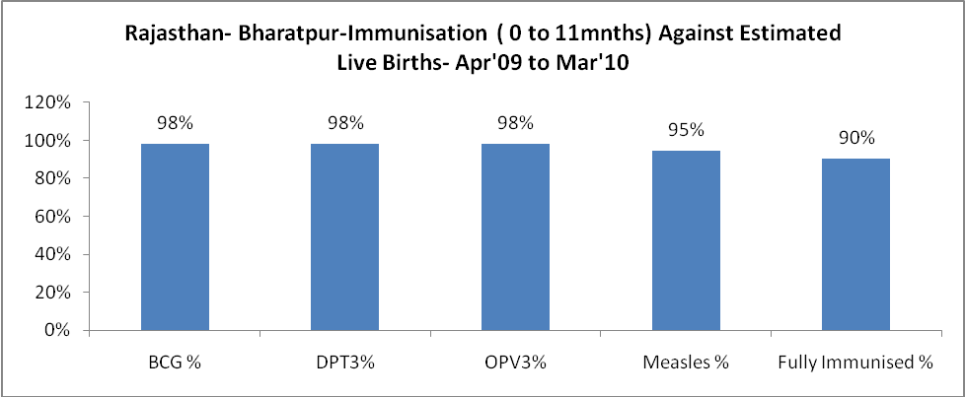

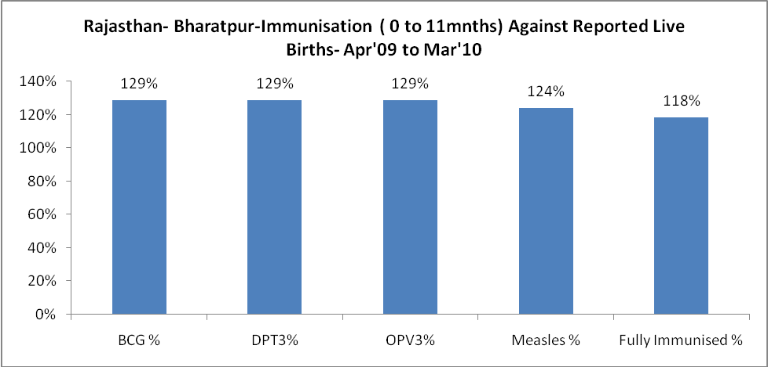

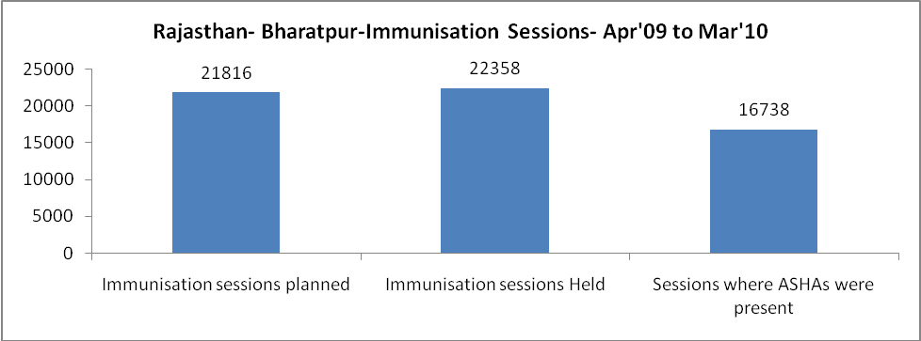

Rajasthan- Bharatpur- Apr'09 to Mar'10
Total Abortions | Abortion Rate
3,329 | 4.4%

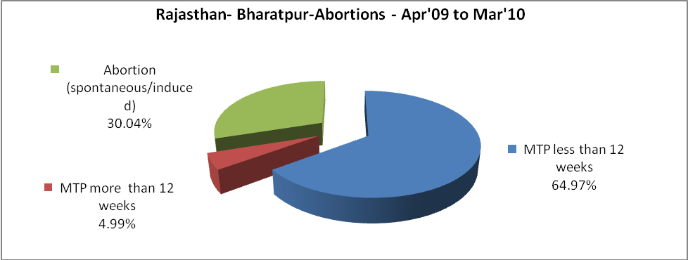

Rajasthan- Bharatpur- Apr'09 to Mar'10
Total OPD | Total RTI/STI cases
705,960 | 5,930

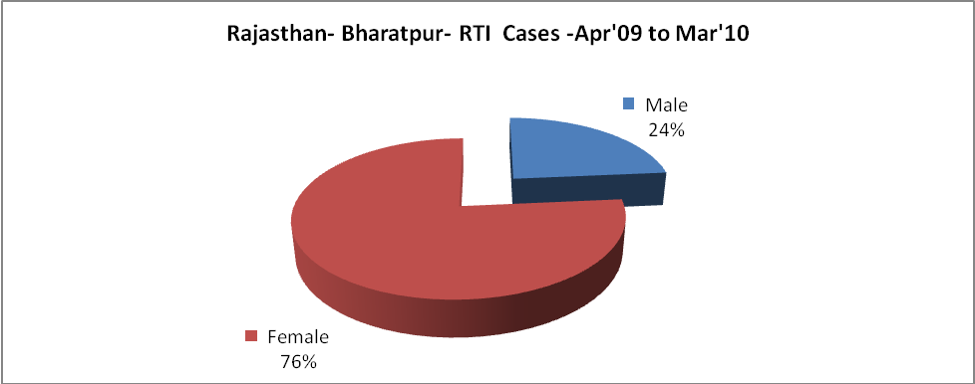

Rajasthan- Bharatpur-Sterilisations - Apr'09 to Mar'10
 | Reported | %age of Reported Sterilisation
Total Sterilisation | 9,541 | -
NSV | 83 | 1%
Laproscopic | 9,016 | 94%
MiniLap | 10 | 0%
Post Partum | 432 | 5%
Male Sterilisation | 83 | 1%
Female Sterilisation | 9,458 | 99%

 |  | Rajasthan- Bharatpur-FP Methods - Apr'09 to Mar'10
 |  |  | Reported |  | %age of All Reported FP Methods
 |  | Total Reported FP Methodd (All types) Users | 60,216 |  | -
 |  | Sterilisations | 9,541 |  | 16%
 |  | IUD | 11,671 |  | 19%
 |  | Condom Users | 26,843 |  | 45%
 |  | OCP Users | 12,161 |  | 20%
 |  | Limiting Methods | 9,541 |  | 16%
 |  | Spacing Methods | 50,675 |  | 84%
Rajasthan- Bharatpur- Lab Services - Apr'09 to Mar'10
Total OPD | Total HB tested |  |  | Total HIV Tested |  | Total Population
705,960 | 12,713 |  |  | 1,152 |  | 2,516,800
HB test conducted as %age of OPD | HB<7gm as %age of HB tested |  |  | HIV test conducted as %age of OPD |  | HIV positive as %age of HIV tested |  | Blood Smear Examined as % of Population
1.8% | 5.6% |  |  | 0.2% |  | 3.1% |  | 5.1%

Rajasthan- Bharatpur- Service Delivery - Apr'09 to Mar'10
Operation major (General and spinal anaesthesia) | Operation minor (No or local anaesthesia) | AYUSH | Dental Procedures | Adolescent counselling services | Total OPD | Total IPD
213 | 1,366 | 30,597 | 715 | 670 | 705,960 | 24,344
Operation major (General and spinal anaesthesia) as %ge of OPD | Operation minor (No or local anaesthesia)as %ge of OPD | AYUSH as %ge of OPD | Dental Procedures as %ge of OPD | Adolescent counselling services as %ge of OPD | IPD as percentage of OPD
0.0% | 0.2% | 4.3% | 0.1% | 0.1% | 3%

Rajasthan- Bharatpur- Childhood Disease - Vaccine Preventable -Apr'09 to Mar'10
Diphtheria | Pertussis | Tetanus Neonatorum | Tetanus others | Polio | Measles
0 | 0 | 0 | 0 | 0 | 79
Rajasthan- Bharatpur-Childhood Disease - Others - Apr'09 to Mar'10
Diarrhoea and dehydration | Malaria | Number admitted with Respiratory Infections
2,211 | 536 | 498

Rajasthan- Bharatpur- Infant & Child Deaths - Apr'09 to Mar'10
Infant Deaths within 24 hrs of birth | Infant Deaths between 24hrs & under 1 week | Infant Deaths between 1 week & under 1 month | Child Deaths between 1 month & under 1 year | Child Deaths between 1yr under 5years | Total Deaths
4 | 14 | 9 | 107 | 157 | 291

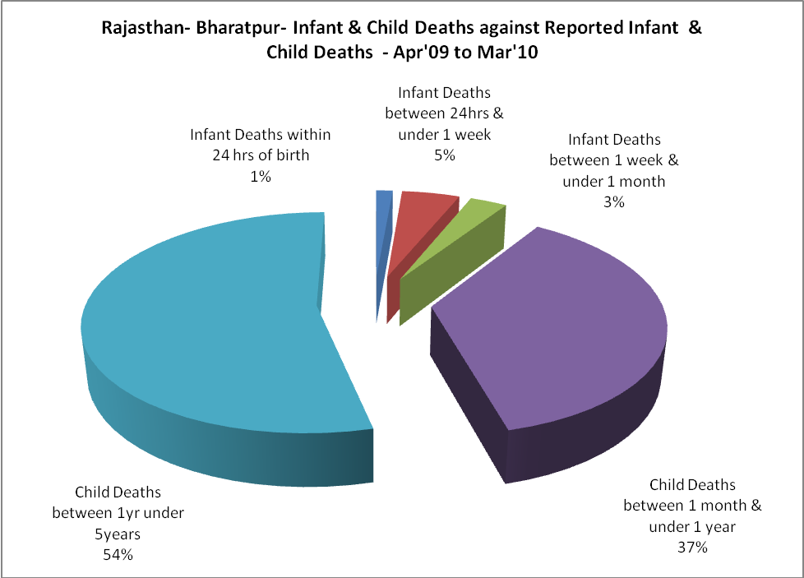

Rajasthan- Bharatpur- Causes of Infant & Child Deaths - Apr'09 to Mar'10
Sepsis |  |  | Asphyxia |  |  | LBW
Up to 1 Weeks of Birth | Between 1 week & 4 weeks of birth | Total | Up to 1 Weeks of Birth | Between 1 week & 4 weeks of birth | Total | Up to 1 Weeks of Birth | Between 1 week & 4 weeks of birth | Total
0 | 1 | 1 | 8 | 1 | 9 | 2 | 3 | 5
Pneumonia |  |  | Diarrhoea |  |  | Fever related
Between 1 month and 11 months | Between 1 year & 5 years | Total | Between 1 month and 11 months | Between 1 year & 5 years | Total | Between 1 month and 11 months | Between 1 year & 5 years | Total
18 | 26 | 44 | 18 | 30 | 48 | 57 | 90 | 147
Others |  |  | Measles |  |  | Others
Up to 1 Weeks of Birth | Between 1 week & 4 weeks of birth | Total | Between 1 month and 11 months | Between 1 year & 5 years | Total | Between 1 month and 11 months | Between 1 year & 5 years | Total
4 | 4 | 8 | 1 | 2 | 3 | 13 | 9 | 22

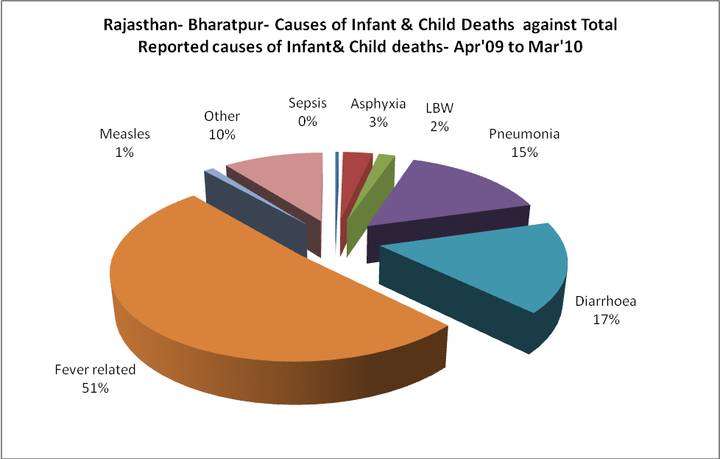
Rajasthan- Bharatpur- Maternal Deaths & Causes - Apr'09 to Mar'10
Abortion |  |  | Obstructed/prolonged labour |  |  | Severe hypertesnion/fits
6-14 yrs | 15-55 yrs. | Total | 6-14 yrs | 15-55 yrs. | Total | 6-14 yrs | 15-55 yrs. | Total
0 | 0 | 0 | 0 | 15 | 15 | 0 | 0 | 0
Bleeding |  |  | High Fever |  |  | Other Causes
6-14 yrs | 15-55 yrs. | Total | 6-14 yrs | 15-55 yrs. | Total | 6-14 yrs | 15-55 yrs. | Total
0 | 17 | 17 | 0 | 0 | 0 | 8 | 15 | 23

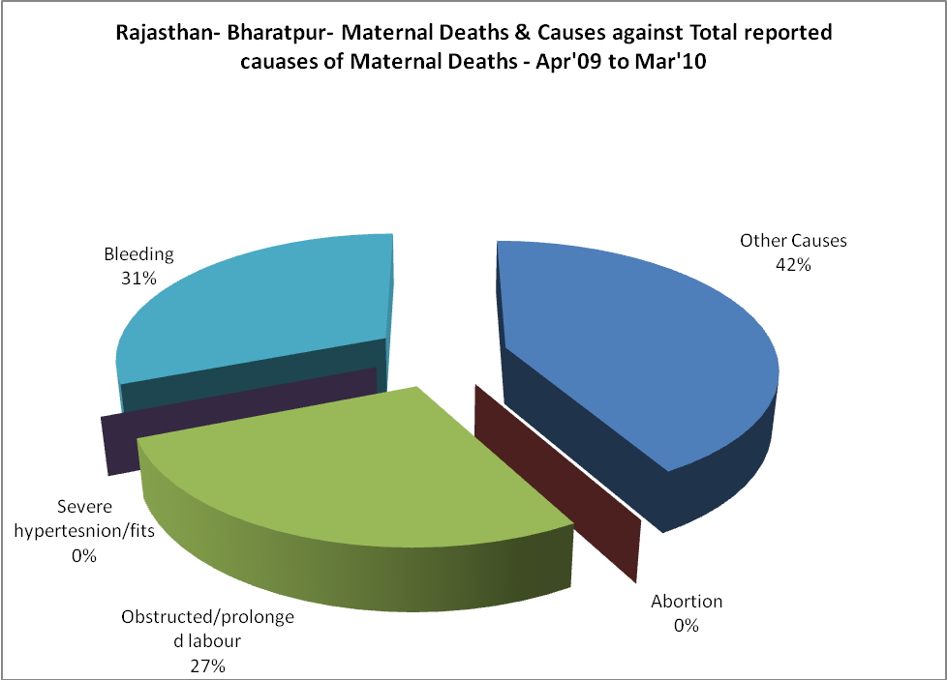

Rajasthan- Bharatpur-Causes of Deaths in 6 to 55yrs age group - Apr'09 to Mar'10
Diarrhoel Diseases |  |  |  | Tuberculosis |  |  |  | Respiratory Diseases( Other than TB)
6-14 yrs | 15-55 yrs. | Above 55yrs | Total | 6-14 yrs | 15-55 yrs. | Above 55yrs | Total | 6-14 yrs | 15-55 yrs. | Above 55yrs | Total
19 | 10 | 5 | 34 | 0 | 3 | 3 | 6 | 0 | 19 | 32 | 51
Malaria |  |  |  | Other fever Related |  |  |  | HIV/Aids
6-14 yrs | 15-55 yrs. | Above 55yrs | Total | 6-14 yrs | 15-55 yrs. | Above 55yrs | Total | 6-14 yrs | 15-55 yrs. | Above 55yrs | Total
0 | 0 | 0 | 0 | 5 | 4 | 3 | 12 | 0 | 0 | 0 | 0
Heart Disease/Hypertenion related |  |  |  | Neurological Disease including strokes |  |  |  | Trauma/Accidents/ Burn Cases
6-14 yrs | 15-55 yrs. | Above 55yrs | Total | 6-14 yrs | 15-55 yrs. | Above 55yrs | Total | 6-14 yrs | 15-55 yrs. | Above 55yrs | Total
0 | 15 | 7 | 22 | 22 | 0 | 0 | 22 | 0 | 1 | 0 | 1
Suicide |  |  |  | Animal Bites & Stings
6-14 yrs | 15-55 yrs. | Above 55yrs | Total | 6-14 yrs | 15-55 yrs. | Above 55yrs | Total
0 | 1 | 1 | 2 | 0 | 14 | 5 | 19

