NHSRC
Rajasthan-Bhilwara
Analysis: Apr 2009 – Mar 2010

ANC
ANC Registration against Expected Pregnancies | 90% | TT1 given to Pregnant women against ANC Registraion | 68%
3 ANC Check ups against ANC Reigtrations | 80% | 100 IFA Tablets given to Pregnant women against ANC Registraion | 86%
Deliveries
Unreported Deliveries against Estimated Deliveries | 30.1% | HOME Deliveries( SBA& Non SBA) against Estimated Deliveries | 16.3%
Institutional Deliveries against Estimated Deliveries | 53.6% | HOME Deliveries( SBA& Non SBA) against Reported Deliveries | 23.4%
Institutional Deliveries against Reported Deliveries | 76.6% | C Section Deliveries against Institutional Deliveries( Pvt & Pub) | 3%
Births & Neonates Care
Live Births Reported against Estimated Live Births | 71% | New borns weighed against Reported Live Births | 92%
Still Births (Reported) | 520 | New borns weighed less than 2.5 kgs against newborns weighed | 15%
Sex Ratio at Birh | 997 | New borns breastfed within one hr of Birth against Reported live Births | 91%
Child Immunization( 0 to 11 months)
BCG given against Expected Live Births | 90% | Measles given against Expected Live Births | 89%
OPV3 given against Expected Live Births | 92% | Fully Immunised Children against Expected Live Births | 77%
DPT3 given against Expected Live Births | 92%
Family Planning
Family Plannig Methods Users ( Sterilisations(Male &Female)+IUD+ Condom pieces/72 + OCP Cycles/13) | 155,573 | IUD Insertions against reported FP Methods | 10%
Sterilisation against reported FP Methods | 6% | Condom Users against reported FP Methods | 52%
 |  | OCP Users against reported FP Methods | 31%
Other Services
OPD | 1,033,816 | Major Operations | 2,414
IPD | 66,707 | Minor Operations | 2,654

Rajasthan- Bhilwara- Deliveries Apr'09 to Mar'10
Total Population | 2,400,600 | Expected Deliveries |  | 68,096
Home SBA | Home Non SBA | Institutional | Total Deliveries Reported | Unreported Deliveries
7,675 | 3,453 | 36,502 | 47,630 | 20,466
Home SBA % | Home Non SBA% | Institutional % | Total Deliveries Reported % | Unreported Deliveries %
11% | 5% | 54% | 70% | 30%

`
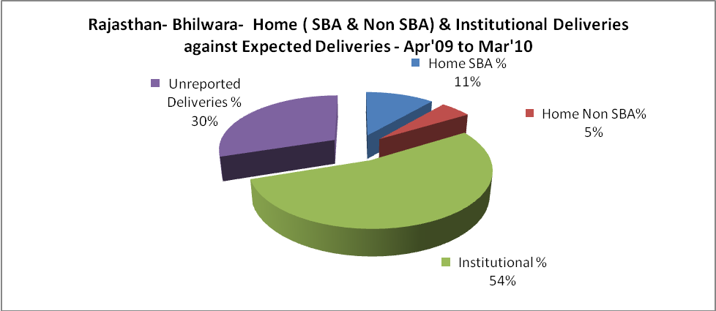

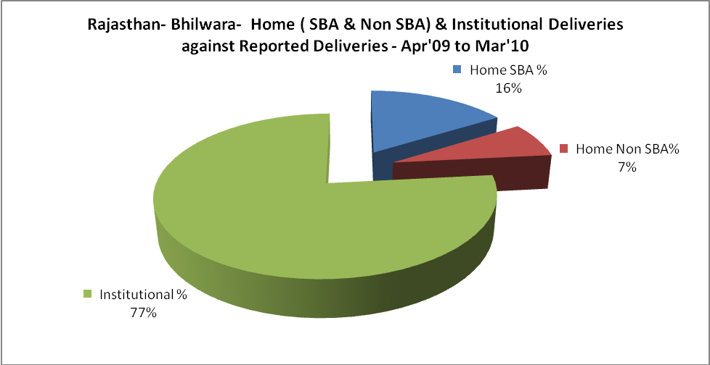

Rajasthan- Bhilwara- C sections & Complicated Deliveries Apr'09 to Mar'10
 | Institutional Deliveries (Public) | Institutional Deliveries (Pvt)
 | 28,811 | 7,691
C Section | 579 | 438
C Section% | 2% | 6%
Complicated Pregnacies attended | 2,035 | 623
Complicated Pregnacies attended % | 7% | 8%

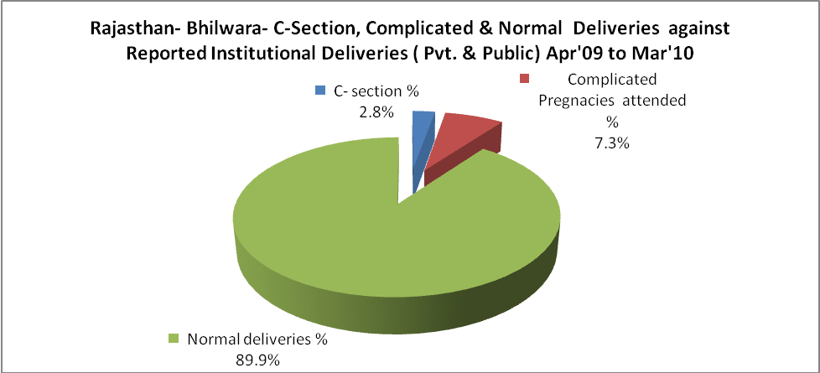

Rajasthan- Bhilwara- Complicated Pregnancies & Deliveries Treated - Apr'09 to Mar'10
Reported Deliveries |  |  | Reported ANC Reigtration
47,630 |  |  | 65,069
Complicated Pregnancies attended | Complicated Pregnancies Rate | C - Section Deliveries | PNC Maternal Complications | Abortions | Still Births
2,658 | 4% | 1,017 | 768 | 1,024 | 520
Complicated Deliveries Treated with |  |  |  | No Of Eclampsia cases Treated | No Of severe anemia cases treated
IV Antibiotics | IV antihypertensive/Magsulph injection | IV Oxytocis | Blood Transfusion | No Of Eclampsia cases Treated | No Of severe anemia cases treated
1,615 | 205 | 1,341 | - | - | 320

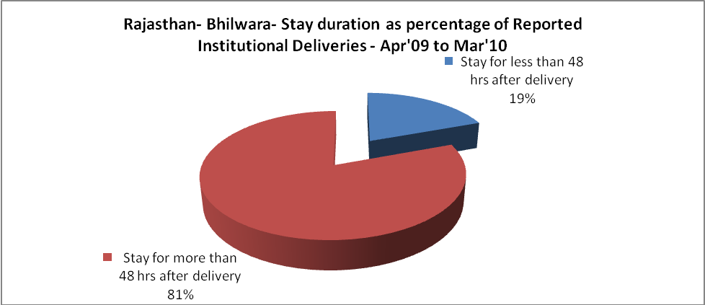

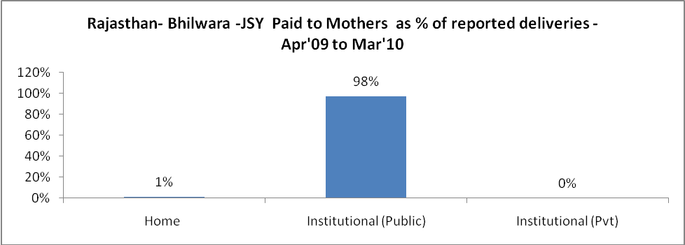

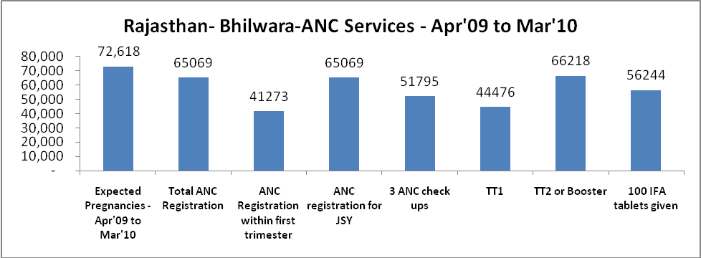
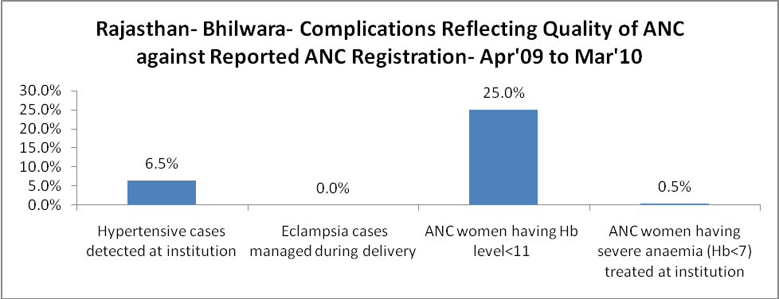

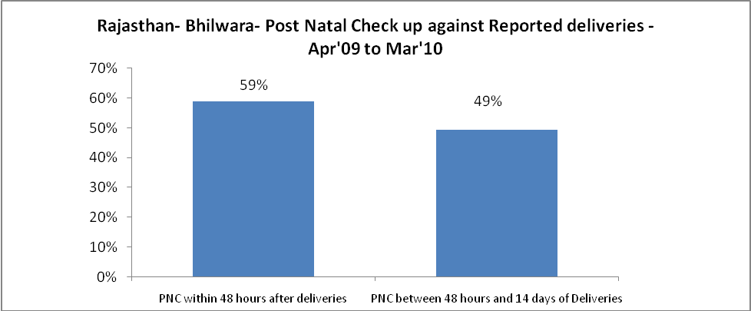

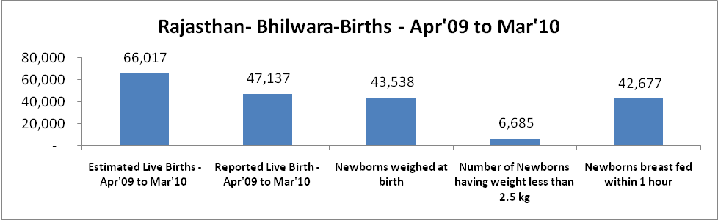

Rajasthan- Bhilwara - Births - Apr'09 to Mar'10
Live Birth - Males | Live Birth - females | Live Birth - Total | Sex Ratio at birth | Still Birth | Abortion( Induced/Spontaneous
23,601 | 23,536 | 47,137 | 997 | 520 | 1,024

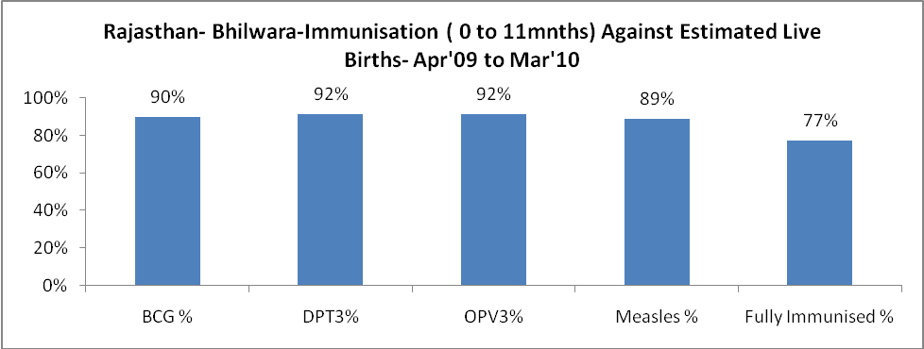

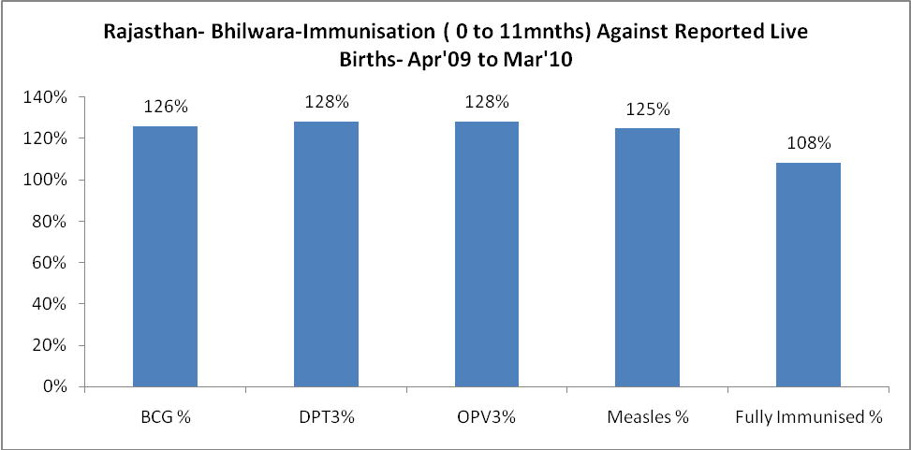
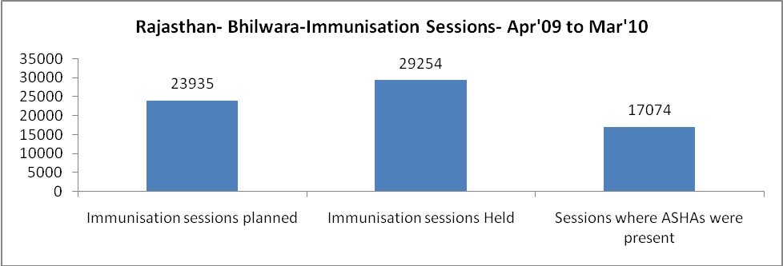

Rajasthan- Bhilwara- Apr'09 to Mar'10
Total Abortions | Abortion Rate
3,511 | 4.8%

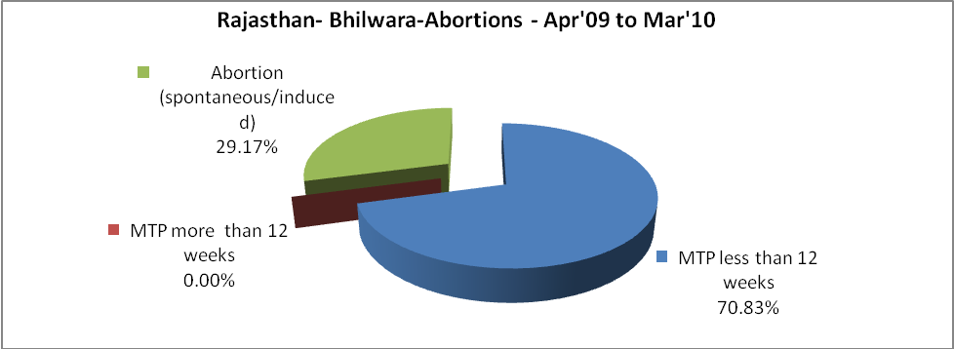

Rajasthan- Bhilwara- Apr'09 to Mar'10
Total OPD | Total RTI/STI cases
1,033,816 | 2,635

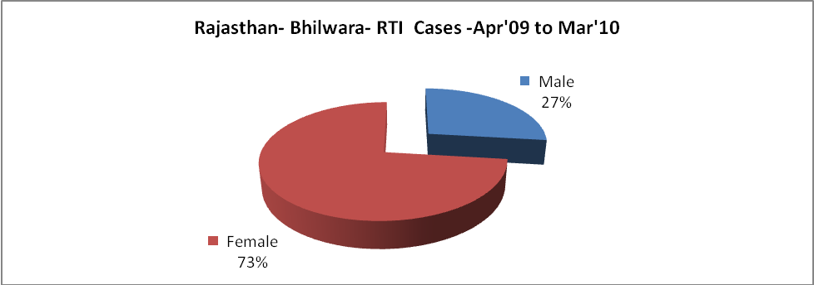

Rajasthan- Bhilwara-Sterilisations - Apr'09 to Mar'10
 | Reported | %age of Reported Sterilisation
Total Sterilisation | 9,773 | -
NSV | 360 | 4%
Laproscopic | 8,291 | 85%
MiniLap | 27 | 0%
Post Partum | 1,095 | 11%
Male Sterilisation | 360 | 4%
Female Sterilisation | 9,413 | 96%

Rajasthan- Bhilwara-FP Methods - Apr'09 to Mar'10
 | Reported | %age of All Reported FP Methods
Total Reported FP Methodd (All types) Users | 155,573 | -
Sterilisations | 9,773 | 6%
IUD | 16,275 | 10%
Condom Users | 80,742 | 52%
OCP Users | 48,783 | 31%
Limiting Methods | 9,773 | 6%
Spacing Methods | 145,800 | 94%

Rajasthan- Bhilwara- Lab Services - Apr'09 to Mar'10
Total OPD | Total HB tested | Total HIV Tested | Total Population
1,033,816 | 24,371 | 906 | 2,400,600
HB test conducted as %age of OPD | HB<7gm as %age of HB tested | HIV test conducted as %age of OPD | HIV positive as %age of HIV tested | Blood Smear Examined as % of Population
2.4% | 7.2% | 0.1% | 0.1% | 5.5%

Rajasthan- Bhilwara- Childhood Disease - Vaccine Preventable -Apr'09 to Mar'10
Diphtheria | Pertussis | Tetanus Neonatorum | Tetanus others | Polio | Measles
0 | 0 | 0 | 3 | 0 | 2
Rajasthan- Bhilwara-Childhood Disease - Others - Apr'09 to Mar'10
Diarrhoea and dehydration | Malaria | Number admitted with Respiratory Infections
7,076 | 148 | 3,700

Rajasthan- Bhilwara- Infant & Child Deaths - Apr'09 to Mar'10
Infant Deaths within 24 hrs of birth | Infant Deaths between 24hrs & under 1 week | Infant Deaths between 1 week & under 1 month | Child Deaths between 1 month & under 1 year | Child Deaths between 1yr under 5years | Total Deaths
129 | 151 | 22 | 102 | 112 | 516

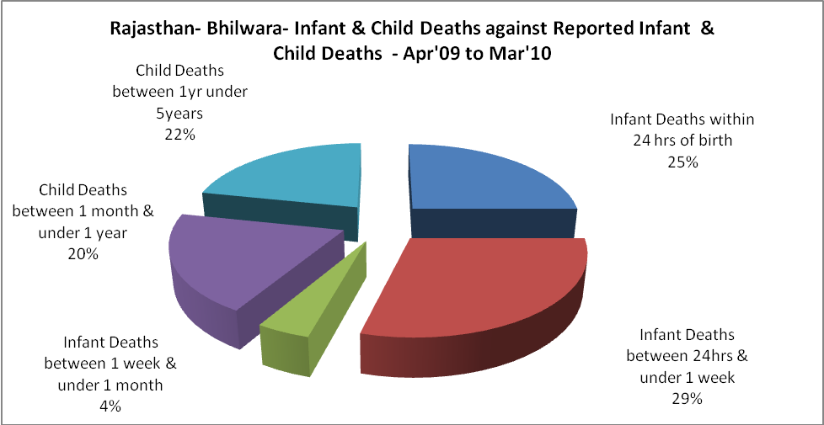

Rajasthan- Bhilwara- Causes of Infant & Child Deaths - Apr'09 to Mar'10
Sepsis |  |  | Asphyxia |  |  | LBW
Up to 1 Weeks of Birth | Between 1 week & 4 weeks of birth | Total | Up to 1 Weeks of Birth | Between 1 week & 4 weeks of birth | Total | Up to 1 Weeks of Birth | Between 1 week & 4 weeks of birth | Total
13 | 2 | 15 | 11 | 4 | 15 | 23 | 4 | 27
Pneumonia |  |  | Diarrhoea |  |  | Fever related
Between 1 month and 11 months | Between 1 year & 5 years | Total | Between 1 month and 11 months | Between 1 year & 5 years | Total | Between 1 month and 11 months | Between 1 year & 5 years | Total
16 | 19 | 35 | 26 | 20 | 46 | 28 | 51 | 79
Others |  |  | Measles |  |  | Others
Up to 1 Weeks of Birth | Between 1 week & 4 weeks of birth | Total | Between 1 month and 11 months | Between 1 year & 5 years | Total | Between 1 month and 11 months | Between 1 year & 5 years | Total
104 | 12 | 116 | 0 | 0 | 0 | 32 | 22 | 54

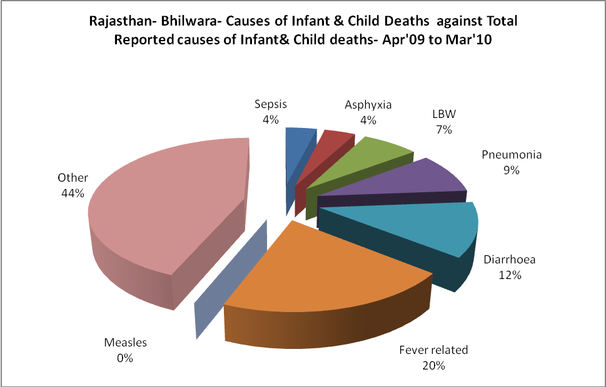

Rajasthan- Bhilwara- Maternal Deaths & Causes - Apr'09 to Mar'10
Abortion |  |  | Obstructed/prolonged labour |  |  | Severe hypertesnion/fits
6-14 yrs | 15-55 yrs. | Total | 6-14 yrs | 15-55 yrs. | Total | 6-14 yrs | 15-55 yrs. | Total
0 | 4 | 4 | 0 | 0 | 0 | 0 | 0 | 0
Bleeding |  |  | High Fever |  |  | Other Causes
6-14 yrs | 15-55 yrs. | Total | 6-14 yrs | 15-55 yrs. | Total | 6-14 yrs | 15-55 yrs. | Total
0 | 1 | 1 | 0 | 0 | 0 | 2 | 3 | 5

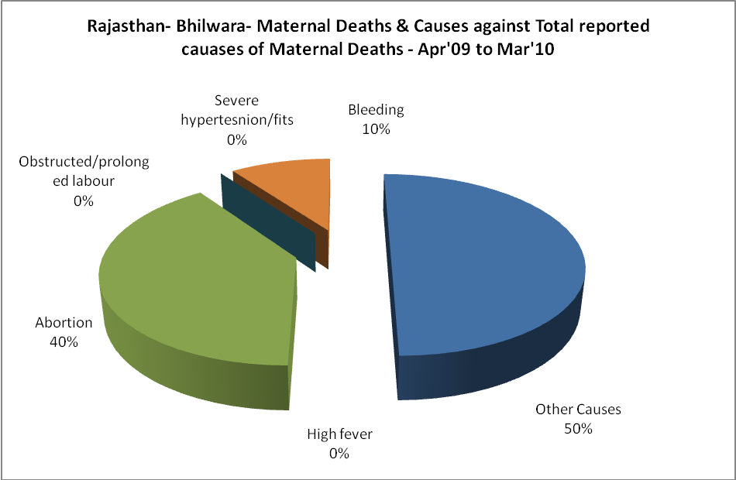

Rajasthan- Bhilwara-Causes of Deaths in 6 to 55yrs age group - Apr'09 to Mar'10
Diarrhoel Diseases |  |  |  | Tuberculosis |  |  |  | Respiratory Diseases( Other than TB)
6-14 yrs | 15-55 yrs. | Above 55yrs | Total | 6-14 yrs | 15-55 yrs. | Above 55yrs | Total | 6-14 yrs | 15-55 yrs. | Above 55yrs | Total
38 | 1 | 0 | 39 | 0 | 11 | 17 | 28 | 6 | 26 | 56 | 88
Malaria |  |  |  | Other fever Related |  |  |  | HIV/Aids
6-14 yrs | 15-55 yrs. | Above 55yrs | Total | 6-14 yrs | 15-55 yrs. | Above 55yrs | Total | 6-14 yrs | 15-55 yrs. | Above 55yrs | Total
0 | 0 | 0 | 0 | 23 | 17 | 14 | 54 | 0 | 0 | 0 | 0
Heart Disease/Hypertenion related |  |  |  | Neurological Disease including strokes |  |  |  | Trauma/Accidents/ Burn Cases
6-14 yrs | 15-55 yrs. | Above 55yrs | Total | 6-14 yrs | 15-55 yrs. | Above 55yrs | Total | 6-14 yrs | 15-55 yrs. | Above 55yrs | Total
0 | 28 | 37 | 65 | 56 | 5 | 8 | 69 | 10 | 50 | 12 | 72
Suicide |  |  |  | Animal Bites & Stings
6-14 yrs | 15-55 yrs. | Above 55yrs | Total | 6-14 yrs | 15-55 yrs. | Above 55yrs | Total
0 | 12 | 2 | 14 | 6 | 13 | 3 | 22

