NHSRC
Rajasthan-Bikaner
Analysis: Apr 2009 – Mar 2010

Rajasthan- Bikaner- Summary-Apr'09 to Mar'10
ANC
ANC Registration against Expected Pregnancies | 114% | TT1 given to Pregnant women against ANC Registraion | 65%
3 ANC Check ups against ANC Reigtrations | 61% | 100 IFA Tablets given to Pregnant women against ANC Registraion | 101%
Deliveries
Unreported Deliveries against Estimated Deliveries | 27.4% | HOME Deliveries( SBA& Non SBA) against Estimated Deliveries | 17.2%
Institutional Deliveries against Estimated Deliveries | 55.5% | HOME Deliveries( SBA& Non SBA) against Reported Deliveries | 23.6%
Institutional Deliveries against Reported Deliveries | 76.4% | C Section Deliveries against Institutional Deliveries( Pvt & Pub) | 2%
Births & Neonates Care
Live Births Reported against Estimated Live Births | 71% | New borns weighed against Reported Live Births | 68%
Still Births (Reported) | 664 | New borns weighed less than 2.5 kgs against newborns weighed | 28%
Sex Ratio at Birh | 868 | New borns breastfed within one hr of Birth against Reported live Births | 65%
Child Immunization( 0 to 11 months)
BCG given against Expected Live Births | 114% | Measles given against Expected Live Births | 103%
OPV3 given against Expected Live Births | 101% | Fully Immunised Children against Expected Live Births | 99%
DPT3 given against Expected Live Births | 103%
Family Planning
Family Plannig Methods Users ( Sterilisations(Male &Female)+IUD+ Condom pieces/72 + OCP Cycles/13) | 98,717 | IUD Insertions against reported FP Methods | 9%
Sterilisation against reported FP Methods | 11% | Condom Users against reported FP Methods | 57%
 |  | OCP Users against reported FP Methods | 24%
Other Services
OPD | 650,958 | Major Operations | 4,266
IPD | 25,543 | Minor Operations | 1,468

Rajasthan- Bikaner- Deliveries Apr'09 to Mar'10
Total Population | 2,273,200 | Expected Deliveries |  | 64,482
Home SBA | Home Non SBA | Institutional | Total Deliveries Reported | Unreported Deliveries
5,123 | 5,940 | 35,757 | 46,820 | 17,662
Home SBA % | Home Non SBA% | Institutional % | Total Deliveries Reported % | Unreported Deliveries %
8% | 9% | 55% | 73% | 27%
`

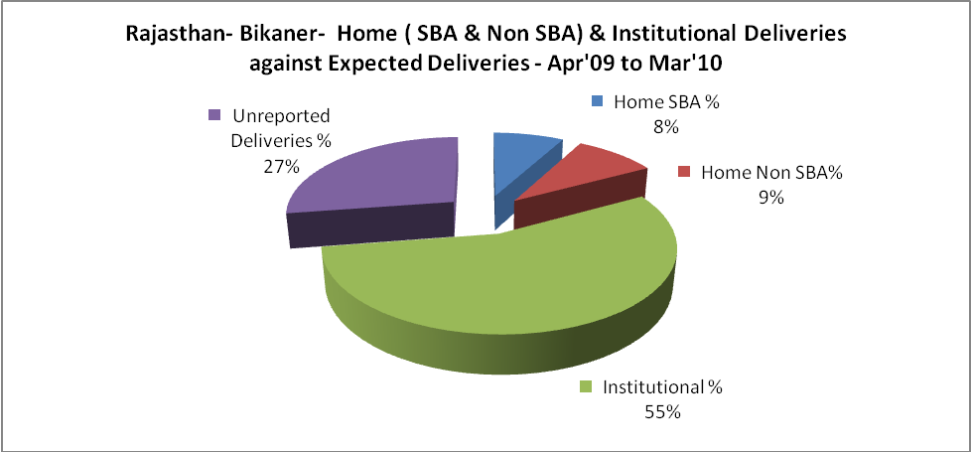

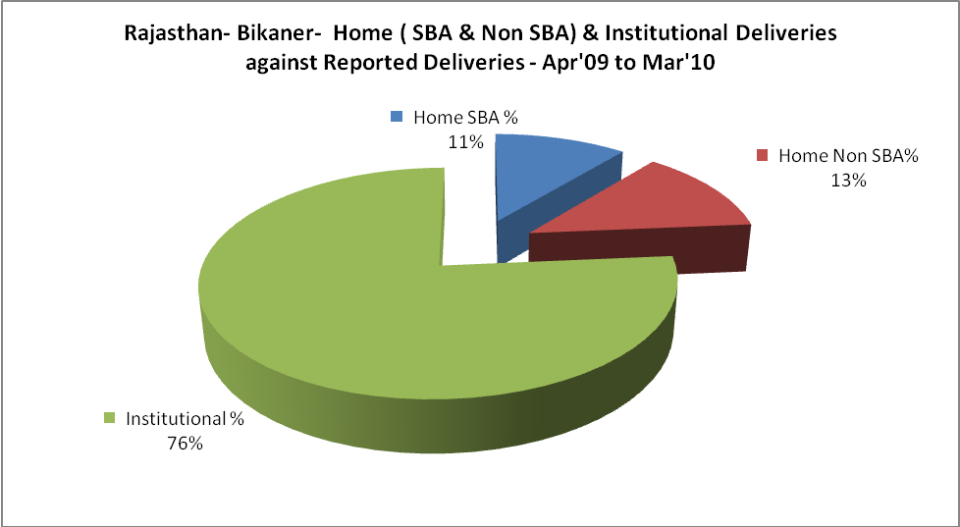

Rajasthan- Bikaner- C sections & Complicated Deliveries Apr'09 to Mar'10
 | Institutional Deliveries (Public) | Institutional Deliveries (Pvt)
 | 31,299 | 4,458
C Section | 686 | 10
C Section% | 2% | 0%
Complicated Pregnacies attended | 178 | 29
Complicated Pregnacies attended % | 1% | 1%

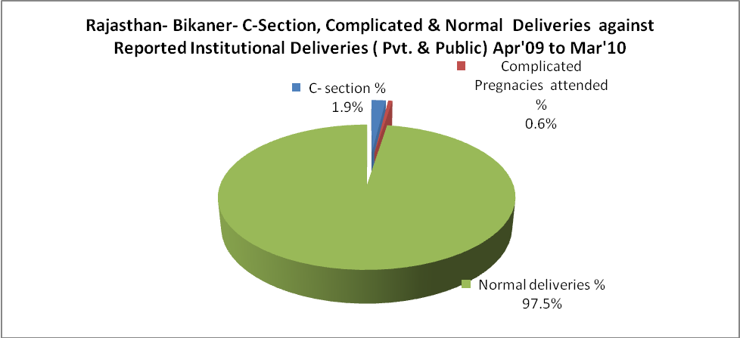

Rajasthan- Bikaner- Complicated Pregnancies & Deliveries Treated - Apr'09 to Mar'10
Reported Deliveries |  |  | Reported ANC Reigtration
46,820 |  |  | 78,697
Complicated Pregnancies attended | Complicated Pregnancies Rate | C - Section Deliveries | PNC Maternal Complications | Abortions | Still Births
207 | 0% | 696 | 151 | 579 | 664
Complicated Deliveries Treated with |  |  |  | No Of Eclampsia cases Treated | No Of severe anemia cases treated
IV Antibiotics | IV antihypertensive/Magsulph injection | IV Oxytocis | Blood Transfusion | No Of Eclampsia cases Treated | No Of severe anemia cases treated
544 | 141 | 637 | 1 | 784 | 1,554

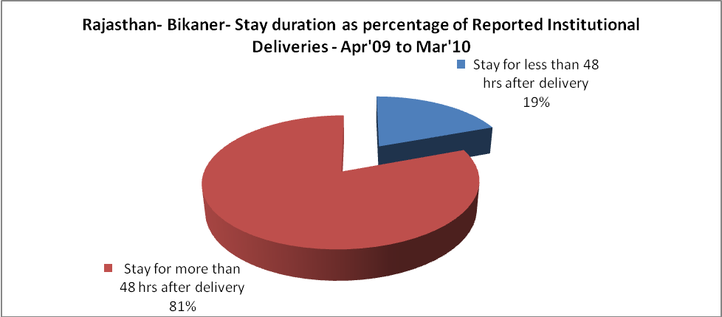

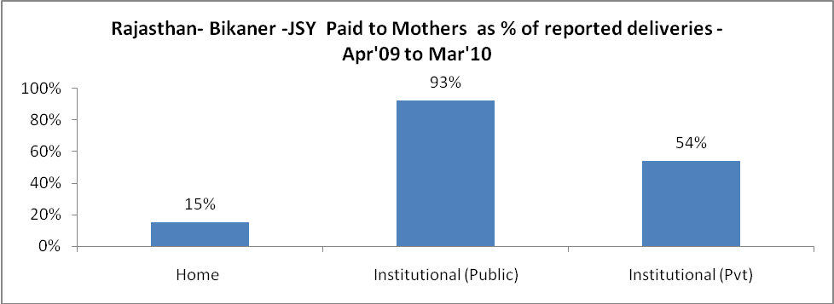

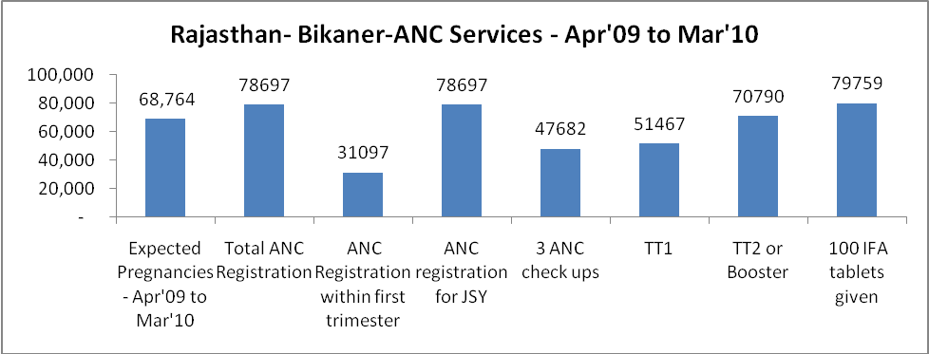

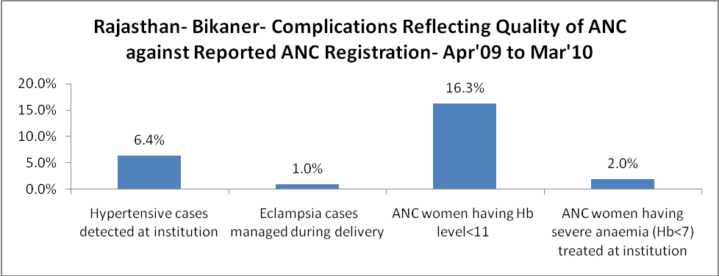
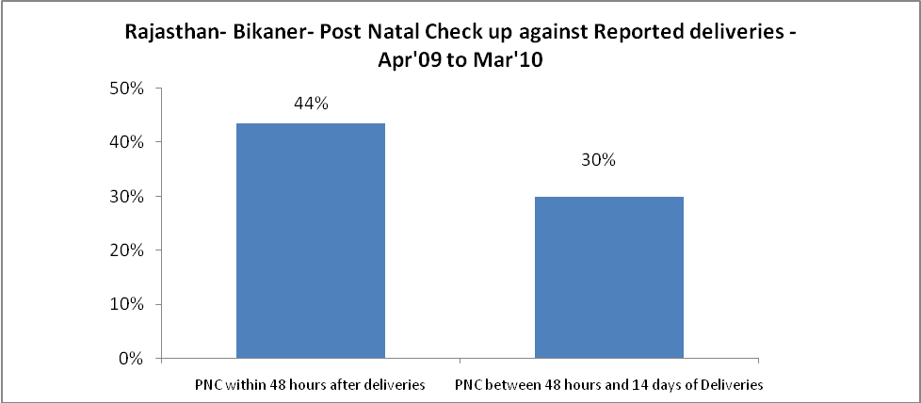

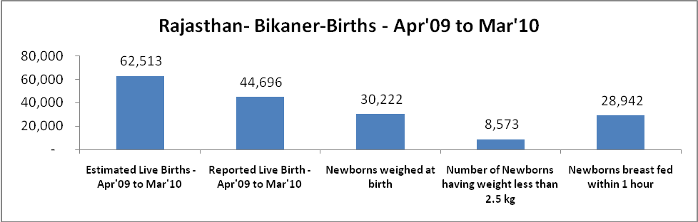

Rajasthan- Bikaner - Births - Apr'09 to Mar'10
Live Birth - Males | Live Birth - females | Live Birth - Total | Sex Ratio at birth | Still Birth | Abortion( Induced/Spontaneous
23,930 | 20,766 | 44,696 | 868 | 664 | 579

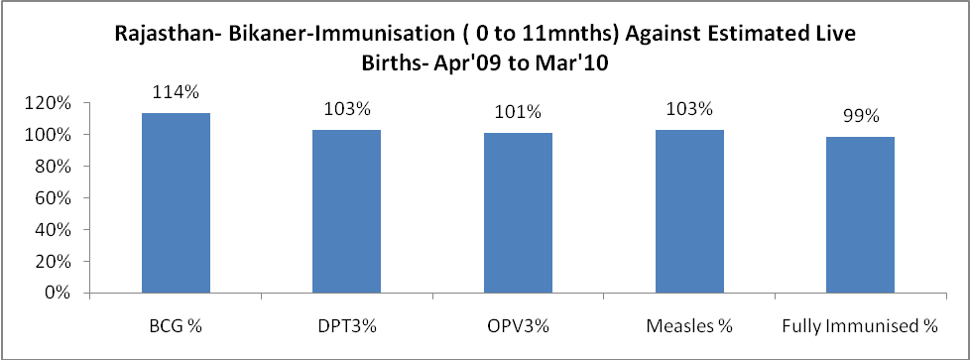

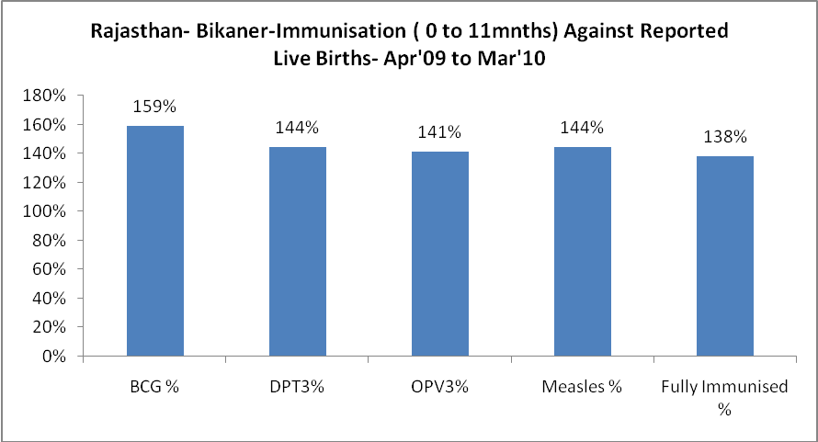

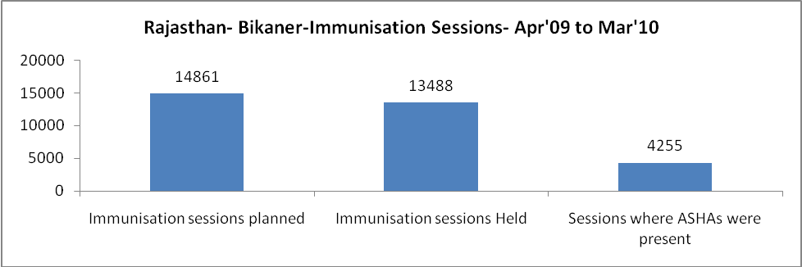

Rajasthan- Bikaner- Apr'09 to Mar'10
Total Abortions | Abortion Rate
1,047 | 1.5%

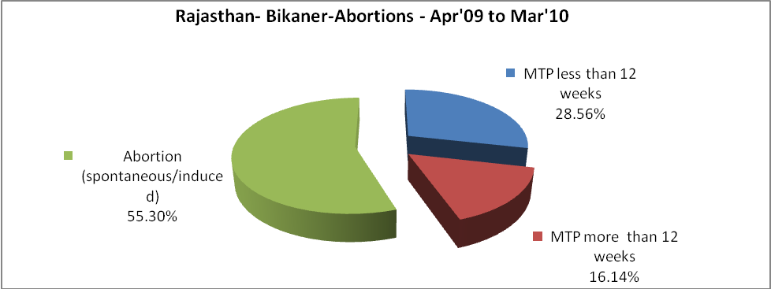

Rajasthan- Bikaner- Apr'09 to Mar'10
Total OPD | Total RTI/STI cases
650,958 | 11,699

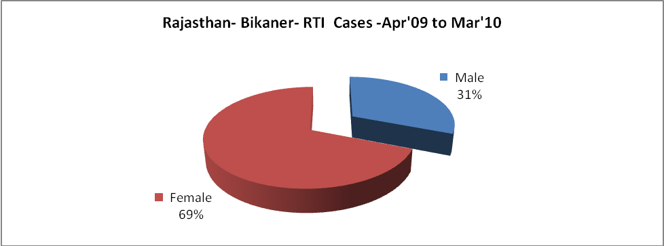

Rajasthan- Bikaner-Sterilisations - Apr'09 to Mar'10
 | Reported | %age of Reported Sterilisation
Total Sterilisation | 10,421 | -
NSV | 272 | 3%
Laproscopic | 9,778 | 94%
MiniLap | 43 | 0%
Post Partum | 328 | 3%
Male Sterilisation | 272 | 3%
Female Sterilisation | 10,149 | 97%

Rajasthan- Bikaner-FP Methods - Apr'09 to Mar'10
 | Reported | %age of All Reported FP Methods
Total Reported FP Methodd (All types) Users | 98,717 | -
Sterilisations | 10,421 | 11%
IUD | 9,015 | 9%
Condom Users | 55,941 | 57%
OCP Users | 23,340 | 24%
Limiting Methods | 10,421 | 11%
Spacing Methods | 88,296 | 89%

Rajasthan- Bikaner- Service Delivery - Apr'09 to Mar'10
Operation major (General and spinal anaesthesia) | Operation minor (No or local anaesthesia) | AYUSH | Dental Procedures | Adolescent counselling services | Total OPD | Total IPD
4,266 | 1,468 | 76,741 | 41 | 216 | 650,958 | 25,543
Operation major (General and spinal anaesthesia) as %ge of OPD | Operation minor (No or local anaesthesia)as %ge of OPD | AYUSH as %ge of OPD | Dental Procedures as %ge of OPD | Adolescent counselling services as %ge of OPD | IPD as percentage of OPD
0.7% | 0.2% | 11.8% | 0.0% | 0.0% | 4%

Rajasthan- Bikaner- Lab Services - Apr'09 to Mar'10
Total OPD | Total HB tested | Total HIV Tested | Total Population
650,958 | 35,024 | 339 | 2,273,200
HB test conducted as %age of OPD | HB<7gm as %age of HB tested | HIV test conducted as %age of OPD | HIV positive as %age of HIV tested | Blood Smear Examined as % of Population
5.4% | 13.7% | 0.1% | 4.7% | 4.6%

Rajasthan- Bikaner- Childhood Disease - Vaccine Preventable -Apr'09 to Mar'10
Diphtheria | Pertussis | Tetanus Neonatorum | Tetanus others | Polio | Measles
30 | 1 | 1 | 4 | 0 | 78
Rajasthan- Bikaner-Childhood Disease - Others - Apr'09 to Mar'10
Diarrhoea and dehydration | Malaria | Number admitted with Respiratory Infections
2,693 | 310 | 67

Rajasthan- Bikaner- Infant & Child Deaths - Apr'09 to Mar'10
Infant Deaths within 24 hrs of birth | Infant Deaths between 24hrs & under 1 week | Infant Deaths between 1 week & under 1 month | Child Deaths between 1 month & under 1 year | Child Deaths between 1yr under 5years | Total Deaths
8 | 3 | 2 | 2 | 0 | 15

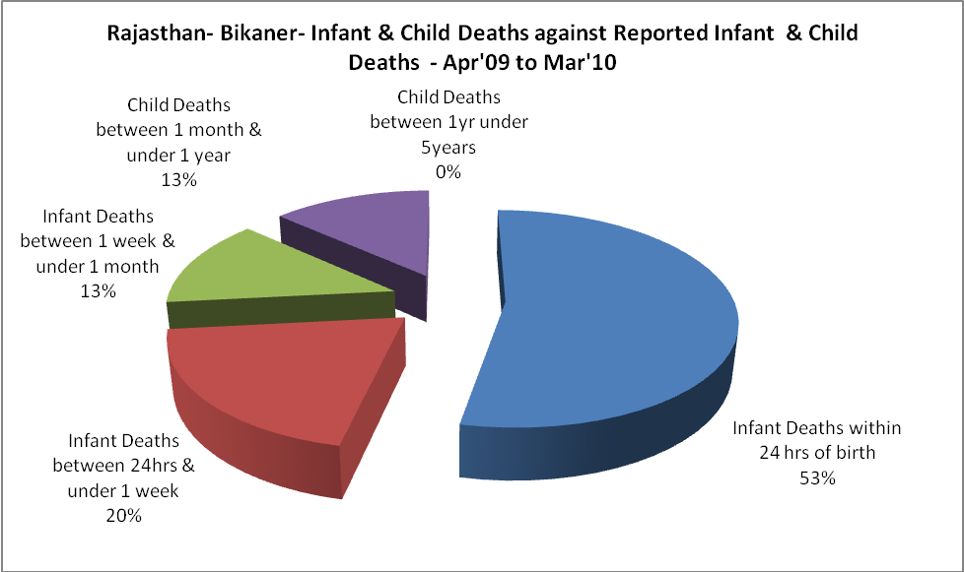

Rajasthan- Bikaner- Causes of Infant & Child Deaths - Apr'09 to Mar'10
Sepsis |  |  | Asphyxia |  |  | LBW
Up to 1 Weeks of Birth | Between 1 week & 4 weeks of birth | Total | Up to 1 Weeks of Birth | Between 1 week & 4 weeks of birth | Total | Up to 1 Weeks of Birth | Between 1 week & 4 weeks of birth | Total
1 | 0 | 1 | 1 | 0 | 1 | 0 | 2 | 2
Pneumonia |  |  | Diarrhoea |  |  | Fever related
Between 1 month and 11 months | Between 1 year & 5 years | Total | Between 1 month and 11 months | Between 1 year & 5 years | Total | Between 1 month and 11 months | Between 1 year & 5 years | Total
2 | 0 | 2 | 0 | 0 | 0 | 0 | 0 | 0
Others |  |  | Measles |  |  | Others
Up to 1 Weeks of Birth | Between 1 week & 4 weeks of birth | Total | Between 1 month and 11 months | Between 1 year & 5 years | Total | Between 1 month and 11 months | Between 1 year & 5 years | Total
1 | 0 | 1 | 0 | 0 | 0 | 0 | 0 | 0

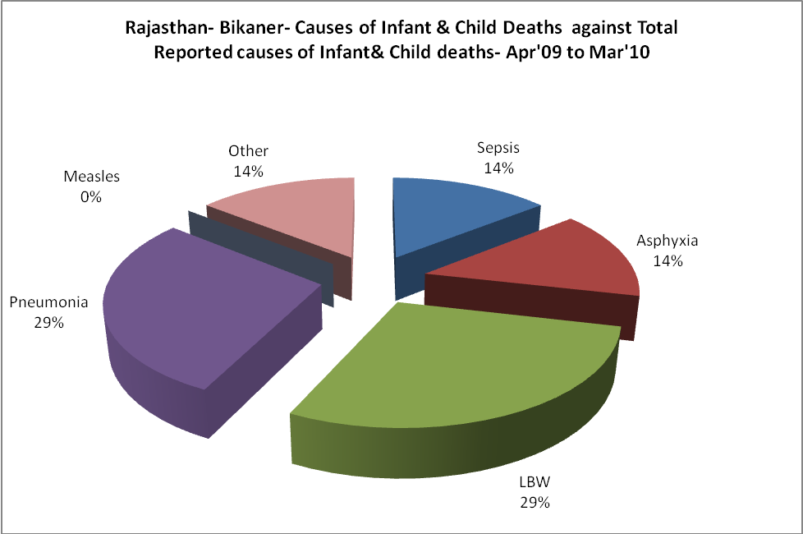

Rajasthan- Bikaner- Maternal Deaths & Causes - Apr'09 to Mar'10
Abortion |  |  | Obstructed/prolonged labour |  |  | Severe hypertesnion/fits
6-14 yrs | 15-55 yrs. | Total | 6-14 yrs | 15-55 yrs. | Total | 6-14 yrs | 15-55 yrs. | Total
0 | 0 | 0 | 0 | 0 | 0 | 0 | 0 | 0
Bleeding |  |  | High Fever |  |  | Other Causes
6-14 yrs | 15-55 yrs. | Total | 6-14 yrs | 15-55 yrs. | Total | 6-14 yrs | 15-55 yrs. | Total
0 | 0 | 0 | 0 | 0 | 0 | 0 | 0 | 0

Rajasthan- Bikaner-Causes of Deaths in 6 to 55yrs age group - Apr'09 to Mar'10
Diarrhoel Diseases |  |  |  | Tuberculosis |  |  |  | Respiratory Diseases( Other than TB)
6-14 yrs | 15-55 yrs. | Above 55yrs | Total | 6-14 yrs | 15-55 yrs. | Above 55yrs | Total | 6-14 yrs | 15-55 yrs. | Above 55yrs | Total
83 | 0 | 0 | 83 | 8 | 0 | 0 | 8 | 14 | 0 | 0 | 14
Malaria |  |  |  | Other fever Related |  |  |  | HIV/Aids
6-14 yrs | 15-55 yrs. | Above 55yrs | Total | 6-14 yrs | 15-55 yrs. | Above 55yrs | Total | 6-14 yrs | 15-55 yrs. | Above 55yrs | Total
0 | 0 | 0 | 0 | 64 | 0 | 0 | 64 | 0 | 0 | 0 | 0
Heart Disease/Hypertenion related |  |  |  | Neurological Disease including strokes |  |  |  | Trauma/Accidents/ Burn Cases
6-14 yrs | 15-55 yrs. | Above 55yrs | Total | 6-14 yrs | 15-55 yrs. | Above 55yrs | Total | 6-14 yrs | 15-55 yrs. | Above 55yrs | Total
30 | 0 | 0 | 30 | 30 | 0 | 0 | 30 | 20 | 22 | 0 | 42
Suicide |  |  |  | Animal Bites & Stings
6-14 yrs | 15-55 yrs. | Above 55yrs | Total | 6-14 yrs | 15-55 yrs. | Above 55yrs | Total
0 | 1 | 0 | 1 | 0 | 0 | 0 | 0

