NHSRC
Himachal Pradesh-Bilaspur District
Analysis 2009-10

7/22/2010

Bilaspur Dist.- Summary-Apr'09 to Mar'10
ANC
ANC Registration against Expected Pregnancies | 100% | TT1 given to Pregnant women against ANC Registration | 58%
3 ANC Check ups against ANC Registrations | 84% | 100 IFA Tablets given to Pregnant women against ANC Registration | 92%
Deliveries
Unreported Deliveries against Estimated Deliveries | 2.5% | HOME Deliveries( SBA& Non SBA) against Estimated Deliveries | 42.4%
Institutional Deliveries against Estimated Deliveries | 55.1% | HOME Deliveries( SBA& Non SBA) against Reported Deliveries | 43.5%
Institutional Deliveries against Reported Deliveries | 56.5% | C Section Deliveries against Institutional Deliveries( Pvt & Pub) | 20%
Births & Neonates Care
Live Births Reported against Estimated Live Births | 101% | New borns weighed against Reported Live Births | 95%
Still Births (Reported) | 43 | New borns weighed less than 2.5 kgs against newborns weighed | 7%
Sex Ratio at Birth | 904 | New borns breastfed within one hr of Birth against Reported live Births | 88%
Child Immunization( 0 to 11 months)
BCG given against Expected Live Births | 119% | Measles given against Expected Live Births | 103%
OPV3 given against Expected Live Births | 105% | Fully Immunized Children against Expected Live Births | 103%
DPT3 given against Expected Live Births | 105%
Family Planning
Family Planning Methods Users ( Sterilizations(Male &Female)+IUD+ Condom pieces/72 + OCP Cycles/13) | 16,641 | IUD Insertions against reported FP Methods | 17%
Sterilization against reported FP Methods | 12% | Condom Users against reported FP Methods | 57%
 |  | OCP Users against reported FP Methods | 15%
Other Services
OPD | 420,048 | Major Operations | -
IPD | 12,791 | Minor Operations | 2,466

Bilaspur Dist.- Deliveries Apr'09 to Mar'10
Total Population | 375,888 | Expected Deliveries |  | 6,800
Home SBA | Home Non SBA | Institutional | Total Deliveries Reported | Unreported Deliveries
989 | 1,895 | 3,748 | 6,632 | 168
Home SBA % | Home Non SBA% | Institutional % | Total Deliveries Reported % | Unreported Deliveries %
15% | 28% | 55% | 98% | 2%

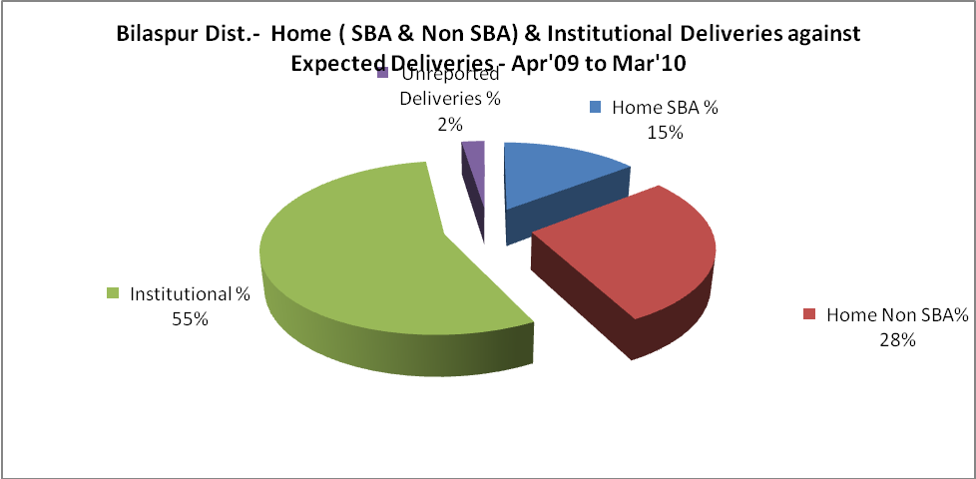

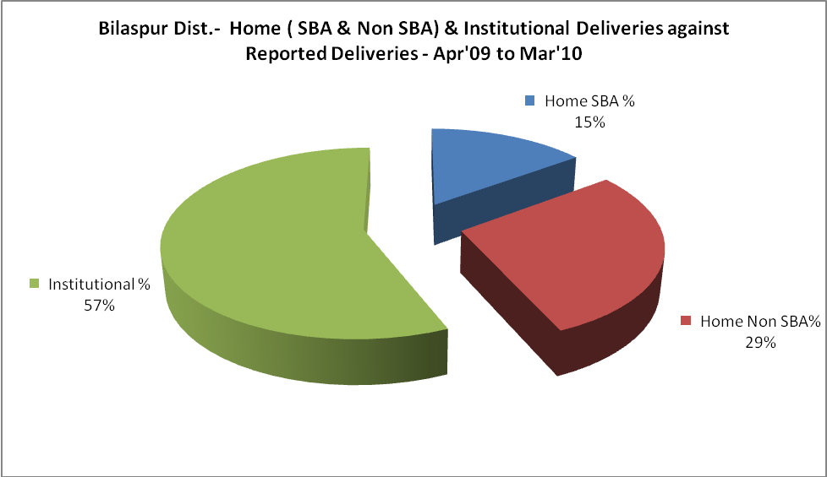

Bilaspur Dist.- C sections & Complicated Deliveries Apr'09 to Mar'10
 | Institutional Deliveries (Public) | Institutional Deliveries (Pvt)
 | 2,488 | 1,260
C Section | 309 | 101
C Section% | 12% | 8%
Complicated Pregnancies attended | 1 | -
Complicated Pregnancies attended % | 0% | 0%

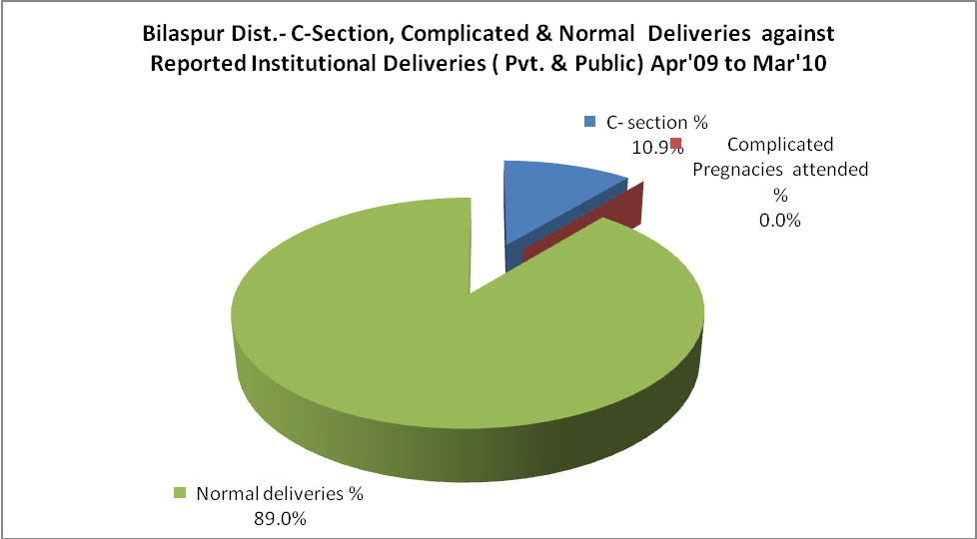

 | C- section % | Complicated Pregnancies attended % | Normal deliveries %
Bilaspur Dist.- C-Section, Complicated & Normal Deliveries against Reported Institutional Deliveries ( Pvt. & Public) Apr'09 to Mar'10 | 10.9% | 0.0% | 89.0%

Bilaspur Dist.- Complicated Pregnancies & Deliveries Treated - Apr'09 to Mar'10
Reported Deliveries |  |  | Reported ANC Registration
6,632 |  |  | 7,324
Complicated Pregnancies attended | Complicated Pregnancies Rate | C - Section Deliveries | PNC Maternal Complications | Abortions | Still Births
1 | 0% | 410 | 7 | 183 | 43
Complicated Deliveries Treated with |  |  |  | No Of Eclampsia cases Treated | No Of severe anemia cases treated
IV Antibiotics | IV antihypertensive/Magsulph injection | IV Oxytocis | Blood Transfusion | No Of Eclampsia cases Treated | No Of severe anemia cases treated
- | - | - | - | 2 | 126

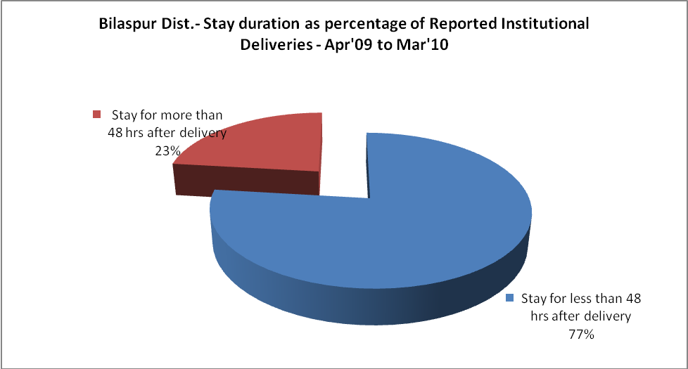

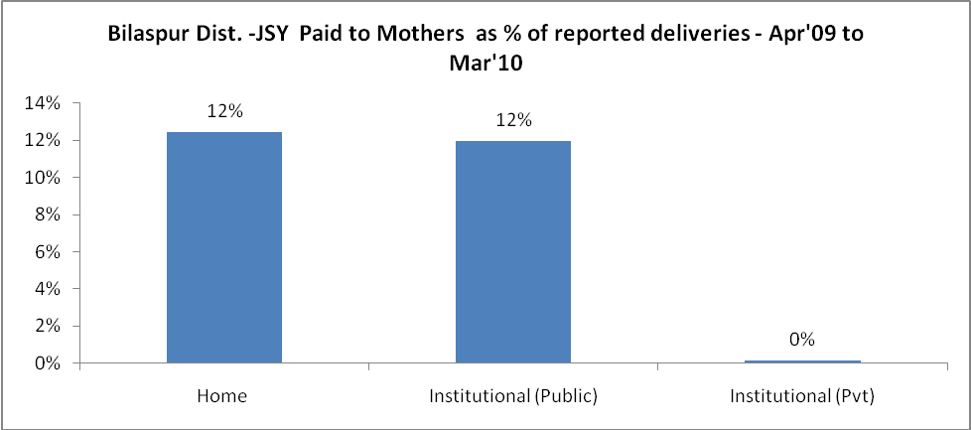
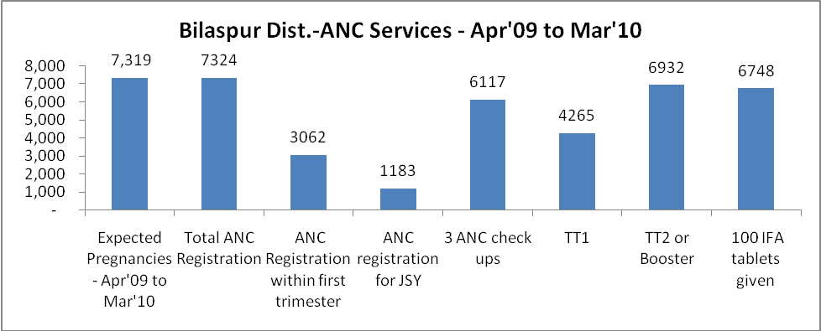

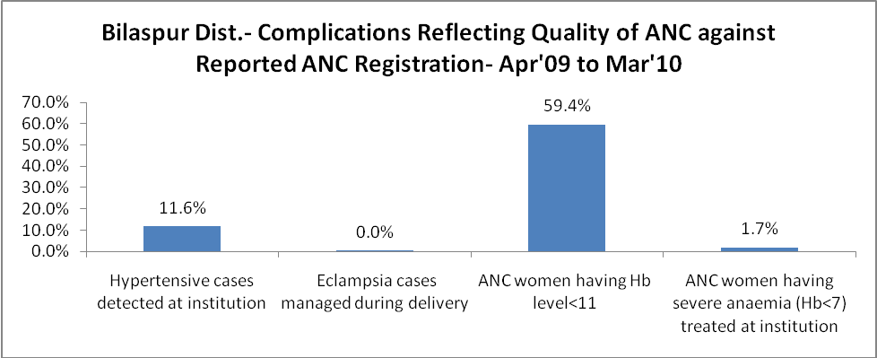

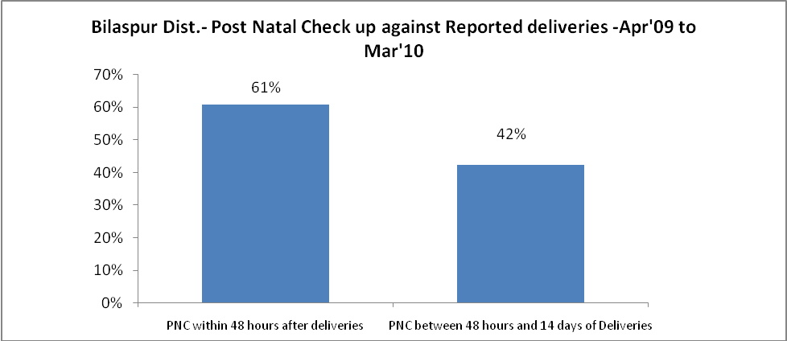

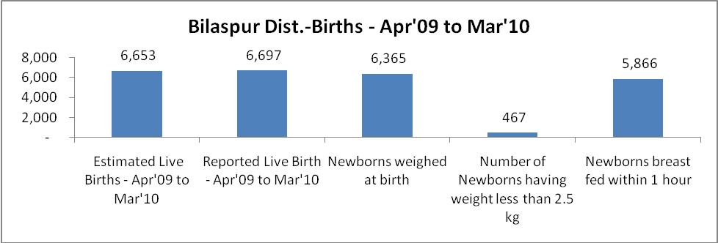
Bilaspur Dist. - Births - Apr'09 to Mar'10
Live Birth - Males | Live Birth - females | Live Birth - Total | Sex Ratio at birth | Still Birth | Abortion( Induced/Spontaneous
3,517 | 3,180 | 6,697 | 904 | 43 | 183

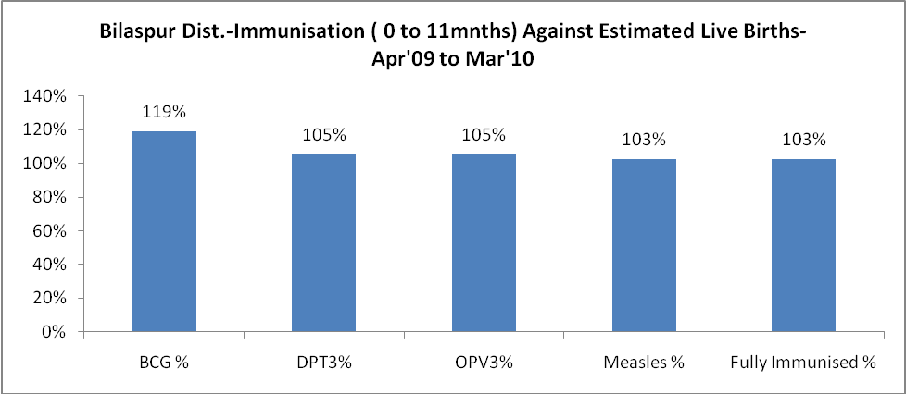
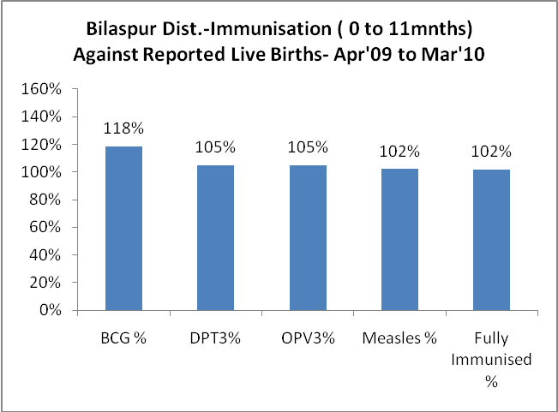
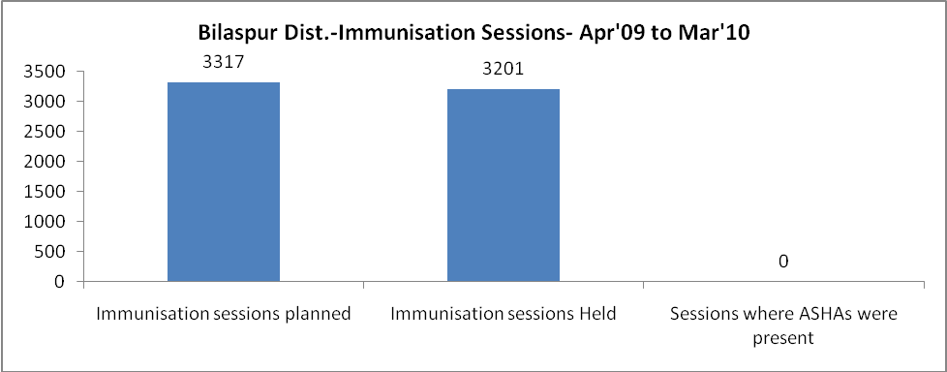
Bilaspur Dist.- Apr'09 to Mar'10
Total Abortions | Abortion Rate
276 | 3.8%

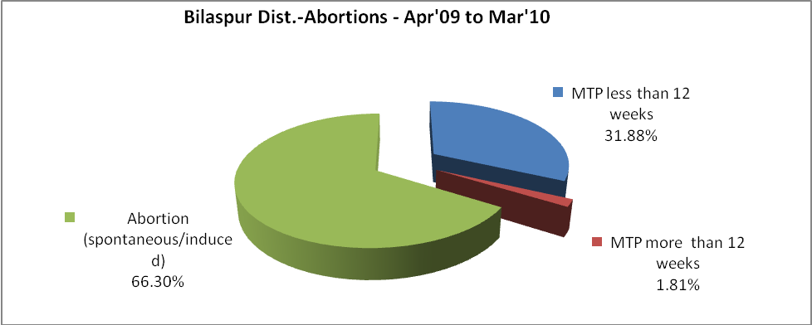
Bilaspur Dist.- Apr'09 to Mar'10
Total OPD | Total RTI/STI cases
420,048 | 3,312

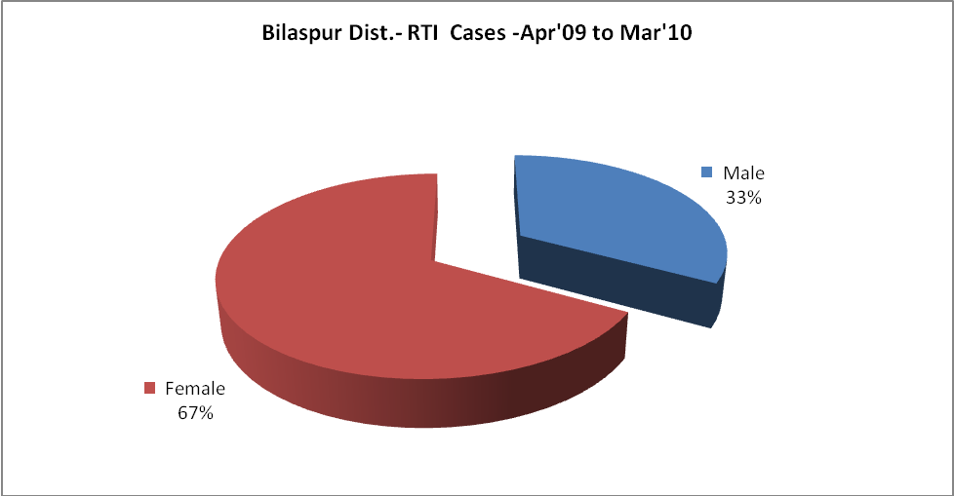
Bilaspur Dist.-Sterilizations - Apr'09 to Mar'10
 | Reported | %age of Reported Sterilizations
Total Sterilizations | 1,935 | -
NSV | 114 | 6%
Laproscopic | 1,803 | 93%
MiniLap | 18 | 1%
Post Partum | - | 0%
Male Sterilization | 114 | 6%
Female Sterilization | 1,821 | 94%

Bilaspur Dist.-FP Methods - Apr'09 to Mar'10
 | Reported | %age of All Reported FP Methods
Total Reported FP Method (All types) Users | 16,641 | -
Sterilizations | 1,935 | 12%
IUD | 2,756 | 17%
Condom Users | 9,424 | 57%
OCP Users | 2,525 | 15%
Limiting Methods | 1,935 | 12%
Spacing Methods | 14,706 | 88%

Bilaspur Dist.- Service Delivery - Apr'09 to Mar'10
Operation major (General and spinal anaesthesia) | Operation minor (No or local anaesthesia) | AYUSH | Dental Procedures | Adolescent counseling services | Total OPD | Total IPD
- | 2,466 | 10 | 7,669 | 18 | 420,048 | 12,791
Operation major (General and spinal anaesthesia) as %ge of OPD | Operation minor (No or local anaesthesia)as %ge of OPD | AYUSH as %ge of OPD | Dental Procedures as %ge of OPD | Adolescent counseling services as %ge of OPD | IPD as percentage of OPD
0.0% | 0.6% | 0.0% | 1.8% | 0.0% | 3%

Bilaspur Dist.- Lab Services - Apr'09 to Mar'10
Total OPD | Total HB tested | Total HIV Tested | Total Population
420,048 | 19,064 | 2,637 | 375,888
HB test conducted as %age of OPD | HB<7gm as %age of HB tested | HIV test conducted as %age of OPD | HIV positive as %age of HIV tested | Blood Smear Examined as % of Population
4.5% | 2.7% | 0.6% | 1.9% | 4.6%

Bilaspur Dist.- Childhood Disease - Vaccine Preventable -Apr'09 to Mar'10
Diphtheria |  | Pertussis |  | Tetanus Neonatorum |  | Tetanus others |  | Polio |  | Measles
0 |  | 0 |  | 0 |  | 0 |  | 0 |  | 0
Bilaspur Dist.-Childhood Disease - Others - Apr'09 to Mar'10
Diarrhoea and dehydration |  | Malaria |  | Number admitted with Respiratory Infections
1,919 |  | - |  | 186
Bilaspur Dist.- Infant & Child Deaths - Apr'09 to Mar'10
Infant Deaths within 24 hrs of birth | Infant Deaths under 1 week |  | Infant Deaths under 1 month |  | Child Deaths under 1 year |  | Child Deaths under 5years |  | Total Deaths
12 | 23 |  | 14 |  | 18 |  | 22 |  | 89

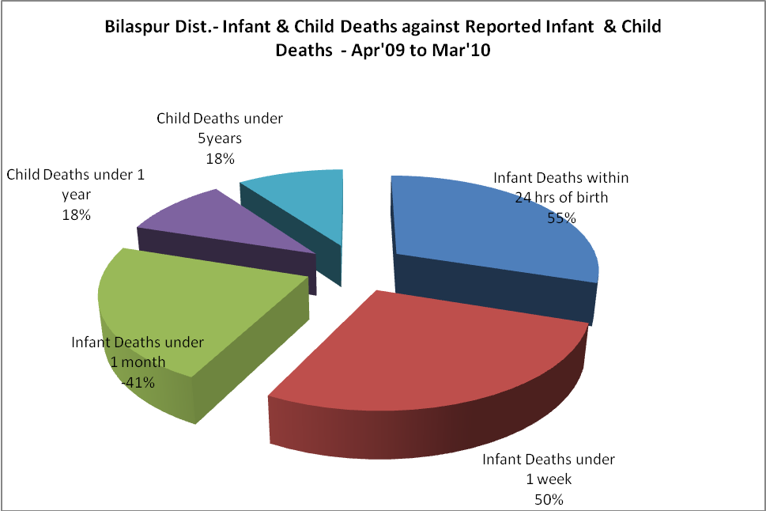

Bilaspur Dist.- Causes of Infant & Child Deaths - Apr'09 to Mar'10
Sepsis |  |  | Asphyxia |  |  | LBW
Up to 1 Weeks of Birth | Between 1 week & 4 weeks of birth | Total | Up to 1 Weeks of Birth | Between 1 week & 4 weeks of birth | Total | Up to 1 Weeks of Birth | Between 1 week & 4 weeks of birth | Total
0 | 1 | 1 | 5 | 0 | 5 | 6 | 2 | 8
Pneumonia |  |  | Diarrhoea |  |  | Fever related
Between 1 month and 11 months | Between 1 year & 5 years | Total | Between 1 month and 11 months | Between 1 year & 5 years | Total | Between 1 month and 11 months | Between 1 year & 5 years | Total
1 | 2 | 3 | 0 | 0 | 0 | 1 | 0 | 1
Others |  |  | Measles |  |  | Others
Up to 1 Weeks of Birth | Between 1 week & 4 weeks of birth | Total | Between 1 month and 11 months | Between 1 year & 5 years | Total | Between 1 month and 11 months | Between 1 year & 5 years | Total
0 | 0 | 0 | 0 | 0 | 0 | 2 | 2 | 4

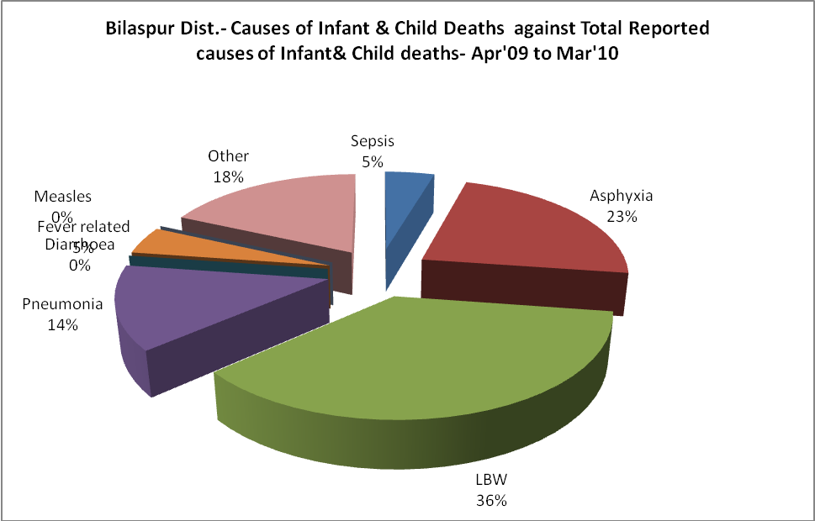

Bilaspur Dist.- Maternal Deaths & Causes - Apr'09 to Mar'10
Abortion |  |  | Obstructed/prolonged labour |  |  | Severe hypertension/fits
6-14 yrs | 15-55 yrs. | Total | 6-14 yrs | 15-55 yrs. | Total | 6-14 yrs | 15-55 yrs. | Total
0 | 0 | 0 | 0 | 0 | 0 | 0 | 0 | 0
Bleeding |  |  | High Fever |  |  | Other Causes
6-14 yrs | 15-55 yrs. | Total | 6-14 yrs | 15-55 yrs. | Total | 6-14 yrs | 15-55 yrs. | Total
0 | 0 | 0 | 0 | 1 | 1 | 0 | 0 | 0

Bilaspur Dist.-Causes of Deaths in 6 to 55yrs age group - Apr'09 to Mar'10
Diarrhoel Diseases |  |  |  | Tuberculosis |  |  |  | Respiratory Diseases( Other than TB)
6-14 yrs | 15-55 yrs. | Above 55yrs | Total | 6-14 yrs | 15-55 yrs. | Above 55yrs | Total | 6-14 yrs | 15-55 yrs. | Above 55yrs | Total
0 | 0 | 0 | 0 | 0 | 2 | 4 | 6 | 0 | 1 | 2 | 3
Malaria |  |  |  | Other fever Related |  |  |  | HIV/Aids
6-14 yrs | 15-55 yrs. | Above 55yrs | Total | 6-14 yrs | 15-55 yrs. | Above 55yrs | Total | 6-14 yrs | 15-55 yrs. | Above 55yrs | Total
0 | 0 | 0 | 0 | 1 | 2 | 9 | 12 | 0 | 0 | 0 | 0
Heart Disease/Hypertension related |  |  |  | Neurological Disease including strokes |  |  |  | Trauma/Accidents/ Burn Cases
6-14 yrs | 15-55 yrs. | Above 55yrs | Total | 6-14 yrs | 15-55 yrs. | Above 55yrs | Total | 6-14 yrs | 15-55 yrs. | Above 55yrs | Total
0 | 11 | 19 | 30 | 0 | 1 | 2 | 3 | 0 | 17 | 3 | 20
Suicide |  |  |  | Animal Bites & Stings
6-14 yrs | 15-55 yrs. | Above 55yrs | Total | 6-14 yrs | 15-55 yrs. | Above 55yrs | Total
0 | 3 | 0 | 3 | 1 | 0 | 0 | 1

