NHSRC
Rajasthan-Bundi
Analysis: Apr 2009 – Mar 2010

ANC
ANC Registration against Expected Pregnancies | 97% | TT1 given to Pregnant women against ANC Registraion | 71%
3 ANC Check ups against ANC Reigtrations | 87% | 100 IFA Tablets given to Pregnant women against ANC Registraion | 77%
Deliveries
Unreported Deliveries against Estimated Deliveries | 30.0% | HOME Deliveries( SBA& Non SBA) against Estimated Deliveries | 1.4%
Institutional Deliveries against Estimated Deliveries | 68.6% | HOME Deliveries( SBA& Non SBA) against Reported Deliveries | 2.0%
Institutional Deliveries against Reported Deliveries | 98.0% | C Section Deliveries against Institutional Deliveries( Pvt & Pub) | 4%
Births & Neonates Care
Live Births Reported against Estimated Live Births | 71% | New borns weighed against Reported Live Births | 96%
Still Births (Reported) | 363 | New borns weighed less than 2.5 kgs against newborns weighed | 14%
Sex Ratio at Birh | 918 | New borns breastfed within one hr of Birth against Reported live Births | 93%
Child Immunization( 0 to 11 months)
BCG given against Expected Live Births | 80% | Measles given against Expected Live Births | 89%
OPV3 given against Expected Live Births | 94% | Fully Immunised Children against Expected Live Births | 87%
DPT3 given against Expected Live Births | 94%
Family Planning
Family Plannig Methods Users ( Sterilisations(Male &Female)+IUD+ Condom pieces/72 + OCP Cycles/13) | 74,059 | IUD Insertions against reported FP Methods | 10%
Sterilisation against reported FP Methods | 8% | Condom Users against reported FP Methods | 53%
 |  | OCP Users against reported FP Methods | 29%
Other Services
OPD | 525,475 | Major Operations | 828
IPD | 37,369 | Minor Operations | 4,095

Rajasthan- Bundi- Deliveries Apr'09 to Mar'10
Total Population | 1,145,300 | Expected Deliveries |  | 32,488
Home SBA | Home Non SBA | Institutional | Total Deliveries Reported | Unreported Deliveries
436 | 16 | 22,294 | 22,746 | 9,742
Home SBA % | Home Non SBA% | Institutional % | Total Deliveries Reported % | Unreported Deliveries %
1% | 0% | 69% | 70% | 30%
`

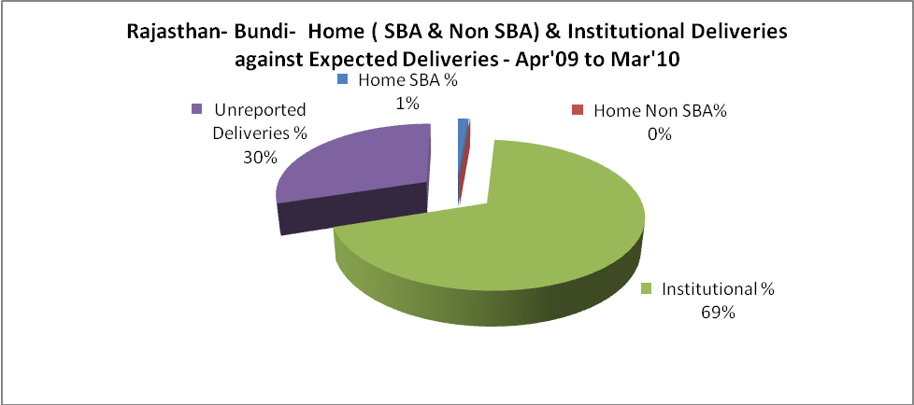

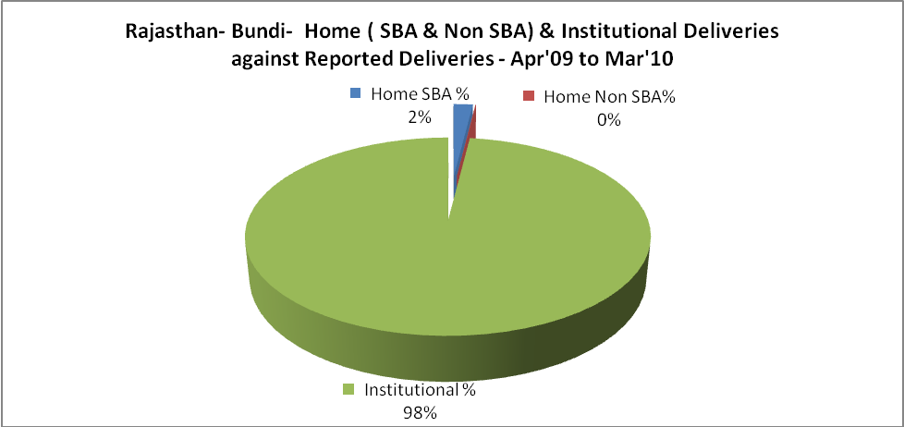

Rajasthan- Bundi- C sections & Complicated Deliveries Apr'09 to Mar'10
 | Institutional Deliveries (Public) | Institutional Deliveries (Pvt)
 | 19,996 | 2,298
C Section | 514 | 282
C Section% | 3% | 12%
Complicated Pregnacies attended | 2,138 | 284
Complicated Pregnacies attended % | 11% | 12%

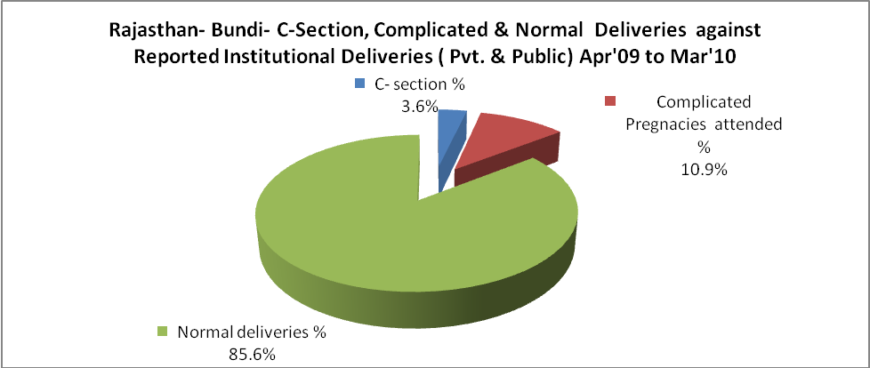

Rajasthan- Bundi- Complicated Pregnancies & Deliveries Treated - Apr'09 to Mar'10
Reported Deliveries |  |  | Reported ANC Reigtration
22,746 |  |  | 33,459
Complicated Pregnancies attended | Complicated Pregnancies Rate | C - Section Deliveries | PNC Maternal Complications | Abortions | Still Births
2,422 | 7% | 796 | 1,530 | 612 | 363
Complicated Deliveries Treated with |  |  |  | No Of Eclampsia cases Treated | No Of severe anemia cases treated
IV Antibiotics | IV antihypertensive/Magsulph injection | IV Oxytocis | Blood Transfusion | No Of Eclampsia cases Treated | No Of severe anemia cases treated
561 | 291 | 59 | - | 949 | 736

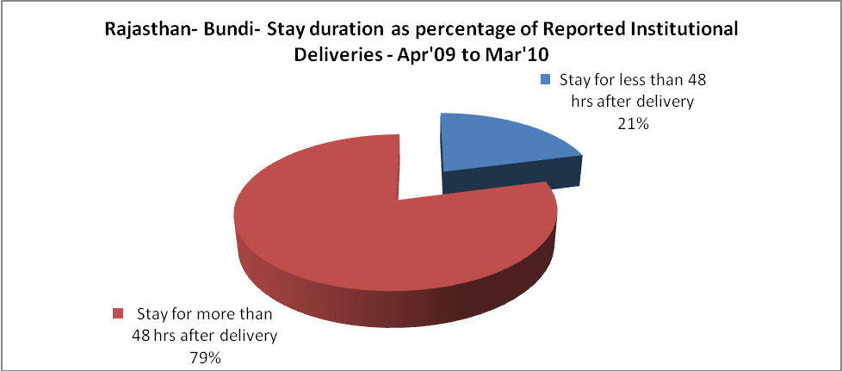

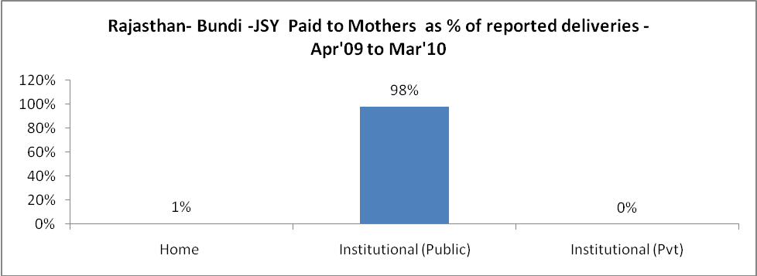

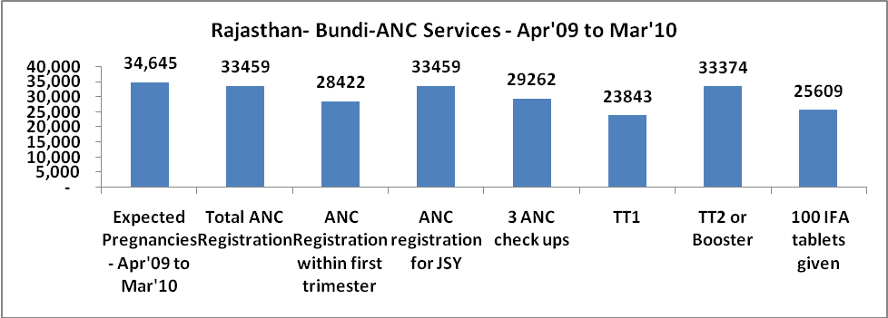

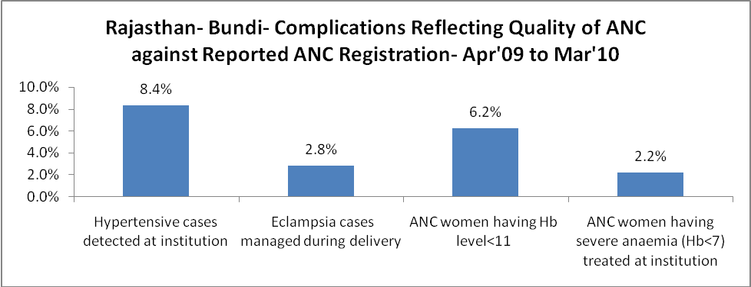
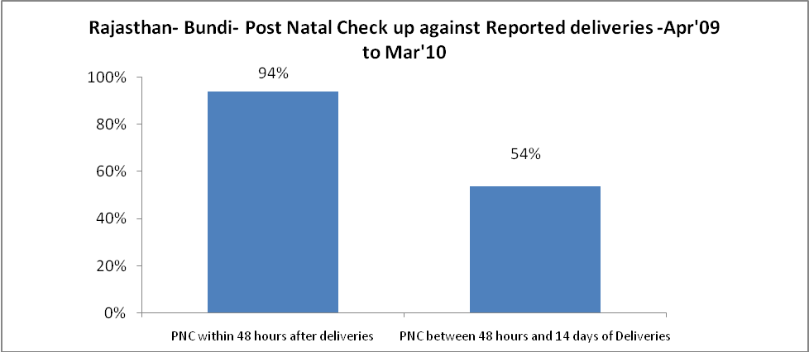
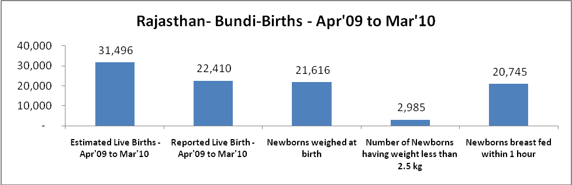

Rajasthan- Bundi - Births - Apr'09 to Mar'10
Live Birth - Males | Live Birth - females | Live Birth - Total | Sex Ratio at birth | Still Birth | Abortion( Induced/Spontaneous
11,682 | 10,728 | 22,410 | 918 | 363 | 612

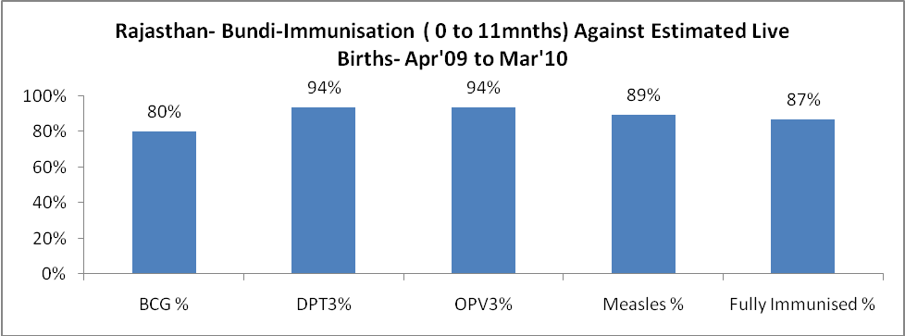

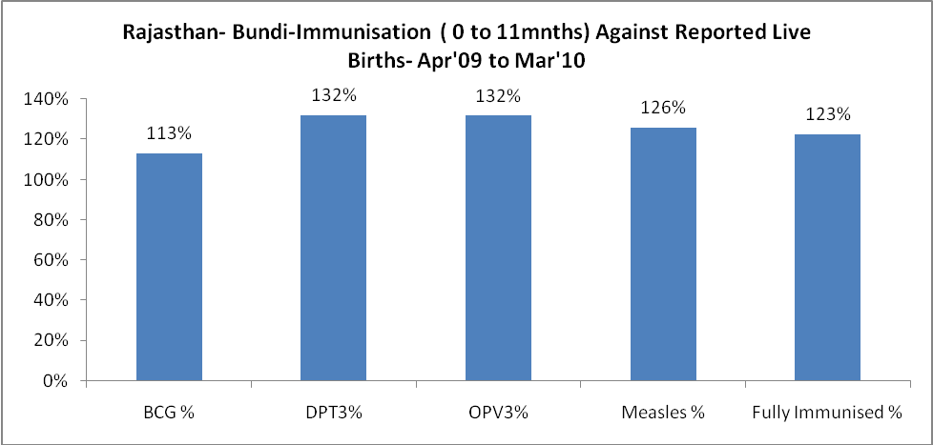

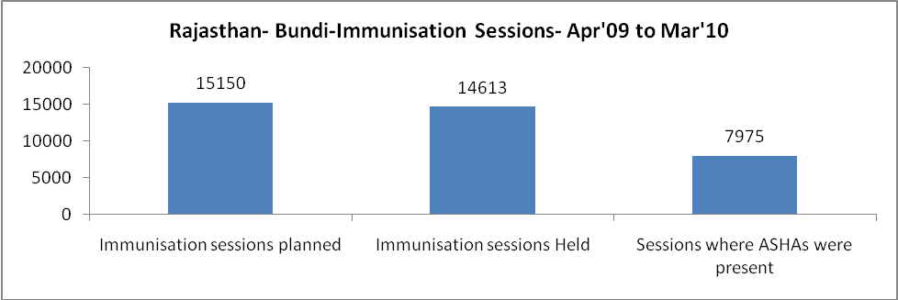

Rajasthan- Bundi- Apr'09 to Mar'10
Total Abortions | Abortion Rate
1,357 | 3.9%

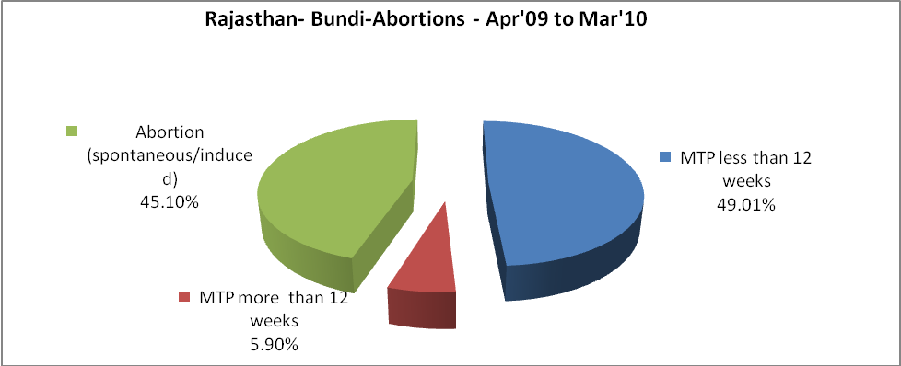

Rajasthan- Bundi- Apr'09 to Mar'10
Total OPD | Total RTI/STI cases
525,475 | 2,548

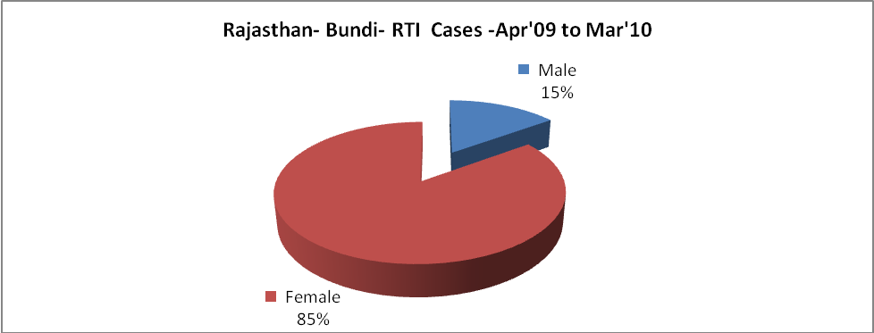
Rajasthan- Bundi-Sterilisations - Apr'09 to Mar'10
 | Reported | %age of Reported Sterilisation
Total Sterilisation | 5,797 | -
NSV | 86 | 1%
Laproscopic | 5,659 | 98%
MiniLap | - | 0%
Post Partum | 52 | 1%
Male Sterilisation | 86 | 1%
Female Sterilisation | 5,711 | 99%

Rajasthan- Bundi-FP Methods - Apr'09 to Mar'10
 | Reported | %age of All Reported FP Methods
Total Reported FP Methodd (All types) Users | 74,059 | -
Sterilisations | 5,797 | 8%
IUD | 7,213 | 10%
Condom Users | 39,524 | 53%
OCP Users | 21,525 | 29%
Limiting Methods | 5,797 | 8%
Spacing Methods | 68,262 | 92%

Rajasthan- Bundi- Service Delivery - Apr'09 to Mar'10
Operation major (General and spinal anaesthesia) | Operation minor (No or local anaesthesia) | AYUSH | Dental Procedures | Adolescent counselling services | Total OPD | Total IPD
828 | 4,095 | 31,747 | 842 | 675 | 525,475 | 37,369
Operation major (General and spinal anaesthesia) as %ge of OPD | Operation minor (No or local anaesthesia)as %ge of OPD | AYUSH as %ge of OPD | Dental Procedures as %ge of OPD | Adolescent counselling services as %ge of OPD | IPD as percentage of OPD
0.2% | 0.8% | 6.0% | 0.2% | 0.1% | 7%

Rajasthan- Bundi- Lab Services - Apr'09 to Mar'10
Total OPD | Total HB tested | Total HIV Tested | Total Population
525,475 | 10,134 | 2,712 | 1,145,300
HB test conducted as %age of OPD | HB<7gm as %age of HB tested | HIV test conducted as %age of OPD | HIV positive as %age of HIV tested | Blood Smear Examined as % of Population
1.9% | 14.2% | 0.5% | 0.3% | 7.2%

Rajasthan- Bundi- Childhood Disease - Vaccine Preventable -Apr'09 to Mar'10
Diphtheria | Pertussis | Tetanus Neonatorum | Tetanus others | Polio | Measles
0 | 0 | 1 | 9 | 0 | 100
Rajasthan- Bundi-Childhood Disease - Others - Apr'09 to Mar'10
Diarrhoea and dehydration | Malaria | Number admitted with Respiratory Infections
4,006 | 380 | 3,236

Rajasthan- Bundi- Infant & Child Deaths - Apr'09 to Mar'10
Infant Deaths within 24 hrs of birth | Infant Deaths between 24hrs & under 1 week | Infant Deaths between 1 week & under 1 month | Child Deaths between 1 month & under 1 year | Child Deaths between 1yr under 5years | Total Deaths
37 | 34 | 23 | 90 | 45 | 229

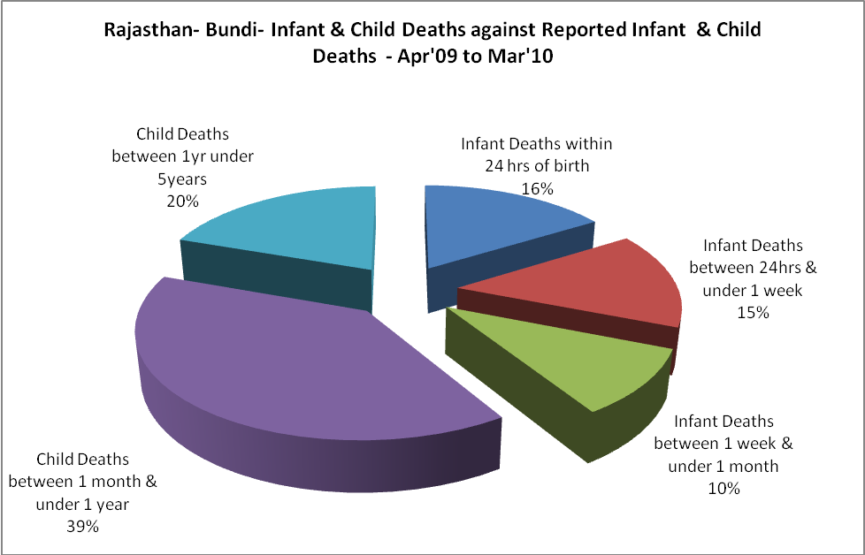

Rajasthan- Bundi- Causes of Infant & Child Deaths - Apr'09 to Mar'10
Sepsis |  |  | Asphyxia |  |  | LBW
Up to 1 Weeks of Birth | Between 1 week & 4 weeks of birth | Total | Up to 1 Weeks of Birth | Between 1 week & 4 weeks of birth | Total | Up to 1 Weeks of Birth | Between 1 week & 4 weeks of birth | Total
3 | 0 | 3 | 1 | 1 | 2 | 5 | 2 | 7
Pneumonia |  |  | Diarrhoea |  |  | Fever related
Between 1 month and 11 months | Between 1 year & 5 years | Total | Between 1 month and 11 months | Between 1 year & 5 years | Total | Between 1 month and 11 months | Between 1 year & 5 years | Total
3 | 2 | 5 | 5 | 2 | 7 | 3 | 4 | 7
Others |  |  | Measles |  |  | Others
Up to 1 Weeks of Birth | Between 1 week & 4 weeks of birth | Total | Between 1 month and 11 months | Between 1 year & 5 years | Total | Between 1 month and 11 months | Between 1 year & 5 years | Total
25 | 20 | 45 | 0 | 0 | 0 | 79 | 37 | 116

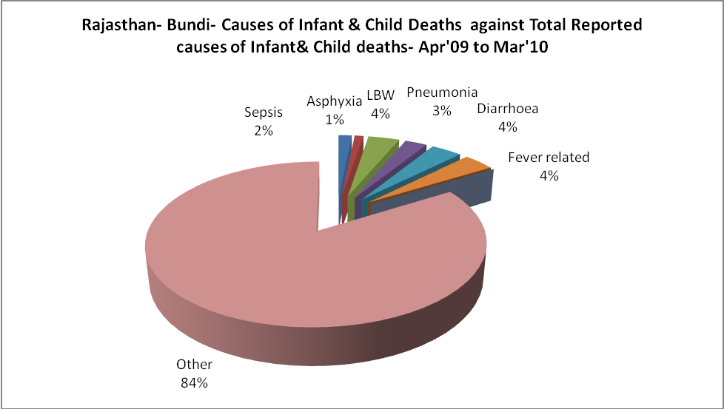

Rajasthan- Bundi- Maternal Deaths & Causes - Apr'09 to Mar'10
Abortion |  |  | Obstructed/prolonged labour |  |  | Severe hypertesnion/fits
6-14 yrs | 15-55 yrs. | Total | 6-14 yrs | 15-55 yrs. | Total | 6-14 yrs | 15-55 yrs. | Total
0 | 3 | 3 | 0 | 1 | 1 | 0 | 0 | 0
Bleeding |  |  | High Fever |  |  | Other Causes
6-14 yrs | 15-55 yrs. | Total | 6-14 yrs | 15-55 yrs. | Total | 6-14 yrs | 15-55 yrs. | Total
0 | 0 | 0 | 0 | 0 | 0 | 3 | 8 | 11

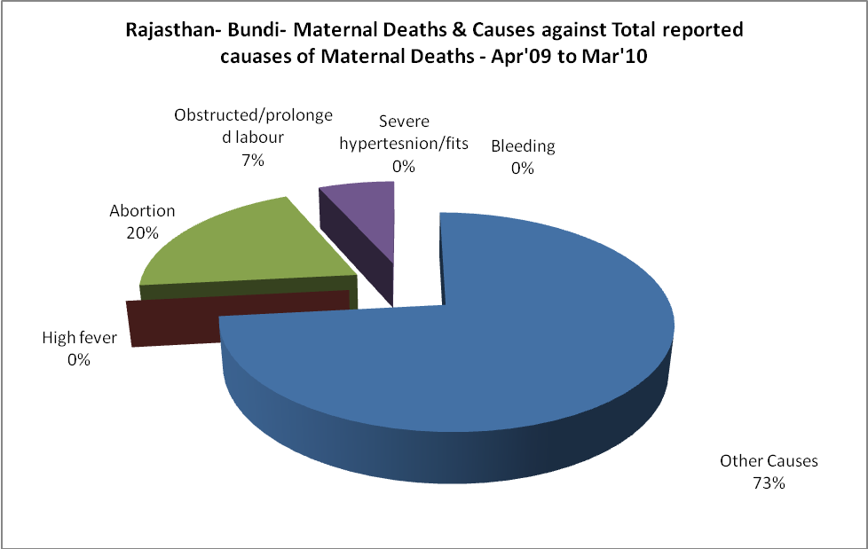

Rajasthan- Bundi-Causes of Deaths in 6 to 55yrs age group - Apr'09 to Mar'10
Diarrhoel Diseases |  |  |  | Tuberculosis |  |  |  | Respiratory Diseases( Other than TB)
6-14 yrs | 15-55 yrs. | Above 55yrs | Total | 6-14 yrs | 15-55 yrs. | Above 55yrs | Total | 6-14 yrs | 15-55 yrs. | Above 55yrs | Total
11 | 15 | 5 | 31 | 0 | 5 | 8 | 13 | 1 | 11 | 23 | 35
Malaria |  |  |  | Other fever Related |  |  |  | HIV/Aids
6-14 yrs | 15-55 yrs. | Above 55yrs | Total | 6-14 yrs | 15-55 yrs. | Above 55yrs | Total | 6-14 yrs | 15-55 yrs. | Above 55yrs | Total
0 | 1 | 0 | 1 | 21 | 9 | 19 | 49 | 0 | 0 | 0 | 0
Heart Disease/Hypertenion related |  |  |  | Neurological Disease including strokes |  |  |  | Trauma/Accidents/ Burn Cases
6-14 yrs | 15-55 yrs. | Above 55yrs | Total | 6-14 yrs | 15-55 yrs. | Above 55yrs | Total | 6-14 yrs | 15-55 yrs. | Above 55yrs | Total
2 | 8 | 9 | 19 | 12 | 3 | 2 | 17 | 2 | 7 | 6 | 15
Suicide |  |  |  | Animal Bites & Stings
6-14 yrs | 15-55 yrs. | Above 55yrs | Total | 6-14 yrs | 15-55 yrs. | Above 55yrs | Total
0 | 1 | 0 | 1 | 1 | 2 | 2 | 5

