NHSRC
Himachal Pradesh-Chamba District
Analysis 2009-10

7/22/2010

Chamba Dist.- Summary-Apr'09 to Mar'10
ANC
ANC Registration against Expected Pregnancies | 115% | TT1 given to Pregnant women against ANC Registration | 62%
3 ANC Check ups against ANC Registrations | 65% | 100 IFA Tablets given to Pregnant women against ANC Registration | 75%
Deliveries
Unreported Deliveries against Estimated Deliveries | 12.6% | HOME Deliveries( SBA& Non SBA) against Estimated Deliveries | 58.8%
Institutional Deliveries against Estimated Deliveries | 28.6% | HOME Deliveries( SBA& Non SBA) against Reported Deliveries | 67.3%
Institutional Deliveries against Reported Deliveries | 32.7% | C Section Deliveries against Institutional Deliveries( Pvt & Pub) | 12%
Births & Neonates Care
Live Births Reported against Estimated Live Births | 88% | New borns weighed against Reported Live Births | 92%
Still Births (Reported) | 117 | New borns weighed less than 2.5 kgs against newborns weighed | 5%
Sex Ratio at Birth | 906 | New borns breastfed within one hr of Birth against Reported live Births | 51%
Child Immunization( 0 to 11 months)
BCG given against Expected Live Births | 112% | Measles given against Expected Live Births | 105%
OPV3 given against Expected Live Births | 109% | Fully Immunized Children against Expected Live Births | 105%
DPT3 given against Expected Live Births | 109%
Family Planning
Family Planning Methods Users ( Sterilizations(Male &Female)+IUD+ Condom pieces/72 + OCP Cycles/13) | 14,709 | IUD Insertions against reported FP Methods | 10%
Sterilization against reported FP Methods | 13% | Condom Users against reported FP Methods | 62%
 |  | OCP Users against reported FP Methods | 14%
Other Services
OPD | 521,512 | Major Operations | 2,519
IPD | 13,659 | Minor Operations | 1,435

Chamba Dist.- Deliveries Apr'09 to Mar'10
Total Population | 508,212 | Expected Deliveries |  | 9,193
Home SBA | Home Non SBA | Institutional | Total Deliveries Reported | Unreported Deliveries
781 | 4,622 | 2,631 | 8,034 | 1,159
Home SBA % | Home Non SBA% | Institutional % | Total Deliveries Reported % | Unreported Deliveries %
8% | 50% | 29% | 87% | 13%

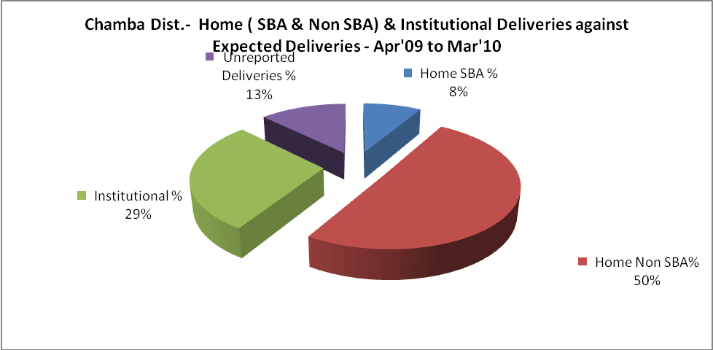
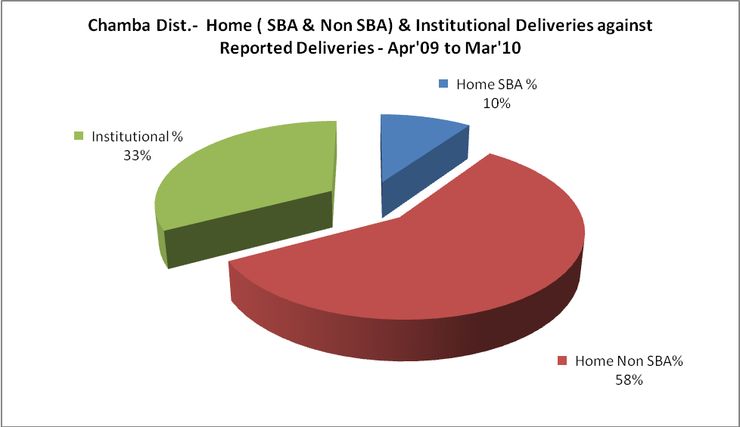

Chamba Dist.- C sections & Complicated Deliveries Apr'09 to Mar'10
 | Institutional Deliveries (Public) | Institutional Deliveries (Pvt)
 | 2,325 | 306
C Section | 174 | 14
C Section% | 7% | 5%
Complicated Pregnancies attended | 187 | -
Complicated Pregnancies attended % | 8% | 0%

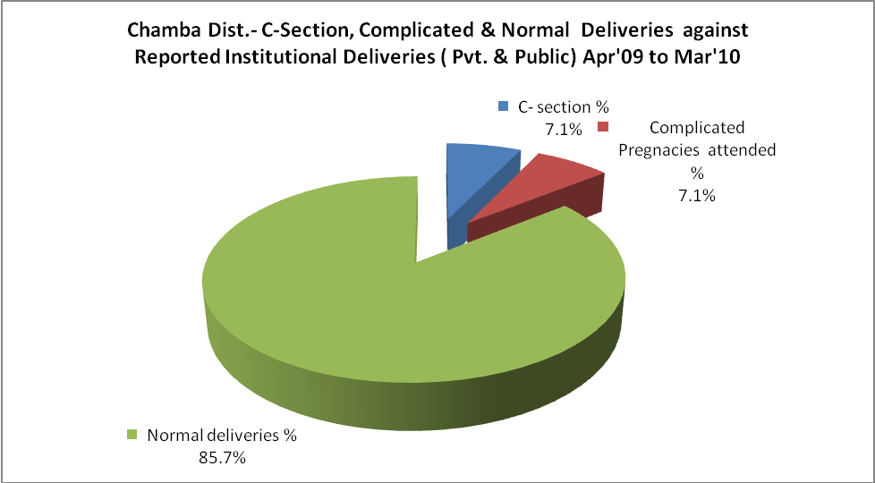

Chamba Dist.- Complicated Pregnancies & Deliveries Treated - Apr'09 to Mar'10
Reported Deliveries |  |  | Reported ANC Registration
8,034 |  |  | 11,390
Complicated Pregnancies attended | Complicated Pregnancies Rate | C - Section Deliveries | PNC Maternal Complications | Abortions | Still Births
187 | 2% | 188 | 1 | 114 | 117
Complicated Deliveries Treated with |  |  |  | No Of Eclampsia cases Treated | No Of severe anemia cases treated
IV Antibiotics | IV antihypertensive/Magsulph injection | IV Oxytocis | Blood Transfusion | No Of Eclampsia cases Treated | No Of severe anemia cases treated
141 | 17 | 6 | - | 5 | 163

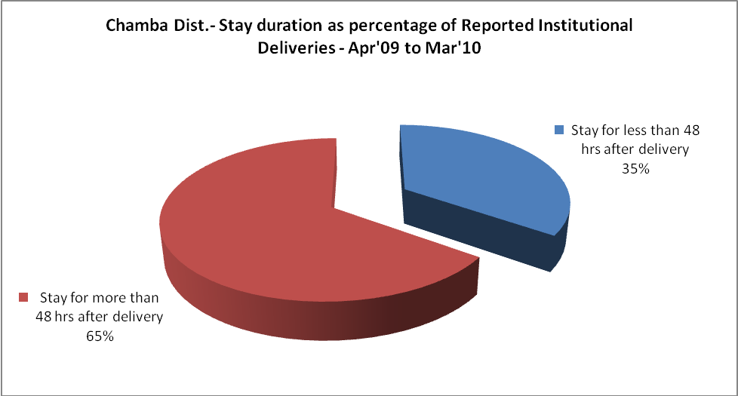
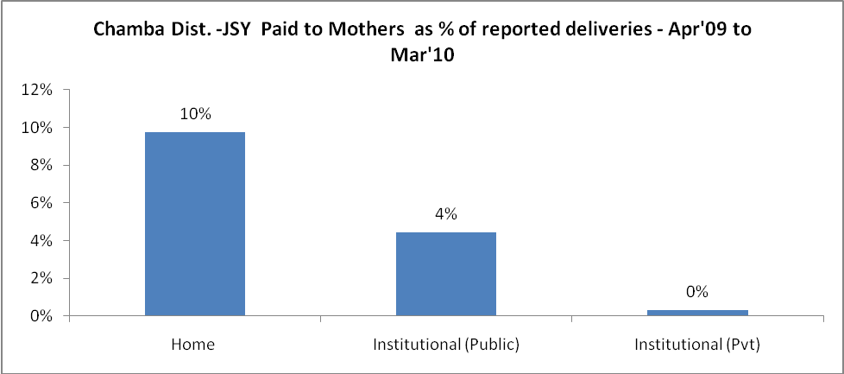
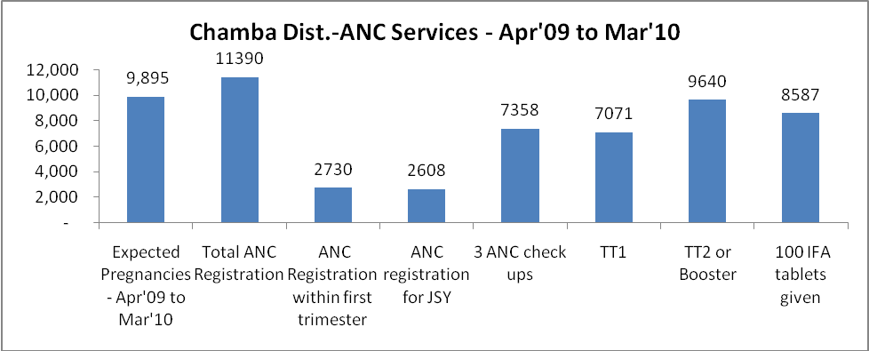
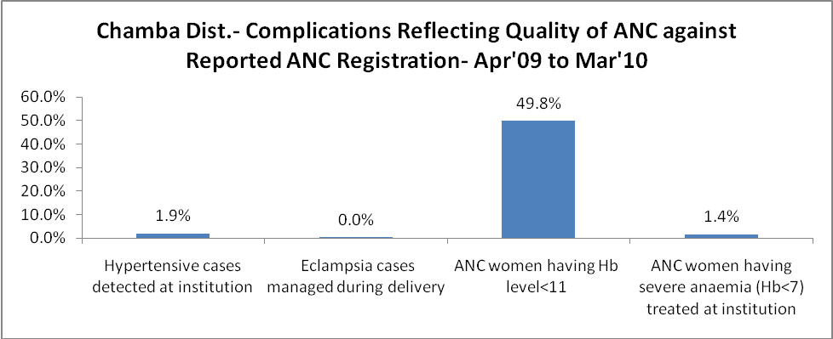
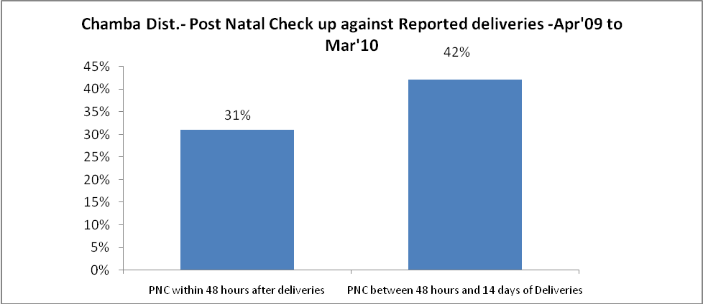

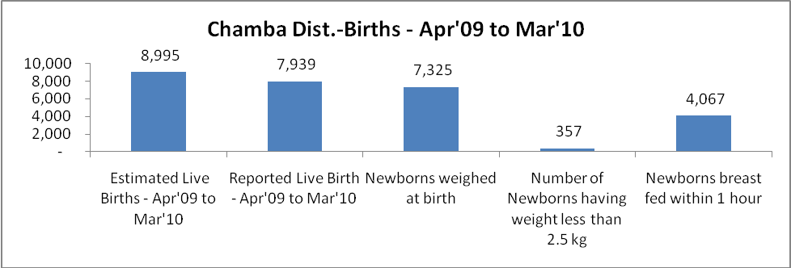

Chamba Dist. - Births - Apr'09 to Mar'10
Live Birth - Males | Live Birth - females | Live Birth - Total | Sex Ratio at birth | Still Birth | Abortion( Induced/Spontaneous
4,165 | 3,774 | 7,939 | 906 | 117 | 114

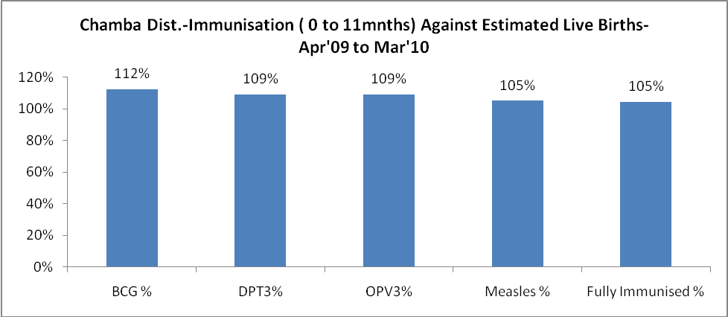

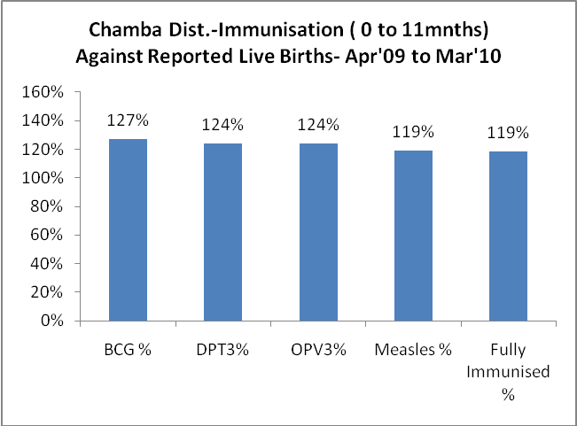
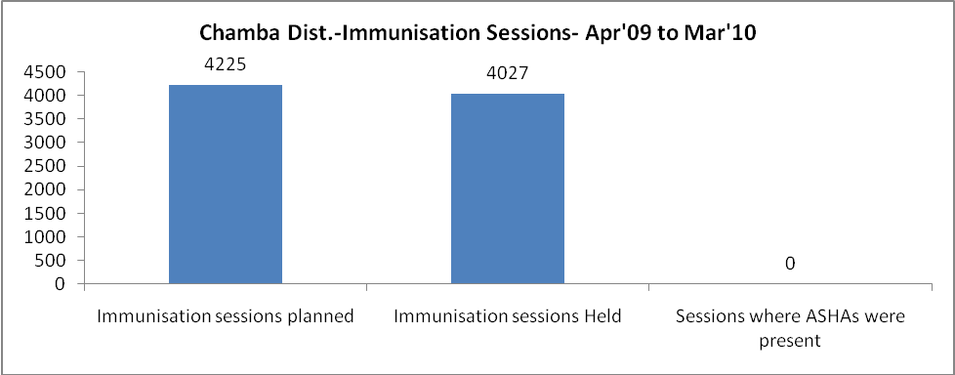
Chamba Dist.- Apr'09 to Mar'10
Total Abortions | Abortion Rate
135 | 1.4%

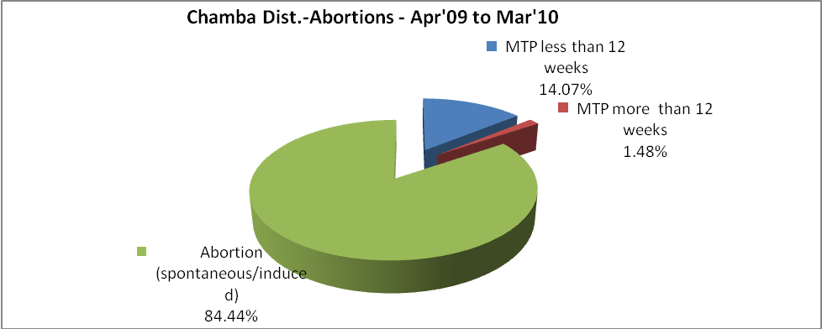
Chamba Dist.- Apr'09 to Mar'10
Total OPD | Total RTI/STI cases
521,512 | 3,097

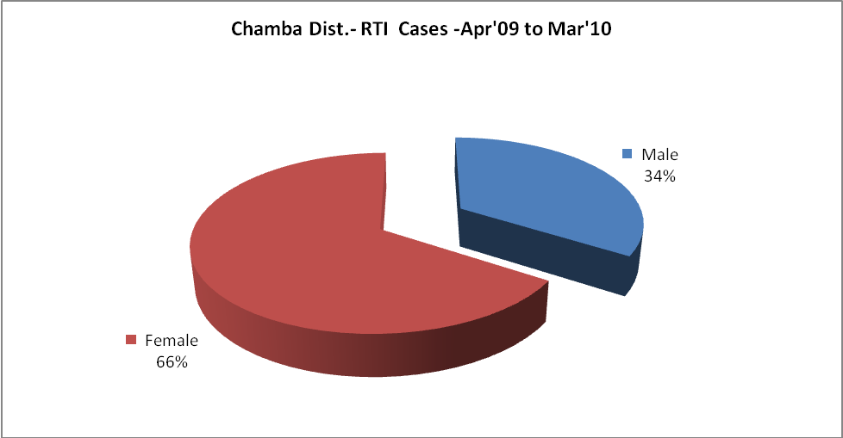

Chamba Dist.-Sterilizations - Apr'09 to Mar'10
 | Reported | %age of Reported Sterilization
Total Sterilization | 1,958 | -
NSV | 1,159 | 59%
Laproscopic | 790 | 40%
MiniLap | 9 | 0%
Post Partum | - | 0%
Male Sterilization | 1,159 | 59%
Female Sterilization | 799 | 41%

Chamba Dist.-FP Methods - Apr'09 to Mar'10
 | Reported | %age of All Reported FP Methods
Total Reported FP Method (All types) Users | 14,709 | -
Sterilizations | 1,958 | 13%
IUD | 1,501 | 10%
Condom Users | 9,164 | 62%
OCP Users | 2,086 | 14%
Limiting Methods | 1,958 | 13%
Spacing Methods | 12,751 | 87%

Chamba Dist.- Service Delivery - Apr'09 to Mar'10
Operation major (General and spinal anaesthesia) | Operation minor (No or local anaesthesia) | AYUSH | Dental Procedures | Adolescent counseling services | Total OPD | Total IPD
2,519 | 1,435 | 6 | 1,739 | 1,553 | 521,512 | 13,659
Operation major (General and spinal anaesthesia) as %ge of OPD | Operation minor (No or local anaesthesia)as %ge of OPD | AYUSH as %ge of OPD | Dental Procedures as %ge of OPD | Adolescent counseling services as %ge of OPD | IPD as percentage of OPD
0.5% | 0.3% | 0.0% | 0.3% | 0.3% | 3%

Chamba Dist.- Lab Services - Apr'09 to Mar'10
Total OPD | Total HB tested | Total HIV Tested | Total Population
521,512 | 18,396 | 1,145 | 508,212
HB test conducted as %age of OPD | HB<7gm as %age of HB tested | HIV test conducted as %age of OPD | HIV positive as %age of HIV tested | Blood Smear Examined as % of Population
3.5% | 4.3% | 0.2% | 0.2% | 2.0%

Chamba Dist.- Childhood Disease - Vaccine Preventable -Apr'09 to Mar'10
Diphtheria | Pertussis | Tetanus Neonatorum | Tetanus others | Polio | Measles
0 | 0 | 0 | 0 | 0 | 0
Chamba Dist.-Childhood Disease - Others - Apr'09 to Mar'10
Diarrhoea and dehydration | Malaria | Number admitted with Respiratory Infections
4,428 | - | 4,117
Chamba Dist.- Infant & Child Deaths - Apr'09 to Mar'10
Infant Deaths within 24 hrs of birth | Infant Deaths under 1 week | Infant Deaths under 1 month | Child Deaths under 1 year | Child Deaths under 5years | Total Deaths
3 | 47 | 66 | 131 | 176 | 423

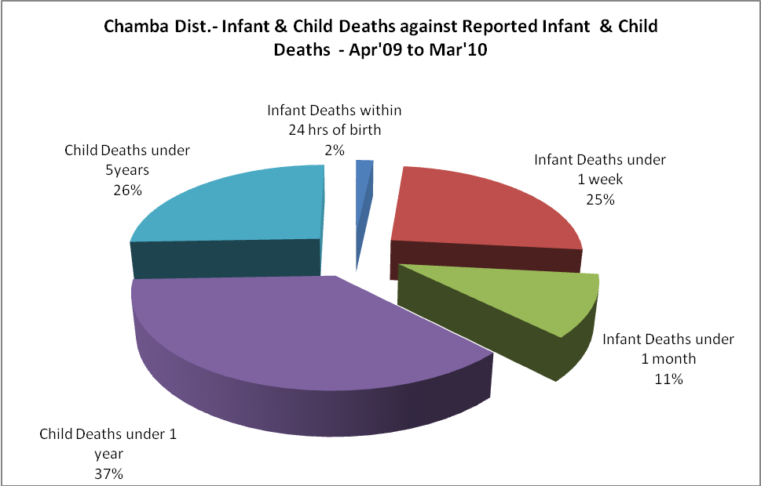

Chamba Dist.- Causes of Infant & Child Deaths - Apr'09 to Mar'10
Sepsis |  |  | Asphyxia |  |  | LBW
Up to 1 Weeks of Birth | Between 1 week & 4 weeks of birth | Total | Up to 1 Weeks of Birth | Between 1 week & 4 weeks of birth | Total | Up to 1 Weeks of Birth | Between 1 week & 4 weeks of birth | Total
6 | 1 | 7 | 5 | 4 | 9 | 6 | 2 | 8
Pneumonia |  |  | Diarrhoea |  |  | Fever related
Between 1 month and 11 months | Between 1 year & 5 years | Total | Between 1 month and 11 months | Between 1 year & 5 years | Total | Between 1 month and 11 months | Between 1 year & 5 years | Total
16 | 10 | 26 | 2 | 1 | 3 | 8 | 7 | 15
Others |  |  | Measles |  |  | Others
Up to 1 Weeks of Birth | Between 1 week & 4 weeks of birth | Total | Between 1 month and 11 months | Between 1 year & 5 years | Total | Between 1 month and 11 months | Between 1 year & 5 years | Total
27 | 15 | 42 | 0 | 0 | 0 | 39 | 27 | 66

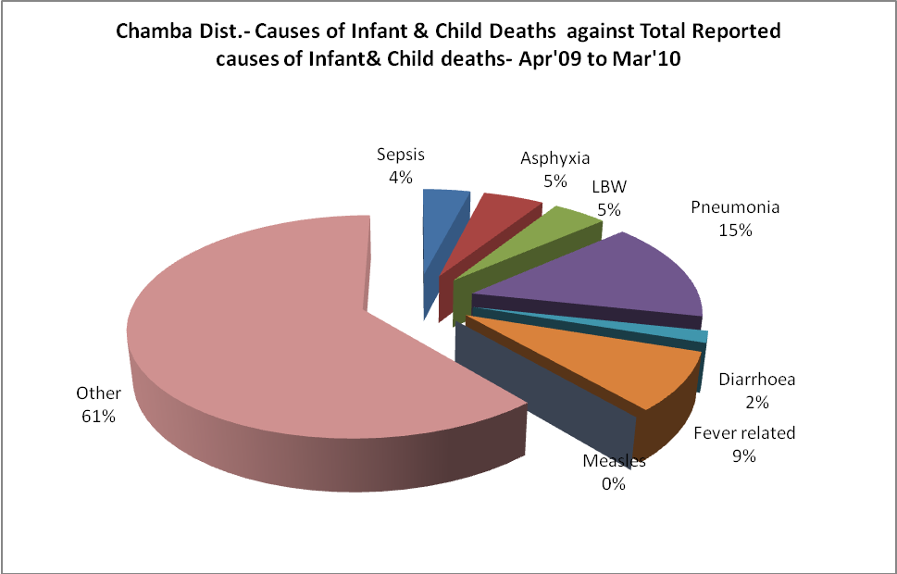

Chamba Dist.- Maternal Deaths & Causes - Apr'09 to Mar'10
Abortion |  |  | Obstructed/prolonged labour |  |  | Severe hypertension/fits
6-14 yrs | 15-55 yrs. | Total | 6-14 yrs | 15-55 yrs. | Total | 6-14 yrs | 15-55 yrs. | Total
0 | 0 | 0 | 0 | 1 | 1 | 0 | 4 | 4
Bleeding |  |  | High Fever |  |  | Other Causes
6-14 yrs | 15-55 yrs. | Total | 6-14 yrs | 15-55 yrs. | Total | 6-14 yrs | 15-55 yrs. | Total
0 | 5 | 5 | 0 | 0 | 0 | 0 | 1 | 1

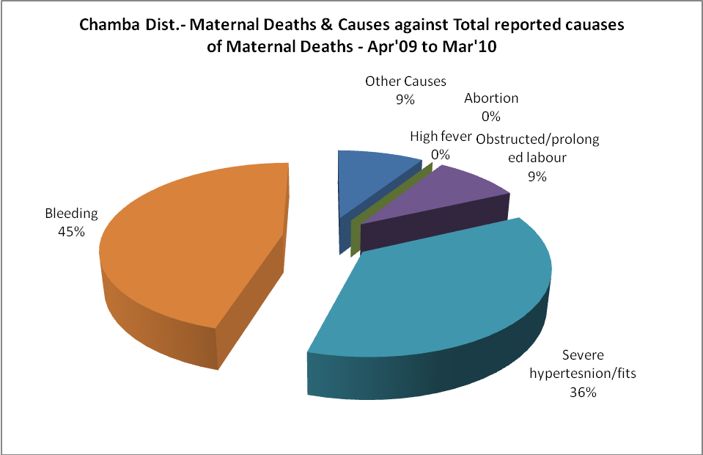
Chamba Dist.-Causes of Deaths in 6 to 55yrs age group - Apr'09 to Mar'10
Diarrhoel Diseases |  |  |  | Tuberculosis |  |  |  | Respiratory Diseases( Other than TB)
6-14 yrs | 15-55 yrs. | Above 55yrs | Total | 6-14 yrs | 15-55 yrs. | Above 55yrs | Total | 6-14 yrs | 15-55 yrs. | Above 55yrs | Total
11 | 4 | 9 | 24 | 1 | 9 | 6 | 16 | 0 | 17 | 53 | 70
Malaria |  |  |  | Other fever Related |  |  |  | HIV/Aids
6-14 yrs | 15-55 yrs. | Above 55yrs | Total | 6-14 yrs | 15-55 yrs. | Above 55yrs | Total | 6-14 yrs | 15-55 yrs. | Above 55yrs | Total
0 | 1 | 1 | 2 | 0 | 5 | 13 | 18 | 0 | 1 | 0 | 1
Heart Disease/Hypertenion related |  |  |  | Neurological Disease including strokes |  |  |  | Trauma/Accidents/ Burn Cases
6-14 yrs | 15-55 yrs. | Above 55yrs | Total | 6-14 yrs | 15-55 yrs. | Above 55yrs | Total | 6-14 yrs | 15-55 yrs. | Above 55yrs | Total
4 | 37 | 36 | 77 | 7 | 5 | 8 | 20 | 14 | 99 | 19 | 132
Suicide |  |  |  | Animal Bites & Stings
6-14 yrs | 15-55 yrs. | Above 55yrs | Total | 6-14 yrs | 15-55 yrs. | Above 55yrs | Total
0 | 7 | 2 | 9 | 1 | 5 | 4 | 10

