[NHSRC]
Delhi-Central
[ Analysis 2009-10]

Delhi - Central- Summary-Apr'09 to Mar'10
ANC
ANC Registration against Expected Pregnancies |  |  | 621% |  | TT1 given to Pregnant women against ANC Registraion |  |  | 16%
3 ANC Check ups against ANC Reigtrations |  |  | 8% |  | 100 IFA Tablets given to Pregnant women against ANC Registraion |  |  | 21%
Deliveries
Unreported Deliveries against Estimated Deliveries |  |  | -53.5% |  | HOME Deliveries( SBA& Non SBA) against Estimated Deliveries |  |  | 0.0%
Institutional Deliveries against Estimated Deliveries |  |  | 153.5% |  | HOME Deliveries( SBA& Non SBA) against Reported Deliveries |  |  | 0.0%
Institutional Deliveries against Reported Deliveries |  |  | 100.0% |  | C Section Deliveries against Institutional Deliveries( Pvt & Pub) |  |  | 25%
Births & Neonates Care
Live Births Reported against Estimated Live Births |  |  | 154% |  | New borns weighed against Reported Live Births |  |  | 96%
Still Births (Reported) |  |  | 439 |  | New borns weighed less than 2.5 kgs against newborns weighed |  |  | 23%
Sex Ratio at Birh |  |  | 888 |  | New borns breastfed within one hr of Birth against Reported live Births |  |  | 9%
Child Immunisation( 0 to 11 mnths)
BCG given against Expected Live Births |  |  | 135% |  | Measles given against Expected Live Births |  |  | 71%
OPV3 given against Expected Live Births |  |  | 71% |  | Fully Immunised Children against Expected Live Births |  |  | 71%
DPT3 given against Expected Live Births |  |  | 71%
Family Planing
Family Plannig Methods Users ( Sterilisations(Male &Female)+IUD+ Condom pieces/72 + OCP Cycles/13) |  |  | 17,582 |  | IUD Insertions against reported FP Methods |  |  | 12%
Sterilisation against reported FP Methods |  |  | 26% |  | Condom Users against reported FP Methods |  |  | 58%
 |  |  |  |  | OCP Users against reported FP Methods |  |  | 4%
Other Services
OPD |  |  | 1,454,884 |  | Major Operations |  |  | 7,290
IPD |  |  | 77,677 |  | Minor Operations |  |  | 7,935
Delhi - Central- Deliveries Apr'09 to Mar'10
Total Population | 781,327 | Expected Deliveries |  |  |  | 14,628
Home SBA | Home Non SBA | Institutional |  | Total Deliveries Reported |  | Unreported Deliveries
- | - | 22,458 |  | 22,458 |  | (7,830)
Home SBA % | Home Non SBA% | Institutional % |  | Total Deliveries Reported % |  | Unreported Deliveries %
0% | 0% | 154% |  | 154% |  | -54%

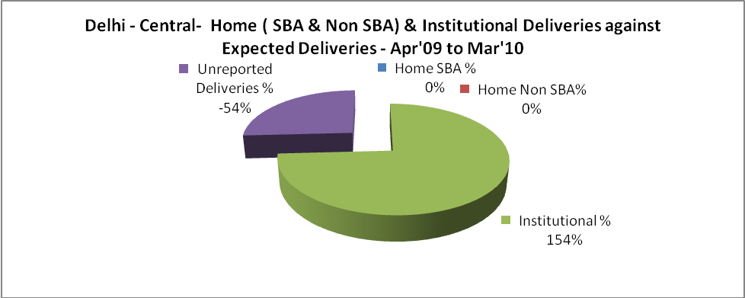

Delhi - Central- C sections & Complicated Deliveries Apr'09 to Mar'10
 | Institutional Deliveries (Public) | Institutional Deliveries (Pvt)
 | 22,458 | -
C Section | 3,937 | 1,606
C Section% | 18% | -
Complicated Pregnacies attended | 5,654 | 130
Complicated Pregnacies attended % | 25% | -

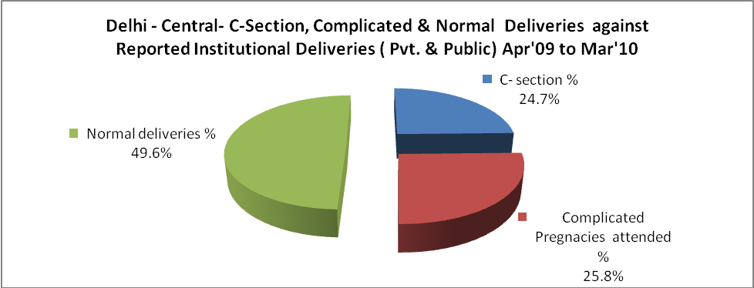

Delhi - Central- Complicated Pregnancies & Deliveries Treated - Apr'09 to Mar'10
Reported Deliveries |  |  | Reported ANC Reigtration
22,458 |  |  | 98,217
Complicated Pregnancies attended | Complicated Pregnancies Rate | C - Section Deliveries | PNC Maternal Complications | Abortions | Still Births
5,784 | 37% | 5,543 | 143 | 4,958 | 439
Complicated Deliveries Treated with |  |  |  | No Of Eclampsia cases Treated | No Of severe anemia cases treated
IV Antibiotics | IV antihypertensive/Magsulph injection | IV Oxytocis | Blood Transfusion | No Of Eclampsia cases Treated | No Of severe anemia cases treated
5,798 | 55 | 4,667 | 724 | 35 | 273

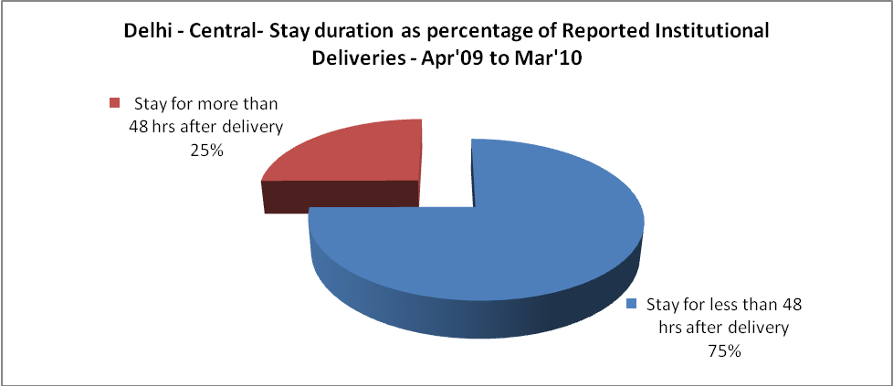

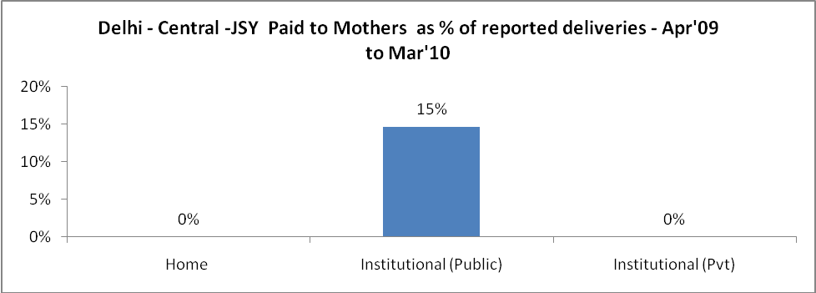

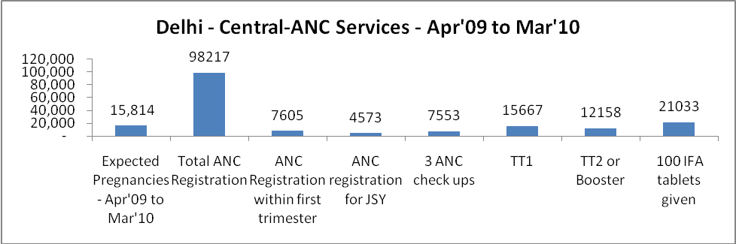

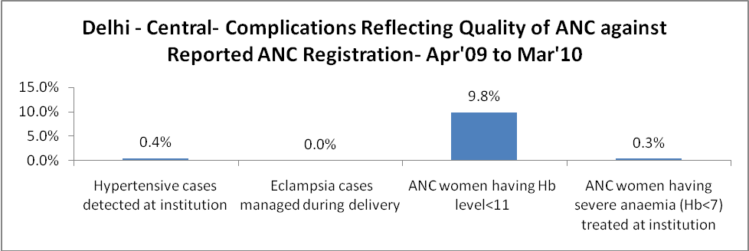

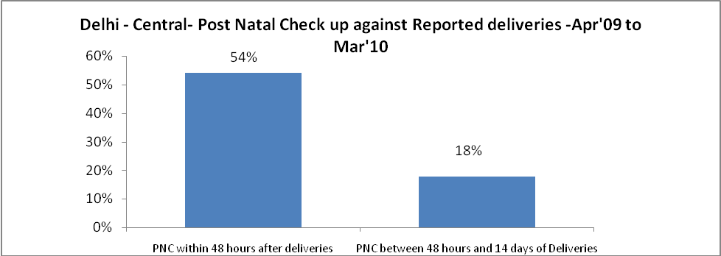

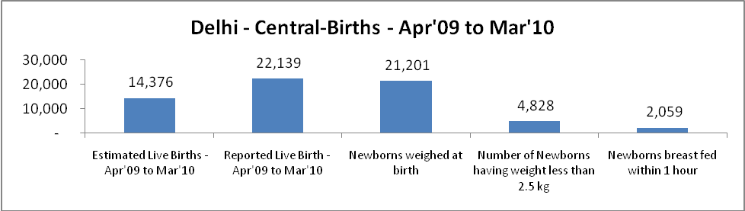

Delhi - Central - Births - Apr'09 to Mar'10
Live Birth - Males | Live Birth - females | Live Birth - Total | Sex Ratio at birth | Still Birth | Abortion( Induced/Spontaneous
11,728 | 10,411 | 22,139 | 888 | 439 | 4,958

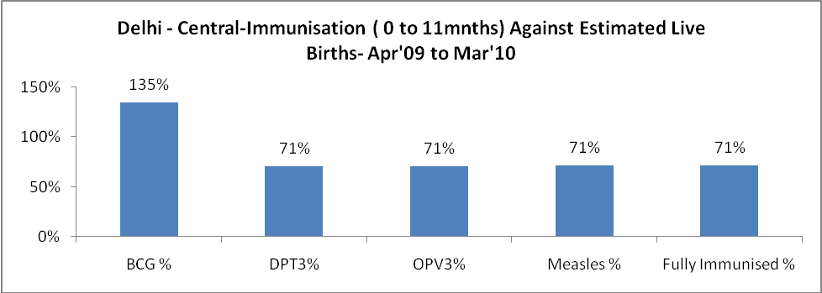

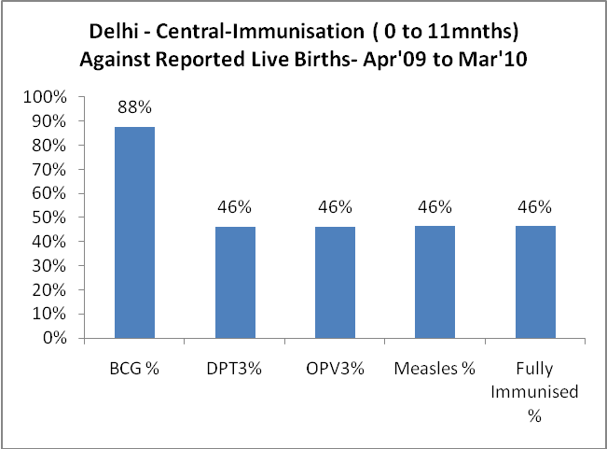

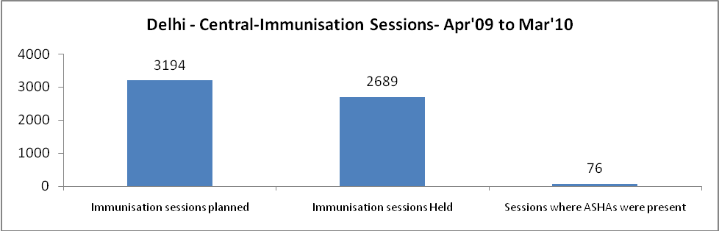

Delhi - Central- Apr'09 to Mar'10
Total Abortions | Abortion Rate
6,542 | 41.4%

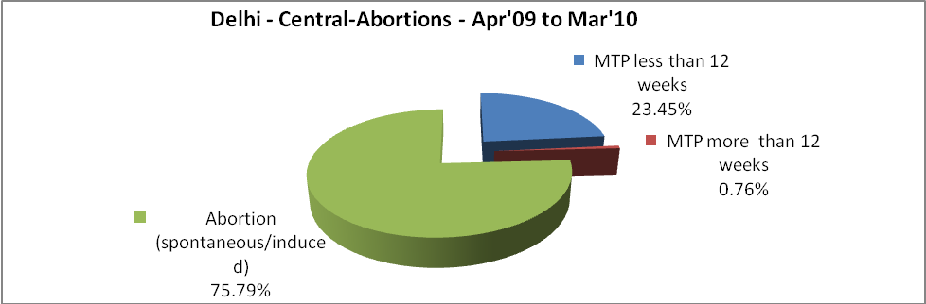

Delhi - Central- Apr'09 to Mar'10
Total OPD | Total RTI/STI cases
1,454,884 | 8,613

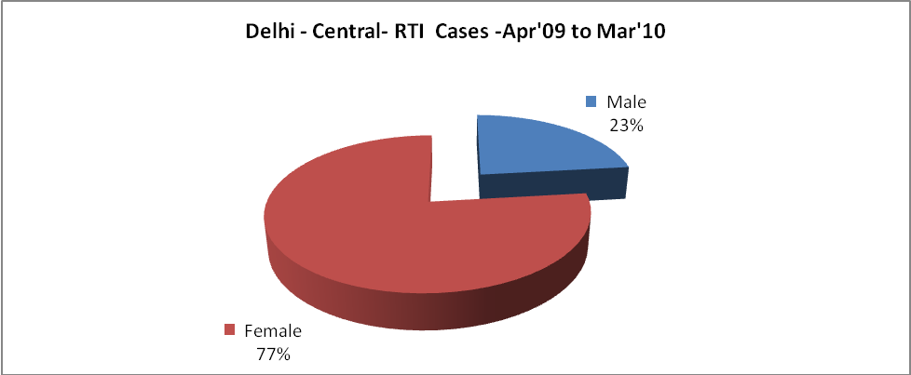

Delhi - Central-Sterilisations - Apr'09 to Mar'10
 | Reported | %age of Reported Sterilisation
Total Sterilisation | 4,619 | -
NSV | 2,092 | 45%
Laproscopic | 2,343 | 51%
MiniLap | 82 | 2%
Post Partum | 102 | 2%
Male Sterilisation | 2,092 | 45%
Female Sterilisation | 2,527 | 55%

Delhi - Central-FP Methods - Apr'09 to Mar'10
 | Reported | %age of All Reported FP Methods
Total Reported FP Methodd (All types) Users | 17,582 | -
Sterilisations | 4,619 | 26%
IUD | 2,073 | 12%
Condom Users | 10,212 | 58%
OCP Users | 678 | 4%
Limiting Methods | 4,619 | 26%
Spacing Methods | 12,963 | 74%

Delhi - Central- Service Delivery - Apr'09 to Mar'10
Operation major (General and spinal anaesthesia) | Operation minor (No or local anaesthesia) | AYUSH | Dental Procedures | Adolescent counselling services | Total OPD | Total IPD
7,290 | 7,935 | 73,979 | 1,539 | 172 | 1,454,884 | 77,677
Operation major (General and spinal anaesthesia) as %ge of OPD | Operation minor (No or local anaesthesia)as %ge of OPD | AYUSH as %ge of OPD | Dental Procedures as %ge of OPD | Adolescent counselling services as %ge of OPD | IPD as percentage of OPD
0.5% | 0.5% | 5.1% | 0.1% | 0.0% | 5%

Delhi - Central- Lab Services - Apr'09 to Mar'10
Total OPD | Total HB tested | Total HIV Tested | Total Population
1,454,884 | 166,678 | 28,492 | 781,327
HB test conducted as %age of OPD | HB<7gm as %age of HB tested | HIV test conducted as %age of OPD | HIV positive as %age of HIV tested | Blood Smear Examined as % of Population
11.5% | 10.2% | 2.0% | 1.5% | 2.9%

Delhi - Central- Childhood Disease - Vaccine Preventable -Apr'09 to Mar'10
Diphtheria | Pertussis | Tetanus Neonatorum | Tetanus others | Polio | Measles
0 | 0 | 0 | 0 | 0 | 0
Delhi - Central-Childhood Disease - Others - Apr'09 to Mar'10
Diarrhoea and dehydration | Malaria | Number admitted with Respiratory Infections
6,763 | 5 | 7,723

Delhi - Central- Infant & Child Deaths - Apr'09 to Mar'10
Infant Deaths within 24 hrs of birth | Infant Deaths between 24hrs & under 1 week | Infant Deaths between 1 week & under 1 month | Child Deaths between 1 month & under 1 year | Child Deaths between 1yr under 5years | Total Deaths
1 | 241 | 101 | 40 | 40 | 423

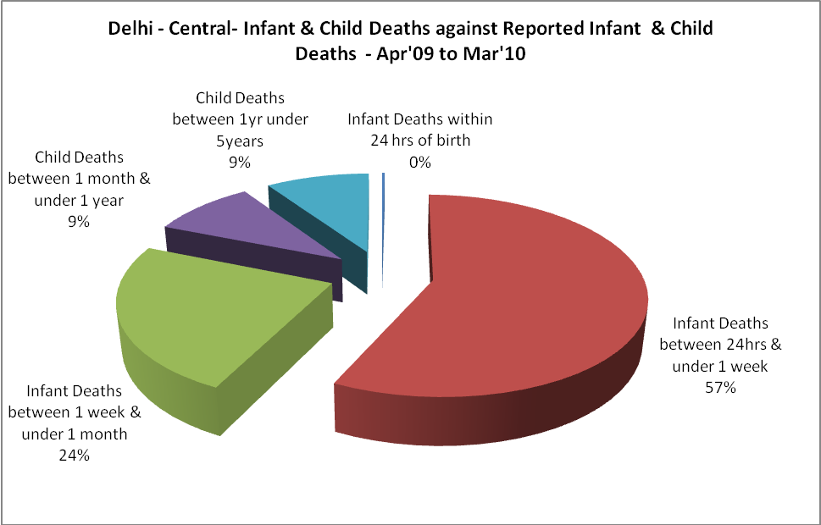
Delhi - Central- Causes of Infant & Child Deaths - Apr'09 to Mar'10
Sepsis |  |  | Asphyxia |  |  | LBW
Up to 1 Weeks of Birth | Between 1 week & 4 weeks of birth | Total | Up to 1 Weeks of Birth | Between 1 week & 4 weeks of birth | Total | Up to 1 Weeks of Birth | Between 1 week & 4 weeks of birth | Total
41 | 53 | 94 | 81 | 7 | 88 | 57 | 17 | 74
Pneumonia |  |  | Diarrhoea |  |  | Fever related
Between 1 month and 11 months | Between 1 year & 5 years | Total | Between 1 month and 11 months | Between 1 year & 5 years | Total | Between 1 month and 11 months | Between 1 year & 5 years | Total
27 | 11 | 38 | 7 | 2 | 9 | 3 | 12 | 15
Others |  |  | Measles |  |  | Others
Up to 1 Weeks of Birth | Between 1 week & 4 weeks of birth | Total | Between 1 month and 11 months | Between 1 year & 5 years | Total | Between 1 month and 11 months | Between 1 year & 5 years | Total
62 | 24 | 86 | 0 | 3 | 3 | 3 | 12 | 15

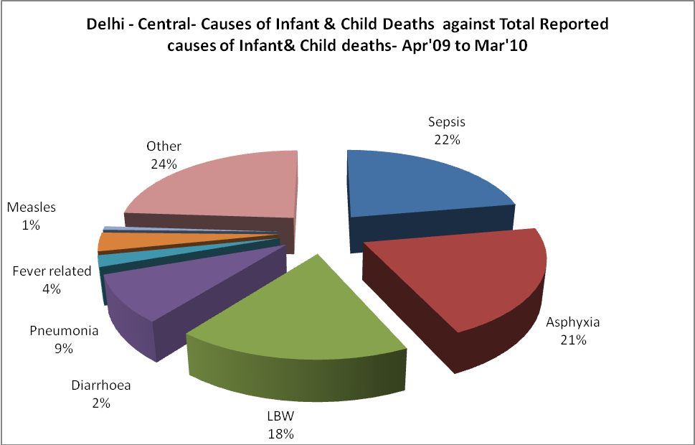
Delhi - Central- Maternal Deaths & Causes - Apr'09 to Mar'10
Abortion |  |  | Obstructed/prolonged labour |  |  | Severe hypertesnion/fits
6-14 yrs | 15-55 yrs. | Total | 6-14 yrs | 15-55 yrs. | Total | 6-14 yrs | 15-55 yrs. | Total
0 | 0 | 0 | 0 | 0 | 0 | 0 | 1 | 1
Bleeding |  |  | High Fever |  |  | Other Causes
6-14 yrs | 15-55 yrs. | Total | 6-14 yrs | 15-55 yrs. | Total | 6-14 yrs | 15-55 yrs. | Total
0 | 5 | 5 | 0 | 0 | 0 | 0 | 17 | 17

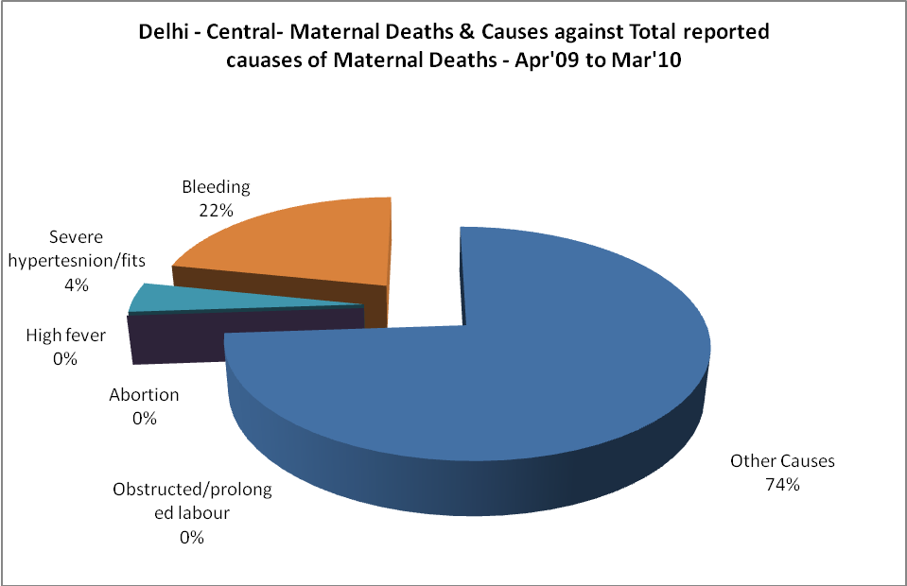

Delhi - Central-Causes of Deaths in 6 to 55yrs age group - Apr'09 to Mar'10
Diarrhoel Diseases |  |  |  | Tuberculosis |  |  |  | Respiratory Diseases( Other than TB)
6-14 yrs | 15-55 yrs. | Above 55yrs | Total | 6-14 yrs | 15-55 yrs. | Above 55yrs | Total | 6-14 yrs | 15-55 yrs. | Above 55yrs | Total
2 | 8 | 1 | 11 | 3 | 32 | 26 | 61 | 1 | 8 | 5 | 14
Malaria |  |  |  | Other fever Related |  |  |  | HIV/Aids
6-14 yrs | 15-55 yrs. | Above 55yrs | Total | 6-14 yrs | 15-55 yrs. | Above 55yrs | Total | 6-14 yrs | 15-55 yrs. | Above 55yrs | Total
1 | 6 | 1 | 8 | 15 | 15 | 1 | 31 | 0 | 18 | 0 | 18
Heart Disease/Hypertenion related |  |  |  | Neurological Disease including strokes |  |  |  | Trauma/Accidents/ Burn Cases
6-14 yrs | 15-55 yrs. | Above 55yrs | Total | 6-14 yrs | 15-55 yrs. | Above 55yrs | Total | 6-14 yrs | 15-55 yrs. | Above 55yrs | Total
25 | 232 | 285 | 542 | 11 | 51 | 70 | 132 | 21 | 257 | 31 | 309
Suicide |  |  |  | Animal Bites & Stings
6-14 yrs | 15-55 yrs. | Above 55yrs | Total | 6-14 yrs | 15-55 yrs. | Above 55yrs | Total
0 | 0 | 0 | 0 | 0 | 2 | 0 | 2

