[NHSRC]
Delhi-East
[ Analysis 2009-10]

Delhi - East- Summary-Apr'09 to Mar'10
ANC
ANC Registration against Expected Pregnancies |  |  | 183% |  | TT1 given to Pregnant women against ANC Registraion |  |  | 35%
3 ANC Check ups against ANC Reigtrations |  |  | 57% |  | 100 IFA Tablets given to Pregnant women against ANC Registraion |  |  | 49%
Deliveries
Unreported Deliveries against Estimated Deliveries |  |  | 67.9% |  | HOME Deliveries( SBA& Non SBA) against Estimated Deliveries |  |  | 0.8%
Institutional Deliveries against Estimated Deliveries |  |  | 31.3% |  | HOME Deliveries( SBA& Non SBA) against Reported Deliveries |  |  | 2.4%
Institutional Deliveries against Reported Deliveries |  |  | 97.6% |  | C Section Deliveries against Institutional Deliveries( Pvt & Pub) |  |  | 47%
Births & Neonates Care
Live Births Reported against Estimated Live Births |  |  | 48% |  | New borns weighed against Reported Live Births |  |  | 95%
Still Births (Reported) |  |  | 194 |  | New borns weighed less than 2.5 kgs against newborns weighed |  |  | 25%
Sex Ratio at Birh |  |  | 873 |  | New borns breastfed within one hr of Birth against Reported live Births |  |  | 63%
Child Immunisation( 0 to 11 mnths)
BCG given against Expected Live Births |  |  | 69% |  | Measles given against Expected Live Births |  |  | 64%
OPV3 given against Expected Live Births |  |  | 64% |  | Fully Immunised Children against Expected Live Births |  |  | 63%
DPT3 given against Expected Live Births |  |  | 64%
Family Plannng
Family Plannig Methods Users ( Sterilisations(Male &Female)+IUD+ Condom pieces/72 + OCP Cycles/13) |  |  | 13,292 |  | IUD Insertions against reported FP Methods |  |  | 31%
Sterilisation against reported FP Methods |  |  | 5% |  | Condom Users against reported FP Methods |  |  | 53%
 |  |  |  |  | OCP Users against reported FP Methods |  |  | 11%
Other Services
OPD |  |  | 2,913,380 |  | Major Operations |  |  | 14,631
IPD |  |  | 105,664 |  | Minor Operations |  |  | 18,309
Delhi - East- Deliveries Apr'09 to Mar'10
Total Population | 1,769,127 | Expected Deliveries |  |  |  | 33,122
Home SBA | Home Non SBA | Institutional |  | Total Deliveries Reported |  | Unreported Deliveries
133 | 122 | 10,371 |  | 10,626 |  | 22,496
Home SBA % | Home Non SBA% | Institutional % |  | Total Deliveries Reported % |  | Unreported Deliveries %
0% | 0% | 31% |  | 32% |  | 68%

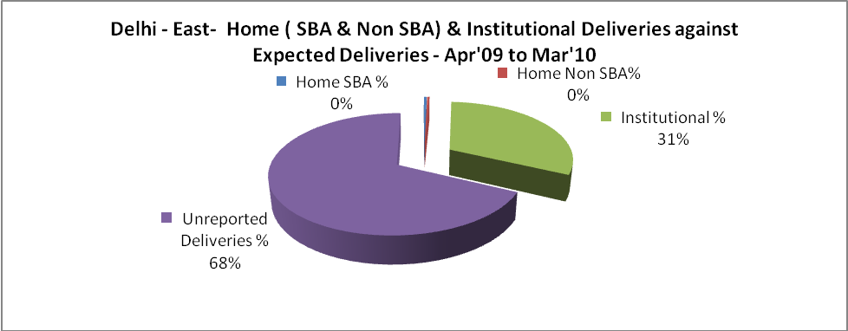

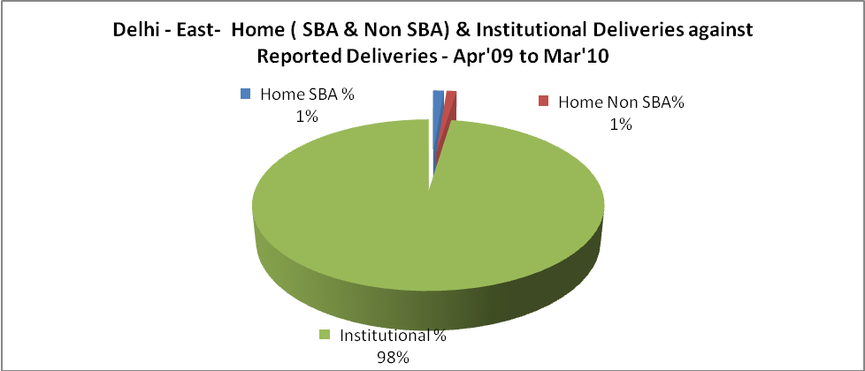

Delhi - East- C sections & Complicated Deliveries Apr'09 to Mar'10
 | Institutional Deliveries (Public) | Institutional Deliveries (Pvt)
 | 8,560 | 1,811
C Section | 2,617 | 2,231
C Section% | 31% | 123%
Complicated Pregnacies attended | 2,573 | 346
Complicated Pregnacies attended % | 30% | 19%

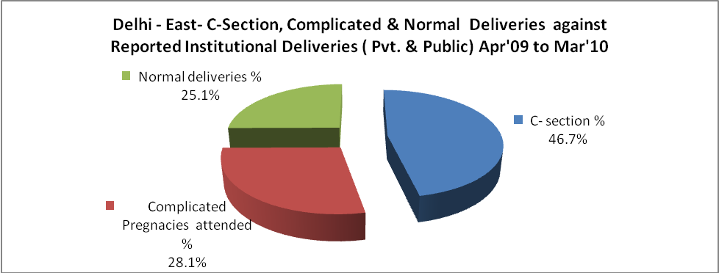

Delhi - East- Complicated Pregnancies & Deliveries Treated - Apr'09 to Mar'10
Reported Deliveries |  |  | Reported ANC Reigtration
10,626 |  |  | 65,551
Complicated Pregnancies attended | Complicated Pregnancies Rate | C - Section Deliveries | PNC Maternal Complications | Abortions | Still Births
2,919 | 8% | 4,848 | 630 | 2,848 | 194
Complicated Deliveries Treated with |  |  |  | No Of Eclampsia cases Treated | No Of severe anemia cases treated
IV Antibiotics | IV antihypertensive/Magsulph injection | IV Oxytocis | Blood Transfusion | No Of Eclampsia cases Treated | No Of severe anemia cases treated
7,234 | 370 | 7,509 | 464 | 54 | 717

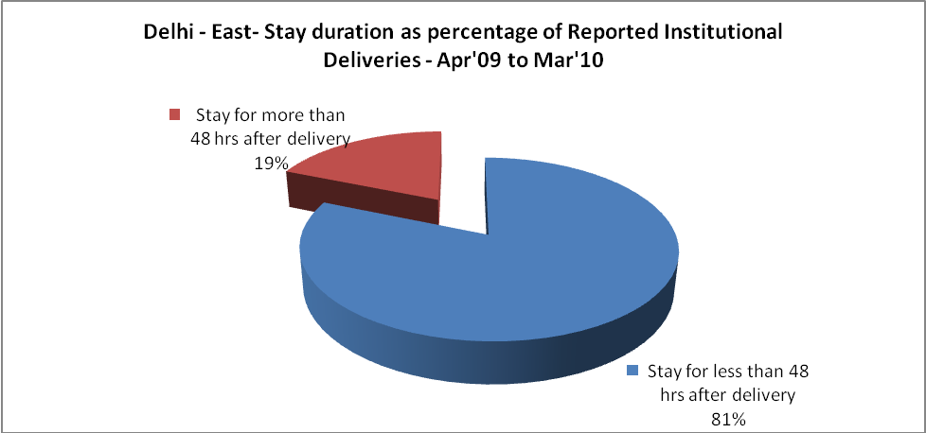

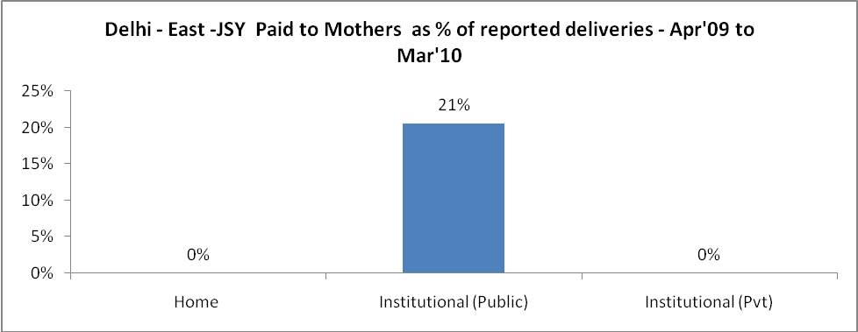

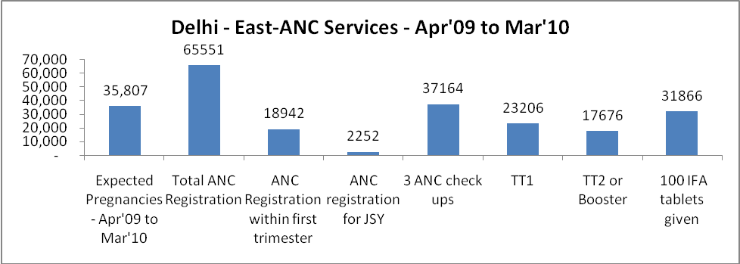

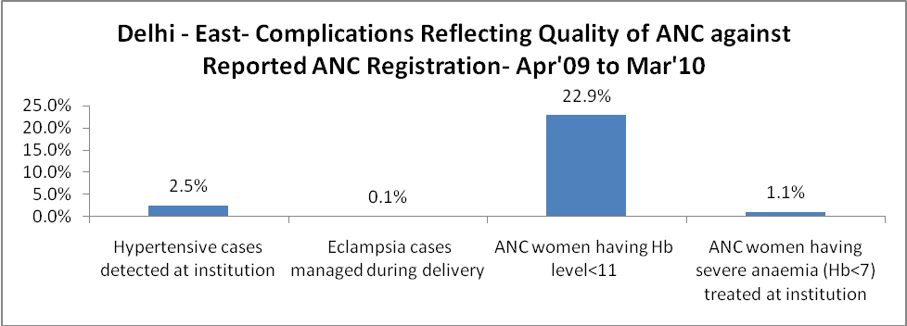

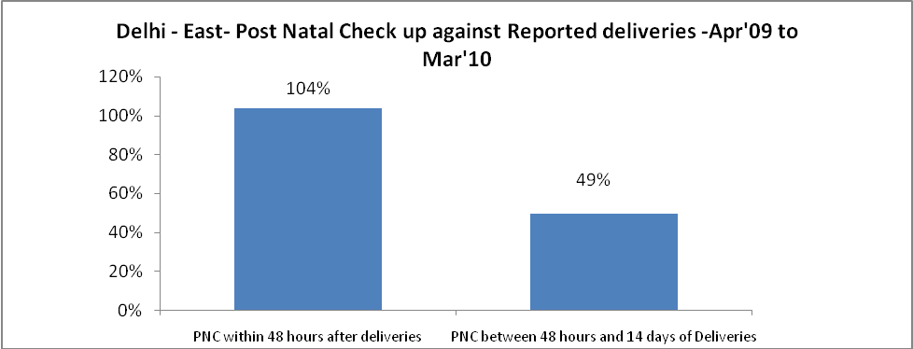

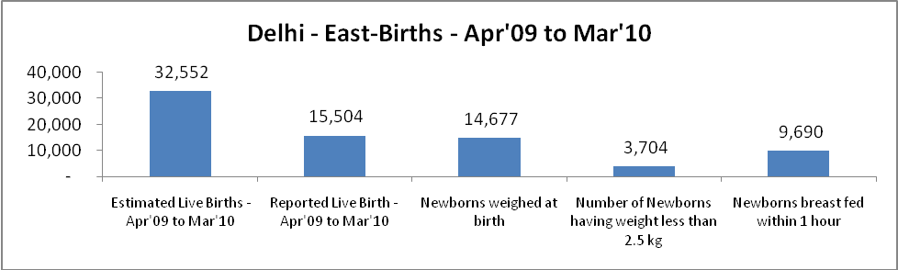

Delhi - East - Births - Apr'09 to Mar'10
Live Birth - Males | Live Birth - females | Live Birth - Total | Sex Ratio at birth | Still Birth | Abortion( Induced/Spontaneous
8,276 | 7,228 | 15,504 | 873 | 194 | 2,848

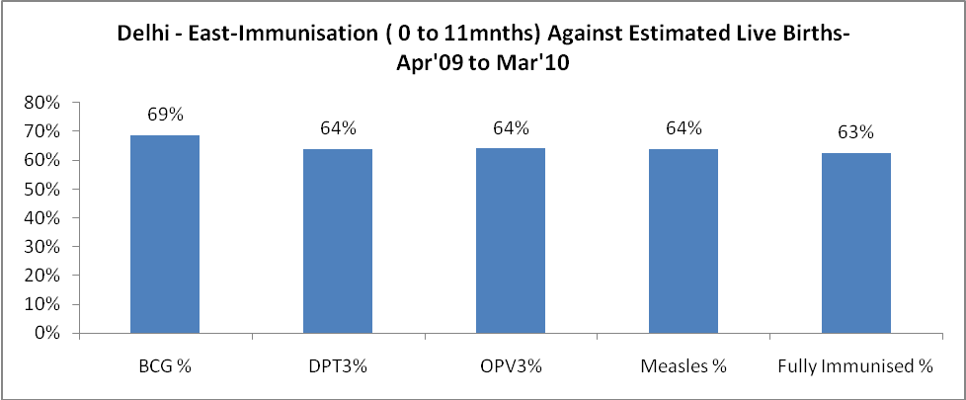

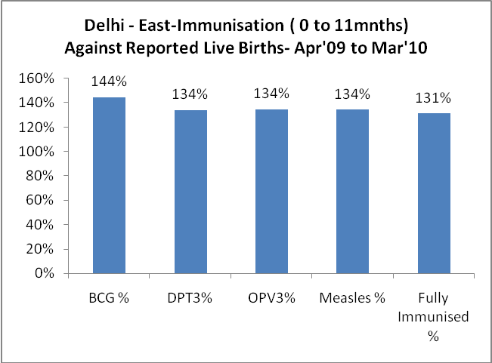
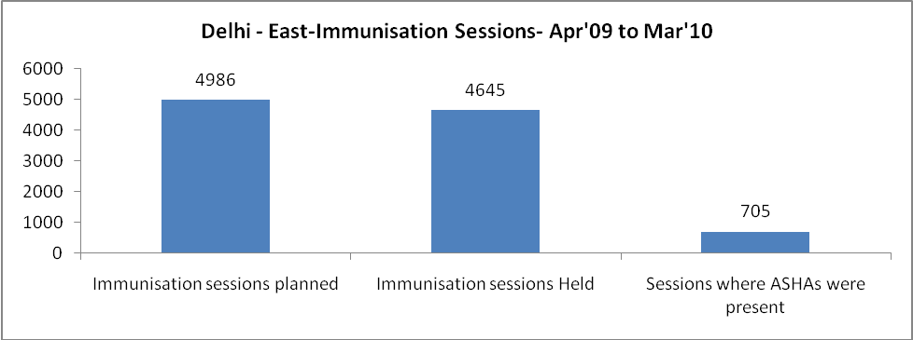

Delhi - East- Apr'09 to Mar'10
Total Abortions | Abortion Rate
3,911 | 10.9%

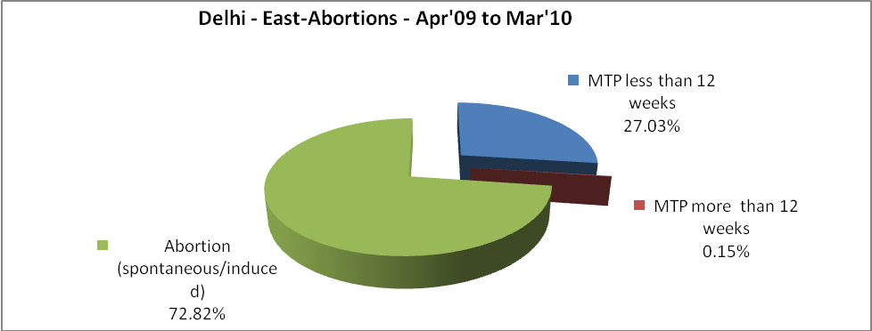

Delhi - East- Apr'09 to Mar'10
Total OPD | Total RTI/STI cases
2,913,380 | 22,830

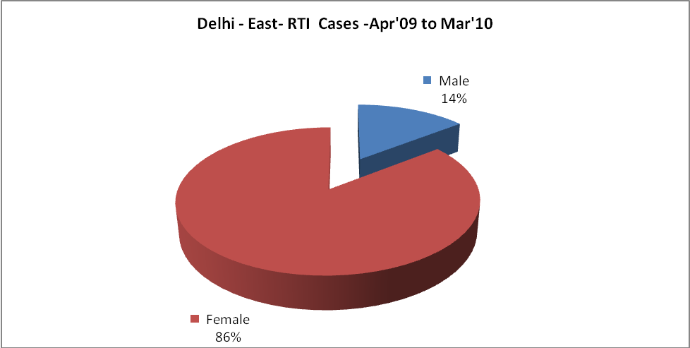

Delhi - East-Sterilisations - Apr'09 to Mar'10
 | Reported | %age of Reported Sterilisation
Total Sterilisation | 706 | -
NSV | 94 | 13%
Laproscopic | 178 | 25%
MiniLap | 156 | 22%
Post Partum | 278 | 39%
Male Sterilisation | 94 | 13%
Female Sterilisation | 612 | 87%

Delhi - East-FP Methods - Apr'09 to Mar'10
 | Reported | %age of All Reported FP Methods
Total Reported FP Methodd (All types) Users | 13,292 | -
Sterilisations | 706 | 5%
IUD | 4,170 | 31%
Condom Users | 7,011 | 53%
OCP Users | 1,405 | 11%
Limiting Methods | 706 | 5%
Spacing Methods | 12,586 | 95%

Delhi - East- Service Delivery - Apr'09 to Mar'10
Operation major (General and spinal anaesthesia) | Operation minor (No or local anaesthesia) | AYUSH | Dental Procedures | Adolescent counselling services | Total OPD | Total IPD
14,631 | 18,309 | 7,120 | 22,103 | 9,413 | 2,913,380 | 105,664
Operation major (General and spinal anaesthesia) as %ge of OPD | Operation minor (No or local anaesthesia)as %ge of OPD | AYUSH as %ge of OPD | Dental Procedures as %ge of OPD | Adolescent counselling services as %ge of OPD | IPD as percentage of OPD
0.5% | 0.6% | 0.2% | 0.8% | 0.3% | 4%

Delhi - East- Lab Services - Apr'09 to Mar'10
Total OPD | Total HB tested | Total HIV Tested | Total Population
2,913,380 | 221,322 | 39,167 | 1,769,127
HB test conducted as %age of OPD | HB<7gm as %age of HB tested | HIV test conducted as %age of OPD | HIV positive as %age of HIV tested | Blood Smear Examined as % of Population
7.6% | 3.6% | 1.3% | 0.7% | 1.7%

Delhi - East- Childhood Disease - Vaccine Preventable -Apr'09 to Mar'10
Diphtheria | Pertussis | Tetanus Neonatorum | Tetanus others | Polio | Measles
7 | 0 | 0 | 2 | 0 | 151
Delhi - East-Childhood Disease - Others - Apr'09 to Mar'10
Diarrhoea and dehydration | Malaria | Number admitted with Respiratory Infections
24,105 | 146 | 6,135

Delhi - East- Infant & Child Deaths - Apr'09 to Mar'10
Infant Deaths within 24 hrs of birth | Infant Deaths between 24hrs & under 1 week | Infant Deaths between 1 week & under 1 month | Child Deaths between 1 month & under 1 year | Child Deaths between 1yr under 5years | Total Deaths
75 | 143 | 154 | 347 | 219 | 938

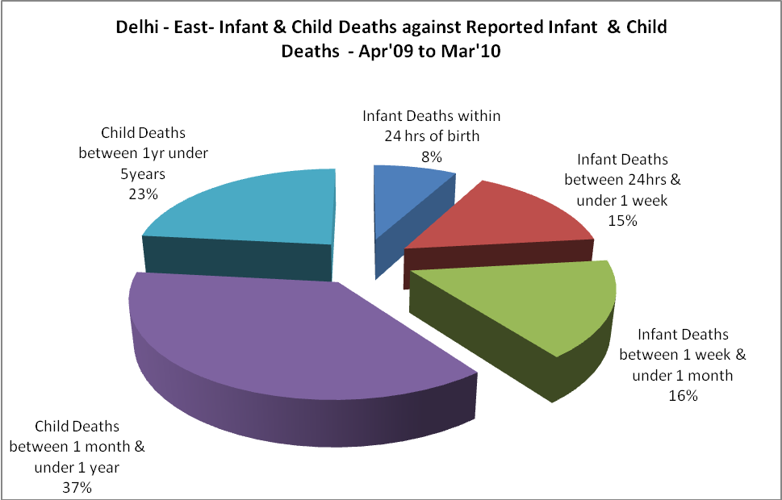

Delhi - East- Causes of Infant & Child Deaths - Apr'09 to Mar'10
Sepsis |  |  | Asphyxia |  |  | LBW
Up to 1 Weeks of Birth | Between 1 week & 4 weeks of birth | Total | Up to 1 Weeks of Birth | Between 1 week & 4 weeks of birth | Total | Up to 1 Weeks of Birth | Between 1 week & 4 weeks of birth | Total
55 | 114 | 169 | 34 | 2 | 36 | 20 | 15 | 35
Pneumonia |  |  | Diarrhoea |  |  | Fever related
Between 1 month and 11 months | Between 1 year & 5 years | Total | Between 1 month and 11 months | Between 1 year & 5 years | Total | Between 1 month and 11 months | Between 1 year & 5 years | Total
118 | 53 | 171 | 16 | 7 | 23 | 9 | 25 | 34
Others |  |  | Measles |  |  | Others
Up to 1 Weeks of Birth | Between 1 week & 4 weeks of birth | Total | Between 1 month and 11 months | Between 1 year & 5 years | Total | Between 1 month and 11 months | Between 1 year & 5 years | Total

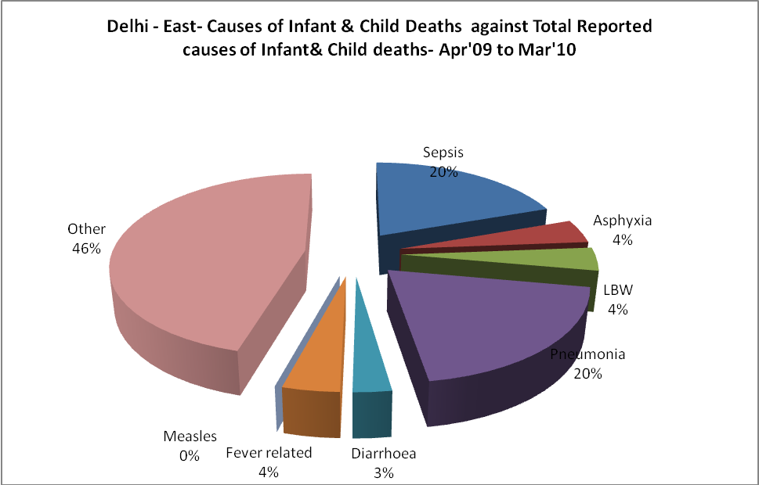
Delhi - East- Maternal Deaths & Causes - Apr'09 to Mar'10
Abortion |  |  | Obstructed/prolonged labour |  |  | Severe hypertesnion/fits
6-14 yrs | 15-55 yrs. | Total | 6-14 yrs | 15-55 yrs. | Total | 6-14 yrs | 15-55 yrs. | Total
0 | 0 | 0 | 0 | 0 | 0 | 0 | 2 | 2
Bleeding |  |  | High Fever |  |  | Other Causes
6-14 yrs | 15-55 yrs. | Total | 6-14 yrs | 15-55 yrs. | Total | 6-14 yrs | 15-55 yrs. | Total
0 | 0 | 0 | 0 | 0 | 0 | 4 | 8 | 12

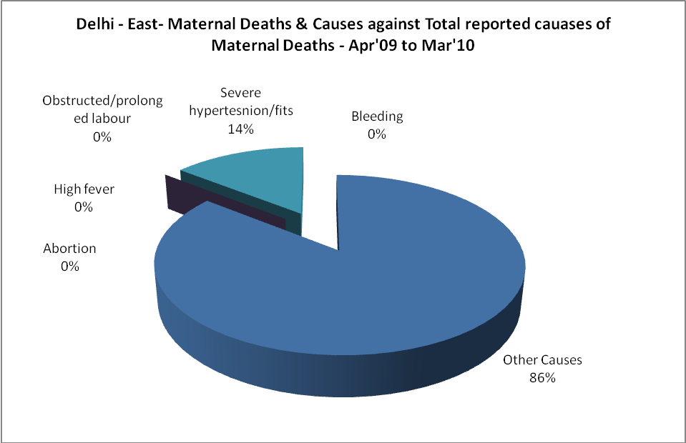

Delhi - East-Causes of Deaths in 6 to 55yrs age group - Apr'09 to Mar'10
Diarrhoel Diseases |  |  |  | Tuberculosis |  |  |  | Respiratory Diseases( Other than TB)
6-14 yrs | 15-55 yrs. | Above 55yrs | Total | 6-14 yrs | 15-55 yrs. | Above 55yrs | Total | 6-14 yrs | 15-55 yrs. | Above 55yrs | Total
1 | 4 | 3 | 8 | 5 | 16 | 14 | 35 | 2 | 37 | 73 | 112
Malaria |  |  |  | Other fever Related |  |  |  | HIV/Aids
6-14 yrs | 15-55 yrs. | Above 55yrs | Total | 6-14 yrs | 15-55 yrs. | Above 55yrs | Total | 6-14 yrs | 15-55 yrs. | Above 55yrs | Total
0 | 1 | 1 | 2 | 4 | 13 | 24 | 41 | 0 | 1 | 5 | 6
Heart Disease/Hypertenion related |  |  |  | Neurological Disease including strokes |  |  |  | Trauma/Accidents/ Burn Cases
6-14 yrs | 15-55 yrs. | Above 55yrs | Total | 6-14 yrs | 15-55 yrs. | Above 55yrs | Total | 6-14 yrs | 15-55 yrs. | Above 55yrs | Total
7 | 85 | 164 | 256 | 0 | 5 | 18 | 23 | 0 | 17 | 1 | 18
Suicide |  |  |  | Animal Bites & Stings
6-14 yrs | 15-55 yrs. | Above 55yrs | Total | 6-14 yrs | 15-55 yrs. | Above 55yrs | Total
0 | 2 | 0 | 2 | 0 | 0 | 0 | 0

