[NHSRC]
Delhi-New Delhi
[ Analysis 2009-10]

Delhi - New Delhi- Summary-Apr'09 to Mar'10
ANC
ANC Registration against Expected Pregnancies | 525% | TT1 given to Pregnant women against ANC Registraion | 26%
3 ANC Check ups against ANC Reigtrations | 21% | 100 IFA Tablets given to Pregnant women against ANC Registraion | 4%
Deliveries
Unreported Deliveries against Estimated Deliveries | -268.9% | HOME Deliveries( SBA& Non SBA) against Estimated Deliveries | 0.0%
Institutional Deliveries against Estimated Deliveries | 368.9% | HOME Deliveries( SBA& Non SBA) against Reported Deliveries | 0.0%
Institutional Deliveries against Reported Deliveries | 100.0% | C Section Deliveries against Institutional Deliveries( Pvt & Pub) | 19%
Births & Neonates Care
Live Births Reported against Estimated Live Births | 371% | New borns weighed against Reported Live Births | 100%
Still Births (Reported) | 399 | New borns weighed less than 2.5 kgs against newborns weighed | 2%
Sex Ratio at Birh | 888 | New borns breastfed within one hr of Birth against Reported live Births | 8%
Child Immunisation( 0 to 11 mnths)
BCG given against Expected Live Births | 91% | Measles given against Expected Live Births | 71%
OPV3 given against Expected Live Births | 71% | Fully Immunised Children against Expected Live Births | 71%
DPT3 given against Expected Live Births | 70%
Family Planing
Family Plannig Methods Users ( Sterilisations(Male &Female)+IUD+ Condom pieces/72 + OCP Cycles/13) | 4,572 | IUD Insertions against reported FP Methods | 16%
Sterilisation against reported FP Methods | 39% | Condom Users against reported FP Methods | 41%
 |  | OCP Users against reported FP Methods | 3%
Other Services
OPD | 870,998 | Major Operations | 2,527
IPD | 13,842 | Minor Operations | 2,311

Delhi - New Delhi- Deliveries Apr'09 to Mar'10
Total Population | 216,504 | Expected Deliveries |  | 4,053
Home SBA | Home Non SBA | Institutional | Total Deliveries Reported | Unreported Deliveries
- | - | 14,953 | 14,953 | (10,900)
Home SBA % | Home Non SBA% | Institutional % | Total Deliveries Reported % | Unreported Deliveries %
0% | 0% | 369% | 369% | -269%

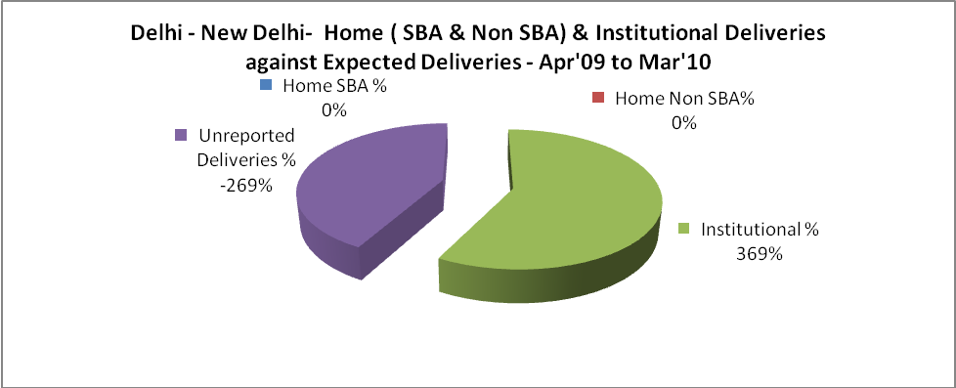

Delhi - New Delhi- C sections & Complicated Deliveries Apr'09 to Mar'10
 | Institutional Deliveries (Public) | Institutional Deliveries (Pvt)
 | 14,953 | -
C Section | 2,862 | -
C Section% | 19% | -
Complicated Pregnacies attended | 4,825 | -
Complicated Pregnacies attended % | 32% | -

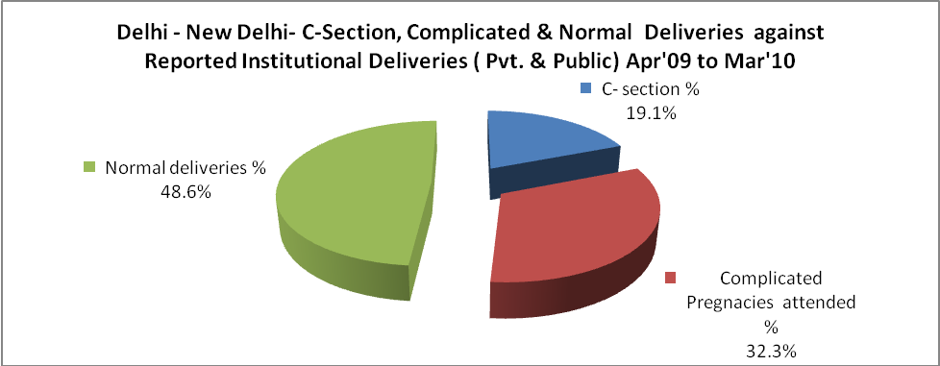

Delhi - New Delhi- Complicated Pregnancies & Deliveries Treated - Apr'09 to Mar'10
Reported Deliveries |  |  | Reported ANC Reigtration
14,953 |  |  | 23,014
Complicated Pregnancies attended | Complicated Pregnancies Rate | C - Section Deliveries | PNC Maternal Complications | Abortions | Still Births
4,825 | 110% | 2,862 | 78 | 953 | 399
Complicated Deliveries Treated with |  |  |  | No Of Eclampsia cases Treated | No Of severe anemia cases treated
IV Antibiotics | IV antihypertensive/Magsulph injection | IV Oxytocis | Blood Transfusion | No Of Eclampsia cases Treated | No Of severe anemia cases treated
- | - | - | - | 45 | 98

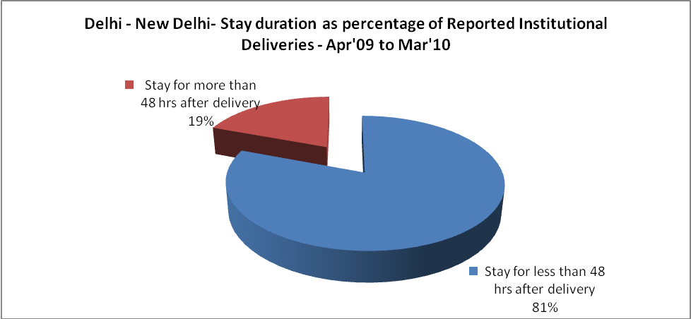

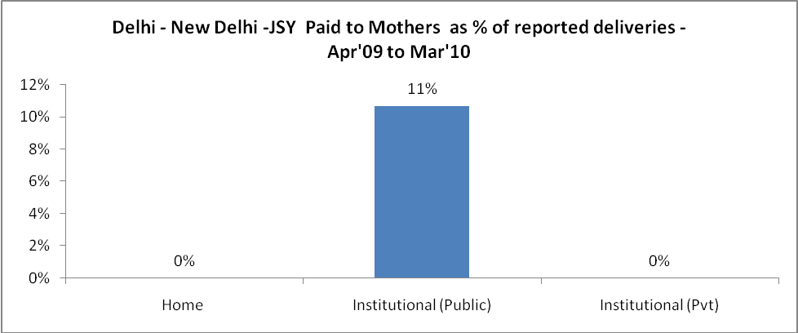

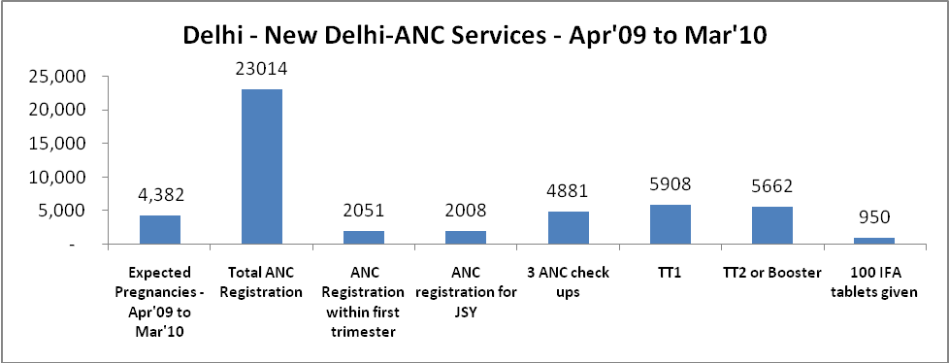

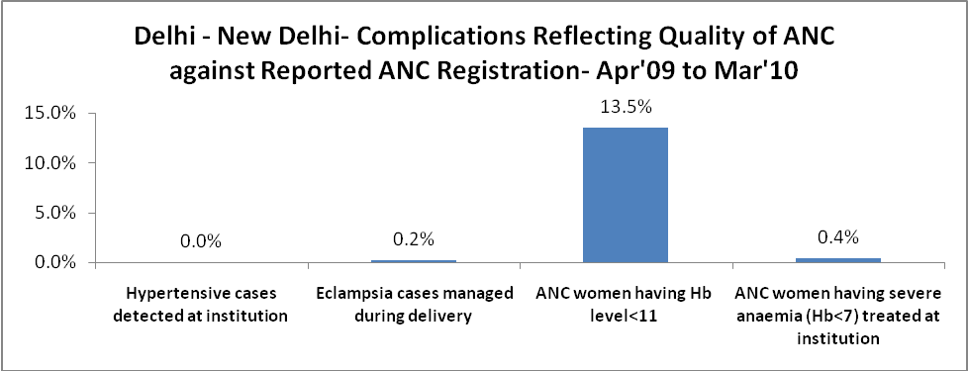

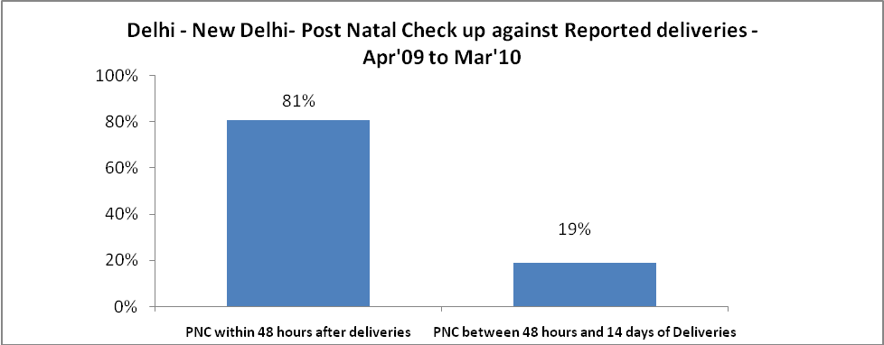

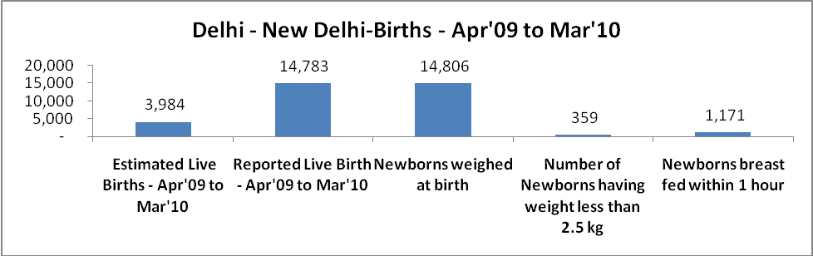

Delhi - New Delhi - Births - Apr'09 to Mar'10
Live Birth - Males | Live Birth - females | Live Birth - Total | Sex Ratio at birth | Still Birth | Abortion( Induced/Spontaneous
7,828 | 6,955 | 14,783 | 888 | 399 | 953

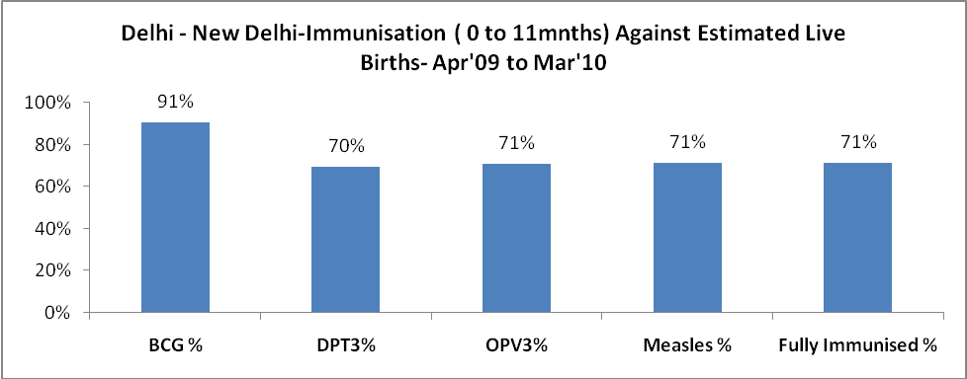

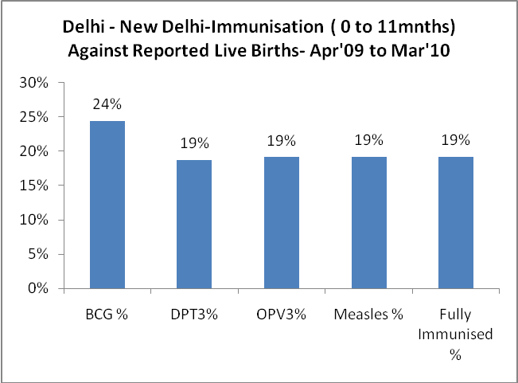

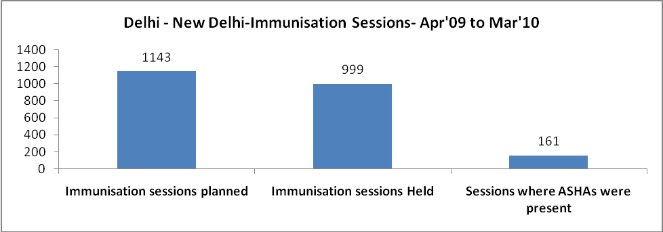

Delhi - New Delhi- Apr'09 to Mar'10
Total Abortions | Abortion Rate
1,746 | 39.8%

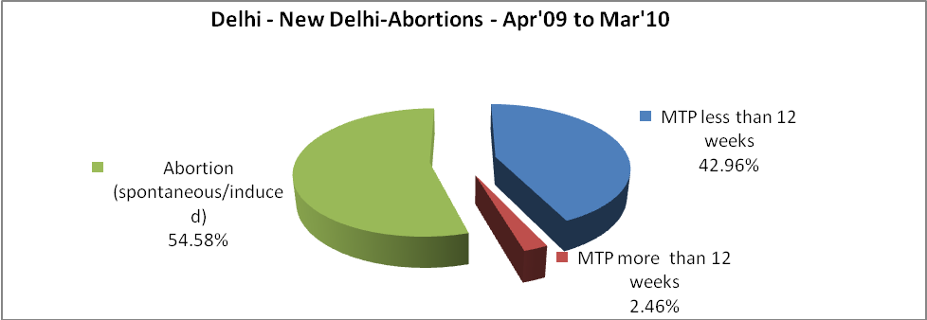

Delhi - New Delhi- Apr'09 to Mar'10
Total OPD | Total RTI/STI cases
870,998 | 2,389

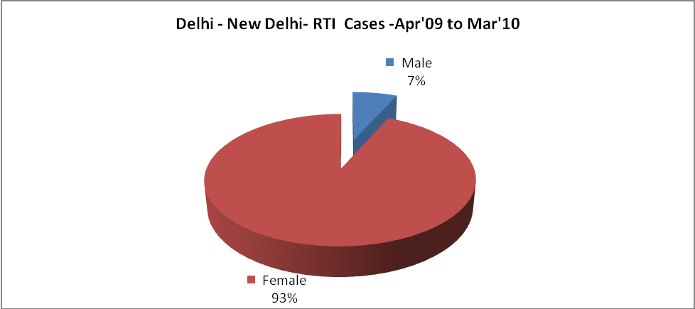

Delhi - New Delhi-FP Methods - Apr'09 to Mar'10
 | Reported | %age of All Reported FP Methods
Total Reported FP Methodd (All types) Users | 4,572 | -
Sterilisations | 1,802 | 39%
IUD | 744 | 16%
Condom Users | 1,867 | 41%
OCP Users | 158 | 3%
Limiting Methods | 1,802 | 39%
Spacing Methods | 2,770 | 61%

Delhi - New Delhi- Service Delivery - Apr'09 to Mar'10
Operation major (General and spinal anaesthesia) | Operation minor (No or local anaesthesia) | AYUSH | Dental Procedures | Adolescent counselling services | Total OPD | Total IPD
2,527 | 2,311 | 59,919 | 6,135 | 85 | 870,998 | 13,842
Operation major (General and spinal anaesthesia) as %ge of OPD | Operation minor (No or local anaesthesia)as %ge of OPD | AYUSH as %ge of OPD | Dental Procedures as %ge of OPD | Adolescent counselling services as %ge of OPD | IPD as percentage of OPD
0.3% | 0.3% | 6.9% | 0.7% | 0.0% | 2%

Delhi - New Delhi- Lab Services - Apr'09 to Mar'10
Total OPD | Total HB tested | Total HIV Tested | Total Population
870,998 | 38,963 | 11,875 | 216,504
HB test conducted as %age of OPD | HB<7gm as %age of HB tested | HIV test conducted as %age of OPD | HIV positive as %age of HIV tested | Blood Smear Examined as % of Population
4.5% | 3.3% | 1.4% | 0.6% | 5.3%

Delhi - New Delhi- Childhood Disease - Vaccine Preventable -Apr'09 to Mar'10
Diphtheria | Pertussis | Tetanus Neonatorum | Tetanus others | Polio | Measles
2 | 0 | 6 | 9 | 0 | 10
Delhi - New Delhi-Childhood Disease - Others - Apr'09 to Mar'10
Diarrhoea and dehydration | Malaria | Number admitted with Respiratory Infections
5,825 | 23 | 1,399

Delhi - New Delhi- Infant & Child Deaths - Apr'09 to Mar'10
Infant Deaths within 24 hrs of birth | Infant Deaths between 24hrs & under 1 week | Infant Deaths between 1 week & under 1 month | Child Deaths between 1 month & under 1 year | Child Deaths between 1yr under 5years | Total Deaths
30 | 143 | 42 | 114 | 57 | 386

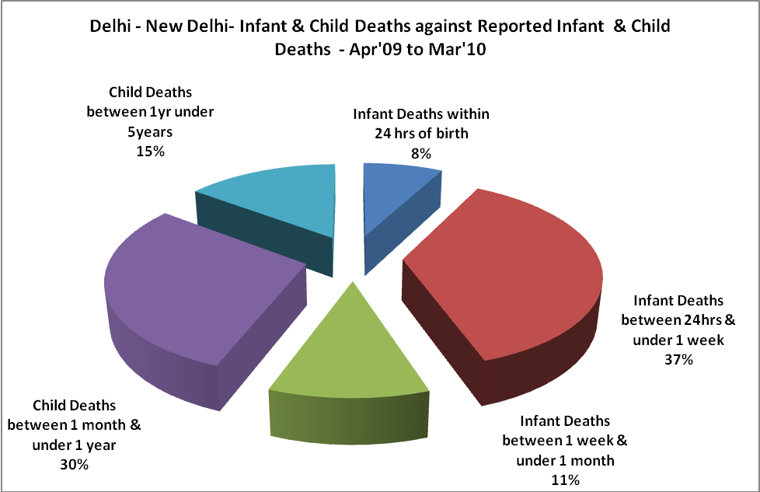

Delhi - New Delhi- Causes of Infant & Child Deaths - Apr'09 to Mar'10
Sepsis |  |  | Asphyxia |  |  | LBW
Up to 1 Weeks of Birth | Between 1 week & 4 weeks of birth | Total | Up to 1 Weeks of Birth | Between 1 week & 4 weeks of birth | Total | Up to 1 Weeks of Birth | Between 1 week & 4 weeks of birth | Total
52 | 33 | 85 | 21 | 2 | 23 | 32 | 3 | 35
Pneumonia |  |  | Diarrhoea |  |  | Fever related
Between 1 month and 11 months | Between 1 year & 5 years | Total | Between 1 month and 11 months | Between 1 year & 5 years | Total | Between 1 month and 11 months | Between 1 year & 5 years | Total
44 | 19 | 63 | 8 | 1 | 9 | 17 | 13 | 30
Others |  |  | Measles |  |  | Others
Up to 1 Weeks of Birth | Between 1 week & 4 weeks of birth | Total | Between 1 month and 11 months | Between 1 year & 5 years | Total | Between 1 month and 11 months | Between 1 year & 5 years | Total
38 | 4 | 42 | 2 | 5 | 7 | 43 | 19 | 62

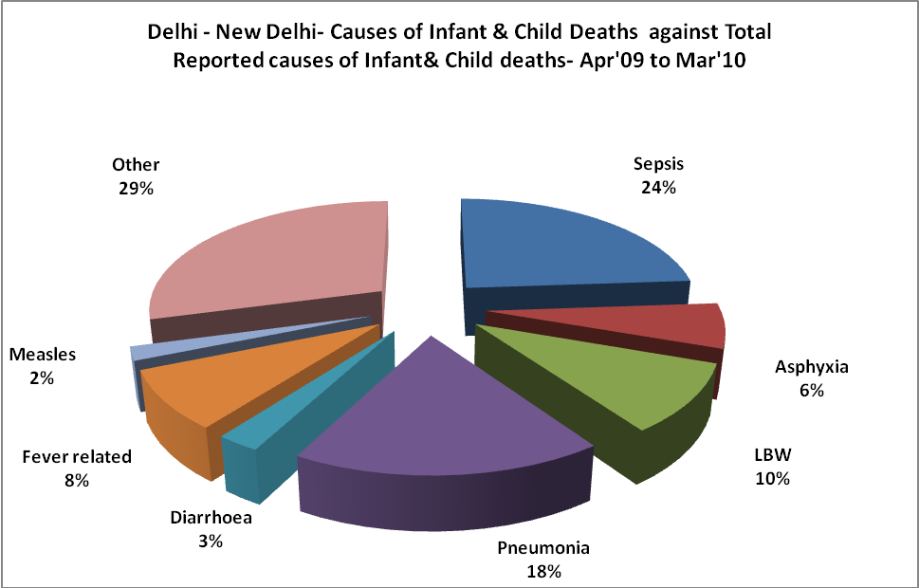
Delhi - New Delhi- Maternal Deaths & Causes - Apr'09 to Mar'10
Abortion |  |  | Obstructed/prolonged labour |  |  | Severe hypertesnion/fits
6-14 yrs | 15-55 yrs. | Total | 6-14 yrs | 15-55 yrs. | Total | 6-14 yrs | 15-55 yrs. | Total
0 | 0 | 0 | 0 | 0 | 0 | 0 | 8 | 8
Bleeding |  |  | High Fever |  |  | Other Causes
6-14 yrs | 15-55 yrs. | Total | 6-14 yrs | 15-55 yrs. | Total | 6-14 yrs | 15-55 yrs. | Total
0 | 4 | 4 | 0 | 4 | 4 | 0 | 19 | 19

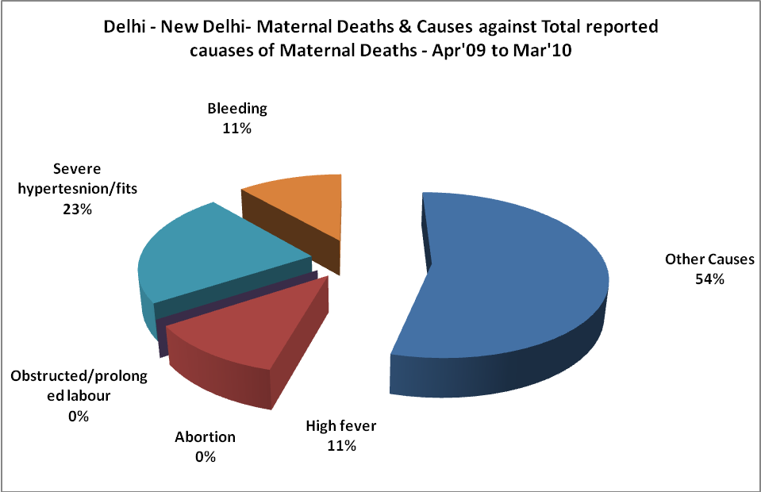

Delhi - New Delhi-Causes of Deaths in 6 to 55yrs age group - Apr'09 to Mar'10
Diarrhoel Diseases |  |  |  | Tuberculosis |  |  |  | Respiratory Diseases( Other than TB)
6-14 yrs | 15-55 yrs. | Above 55yrs | Total | 6-14 yrs | 15-55 yrs. | Above 55yrs | Total | 6-14 yrs | 15-55 yrs. | Above 55yrs | Total
7 | 1 | 0 | 8 | 4 | 8 | 3 | 15 | 4 | 9 | 11 | 24
Malaria |  |  |  | Other fever Related |  |  |  | HIV/Aids
6-14 yrs | 15-55 yrs. | Above 55yrs | Total | 6-14 yrs | 15-55 yrs. | Above 55yrs | Total | 6-14 yrs | 15-55 yrs. | Above 55yrs | Total
3 | 0 | 0 | 3 | 14 | 1 | 1 | 16 | 0 | 0 | 0 | 0
Heart Disease/Hypertenion related |  |  |  | Neurological Disease including strokes |  |  |  | Trauma/Accidents/ Burn Cases
6-14 yrs | 15-55 yrs. | Above 55yrs | Total | 6-14 yrs | 15-55 yrs. | Above 55yrs | Total | 6-14 yrs | 15-55 yrs. | Above 55yrs | Total
3 | 8 | 15 | 26 | 1 | 0 | 2 | 3 | 0 | 1 | 0 | 1
Suicide |  |  |  | Animal Bites & Stings
6-14 yrs | 15-55 yrs. | Above 55yrs | Total | 6-14 yrs | 15-55 yrs. | Above 55yrs | Total
0 | 0 | 0 | 0 | 0 | 0 | 0 | 0

