NHSRC
Delhi-North East
Analysis: Apr 2009 – Mar 2010

Delhi - North East- Summary-Apr'09 to Mar'10
ANC
ANC Registration against Expected Pregnancies | 216% | TT1 given to Pregnant women against ANC Registraion | 31%
3 ANC Check ups against ANC Reigtrations | 19% | 100 IFA Tablets given to Pregnant women against ANC Registraion | 44%
Deliveries
Unreported Deliveries against Estimated Deliveries | 68.3% | HOME Deliveries( SBA& Non SBA) against Estimated Deliveries | 1.6%
Institutional Deliveries against Estimated Deliveries | 30.1% | HOME Deliveries( SBA& Non SBA) against Reported Deliveries | 5.1%
Institutional Deliveries against Reported Deliveries | 94.9% | C Section Deliveries against Institutional Deliveries( Pvt & Pub) | 60%
Births & Neonates Care
Live Births Reported against Estimated Live Births | 35% | New borns weighed against Reported Live Births | 69%
Still Births (Reported) | 399 | New borns weighed less than 2.5 kgs against newborns weighed | 10%
Sex Ratio at Birh | 657 | New borns breastfed within one hr of Birth against Reported live Births | 70%
Child Immunisation( 0 to 11 months)
BCG given against Expected Live Births | 82% | Measles given against Expected Live Births | 60%
OPV3 given against Expected Live Births | 63% | Fully Immunised Children against Expected Live Births | 65%
DPT3 given against Expected Live Births | 63%
Family Planning
Family Plannig Methods Users ( Sterilisations(Male &Female)+IUD+ Condom pieces/72 + OCP Cycles/13) | 21,046 | IUD Insertions against reported FP Methods | 21%
Sterilisation against reported FP Methods | 45% | Condom Users against reported FP Methods | 31%
 |  | OCP Users against reported FP Methods | 4%
Other Services
OPD | 803,396 | Major Operations | 2,945
IPD | 5,231 | Minor Operations | 868

Delhi - North East- Deliveries Apr'09 to Mar'10
Total Population | 2,137,169 | Expected Deliveries |  | 40,012
Home SBA | Home Non SBA | Institutional | Total Deliveries Reported | Unreported Deliveries
523 | 127 | 12,033 | 12,683 | 27,329
Home SBA % | Home Non SBA% | Institutional % | Total Deliveries Reported % | Unreported Deliveries %
1% | 0% | 30% | 32% | 68%
`

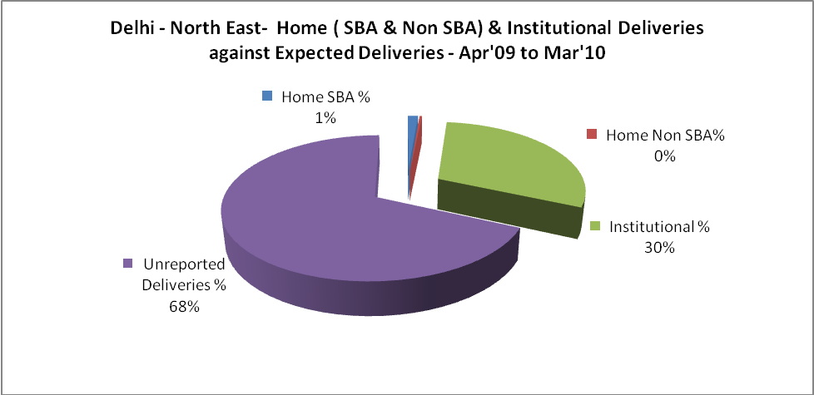

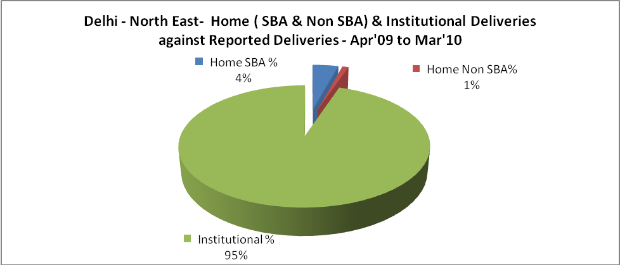

Delhi - North East- C sections & Complicated Deliveries Apr'09 to Mar'10
 | Institutional Deliveries (Public) | Institutional Deliveries (Pvt)
 | 12,033 | -
C Section | 6,237 | 1,026
C Section% | 52% | 0%
Complicated Pregnacies attended | 10,707 | 2,235
Complicated Pregnacies attended % | 89% | 0%

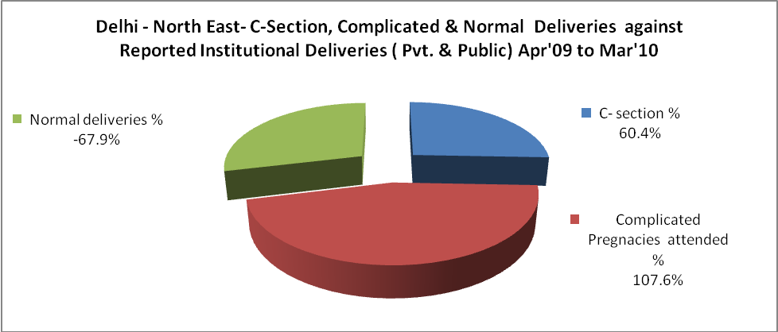

Delhi - North East- Complicated Pregnancies & Deliveries Treated - Apr'09 to Mar'10
Reported Deliveries |  |  | Reported ANC Reigtration
12,683 |  |  | 93,632
Complicated Pregnancies attended | Complicated Pregnancies Rate | C - Section Deliveries | PNC Maternal Complications | Abortions | Still Births
12,942 | 30% | 7,263 | 2,066 | 711 | 399
Complicated Deliveries Treated with |  |  |  | No Of Eclampsia cases Treated | No Of severe anemia cases treated
IV Antibiotics | IV antihypertensive/Magsulph injection | IV Oxytocis | Blood Transfusion | No Of Eclampsia cases Treated | No Of severe anemia cases treated
6,690 | 489 | 7,150 | 143 | 575 | 3,061

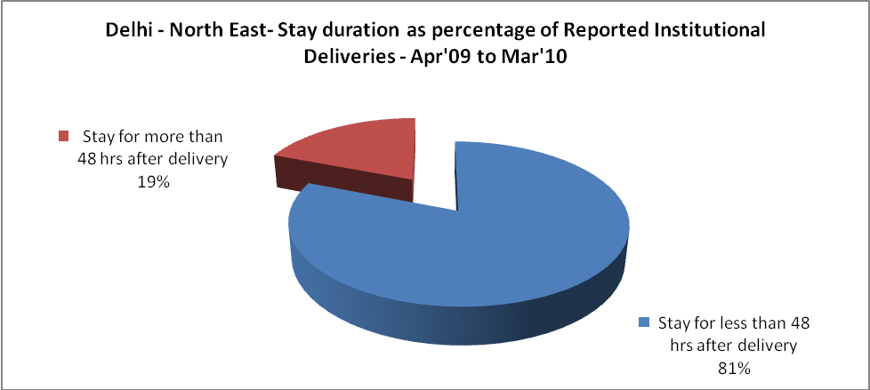

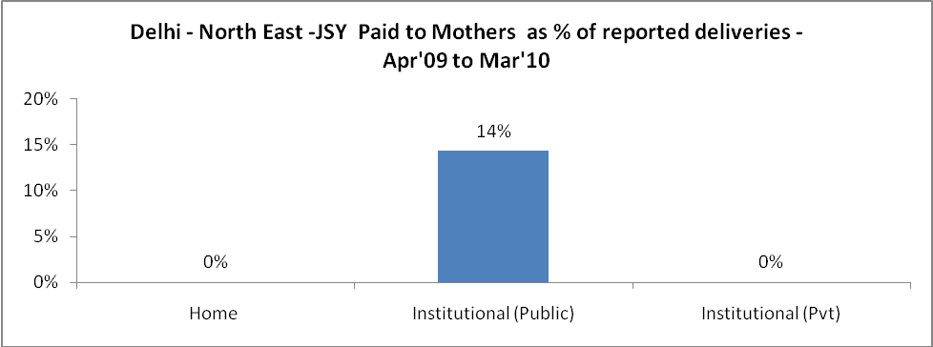

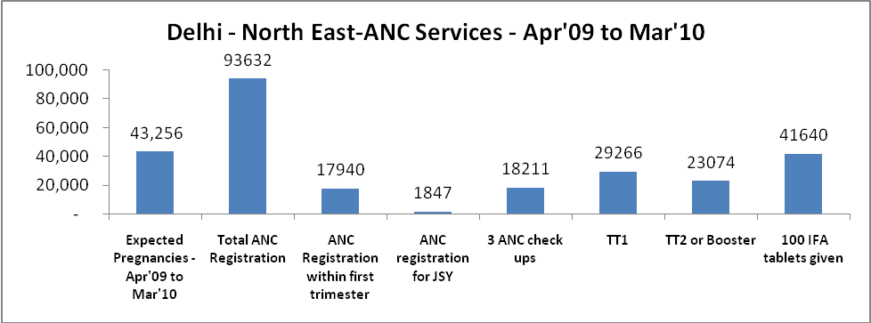

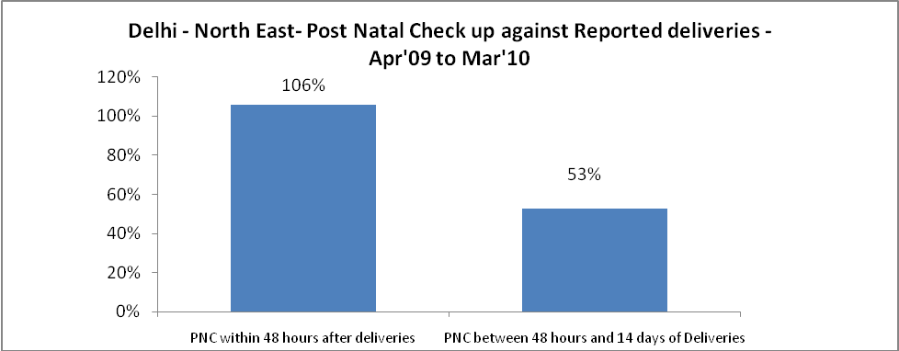

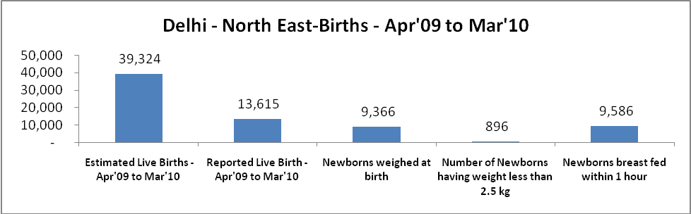

Delhi - North East - Births - Apr'09 to Mar'10
Live Birth - Males | Live Birth - females | Live Birth - Total | Sex Ratio at birth | Still Birth | Abortion( Induced/Spontaneous
8,215 | 5,400 | 13,615 | 657 | 399 | 711

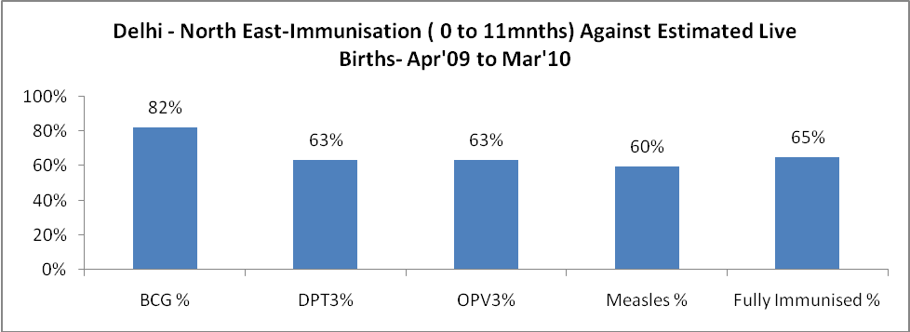

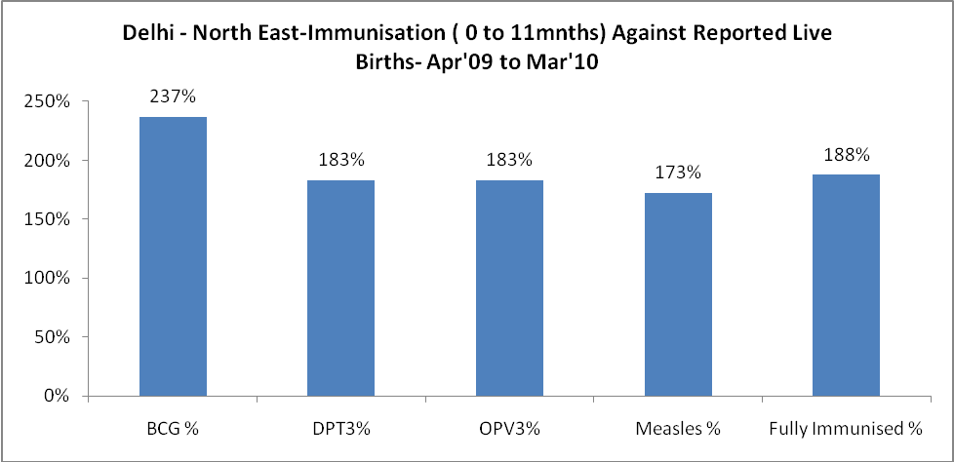

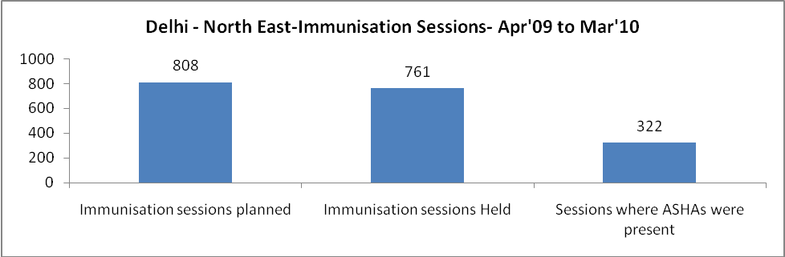

Delhi - North East- Apr'09 to Mar'10
Total Abortions | Abortion Rate
4,196 | 9.7%

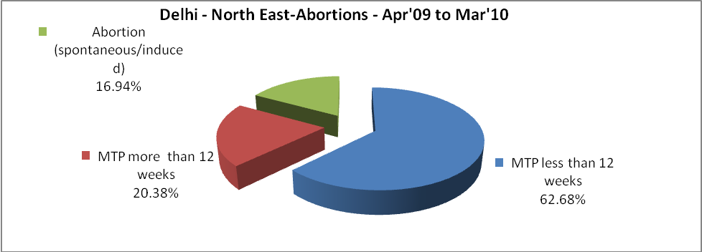

Delhi - North East- Apr'09 to Mar'10
Total OPD | Total RTI/STI cases
803,396 | 13,556

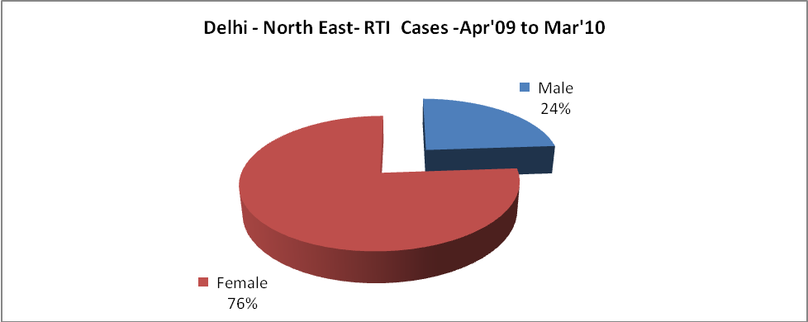

Delhi - North East-Sterilisations - Apr'09 to Mar'10
 | Reported | %age of Reported Sterilisation
Total Sterilisation | 9,507 | -
NSV | 2,656 | 28%
Laproscopic | 2,076 | 22%
MiniLap | 3,470 | 36%
Post Partum | 1,305 | 14%
Male Sterilisation | 2,656 | 28%
Female Sterilisation | 6,851 | 72%

Delhi - North East-FP Methods - Apr'09 to Mar'10
 | Reported | %age of All Reported FP Methods
Total Reported FP Methodd (All types) Users | 21,046 | -
Sterilisations | 9,507 | 45%
IUD | 4,331 | 21%
Condom Users | 6,459 | 31%
OCP Users | 749 | 4%
Limiting Methods | 9,507 | 45%
Spacing Methods | 11,539 | 55%

Delhi - North East- Service Delivery - Apr'09 to Mar'10
Operation major (General and spinal anaesthesia) | Operation minor (No or local anaesthesia) | AYUSH | Dental Procedures | Adolescent counselling services | Total OPD | Total IPD
2,945 | 868 | 8,937 | - | - | 803,396 | 5,231
Operation major (General and spinal anaesthesia) as %ge of OPD | Operation minor (No or local anaesthesia)as %ge of OPD | AYUSH as %ge of OPD | Dental Procedures as %ge of OPD | Adolescent counselling services as %ge of OPD | IPD as percentage of OPD
0.4% | 0.1% | 1.1% | 0.0% | 0.0% | 1%

Delhi - North East- Lab Services - Apr'09 to Mar'10
Total OPD | Total HB tested | Total HIV Tested | Total Population
803,396 | 19,399 | 7,774 | 2,137,169
HB test conducted as %age of OPD | HB<7gm as %age of HB tested | HIV test conducted as %age of OPD | HIV positive as %age of HIV tested | Blood Smear Examined as % of Population
2.4% | 30.1% | 1.0% | 0.0% | 0.1%

Delhi - North East- Childhood Disease - Vaccine Preventable -Apr'09 to Mar'10
Diphtheria | Pertussis | Tetanus Neonatorum | Tetanus others | Polio | Measles
0 | 0 | 0 | 0 | 0 | 136
Delhi - North East-Childhood Disease - Others - Apr'09 to Mar'10
Diarrhoea and dehydration | Malaria | Number admitted with Respiratory Infections
10,842 | - | 1,682

Delhi - North East- Infant & Child Deaths - Apr'09 to Mar'10
Infant Deaths within 24 hrs of birth | Infant Deaths between 24hrs & under 1 week | Infant Deaths between 1 week & under 1 month | Child Deaths between 1 month & under 1 year | Child Deaths between 1yr under 5years | Total Deaths
0 | 0 | 0 | 0 | 0 | 0

Delhi - North East- Causes of Infant & Child Deaths - Apr'09 to Mar'10
Sepsis |  |  | Asphyxia |  |  | LBW
Up to 1 Weeks of Birth | Between 1 week & 4 weeks of birth | Total | Up to 1 Weeks of Birth | Between 1 week & 4 weeks of birth | Total | Up to 1 Weeks of Birth | Between 1 week & 4 weeks of birth | Total
0 | 0 | 0 | 0 | 0 | 0 | 0 | 0 | 0
Pneumonia |  |  | Diarrhoea |  |  | Fever related
Between 1 month and 11 months | Between 1 year & 5 years | Total | Between 1 month and 11 months | Between 1 year & 5 years | Total | Between 1 month and 11 months | Between 1 year & 5 years | Total
0 | 0 | 0 | 0 | 0 | 0 | 0 | 0 | 0
Others |  |  | Measles |  |  | Others
Up to 1 Weeks of Birth | Between 1 week & 4 weeks of birth | Total | Between 1 month and 11 months | Between 1 year & 5 years | Total | Between 1 month and 11 months | Between 1 year & 5 years | Total
0 | 0 | 0 | 0 | 0 | 0 | 0 | 0 | 0

Delhi - North East- Maternal Deaths & Causes - Apr'09 to Mar'10
Abortion |  |  | Obstructed/prolonged labour |  |  | Severe hypertesnion/fits
6-14 yrs | 15-55 yrs. | Total | 6-14 yrs | 15-55 yrs. | Total | 6-14 yrs | 15-55 yrs. | Total
0 | 0 | 0 | 0 | 0 | 0 | 0 | 0 | 0
Bleeding |  |  | High Fever |  |  | Other Causes
6-14 yrs | 15-55 yrs. | Total | 6-14 yrs | 15-55 yrs. | Total | 6-14 yrs | 15-55 yrs. | Total
0 | 0 | 0 | 0 | 0 | 0 | 0 | 0 | 0

Delhi - North East-Causes of Deaths in 6 to 55yrs age group - Apr'09 to Mar'10
Diarrhoel Diseases |  |  |  | Tuberculosis |  |  |  | Respiratory Diseases( Other than TB)
6-14 yrs | 15-55 yrs. | Above 55yrs | Total | 6-14 yrs | 15-55 yrs. | Above 55yrs | Total | 6-14 yrs | 15-55 yrs. | Above 55yrs | Total
0 | 0 | 0 | 0 | 0 | 0 | 0 | 0 | 0 | 0 | 0 | 0
Malaria |  |  |  | Other fever Related |  |  |  | HIV/Aids
6-14 yrs | 15-55 yrs. | Above 55yrs | Total | 6-14 yrs | 15-55 yrs. | Above 55yrs | Total | 6-14 yrs | 15-55 yrs. | Above 55yrs | Total
0 | 0 | 0 | 0 | 0 | 0 | 0 | 0 | 0 | 0 | 0 | 0
Heart Disease/Hypertenion related |  |  |  | Neurological Disease including strokes |  |  |  | Trauma/Accidents/ Burn Cases
6-14 yrs | 15-55 yrs. | Above 55yrs | Total | 6-14 yrs | 15-55 yrs. | Above 55yrs | Total | 6-14 yrs | 15-55 yrs. | Above 55yrs | Total
0 | 0 | 0 | 0 | 0 | 0 | 0 | 0 | 0 | 0 | 0 | 0
Suicide |  |  |  | Animal Bites & Stings
6-14 yrs | 15-55 yrs. | Above 55yrs | Total | 6-14 yrs | 15-55 yrs. | Above 55yrs | Total
0 | 0 | 0 | 0 | 0 | 0 | 0 | 0

