NHSRC
Delhi-North West
Analysis: Apr 2009 – Mar 2010

Delhi - North West- Summary-Apr'09 to Mar'10
ANC
ANC Registration against Expected Pregnancies | 186% | TT1 given to Pregnant women against ANC Registraion | 41%
3 ANC Check ups against ANC Reigtrations | 38% | 100 IFA Tablets given to Pregnant women against ANC Registraion | 49%
Deliveries
Unreported Deliveries against Estimated Deliveries | 74.8% | HOME Deliveries( SBA& Non SBA) against Estimated Deliveries | 5.3%
Institutional Deliveries against Estimated Deliveries | 19.9% | HOME Deliveries( SBA& Non SBA) against Reported Deliveries | 21.1%
Institutional Deliveries against Reported Deliveries | 78.9% | C Section Deliveries against Institutional Deliveries( Pvt & Pub) | 24%
Births & Neonates Care
Live Births Reported against Estimated Live Births | 41% | New borns weighed against Reported Live Births | 59%
Still Births (Reported) | 539 | New borns weighed less than 2.5 kgs against newborns weighed | 27%
Sex Ratio at Birh | 890 | New borns breastfed within one hr of Birth against Reported live Births | 39%
Child Immunisation( 0 to 11 months)
BCG given against Expected Live Births | 87% | Measles given against Expected Live Births | 84%
OPV3 given against Expected Live Births | 86% | Fully Immunised Children against Expected Live Births | 102%
DPT3 given against Expected Live Births | 86%
Family Planning
Family Plannig Methods Users ( Sterilisations(Male &Female)+IUD+ Condom pieces/72 + OCP Cycles/13) | 41,066 | IUD Insertions against reported FP Methods | 16%
Sterilisation against reported FP Methods | 7% | Condom Users against reported FP Methods | 66%
 |  | OCP Users against reported FP Methods | 11%
Other Services
OPD | 5,004,505 | Major Operations | 8,977
IPD | 38,901 | Minor Operations | 17,941

Delhi - North West- Deliveries Apr'09 to Mar'10
Total Population | 3,458,117 | Expected Deliveries |  | 64,743
Home SBA | Home Non SBA | Institutional | Total Deliveries Reported | Unreported Deliveries
728 | 2,705 | 12,857 | 16,290 | 48,453
Home SBA % | Home Non SBA% | Institutional % | Total Deliveries Reported % | Unreported Deliveries %
1% | 4% | 20% | 25% | 75%
`

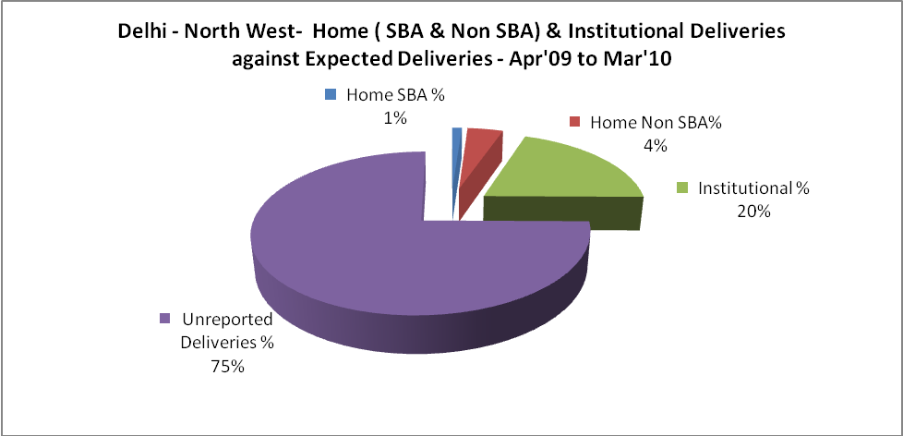

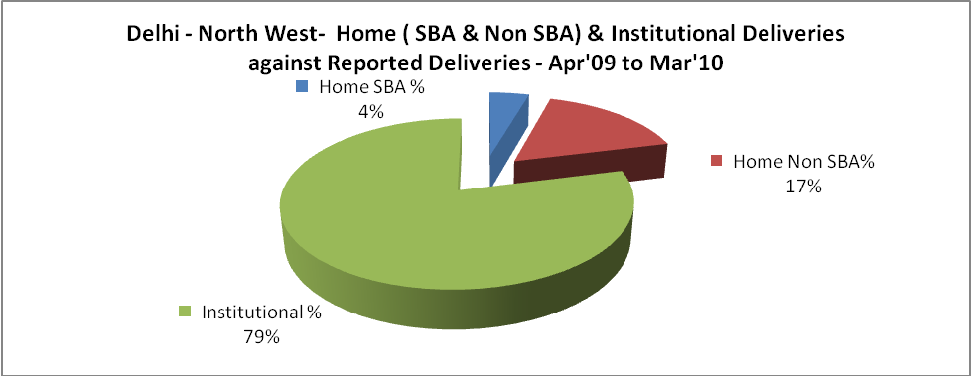

Delhi - North West- C sections & Complicated Deliveries Apr'09 to Mar'10
 | Institutional Deliveries (Public) | Institutional Deliveries (Pvt)
 | 12,296 | 561
C Section | 2,650 | 432
C Section% | 22% | 77%
Complicated Pregnacies attended | 6,511 | 101
Complicated Pregnacies attended % | 53% | 18%

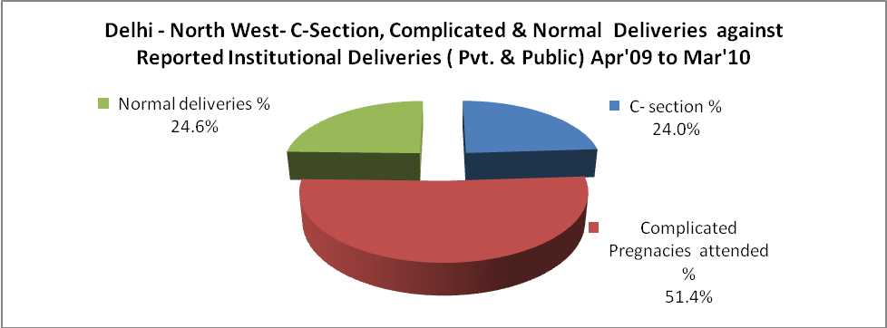

Delhi - North West- Complicated Pregnancies & Deliveries Treated - Apr'09 to Mar'10
Reported Deliveries |  |  | Reported ANC Reigtration
16,290 |  |  | 130,531
Complicated Pregnancies attended | Complicated Pregnancies Rate | C - Section Deliveries | PNC Maternal Complications | Abortions | Still Births
6,612 | 9% | 3,082 | 424 | 1,881 | 539
Complicated Deliveries Treated with |  |  |  | No Of Eclampsia cases Treated | No Of severe anemia cases treated
IV Antibiotics | IV antihypertensive/Magsulph injection | IV Oxytocis | Blood Transfusion | No Of Eclampsia cases Treated | No Of severe anemia cases treated
2,368 | 136 | 2,767 | 367 | 47 | 1,358

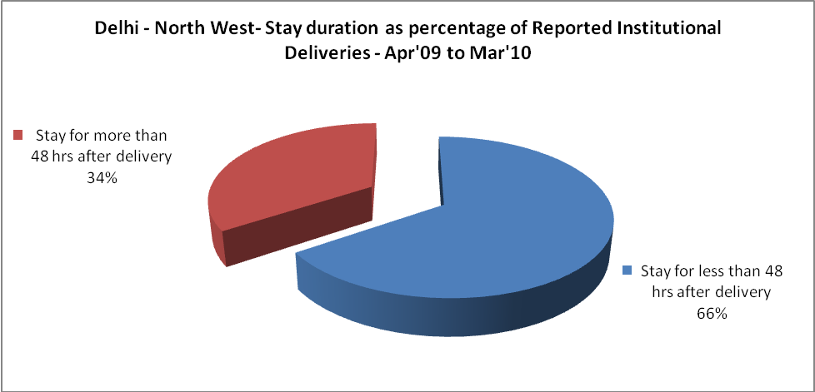

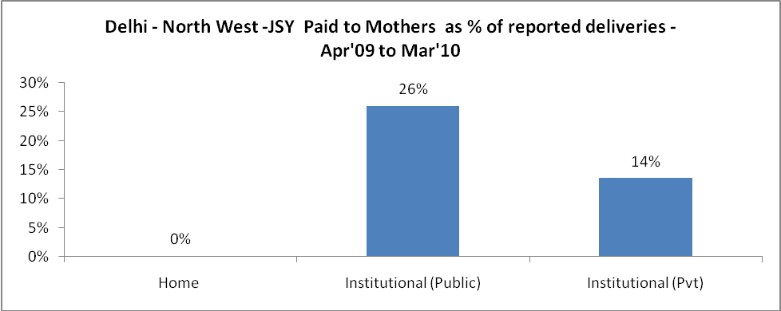

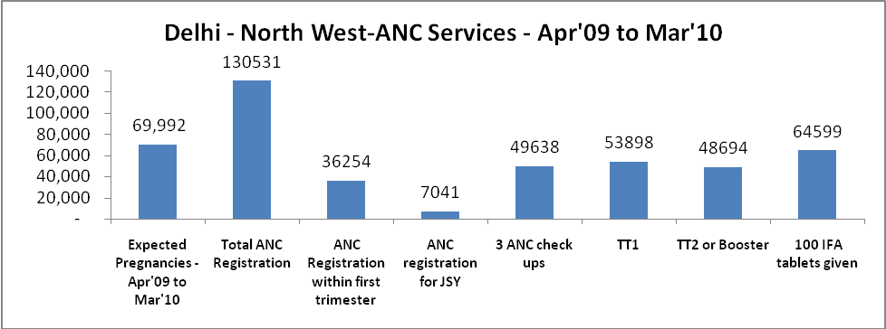

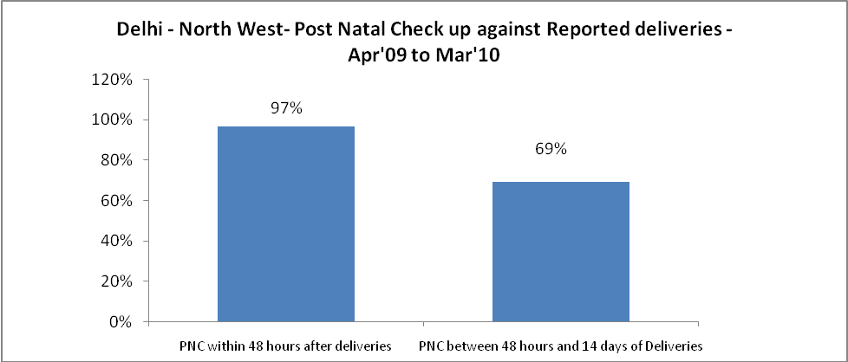

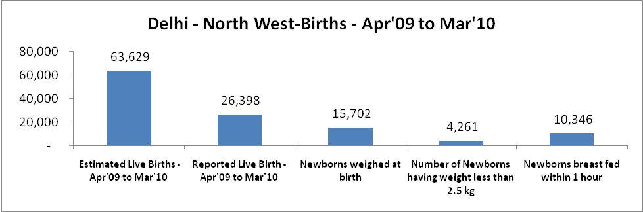

Delhi - North West - Births - Apr'09 to Mar'10
Live Birth - Males | Live Birth - females | Live Birth - Total | Sex Ratio at birth | Still Birth | Abortion( Induced/Spontaneous
13,964 | 12,434 | 26,398 | 890 | 539 | 1,881

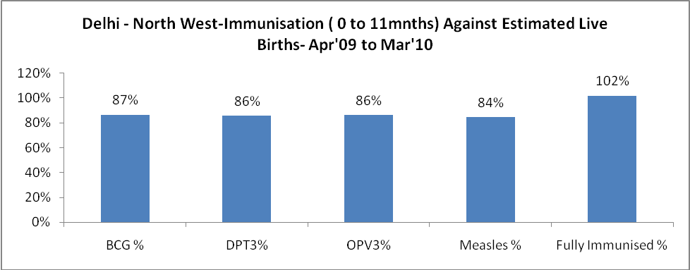

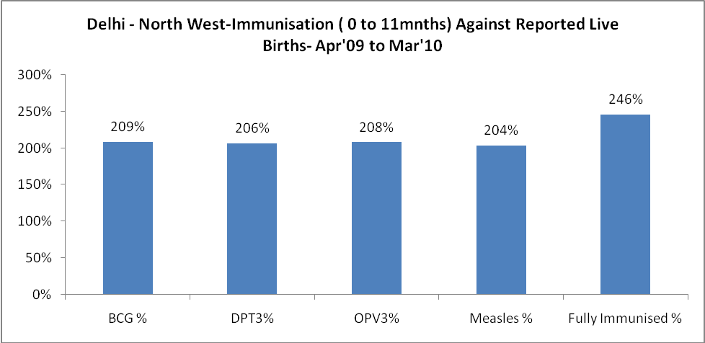

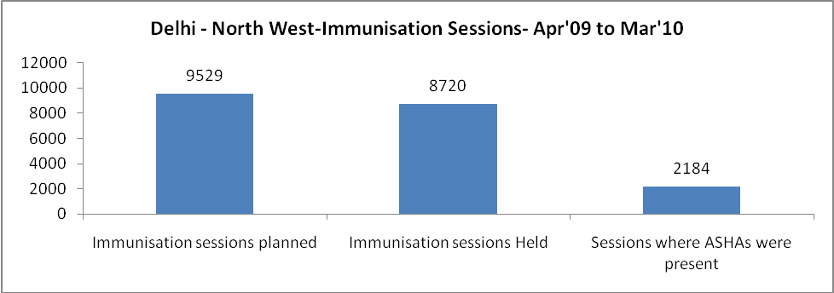

Delhi - North West- Apr'09 to Mar'10
Total Abortions | Abortion Rate
4,138 | 5.9%

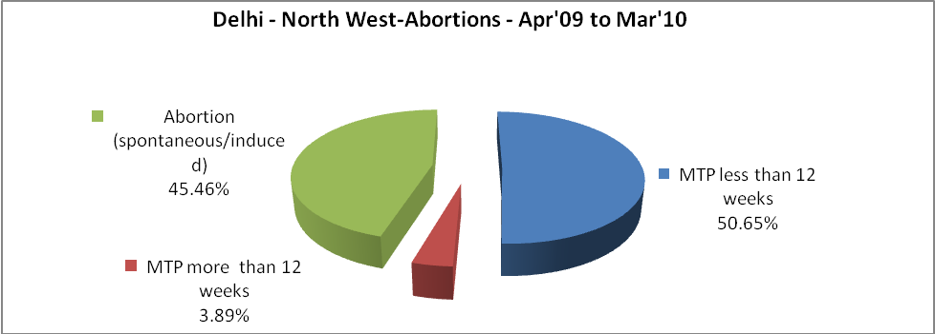

Delhi - North West- Apr'09 to Mar'10
Total OPD | Total RTI/STI cases
5,004,505 | 29,493

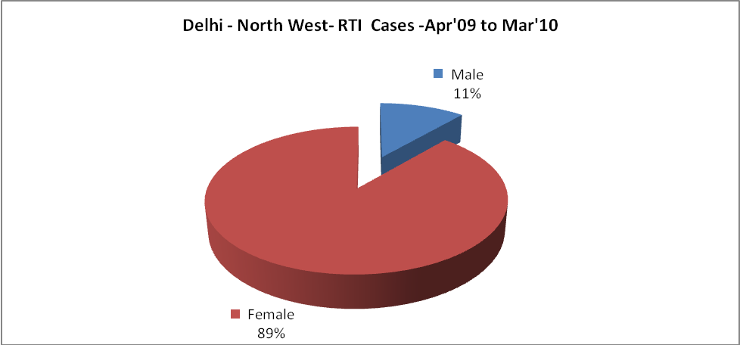

Delhi - North West-Sterilisations - Apr'09 to Mar'10
 | Reported | %age of Reported Sterilisation
Total Sterilisation | 2,676 | -
NSV | 147 | 5%
Laproscopic | 2,010 | 75%
MiniLap | 194 | 7%
Post Partum | 325 | 12%
Male Sterilisation | 147 | 5%
Female Sterilisation | 2,529 | 95%

Delhi - North West-FP Methods - Apr'09 to Mar'10
 | Reported | %age of All Reported FP Methods
Total Reported FP Methodd (All types) Users | 41,066 | -
Sterilisations | 2,676 | 7%
IUD | 6,736 | 16%
Condom Users | 27,222 | 66%
OCP Users | 4,432 | 11%
Limiting Methods | 2,676 | 7%
Spacing Methods | 38,390 | 93%

Delhi - North West- Service Delivery - Apr'09 to Mar'10
Operation major (General and spinal anaesthesia) | Operation minor (No or local anaesthesia) | AYUSH | Dental Procedures | Adolescent counselling services | Total OPD | Total IPD
8,977 | 17,941 | 25,584 | 20,144 | 2,674 | 5,004,505 | 38,901
Operation major (General and spinal anaesthesia) as %ge of OPD | Operation minor (No or local anaesthesia)as %ge of OPD | AYUSH as %ge of OPD | Dental Procedures as %ge of OPD | Adolescent counselling services as %ge of OPD | IPD as percentage of OPD
0.2% | 0.4% | 0.5% | 0.4% | 0.1% | 1%

Delhi - North West- Lab Services - Apr'09 to Mar'10
Total OPD | Total HB tested | Total HIV Tested | Total Population
5,004,505 | 172,561 | 22,951 | 3,458,117
HB test conducted as %age of OPD | HB<7gm as %age of HB tested | HIV test conducted as %age of OPD | HIV positive as %age of HIV tested | Blood Smear Examined as % of Population
3.4% | 4.6% | 0.5% | 1.7% | 1.0%

Delhi - North West- Childhood Disease - Vaccine Preventable -Apr'09 to Mar'10
Diphtheria | Pertussis | Tetanus Neonatorum | Tetanus others | Polio | Measles
0 | 0 | 1 | 0 | 0 | 0
Delhi - North West-Childhood Disease - Others - Apr'09 to Mar'10
Diarrhoea and dehydration | Malaria | Number admitted with Respiratory Infections
23,998 | 34 | 7,504

Delhi - North West- Infant & Child Deaths - Apr'09 to Mar'10
Infant Deaths within 24 hrs of birth | Infant Deaths between 24hrs & under 1 week | Infant Deaths between 1 week & under 1 month | Child Deaths between 1 month & under 1 year | Child Deaths between 1yr under 5years | Total Deaths
7 | 96 | 85 | 71 | 78 | 337

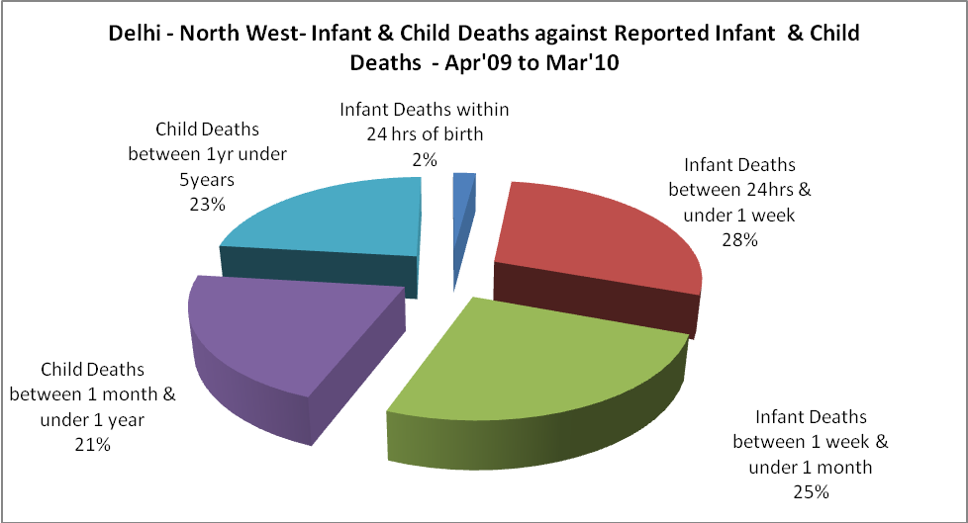

Delhi - North West- Causes of Infant & Child Deaths - Apr'09 to Mar'10
Sepsis |  |  | Asphyxia |  |  | LBW
Up to 1 Weeks of Birth | Between 1 week & 4 weeks of birth | Total | Up to 1 Weeks of Birth | Between 1 week & 4 weeks of birth | Total | Up to 1 Weeks of Birth | Between 1 week & 4 weeks of birth | Total
29 | 29 | 58 | 43 | 19 | 62 | 15 | 19 | 34
Pneumonia |  |  | Diarrhoea |  |  | Fever related
Between 1 month and 11 months | Between 1 year & 5 years | Total | Between 1 month and 11 months | Between 1 year & 5 years | Total | Between 1 month and 11 months | Between 1 year & 5 years | Total
30 | 14 | 44 | 6 | 30 | 36 | 17 | 4 | 21
Others |  |  | Measles |  |  | Others
Up to 1 Weeks of Birth | Between 1 week & 4 weeks of birth | Total | Between 1 month and 11 months | Between 1 year & 5 years | Total | Between 1 month and 11 months | Between 1 year & 5 years | Total
9 | 18 | 27 | 1 | 1 | 2 | 17 | 29 | 46

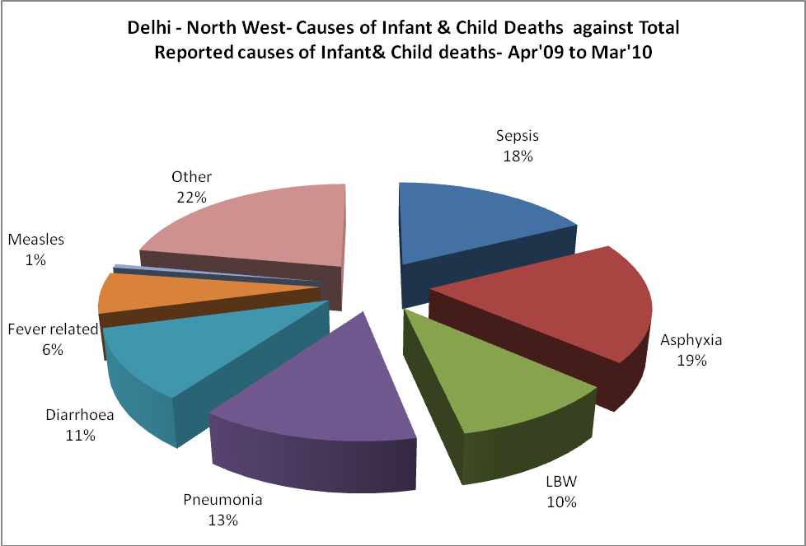

Delhi - North West- Maternal Deaths & Causes - Apr'09 to Mar'10
Abortion |  |  | Obstructed/prolonged labour |  |  | Severe hypertesnion/fits
6-14 yrs | 15-55 yrs. | Total | 6-14 yrs | 15-55 yrs. | Total | 6-14 yrs | 15-55 yrs. | Total
0 | 0 | 0 | 0 | 0 | 0 | 0 | 2 | 2
Bleeding |  |  | High Fever |  |  | Other Causes
6-14 yrs | 15-55 yrs. | Total | 6-14 yrs | 15-55 yrs. | Total | 6-14 yrs | 15-55 yrs. | Total
0 | 8 | 8 | 0 | 5 | 5 | 0 | 8 | 8

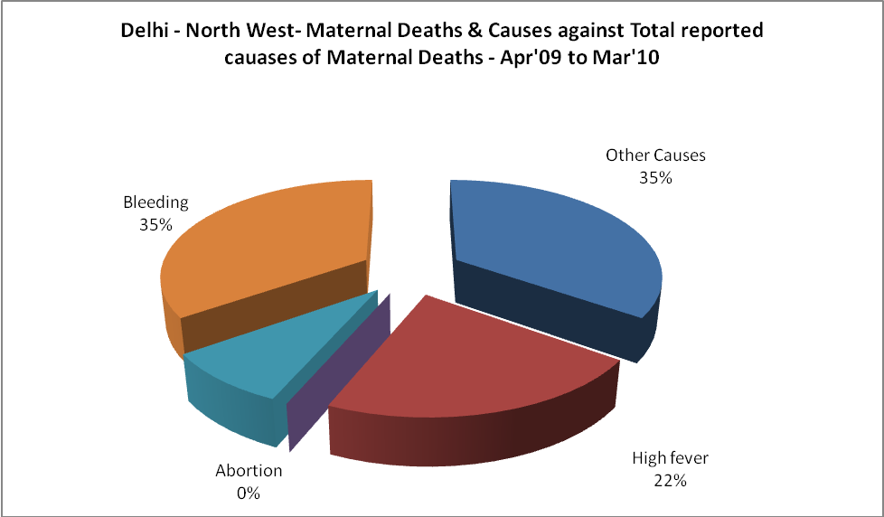

Delhi - North West-Causes of Deaths in 6 to 55yrs age group - Apr'09 to Mar'10
Diarrhoel Diseases |  |  |  | Tuberculosis |  |  |  | Respiratory Diseases( Other than TB)
6-14 yrs | 15-55 yrs. | Above 55yrs | Total | 6-14 yrs | 15-55 yrs. | Above 55yrs | Total | 6-14 yrs | 15-55 yrs. | Above 55yrs | Total
5 | 2 | 1 | 8 | 3 | 74 | 18 | 95 | 4 | 103 | 70 | 177
Malaria |  |  |  | Other fever Related |  |  |  | HIV/Aids
6-14 yrs | 15-55 yrs. | Above 55yrs | Total | 6-14 yrs | 15-55 yrs. | Above 55yrs | Total | 6-14 yrs | 15-55 yrs. | Above 55yrs | Total
2 | 1 | 6 | 9 | 2 | 52 | 9 | 63 | 0 | 18 | 0 | 18
Heart Disease/Hypertenion related |  |  |  | Neurological Disease including strokes |  |  |  | Trauma/Accidents/ Burn Cases
6-14 yrs | 15-55 yrs. | Above 55yrs | Total | 6-14 yrs | 15-55 yrs. | Above 55yrs | Total | 6-14 yrs | 15-55 yrs. | Above 55yrs | Total
5 | 83 | 102 | 190 | 5 | 34 | 13 | 52 | 1 | 29 | 3 | 33
Suicide |  |  |  | Animal Bites & Stings
6-14 yrs | 15-55 yrs. | Above 55yrs | Total | 6-14 yrs | 15-55 yrs. | Above 55yrs | Total
1 | 11 | 1 | 13 | 0 | 1 | 0 | 1

