NHSRC
Delhi-North
Analysis: Apr 2009 – Mar 2010

Delhi - North- Summary-Apr'09 to Mar'10
ANC
ANC Registration against Expected Pregnancies | 275% | TT1 given to Pregnant women against ANC Registraion | 27%
3 ANC Check ups against ANC Reigtrations | 56% | 100 IFA Tablets given to Pregnant women against ANC Registraion | 43%
Deliveries
Unreported Deliveries against Estimated Deliveries | 26.8% | HOME Deliveries( SBA& Non SBA) against Estimated Deliveries | 3.4%
Institutional Deliveries against Estimated Deliveries | 69.8% | HOME Deliveries( SBA& Non SBA) against Reported Deliveries | 4.7%
Institutional Deliveries against Reported Deliveries | 95.3% | C Section Deliveries against Institutional Deliveries( Pvt & Pub) | 25%
Births & Neonates Care
Live Births Reported against Estimated Live Births | 74% | New borns weighed against Reported Live Births | 93%
Still Births (Reported) | 215 | New borns weighed less than 2.5 kgs against newborns weighed | 22%
Sex Ratio at Birh | 903 | New borns breastfed within one hr of Birth against Reported live Births | 73%
Child Immunisation( 0 to 11 months)
BCG given against Expected Live Births | 99% | Measles given against Expected Live Births | 73%
OPV3 given against Expected Live Births | 74% | Fully Immunised Children against Expected Live Births | 87%
DPT3 given against Expected Live Births | 73%
Family Planning
Family Plannig Methods Users ( Sterilisations(Male &Female)+IUD+ Condom pieces/72 + OCP Cycles/13) | 13,097 | IUD Insertions against reported FP Methods | 17%
Sterilisation against reported FP Methods | 10% | Condom Users against reported FP Methods | 67%
 |  | OCP Users against reported FP Methods | 6%
Other Services
OPD | 1,653,217 | Major Operations | 8,752
IPD | 83,305 | Minor Operations | 16,992

`
Delhi - North- Deliveries Apr'09 to Mar'10
Total Population | 944,680 | Expected Deliveries |  | 17,686
Home SBA | Home Non SBA | Institutional | Total Deliveries Reported | Unreported Deliveries
74 | 529 | 12,352 | 12,955 | 4,731
Home SBA % | Home Non SBA% | Institutional % | Total Deliveries Reported % | Unreported Deliveries %
0% | 3% | 70% | 73% | 27%

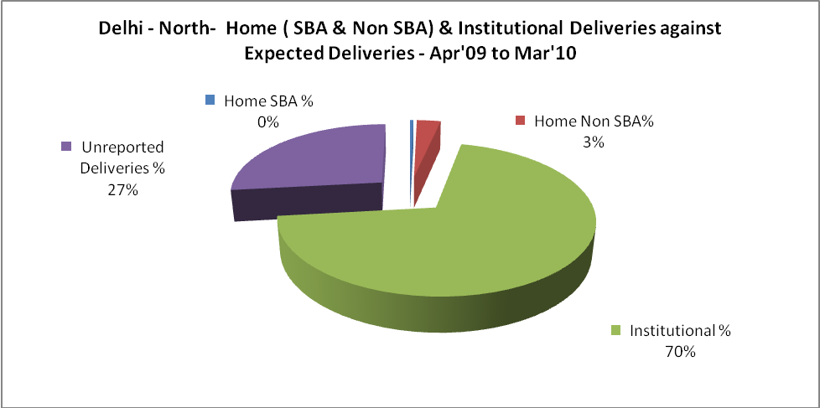

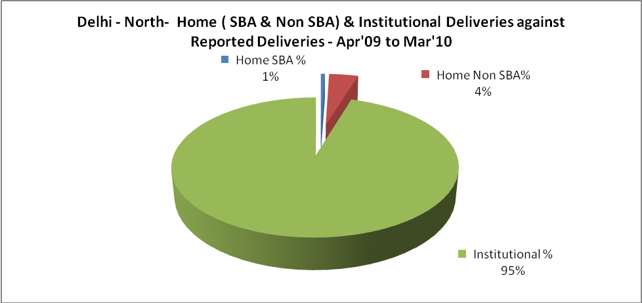

Delhi - North- C sections & Complicated Deliveries Apr'09 to Mar'10
 | Institutional Deliveries (Public) | Institutional Deliveries (Pvt)
 | 7,172 | 5,180
C Section | 1,245 | 1,789
C Section% | 17% | 35%
Complicated Pregnacies attended | 3,653 | 206
Complicated Pregnacies attended % | 51% | 4%

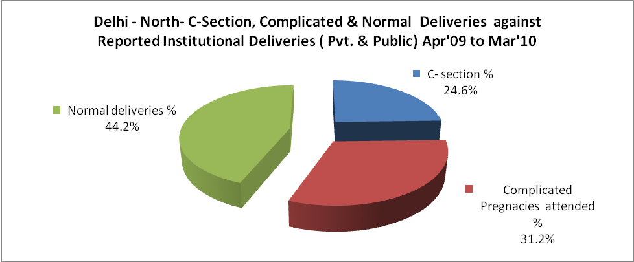

Delhi - North- Complicated Pregnancies & Deliveries Treated - Apr'09 to Mar'10
Reported Deliveries |  |  | Reported ANC Reigtration
12,955 |  |  | 52,504
Complicated Pregnancies attended | Complicated Pregnancies Rate | C - Section Deliveries | PNC Maternal Complications | Abortions | Still Births
3,859 | 20% | 3,034 | 489 | 1,182 | 215
Complicated Deliveries Treated with |  |  |  | No Of Eclampsia cases Treated | No Of severe anemia cases treated
IV Antibiotics | IV antihypertensive/Magsulph injection | IV Oxytocis | Blood Transfusion | No Of Eclampsia cases Treated | No Of severe anemia cases treated
2,030 | 94 | 3,557 | 484 | 99 | 906

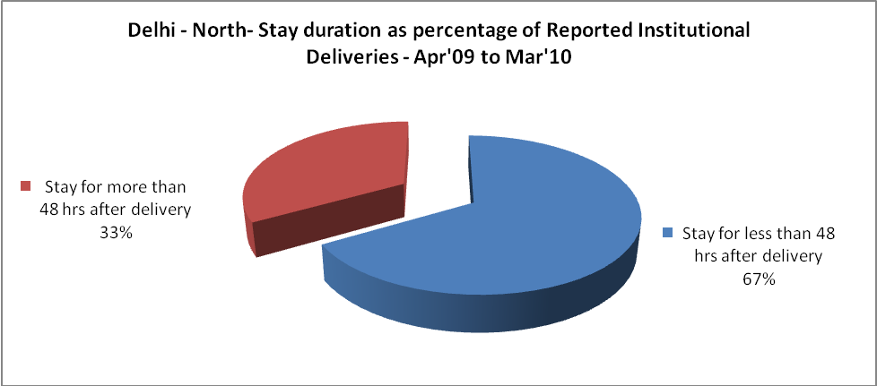

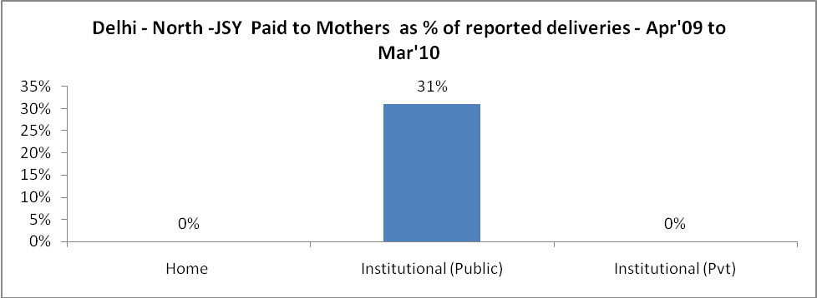

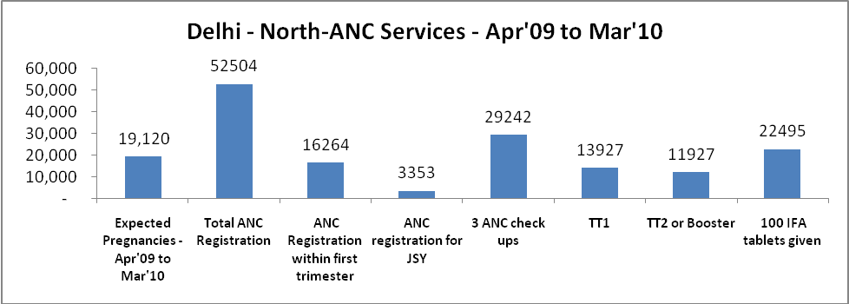

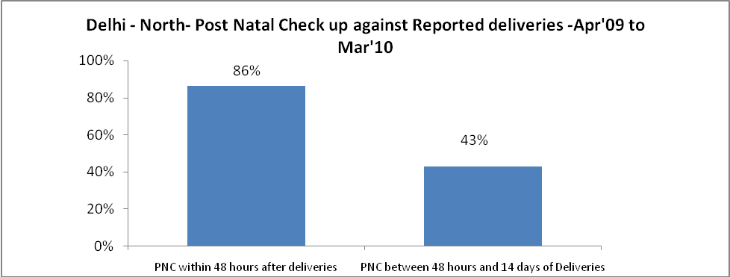

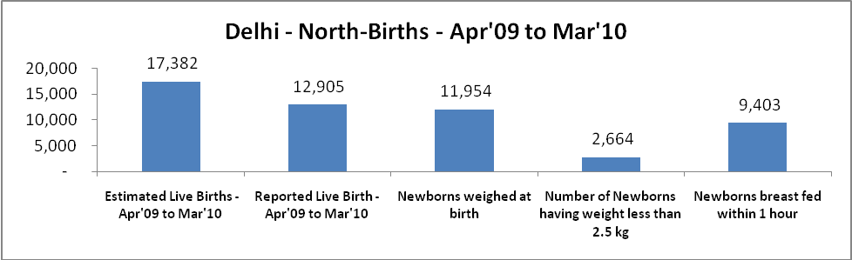

Delhi - North - Births - Apr'09 to Mar'10
Live Birth - Males | Live Birth - females | Live Birth - Total | Sex Ratio at birth | Still Birth | Abortion( Induced/Spontaneous
6,780 | 6,125 | 12,905 | 903 | 215 | 1,182

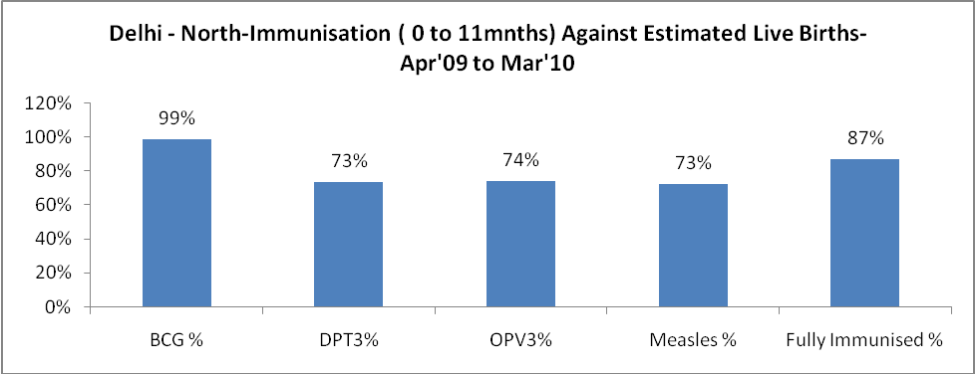

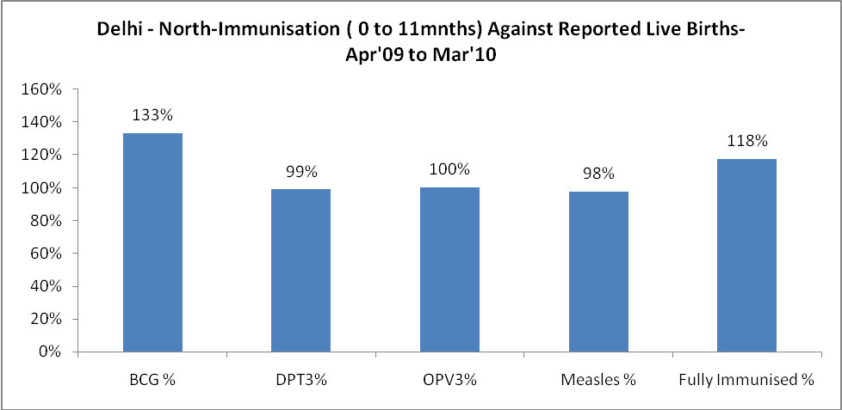

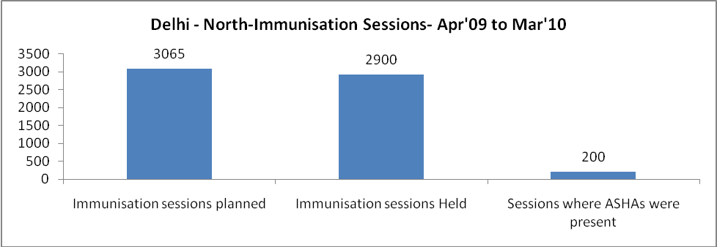

Delhi - North- Apr'09 to Mar'10
Total Abortions | Abortion Rate
1,743 | 9.1%

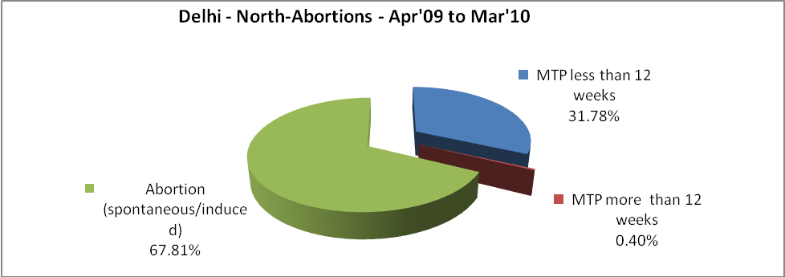

Delhi - North- Apr'09 to Mar'10
Total OPD | Total RTI/STI cases
1,653,217 | 12,372

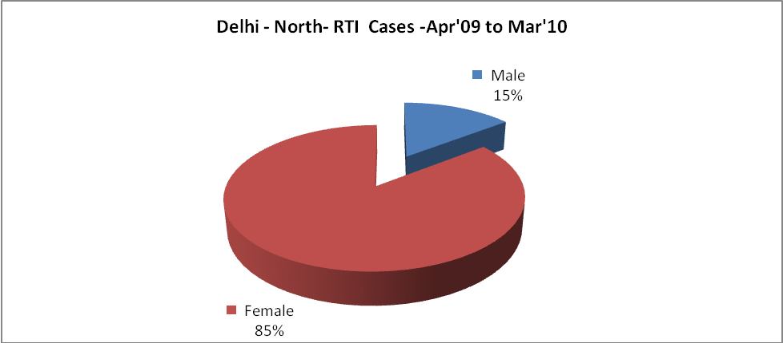

Delhi - North-Sterilisations - Apr'09 to Mar'10
 | Reported | %age of Reported Sterilisation
Total Sterilisation | 1,362 | -
NSV | 763 | 56%
Laproscopic | 565 | 41%
MiniLap | 31 | 2%
Post Partum | 3 | 0%
Male Sterilisation | 763 | 56%
Female Sterilisation | 599 | 44%

Delhi - North-FP Methods - Apr'09 to Mar'10
 | Reported | %age of All Reported FP Methods
Total Reported FP Methodd (All types) Users | 13,097 | -
Sterilisations | 1,362 | 10%
IUD | 2,270 | 17%
Condom Users | 8,713 | 67%
OCP Users | 752 | 6%
Limiting Methods | 1,362 | 10%
Spacing Methods | 11,735 | 90%

Delhi - North- Service Delivery - Apr'09 to Mar'10
Operation major (General and spinal anaesthesia) | Operation minor (No or local anaesthesia) | AYUSH | Dental Procedures | Adolescent counselling services | Total OPD | Total IPD
8,752 | 16,992 | 41,567 | 25,067 | 175 | 1,653,217 | 83,305
Operation major (General and spinal anaesthesia) as %ge of OPD | Operation minor (No or local anaesthesia)as %ge of OPD | AYUSH as %ge of OPD | Dental Procedures as %ge of OPD | Adolescent counselling services as %ge of OPD | IPD as percentage of OPD
0.5% | 1.0% | 2.5% | 1.5% | 0.0% | 5%

Delhi - North- Lab Services - Apr'09 to Mar'10
Total OPD | Total HB tested | Total HIV Tested | Total Population
1,653,217 | 71,678 | 11,076 | 944,680
HB test conducted as %age of OPD | HB<7gm as %age of HB tested | HIV test conducted as %age of OPD | HIV positive as %age of HIV tested | Blood Smear Examined as % of Population
4.3% | 4.2% | 0.7% | 1.1% | 0.8%

Delhi - North- Childhood Disease - Vaccine Preventable -Apr'09 to Mar'10
Diphtheria | Pertussis | Tetanus Neonatorum | Tetanus others | Polio | Measles
1 | 0 | 1 | 1 | 1 | 14
Delhi - North-Childhood Disease - Others - Apr'09 to Mar'10
Diarrhoea and dehydration | Malaria | Number admitted with Respiratory Infections
4,914 | 60 | 1,789

Delhi - North- Infant & Child Deaths - Apr'09 to Mar'10
Infant Deaths within 24 hrs of birth | Infant Deaths between 24hrs & under 1 week | Infant Deaths between 1 week & under 1 month | Child Deaths between 1 month & under 1 year | Child Deaths between 1yr under 5years | Total Deaths
0 | 1 | 2 | 2 | 1 | 6

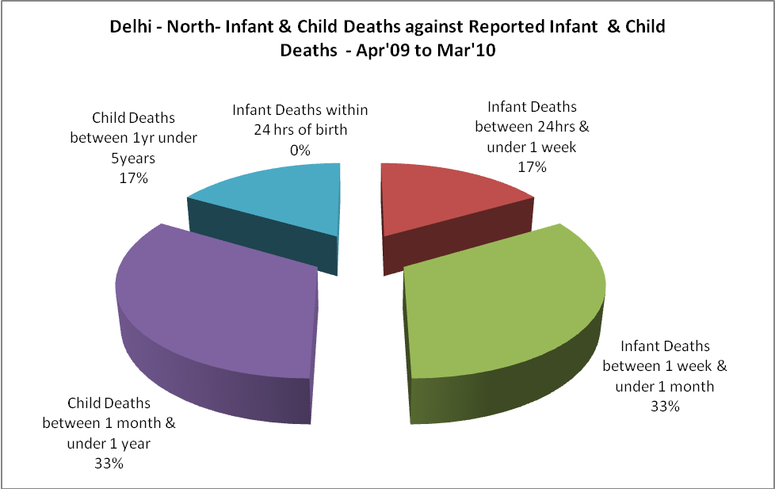

Delhi - North- Causes of Infant & Child Deaths - Apr'09 to Mar'10
Sepsis |  |  | Asphyxia |  |  | LBW
Up to 1 Weeks of Birth | Between 1 week & 4 weeks of birth | Total | Up to 1 Weeks of Birth | Between 1 week & 4 weeks of birth | Total | Up to 1 Weeks of Birth | Between 1 week & 4 weeks of birth | Total
0 | 2 | 2 | 1 | 0 | 1 | 0 | 0 | 0
Pneumonia |  |  | Diarrhoea |  |  | Fever related
Between 1 month and 11 months | Between 1 year & 5 years | Total | Between 1 month and 11 months | Between 1 year & 5 years | Total | Between 1 month and 11 months | Between 1 year & 5 years | Total
1 | 1 | 2 | 1 | 0 | 1 | 0 | 0 | 0
Others |  |  | Measles |  |  | Others
Up to 1 Weeks of Birth | Between 1 week & 4 weeks of birth | Total | Between 1 month and 11 months | Between 1 year & 5 years | Total | Between 1 month and 11 months | Between 1 year & 5 years | Total
0 | 0 | 0 | 0 | 0 | 0 | 0 | 0 | 0

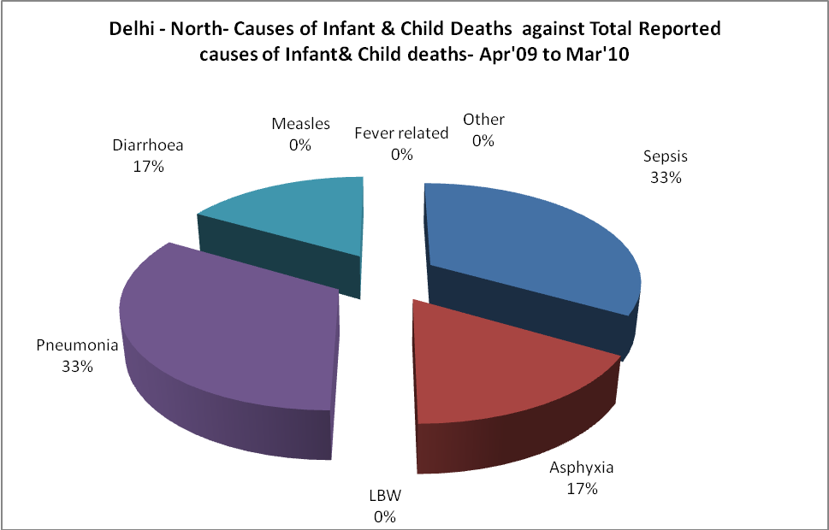

Delhi - North- Maternal Deaths & Causes - Apr'09 to Mar'10
Abortion |  |  | Obstructed/prolonged labour |  |  | Severe hypertesnion/fits
6-14 yrs | 15-55 yrs. | Total | 6-14 yrs | 15-55 yrs. | Total | 6-14 yrs | 15-55 yrs. | Total
0 | 0 | 0 | 0 | 0 | 0 | 0 | 0 | 0
Bleeding |  |  | High Fever |  |  | Other Causes
6-14 yrs | 15-55 yrs. | Total | 6-14 yrs | 15-55 yrs. | Total | 6-14 yrs | 15-55 yrs. | Total
0 | 0 | 0 | 0 | 0 | 0 | 0 | 0 | 0

Delhi - North-Causes of Deaths in 6 to 55yrs age group - Apr'09 to Mar'10
Diarrhoel Diseases |  |  |  | Tuberculosis |  |  |  | Respiratory Diseases( Other than TB)
6-14 yrs | 15-55 yrs. | Above 55yrs | Total | 6-14 yrs | 15-55 yrs. | Above 55yrs | Total | 6-14 yrs | 15-55 yrs. | Above 55yrs | Total
0 | 0 | 1 | 1 | 0 | 1 | 1 | 2 | 0 | 2 | 0 | 2
Malaria |  |  |  | Other fever Related |  |  |  | HIV/Aids
6-14 yrs | 15-55 yrs. | Above 55yrs | Total | 6-14 yrs | 15-55 yrs. | Above 55yrs | Total | 6-14 yrs | 15-55 yrs. | Above 55yrs | Total
0 | 0 | 0 | 0 | 0 | 2 | 0 | 2 | 0 | 0 | 0 | 0
Heart Disease/Hypertenion related |  |  |  | Neurological Disease including strokes |  |  |  | Trauma/Accidents/ Burn Cases
6-14 yrs | 15-55 yrs. | Above 55yrs | Total | 6-14 yrs | 15-55 yrs. | Above 55yrs | Total | 6-14 yrs | 15-55 yrs. | Above 55yrs | Total
0 | 0 | 0 | 0 | 1 | 0 | 0 | 1 | 0 | 0 | 0 | 0
Suicide |  |  |  | Animal Bites & Stings
6-14 yrs | 15-55 yrs. | Above 55yrs | Total | 6-14 yrs | 15-55 yrs. | Above 55yrs | Total
0 | 0 | 0 | 0 | 0 | 0 | 0 | 0

