NHSRC
Delhi-South West
Analysis: Apr 2009 – Mar 2010

Delhi - South West- Summary-Apr'09 to Mar'10
ANC
ANC Registration against Expected Pregnancies | 254% | TT1 given to Pregnant women against ANC Registraion | 32%
3 ANC Check ups against ANC Reigtrations | 61% | 100 IFA Tablets given to Pregnant women against ANC Registraion | 64%
Deliveries
Unreported Deliveries against Estimated Deliveries | 21.9% | HOME Deliveries( SBA& Non SBA) against Estimated Deliveries | 4.4%
Institutional Deliveries against Estimated Deliveries | 73.7% | HOME Deliveries( SBA& Non SBA) against Reported Deliveries | 5.6%
Institutional Deliveries against Reported Deliveries | 94.4% | C Section Deliveries against Institutional Deliveries( Pvt & Pub) | 15%
Births & Neonates Care
Live Births Reported against Estimated Live Births | 78% | New borns weighed against Reported Live Births | 82%
Still Births (Reported) | 712 | New borns weighed less than 2.5 kgs against newborns weighed | 20%
Sex Ratio at Birh | 896 | New borns breastfed within one hr of Birth against Reported live Births | 68%
Child Immunisation( 0 to 11 months)
BCG given against Expected Live Births | 114% | Measles given against Expected Live Births | 70%
OPV3 given against Expected Live Births | 72% | Fully Immunised Children against Expected Live Births | 67%
DPT3 given against Expected Live Births | 72%
Family Planning
Family Plannig Methods Users ( Sterilisations(Male &Female)+IUD+ Condom pieces/72 + OCP Cycles/13) | 25,357 | IUD Insertions against reported FP Methods | 18%
Sterilisation against reported FP Methods | 12% | Condom Users against reported FP Methods | 63%
 |  | OCP Users against reported FP Methods | 8%
Other Services
OPD | 2,911,226 | Major Operations | 5,007
IPD | 27,378 | Minor Operations | 4,328

Delhi - South West- Deliveries Apr'09 to Mar'10
Total Population | 2,121,431 | Expected Deliveries |  | 39,717
Home SBA | Home Non SBA | Institutional | Total Deliveries Reported | Unreported Deliveries
1,059 | 693 | 29,258 | 31,010 | 8,707
Home SBA % | Home Non SBA% | Institutional % | Total Deliveries Reported % | Unreported Deliveries %
3% | 2% | 74% | 78% | 22%
`

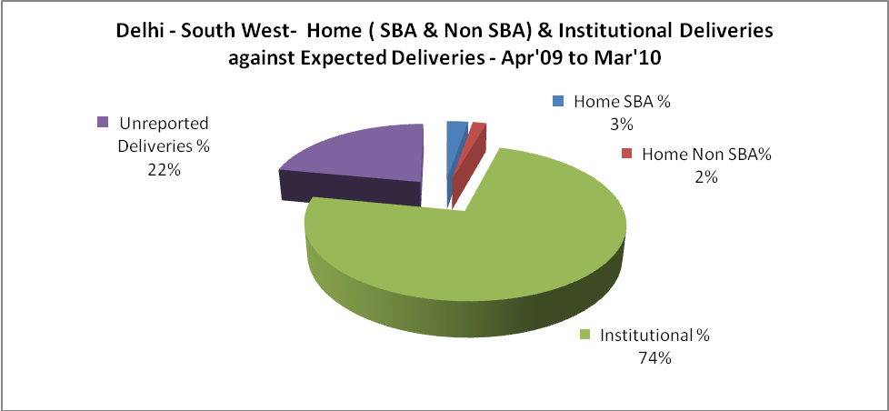

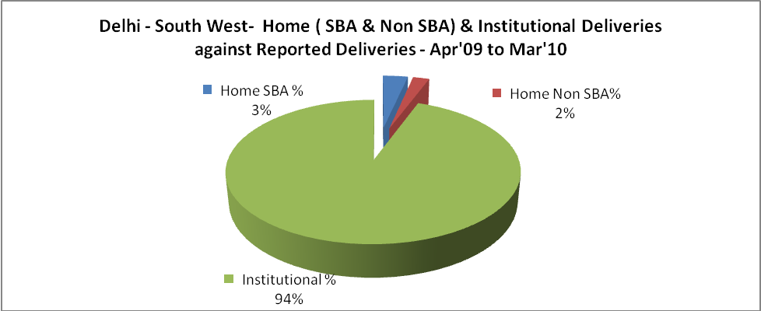

Delhi - South West- C sections & Complicated Deliveries Apr'09 to Mar'10
 | Institutional Deliveries (Public) | Institutional Deliveries (Pvt)
 | 29,257 | 1
C Section | 3,902 | 441
C Section% | 13% | 44100%
Complicated Pregnacies attended | 1,528 | 148
Complicated Pregnacies attended % | 5% | 14800%

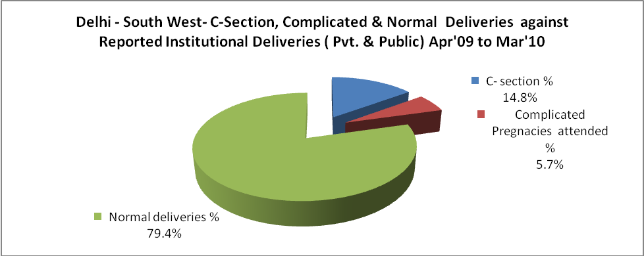

Delhi - South West- Complicated Pregnancies & Deliveries Treated - Apr'09 to Mar'10
Reported Deliveries |  |  | Reported ANC Reigtration
31,010 |  |  | 109,122
Complicated Pregnancies attended | Complicated Pregnancies Rate | C - Section Deliveries | PNC Maternal Complications | Abortions | Still Births
1,676 | 4% | 4,343 | 639 | 2,537 | 712
Complicated Deliveries Treated with |  |  |  | No Of Eclampsia cases Treated | No Of severe anemia cases treated
IV Antibiotics | IV antihypertensive/Magsulph injection | IV Oxytocis | Blood Transfusion | No Of Eclampsia cases Treated | No Of severe anemia cases treated
6,913 | 1,489 | 7,290 | 6,033 | 236 | 4,404

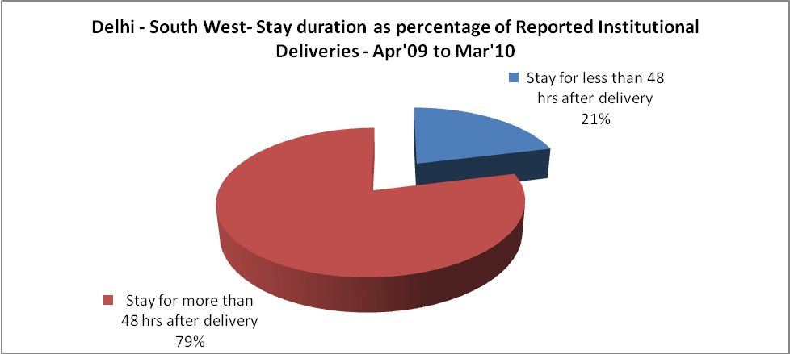

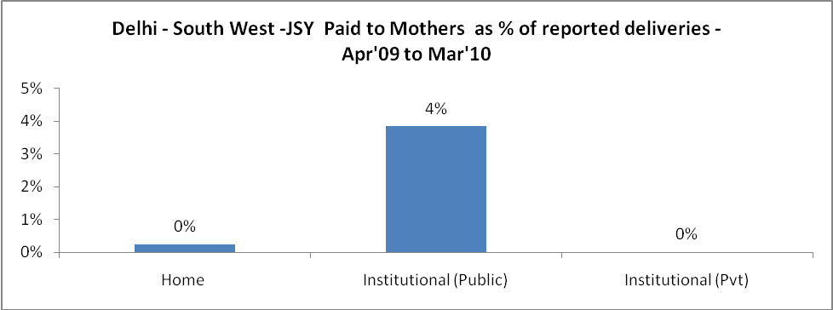

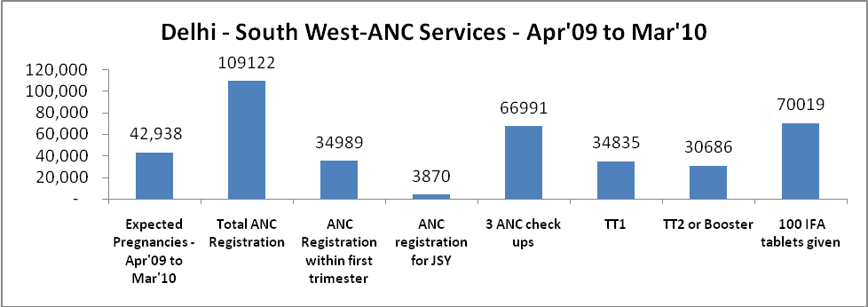

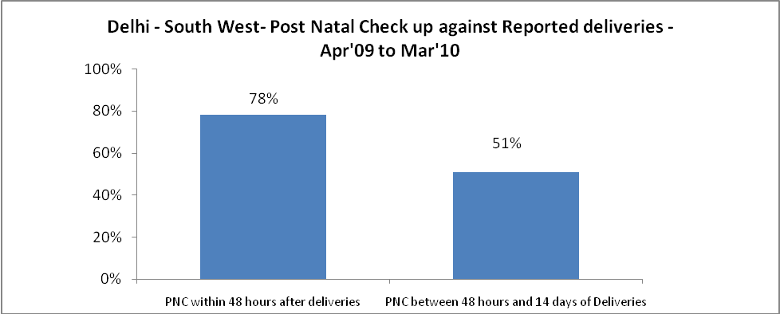

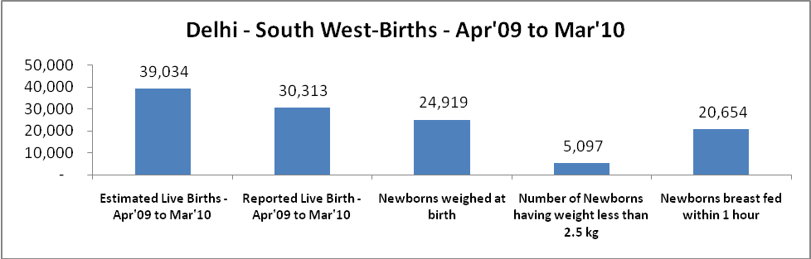

Delhi - South West - Births - Apr'09 to Mar'10
Live Birth - Males | Live Birth - females | Live Birth - Total | Sex Ratio at birth | Still Birth | Abortion( Induced/Spontaneous
15,988 | 14,325 | 30,313 | 896 | 712 | 2,537

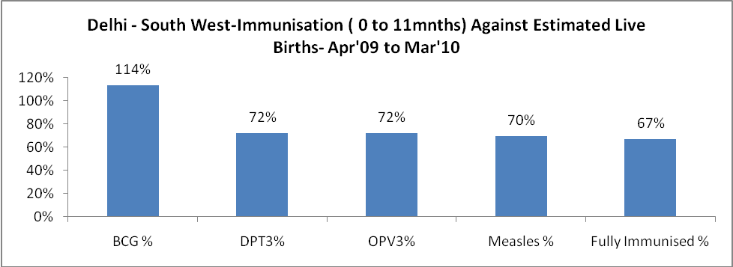

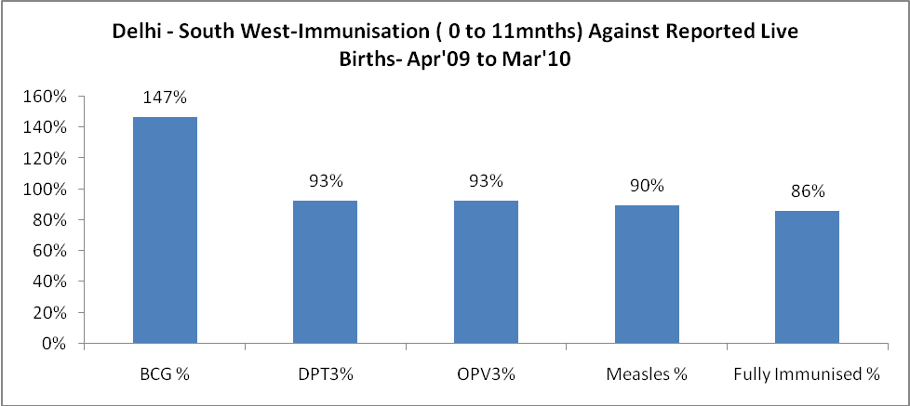

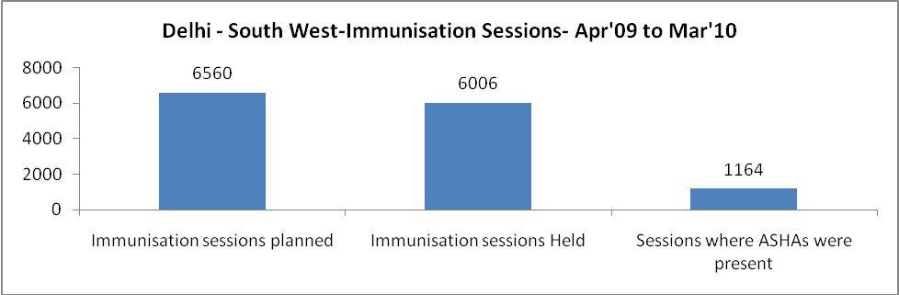

Delhi - South West- Apr'09 to Mar'10
Total Abortions | Abortion Rate
4,034 | 9.4%

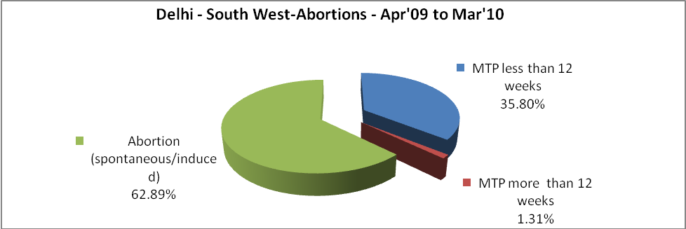

Delhi - South West- Apr'09 to Mar'10
Total OPD | Total RTI/STI cases
2,911,226 | 47,252

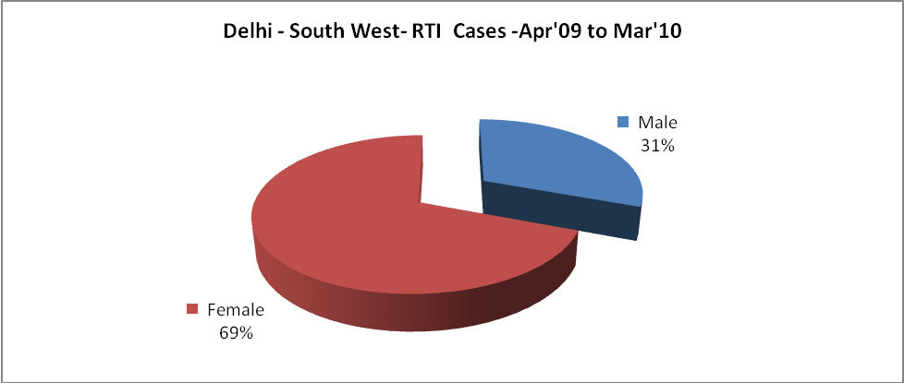

Delhi - South West-Sterilisations - Apr'09 to Mar'10
 | Reported | %age of Reported Sterilisation
Total Sterilisation | 2,951 | -
NSV | 218 | 7%
Laproscopic | 1,818 | 62%
MiniLap | 160 | 5%
Post Partum | 755 | 26%
Male Sterilisation | 218 | 7%
Female Sterilisation | 2,733 | 93%

Delhi - South West-FP Methods - Apr'09 to Mar'10
 | Reported | %age of All Reported FP Methods
Total Reported FP Methodd (All types) Users | 25,357 | -
Sterilisations | 2,951 | 12%
IUD | 4,528 | 18%
Condom Users | 15,889 | 63%
OCP Users | 1,989 | 8%
Limiting Methods | 2,951 | 12%
Spacing Methods | 22,406 | 88%

Delhi - South West- Service Delivery - Apr'09 to Mar'10
Operation major (General and spinal anaesthesia) | Operation minor (No or local anaesthesia) | AYUSH | Dental Procedures | Adolescent counselling services | Total OPD | Total IPD
5,007 | 4,328 | 25,524 | 21,572 | 851 | 2,911,226 | 27,378
Operation major (General and spinal anaesthesia) as %ge of OPD | Operation minor (No or local anaesthesia)as %ge of OPD | AYUSH as %ge of OPD | Dental Procedures as %ge of OPD | Adolescent counselling services as %ge of OPD | IPD as percentage of OPD
0.2% | 0.1% | 0.9% | 0.7% | 0.0% | 1%

Delhi - South West- Lab Services - Apr'09 to Mar'10
Total OPD | Total HB tested | Total HIV Tested | Total Population
2,911,226 | 146,314 | 30,896 | 2,121,431
HB test conducted as %age of OPD | HB<7gm as %age of HB tested | HIV test conducted as %age of OPD | HIV positive as %age of HIV tested | Blood Smear Examined as % of Population
5.0% | 2.9% | 1.1% | 0.8% | 1.5%

Delhi - South West- Childhood Disease - Vaccine Preventable -Apr'09 to Mar'10
Diphtheria | Pertussis | Tetanus Neonatorum | Tetanus others | Polio | Measles
6 | 1 | 4 | 51 | 26 | 187
Delhi - South West-Childhood Disease - Others - Apr'09 to Mar'10
Diarrhoea and dehydration | Malaria | Number admitted with Respiratory Infections
29,043 | 686 | 8,980

Delhi - South West- Infant & Child Deaths - Apr'09 to Mar'10
Infant Deaths within 24 hrs of birth | Infant Deaths between 24hrs & under 1 week | Infant Deaths between 1 week & under 1 month | Child Deaths between 1 month & under 1 year | Child Deaths between 1yr under 5years | Total Deaths
0 | 77 | 36 | 44 | 25 | 182

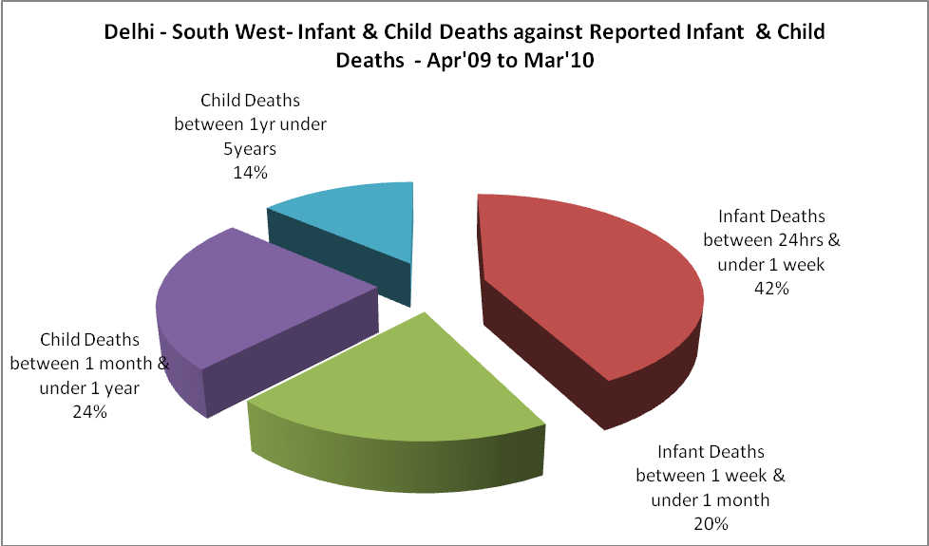

Delhi - South West- Causes of Infant & Child Deaths - Apr'09 to Mar'10
Sepsis |  |  | Asphyxia |  |  | LBW
Up to 1 Weeks of Birth | Between 1 week & 4 weeks of birth | Total | Up to 1 Weeks of Birth | Between 1 week & 4 weeks of birth | Total | Up to 1 Weeks of Birth | Between 1 week & 4 weeks of birth | Total
4 | 6 | 10 | 20 | 5 | 25 | 6 | 4 | 10
Pneumonia |  |  | Diarrhoea |  |  | Fever related
Between 1 month and 11 months | Between 1 year & 5 years | Total | Between 1 month and 11 months | Between 1 year & 5 years | Total | Between 1 month and 11 months | Between 1 year & 5 years | Total
16 | 5 | 21 | 7 | 4 | 11 | 5 | 5 | 10
Others |  |  | Measles |  |  | Others
Up to 1 Weeks of Birth | Between 1 week & 4 weeks of birth | Total | Between 1 month and 11 months | Between 1 year & 5 years | Total | Between 1 month and 11 months | Between 1 year & 5 years | Total
47 | 21 | 68 | 0 | 0 | 0 | 16 | 11 | 27

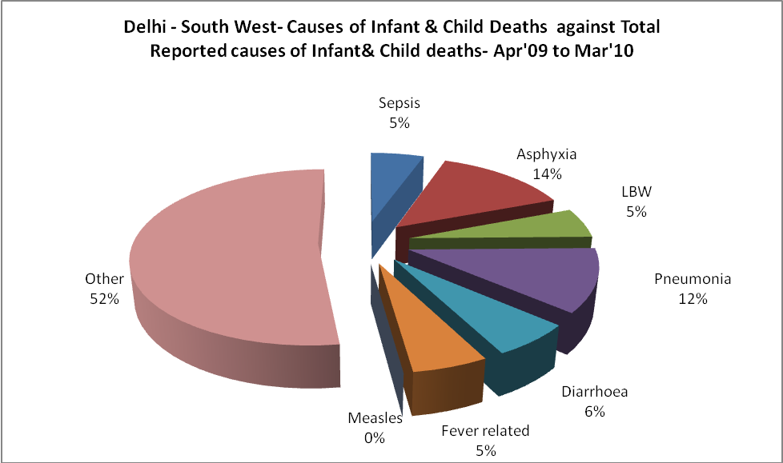
Delhi - South West- Maternal Deaths & Causes - Apr'09 to Mar'10
Abortion |  |  | Obstructed/prolonged labour |  |  | Severe hypertesnion/fits
6-14 yrs | 15-55 yrs. | Total | 6-14 yrs | 15-55 yrs. | Total | 6-14 yrs | 15-55 yrs. | Total
0 | 2 | 2 | 0 | 2 | 2 | 0 | 14 | 14
Bleeding |  |  | High Fever |  |  | Other Causes
6-14 yrs | 15-55 yrs. | Total | 6-14 yrs | 15-55 yrs. | Total | 6-14 yrs | 15-55 yrs. | Total
0 | 15 | 15 | 0 | 0 | 0 | 0 | 64 | 64

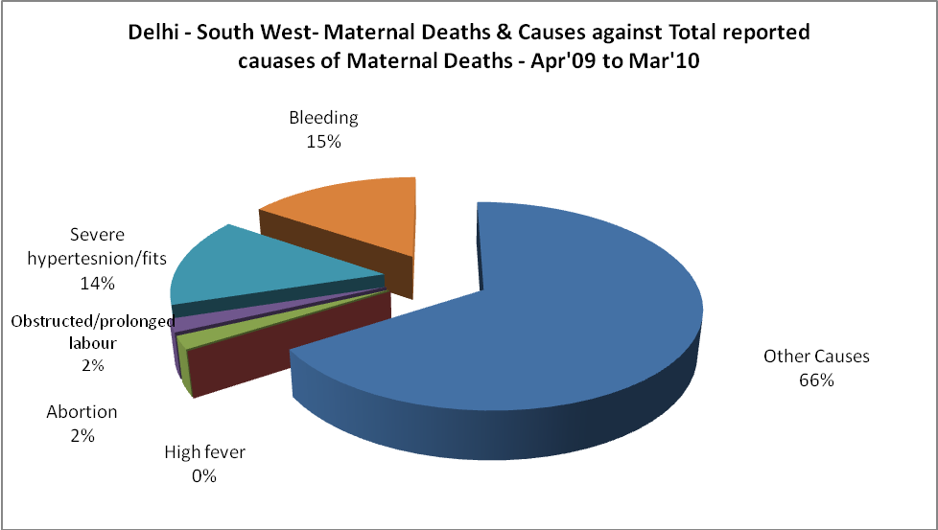

Delhi - South West-Causes of Deaths in 6 to 55yrs age group - Apr'09 to Mar'10
Diarrhoel Diseases |  |  |  | Tuberculosis |  |  |  | Respiratory Diseases( Other than TB)
6-14 yrs | 15-55 yrs. | Above 55yrs | Total | 6-14 yrs | 15-55 yrs. | Above 55yrs | Total | 6-14 yrs | 15-55 yrs. | Above 55yrs | Total
0 | 3 | 3 | 6 | 0 | 10 | 6 | 16 | 0 | 6 | 9 | 15
Malaria |  |  |  | Other fever Related |  |  |  | HIV/Aids
6-14 yrs | 15-55 yrs. | Above 55yrs | Total | 6-14 yrs | 15-55 yrs. | Above 55yrs | Total | 6-14 yrs | 15-55 yrs. | Above 55yrs | Total
1 | 0 | 0 | 1 | 5 | 14 | 15 | 34 | 0 | 5 | 0 | 5
Heart Disease/Hypertenion related |  |  |  | Neurological Disease including strokes |  |  |  | Trauma/Accidents/ Burn Cases
6-14 yrs | 15-55 yrs. | Above 55yrs | Total | 6-14 yrs | 15-55 yrs. | Above 55yrs | Total | 6-14 yrs | 15-55 yrs. | Above 55yrs | Total
5 | 52 | 46 | 103 | 0 | 4 | 2 | 6 | 4 | 42 | 9 | 55
Suicide |  |  |  | Animal Bites & Stings
6-14 yrs | 15-55 yrs. | Above 55yrs | Total | 6-14 yrs | 15-55 yrs. | Above 55yrs | Total
1 | 22 | 0 | 23 | 0 | 2 | 1 | 3

