NHSRC
Delhi-West
Analysis: Apr 2009 – Mar 2010

Delhi -West- Summary-Apr'09 to Mar'10
ANC
ANC Registration against Expected Pregnancies | 234% | TT1 given to Pregnant women against ANC Registraion | 28%
3 ANC Check ups against ANC Reigtrations | 49% | 100 IFA Tablets given to Pregnant women against ANC Registraion | 70%
Deliveries
Unreported Deliveries against Estimated Deliveries | 48.7% | HOME Deliveries( SBA& Non SBA) against Estimated Deliveries | 7.5%
Institutional Deliveries against Estimated Deliveries | 43.8% | HOME Deliveries( SBA& Non SBA) against Reported Deliveries | 14.5%
Institutional Deliveries against Reported Deliveries | 85.5% | C Section Deliveries against Institutional Deliveries( Pvt & Pub) | 25%
Births & Neonates Care
Live Births Reported against Estimated Live Births | 51% | New borns weighed against Reported Live Births | 89%
Still Births (Reported) | 405 | New borns weighed less than 2.5 kgs against newborns weighed | 29%
Sex Ratio at Birh | 894 | New borns breastfed within one hr of Birth against Reported live Births | 79%
Child Immunisation( 0 to 11 months)
BCG given against Expected Live Births | 85% | Measles given against Expected Live Births | 72%
OPV3 given against Expected Live Births | 77% | Fully Immunised Children against Expected Live Births | 72%
DPT3 given against Expected Live Births | 77%
Family Planning
Family Plannig Methods Users ( Sterilisations(Male &Female)+IUD+ Condom pieces/72 + OCP Cycles/13) | 27,357 | IUD Insertions against reported FP Methods | 18%
Sterilisation against reported FP Methods | 11% | Condom Users against reported FP Methods | 64%
 |  | OCP Users against reported FP Methods | 7%
Other Services
OPD | 4,264,373 | Major Operations | 19,262
IPD | 101,959 | Minor Operations | 33,331

Delhi -West- Deliveries Apr'09 to Mar'10
Total Population | 2,573,348 | Expected Deliveries |  | 48,178
Home SBA | Home Non SBA | Institutional | Total Deliveries Reported | Unreported Deliveries
339 | 3,252 | 21,107 | 24,698 | 23,480
Home SBA % | Home Non SBA% | Institutional % | Total Deliveries Reported % | Unreported Deliveries %
1% | 7% | 44% | 51% | 49%
`

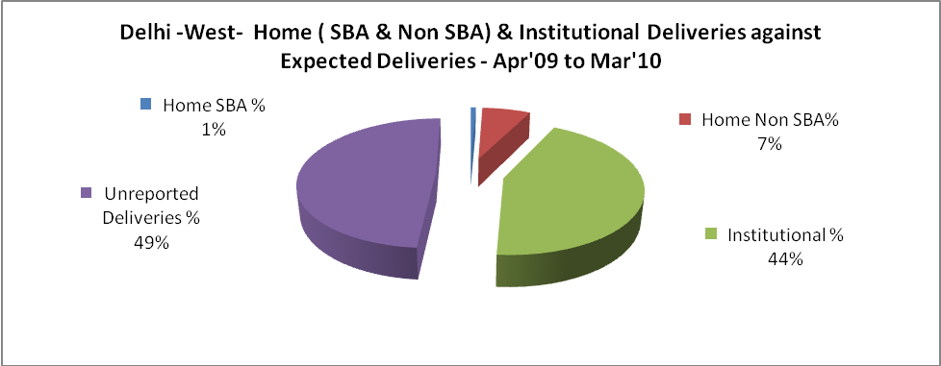

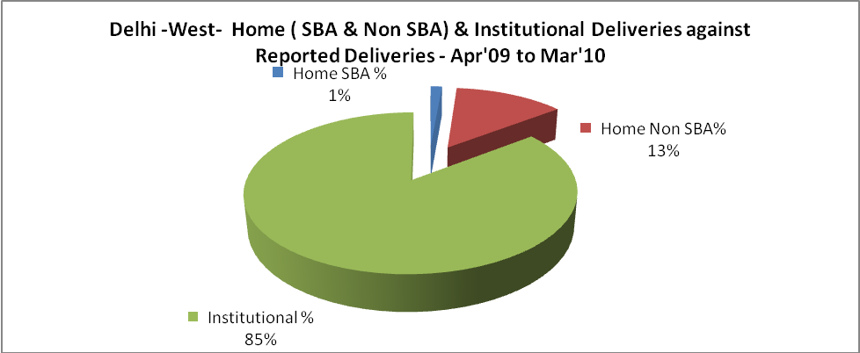

Delhi -West- C sections & Complicated Deliveries Apr'09 to Mar'10
 | Institutional Deliveries (Public) | Institutional Deliveries (Pvt)
 | 16,752 | 4,355
C Section | 3,110 | 2,143
C Section% | 19% | 49%
Complicated Pregnacies attended | 5,371 | 227
Complicated Pregnacies attended % | 32% | 5%

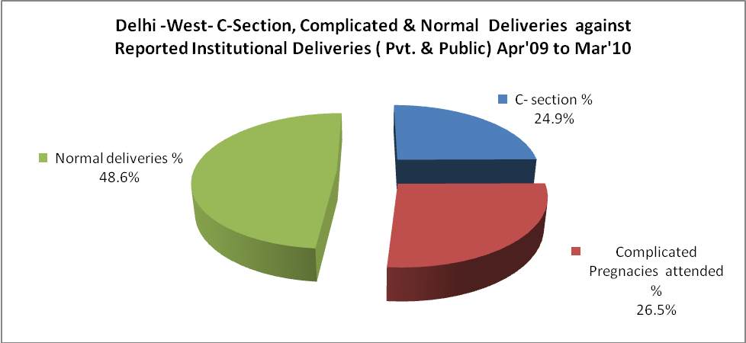

Delhi -West- Complicated Pregnancies & Deliveries Treated - Apr'09 to Mar'10
Reported Deliveries |  |  | Reported ANC Reigtration
24,698 |  |  | 121,969
Complicated Pregnancies attended | Complicated Pregnancies Rate | C - Section Deliveries | PNC Maternal Complications | Abortions | Still Births
5,598 | 11% | 5,253 | 392 | 1,574 | 405
Complicated Deliveries Treated with |  |  |  | No Of Eclampsia cases Treated | No Of severe anemia cases treated
IV Antibiotics | IV antihypertensive/Magsulph injection | IV Oxytocis | Blood Transfusion | No Of Eclampsia cases Treated | No Of severe anemia cases treated
4,402 | 540 | 8,096 | 882 | 119 | 6,799

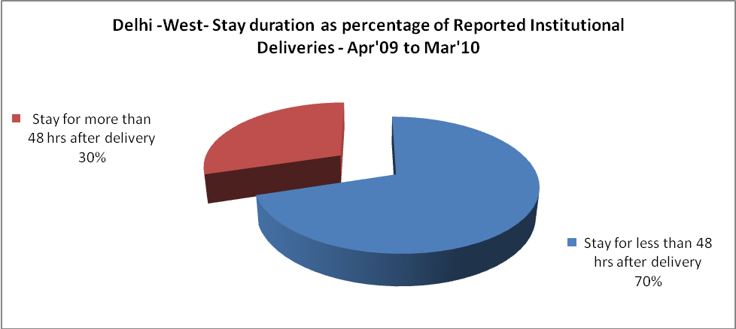

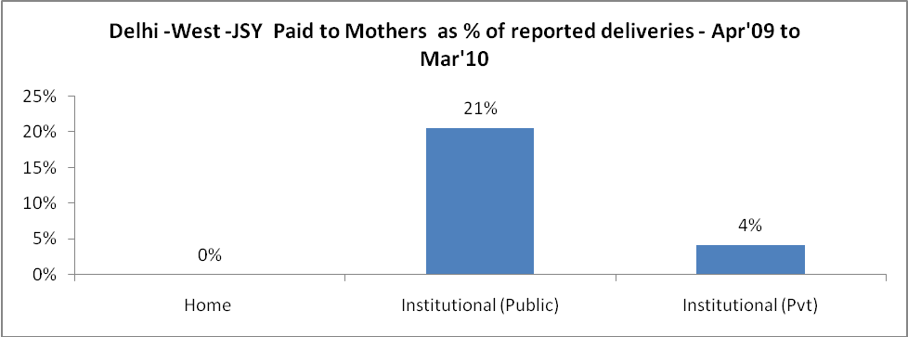

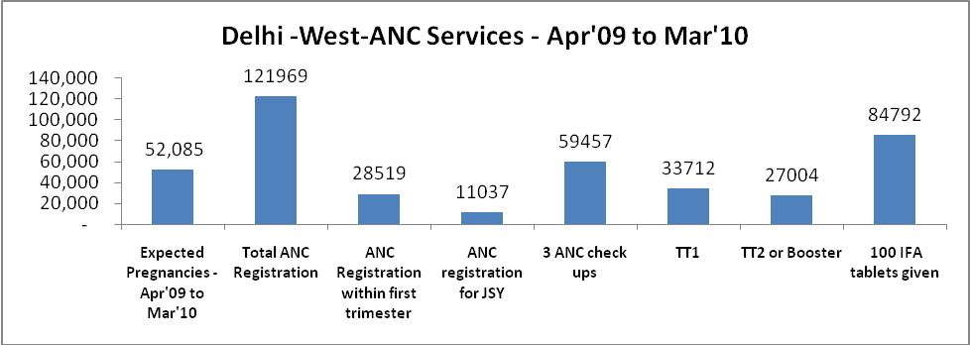

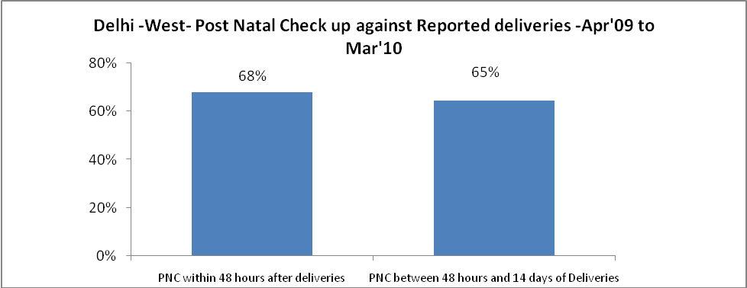

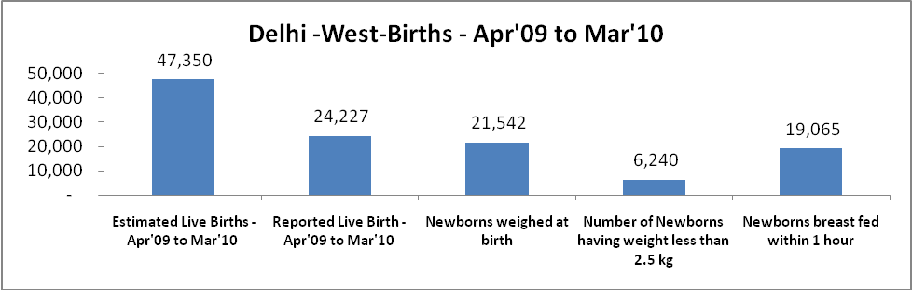

Delhi -West - Births - Apr'09 to Mar'10
Live Birth - Males | Live Birth - females | Live Birth - Total | Sex Ratio at birth | Still Birth | Abortion( Induced/Spontaneous
12,789 | 11,438 | 24,227 | 894 | 405 | 1,574

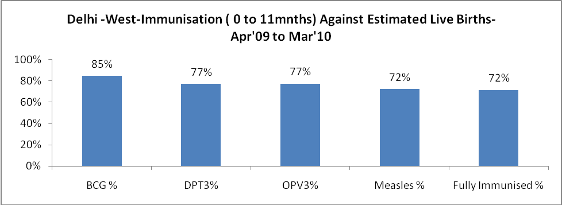

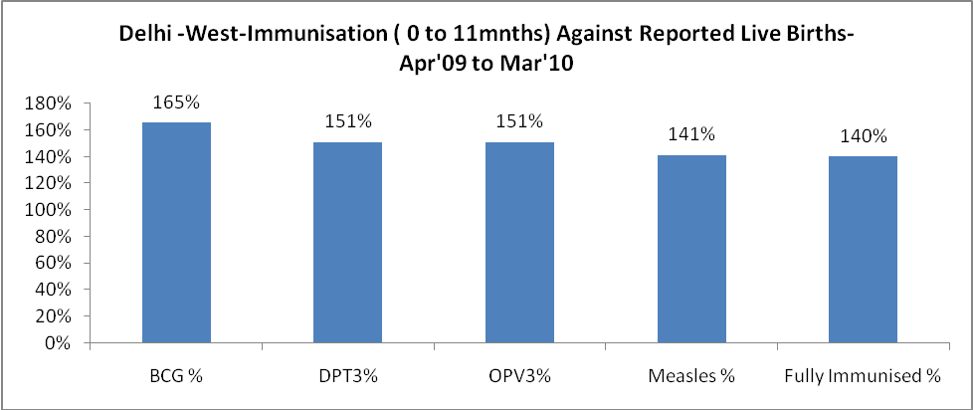

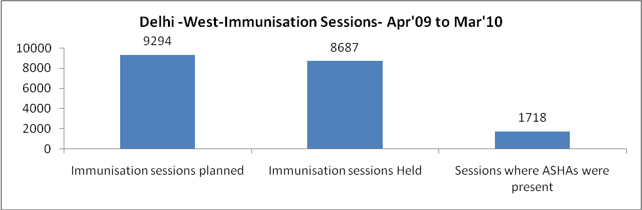

Delhi -West- Apr'09 to Mar'10
Total Abortions | Abortion Rate
2,953 | 5.7%

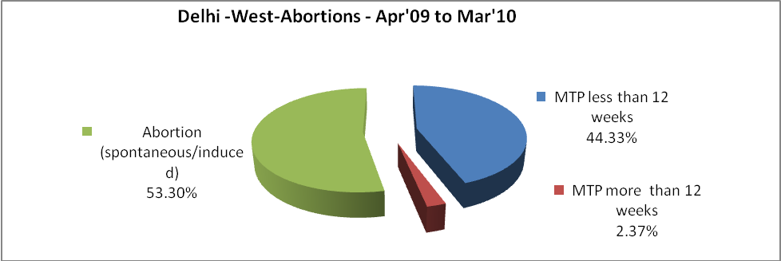

Delhi -West- Apr'09 to Mar'10
Total OPD | Total RTI/STI cases
4,264,373 | 29,838

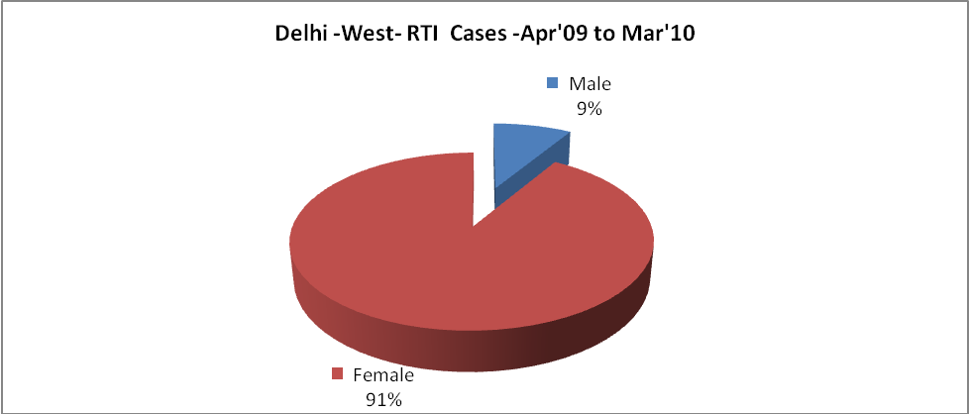

Delhi -West-Sterilisations - Apr'09 to Mar'10
 | Reported | %age of Reported Sterilisation
Total Sterilisation | 3,033 | -
NSV | 253 | 8%
Laproscopic | 2,221 | 73%
MiniLap | 197 | 6%
Post Partum | 362 | 12%
Male Sterilisation | 253 | 8%
Female Sterilisation | 2,780 | 92%

Delhi -West-FP Methods - Apr'09 to Mar'10
 | Reported | %age of All Reported FP Methods
Total Reported FP Methodd (All types) Users | 27,357 | -
Sterilisations | 3,033 | 11%
IUD | 4,880 | 18%
Condom Users | 17,402 | 64%
OCP Users | 2,043 | 7%
Limiting Methods | 3,033 | 11%
Spacing Methods | 24,324 | 89%

Delhi -West- Service Delivery - Apr'09 to Mar'10
Operation major (General and spinal anaesthesia) | Operation minor (No or local anaesthesia) | AYUSH | Dental Procedures | Adolescent counselling services | Total OPD | Total IPD
19,262 | 33,331 | 85,971 | 20,781 | 2,111 | 4,264,373 | 101,959
Operation major (General and spinal anaesthesia) as %ge of OPD | Operation minor (No or local anaesthesia)as %ge of OPD | AYUSH as %ge of OPD | Dental Procedures as %ge of OPD | Adolescent counselling services as %ge of OPD | IPD as percentage of OPD
0.5% | 0.8% | 2.0% | 0.5% | 0.0% | 2%

Delhi -West- Lab Services - Apr'09 to Mar'10
Total OPD | Total HB tested | Total HIV Tested | Total Population
4,264,373 | 360,233 | 34,569 | 2,573,348
HB test conducted as %age of OPD | HB<7gm as %age of HB tested | HIV test conducted as %age of OPD | HIV positive as %age of HIV tested | Blood Smear Examined as % of Population
8.4% | 3.1% | 0.8% | 1.0% | 1.1%

Delhi -West- Childhood Disease - Vaccine Preventable -Apr'09 to Mar'10
Diphtheria | Pertussis | Tetanus Neonatorum | Tetanus others | Polio | Measles
0 | 0 | 0 | 2 | 0 | 35
Delhi -West-Childhood Disease - Others - Apr'09 to Mar'10
Diarrhoea and dehydration | Malaria | Number admitted with Respiratory Infections
27,044 | 42 | 6,262

Delhi -West- Infant & Child Deaths - Apr'09 to Mar'10
Infant Deaths within 24 hrs of birth | Infant Deaths between 24hrs & under 1 week | Infant Deaths between 1 week & under 1 month | Child Deaths between 1 month & under 1 year | Child Deaths between 1yr under 5years | Total Deaths
168 | 300 | 76 | 156 | 94 | 794

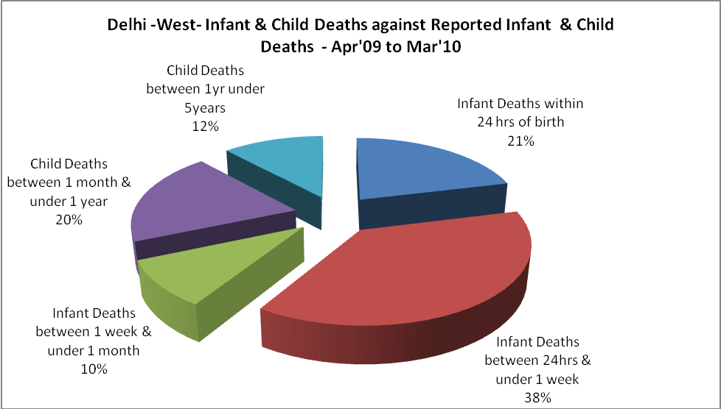

Delhi -West- Causes of Infant & Child Deaths - Apr'09 to Mar'10
Sepsis |  |  | Asphyxia |  |  | LBW
Up to 1 Weeks of Birth | Between 1 week & 4 weeks of birth | Total | Up to 1 Weeks of Birth | Between 1 week & 4 weeks of birth | Total | Up to 1 Weeks of Birth | Between 1 week & 4 weeks of birth | Total
43 | 18 | 61 | 30 | 3 | 33 | 138 | 29 | 167
Pneumonia |  |  | Diarrhoea |  |  | Fever related
Between 1 month and 11 months | Between 1 year & 5 years | Total | Between 1 month and 11 months | Between 1 year & 5 years | Total | Between 1 month and 11 months | Between 1 year & 5 years | Total
51 | 27 | 78 | 20 | 3 | 23 | 3 | 3 | 6
Others |  |  | Measles |  |  | Others
Up to 1 Weeks of Birth | Between 1 week & 4 weeks of birth | Total | Between 1 month and 11 months | Between 1 year & 5 years | Total | Between 1 month and 11 months | Between 1 year & 5 years | Total
89 | 26 | 115 | 0 | 0 | 0 | 82 | 61 | 143

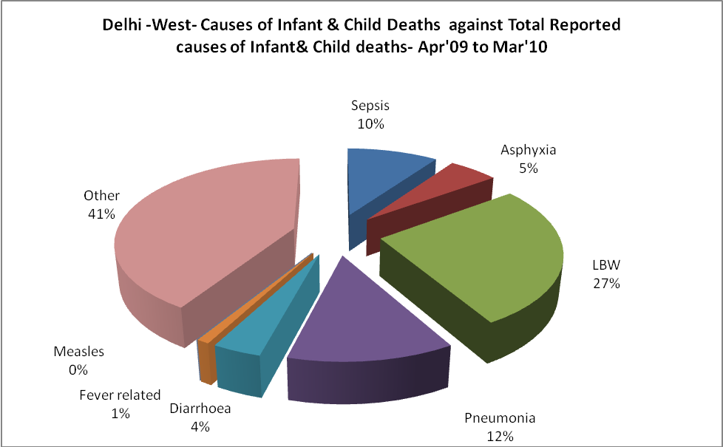

Delhi -West- Maternal Deaths & Causes - Apr'09 to Mar'10
Abortion |  |  | Obstructed/prolonged labour |  |  | Severe hypertesnion/fits
6-14 yrs | 15-55 yrs. | Total | 6-14 yrs | 15-55 yrs. | Total | 6-14 yrs | 15-55 yrs. | Total
0 | 2 | 2 | 0 | 3 | 3 | 0 | 2 | 2
Bleeding |  |  | High Fever |  |  | Other Causes
6-14 yrs | 15-55 yrs. | Total | 6-14 yrs | 15-55 yrs. | Total | 6-14 yrs | 15-55 yrs. | Total
0 | 2 | 2 | 0 | 2 | 2 | 1 | 22 | 23

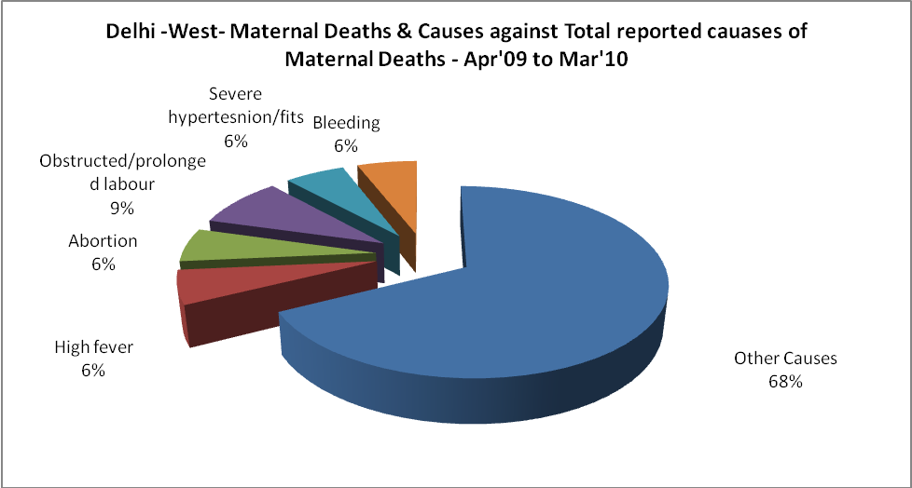

Delhi -West-Causes of Deaths in 6 to 55yrs age group - Apr'09 to Mar'10
Diarrhoel Diseases |  |  |  | Tuberculosis |  |  |  | Respiratory Diseases( Other than TB)
6-14 yrs | 15-55 yrs. | Above 55yrs | Total | 6-14 yrs | 15-55 yrs. | Above 55yrs | Total | 6-14 yrs | 15-55 yrs. | Above 55yrs | Total
1 | 15 | 13 | 29 | 2 | 11 | 19 | 32 | 14 | 107 | 135 | 256
Malaria |  |  |  | Other fever Related |  |  |  | HIV/Aids
6-14 yrs | 15-55 yrs. | Above 55yrs | Total | 6-14 yrs | 15-55 yrs. | Above 55yrs | Total | 6-14 yrs | 15-55 yrs. | Above 55yrs | Total
4 | 5 | 0 | 9 | 16 | 39 | 39 | 94 | 1 | 8 | 4 | 13
Heart Disease/Hypertenion related |  |  |  | Neurological Disease including strokes |  |  |  | Trauma/Accidents/ Burn Cases
6-14 yrs | 15-55 yrs. | Above 55yrs | Total | 6-14 yrs | 15-55 yrs. | Above 55yrs | Total | 6-14 yrs | 15-55 yrs. | Above 55yrs | Total
6 | 233 | 390 | 629 | 3 | 51 | 42 | 96 | 7 | 74 | 21 | 102
Suicide |  |  |  | Animal Bites & Stings
6-14 yrs | 15-55 yrs. | Above 55yrs | Total | 6-14 yrs | 15-55 yrs. | Above 55yrs | Total
0 | 26 | 1 | 27 | 1 | 3 | 0 | 4

