NHSRC
Delhi-South
Analysis: Apr 2009 – Mar 2010

Delhi - South- Summary-Apr'09 to Mar'10
ANC
ANC Registration against Expected Pregnancies | 153% | TT1 given to Pregnant women against ANC Registraion | 37%
3 ANC Check ups against ANC Reigtrations | 62% | 100 IFA Tablets given to Pregnant women against ANC Registraion | 44%
Deliveries
Unreported Deliveries against Estimated Deliveries | 78.2% | HOME Deliveries( SBA& Non SBA) against Estimated Deliveries | 2.8%
Institutional Deliveries against Estimated Deliveries | 18.9% | HOME Deliveries( SBA& Non SBA) against Reported Deliveries | 13.0%
Institutional Deliveries against Reported Deliveries | 87.0% | C Section Deliveries against Institutional Deliveries( Pvt & Pub) | 36%
Births & Neonates Care
Live Births Reported against Estimated Live Births | 24% | New borns weighed against Reported Live Births | 76%
Still Births (Reported) | 525 | New borns weighed less than 2.5 kgs against newborns weighed | 17%
Sex Ratio at Birh | 877 | New borns breastfed within one hr of Birth against Reported live Births | 53%
Child Immunisation( 0 to 11 months)
BCG given against Expected Live Births | 68% | Measles given against Expected Live Births | 68%
OPV3 given against Expected Live Births | 72% | Fully Immunised Children against Expected Live Births | 77%
DPT3 given against Expected Live Births | 71%
Family Planning
Family Plannig Methods Users ( Sterilisations(Male &Female)+IUD+ Condom pieces/72 + OCP Cycles/13) | 30,579 | IUD Insertions against reported FP Methods | 18%
Sterilisation against reported FP Methods | 7% | Condom Users against reported FP Methods | 65%
 |  | OCP Users against reported FP Methods | 10%
Other Services
OPD | 2,729,555 | Major Operations | 20,715
IPD | 38,533 | Minor Operations | 9,317

Delhi - South- Deliveries Apr'09 to Mar'10
Total Population | 2,740,297 | Expected Deliveries |  | 51,304
Home SBA | Home Non SBA | Institutional | Total Deliveries Reported | Unreported Deliveries
335 | 1,115 | 9,717 | 11,167 | 40,137
Home SBA % | Home Non SBA% | Institutional % | Total Deliveries Reported % | Unreported Deliveries %
1% | 2% | 19% | 22% | 78%
`

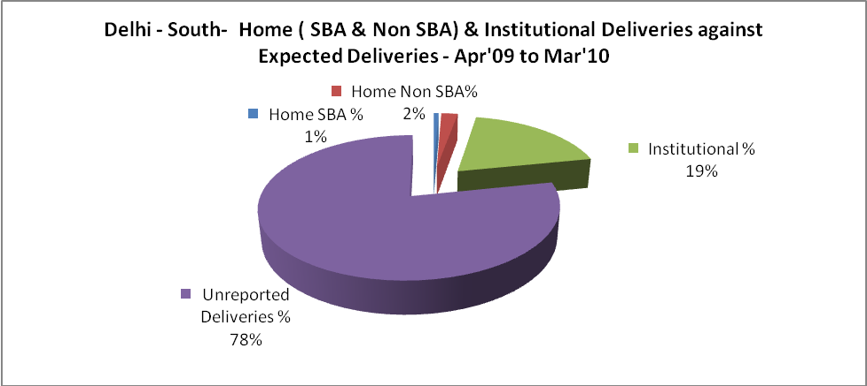

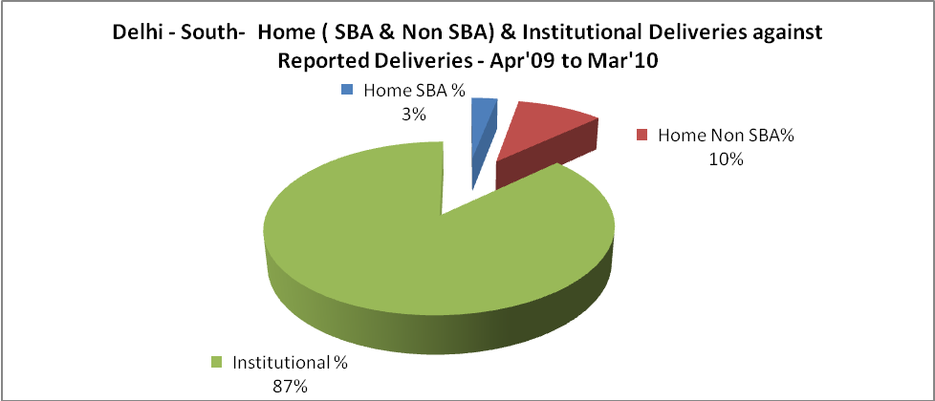

Delhi - South- C sections & Complicated Deliveries Apr'09 to Mar'10
 | Institutional Deliveries (Public) | Institutional Deliveries (Pvt)
 | 4,446 | 5,271
C Section | 792 | 2,698
C Section% | 18% | 51%
Complicated Pregnacies attended | 4,005 | 2,765
Complicated Pregnacies attended % | 90% | 52%

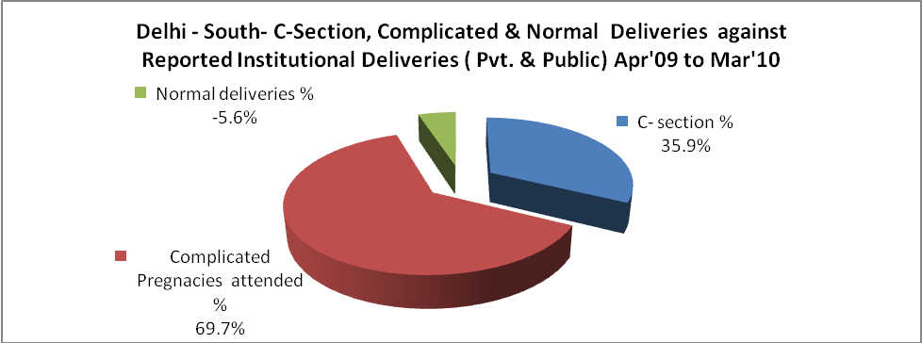

Delhi - South- Complicated Pregnancies & Deliveries Treated - Apr'09 to Mar'10
Reported Deliveries |  |  | Reported ANC Reigtration
11,167 |  |  | 84,848
Complicated Pregnancies attended | Complicated Pregnancies Rate | C - Section Deliveries | PNC Maternal Complications | Abortions | Still Births
6,770 | 12% | 3,490 | 583 | 4,032 | 525
Complicated Deliveries Treated with |  |  |  | No Of Eclampsia cases Treated | No Of severe anemia cases treated
IV Antibiotics | IV antihypertensive/Magsulph injection | IV Oxytocis | Blood Transfusion | No Of Eclampsia cases Treated | No Of severe anemia cases treated
1,637 | 415 | 2,417 | 130 | 20 | 1,456

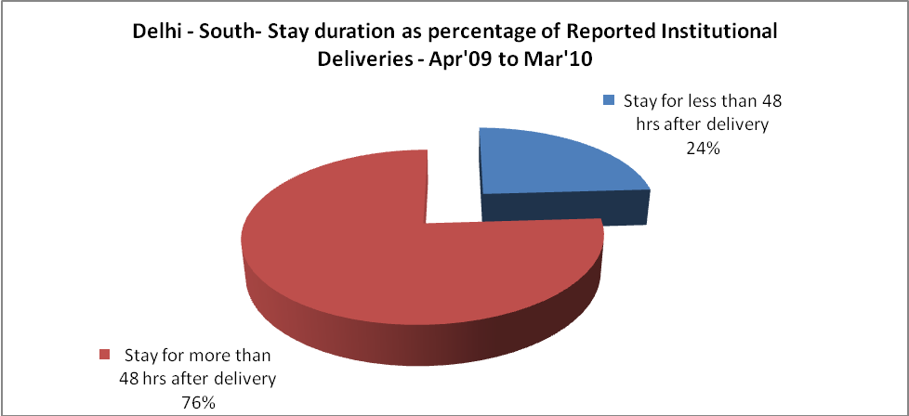

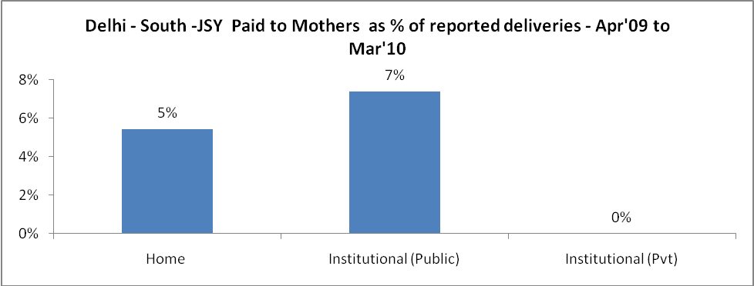

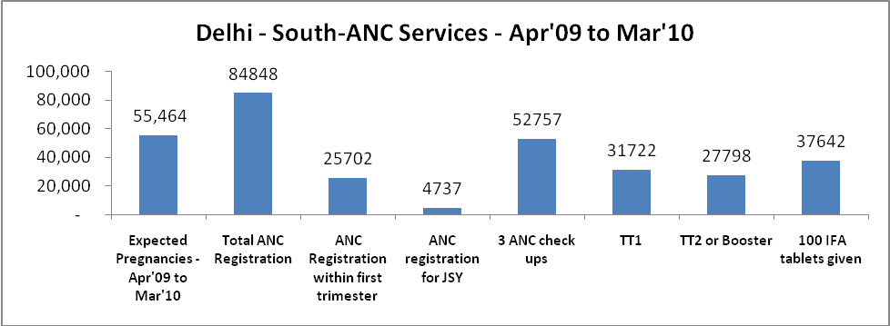

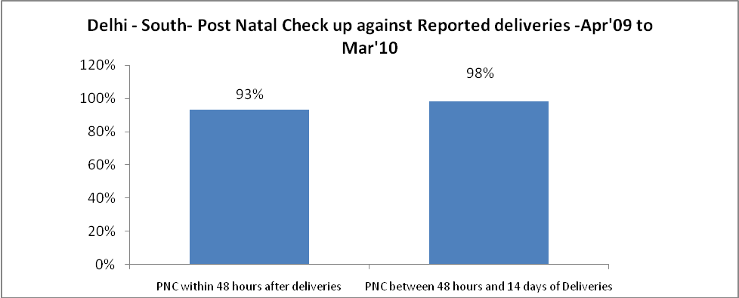

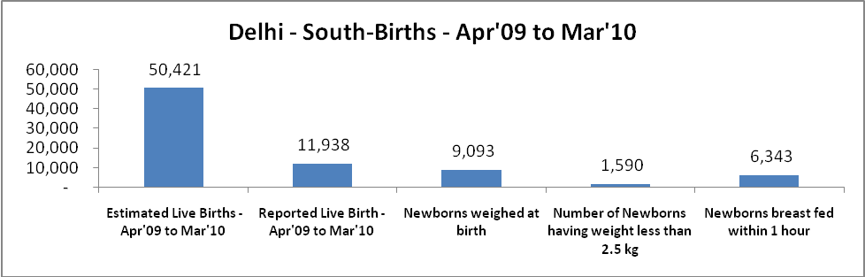

Delhi - South - Births - Apr'09 to Mar'10
Live Birth - Males | Live Birth - females | Live Birth - Total | Sex Ratio at birth | Still Birth | Abortion( Induced/Spontaneous
6,361 | 5,577 | 11,938 | 877 | 525 | 4,032

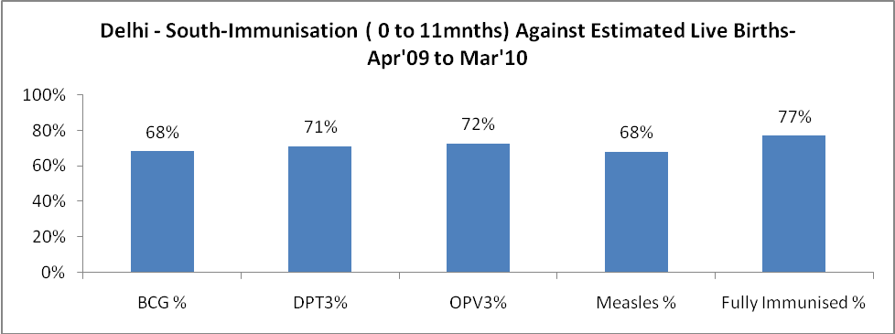

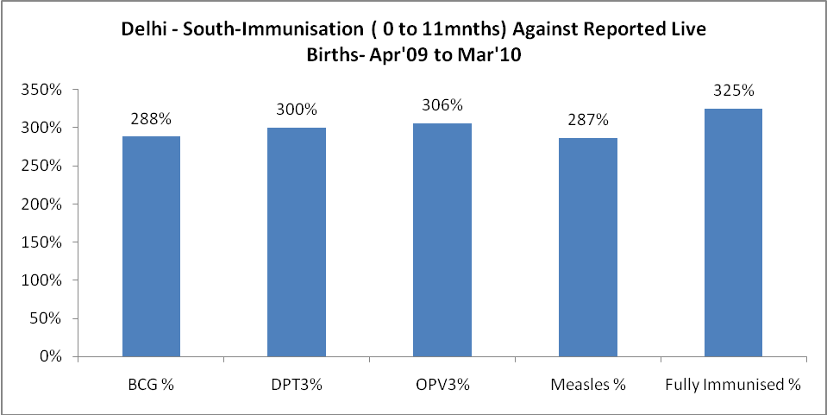

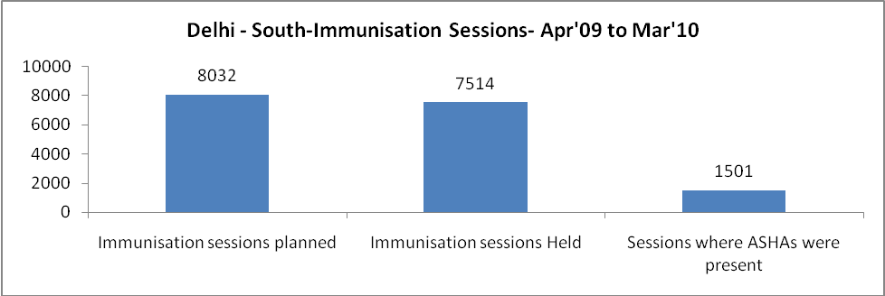

Delhi - South- Apr'09 to Mar'10
Total Abortions | Abortion Rate
5,242 | 9.5%

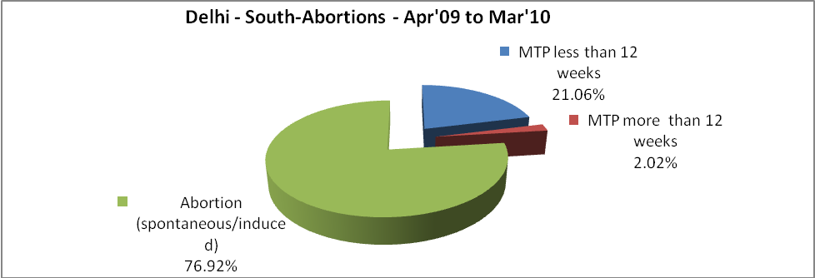

+

Delhi - South- Apr'09 to Mar'10
Total OPD | Total RTI/STI cases
2,729,555 | 22,197
v

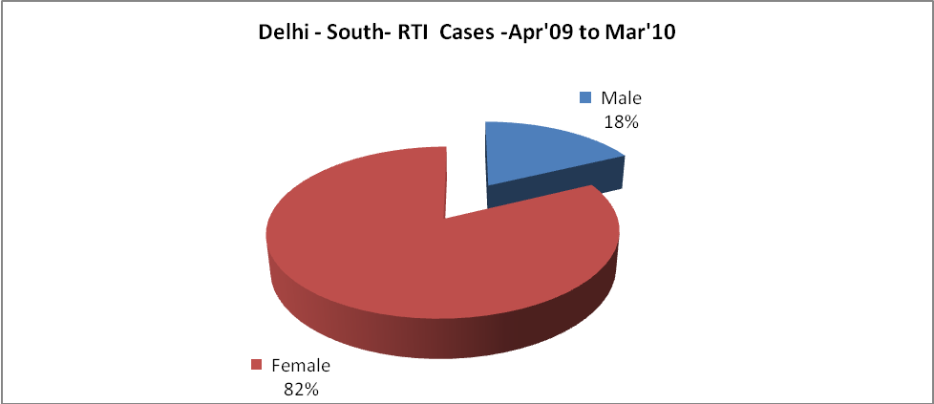

Delhi - South-Sterilisations - Apr'09 to Mar'10
 | Reported | %age of Reported Sterilisation
Total Sterilisation | 2,029 | -
NSV | 133 | 7%
Laproscopic | 1,516 | 75%
MiniLap | 80 | 4%
Post Partum | 300 | 15%
Male Sterilisation | 133 | 7%
Female Sterilisation | 1,896 | 93%

Delhi - South-FP Methods - Apr'09 to Mar'10
 | Reported | %age of All Reported FP Methods
Total Reported FP Methodd (All types) Users | 30,579 | -
Sterilisations | 2,029 | 7%
IUD | 5,497 | 18%
Condom Users | 20,010 | 65%
OCP Users | 3,044 | 10%
Limiting Methods | 2,029 | 7%
Spacing Methods | 28,550 | 93%

Delhi - South- Service Delivery - Apr'09 to Mar'10
Operation major (General and spinal anaesthesia) | Operation minor (No or local anaesthesia) | AYUSH | Dental Procedures | Adolescent counselling services | Total OPD | Total IPD
20,715 | 9,317 | 3,353 | 7,298 | 867 | 2,729,555 | 38,533
Operation major (General and spinal anaesthesia) as %ge of OPD | Operation minor (No or local anaesthesia)as %ge of OPD | AYUSH as %ge of OPD | Dental Procedures as %ge of OPD | Adolescent counselling services as %ge of OPD | IPD as percentage of OPD
0.8% | 0.3% | 0.1% | 0.3% | 0.0% | 1%

Delhi - South- Lab Services - Apr'09 to Mar'10
Total OPD | Total HB tested | Total HIV Tested | Total Population
2,729,555 | 261,884 | 32,956 | 2,740,297
HB test conducted as %age of OPD | HB<7gm as %age of HB tested | HIV test conducted as %age of OPD | HIV positive as %age of HIV tested | Blood Smear Examined as % of Population
9.6% | 1.7% | 1.2% | 0.5% | 4.6%

Delhi - South- Childhood Disease - Vaccine Preventable -Apr'09 to Mar'10
Diphtheria | Pertussis | Tetanus Neonatorum | Tetanus others | Polio | Measles
0 | 1 | 0 | 0 | 0 | 38
Delhi - South-Childhood Disease - Others - Apr'09 to Mar'10
Diarrhoea and dehydration | Malaria | Number admitted with Respiratory Infections
26,408 | 368 | 1,505

Delhi - South- Infant & Child Deaths - Apr'09 to Mar'10
Infant Deaths within 24 hrs of birth | Infant Deaths between 24hrs & under 1 week | Infant Deaths between 1 week & under 1 month | Child Deaths between 1 month & under 1 year | Child Deaths between 1yr under 5years | Total Deaths
2 | 9 | 3 | 17 | 57 | 88

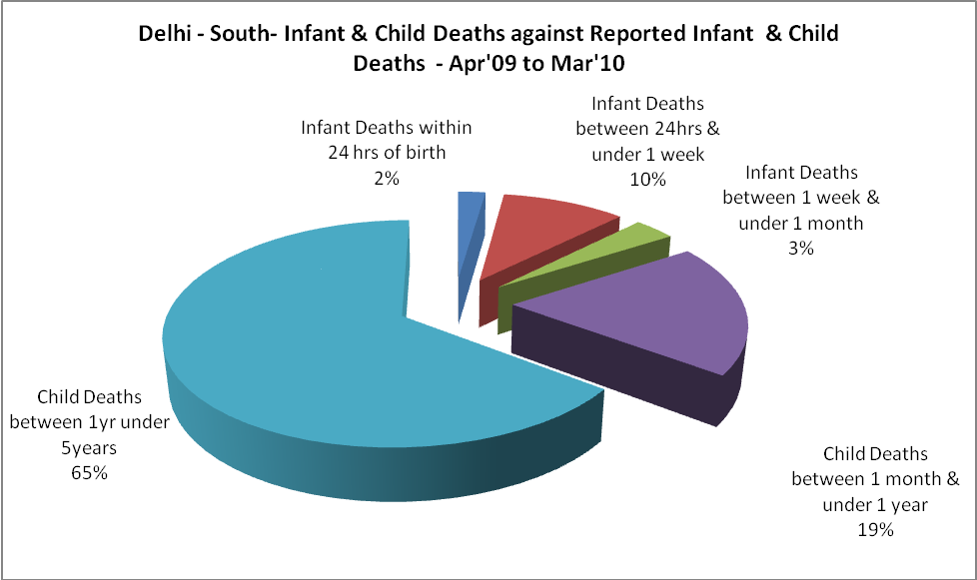

Delhi - South- Causes of Infant & Child Deaths - Apr'09 to Mar'10
Sepsis |  |  | Asphyxia |  |  | LBW
Up to 1 Weeks of Birth | Between 1 week & 4 weeks of birth | Total | Up to 1 Weeks of Birth | Between 1 week & 4 weeks of birth | Total | Up to 1 Weeks of Birth | Between 1 week & 4 weeks of birth | Total
0 | 0 | 0 | 1 | 0 | 1 | 1 | 1 | 2
Pneumonia |  |  | Diarrhoea |  |  | Fever related
Between 1 month and 11 months | Between 1 year & 5 years | Total | Between 1 month and 11 months | Between 1 year & 5 years | Total | Between 1 month and 11 months | Between 1 year & 5 years | Total
0 | 13 | 13 | 0 | 1 | 1 | 0 | 1 | 1
Others |  |  | Measles |  |  | Others
Up to 1 Weeks of Birth | Between 1 week & 4 weeks of birth | Total | Between 1 month and 11 months | Between 1 year & 5 years | Total | Between 1 month and 11 months | Between 1 year & 5 years | Total
7 | 2 | 9 | 0 | 0 | 0 | 17 | 42 | 59

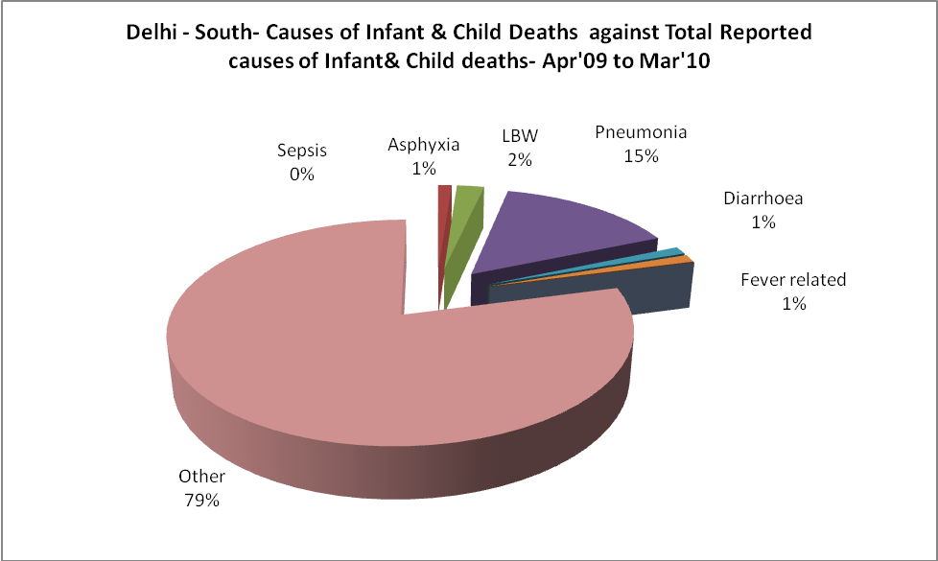
Delhi - South- Maternal Deaths & Causes - Apr'09 to Mar'10
Abortion |  |  | Obstructed/prolonged labour |  |  | Severe hypertesnion/fits
6-14 yrs | 15-55 yrs. | Total | 6-14 yrs | 15-55 yrs. | Total | 6-14 yrs | 15-55 yrs. | Total
0 | 0 | 0 | 0 | 0 | 0 | 0 | 0 | 0
Bleeding |  |  | High Fever |  |  | Other Causes
6-14 yrs | 15-55 yrs. | Total | 6-14 yrs | 15-55 yrs. | Total | 6-14 yrs | 15-55 yrs. | Total
0 | 0 | 0 | 0 | 0 | 0 | 0 | 0 | 0

Delhi - South-Causes of Deaths in 6 to 55yrs age group - Apr'09 to Mar'10
Diarrhoel Diseases |  |  |  | Tuberculosis |  |  |  | Respiratory Diseases( Other than TB)
6-14 yrs | 15-55 yrs. | Above 55yrs | Total | 6-14 yrs | 15-55 yrs. | Above 55yrs | Total | 6-14 yrs | 15-55 yrs. | Above 55yrs | Total
1 | 1 | 0 | 2 | 1 | 3 | 1 | 5 | 0 | 4 | 6 | 10
Malaria |  |  |  | Other fever Related |  |  |  | HIV/Aids
6-14 yrs | 15-55 yrs. | Above 55yrs | Total | 6-14 yrs | 15-55 yrs. | Above 55yrs | Total | 6-14 yrs | 15-55 yrs. | Above 55yrs | Total
0 | 0 | 0 | 0 | 0 | 4 | 3 | 7 | 0 | 0 | 0 | 0
Heart Disease/Hypertenion related |  |  |  | Neurological Disease including strokes |  |  |  | Trauma/Accidents/ Burn Cases
6-14 yrs | 15-55 yrs. | Above 55yrs | Total | 6-14 yrs | 15-55 yrs. | Above 55yrs | Total | 6-14 yrs | 15-55 yrs. | Above 55yrs | Total
2 | 0 | 4 | 6 | 3 | 2 | 3 | 8 | 0 | 0 | 0 | 0
Suicide |  |  |  | Animal Bites & Stings
6-14 yrs | 15-55 yrs. | Above 55yrs | Total | 6-14 yrs | 15-55 yrs. | Above 55yrs | Total
0 | 0 | 1 | 1 | 0 | 0 | 0 | 0

