NHSRC
Rajasthan-Duganpur
Analysis: Apr 2009 – Mar 2010

Rajasthan- Duganpur- Summary-Apr'09 to Mar'10
ANC
ANC Registration against Expected Pregnancies | 94% | TT1 given to Pregnant women against ANC Registration | 68%
3 ANC Checkups against ANC Registrations | 77% | 100 IFA Tablets given to Pregnant women against ANC Registration | 87%
Deliveries
Unreported Deliveries against Estimated Deliveries | 25.1% | HOME Deliveries( SBA& Non SBA) against Estimated Deliveries | 13.9%
Institutional Deliveries against Estimated Deliveries | 61.0% | HOME Deliveries( SBA& Non SBA) against Reported Deliveries | 18.5%
Institutional Deliveries against Reported Deliveries | 81.5% | C Section Deliveries against Institutional Deliveries( Pvt & Pub) | 2%
Births & Neonates Care
Live Births Reported against Estimated Live Births | 76% | New borns weighed against Reported Live Births | 88%
Still Births (Reported) | 581 | New borns weighed less than 2.5 kgs against newborns weighed | 11%
Sex Ratio at Birth | 971 | New borns breastfed within one hr of Birth against Reported live Births | 81%
Child Immunisation( 0 to 11 months)
BCG given against Expected Live Births | 95% | Measles given against Expected Live Births | 87%
OPV3 given against Expected Live Births | 87% | Fully Immunised Children against Expected Live Births | 77%
DPT3 given against Expected Live Births | 87%
Family Planning
Family Plannig Methods Users ( Sterilisations(Male &Female)+IUD+ Condom pieces/72 + OCP Cycles/13) | 91,677 | IUD Insertions against reported FP Methods | 15%
Sterilisation against reported FP Methods | 6% | Condom Users against reported FP Methods | 49%
 |  | OCP Users against reported FP Methods | 31%
Other Services
OPD | 484,556 | Major Operations | 2,211
IPD | 61,215 | Minor Operations | 3,630
`
Rajasthan- Duganpur- Deliveries Apr'09 to Mar'10
Total Population | 1,317,300 | Expected Deliveries |  | 37,367
Home SBA | Home Non SBA | Institutional | Total Deliveries Reported | Unreported Deliveries
3,442 | 1,746 | 22,811 | 27,999 | 9,368
Home SBA % | Home Non SBA% | Institutional % | Total Deliveries Reported % | Unreported Deliveries %
9% | 5% | 61% | 75% | 25%

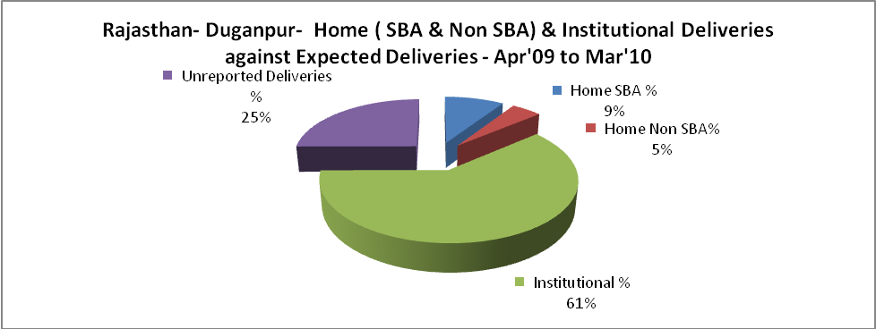

Rajasthan- Duganpur- C sections & Complicated Deliveries Apr'09 to Mar'10
 | Institutional Deliveries (Public) | Institutional Deliveries (Pvt)
 | 20,865 | 1,946
C Section | 570 | -
C Section% | 3% | 0%
Complicated Pregnacies attended | 897 | -
Complicated Pregnacies attended % | 4% | 0%

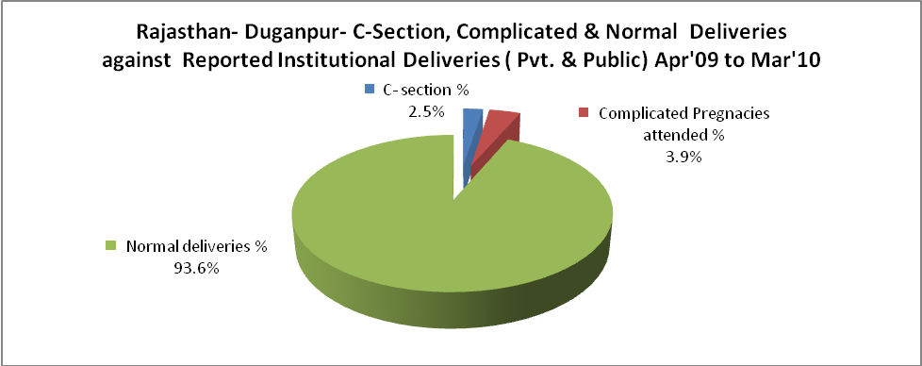

Rajasthan- Duganpur- Complicated Pregnancies & Deliveries Treated - Apr'09 to Mar'10
Reported Deliveries |  |  | Reported ANC Reigtration
27,999 |  |  | 37,622
Complicated Pregnancies attended | Complicated Pregnancies Rate | C - Section Deliveries | PNC Maternal Complications | Abortions | Still Births
897 | 2% | 570 | 854 | 573 | 581
Complicated Deliveries Treated with |  |  |  | No Of Eclampsia cases Treated | No Of severe anemia cases treated
IV Antibiotics | IV antihypertensive/Magsulph injection | IV Oxytocis | Blood Transfusion | No Of Eclampsia cases Treated | No Of severe anemia cases treated
467 | 217 | 178 | 35 | 23 | 1,820

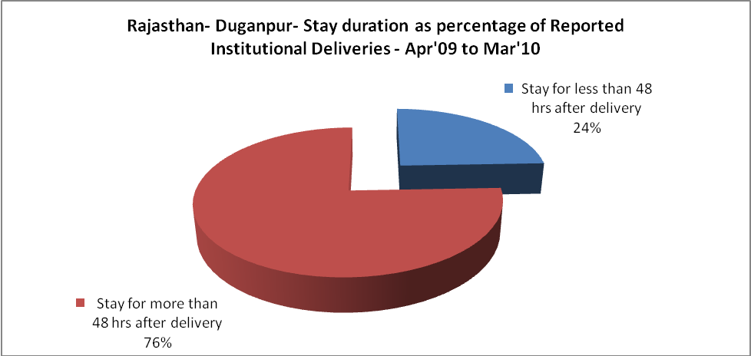

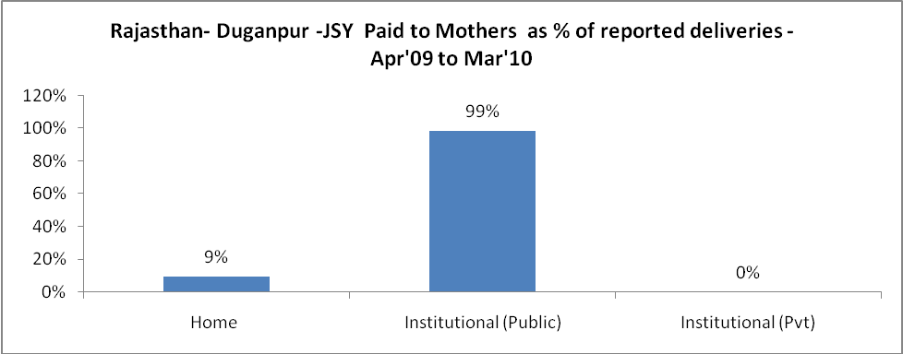

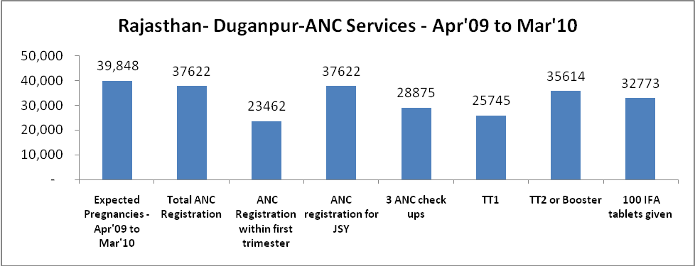

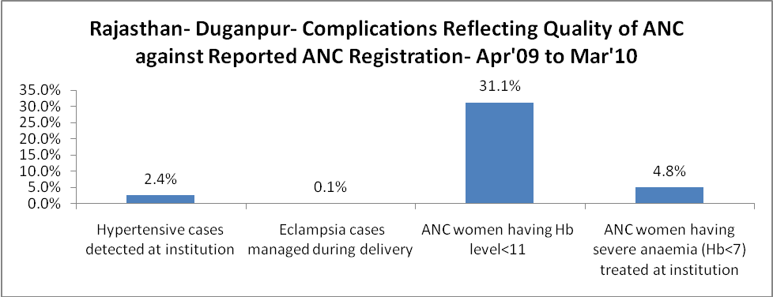

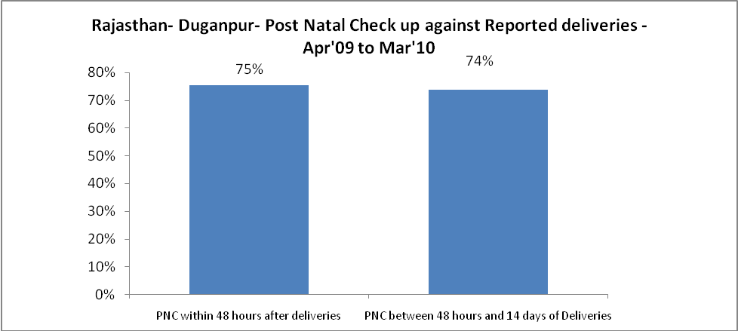

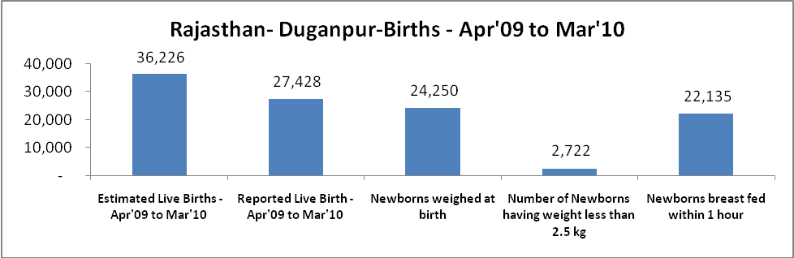

Rajasthan- Duganpur - Births - Apr'09 to Mar'10
Live Birth - Males | Live Birth - females | Live Birth - Total | Sex Ratio at birth | Still Birth | Abortion( Induced/Spontaneous
13,913 | 13,515 | 27,428 | 971 | 581 | 573

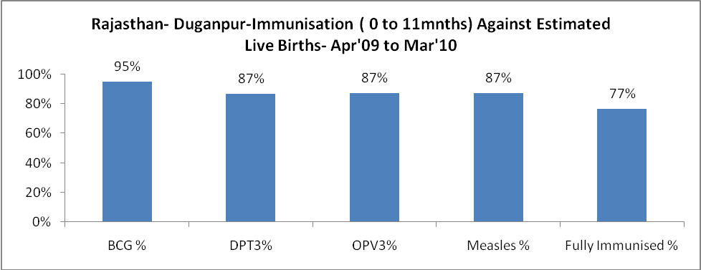

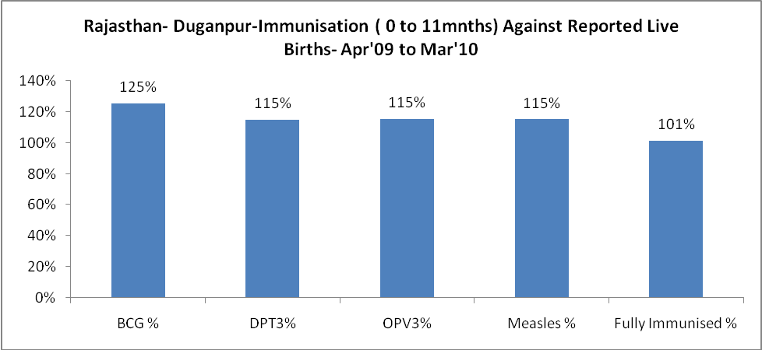

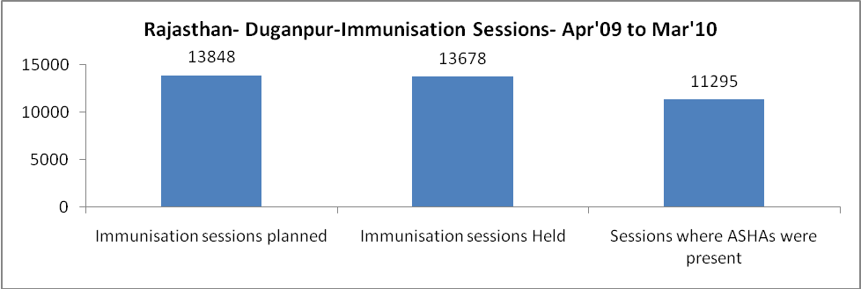

Rajasthan- Duganpur- Apr'09 to Mar'10
Total Abortions | Abortion Rate
1,641 | 4.1%

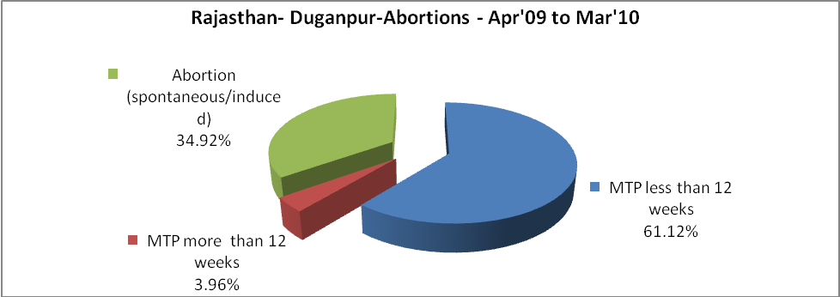

Rajasthan- Duganpur- Apr'09 to Mar'10
Total OPD | Total RTI/STI cases
484,556 | 4,362

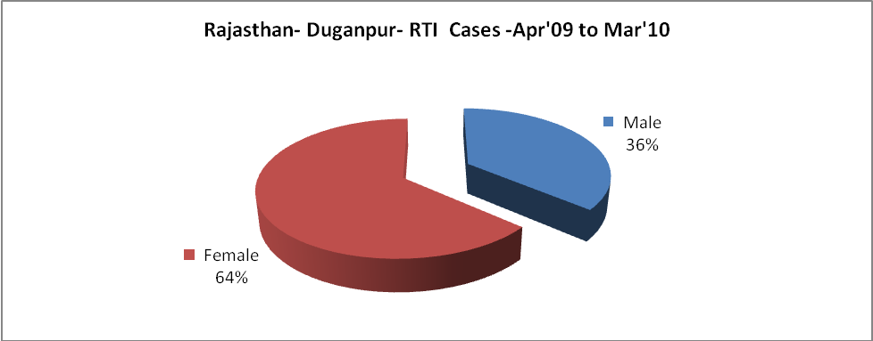

Rajasthan- Duganpur-Sterilisations - Apr'09 to Mar'10
 | Reported | %age of Reported Sterilisation
Total Sterilisation | 5,157 | -
NSV | 34 | 1%
Laproscopic | 4,030 | 78%
MiniLap | - | 0%
Post Partum | 1,093 | 21%
Male Sterilisation | 34 | 1%
Female Sterilisation | 5,123 | 99%

Rajasthan- Duganpur-FP Methods - Apr'09 to Mar'10
 | Reported | %age of All Reported FP Methods
Total Reported FP Methodd (All types) Users | 91,677 | -
Sterilisations | 5,157 | 6%
IUD | 13,437 | 15%
Condom Users | 44,860 | 49%
OCP Users | 28,223 | 31%
Limiting Methods | 5,157 | 6%
Spacing Methods | 86,520 | 94%

Rajasthan- Duganpur- Service Delivery - Apr'09 to Mar'10
Operation major (General and spinal anaesthesia) | Operation minor (No or local anaesthesia) | AYUSH | Dental Procedures | Adolescent counselling services | Total OPD | Total IPD
2,211 | 3,630 | 22,673 | 2,321 | 343 | 484,556 | 61,215
Operation major (General and spinal anaesthesia) as %ge of OPD | Operation minor (No or local anaesthesia)as %ge of OPD | AYUSH as %ge of OPD | Dental Procedures as %ge of OPD | Adolescent counselling services as %ge of OPD | IPD as percentage of OPD
0.5% | 0.7% | 4.7% | 0.5% | 0.1% | 13%

Rajasthan- Duganpur- Lab Services - Apr'09 to Mar'10
Total OPD | Total HB tested | Total HIV Tested | Total Population
484,556 | 16,769 | 4,905 | 1,317,300
HB test conducted as %age of OPD | HB<7gm as %age of HB tested | HIV test conducted as %age of OPD | HIV positive as %age of HIV tested | Blood Smear Examined as % of Population
3.5% | 11.6% | 1.0% | 0.2% | 11.0%

Rajasthan- Duganpur- Childhood Disease - Vaccine Preventable -Apr'09 to Mar'10
Diphtheria | Pertussis | Tetanus Neonatorum | Tetanus others | Polio | Measles
1 | 0 | 1 | 0 | 0 | 16
Rajasthan- Duganpur-Childhood Disease - Others - Apr'09 to Mar'10
Diarrhoea and dehydration | Malaria | Number admitted with Respiratory Infections
2,243 | 200 | 46

Rajasthan- Duganpur- Infant & Child Deaths - Apr'09 to Mar'10
Infant Deaths within 24 hrs of birth | Infant Deaths between 24hrs & under 1 week | Infant Deaths between 1 week & under 1 month | Child Deaths between 1 month & under 1 year | Child Deaths between 1yr under 5years | Total Deaths
46 | 53 | 31 | 43 | 20 | 193

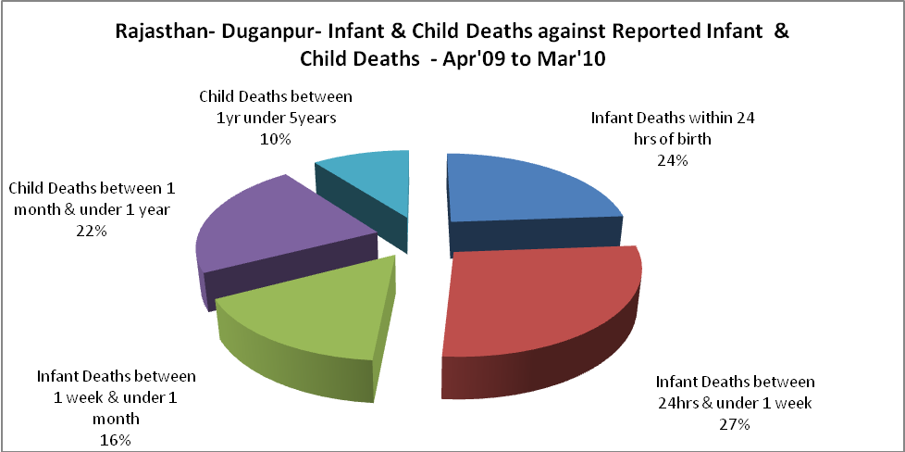

Rajasthan- Duganpur- Causes of Infant & Child Deaths - Apr'09 to Mar'10
Sepsis |  |  | Asphyxia |  |  | LBW
Up to 1 Weeks of Birth | Between 1 week & 4 weeks of birth | Total | Up to 1 Weeks of Birth | Between 1 week & 4 weeks of birth | Total | Up to 1 Weeks of Birth | Between 1 week & 4 weeks of birth | Total
6 | 4 | 10 | 11 | 2 | 13 | 7 | 3 | 10
Pneumonia |  |  | Diarrhoea |  |  | Fever related
Between 1 month and 11 months | Between 1 year & 5 years | Total | Between 1 month and 11 months | Between 1 year & 5 years | Total | Between 1 month and 11 months | Between 1 year & 5 years | Total
9 | 2 | 11 | 2 | 1 | 3 | 2 | 6 | 8
Others |  |  | Measles |  |  | Others
Up to 1 Weeks of Birth | Between 1 week & 4 weeks of birth | Total | Between 1 month and 11 months | Between 1 year & 5 years | Total | Between 1 month and 11 months | Between 1 year & 5 years | Total
29 | 22 | 51 | 0 | 0 | 0 | 30 | 11 | 41

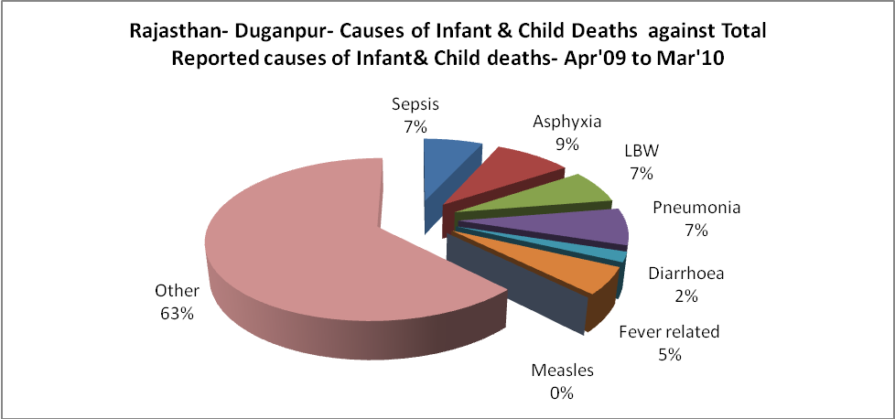

Rajasthan- Duganpur- Maternal Deaths & Causes - Apr'09 to Mar'10
Abortion |  |  | Obstructed/prolonged labour |  |  | Severe hypertesnion/fits
6-14 yrs | 15-55 yrs. | Total | 6-14 yrs | 15-55 yrs. | Total | 6-14 yrs | 15-55 yrs. | Total
0 | 7 | 7 | 0 | 0 | 0 | 0 | 0 | 0
Bleeding |  |  | High Fever |  |  | Other Causes
6-14 yrs | 15-55 yrs. | Total | 6-14 yrs | 15-55 yrs. | Total | 6-14 yrs | 15-55 yrs. | Total
0 | 3 | 3 | 0 | 5 | 5 | 2 | 17 | 19

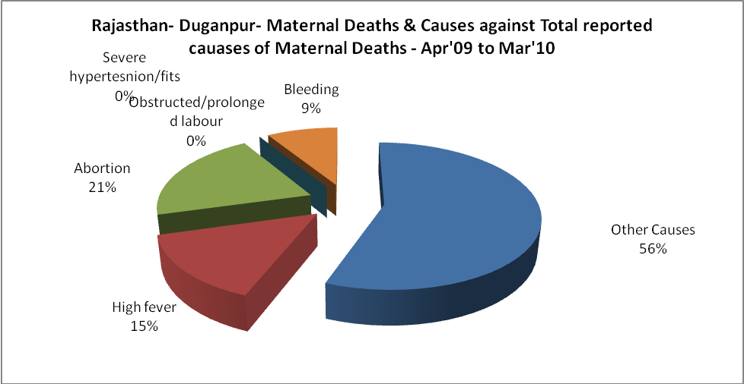

Rajasthan- Duganpur-Causes of Deaths in 6 to 55yrs age group - Apr'09 to Mar'10
Diarrhoel Diseases |  |  |  | Tuberculosis |  |  |  | Respiratory Diseases( Other than TB)
6-14 yrs | 15-55 yrs. | Above 55yrs | Total | 6-14 yrs | 15-55 yrs. | Above 55yrs | Total | 6-14 yrs | 15-55 yrs. | Above 55yrs | Total
1 | 5 | 11 | 17 | 8 | 19 | 13 | 40 | 6 | 26 | 23 | 55
Malaria |  |  |  | Other fever Related |  |  |  | HIV/Aids
6-14 yrs | 15-55 yrs. | Above 55yrs | Total | 6-14 yrs | 15-55 yrs. | Above 55yrs | Total | 6-14 yrs | 15-55 yrs. | Above 55yrs | Total
0 | 3 | 3 | 6 | 4 | 25 | 18 | 47 | 0 | 2 | 1 | 3
Heart Disease/Hypertenion related |  |  |  | Neurological Disease including strokes |  |  |  | Trauma/Accidents/ Burn Cases
6-14 yrs | 15-55 yrs. | Above 55yrs | Total | 6-14 yrs | 15-55 yrs. | Above 55yrs | Total | 6-14 yrs | 15-55 yrs. | Above 55yrs | Total
5 | 17 | 29 | 51 | 32 | 7 | 35 | 74 | 3 | 24 | 7 | 34
Suicide |  |  |  | Animal Bites & Stings
6-14 yrs | 15-55 yrs. | Above 55yrs | Total | 6-14 yrs | 15-55 yrs. | Above 55yrs | Total
0 | 2 | 0 | 2 | 1 | 3 | 5 | 9

