NHSRC
Rajasthan-Ganganagar
Analysis: Apr 2009 – Mar 2010

Rajasthan- Ganganagar- Summary-Apr'09 to Mar'10
ANC
ANC Registration against Expected Pregnancies | 80% | TT1 given to Pregnant women against ANC Registration | 63%
3 ANC Check ups against ANC Registrations | 81% | 100 IFA Tablets given to Pregnant women against ANC Registration | 79%
Deliveries
Unreported Deliveries against Estimated Deliveries | 41.9% | HOME Deliveries( SBA& Non SBA) against Estimated Deliveries | 2.9%
Institutional Deliveries against Estimated Deliveries | 55.2% | HOME Deliveries( SBA& Non SBA) against Reported Deliveries | 5.0%
Institutional Deliveries against Reported Deliveries | 95.0% | C Section Deliveries against Institutional Deliveries( Pvt & Pub) | 3%
Births & Neonates Care
Live Births Reported against Estimated Live Births | 59% | New borns weighed against Reported Live Births | 99%
Still Births (Reported) | 604 | New borns weighed less than 2.5 kgs against newborns weighed | 15%
Sex Ratio at Birth | 894 | New borns breastfed within one hr of Birth against Reported live Births | 64%
Child Immunisation( 0 to 11 months)
BCG given against Expected Live Births | 79% | Measles given against Expected Live Births | 71%
OPV3 given against Expected Live Births | 74% | Fully Immunised Children against Expected Live Births | 70%
DPT3 given against Expected Live Births | 74%
Family Planning
Family Plannig Methods Users ( Sterilisations(Male &Female)+IUD+ Condom pieces/72 + OCP Cycles/13) | 120,699 | IUD Insertions against reported FP Methods | 11%
Sterilisation against reported FP Methods | 10% | Condom Users against reported FP Methods | 51%
 |  | OCP Users against reported FP Methods | 28%
Other Services
OPD | 1,258,577 | Major Operations | 1,524
IPD | 63,366 | Minor Operations | 4,276

Rajasthan- Ganganagar- Deliveries Apr'09 to Mar'10
Total Population | 2,132,900 | Expected Deliveries |  | 60,502
Home SBA | Home Non SBA | Institutional | Total Deliveries Reported | Unreported Deliveries
890 | 873 | 33,401 | 35,164 | 25,338
Home SBA % | Home Non SBA% | Institutional % | Total Deliveries Reported % | Unreported Deliveries %
1% | 1% | 55% | 58% | 42%
`

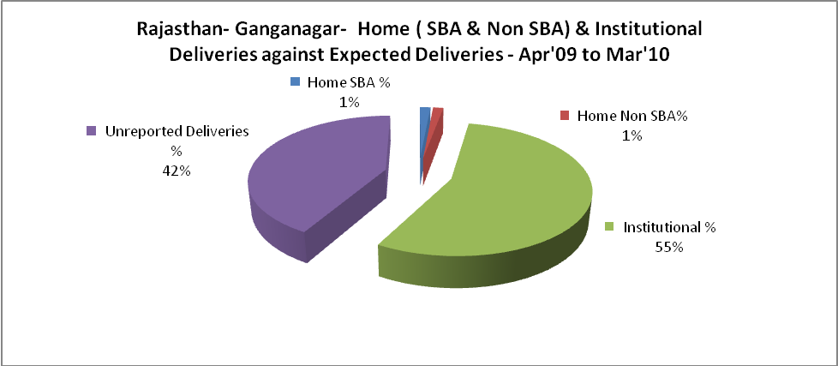

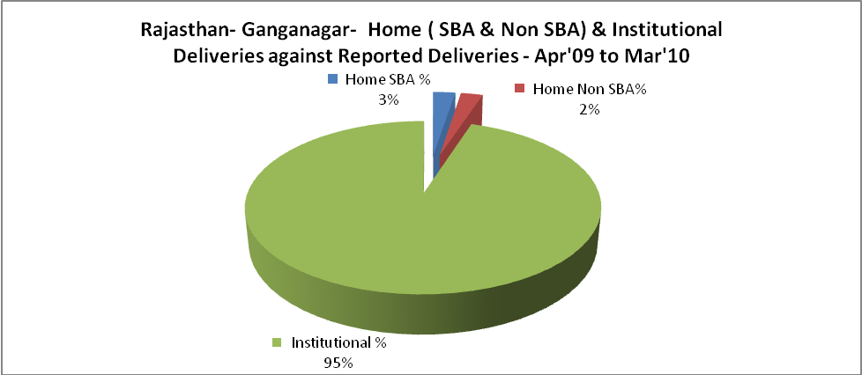

Rajasthan- Ganganagar- C sections & Complicated Deliveries Apr'09 to Mar'10
 | Institutional Deliveries (Public) | Institutional Deliveries (Pvt)
 | 23,944 | 9,457
C Section | 357 | 604
C Section% | 1% | 6%
Complicated Pregnacies attended | 187 | 405
Complicated Pregnacies attended % | 1% | 4%

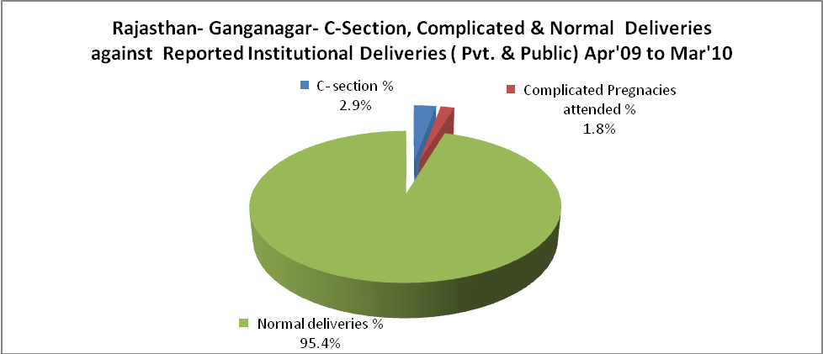

Rajasthan- Ganganagar- Complicated Pregnancies & Deliveries Treated - Apr'09 to Mar'10
Reported Deliveries |  |  | Reported ANC Reigtration
35,164 |  |  | 51,312
Complicated Pregnancies attended | Complicated Pregnancies Rate | C - Section Deliveries | PNC Maternal Complications | Abortions | Still Births
592 | 1% | 961 | 110 | 432 | 604
Complicated Deliveries Treated with |  |  |  | No Of Eclampsia cases Treated | No Of severe anemia cases treated
IV Antibiotics | IV antihypertensive/Magsulph injection | IV Oxytocis | Blood Transfusion | No Of Eclampsia cases Treated | No Of severe anemia cases treated
495 | 36 | 243 | 5 | 92 | 566

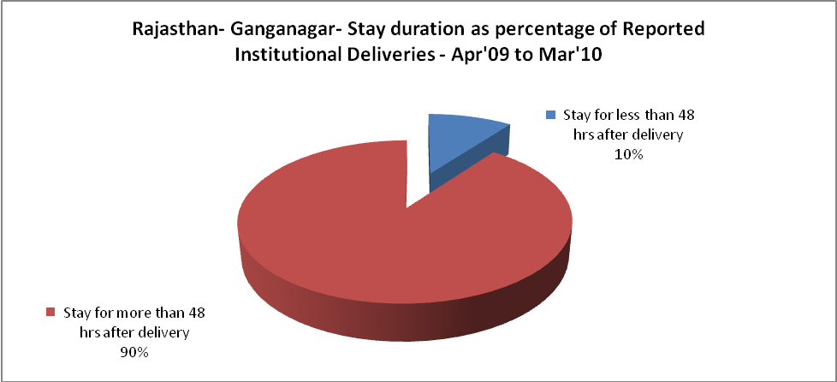

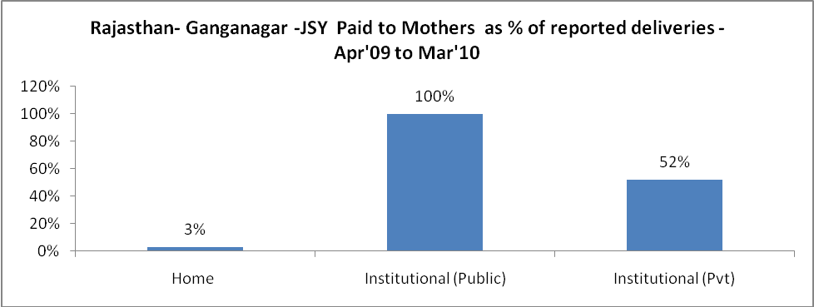

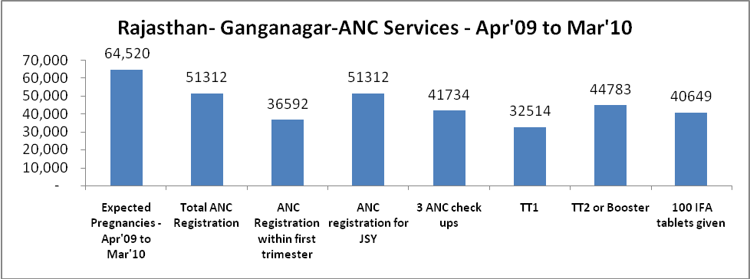

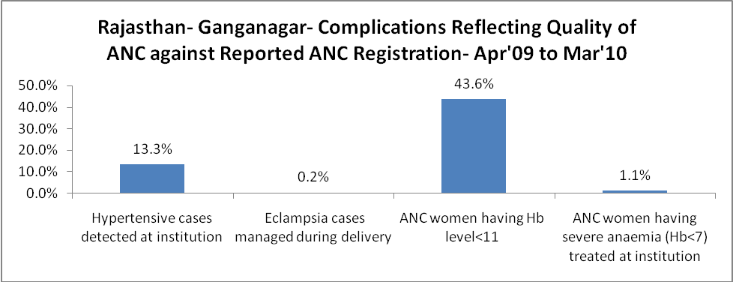

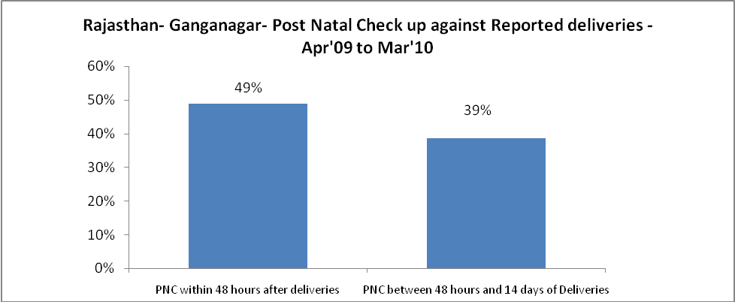

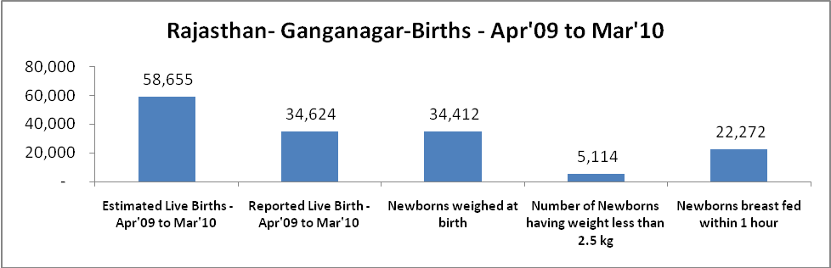

Rajasthan- Ganganagar - Births - Apr'09 to Mar'10
Live Birth - Males | Live Birth - females | Live Birth - Total | Sex Ratio at birth | Still Birth | Abortion( Induced/Spontaneous
18,282 | 16,342 | 34,624 | 894 | 604 | 432

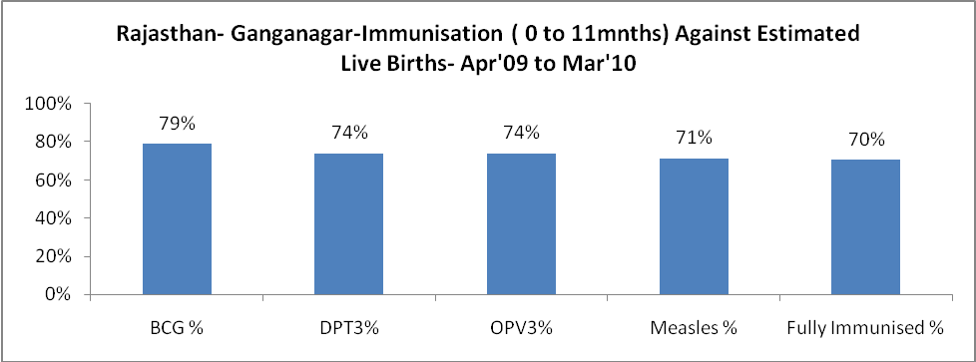

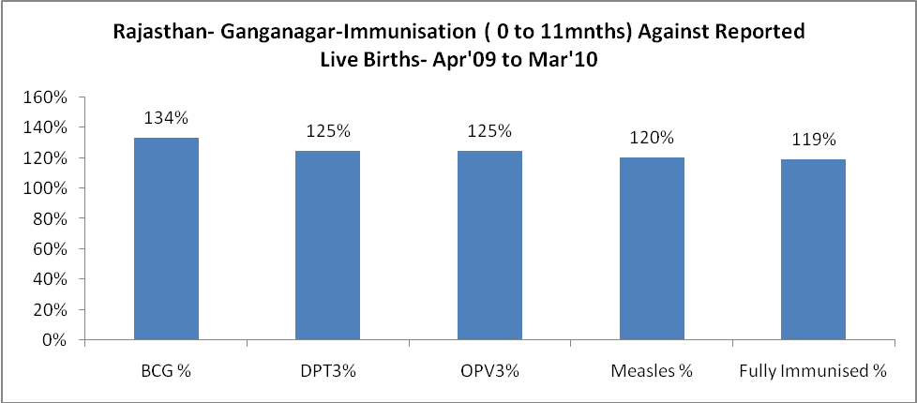

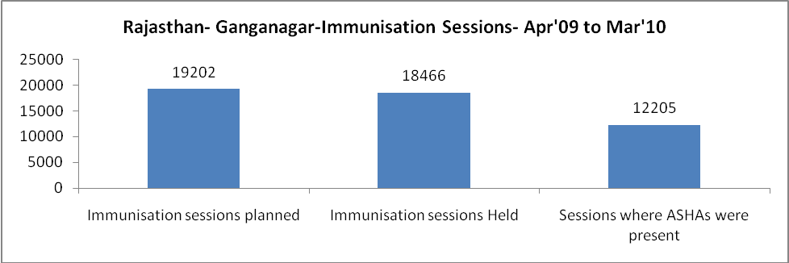

Rajasthan- Ganganagar- Apr'09 to Mar'10
Total Abortions | Abortion Rate
432 | 0.7%

Rajasthan- Ganganagar- Apr'09 to Mar'10
Total OPD | Total RTI/STI cases
1,258,577 | 3,216

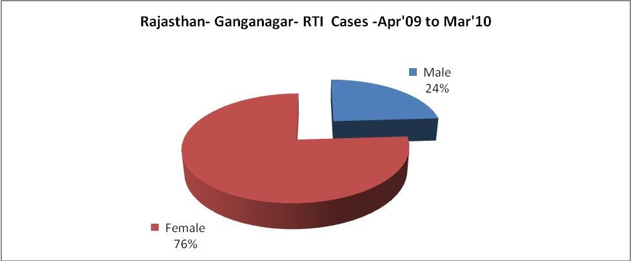

Rajasthan- Ganganagar-Sterilisations - Apr'09 to Mar'10
 | Reported | %age of Reported Sterilisation
Total Sterilisation | 11,776 | -
NSV | 1,049 | 9%
Laproscopic | 9,909 | 84%
MiniLap | 816 | 7%
Post Partum | 2 | 0%
Male Sterilisation | 1,049 | 9%
Female Sterilisation | 10,727 | 91%

Rajasthan- Ganganagar-FP Methods - Apr'09 to Mar'10
 | Reported | %age of All Reported FP Methods
Total Reported FP Methodd (All types) Users | 120,699 | -
Sterilisations | 11,776 | 10%
IUD | 13,832 | 11%
Condom Users | 61,655 | 51%
OCP Users | 33,436 | 28%
Limiting Methods | 11,776 | 10%
Spacing Methods | 108,923 | 90%

Rajasthan- Ganganagar- Lab Services - Apr'09 to Mar'10
Total OPD | Total HB tested | Total HIV Tested | Total Population
1,258,577 | 38,093 | 14,763 | 2,132,900
HB test conducted as %age of OPD | HB<7gm as %age of HB tested | HIV test conducted as %age of OPD | HIV positive as %age of HIV tested | Blood Smear Examined as % of Population
3.0% | 5.4% | 1.2% | 0.3% | 10.0%

Rajasthan- Ganganagar- Childhood Disease - Vaccine Preventable -Apr'09 to Mar'10
Diphtheria | Pertussis | Tetanus Neonatorum | Tetanus others | Polio | Measles
0 | 0 | 0 | 0 | 0 | 9
Rajasthan- Ganganagar-Childhood Disease - Others - Apr'09 to Mar'10
Diarrhoea and dehydration | Malaria | Number admitted with Respiratory Infections
1,920 | 60 | 1,197

Rajasthan- Ganganagar- Infant & Child Deaths - Apr'09 to Mar'10
Infant Deaths within 24 hrs of birth | Infant Deaths between 24hrs & under 1 week | Infant Deaths between 1 week & under 1 month | Child Deaths between 1 month & under 1 year | Child Deaths between 1yr under 5years | Total Deaths
51 | 104 | 32 | 57 | 43 | 287

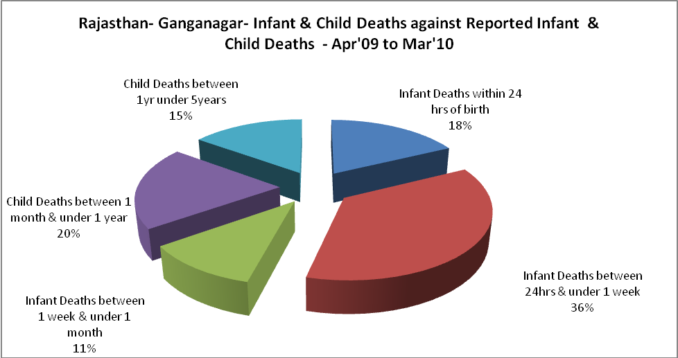

Rajasthan- Ganganagar- Causes of Infant & Child Deaths - Apr'09 to Mar'10
Sepsis |  |  | Asphyxia |  |  | LBW
Up to 1 Weeks of Birth | Between 1 week & 4 weeks of birth | Total | Up to 1 Weeks of Birth | Between 1 week & 4 weeks of birth | Total | Up to 1 Weeks of Birth | Between 1 week & 4 weeks of birth | Total
9 | 2 | 11 | 24 | 2 | 26 | 22 | 11 | 33
Pneumonia |  |  | Diarrhoea |  |  | Fever related
Between 1 month and 11 months | Between 1 year & 5 years | Total | Between 1 month and 11 months | Between 1 year & 5 years | Total | Between 1 month and 11 months | Between 1 year & 5 years | Total
16 | 2 | 18 | 7 | 2 | 9 | 3 | 7 | 10
Others |  |  | Measles |  |  | Others
Up to 1 Weeks of Birth | Between 1 week & 4 weeks of birth | Total | Between 1 month and 11 months | Between 1 year & 5 years | Total | Between 1 month and 11 months | Between 1 year & 5 years | Total
49 | 17 | 66 | 0 | 0 | 0 | 31 | 32 | 63

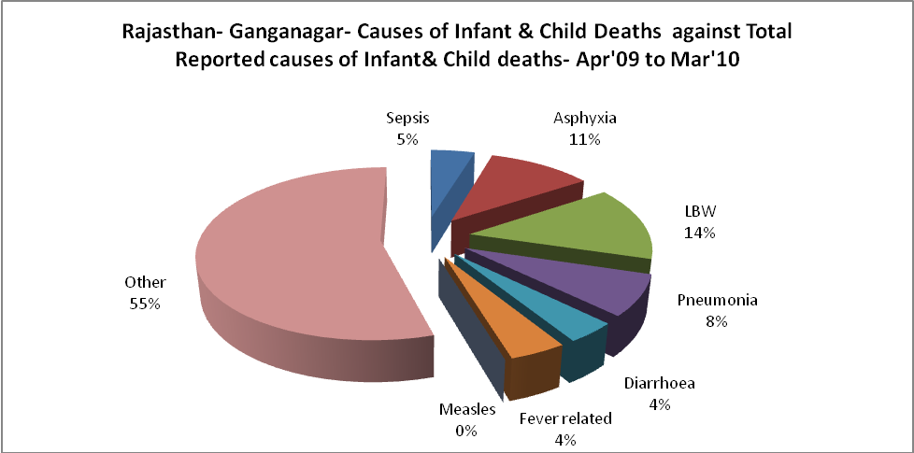

Rajasthan- Ganganagar- Maternal Deaths & Causes - Apr'09 to Mar'10
Abortion |  |  | Obstructed/prolonged labour |  |  | Severe hypertesnion/fits
6-14 yrs | 15-55 yrs. | Total | 6-14 yrs | 15-55 yrs. | Total | 6-14 yrs | 15-55 yrs. | Total
0 | 3 | 3 | 0 | 0 | 0 | 2 | 2 | 4
Bleeding |  |  | High Fever |  |  | Other Causes
6-14 yrs | 15-55 yrs. | Total | 6-14 yrs | 15-55 yrs. | Total | 6-14 yrs | 15-55 yrs. | Total
1 | 1 | 2 | 0 | 0 | 0 | 3 | 15 | 18

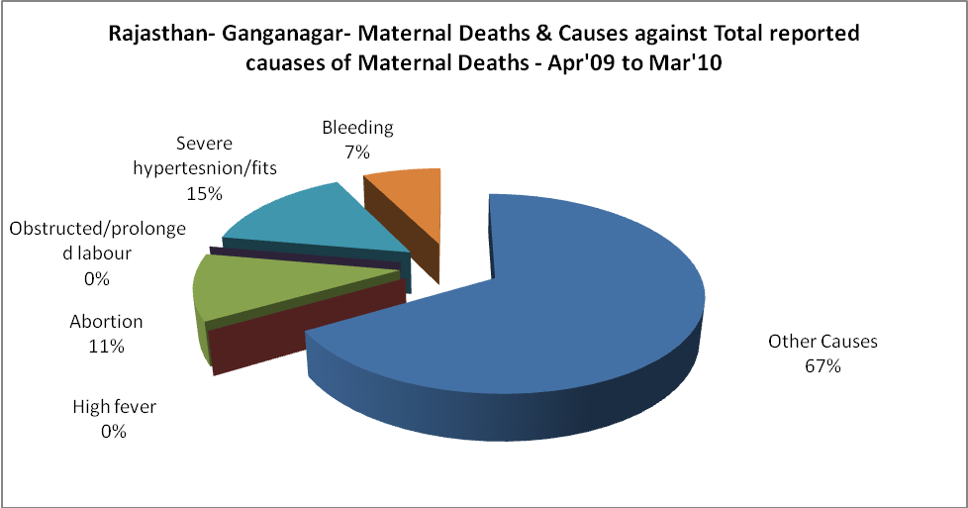

Rajasthan- Ganganagar-Causes of Deaths in 6 to 55yrs age group - Apr'09 to Mar'10
Diarrhoel Diseases |  |  |  | Tuberculosis |  |  |  | Respiratory Diseases( Other than TB)
6-14 yrs | 15-55 yrs. | Above 55yrs | Total | 6-14 yrs | 15-55 yrs. | Above 55yrs | Total | 6-14 yrs | 15-55 yrs. | Above 55yrs | Total
40 | 14 | 10 | 64 | 4 | 33 | 20 | 57 | 2 | 40 | 60 | 102
Malaria |  |  |  | Other fever Related |  |  |  | HIV/Aids
6-14 yrs | 15-55 yrs. | Above 55yrs | Total | 6-14 yrs | 15-55 yrs. | Above 55yrs | Total | 6-14 yrs | 15-55 yrs. | Above 55yrs | Total
0 | 1 | 3 | 4 | 18 | 20 | 13 | 51 | 0 | 0 | 0 | 0
Heart Disease/Hypertenion related |  |  |  | Neurological Disease including strokes |  |  |  | Trauma/Accidents/ Burn Cases
6-14 yrs | 15-55 yrs. | Above 55yrs | Total | 6-14 yrs | 15-55 yrs. | Above 55yrs | Total | 6-14 yrs | 15-55 yrs. | Above 55yrs | Total
12 | 69 | 103 | 184 | 93 | 26 | 22 | 141 | 23 | 45 | 21 | 89
Suicide |  |  |  | Animal Bites & Stings
6-14 yrs | 15-55 yrs. | Above 55yrs | Total | 6-14 yrs | 15-55 yrs. | Above 55yrs | Total
10 | 81 | 19 | 110 | 1 | 4 | 4 | 9

