HMIS Analysis – Goa across Districts - Apr'14 to Sep'14
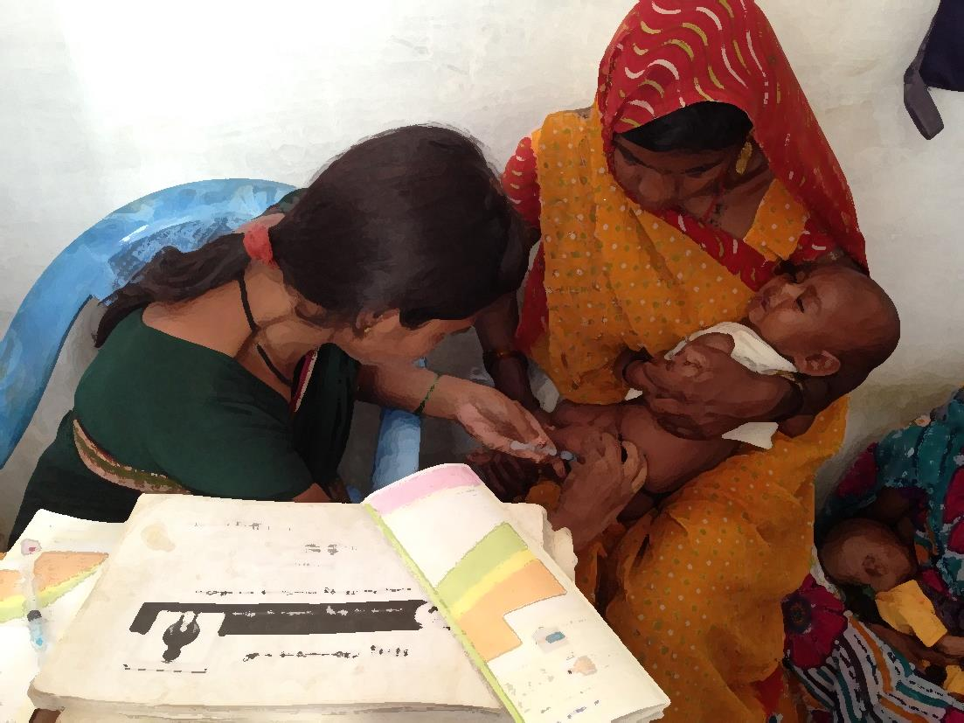

Data as on 14th Nov’14

 | _Goa | North Goa | South Goa
Population - Census - 2011 | 1,596,502 | 895,380 | 701,122
estimated Pregnancies | 22,900 | 12,843 | 10,057
estimated Deliveries | 20,800 | 11,665 | 9,135
estimated Live Births | 20,800 | 11,665 | 9,135
Children ( 0 to 1 yr) | 20,600 | 11,553 | 9,047

Goa across Districts - ANC Registration - Apr'14 to Sep'14
 | _Goa | North Goa | South Goa
Estimated Pregnancies | 22,900 | 12,843 | 10,057
Reported ANC Registration | 12,663 | 8,155 | 4,508
Goa across Districts- % ANC Registration against estimated pregnancies - Apr'14 to Sep'14 | 55% | 63% | 45%

Goa across Districts- ANC Services - Apr'14 to Sep'14
 | _Goa | North Goa | South Goa
Reported ANC Registration | 12,663 | 8,155 | 4,508
ANC registered within first trimester | 7,308 | 4,692 | 2,616
Goa across Districts- % ANC Registration in 1st Trimester against Reported ANC Registration -Apr'14 to Sep'14 | 58% | 58% | 58%
Number of pregnant women received 3 ANC check ups | 8,480 | 5,293 | 3,187
Goa across Districts- % 3 ANC Check ups against Reported ANC Registration -Apr'14 to Sep'14 | 67% | 65% | 71%
TT1 | 6,225 | 3,970 | 2,255
Goa across Districts- % TT1 against ANC Registration -Apr'14 to Sep'14 | 49% | 49% | 50%
TT2 or Booster | 6,587 | 3,896 | 2,691
Goa across Districts- % TT2 against Reported ANC Registration -Apr'14 to Sep'14 | 52% | 48% | 60%
Total number of pregnant women given 100 IFA tablets | 10,768 | 7,190 | 3,578
Goa across Districts- % ANC Pregnant Women given 100 IFA Tablets against Reported ANC Registration -Apr'14 to Sep'14 | 85% | 88% | 79%

Goa across Districts - Complications Reflecting Quality of ANC- Apr'14 to Sep'14
 | _Goa | North Goa | South Goa
Reported ANC Registration | 12,663 | 8,155 | 4,508
New cases of BP detected at institution | 283 | 255 | 28
Goa across Districts - % High BP cases detected against Reported ANC Registration -Apr'14 to Sep'14 | 2.2% | 3.1% | 0.6%
Number of Eclampsia cases managed during delivery | 42 | 39 | 3
Goa across Districts - % Eclampsia Cases Manged against Reported ANC Registration -Apr'14 to Sep'14 | 0.33% | 0.48% | 0.07%
Number having Hb level<11 (tested cases) | 2,857 | 1,645 | 1,212
Goa across Districts - % HB<11 gms against Reported ANC Registration -Apr'14 to Sep'14 | 22.6% | 20.2% | 26.9%
Number having severe anaemia (Hb<7) treated at institution | 142 | 47 | 95
Goa across Districts - %Severe Anaemia(HB < 7) treated against Reported ANC Registration -Apr'14 to Sep'14 | 1.12% | 0.58% | 2.11%

Goa across Districts - Deliveries - Apr'14 to Sep'14
 | _Goa | North Goa | South Goa
Estimated Deliveries | 20,800 | 11,665 | 9,135
Home SBA | - | - | -
Home Non SBA | 11 | 8 | 3
Total Home Deliveries | 11 | 8 | 3
Goa across Districts- % Home Deliveries against estimated Deliveries -Apr'14 to Sep'14 | 0% | 0% | 0%
Institutional (Pub) | 5,809 | 4,197 | 1,612
Institutional (Pvt) | 2,707 | 1,623 | 1,084
Total Institutional Deliveries | 8,516 | 5,820 | 2,696
Goa across Districts - % Institutional Deliveries against estimated Deliveries -Apr'14 to Sep'14 | 41% | 50% | 30%
Total Reported Deliveries | 8,527 | 5,828 | 2,699
Goa across Districts - % Unreported Deliveries against estimated Deliveries -Apr'14 to Sep'14 | 59% | 50% | 70%

Goa across Districts -% Deliveries against Reported - Apr'14 to Sep'14
 | _Goa | North Goa | South Goa
Goa across Districts- % Home Deliveries(SBA) against Reported Deliveries - Apr'14 to Sep'14 | 0% | 0% | 0%
Goa across Districts- % Home Deliveries(Non SBA) against Reported Deliveries - Apr'14 to Sep'14 | 0% | 0% | 0%
Goa across Districts- % Institutional Deliveries against Reported Deliveries - Apr'14 to Sep'14 | 100% | 100% | 100%

Goa across Districts - C- Section Deliveries -Apr'14 to Sep'14
 | _Goa | North Goa | South Goa
Total Reported Institutional Deliveries | 8,516 | 5,820 | 2,696
C- Section Deliveries (Pub) | 1,689 | 1,176 | 513
C- Section Deliveries (Pvt) | 1,148 | 646 | 502
Total C- Section Deliveries (Pub & Pvt) | 2,837 | 1,822 | 1,015
Goa across Districts - C - Section deliveries against Institutional(Pub & Pvt) deliveries - Apr'14 to Sep'14 | 33.3% | 31.3% | 37.6%

Goa across Districts - Stay Duration for Institutional Deliveries - Apr'14 to Sep'14
 | _Goa | North Goa | South Goa
Total Reported Institutional Deliveries(Pub + Pvt) | 8,516 | 5,820 | 2,696
Stay Duration less than 48 hrs | 1 | 1 | -
Goa across Districts - Duration of stay less than 48 hrs as Percentage of Reported Institutional Deliveries - Apr'14 to Sep'14 | 0% | 0% | 0%

Goa across Districts - Post Natal Check Up - Apr'14 to Sep'14
 | _Goa | North Goa | South Goa
% Women receiving post partum check-up within 48 hours after delivery against total deliveries | 83% | 75% | 99%
% Women getting a post partum check up between 48 hours and 14 days against total deliveries | 48% | 30% | 86%

Goa across Districts- JSY Payments- Apr'14 to Sep'14
 | _Goa | North Goa | South Goa
Home Deliveries | 11 | 8 | 3
JSY Paid to mothers for Home Deliveries | 0 | 0 | 0
Goa across Districts - JSY paid to mothers -%age of Reported Home deliveries - Apr'14 to Sep'14 | 0.0% | 0.0% | 0.0%
Institutional Deliveries(Pub) | 5,809 | 4,197 | 1,612
JSY Paid to mothers for Institutional Deliveries(Pub) | 293 | 153 | 140
Goa across Districts - JSY paid to mothers -%age of Reported Institutional deliveries - Public - Apr'14 to Sep'14 | 5% | 4% | 9%
Institutional Deliveries(Pvt) | 2,707 | 1,623 | 1,084
JSY Paid to mothers for Institutional Deliveries(Pvt) | 0 | 0 | 0
Goa across Districts - JSY paid to mothers -%age of Reported Institutional deliveries - Pvt - Apr'14 to Sep'14 | 0% | 0% | 0%

Goa across Districts - Newborn Care- Apr'14 to Sep'14
 | _Goa | North Goa | South Goa
Estimated Live Births | 20,800 | 11,665 | 9,135
Reported Live Births | 8,421 | 5,721 | 2,700
Goa across Districts - %ge Reported Live Births against Estimated Live Births - Apr'14 to Sep'14 | 40% | 49% | 30%
Newborns Weighed | 8,415 | 5,715 | 2,700
Goa across Districts - %ge Newborns weighed against Reported Live Births - Apr'14 to Sep'14 | 100% | 100% | 100%
Newborns Weighed Less than 2.5kgs | 1,422 | 1,085 | 337
Goa across Districts - %ge Newborns weighed less than 2.5 Kgs against Newborn weighed - Apr'14 to Sep'14 | 17% | 19% | 12%
Newborns Breastfed within 1 hr of Birth | 6,259 | 4,213 | 2,046
Goa across Districts - %ge Newborns Breastfed within 1 hr of Birth against Reported Live Births - Apr'14 to Sep'14 | 74% | 74% | 76%
Still Births | 183 | 175 | 8
Abortions - Spontaneous/Induced | 348 | 179 | 169

Goa across Districts - Abortions - Apr'14 to Sep'14
Abortion | _Goa | North Goa | South Goa
MTP - Up to 12 weeks of pregnancy | 159 | 127 | 32
MTP - More than 12 weeks of pregnancy | 0 | 0 | 0
Total MTP in Public Facilities | 159 | 127 | 32
Number of MTPs conducted at Private Facilities | 75 | 64 | 11
Abortions ( Induced/Spontaneous) | 348 | 179 | 169

Goa across Districts - Child Immunisation ( 0 to 11mnth )- Apr'14 to Sep'14
 | _Goa | North Goa | South Goa
Estimated Live Births | 20,800 | 11,665 | 9,135
BCG Given ( 0 -11 mnth) | 8,993 | 5,636 | 3,357
Goa across Districts- BCG given to( 0 to 11 mnths) Against estimated Live Births-Apr'14 to Sep'14 | 43.2% | 48.3% | 36.7%
OPV3 Given ( 0 -11 mnth) | 9,797 | 5,290 | 4,507
Goa across Districts- OPV3 given to( 0 to 11 mnths) Against estimated Live Births-Apr'14 to Sep'14 | 47.1% | 45.3% | 49.3%
DPT3 Given ( 0 -11 mnth) | 177 | 120 | 57
Goa across Districts- DPT3 given to( 0 to 11 mnths) Against estimated Live Births-Apr'14 to Sep'14 | 0.9% | 1.0% | 0.6%
Measles Given ( 0 -11 mnth) | 10835 | 5742 | 5093
Fully Immunised ( 0 -11 mnth) | 9309 | 4607 | 4702
Goa across Districts- Fully Immunised ( 0 to 11 mnths) Against estimated Live Births-Apr'14 to Sep'14 | 45% | 39% | 51%
Reported Live Births | 8,421 | 5,721 | 2,700
Goa across Districts- Fully Immunised ( 0 to 11 mnths) Against Reported Live Births- Apr'14 to Sep'14 | 111% | 81% | 174%
Deaths Due to Immunisation | 0 | 0 | 0
Goa across Districts - BCG to Measels Drop out Rate - Apr'14 to Sep'14 | -20% | -2% | -52%

Goa across Districts - VHND & Immunisation Sessions - Apr'14 to Sep'14
 | _Goa | North Goa | South Goa
Required numbers of VHNDs per thousand population in 12 mnths | 19,158 | 5,372 | 4,207
Immunisation Sessions held as percentage of required VHNDs | 14% | 31% | 25%
% Sessions where ASHAs were present | 0% | 0% | 0%

Goa across Districts - Family Planning - Apr'14 to Sep'14
 | _Goa | North Goa | South Goa
Male Sterilisations | 10 | 3 | 7
Female Sterilisations | 1,405 | 932 | 473
IUCD | 737 | 491 | 246
Post Partum (within 48 hours of delivery) IUCD insertions | 37 | 35 | 2
% Post Partum (within 48 hours of delivery) IUCD insertions against total IUCD inserted | 5% | 7% | 1%
OCP Users ( OCP Cycles/13) | 1,574 | 1,082 | 491
Condom Users ( Condom Pieces/72 ) | 1,491 | 743 | 748
Total FP method Users | 5,216 | 3,251 | 1,965
% Of FP users Using Limiting Methods | 27.13% | 28.76% | 24.43%
% Of FP users Using Spacing Methods | 72.87% | 71.24% | 75.57%

Goa across Districts- Service Delivery - Apr'14 to Sep'14
 | _Goa | North Goa | South Goa
Population | 1,596,502 | 895,380 | 701,122
Total OPD | 810,358 | 519,286 | 291,072
Total IPD | 40,892 | 18,601 | 22,291
OPD per 1000 population | 507.58 | 579.96 | 415.15
IPD per 1000 population | 25.61 | 20.77 | 31.79
Operation Major( General and Spinal Anaesthesia) | 4,213 | 2,445 | 1,768
Operation Major per 100000 population | 263.89 | 273.07 | 252.17
,Gynecology- Hysterectomy surgeries | 480 | 480 | -
% of,Gynecology- Hysterectomy surgeries against total major surgeries | 11.4% | 19.6% | 0.0%
Operation Minor( No or local Anaesthesia) | 2,665 | 1,822 | 843
Operation Minor as % of OPD | 0.33% | 0.35% | 0.29%
AYUSH | 13,055 | 8,189 | 4,866
Ayush as % of OPD | 1.6% | 1.6% | 1.7%
Dental Procedures | 14,603 | 8,006 | 6,597
Dental Procedures as % of OPD | 1.80% | 1.54% | 2.27%
Adolescent Counselling | 2,815 | 1,743 | 1,072
Adolescent Counselling as % of OPD | 0.35% | 0.34% | 0.37%

Goa across Districts -Lab Tests - Apr'14 to Sep'14
 | _Goa | North Goa | South Goa
Total HB tested | 45,497 | 23,600 | 21,897
HB Tested as %age of OPD | 6% | 5% | 8%
HB <7 gm as %age of HB tested | 1.40% | 0.61% | 2.25%
Total HIV tested | 25,372 | 13,278 | 12,094
HIV Tested as %age of OPD | 3.13% | 2.56% | 4.15%
HIV Tested positive as %age of HIV tested | 2.7% | 4.6% | 0.6%
Total VDRL Tested | 12,757 | 5,917 | 6,840
VDRL Tested as %age of OPD | 1.6% | 1.1% | 2.3%
Total Widal Test Conducted | 987 | 514 | 473
Widal Test Conducted as %age of OPD | 0.12% | 0.10% | 0.16%
Blood Smear Examined for Malaria | 219,872 | 150,134 | 69,738
Blood Smear Examined as %age of population | 13.77% | 16.77% | 9.95%

Goa across Districts - Childhood Diseases - Apr'14 to Sep'14
Types of Diseases | _Goa | North Goa | South Goa
Population | 1,596,502 | 895,380 | 701,122
Diphtheria | 1 | 1 | -
Pertussis | - | - | -
Tetanus Neonatorum | - | - | -
Tetanus others | - | - | -
Polio | - | - | -
Measles | 20 | 12 | 8
Diarrhoea and dehydration | 849 | 347 | 502
Malaria | 78 | 50 | 28
Number admitted with Respiratory Infections | 1,203 | 677 | 526

Goa across Districts - Infant Deaths upto 5 yrs - Apr'14 to Sep'14
 | _Goa | North Goa | South Goa
Infant deaths within 24 hrs of Birth | 8 | 8 | 0
Infant deaths between 24 hrs to 4weeks of Birth | 4 | 4 | 0
Infant deaths between 1 month to11months of Birth | 22 | 20 | 2
Infant deaths between 1 year to 5 yrs of Birth | 2 | 1 | 1
Total | 36 | 33 | 3

Goa across Districts - Maternal Deaths - Apr'14 to Sep'14
Maternal Deaths | _Goa | North Goa | South Goa
Abortions | 0 | 0 | 0
Obstructed/prolonged Labour | 0 | 0 | 0
Severe Hypertension/Fits | 1 | 1 | 0
Bleeding | 1 | 1 | 0
High Fever | 0 | 0 | 0
Other Causes | 0 | 0 | 0
Total deaths | 2 | 2 | 0

Goa across Districts - Deaths ( other than Infant & Maternal deaths) - Apr'14 to Sep'14
 | _Goa | North Goa | South Goa
Diarrhoeal Diseases | 4 | 4 | 0
Tuberculosis | 8 | 7 | 1
Respiratory Diseases  (Other than TB) | 34 | 27 | 7
Malaria | 0 | 0 | 0
Other fever Related | 5 | 5 | 0
HIV/AIDS | 0 | 0 | 0
Heart Disease/ Hypertension related | 183 | 147 | 36
Neurological Disease including strokes | 10 | 9 | 1
Trauma/Accidents/ Burn Cases | 18 | 13 | 5
Suicide | 14 | 11 | 3
Animal Bites & Stings | 2 | 1 | 1
Known Acute Disease | 32 | 21 | 11
Known Chronic Disease | 108 | 72 | 36
Causes not known | 2 | 1 | 1
Total Deaths | 420 | 318 | 102

