HMIS Analysis - Sikkim across Districts - Apr'14 to Sep'14
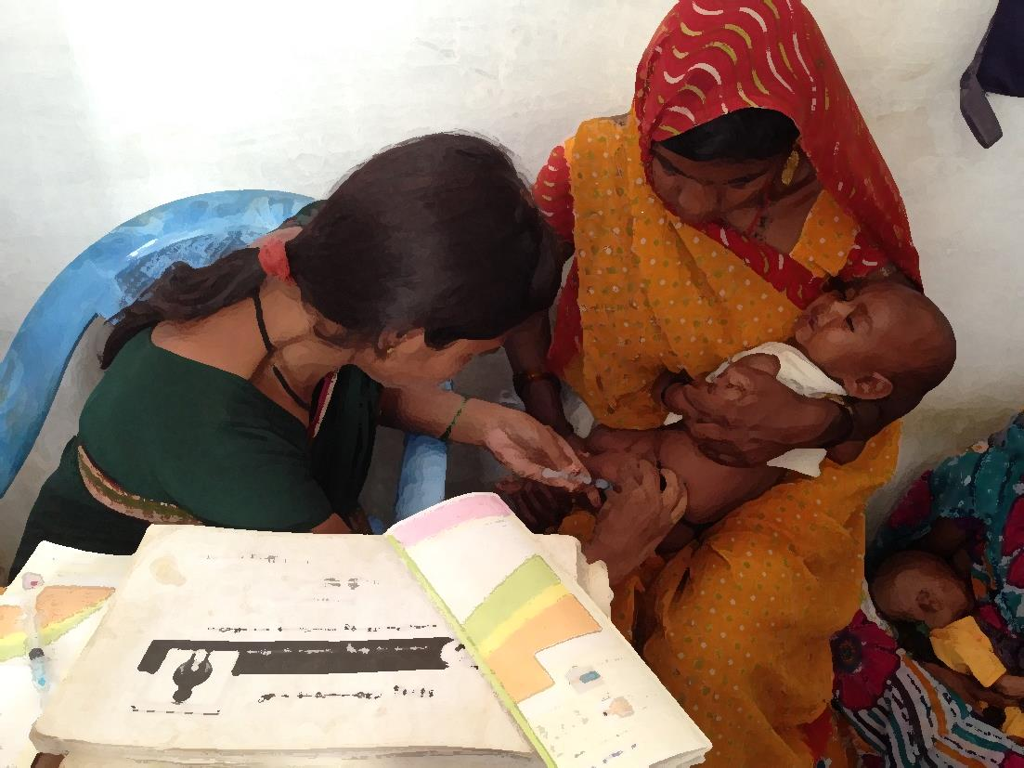

Data as on 14th Nov’14

 | _Sikkim | East | North | South | West
Population - Census - 2011 | 635,559 | 295,186 | 45,497 | 152,859 | 142,017
estimated Pregnancies | 12,000 | 5,574 | 859 | 2,886 | 2,681
estimated Deliveries | 10,900 | 5,063 | 780 | 2,622 | 2,435
estimated Live Births | 10,900 | 5,063 | 780 | 2,622 | 2,435
Children ( 0 to 1 yr) | 10,700 | 4,970 | 766 | 2,573 | 2,391

Sikkim across Districts - ANC Registration - Apr'14 to Sep'14
 | _Sikkim | East | North | South | West
Estimated Pregnancies | 12,000 | 5,574 | 859 | 2,886 | 2,681
Reported ANC Registration | 4,901 | 2,298 | 359 | 1,132 | 1,112
Sikkim across Districts- % ANC Registration against estimated pregnancies - Apr'14 to Sep'14 | 41% | 41% | 42% | 39% | 41%

Sikkim across Districts- ANC Services - Apr'14 to Sep'14
 | _Sikkim | East | North | South | West
Reported ANC Registration | 4,901 | 2,298 | 359 | 1,132 | 1,112
ANC registered within first trimester | 3,829 | 1,667 | 302 | 922 | 938
Sikkim across Districts- % ANC Registration in 1st Trimester against Reported ANC Registration -Apr'14 to Sep'14 | 78% | 73% | 84% | 81% | 84%
Number of pregnant women received 3 ANC check ups | 4,140 | 1,967 | 314 | 995 | 864
Sikkim across Districts- % 3 ANC Check ups against Reported ANC Registration -Apr'14 to Sep'14 | 84% | 86% | 87% | 88% | 78%
TT1 | 3,920 | 1,757 | 301 | 945 | 917
Sikkim across Districts- % TT1 against ANC Registration -Apr'14 to Sep'14 | 80% | 76% | 84% | 83% | 82%
TT2 or Booster | 4,451 | 1,957 | 343 | 1,084 | 1,067
Sikkim across Districts- % TT2 against Reported ANC Registration -Apr'14 to Sep'14 | 91% | 85% | 96% | 96% | 96%
Total number of pregnant women given 100 IFA tablets | 4,064 | 1,845 | 248 | 937 | 1,034
Sikkim across Districts- % ANC Pregnant Women given 100 IFA Tablets against Reported ANC Registration -Apr'14 to Sep'14 | 83% | 80% | 69% | 83% | 93%

Sikkim across Districts - Complications Reflecting Quality of ANC- Apr'14 to Sep'14
 | _Sikkim | East | North | South | West
Reported ANC Registration | 4,901 | 2,298 | 359 | 1,132 | 1,112
New cases of BP detected at institution | 145 | 102 | 15 | 5 | 23
Sikkim across Districts - % High BP cases detected against Reported ANC Registration -Apr'14 to Sep'14 | 3.0% | 4.4% | 4.2% | 0.4% | 2%
Number of Eclampsia cases managed during delivery | - | - | - | - | -
Sikkim across Districts - % Eclampsia Cases Manged against Reported ANC Registration -Apr'14 to Sep'14 | 0.00% | 0.00% | 0.00% | 0.00% | 0.00%
Number having Hb level<11 (tested cases) | 1,798 | 620 | 58 | 591 | 529
Sikkim across Districts - % HB<11 gms against Reported ANC Registration -Apr'14 to Sep'14 | 36.7% | 27.0% | 16.2% | 52.2% | 48%
Number having severe anaemia (Hb<7) treated at institution | 13 | 8 | - | - | 5
Sikkim across Districts - %Severe Anaemia(HB < 7) treated against Reported ANC Registration -Apr'14 to Sep'14 | 0.27% | 0.35% | 0.00% | 0.00% | 0.45%
Total number of pregnant women given 100 IFA tablets | 4,064 | 1,845 | 248 | 937 | 1,034
Sikkim across Districts- % ANC Pregnant Women given 100 IFA Tablets against Reported ANC Registration -Apr'14 to Sep'14 | 83% | 80% | 69% | 83% | 93%

Sikkim across Districts - Deliveries - Apr'14 to Sep'14
 | _Sikkim | East | North | South | West
Estimated Deliveries | 10,900 | 5,063 | 780 | 2,622 | 2,435
Home SBA | 36 | 19 | 1 | 9 | 7
Home Non SBA | 60 | 23 | 4 | 24 | 9
Total Home Deliveries | 96 | 42 | 5 | 33 | 16
Sikkim across Districts- % Home Deliveries against estimated Deliveries -Apr'14 to Sep'14 | 1% | 1% | 1% | 1% | 1%
Institutional (Pub) | 3,025 | 1,512 | 103 | 827 | 583
Institutional (Pvt) | 813 | 813 | - | - | -
Total Institutional Deliveries | 3,838 | 2,325 | 103 | 827 | 583
Sikkim across Districts - % Institutional Deliveries against estimated Deliveries -Apr'14 to Sep'14 | 35% | 46% | 13% | 32% | 24%
Total Reported Deliveries | 3,934 | 2,367 | 108 | 860 | 599
Sikkim across Districts - % Unreported Deliveries against estimated Deliveries -Apr'14 to Sep'14 | 64% | 53% | 86% | 67% | 75%

Sikkim across Districts -% Deliveries against Reported - Apr'14 to Sep'14
 | _Sikkim | East | North | South | West
Sikkim across Districts- % Home Deliveries(SBA) against Reported Deliveries - Apr'14 to Sep'14 | 1% | 1% | 1% | 1% | 1%
Sikkim across Districts- % Home Deliveries(Non SBA) against Reported Deliveries - Apr'14 to Sep'14 | 2% | 1% | 4% | 3% | 2%
Sikkim across Districts- % Institutional Deliveries against Reported Deliveries - Apr'14 to Sep'14 | 98% | 98% | 95% | 96% | 97%

Sikkim across Districts - C- Section Deliveries -Apr'14 to Sep'14
 | _Sikkim | East | North | South | West
Total Reported Institutional Deliveries | 3,838 | 2,325 | 103 | 827 | 583
C- Section Deliveries (Pub) | 606 | 393 | - | 210 | 3
C- Section Deliveries (Pvt) | 439 | 439 | - | - | -
Total C- Section Deliveries (Pub & Pvt) | 1,045 | 832 | - | 210 | 3
Sikkim across Districts - C - Section deliveries against Institutional(Pub & Pvt) deliveries - Apr'14 to Sep'14 | 27.2% | 35.8% | 0.0% | 25.4% | 0.5%

Sikkim across Districts - Stay Duration for Institutional Deliveries - Apr'14 to Sep'14
 | _Sikkim | East | North | South | West
Total Reported Institutional Deliveries(Pub + Pvt) | 3,838 | 2,325 | 103 | 827 | 583
Stay Duration less than 48 hrs | 1,282 | 866 | 4 | 401 | 11
Sikkim across Districts - Duration of stay less than 48 hrs as Percentage of Reported Institutional Deliveries - Apr'14 to Sep'14 | 33% | 37% | 4% | 48% | 2%

Sikkim across Districts - Post Natal Check Up - Apr'14 to Sep'14
 | _Sikkim | East | North | South | West
% Women receiving post partum check-up within 48 hours after delivery against total deliveries | 92% | 93% | 96% | 90% | 89%
% Women getting a post partum check up between 48 hours and 14 days against total deliveries | 85% | 70% | 137% | 85% | 131%

Sikkim across Districts- JSY Payments- Apr'14 to Sep'14
 | _Sikkim | East | North | South | West
Home Deliveries | 96 | 42 | 5 | 33 | 16
JSY Paid to mothers for Home Deliveries | 1 | 0 | 1 | 0 | 0
Sikkim across Districts - JSY paid to mothers -%age of Reported Home deliveries - Apr'14 to Sep'14 | 1.0% | 0.0% | 20.0% | 0.0% | 0.0%
Institutional Deliveries(Pub) | 3,025 | 1,512 | 103 | 827 | 583
JSY Paid to mothers for Institutional Deliveries(Pub) | 372 | 219 | 111 | 21 | 21
Sikkim across Districts - JSY paid to mothers -%age of Reported Institutional deliveries - Public - Apr'14 to Sep'14 | 12% | 14% | 108% | 3% | 4%
Institutional Deliveries(Pvt) | 813 | 813 | - | - | -
JSY Paid to mothers for Institutional Deliveries(Pvt) | 0 | 0 | 0 | 0 | 0
Sikkim across Districts - JSY paid to mothers -%age of Reported Institutional deliveries - Pvt - Apr'14 to Sep'14 | 0% | 0% | #DIV/0! | #DIV/0! | #DIV/0!

Sikkim across Districts - Newborn Care- Apr'14 to Sep'14
 | _Sikkim | East | North | South | West
Estimated Live Births | 10,900 | 5,063 | 780 | 2,622 | 2,435
Reported Live Births | 3,904 | 2,360 | 104 | 846 | 594
Sikkim across Districts - %ge Reported Live Births against Estimated Live Births - Apr'14 to Sep'14 | 36% | 47% | 13% | 32% | 24%
Newborns Weighed | 3,538 | 2,013 | 105 | 832 | 588
Sikkim across Districts - %ge Newborns weighed against Reported Live Births - Apr'14 to Sep'14 | 91% | 85% | 101% | 98% | 99%
Newborns Weighed Less than 2.5kgs | 255 | 191 | 7 | 35 | 22
Sikkim across Districts - %ge Newborns weighed less than 2.5 Kgs against Newborn weighed - Apr'14 to Sep'14 | 7% | 8% | 7% | 4% | 4%
Newborns Breastfed within 1 hr of Birth | 3,555 | 2,026 | 103 | 837 | 589
Sikkim across Districts - %ge Newborns Breastfed within 1 hr of Birth against Reported Live Births - Apr'14 to Sep'14 | 91% | 86% | 99% | 99% | 99%
Still Births | 71 | 30 | 3 | 23 | 15
Abortions - Spontaneous/Induced | 241 | 124 | 10 | 27 | 80

Sikkim across Districts - Sex Ratio- Apr'14 to Sep'14
 | _Sikkim | East | North | South | West
Live Birth - Male | 1944 | 1216 | 53 | 395 | 280
Live Birth - Female | 1960 | 1144 | 51 | 451 | 314
Sikkim across Districts - Sex Ratio at Birth - Apr'14 to Sep'14 | 1008 | 941 | 962 | 1142 | 1121

Sikkim across Districts - Abortions - Apr'14 to Sep'14
Abortion | _Sikkim | East | North | South | West
MTP - Up to 12 weeks of pregnancy | 17 | 4 | 11 | 0 | 2
MTP - More than 12 weeks of pregnancy | 0 | 0 | 0 | 0 | 0
Total MTP in Public Facilities | 17 | 4 | 11 | 0 | 2
Number of MTPs conducted at Private Facilities | 39 | 39 | 0 | 0 | 0
Abortions ( Induced/Spontaneous) | 241 | 124 | 10 | 27 | 80

Sikkim across Districts - Child Immunisation ( 0 to 11mnth )- Apr'14 to Sep'14
 | _Sikkim | East | North | South | West
Estimated Live Births | 10,900 | 5,063 | 780 | 2,622 | 2,435
BCG Given ( 0 -11 mnth) | 3,965 | 2,338 | 108 | 888 | 631
Sikkim across Districts- BCG given to( 0 to 11 mnths) Against estimated Live Births-Apr'14 to Sep'14 | 36.4% | 46.2% | 13.8% | 33.9% | 25.9%
OPV3 Given ( 0 -11 mnth) | 3,889 | 1,812 | 264 | 912 | 901
Sikkim across Districts- OPV3 given to( 0 to 11 mnths) Against estimated Live Births-Apr'14 to Sep'14 | 35.7% | 35.8% | 33.8% | 34.8% | 37.0%
DPT3 Given ( 0 -11 mnth) | 3,670 | 1,599 | 259 | 909 | 903
Sikkim across Districts- DPT3 given to( 0 to 11 mnths) Against estimated Live Births-Apr'14 to Sep'14 | 33.7% | 31.6% | 33.2% | 34.7% | 37.1%
Measles Given ( 0 -11 mnth) | 4369 | 2050 | 289 | 1039 | 991
Fully Immunised ( 0 -11 mnth) | 4311 | 2042 | 270 | 1015 | 984
Sikkim across Districts- Fully Immunised ( 0 to 11 mnths) Against estimated Live Births-Apr'14 to Sep'14 | 40% | 40% | 35% | 39% | 40%
Reported Live Births | 3,904 | 2,360 | 104 | 846 | 594
Sikkim across Districts- Fully Immunised ( 0 to 11 mnths) Against Reported Live Births- Apr'14 to Sep'14 | 110% | 87% | 260% | 120% | 166%
Deaths Due to Immunisation | 0 | 0 | 0 | 0 | 0
Sikkim across Districts - BCG to Measels Drop out Rate - Apr'14 to Sep'14 | -10% | 12% | -168% | -17% | -57%

Sikkim across Districts - VHND & Immunisation Sessions - Apr'14 to Sep'14
 | _Sikkim | East | North | South | West
Required numbers of VHNDs per thousand population in 12 mnths | 7,627 | 1,771 | 273 | 917 | 852
Immunisation Sessions held as percentage of required VHNDs | 57% | 104% | 218% | 77% | 138%
% Sessions where ASHAs were present | 88% | 79% | 95% | 101% | 91%

Sikkim across Districts - Family Planning - Apr'14 to Sep'14
 | _Sikkim | East | North | South | West
Male Sterilisations | 5 | 4 | - | 1 | -
Female Sterilisations | 45 | 25 | - | 20 | -
IUCD | 915 | 387 | 51 | 95 | 382
Post Partum (within 48 hours of delivery) IUCD insertions | 137 | 43 | 4 | 6 | 84
% Post Partum (within 48 hours of delivery) IUCD insertions against total IUCD inserted | 15% | 11% | 8% | 6% | 22%
OCP Users ( OCP Cycles/13) | 2,895 | 682 | 261 | 919 | 1,033
Condom Users ( Condom Pieces/72 ) | 1,562 | 433 | 65 | 400 | 664
Total FP method Users | 5,422 | 1,532 | 377 | 1,435 | 2,079
% Of FP users Using Limiting Methods | 0.92% | 1.89% | 0.00% | 1.46% | 0.00%
% Of FP users Using Spacing Methods | 99.08% | 98.11% | 100.00% | 98.54% | 100.00%

Sikkim across Districts- Service Delivery - Apr'14 to Sep'14
 | _Sikkim | East | North | South | West
Population | 635,559 | 295,186 | 45,497 | 152,859 | 142,017
Total OPD | 519,076 | 251,530 | 30,817 | 139,741 | 96,988
Total IPD | 22,041 | 10,074 | 900 | 6,699 | 4,368
OPD per 1000 population | 816.72 | 852.11 | 677.34 | 914.18 | 682.93
IPD per 1000 population | 34.68 | 34.13 | 19.78 | 43.82 | 30.76
Operation Major( General and Spinal Anaesthesia) | 1,298 | 956 | - | 342 | -
Operation Major per 100000 population | 204.23 | 323.86 | 0.00 | 223.74 | 0.00
,Gynecology- Hysterectomy surgeries | 35 | 33 | - | 2 | -
% of,Gynecology- Hysterectomy surgeries against total major surgeries | 2.7% | 3.5% | #DIV/0! | 0.6% | #DIV/0!
Operation Minor( No or local Anaesthesia) | 5,386 | 3,014 | 258 | 1,883 | 231
Operation Minor as % of OPD | 1.04% | 1.20% | 0.84% | 1.35% | 0.24%
AYUSH | 12,116 | 5,363 | - | 4,439 | 2,314
Ayush as % of OPD | 2.3% | 2.1% | 0.0% | 3.2% | 2.4%
Dental Procedures | 33,397 | 18,763 | 825 | 8,534 | 5,275
Dental Procedures as % of OPD | 6.43% | 7.46% | 2.68% | 6.11% | 5.44%
Adolescent Counselling | 7,879 | 2,973 | 1,174 | 2,836 | 896
Adolescent Counselling as % of OPD | 1.52% | 1.18% | 3.81% | 2.03% | 0.92%

Sikkim across Districts -Lab Tests - Apr'14 to Sep'14
 | _Sikkim | East | North | South | West
Total HB tested | 19,674 | 3,096 | 2,562 | 9,410 | 4,606
HB Tested as %age of OPD | 4% | 1% | 8% | 7% | 5%
HB <7 gm as %age of HB tested | 2.04% | 1.13% | 0.39% | 2.56% | 2.52%
Total HIV tested | 7,810 | 2,240 | 1,168 | 2,502 | 1,900
HIV Tested as %age of OPD | 1.50% | 0.89% | 3.79% | 1.79% | 1.96%
HIV Tested positive as %age of HIV tested | 0.0% | 0.1% | 0.0% | 0.0% | 0.0%
Total VDRL Tested | 4,875 | 1,352 | 496 | 2,158 | 869
VDRL Tested as %age of OPD | 0.9% | 0.5% | 1.6% | 1.5% | 0.9%
Total Widal Test Conducted | 219 | 21 | 1 | - | 197
Widal Test Conducted as %age of OPD | 0.04% | 0.01% | 0.00% | 0.00% | 0.20%
Blood Smear Examined for Malaria | 4,056 | 2,950 | 86 | 773 | 247
Blood Smear Examined as %age of population | 0.64% | 1.00% | 0.19% | 0.51% | 0.17%

Sikkim across Districts - Childhood Diseases - Apr'14 to Sep'14
Types of Diseases | _Sikkim | East | North | South | West
Population | 635,559 | 295,186 | 45,497 | 152,859 | 142,017
Diphtheria | - | - | - | - | -
Pertussis | - | - | - | - | -
Tetanus Neonatorum | - | - | - | - | -
Tetanus others | - | - | - | - | -
Polio | - | - | - | - | -
Measles | 18 | 9 | 3 | 1 | 5
Diarrhoea and dehydration | 4,475 | 1,755 | 384 | 1,092 | 1,244
Malaria | 6 | - | - | 6 | -
Number admitted with Respiratory Infections | 857 | 700 | 80 | 18 | 59

Sikkim across Districts - Infant Deaths upto 5 yrs - Apr'14 to Sep'14
 | _Sikkim | East | North | South | West
Infant deaths within 24 hrs of Birth | 0 | 0 | 0 | 0 | 0
Infant deaths between 24 hrs to 4weeks of Birth | 38 | 26 | 3 | 4 | 5
Infant deaths between 1 month to11months of Birth | 42 | 15 | 7 | 5 | 15
Infant deaths between 1 year to 5 yrs of Birth | 4 | 3 | 0 | 1 | 0
Total | 84 | 44 | 10 | 10 | 20

Sikkim across Districts - Maternal Deaths - Apr'14 to Sep'14
Maternal Deaths | _Sikkim | East | North | South | West
Abortions | 0 | 0 | 0 | 0 | 0
Obstructed/prolonged Labour | 0 | 0 | 0 | 0 | 0
Severe Hypertension/Fits | 1 | 1 | 0 | 0 | 0
Bleeding | 1 | 1 | 0 | 0 | 0
High Fever | 0 | 0 | 0 | 0 | 0
Other Causes | 5 | 4 | 0 | 1 | 0
Total deaths | 7 | 6 | 0 | 1 | 0

Sikkim across Districts - Deaths ( other than Infant & Maternal deaths) - Apr'14 to Sep'14
 | _Sikkim | East | North | South | West
Diarrhoeal Diseases | 1 | 0 | 0 | 1 | 0
Tuberculosis | 6 | 1 | 1 | 0 | 4
Respiratory Diseases  (Other than TB) | 18 | 7 | 0 | 2 | 9
Malaria | 0 | 0 | 0 | 0 | 0
Other fever Related | 6 | 1 | 1 | 3 | 1
HIV/AIDS | 0 | 0 | 0 | 0 | 0
Heart Disease/ Hypertension related | 57 | 6 | 3 | 6 | 42
Neurological Disease including strokes | 1 | 1 | 0 | 0 | 0
Trauma/Accidents/ Burn Cases | 30 | 7 | 5 | 4 | 14
Suicide | 18 | 5 | 1 | 2 | 10
Animal Bites & Stings | 1 | 0 | 0 | 0 | 1
Known Acute Disease | 23 | 1 | 1 | 1 | 20
Known Chronic Disease | 79 | 13 | 6 | 6 | 54
Causes not known | 1 | 0 | 0 | 0 | 1
Total Deaths | 241 | 42 | 18 | 25 | 156

