NHSRC
HIMACHAL PRADESH
Analysis 2009-10

7/22/1010

Fact Sheet - Himachal Pradesh
Indicators
A - General
A.1 | Total Population 2009-10(State Expected fig.) |  |  | 6702000
A.2 | Eligible Couples ((NHSRC Inhouse estimation for March 2008) |  |  | 1687377
A.3 | TFR {Source: Registrar General of India (RGI), Ministry of Home Affairs., May 2009} |  |  | 1.90
A.4 | MMR ( per 100,000 live births){Source: Registrar General of India (RGI), Ministry of Home Affairs., May 2009} |  |  | 186.00
A.5 | IMR (SRS Bulletin - Oct 2009) |  |  | 44
A.6 | CBR ( per 1000 population)(SRS Bulletin - Oct 2009) |  |  | 17.70
A.7 | CDR ( per 1000 population)(SRS Bulletin - Oct 2009) |  |  | 7.40
A.8 | Sex Ratio ( per thousand males)(census 2001) |  |  | 896.00
 | B - Child Health |  |  | HMIS - 2009-10 | Surveys | Source
B.1 | Expected Live Births |  |  | 118,625 | - | NFHSIII
B.2 | New born breastfed in less than 1 hr of birth against Expected Live Births |  |  | 63% | 43.4% | NFHSIII
B.3 | Newborn weighed % against Expected Live Births |  |  | 81% | 44.2% | NFHSIII
B.4 | Newborn weighed less than 2.5 kgs % as percentage of B.3 |  |  | 7% | 24.8% | NFHSIII
 | C - Child Immunisation |  |  | HMIS - 2009-10 | Surveys | Source
C.1 | Fully Immunized Children % ( of Expected Live Births) |  |  | 104% | 74.0% | NFHSIII
C.2 | Children given BCG % ( of Expected Live Births) |  |  | 111% | 97.2% | NFHSIII
C.3 | Children given 3 doses of OPV % ( of Expected Live Births) |  |  | 107% | 88.6% | NFHSIII
C.4 | Children given 3 doses of DPT % ( of Expected Live Births) |  |  | 107% | 85.1% | NFHSIII
C.5 | Children given Measles % ( of Expected Live Births) |  |  | 104% | 86.3% | NFHSIII
 | D - Maternal Health |  |  | HMIS - 2009-10 | Surveys | Source
D.1 | Pregnant women registered for ANC% ( as percentage of expected pregnancies) |  |  | 121% | _ | _
D.2 | ANC registered in First Trimester % ( as percentage of expected pregnancies) |  |  | 50% | 62.1% | DLHSIII
D.3 | Antenatal Care 3 check ups % ( as percentage of expected pregnancies) |  |  | 90% | 61.4% | DLHSIII
D.8 | Home Deliveries % ( as percentage of expected deliveries) |  |  | 41% | 51.3% | DLHSIII
D.9 | Home Deliveries assisted by SBA % ( as percentage of expected deliveries) |  |  | 7% | 5.1% | DLHSIII
D.10 | Institutional Deliveries % ( as percentage of expected deliveries) |  |  | 46% | 48.2% | DLHSIII
D.11 | Post natal check up within 48 hrs of delivery % ( as percentage of reported deliveries) |  |  | 44% | _ | _
D.12 | Deliveries with post natal check up within two days and 14 days of birth % ( as percentage of reported deliveries) |  |  | 42% | 50.5% | DLHSIII

Himachal Pradesh- Summary-Apr'09 to Mar'10
ANC
ANC Registration against Expected Pregnancies | 121% | TT1 given to Pregnant women against ANC Registration | 55%
3 ANC Check ups against ANC Registrations | 74% | 100 IFA Tablets given to Pregnant women against ANC Registration | 71%
Deliveries
Unreported Deliveries against Estimated Deliveries | 13.4% | HOME Deliveries( SBA& Non SBA) against Estimated Deliveries | 40.8%
Institutional Deliveries against Estimated Deliveries | 45.8% | HOME Deliveries( SBA& Non SBA) against Reported Deliveries | 47.1%
Institutional Deliveries against Reported Deliveries | 52.9% | C Section Deliveries against Institutional Deliveries( Pvt & Pub) | 27%
Births & Neonates Care
Live Births Reported against Estimated Live Births | 88% | New borns weighed against Reported Live Births | 92%
Still Births (Reported) | 1,135 | New borns weighed less than 2.5 kgs against newborns weighed | 7%
Sex Ratio at Birth | 898 | New borns breastfed within one hr of Birth against Reported live Births | 72%
Child Immunization( 0 to 11 months)
BCG given against Expected Live Births | 111% | Measles given against Expected Live Births | 104%
OPV3 given against Expected Live Births | 107% | Fully Immunized Children against Expected Live Births | 104%
DPT3 given against Expected Live Births | 107%
Family Planning
Family Planning Methods Users ( Sterilizations(Male &Female)+IUD+ Condom pieces/72 + OCP Cycles/13) | 183,704 | IUD Insertions against reported FP Methods | 13%
Sterilization against reported FP Methods | 15% | Condom Users against reported FP Methods | 56%
 |  | OCP Users against reported FP Methods | 16%
Other Services
OPD | 6,328,446 | Major Operations | 17,987
IPD | 183,594 | Minor Operations | 20,723

Himachal Pradesh- Deliveries Apr'09 to Mar'10
Total Population | 6,702,000 | Expected Deliveries |  | 121,235
Home SBA | Home Non SBA | Institutional | Total Deliveries Reported | Unreported Deliveries
8,940 | 40,547 | 55,483 | 104,970 | 16,265
Home SBA % | Home Non SBA% | Institutional % | Total Deliveries Reported % | Unreported Deliveries %
7% | 33% | 46% | 87% | 13%

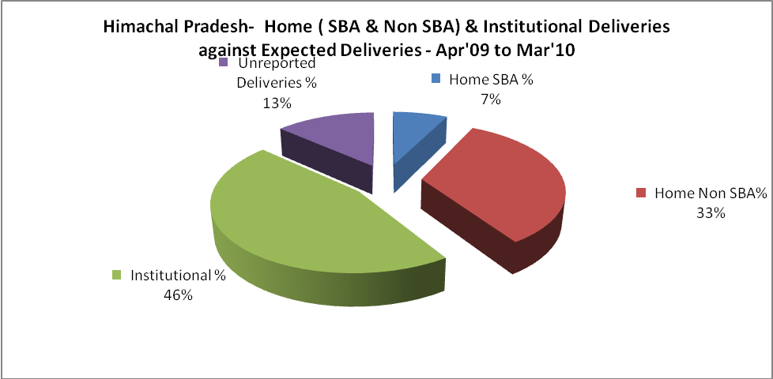
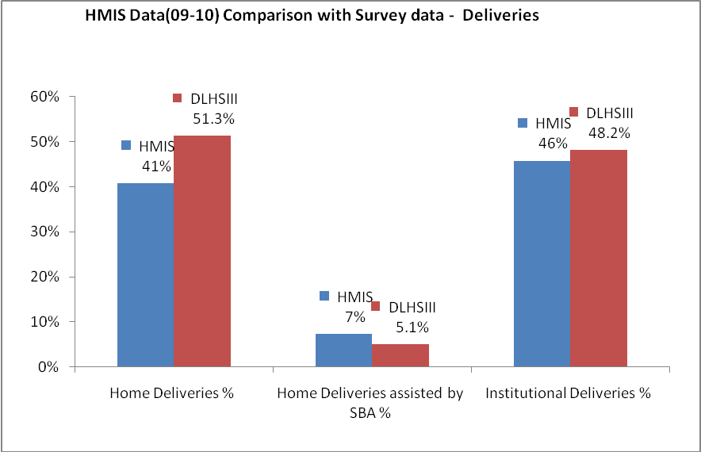

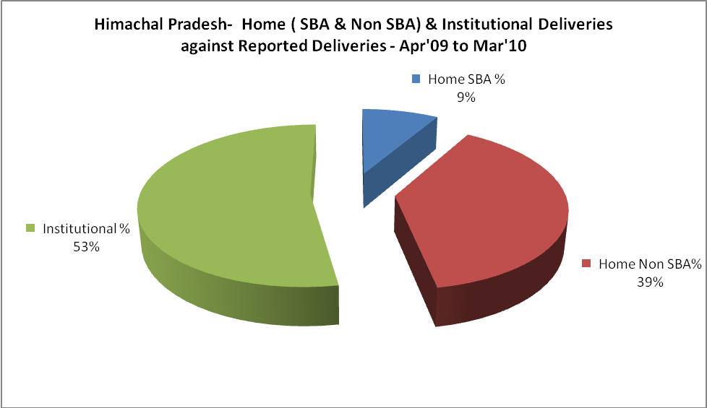

Himachal Pradesh- C sections & Complicated Deliveries Apr'09 to Mar'10
 | Institutional Deliveries (Public) | Institutional Deliveries (Pvt)
 | 45,584 | 9,899
C Section | 4,278 | 1,748
C Section% | 9% | 18%
Complicated Pregnancies attended | 1,952 | 679
Complicated Pregnancies attended % | 4% | 7%

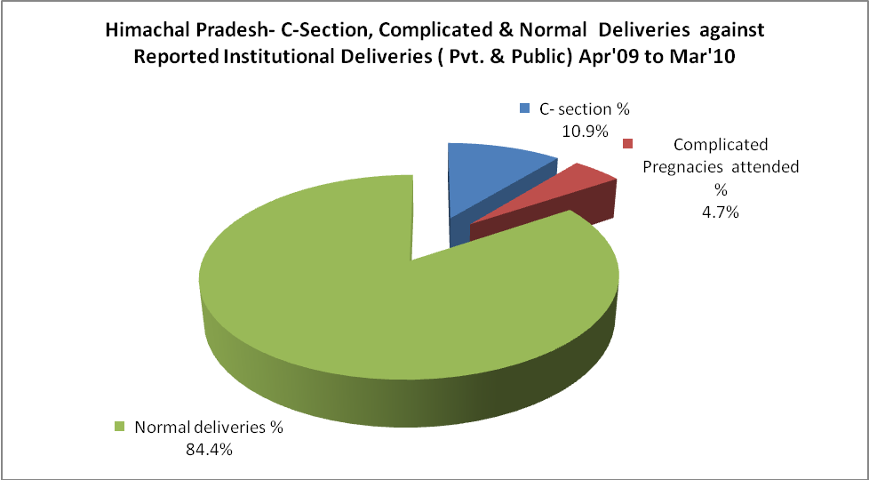

Himachal Pradesh- Complicated Pregnancies & Deliveries Treated - Apr'09 to Mar'10
Reported Deliveries |  |  | Reported ANC Registration
104,970 |  |  | 157,805
Complicated Pregnancies attended | Complicated Pregnancies Rate | C - Section Deliveries | PNC Maternal Complications | Abortions | Still Births
2,631 | 2% | 6,026 | 113 | 2,337 | 1,135
Complicated Deliveries Treated with |  |  |  | No Of Eclampsia cases Treated | No Of severe anemia cases treated
IV Antibiotics | IV antihypertensive/Magsulph injection | IV Oxytocis | Blood Transfusion | No Of Eclampsia cases Treated | No Of severe anemia cases treated
2,125 | 118 | 1,943 | 204 | 28 | 1,816

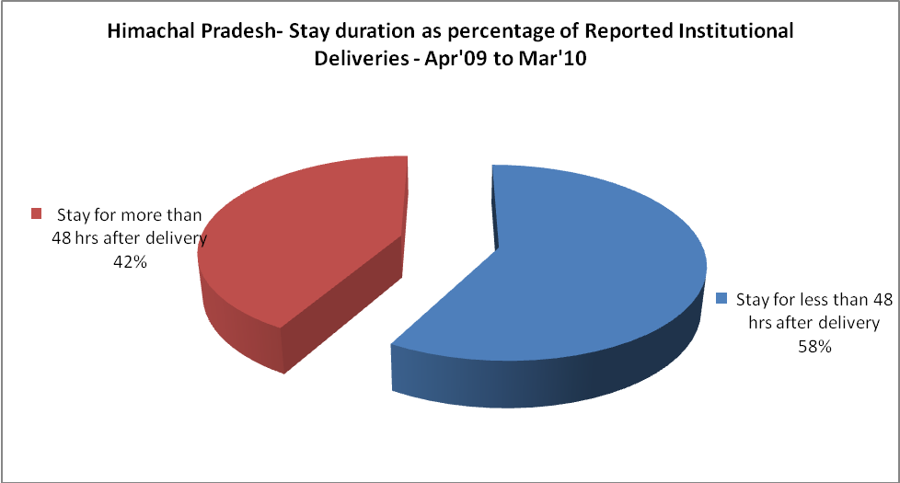
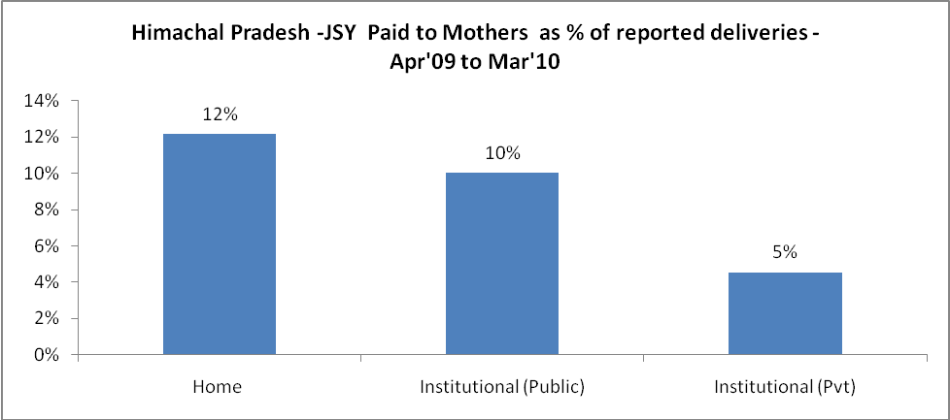
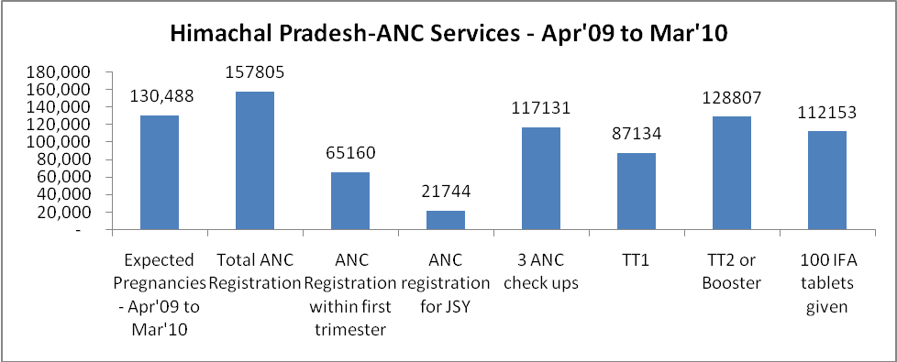
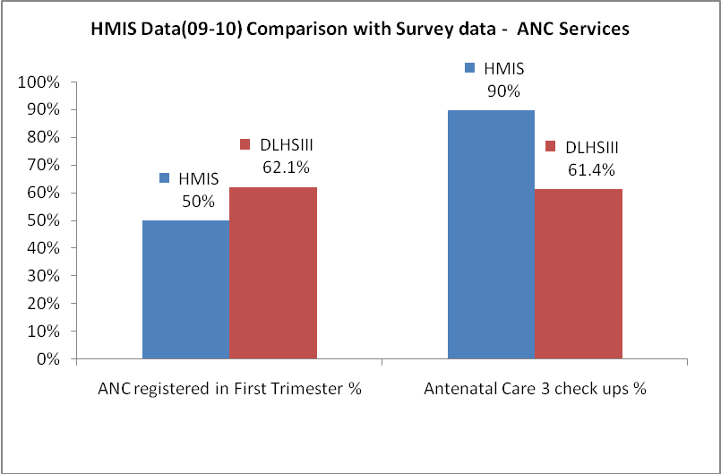
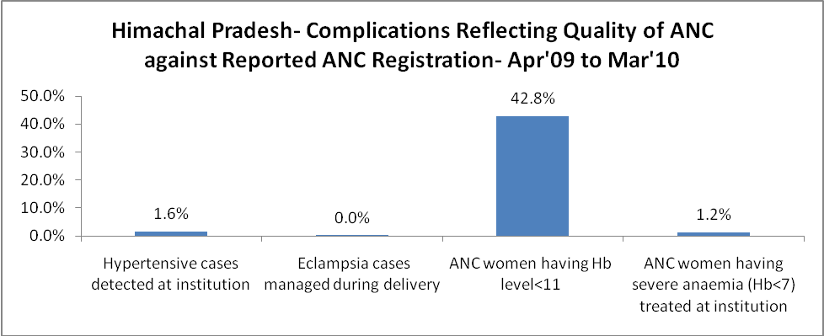
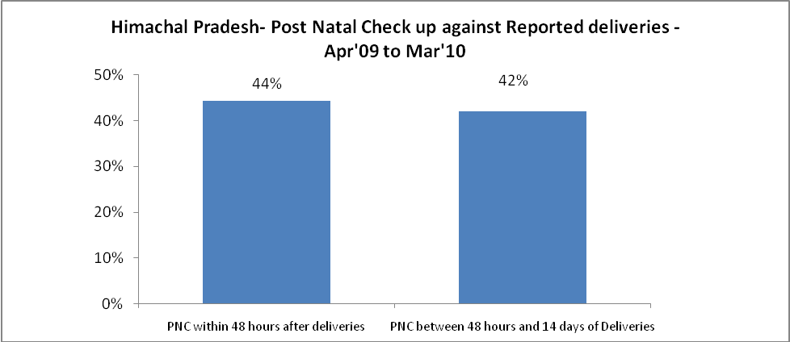
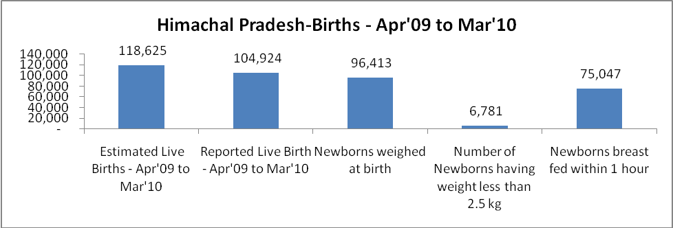
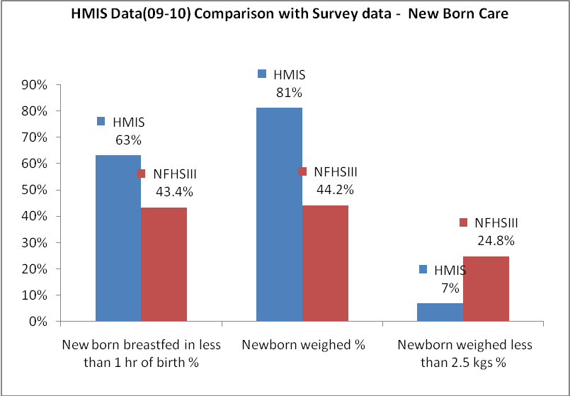

Himachal Pradesh - Births - Apr'09 to Mar'10
Live Birth - Males | Live Birth - females | Live Birth - Total | Sex Ratio at birth | Still Birth | Abortion( Induced/Spontaneous
55,277 | 49,647 | 104,924 | 898 | 1,135 | 2,337

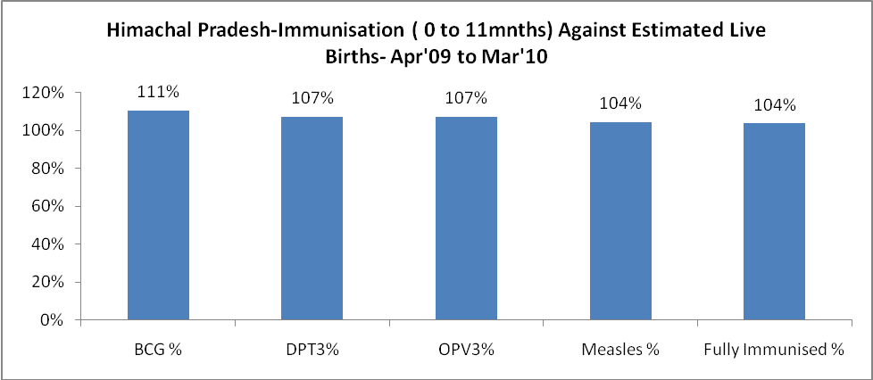
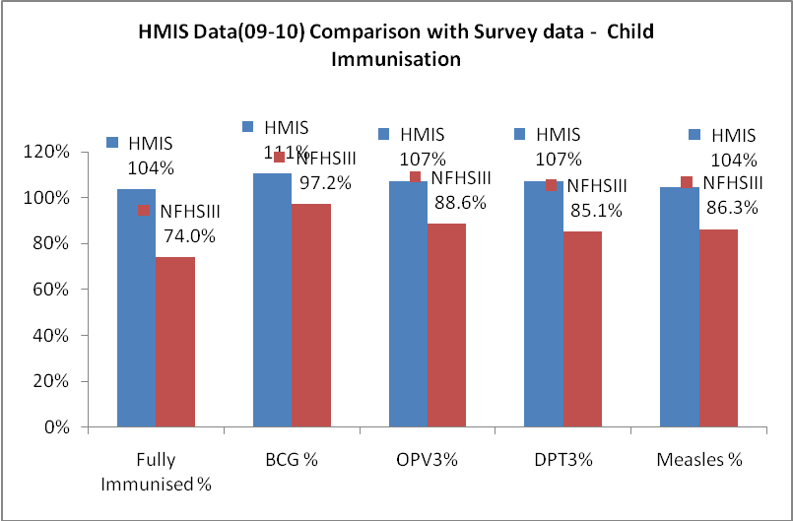
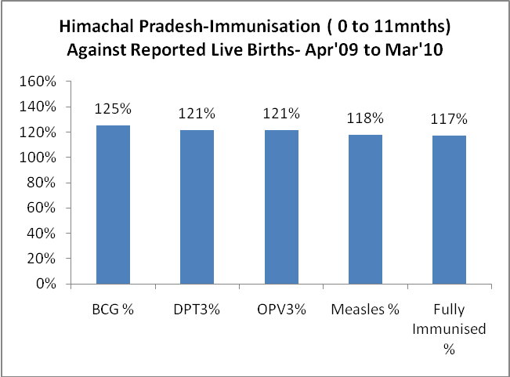
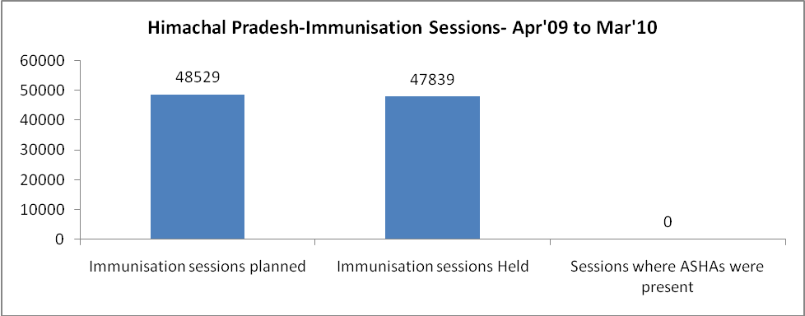
Himachal Pradesh- Apr'09 to Mar'10
Total Abortions | Abortion Rate
4,944 | 3.8%

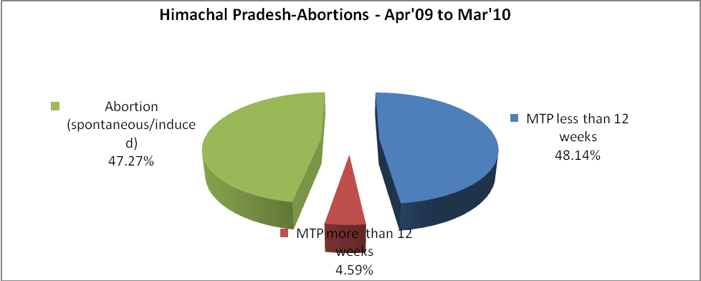
Himachal Pradesh- Apr'09 to Mar'10
Total OPD | Total RTI/STI cases
6,328,446 | 42,474

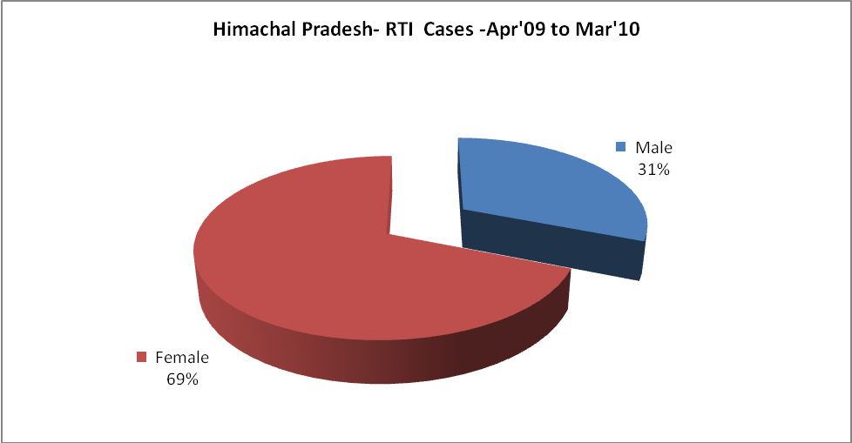
Himachal Pradesh-Sterilizations - Apr'09 to Mar'10
 | Reported | %age of Reported Sterilization
Total Sterilization | 28,075 | -
NSV | 3,184 | 11%
Laproscopic | 23,039 | 82%
MiniLap | 1,077 | 4%
Post Partum | 775 | 3%
Male Sterilization | 3,184 | 11%
Female Sterilization | 24,891 | 89%

Himachal Pradesh-FP Methods - Apr'09 to Mar'10
 | Reported | %age of All Reported FP Methods
Total Reported FP Method (All types) Users | 183,704 | -
Sterilizations | 28,075 | 15%
IUD | 24,193 | 13%
Condom Users | 102,058 | 56%
OCP Users | 29,378 | 16%
Limiting Methods | 28,075 | 15%
Spacing Methods | 155,629 | 85%

Himachal Pradesh- Service Delivery - Apr'09 to Mar'10
Operation major (General and spinal anaesthesia) | Operation minor (No or local anaesthesia) | AYUSH | Dental Procedures | Adolescent counseling services | Total OPD | Total IPD
17,987 | 20,723 | 1,569 | 144,827 | 14,725 | 6,328,446 | 183,594
Operation major (General and spinal anaesthesia) as %ge of OPD | Operation minor (No or local anaesthesia)as %ge of OPD | AYUSH as %ge of OPD | Dental Procedures as %ge of OPD | Adolescent counseling services as %ge of OPD | IPD as percentage of OPD
0.3% | 0.3% | 0.0% | 2.3% | 0.2% | 3%

Himachal Pradesh- Lab Services - Apr'09 to Mar'10
Total OPD | Total HB tested | Total HIV Tested | Total Population
6,328,446 | 244,095 | 32,906 | 6,702,000
HB test conducted as %age of OPD | HB<7gm as %age of HB tested | HIV test conducted as %age of OPD | HIV positive as %age of HIV tested | Blood Smear Examined as % of Population
3.9% | 3.6% | 0.5% | 1.7% | 3.6%

Himachal Pradesh- Childhood Disease - Vaccine Preventable -Apr'09 to Mar'10
Diphtheria | Pertussis | Tetanus Neonatorum | Tetanus others | Polio | Measles
5 | 0 | 0 | 0 | 0 | 102
Himachal Pradesh-Childhood Disease - Others - Apr'09 to Mar'10
Diarrhoea and dehydration | Malaria | Number admitted with Respiratory Infections
30,221 | 275 | 13,599

Himachal Pradesh- Infant & Child Deaths - Apr'09 to Mar'10
Infant Deaths within 24 hrs of birth | Infant Deaths under 1 week | Infant Deaths under 1 month | Child Deaths under 1 year | Child Deaths under 5years | Total Deaths
79 | 260 | 277 | 442 | 540 | 1598

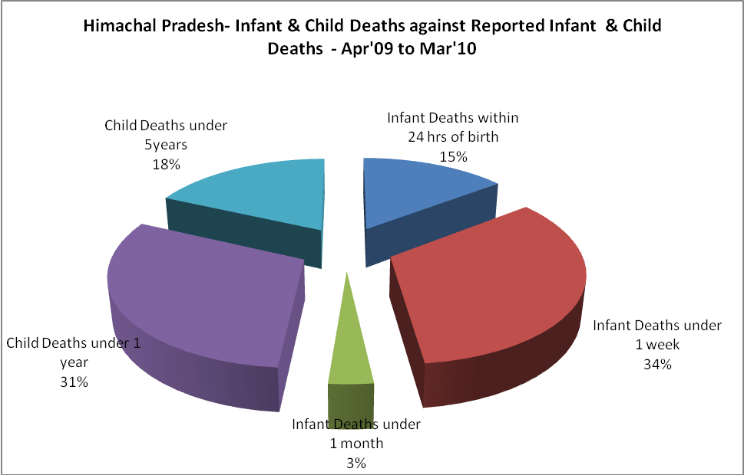

Himachal Pradesh- Causes of Infant & Child Deaths - Apr'09 to Mar'10
Sepsis |  |  | Asphyxia |  |  | LBW
Up to 1 Weeks of Birth | Between 1 week & 4 weeks of birth | Total | Up to 1 Weeks of Birth | Between 1 week & 4 weeks of birth | Total | Up to 1 Weeks of Birth | Between 1 week & 4 weeks of birth | Total
8 | 4 | 12 | 39 | 8 | 47 | 64 | 25 | 89
Pneumonia |  |  | Diarrhoea |  |  | Fever related
Between 1 month and 11 months | Between 1 year & 5 years | Total | Between 1 month and 11 months | Between 1 year & 5 years | Total | Between 1 month and 11 months | Between 1 year & 5 years | Total
33 | 24 | 57 | 6 | 3 | 9 | 20 | 10 | 30
Others |  |  | Measles |  |  | Others
Up to 1 Weeks of Birth | Between 1 week & 4 weeks of birth | Total | Between 1 month and 11 months | Between 1 year & 5 years | Total | Between 1 month and 11 months | Between 1 year & 5 years | Total
70 | 59 | 129 | 0 | 1 | 1 | 106 | 60 | 166

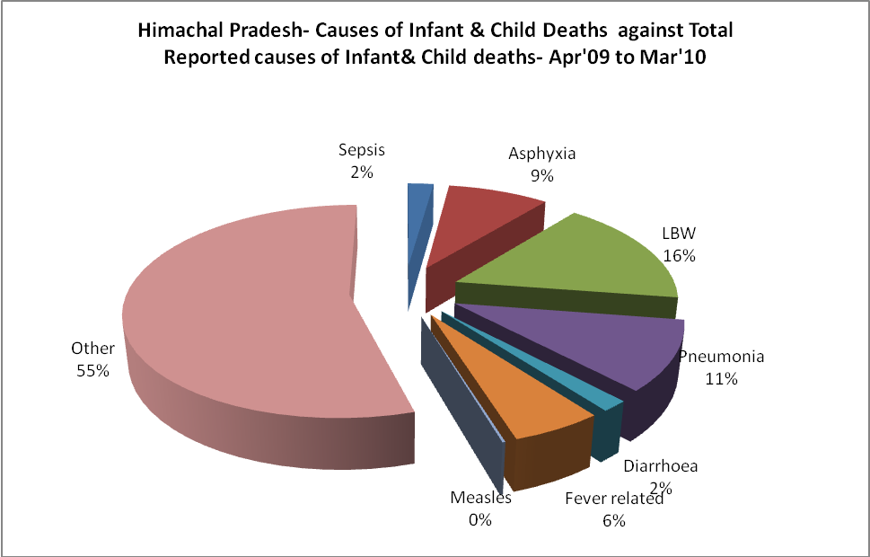

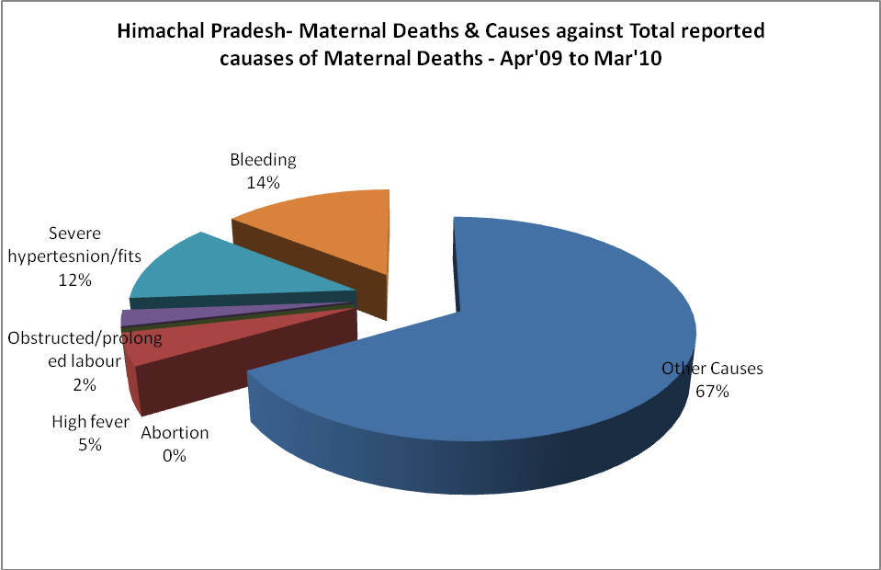

Himachal Pradesh- Maternal Deaths & Causes - Apr'09 to Mar'10
Abortion |  |  | Obstructed/prolonged labour |  |  | Severe hypertension/fits
6-14 yrs | 15-55 yrs. | Total | 6-14 yrs | 15-55 yrs. | Total | 6-14 yrs | 15-55 yrs. | Total
0 | 0 | 0 | 0 | 1 | 1 | 0 | 5 | 5
Bleeding |  |  | High Fever |  |  | Other Causes
6-14 yrs | 15-55 yrs. | Total | 6-14 yrs | 15-55 yrs. | Total | 6-14 yrs | 15-55 yrs. | Total
0 | 6 | 6 | 0 | 2 | 2 | 0 | 28 | 28

Himachal Pradesh-Causes of Deaths in 6 to 55yrs age group - Apr'09 to Mar'10
Diarrhoel Diseases |  |  |  | Tuberculosis |  |  |  | Respiratory Diseases( Other than TB)
6-14 yrs | 15-55 yrs. | Above 55yrs | Total | 6-14 yrs | 15-55 yrs. | Above 55yrs | Total | 6-14 yrs | 15-55 yrs. | Above 55yrs | Total
18 | 11 | 11 | 40 | 1 | 51 | 40 | 92 | 3 | 119 | 251 | 373
Malaria |  |  |  | Other fever Related |  |  |  | HIV/Aids
6-14 yrs | 15-55 yrs. | Above 55yrs | Total | 6-14 yrs | 15-55 yrs. | Above 55yrs | Total | 6-14 yrs | 15-55 yrs. | Above 55yrs | Total
0 | 2 | 6 | 8 | 5 | 38 | 47 | 90 | 3 | 9 | 1 | 13
Heart Disease/Hypertension related |  |  |  | Neurological Disease including strokes |  |  |  | Trauma/Accidents/ Burn Cases
6-14 yrs | 15-55 yrs. | Above 55yrs | Total | 6-14 yrs | 15-55 yrs. | Above 55yrs | Total | 6-14 yrs | 15-55 yrs. | Above 55yrs | Total
16 | 346 | 438 | 800 | 9 | 43 | 43 | 95 | 50 | 299 | 67 | 416
Suicide |  |  |  | Animal Bites & Stings
6-14 yrs | 15-55 yrs. | Above 55yrs | Total | 6-14 yrs | 15-55 yrs. | Above 55yrs | Total
22 | 76 | 6 | 104 | 8 | 26 | 7 | 41

