NHSRC
Himachal Pradesh- Hamirpur District
Analysis 2009-10

7/22/2010

Hamirpur Dist.- Summary-Apr'09 to Mar'10
ANC
ANC Registration against Expected Pregnancies | 123% | TT1 given to Pregnant women against ANC Registration | 62%
3 ANC Check ups against ANC Registrations | 77% | 100 IFA Tablets given to Pregnant women against ANC Registration | 63%
Deliveries
Unreported Deliveries against Estimated Deliveries | 0.6% | HOME Deliveries( SBA& Non SBA) against Estimated Deliveries | 29.2%
Institutional Deliveries against Estimated Deliveries | 70.2% | HOME Deliveries( SBA& Non SBA) against Reported Deliveries | 29.4%
Institutional Deliveries against Reported Deliveries | 70.6% | C Section Deliveries against Institutional Deliveries( Pvt & Pub) | 49%
Births & Neonates Care
Live Births Reported against Estimated Live Births | 100% | New borns weighed against Reported Live Births | 100%
Still Births (Reported) | 78 | New borns weighed less than 2.5 kgs against newborns weighed | 5%
Sex Ratio at Birth | 891 | New borns breastfed within one hr of Birth against Reported live Births | 100%
Child Immunization( 0 to 11 months)
BCG given against Expected Live Births | 120% | Measles given against Expected Live Births | 111%
OPV3 given against Expected Live Births | 117% | Fully Immunized Children against Expected Live Births | 111%
DPT3 given against Expected Live Births | 117%
Family Planning
Family Planning Methods Users ( Sterilizations(Male &Female)+IUD+ Condom pieces/72 + OCP Cycles/13) | 15,437 | IUD Insertions against reported FP Methods | 14%
Sterilization against reported FP Methods | 13% | Condom Users against reported FP Methods | 56%
 |  | OCP Users against reported FP Methods | 16%
Other Services
OPD | 715,667 | Major Operations | 1,155
IPD | 29,092 | Minor Operations | 5,233

Hamirpur Dist.- Deliveries Apr'09 to Mar'10
Total Population | 455,077 | Expected Deliveries |  | 8,232
Home SBA | Home Non SBA | Institutional | Total Deliveries Reported | Unreported Deliveries
389 | 2,015 | 5,776 | 8,180 | 52
Home SBA % | Home Non SBA% | Institutional % | Total Deliveries Reported % | Unreported Deliveries %
5% | 24% | 70% | 99% | 1%

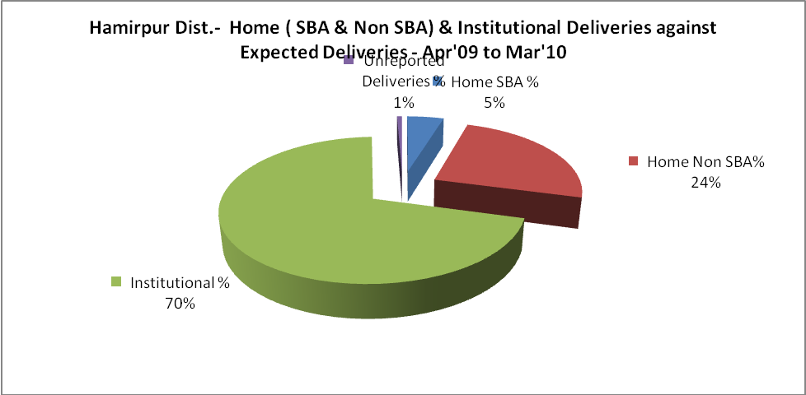
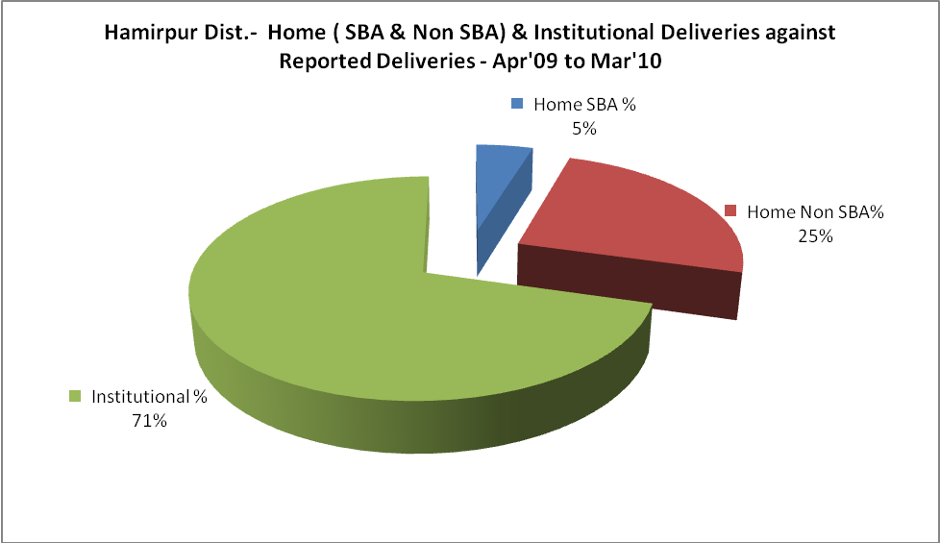

Hamirpur Dist.- C sections & Complicated Deliveries Apr'09 to Mar'10
 | Institutional Deliveries (Public) | Institutional Deliveries (Pvt)
 | 5,158 | 618
C Section | 497 | 244
C Section% | 10% | 39%
Complicated Pregnancies attended | 300 | -
Complicated Pregnancies attended % | 6% | 0%

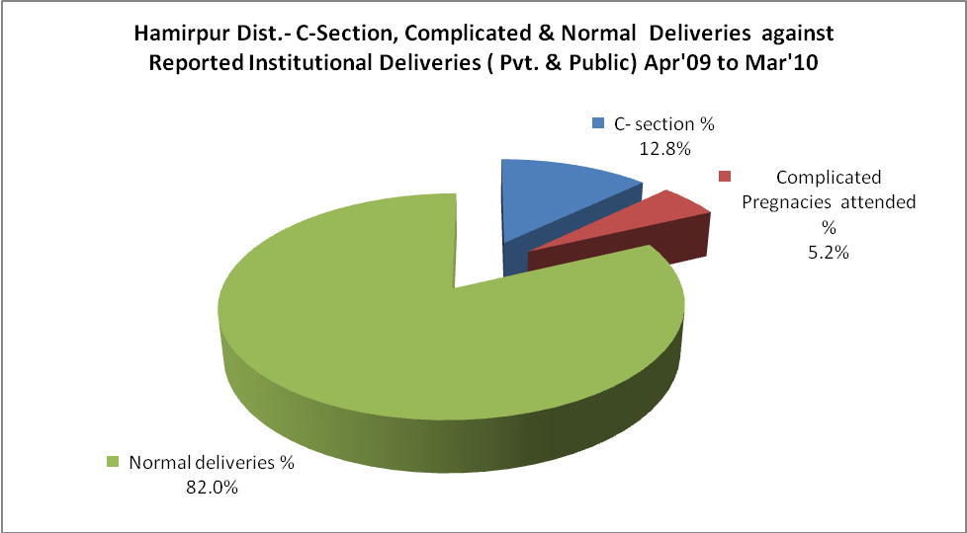

Hamirpur Dist.- Complicated Pregnancies & Deliveries Treated - Apr'09 to Mar'10
Reported Deliveries |  |  | Reported ANC Registration
8,180 |  |  | 10,878
Complicated Pregnancies attended | Complicated Pregnancies Rate | C - Section Deliveries | PNC Maternal Complications | Abortions | Still Births
300 | 3% | 741 | 7 | 108 | 78
Complicated Deliveries Treated with |  |  |  | No Of Eclampsia cases Treated | No Of severe anemia cases treated
IV Antibiotics | IV antihypertensive/Magsulph injection | IV Oxytocis | Blood Transfusion | No Of Eclampsia cases Treated | No Of severe anemia cases treated
93 | - | 17 | - | 7 | 172

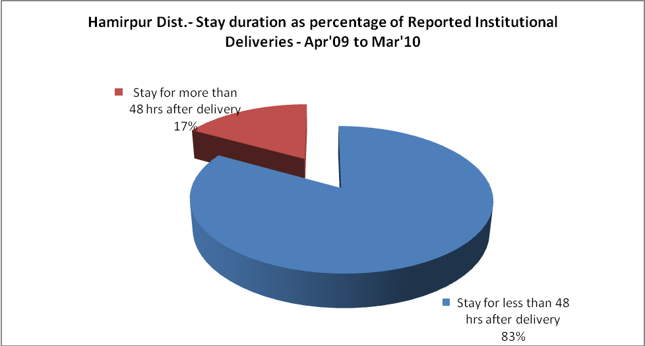

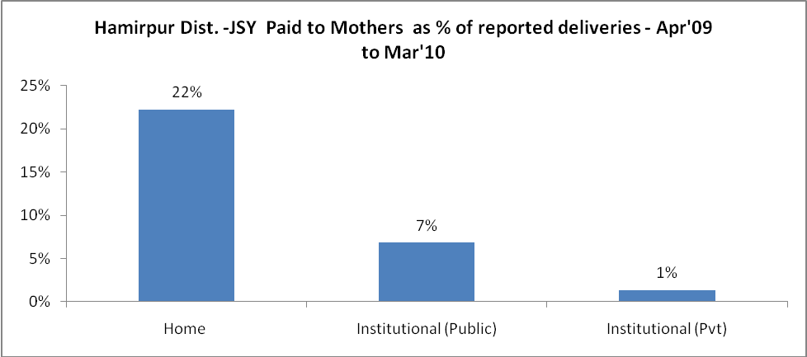
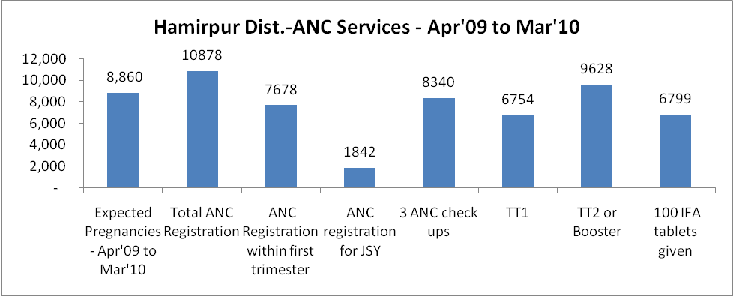

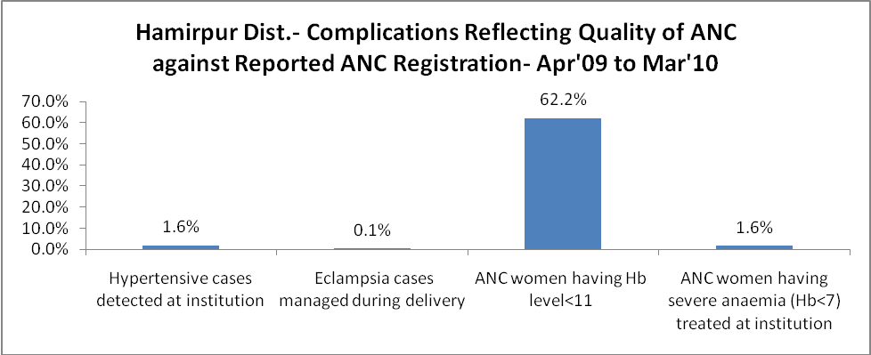

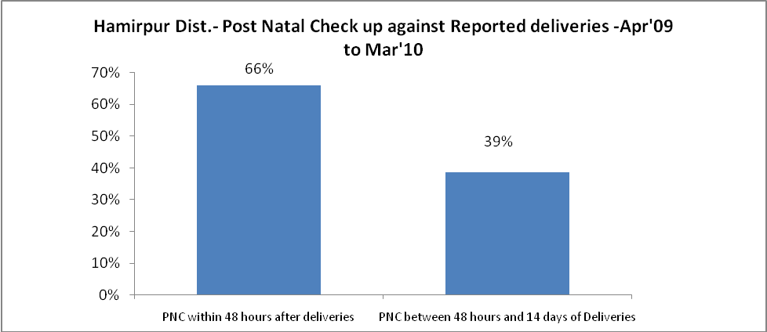

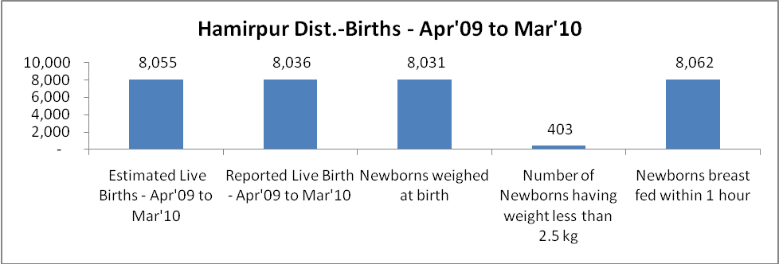

Hamirpur Dist. - Births - Apr'09 to Mar'10
Live Birth - Males | Live Birth - females | Live Birth - Total | Sex Ratio at birth | Still Birth | Abortion( Induced/Spontaneous
4,249 | 3,787 | 8,036 | 891 | 78 | 108

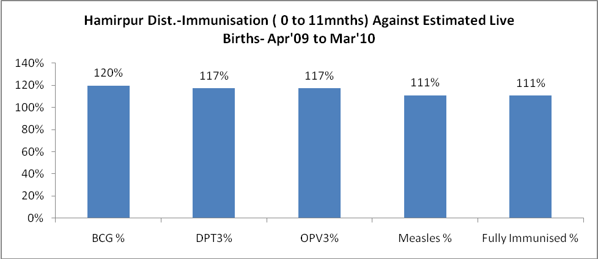
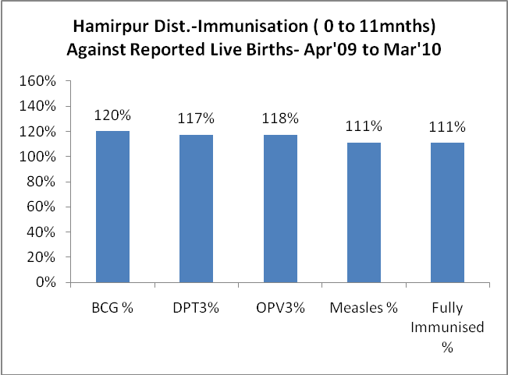
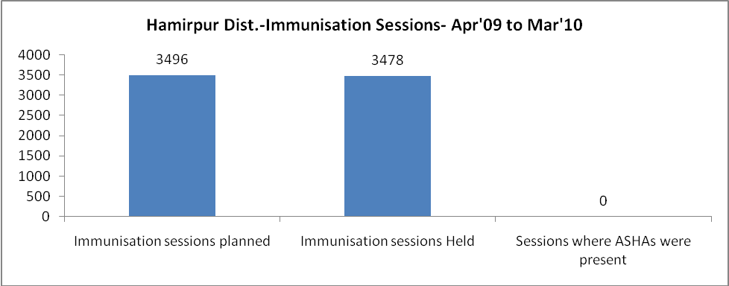
Hamirpur Dist.- Apr'09 to Mar'10
Total Abortions | Abortion Rate
182 | 2.1%

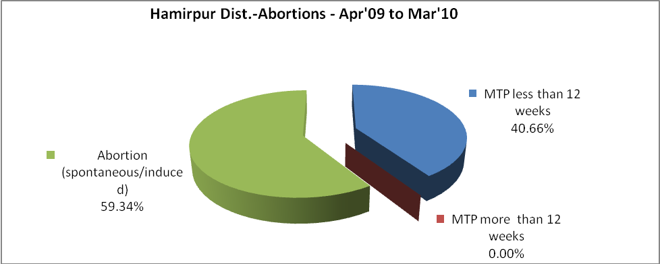
Hamirpur Dist.- Apr'09 to Mar'10
Total OPD | Total RTI/STI cases
715,667 | 3,601

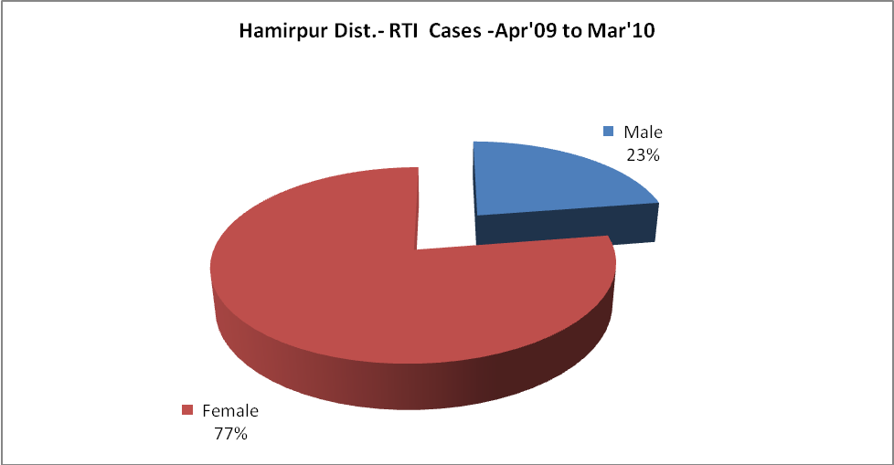
Hamirpur Dist.-Sterilizations - Apr'09 to Mar'10
 | Reported | %age of Reported Sterilization
Total Sterilization | 2,005 | -
NSV | 109 | 5%
Laproscopic | 1,809 | 90%
MiniLap | 64 | 3%
Post Partum | 23 | 1%
Male Sterilization | 109 | 5%
Female Sterilization | 1,896 | 95%

Hamirpur Dist.-FP Methods - Apr'09 to Mar'10
 | Reported | %age of All Reported FP Methods
Total Reported FP Method (All types) Users | 15,437 | -
Sterilizations | 2,005 | 13%
IUD | 2,215 | 14%
Condom Users | 8,716 | 56%
OCP Users | 2,502 | 16%
Limiting Methods | 2,005 | 13%
Spacing Methods | 13,432 | 87%

Hamirpur Dist.- Service Delivery - Apr'09 to Mar'10
Operation major (General and spinal anaesthesia) | Operation minor (No or local anaesthesia) | AYUSH | Dental Procedures | Adolescent counseling services | Total OPD | Total IPD
1,155 | 5,233 | - | 28,119 | 989 | 715,667 | 29,092
Operation major (General and spinal anaesthesia) as %ge of OPD | Operation minor (No or local anaesthesia)as %ge of OPD | AYUSH as %ge of OPD | Dental Procedures as %ge of OPD | Adolescent counseling services as %ge of OPD | IPD as percentage of OPD
0.2% | 0.7% | 0.0% | 3.9% | 0.1% | 4%

Hamirpur Dist.- Lab Services - Apr'09 to Mar'10
Total OPD | Total HB tested | Total HIV Tested | Total Population
715,667 | 36,279 | 2,715 | 455,077
HB test conducted as %age of OPD | HB<7gm as %age of HB tested | HIV test conducted as %age of OPD | HIV positive as %age of HIV tested | Blood Smear Examined as % of Population
5.1% | 2.7% | 0.4% | 6.7% | 9.3%

Hamirpur Dist.- Childhood Disease - Vaccine Preventable -Apr'09 to Mar'10
Diphtheria | Pertussis | Tetanus Neonatorum | Tetanus others | Polio | Measles
0 | 0 | 0 | 0 | 0 | 0
Hamirpur Dist.-Childhood Disease - Others - Apr'09 to Mar'10
Diarrhoea and dehydration | Malaria | Number admitted with Respiratory Infections
3,193 | - | 371

Hamirpur Dist.- Infant & Child Deaths - Apr'09 to Mar'10
Infant Deaths within 24 hrs of birth | Infant Deaths under 1 week | Infant Deaths under 1 month | Child Deaths under 1 year | Child Deaths under 5years | Total Deaths
10 | 15 | 5 | 5 | 5 | 40

Hamirpur Dist.- Causes of Infant & Child Deaths - Apr'09 to Mar'10
Sepsis |  |  | Asphyxia |  |  | LBW
Up to 1 Weeks of Birth | Between 1 week & 4 weeks of birth | Total | Up to 1 Weeks of Birth | Between 1 week & 4 weeks of birth | Total | Up to 1 Weeks of Birth | Between 1 week & 4 weeks of birth | Total
0 | 0 | 0 | 2 | 0 | 2 | 3 | 0 | 3
Pneumonia |  |  | Diarrhoea |  |  | Fever related
Between 1 month and 11 months | Between 1 year & 5 years | Total | Between 1 month and 11 months | Between 1 year & 5 years | Total | Between 1 month and 11 months | Between 1 year & 5 years | Total
0 | 0 | 0 | 0 | 0 | 0 | 0 | 0 | 0
Others |  |  | Measles |  |  | Others
Up to 1 Weeks of Birth | Between 1 week & 4 weeks of birth | Total | Between 1 month and 11 months | Between 1 year & 5 years | Total | Between 1 month and 11 months | Between 1 year & 5 years | Total
0 | 0 | 0 | 0 | 0 | 0 | 0 | 0 | 0

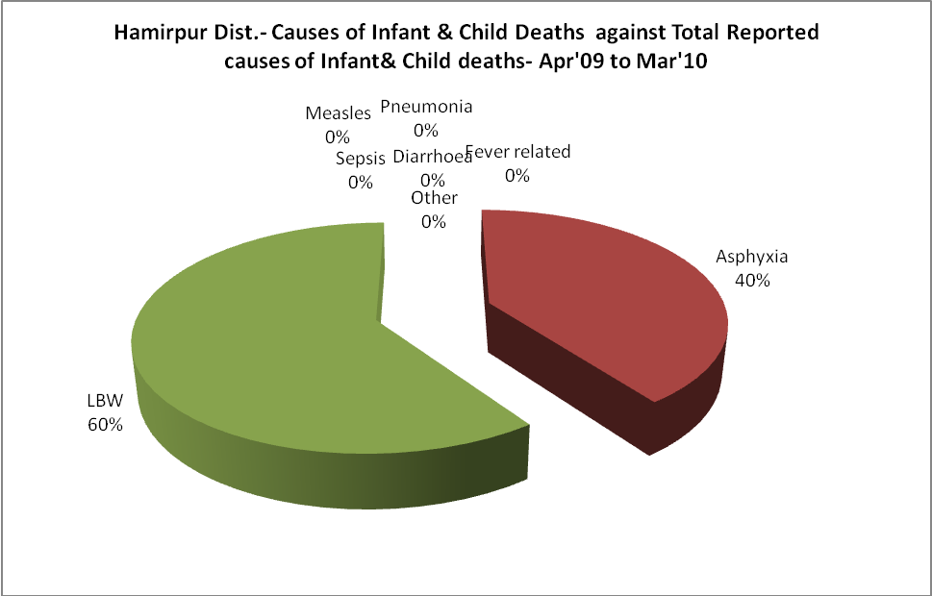

Hamirpur Dist.- Maternal Deaths & Causes - Apr'09 to Mar'10
Abortion |  |  | Obstructed/prolonged labour |  |  | Severe hypertension/fits
6-14 yrs | 15-55 yrs. | Total | 6-14 yrs | 15-55 yrs. | Total | 6-14 yrs | 15-55 yrs. | Total
0 | 0 | 0 | 0 | 0 | 0 | 0 | 0 | 0
Bleeding |  |  | High Fever |  |  | Other Causes
6-14 yrs | 15-55 yrs. | Total | 6-14 yrs | 15-55 yrs. | Total | 6-14 yrs | 15-55 yrs. | Total
0 | 0 | 0 | 0 | 0 | 0 | 0 | 0 | 0

Hamirpur Dist.-Causes of Deaths in 6 to 55yrs age group - Apr'09 to Mar'10
Diarrhoel Diseases |  |  |  | Tuberculosis |  |  |  | Respiratory Diseases( Other than TB)
6-14 yrs | 15-55 yrs. | Above 55yrs | Total | 6-14 yrs | 15-55 yrs. | Above 55yrs | Total | 6-14 yrs | 15-55 yrs. | Above 55yrs | Total
0 | 0 | 0 | 0 | 0 | 0 | 0 | 0 | 0 | 2 | 0 | 2
Malaria |  |  |  | Other fever Related |  |  |  | HIV/Aids
6-14 yrs | 15-55 yrs. | Above 55yrs | Total | 6-14 yrs | 15-55 yrs. | Above 55yrs | Total | 6-14 yrs | 15-55 yrs. | Above 55yrs | Total
0 | 0 | 0 | 0 | 0 | 0 | 0 | 0 | 0 | 0 | 0 | 0
Heart Disease/Hypertension related |  |  |  | Neurological Disease including strokes |  |  |  | Trauma/Accidents/ Burn Cases
6-14 yrs | 15-55 yrs. | Above 55yrs | Total | 6-14 yrs | 15-55 yrs. | Above 55yrs | Total | 6-14 yrs | 15-55 yrs. | Above 55yrs | Total
2 | 1 | 0 | 3 | 0 | 0 | 0 | 0 | 0 | 1 | 0 | 1
Suicide |  |  |  | Animal Bites & Stings
6-14 yrs | 15-55 yrs. | Above 55yrs | Total | 6-14 yrs | 15-55 yrs. | Above 55yrs | Total
3 | 0 | 0 | 3 | 1 | 0 | 0 | 1

