NHSRC
Rajasthan-Hanumangarh
Analysis: Apr 2009 – Mar 2010

Rajasthan- Hanumangarh- Summary-Apr'09 to Mar'10
ANC
ANC Registration against Expected Pregnancies | 96% | TT1 given to Pregnant women against ANC Registration | 72%
3 ANC Checkups against ANC Registrations | 70% | 100 IFA Tablets given to Pregnant women against ANC Registration | 68%
Deliveries
Unreported Deliveries against Estimated Deliveries | 33.2% | HOME Deliveries( SBA& Non SBA) against Estimated Deliveries | 14.7%
Institutional Deliveries against Estimated Deliveries | 52.2% | HOME Deliveries( SBA& Non SBA) against Reported Deliveries | 21.9%
Institutional Deliveries against Reported Deliveries | 78.1% | C Section Deliveries against Institutional Deliveries( Pvt & Pub) | 2%
Births & Neonates Care
Live Births Reported against Estimated Live Births | 68% | New borns weighed against Reported Live Births | 86%
Still Births (Reported) | 346 | New borns weighed less than 2.5 kgs against newborns weighed | 11%
Sex Ratio at Birth | 844 | New borns breastfed within one hr of Birth against Reported live Births | 57%
Child Immunisation( 0 to 11 months)
BCG given against Expected Live Births | 87% | Measles given against Expected Live Births | 83%
OPV3 given against Expected Live Births | 85% | Fully Immunised Children against Expected Live Births | 82%
DPT3 given against Expected Live Births | 85%
Family Planning
Family Plannig Methods Users ( Sterilisations(Male &Female)+IUD+ Condom pieces/72 + OCP Cycles/13) | 105,006 | IUD Insertions against reported FP Methods | 13%
Sterilisation against reported FP Methods | 8% | Condom Users against reported FP Methods | 53%
 |  | OCP Users against reported FP Methods | 26%
Other Services
OPD | 935,360 | Major Operations | 2,169
IPD | 41,863 | Minor Operations | 12,134

`
Rajasthan- Hanumangarh- Deliveries Apr'09 to Mar'10
Total Population | 1,807,900 | Expected Deliveries |  | 51,283
Home SBA | Home Non SBA | Institutional | Total Deliveries Reported | Unreported Deliveries
1,854 | 5,661 | 26,753 | 34,268 | 17,015
Home SBA % | Home Non SBA% | Institutional % | Total Deliveries Reported % | Unreported Deliveries %
4% | 11% | 52% | 67% | 33%

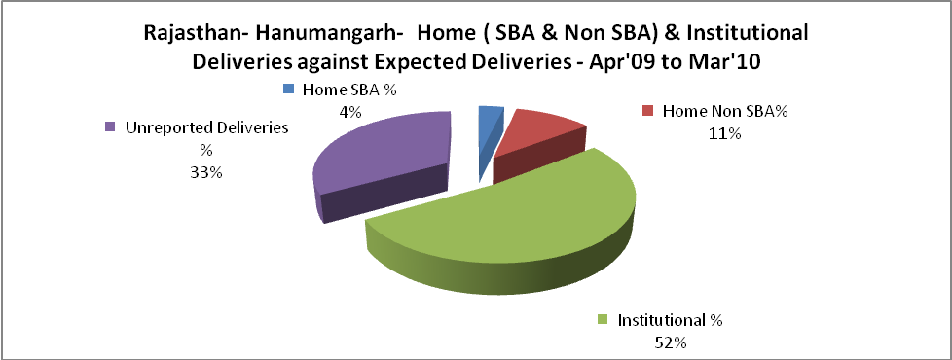

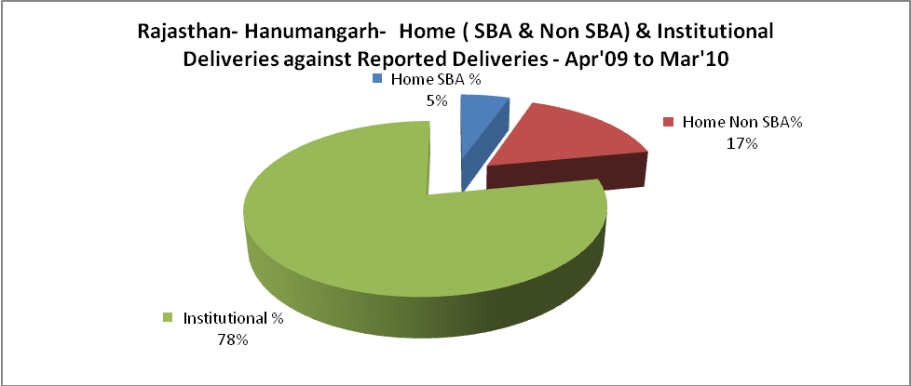

Rajasthan- Hanumangarh- C sections & Complicated Deliveries Apr'09 to Mar'10
 | Institutional Deliveries (Public) | Institutional Deliveries (Pvt)
 | 16,065 | 10,688
C Section | 345 | 264
C Section% | 2% | 2%
Complicated Pregnacies attended | 334 | 285
Complicated Pregnacies attended % | 2% | 3%

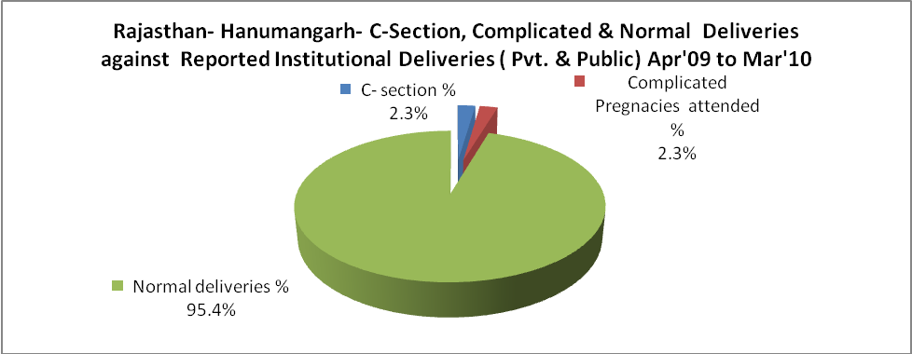

Rajasthan- Hanumangarh- Complicated Pregnancies & Deliveries Treated - Apr'09 to Mar'10
Reported Deliveries |  |  | Reported ANC Reigtration
34,268 |  |  | 52,433
Complicated Pregnancies attended | Complicated Pregnancies Rate | C - Section Deliveries | PNC Maternal Complications | Abortions | Still Births
619 | 1% | 609 | 111 | 278 | 346
Complicated Deliveries Treated with |  |  |  | No Of Eclampsia cases Treated | No Of severe anemia cases treated
IV Antibiotics | IV antihypertensive/Magsulph injection | IV Oxytocis | Blood Transfusion | No Of Eclampsia cases Treated | No Of severe anemia cases treated
205 | 33 | 32 | 10 | - | 14,361

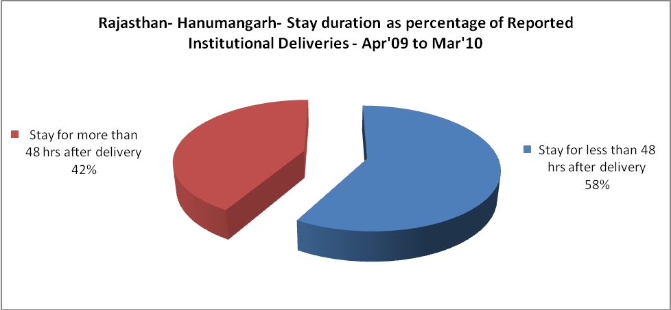

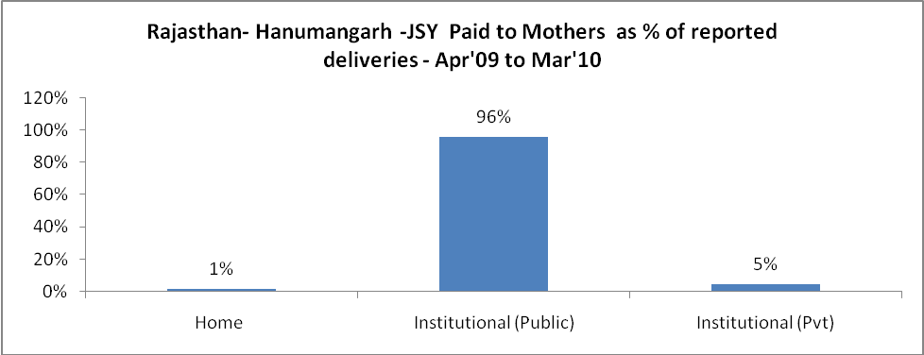

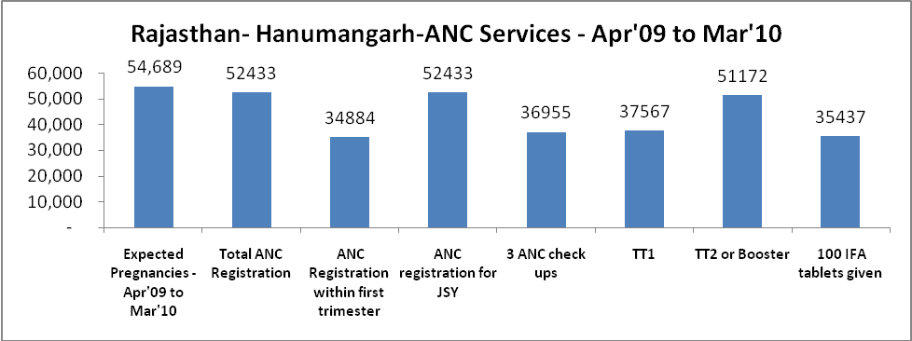

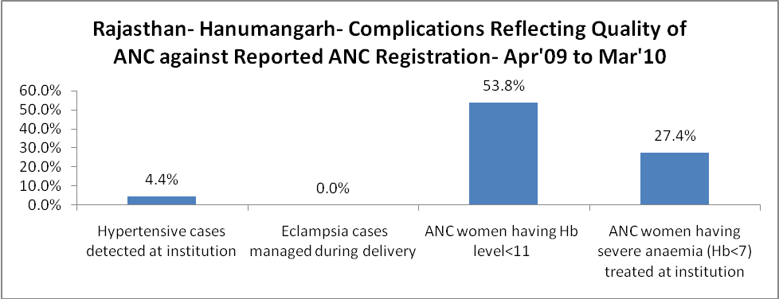
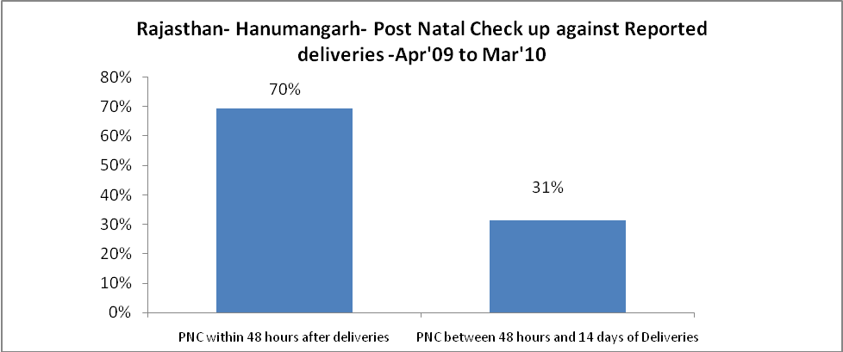
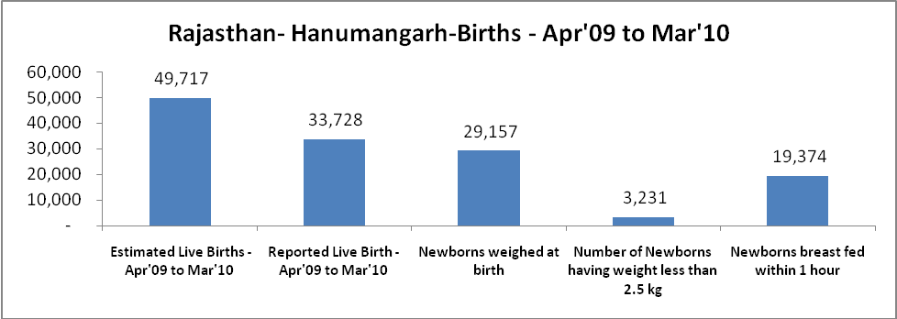

Rajasthan- Hanumangarh - Births - Apr'09 to Mar'10
Live Birth - Males | Live Birth - females | Live Birth - Total | Sex Ratio at birth | Still Birth | Abortion( Induced/Spontaneous
18,290 | 15,438 | 33,728 | 844 | 346 | 278

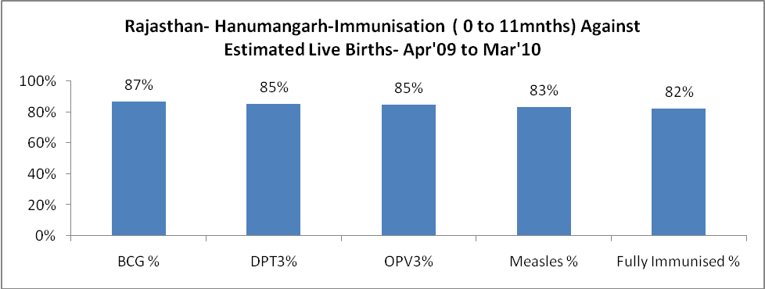

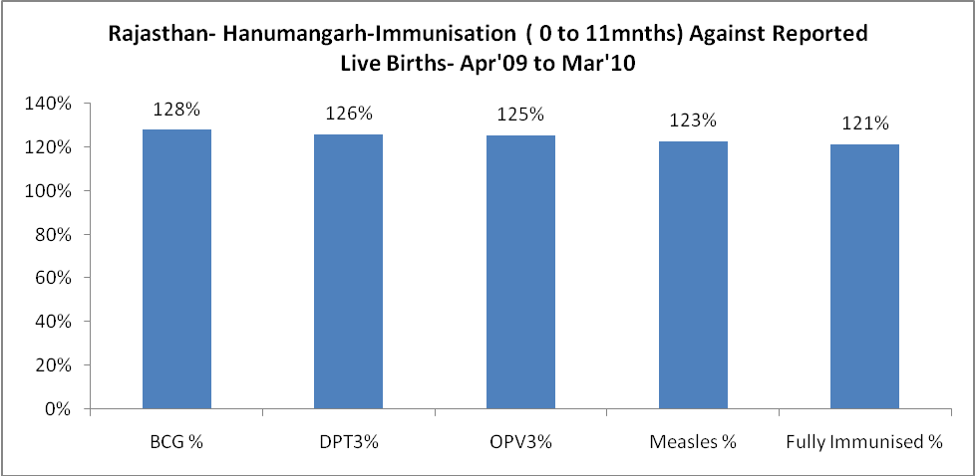

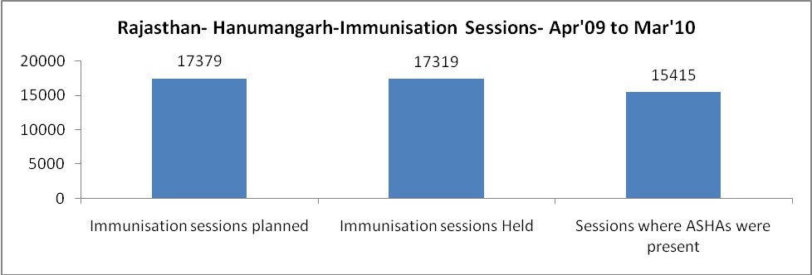

Rajasthan- Hanumangarh- Apr'09 to Mar'10
Total Abortions | Abortion Rate
317 | 0.6%

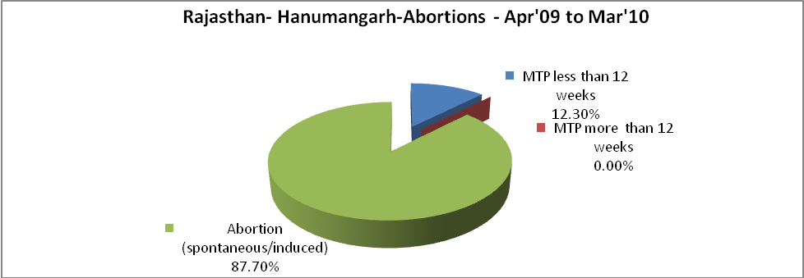

Rajasthan- Hanumangarh- Apr'09 to Mar'10
Total OPD | Total RTI/STI cases
935,360 | 893

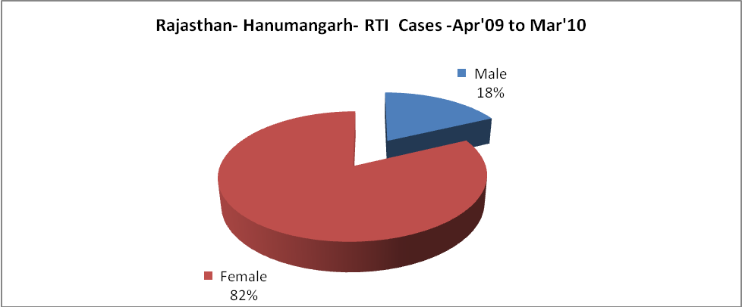

Rajasthan- Hanumangarh-Sterilisations - Apr'09 to Mar'10
 | Reported | %age of Reported Sterilisation
Total Sterilisation | 8,055 | -
NSV | 365 | 5%
Laproscopic | 6,577 | 82%
MiniLap | - | 0%
Post Partum | 1,113 | 14%
Male Sterilisation | 365 | 5%
Female Sterilisation | 7,690 | 95%

Rajasthan- Hanumangarh-FP Methods - Apr'09 to Mar'10
 | Reported | %age of All Reported FP Methods
Total Reported FP Methodd (All types) Users | 105,006 | -
Sterilisations | 8,055 | 8%
IUD | 13,940 | 13%
Condom Users | 55,239 | 53%
OCP Users | 27,771 | 26%
Limiting Methods | 8,055 | 8%
Spacing Methods | 96,951 | 92%

Rajasthan- Hanumangarh- Service Delivery - Apr'09 to Mar'10
Operation major (General and spinal anaesthesia) | Operation minor (No or local anaesthesia) | AYUSH | Dental Procedures | Adolescent counselling services | Total OPD | Total IPD
2,169 | 12,134 | 67,632 | - | - | 935,360 | 41,863
Operation major (General and spinal anaesthesia) as %ge of OPD | Operation minor (No or local anaesthesia)as %ge of OPD | AYUSH as %ge of OPD | Dental Procedures as %ge of OPD | Adolescent counselling services as %ge of OPD | IPD as percentage of OPD
0.2% | 1.3% | 7.2% | 0.0% | 0.0% | 4%

Rajasthan- Hanumangarh- Lab Services - Apr'09 to Mar'10
Total OPD | Total HB tested | Total HIV Tested | Total Population
935,360 | 7,893 | 4,900 | 1,807,900
HB test conducted as %age of OPD | HB<7gm as %age of HB tested | HIV test conducted as %age of OPD | HIV positive as %age of HIV tested | Blood Smear Examined as % of Population
0.8% | 28.2% | 0.5% | 0.8% | 9.9%

Rajasthan- Hanumangarh- Childhood Disease - Vaccine Preventable -Apr'09 to Mar'10
Diphtheria | Pertussis | Tetanus Neonatorum | Tetanus others | Polio | Measles
0 | 0 | 0 | 0 | 0 | 2
Rajasthan- Hanumangarh-Childhood Disease - Others - Apr'09 to Mar'10
Diarrhoea and dehydration | Malaria | Number admitted with Respiratory Infections
3,663 | 308 | 3,309

Rajasthan- Hanumangarh- Infant & Child Deaths - Apr'09 to Mar'10
Infant Deaths within 24 hrs of birth | Infant Deaths between 24hrs & under 1 week | Infant Deaths between 1 week & under 1 month | Child Deaths between 1 month & under 1 year | Child Deaths between 1yr under 5years | Total Deaths
59 | 71 | 84 | 96 | 108 | 418

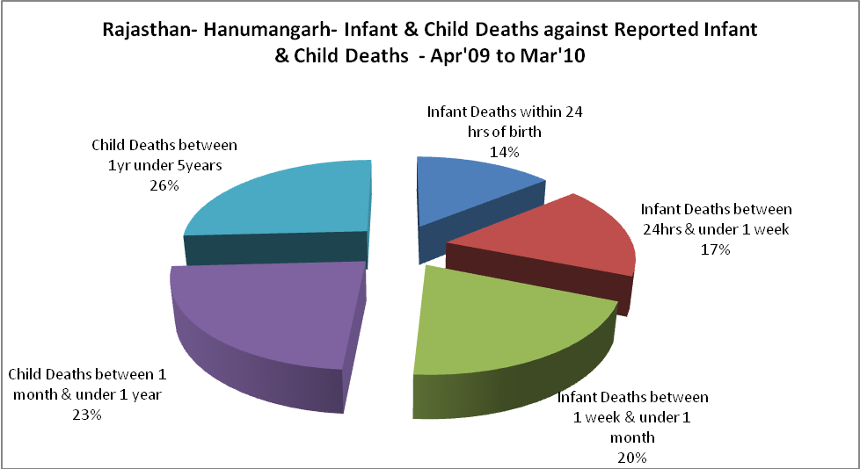

Rajasthan- Hanumangarh- Causes of Infant & Child Deaths - Apr'09 to Mar'10
Sepsis |  |  | Asphyxia |  |  | LBW
Up to 1 Weeks of Birth | Between 1 week & 4 weeks of birth | Total | Up to 1 Weeks of Birth | Between 1 week & 4 weeks of birth | Total | Up to 1 Weeks of Birth | Between 1 week & 4 weeks of birth | Total
2 | 1 | 3 | 4 | 5 | 9 | 4 | 1 | 5
Pneumonia |  |  | Diarrhoea |  |  | Fever related
Between 1 month and 11 months | Between 1 year & 5 years | Total | Between 1 month and 11 months | Between 1 year & 5 years | Total | Between 1 month and 11 months | Between 1 year & 5 years | Total
4 | 13 | 17 | 4 | 17 | 21 | 12 | 23 | 35
Others |  |  | Measles |  |  | Others
Up to 1 Weeks of Birth | Between 1 week & 4 weeks of birth | Total | Between 1 month and 11 months | Between 1 year & 5 years | Total | Between 1 month and 11 months | Between 1 year & 5 years | Total
61 | 77 | 138 | 0 | 0 | 0 | 76 | 55 | 131

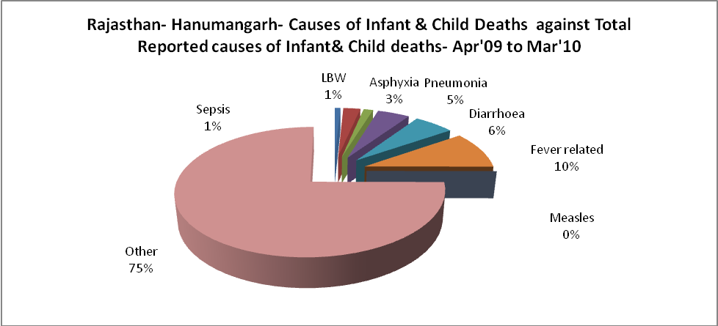

Rajasthan- Hanumangarh- Maternal Deaths & Causes - Apr'09 to Mar'10
Abortion |  |  | Obstructed/prolonged labour |  |  | Severe hypertesnion/fits
6-14 yrs | 15-55 yrs. | Total | 6-14 yrs | 15-55 yrs. | Total | 6-14 yrs | 15-55 yrs. | Total
0 | 0 | 0 | 0 | 0 | 0 | 0 | 0 | 0
Bleeding |  |  | High Fever |  |  | Other Causes
6-14 yrs | 15-55 yrs. | Total | 6-14 yrs | 15-55 yrs. | Total | 6-14 yrs | 15-55 yrs. | Total
0 | 0 | 0 | 1 | 0 | 1 | 7 | 18 | 25

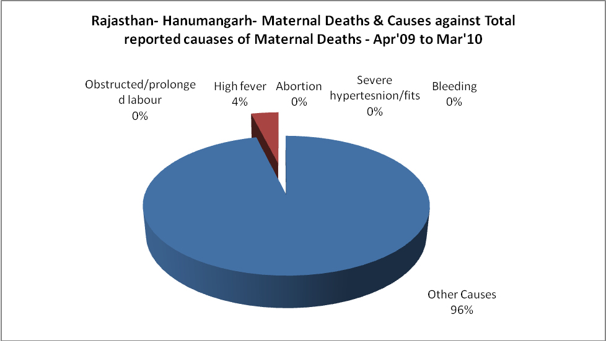

Rajasthan- Hanumangarh-Causes of Deaths in 6 to 55yrs age group - Apr'09 to Mar'10
Diarrhoel Diseases |  |  |  | Tuberculosis |  |  |  | Respiratory Diseases( Other than TB)
6-14 yrs | 15-55 yrs. | Above 55yrs | Total | 6-14 yrs | 15-55 yrs. | Above 55yrs | Total | 6-14 yrs | 15-55 yrs. | Above 55yrs | Total
15 | 7 | 6 | 28 | 0 | 12 | 10 | 22 | 2 | 11 | 29 | 42
Malaria |  |  |  | Other fever Related |  |  |  | HIV/Aids
6-14 yrs | 15-55 yrs. | Above 55yrs | Total | 6-14 yrs | 15-55 yrs. | Above 55yrs | Total | 6-14 yrs | 15-55 yrs. | Above 55yrs | Total
0 | 0 | 0 | 0 | 11 | 2 | 8 | 21 | 0 | 0 | 0 | 0
Heart Disease/Hypertenion related |  |  |  | Neurological Disease including strokes |  |  |  | Trauma/Accidents/ Burn Cases
6-14 yrs | 15-55 yrs. | Above 55yrs | Total | 6-14 yrs | 15-55 yrs. | Above 55yrs | Total | 6-14 yrs | 15-55 yrs. | Above 55yrs | Total
0 | 46 | 69 | 115 | 42 | 9 | 14 | 65 | 6 | 31 | 24 | 61
Suicide |  |  |  | Animal Bites & Stings
6-14 yrs | 15-55 yrs. | Above 55yrs | Total | 6-14 yrs | 15-55 yrs. | Above 55yrs | Total
1 | 16 | 15 | 32 | 1 | 2 | 4 | 7

