NHSRC
Meghalaya-Jaintia
Analysis: Apr 2009 – Mar 2010

MEGHALAYA- JAINTIA DIST.- Summary-Apr'09 to Mar'10
ANC
ANC Registration against Expected Pregnancies | 151% | TT1 given to Pregnant women against ANC Registraion | 43%
3 ANC Check ups against ANC Reigtrations | 31% | 100 IFA Tablets given to Pregnant women against ANC Registraion | 25%
Deliveries
Unreported Deliveries against Estimated Deliveries | -12.7% | HOME Deliveries( SBA& Non SBA) against Estimated Deliveries | 79.3%
Institutional Deliveries against Estimated Deliveries | 33.4% | HOME Deliveries( SBA& Non SBA) against Reported Deliveries | 70.4%
Institutional Deliveries against Reported Deliveries | 29.6% | C Section Deliveries against Institutional Deliveries( Pvt & Pub) | 14%
Births & Neonates Care
Live Births Reported against Estimated Live Births | 121% | New borns weighed against Reported Live Births | 54%
Still Births (Reported) | 373 | New borns weighed less than 2.5 kgs against newborns weighed | 13%
Sex Ratio at Birh | 934 | New borns breastfed within one hr of Birth against Reported live Births | 60%
Child Immunisation( 0 to 11 months)
BCG given against Expected Live Births | 135% | Measles given against Expected Live Births | 95%
OPV3 given against Expected Live Births | 112% | Fully Immunised Children against Expected Live Births | 96%
DPT3 given against Expected Live Births | 113%
Family Planning
Family Plannig Methods Users ( Sterilisations(Male &Female)+IUD+ Condom pieces/72 + OCP Cycles/13) | 1,288 | IUD Insertions against reported FP Methods | 18%
Sterilisation against reported FP Methods | 19% | Condom Users against reported FP Methods | 21%
 |  | OCP Users against reported FP Methods | 42%
Other Services
OPD | 3,70,072 | Major Operations | 118
IPD | 12,306 | Minor Operations | 656

MEGHALAYA- JAINTIA DIST.- Deliveries Apr'09 to Mar'10
Total Population | 3,66,150 | Expected Deliveries |  | 9,495
Home SBA | Home Non SBA | Institutional | Total Deliveries Reported | Unreported Deliveries
1,597 | 5,931 | 3,172 | 10,700 | (1,205)
Home SBA % | Home Non SBA% | Institutional % | Total Deliveries Reported % | Unreported Deliveries %
17% | 62% | 33% | 113% | -13%
`

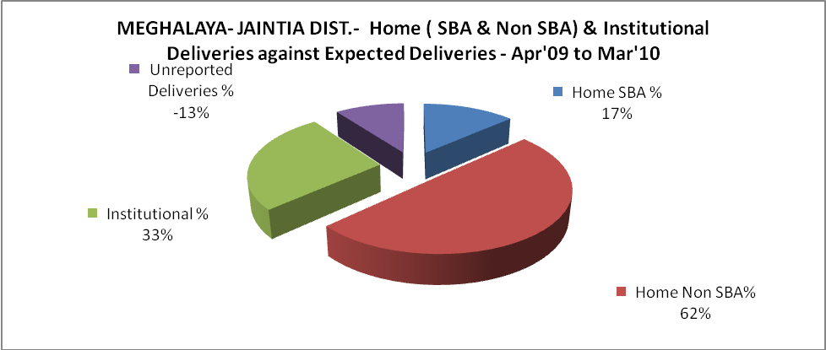

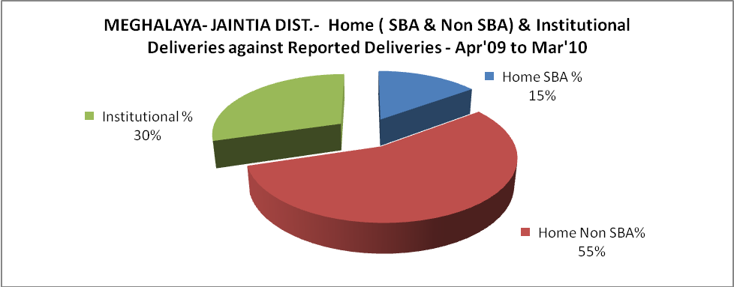

MEGHALAYA- JAINTIA DIST.- C sections & Complicated Deliveries Apr'09 to Mar'10
 | Institutional Deliveries (Public) | Institutional Deliveries (Pvt)
 | 2,202 | 970
C Section | 100 | 333
C Section% | 5% | 34%
Complicated Pregnacies attended | 90 | -
Complicated Pregnacies attended % | 4% | 0%

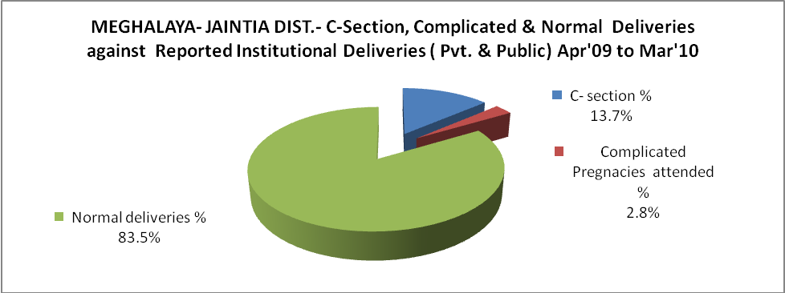

MEGHALAYA- JAINTIA DIST.- Complicated Pregnancies & Deliveries Treated - Apr'09 to Mar'10
Reported Deliveries |  |  | Reported ANC Reigtration
10,700 |  |  | 15,276
Complicated Pregnancies attended | Complicated Pregnancies Rate | C - Section Deliveries | PNC Maternal Complications | Abortions | Still Births
90 | 1% | 433 | 38 | 462 | 373
Complicated Deliveries Treated with |  |  |  | No Of Eclampsia cases Treated | No Of severe anemia cases treated
IV Antibiotics | IV antihypertensive/Magsulph injection | IV Oxytocis | Blood Transfusion | No Of Eclampsia cases Treated | No Of severe anemia cases treated
236 | 10 | 275 | 12 | 18 | 245

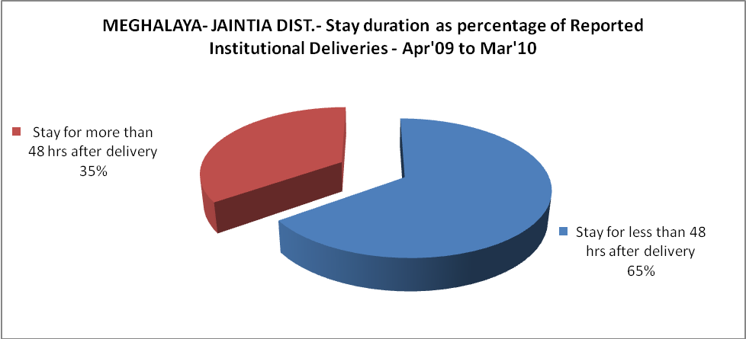

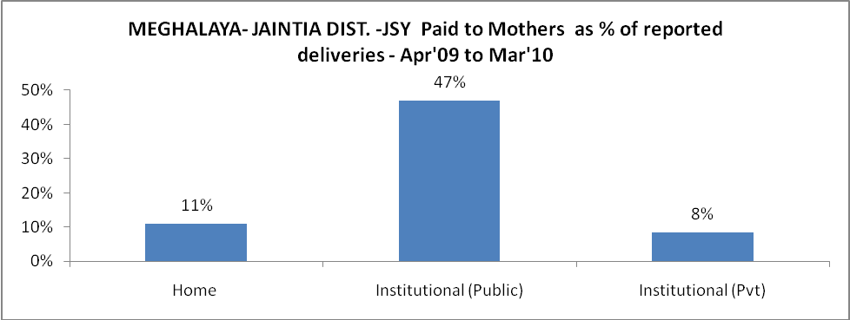

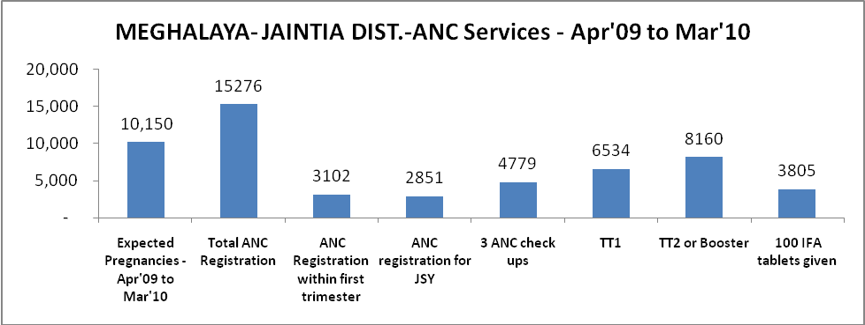

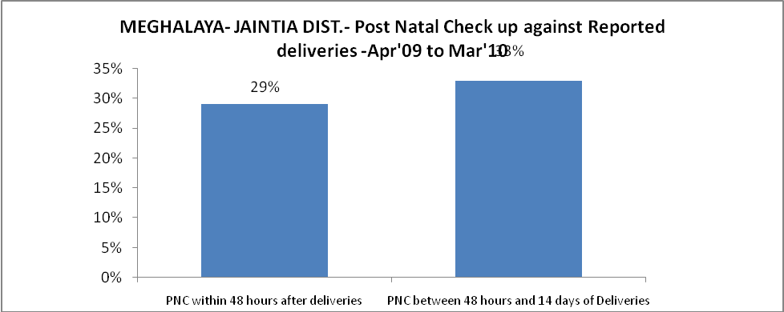

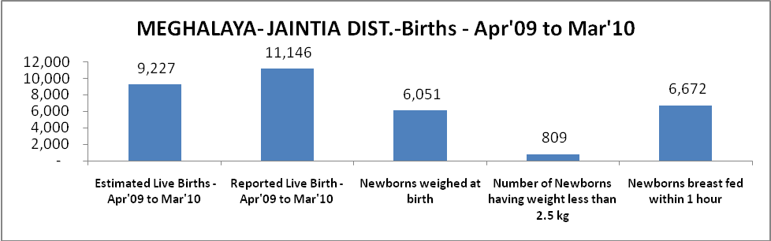

MEGHALAYA- JAINTIA DIST. - Births - Apr'09 to Mar'10
Live Birth - Males | Live Birth - females | Live Birth - Total | Sex Ratio at birth | Still Birth | Abortion( Induced/Spontaneous
5,762 | 5,384 | 11,146 | 934 | 373 | 462

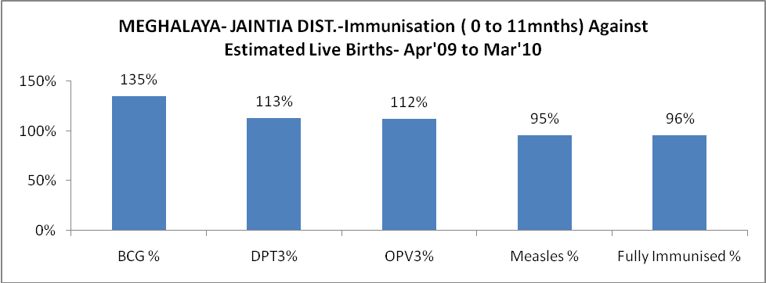

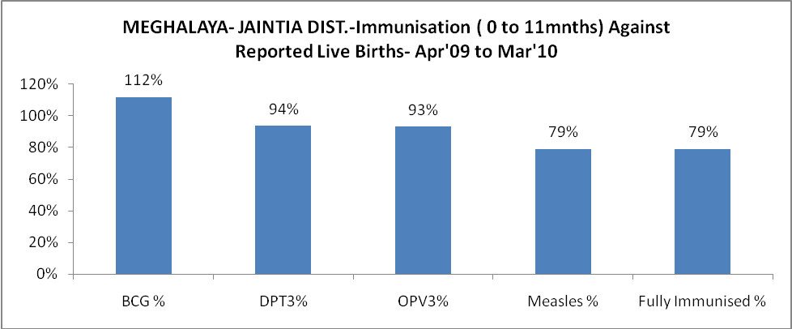

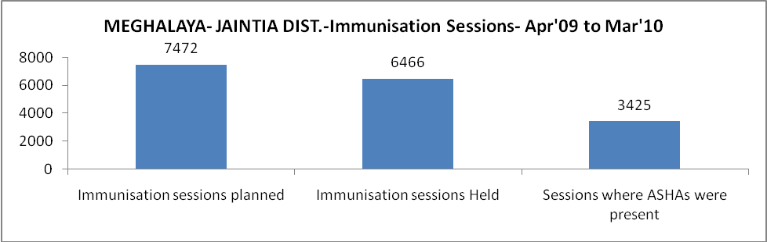

MEGHALAYA- JAINTIA DIST.- Apr'09 to Mar'10
Total Abortions | Abortion Rate
548 | 5.4%

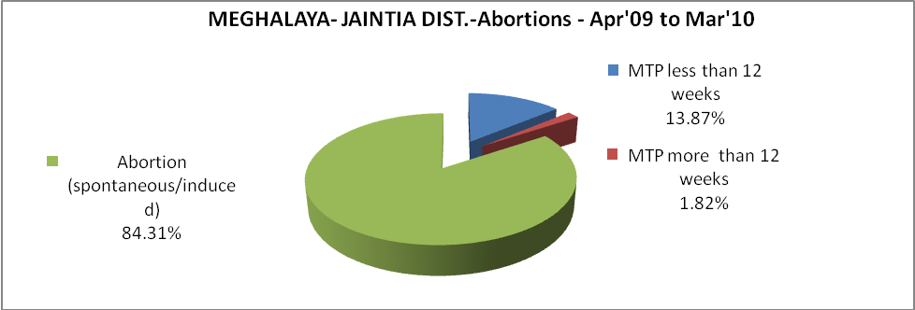

MEGHALAYA- JAINTIA DIST.- Apr'09 to Mar'10
Total OPD | Total RTI/STI cases
3,70,072 | 1,074

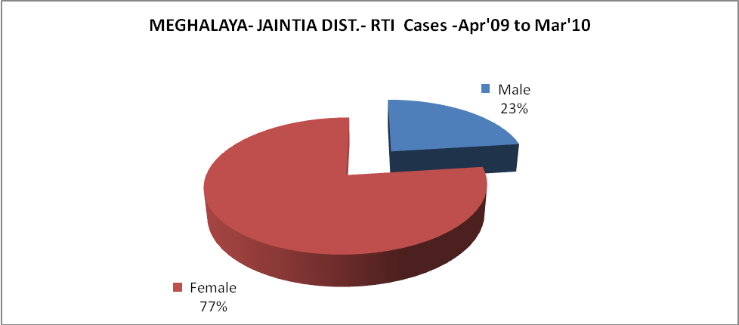

MEGHALAYA- JAINTIA DIST.-Sterilisations - Apr'09 to Mar'10
 | Reported | %age of Reported Sterilisation
Total Sterilisation | 245 | -
NSV | 22 | 9%
Laproscopic | 16 | 7%
MiniLap | 92 | 38%
Post Partum | 115 | 47%
Male Sterilisation | 22 | 9%
Female Sterilisation | 223 | 91%

MEGHALAYA- JAINTIA DIST.-FP Methods - Apr'09 to Mar'10
 | Reported | %age of All Reported FP Methods
Total Reported FP Methodd (All types) Users | 1,288 | -
Sterilisations | 245 | 19%
IUD | 232 | 18%
Condom Users | 272 | 21%
OCP Users | 539 | 42%
Limiting Methods | 245 | 19%
Spacing Methods | 1,043 | 81%

MEGHALAYA- JAINTIA DIST.- Service Delivery - Apr'09 to Mar'10
Operation major (General and spinal anaesthesia) | Operation minor (No or local anaesthesia) | AYUSH | Dental Procedures | Adolescent counselling services | Total OPD | Total IPD
118 | 656 | 13,801 | 851 | 57 | 3,70,072 | 12,306
Operation major (General and spinal anaesthesia) as %ge of OPD | Operation minor (No or local anaesthesia)as %ge of OPD | AYUSH as %ge of OPD | Dental Procedures as %ge of OPD | Adolescent counselling services as %ge of OPD | IPD as percentage of OPD
0.0% | 0.2% | 3.7% | 0.2% | 0.0% | 3%

MEGHALAYA- JAINTIA DIST.- Lab Services - Apr'09 to Mar'10
Total OPD | Total HB tested | Total HIV Tested | Total Population
3,70,072 | 5,279 | 1,249 | 3,66,150
HB test conducted as %age of OPD | HB<7gm as %age of HB tested | HIV test conducted as %age of OPD | HIV positive as %age of HIV tested | Blood Smear Examined as % of Population
1.4% | 13.3% | 0.3% | 0.3% | 9.3%

MEGHALAYA- JAINTIA DIST.- Childhood Disease - Vaccine Preventable -Apr'09 to Mar'10
Diphtheria | Pertussis | Tetanus Neonatorum | Tetanus others | Polio | Measles
0 | 0 | 0 | 0 | 0 | 992
MEGHALAYA- JAINTIA DIST.-Childhood Disease - Others - Apr'09 to Mar'10
Diarrhoea and dehydration | Malaria | Number admitted with Respiratory Infections
22,450 | 4,766 | 3,030

MEGHALAYA- JAINTIA DIST.- Infant & Child Deaths - Apr'09 to Mar'10
Infant Deaths within 24 hrs of birth | Infant Deaths between 24hrs & under 1 week | Infant Deaths between 1 week & under 1 month | Child Deaths between 1 month & under 1 year | Child Deaths between 1yr under 5years | Total Deaths
20 | 107 | 45 | 82 | 108 | 362

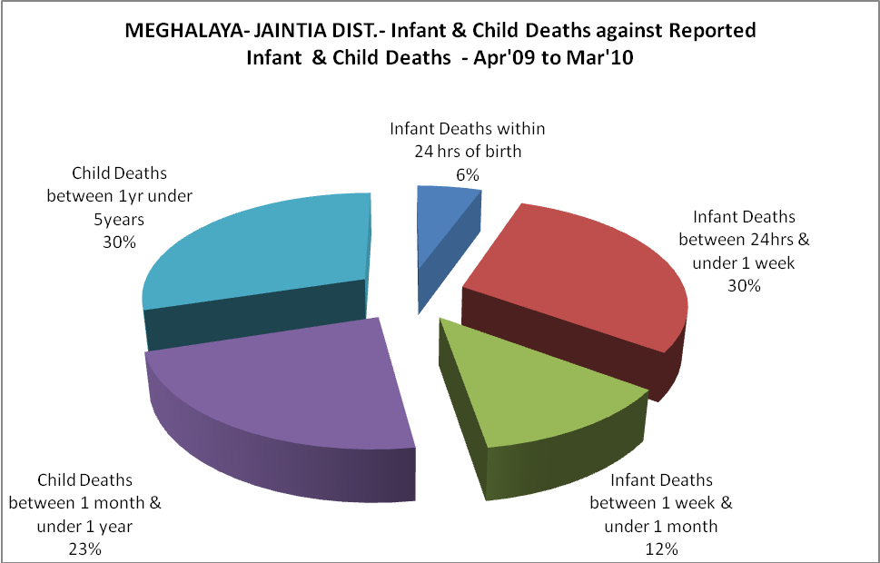

MEGHALAYA- JAINTIA DIST.- Causes of Infant & Child Deaths - Apr'09 to Mar'10
Sepsis |  |  | Asphyxia |  |  | LBW
Up to 1 Weeks of Birth | Between 1 week & 4 weeks of birth | Total | Up to 1 Weeks of Birth | Between 1 week & 4 weeks of birth | Total | Up to 1 Weeks of Birth | Between 1 week & 4 weeks of birth | Total
14 | 1 | 15 | 15 | 5 | 20 | 25 | 7 | 32
Pneumonia |  |  | Diarrhoea |  |  | Fever related
Between 1 month and 11 months | Between 1 year & 5 years | Total | Between 1 month and 11 months | Between 1 year & 5 years | Total | Between 1 month and 11 months | Between 1 year & 5 years | Total
14 | 7 | 21 | 9 | 11 | 20 | 21 | 13 | 34
Others |  |  | Measles |  |  | Others
Up to 1 Weeks of Birth | Between 1 week & 4 weeks of birth | Total | Between 1 month and 11 months | Between 1 year & 5 years | Total | Between 1 month and 11 months | Between 1 year & 5 years | Total
53 | 32 | 85 | 4 | 6 | 10 | 34 | 71 | 105

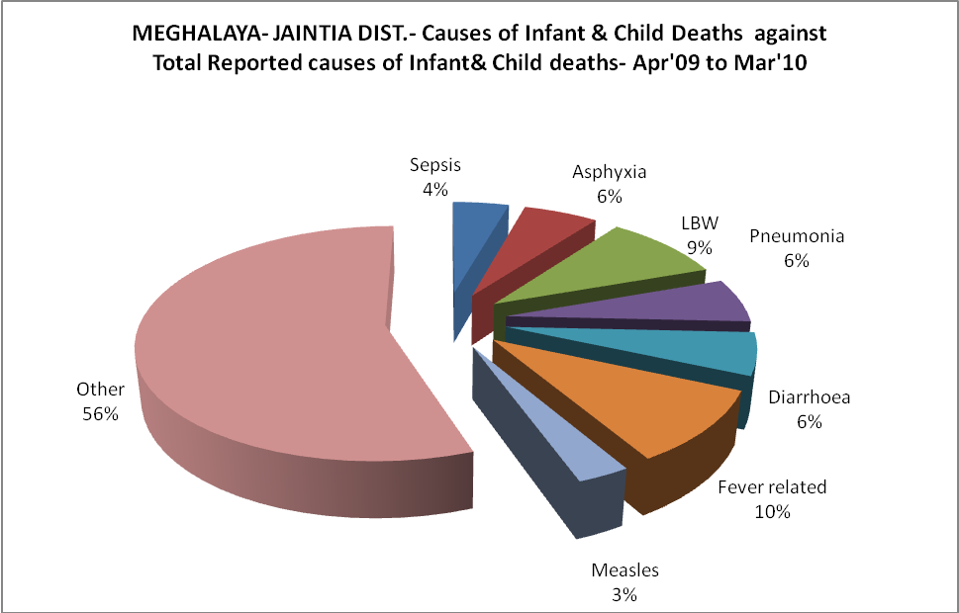
MEGHALAYA- JAINTIA DIST.- Maternal Deaths & Causes - Apr'09 to Mar'10
Abortion |  |  | Obstructed/prolonged labour |  |  | Severe hypertesnion/fits
6-14 yrs | 15-55 yrs. | Total | 6-14 yrs | 15-55 yrs. | Total | 6-14 yrs | 15-55 yrs. | Total
1 | 0 | 1 | 1 | 0 | 1 | 0 | 0 | 0
Bleeding |  |  | High Fever |  |  | Other Causes
6-14 yrs | 15-55 yrs. | Total | 6-14 yrs | 15-55 yrs. | Total | 6-14 yrs | 15-55 yrs. | Total
0 | 1 | 1 | 3 | 1 | 4 | 8 | 10 | 18

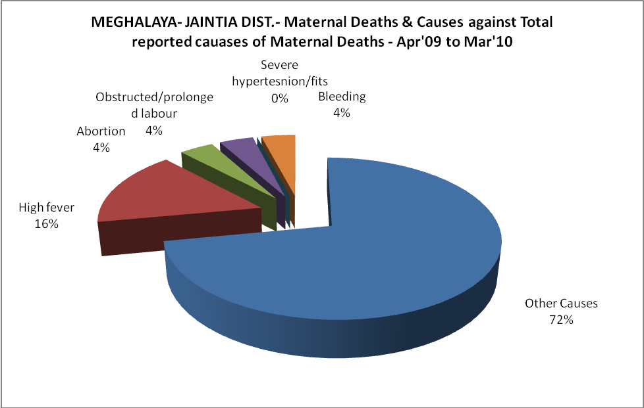

MEGHALAYA- JAINTIA DIST.-Causes of Deaths in 6 to 55yrs age group - Apr'09 to Mar'10
Diarrhoel Diseases |  |  |  | Tuberculosis |  |  |  | Respiratory Diseases( Other than TB)
6-14 yrs | 15-55 yrs. | Above 55yrs | Total | 6-14 yrs | 15-55 yrs. | Above 55yrs | Total | 6-14 yrs | 15-55 yrs. | Above 55yrs | Total
5 | 6 | 6 | 17 | 2 | 7 | 7 | 16 | 10 | 8 | 6 | 24
Malaria |  |  |  | Other fever Related |  |  |  | HIV/Aids
6-14 yrs | 15-55 yrs. | Above 55yrs | Total | 6-14 yrs | 15-55 yrs. | Above 55yrs | Total | 6-14 yrs | 15-55 yrs. | Above 55yrs | Total
0 | 6 | 3 | 9 | 19 | 21 | 25 | 65 | 0 | 0 | 0 | 0
Heart Disease/Hypertenion related |  |  |  | Neurological Disease including strokes |  |  |  | Trauma/Accidents/ Burn Cases
6-14 yrs | 15-55 yrs. | Above 55yrs | Total | 6-14 yrs | 15-55 yrs. | Above 55yrs | Total | 6-14 yrs | 15-55 yrs. | Above 55yrs | Total
6 | 5 | 12 | 23 | 2 | 2 | 7 | 11 | 7 | 9 | 4 | 20
Suicide |  |  |  | Animal Bites & Stings
6-14 yrs | 15-55 yrs. | Above 55yrs | Total | 6-14 yrs | 15-55 yrs. | Above 55yrs | Total
4 | 8 | 2 | 14 | 2 | 1 | 0 | 3

