NHSRC
Rajasthan-Jaipur
Analysis: Apr 2009 – Mar 2010

Rajasthan- Jaipur- Summary-Apr'09 to Mar'10
ANC
ANC Registration against Expected Pregnancies | 105% | TT1 given to Pregnant women against ANC Registration | 66%
3 ANC Checkups against ANC Registrations | 58% | 100 IFA Tablets given to Pregnant women against ANC Registration | 58%
Deliveries
Unreported Deliveries against Estimated Deliveries | 22.2% | HOME Deliveries( SBA& Non SBA) against Estimated Deliveries | 4.5%
Institutional Deliveries against Estimated Deliveries | 73.3% | HOME Deliveries( SBA& Non SBA) against Reported Deliveries | 5.8%
Institutional Deliveries against Reported Deliveries | 94.2% | C Section Deliveries against Institutional Deliveries( Pvt & Pub) | 9%
Births & Neonates Care
Live Births Reported against Estimated Live Births | 76% | New borns weighed against Reported Live Births | 92%
Still Births (Reported) | 1,831 | New borns weighed less than 2.5 kgs against newborns weighed | 16%
Sex Ratio at Birth | 907 | New borns breastfed within one hr of Birth against Reported live Births | 63%
Child Immunisation( 0 to 11 months)
BCG given against Expected Live Births | 92% | Measles given against Expected Live Births | 72%
OPV3 given against Expected Live Births | 76% | Fully Immunised Children against Expected Live Births | 70%
DPT3 given against Expected Live Births | 76%
Family Planning
Family Plannig Methods Users ( Sterilisations(Male &Female)+IUD+ Condom pieces/72 + OCP Cycles/13) | 150,601 | IUD Insertions against reported FP Methods | 20%
Sterilisation against reported FP Methods | 17% | Condom Users against reported FP Methods | 40%
 |  | OCP Users against reported FP Methods | 24%
Other Services
OPD | 2,788,315 | Major Operations | 12,977
IPD | 74,460 | Minor Operations | 20,159
`
Rajasthan- Jaipur- Deliveries Apr'09 to Mar'10
Total Population | 6,410,900 | Expected Deliveries |  | 181,853
Home SBA | Home Non SBA | Institutional | Total Deliveries Reported | Unreported Deliveries
5,200 | 2,940 | 133,267 | 141,407 | 40,446
Home SBA % | Home Non SBA% | Institutional % | Total Deliveries Reported % | Unreported Deliveries %
3% | 2% | 73% | 78% | 22%

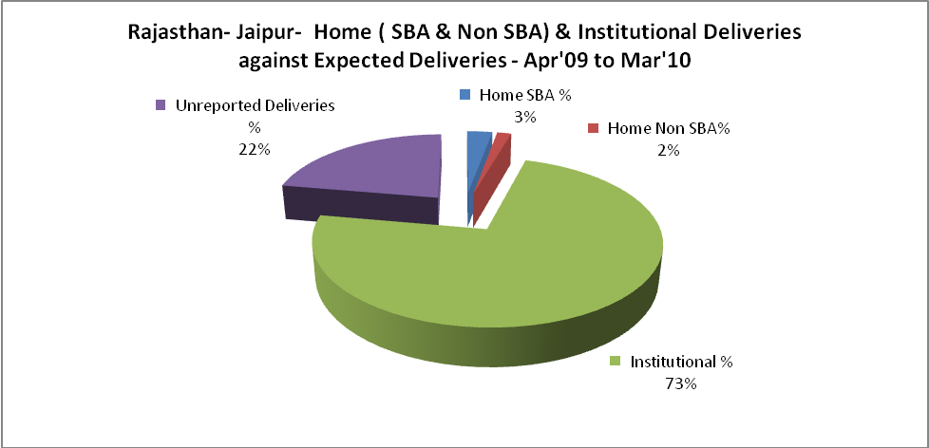

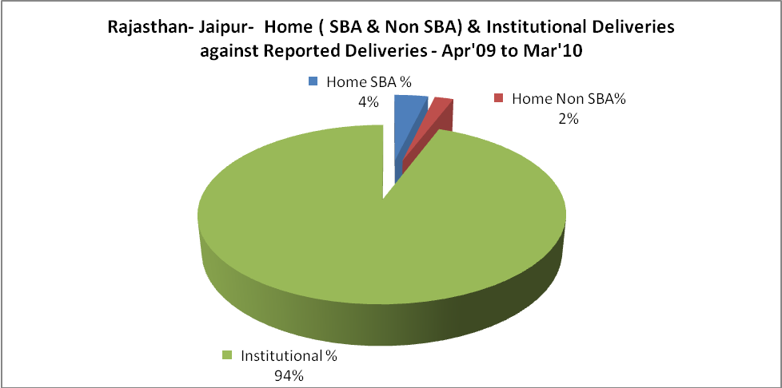

Rajasthan- Jaipur- C sections & Complicated Deliveries Apr'09 to Mar'10
 | Institutional Deliveries (Public) | Institutional Deliveries (Pvt)
 | 79,256 | 54,011
C Section | 10,791 | 1,414
C Section% | 14% | 3%
Complicated Pregnacies attended | 6,988 | 1,359
Complicated Pregnacies attended % | 9% | 3%

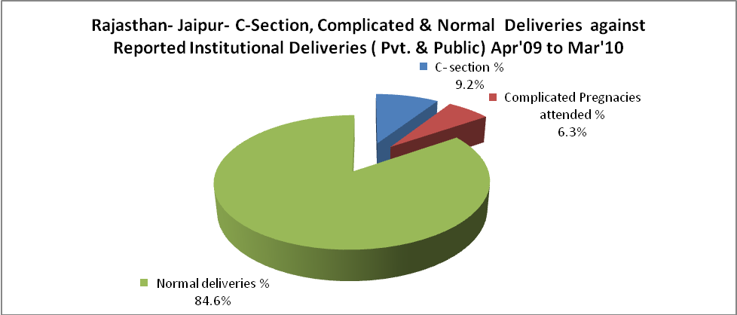

Rajasthan- Jaipur- Complicated Pregnancies & Deliveries Treated - Apr'09 to Mar'10
Reported Deliveries |  |  | Reported ANC Reigtration
141,407 |  |  | 203,573
Complicated Pregnancies attended | Complicated Pregnancies Rate | C - Section Deliveries | PNC Maternal Complications | Abortions | Still Births
8,347 | 4% | 12,205 | 1,966 | 2,607 | 1,831
Complicated Deliveries Treated with |  |  |  | No Of Eclampsia cases Treated | No Of severe anemia cases treated
IV Antibiotics | IV antihypertensive/Magsulph injection | IV Oxytocis | Blood Transfusion | No Of Eclampsia cases Treated | No Of severe anemia cases treated
17,221 | 1,590 | 12,146 | 3,546 | 2,003 | 9,313

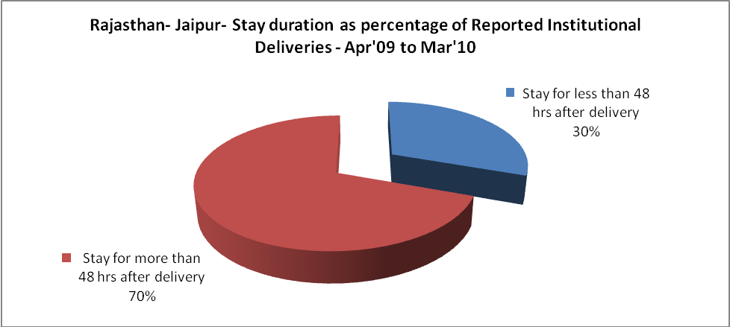

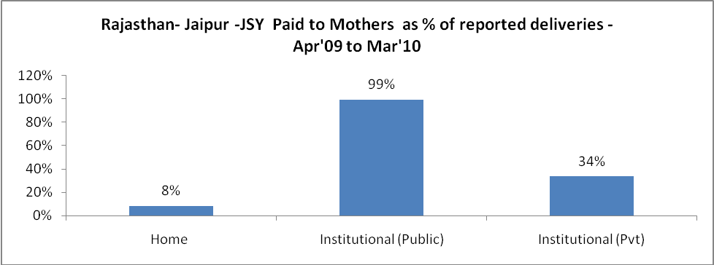

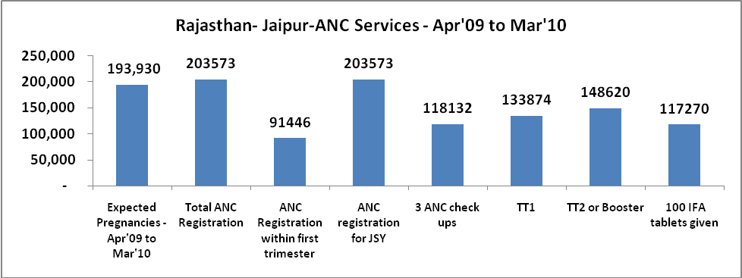

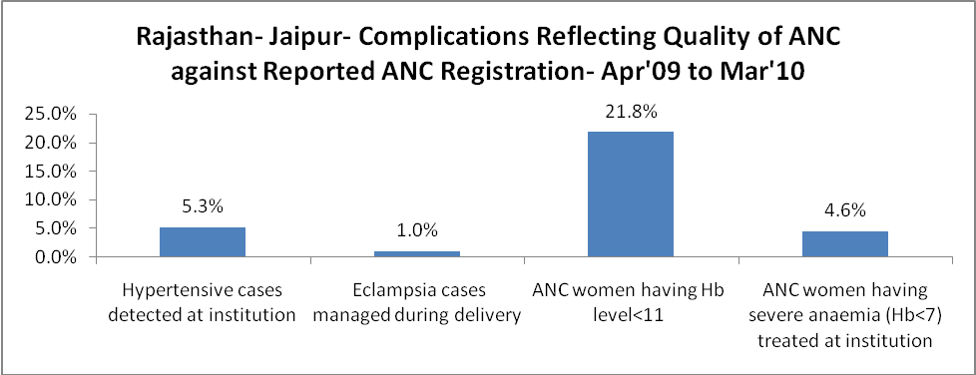
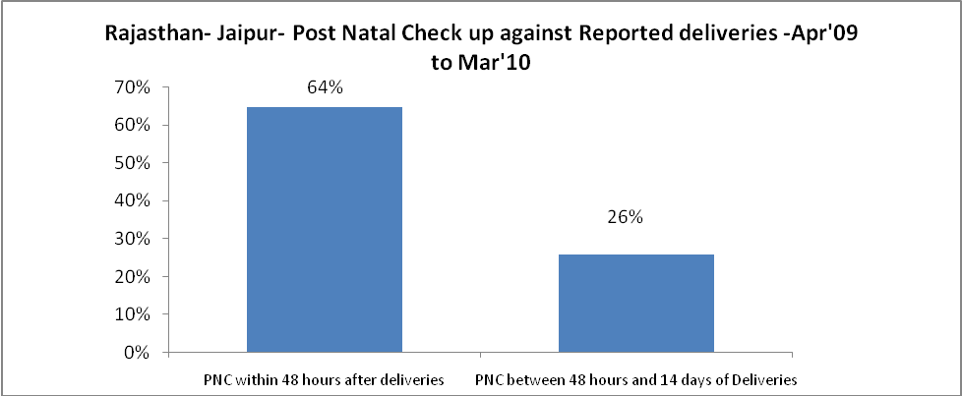

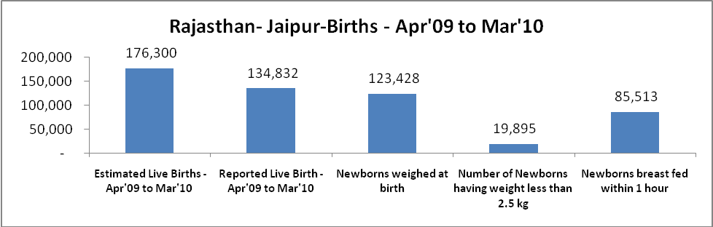

Rajasthan- Jaipur - Births - Apr'09 to Mar'10
Live Birth - Males | Live Birth - females | Live Birth - Total | Sex Ratio at birth | Still Birth | Abortion( Induced/Spontaneous
70,704 | 64,128 | 134,832 | 907 | 1,831 | 2,607

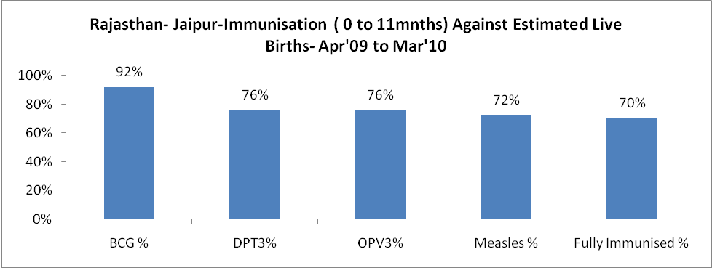

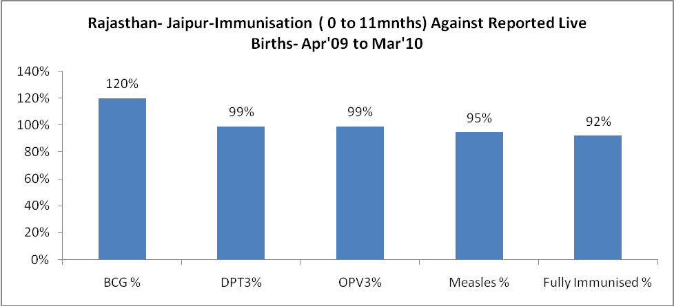

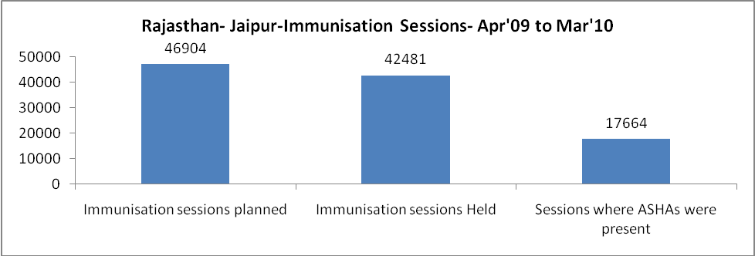

Rajasthan- Jaipur- Apr'09 to Mar'10
Total Abortions | Abortion Rate
4,888 | 2.5%

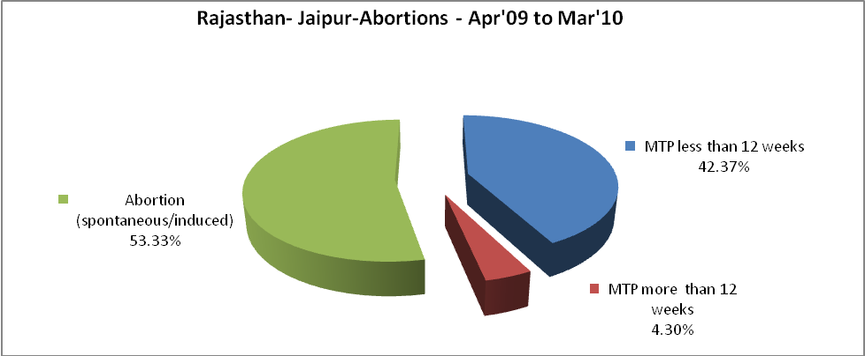

Rajasthan- Jaipur- Apr'09 to Mar'10
Total OPD | Total RTI/STI cases
2,788,315 | 28,672

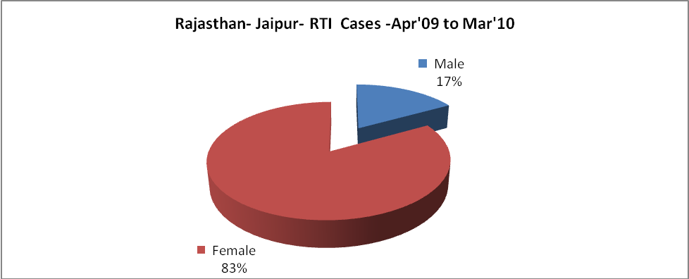

Rajasthan- Jaipur-Sterilisations - Apr'09 to Mar'10
 | Reported | %age of Reported Sterilisation
Total Sterilisation | 24,959 | -
NSV | 1,671 | 7%
Laproscopic | 20,793 | 83%
MiniLap | 60 | 0%
Post Partum | 2,435 | 10%
Male Sterilisation | 1,671 | 7%
Female Sterilisation | 23,288 | 93%

Rajasthan- Jaipur-FP Methods - Apr'09 to Mar'10
 | Reported | %age of All Reported FP Methods
Total Reported FP Methodd (All types) Users | 150,601 | -
Sterilisations | 24,959 | 17%
IUD | 29,841 | 20%
Condom Users | 60,406 | 40%
OCP Users | 35,396 | 24%
Limiting Methods | 24,959 | 17%
Spacing Methods | 125,642 | 83%

Rajasthan- Jaipur- Lab Services - Apr'09 to Mar'10
Total OPD | Total HB tested | Total HIV Tested | Total Population
2,788,315 | 136,808 | 35,136 | 6,410,900
HB test conducted as %age of OPD | HB<7gm as %age of HB tested | HIV test conducted as %age of OPD | HIV positive as %age of HIV tested | Blood Smear Examined as % of Population
4.9% | 4.8% | 1.3% | 0.1% | 3.7%

Rajasthan- Jaipur- Childhood Disease - Vaccine Preventable -Apr'09 to Mar'10
Diphtheria | Pertussis | Tetanus Neonatorum | Tetanus others | Polio | Measles
9 | 63 | 2 | 36 | 0 | 171
Rajasthan- Jaipur-Childhood Disease - Others - Apr'09 to Mar'10
Diarrhoea and dehydration | Malaria | Number admitted with Respiratory Infections
4,764 | 669 | 4,478

Rajasthan- Jaipur- Infant & Child Deaths - Apr'09 to Mar'10
Infant Deaths within 24 hrs of birth | Infant Deaths between 24hrs & under 1 week | Infant Deaths between 1 week & under 1 month | Child Deaths between 1 month & under 1 year | Child Deaths between 1yr under 5years | Total Deaths
153 | 73 | 73 | 78 | 52 | 429

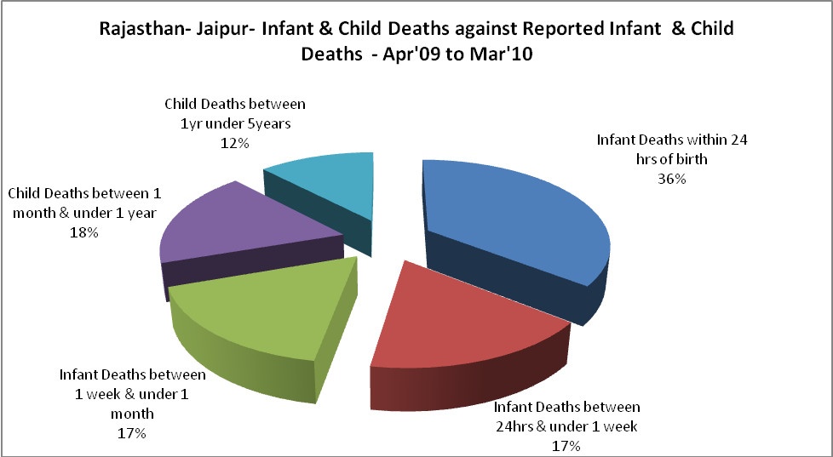

Rajasthan- Jaipur- Causes of Infant & Child Deaths - Apr'09 to Mar'10
Sepsis |  |  | Asphyxia |  |  | LBW
Up to 1 Weeks of Birth | Between 1 week & 4 weeks of birth | Total | Up to 1 Weeks of Birth | Between 1 week & 4 weeks of birth | Total | Up to 1 Weeks of Birth | Between 1 week & 4 weeks of birth | Total
6 | 2 | 8 | 12 | 19 | 31 | 24 | 40 | 64
Pneumonia |  |  | Diarrhoea |  |  | Fever related
Between 1 month and 11 months | Between 1 year & 5 years | Total | Between 1 month and 11 months | Between 1 year & 5 years | Total | Between 1 month and 11 months | Between 1 year & 5 years | Total
9 | 7 | 16 | 17 | 13 | 30 | 34 | 10 | 44
Others |  |  | Measles |  |  | Others
Up to 1 Weeks of Birth | Between 1 week & 4 weeks of birth | Total | Between 1 month and 11 months | Between 1 year & 5 years | Total | Between 1 month and 11 months | Between 1 year & 5 years | Total
31 | 12 | 43 | 0 | 0 | 0 | 18 | 22 | 40

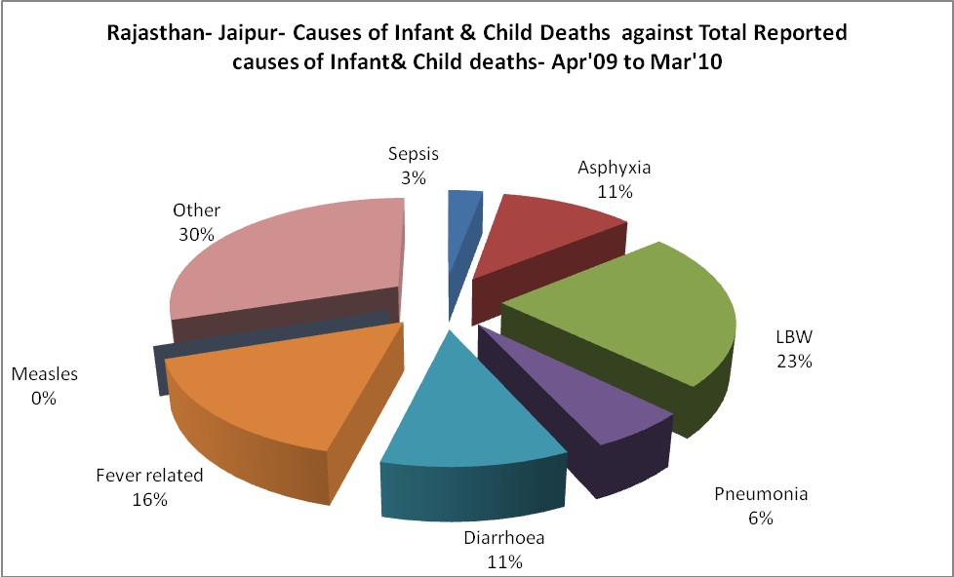

Rajasthan- Jaipur- Maternal Deaths & Causes - Apr'09 to Mar'10
Abortion |  |  | Obstructed/prolonged labour |  |  | Severe hypertesnion/fits
6-14 yrs | 15-55 yrs. | Total | 6-14 yrs | 15-55 yrs. | Total | 6-14 yrs | 15-55 yrs. | Total
1 | 0 | 1 | 0 | 2 | 2 | 2 | 1 | 3
Bleeding |  |  | High Fever |  |  | Other Causes
6-14 yrs | 15-55 yrs. | Total | 6-14 yrs | 15-55 yrs. | Total | 6-14 yrs | 15-55 yrs. | Total
0 | 6 | 6 | 1 | 4 | 5 | 1 | 36 | 37

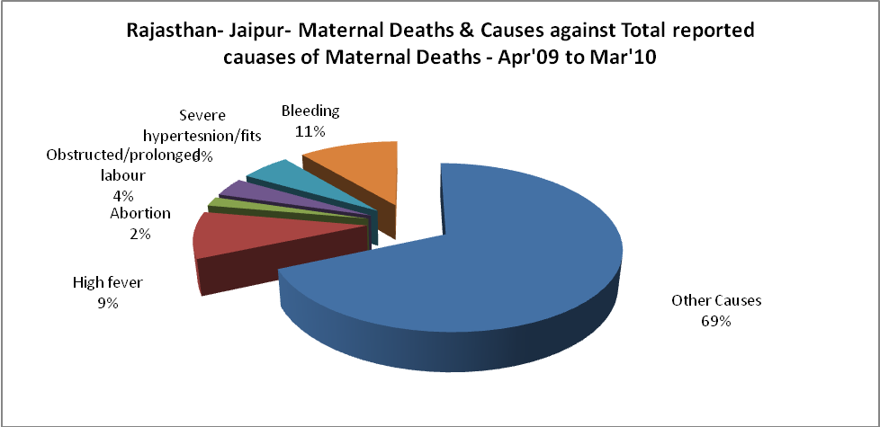

Rajasthan- Jaipur-Causes of Deaths in 6 to 55yrs age group - Apr'09 to Mar'10
Diarrhoel Diseases |  |  |  | Tuberculosis |  |  |  | Respiratory Diseases( Other than TB)
6-14 yrs | 15-55 yrs. | Above 55yrs | Total | 6-14 yrs | 15-55 yrs. | Above 55yrs | Total | 6-14 yrs | 15-55 yrs. | Above 55yrs | Total
5 | 7 | 3 | 15 | 6 | 34 | 31 | 71 | 6 | 15 | 46 | 67
Malaria |  |  |  | Other fever Related |  |  |  | HIV/Aids
6-14 yrs | 15-55 yrs. | Above 55yrs | Total | 6-14 yrs | 15-55 yrs. | Above 55yrs | Total | 6-14 yrs | 15-55 yrs. | Above 55yrs | Total
0 | 1 | 0 | 1 | 28 | 48 | 67 | 143 | 0 | 3 | 2 | 5
Heart Disease/Hypertenion related |  |  |  | Neurological Disease including strokes |  |  |  | Trauma/Accidents/ Burn Cases
6-14 yrs | 15-55 yrs. | Above 55yrs | Total | 6-14 yrs | 15-55 yrs. | Above 55yrs | Total | 6-14 yrs | 15-55 yrs. | Above 55yrs | Total
17 | 110 | 111 | 238 | 55 | 7 | 11 | 73 | 11 | 54 | 23 | 88
Suicide |  |  |  | Animal Bites & Stings
6-14 yrs | 15-55 yrs. | Above 55yrs | Total | 6-14 yrs | 15-55 yrs. | Above 55yrs | Total
12 | 5 | 3 | 20 | 3 | 9 | 3 | 15
