NHSRC
Rajasthan-Jhalawar
Analysis: Apr 2009 – Mar 2010

Rajasthan- Jhalawar- Summary-Apr'09 to Mar'10
ANC
ANC Registration against Expected Pregnancies | 93% | TT1 given to Pregnant women against ANC Registration | 67%
3 ANC Checkups against ANC Registrations | 63% | 100 IFA Tablets given to Pregnant women against ANC Registration | 76%
Deliveries
Unreported Deliveries against Estimated Deliveries | 27.8% | HOME Deliveries( SBA& Non SBA) against Estimated Deliveries | 8.5%
Institutional Deliveries against Estimated Deliveries | 63.7% | HOME Deliveries( SBA& Non SBA) against Reported Deliveries | 11.8%
Institutional Deliveries against Reported Deliveries | 88.2% | C Section Deliveries against Institutional Deliveries( Pvt & Pub) | 5%
Births & Neonates Care
Live Births Reported against Estimated Live Births | 73% | New borns weighed against Reported Live Births | 85%
Still Births (Reported) | 622 | New borns weighed less than 2.5 kgs against newborns weighed | 26%
Sex Ratio at Birth | 908 | New borns breastfed within one hr of Birth against Reported live Births | 80%
Child Immunisation( 0 to 11 months)
BCG given against Expected Live Births | 92% | Measles given against Expected Live Births | 79%
OPV3 given against Expected Live Births | 84% | Fully Immunised Children against Expected Live Births | 77%
DPT3 given against Expected Live Births | 83%
Family Planning
Family Plannig Methods Users ( Sterilisations(Male &Female)+IUD+ Condom pieces/72 + OCP Cycles/13) | 95,083 | IUD Insertions against reported FP Methods | 11%
Sterilisation against reported FP Methods | 8% | Condom Users against reported FP Methods | 62%
 |  | OCP Users against reported FP Methods | 20%
Other Services
OPD | 781,207 | Major Operations | 1,086
IPD | 62,505 | Minor Operations | 1,073

Rajasthan- Jhalawar- Deliveries Apr'09 to Mar'10
Total Population | 1,405,200 | Expected Deliveries |  | 39,860
Home SBA | Home Non SBA | Institutional | Total Deliveries Reported | Unreported Deliveries
2,398 | 987 | 25,379 | 28,764 | 11,096
Home SBA % | Home Non SBA% | Institutional % | Total Deliveries Reported % | Unreported Deliveries %
6% | 2% | 64% | 72% | 28%

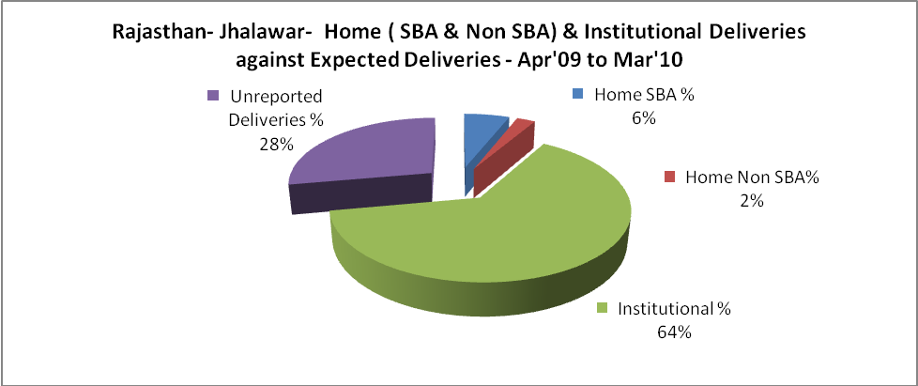

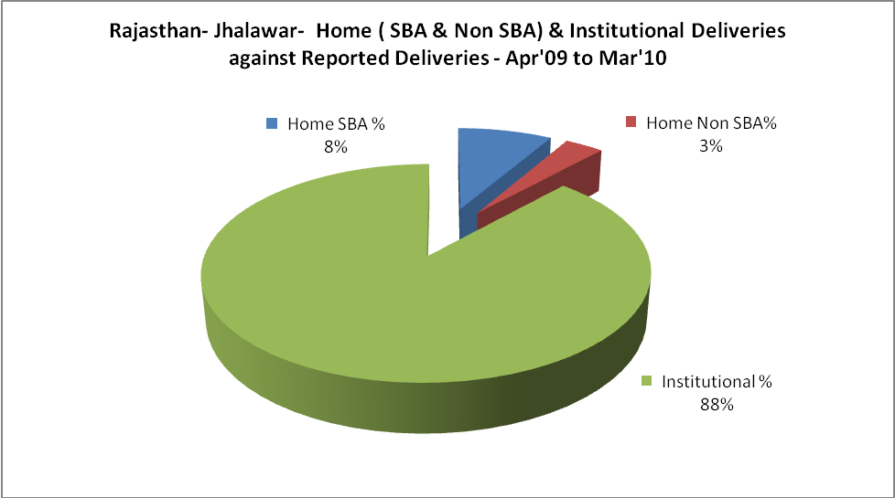

Rajasthan- Jhalawar- C sections & Complicated Deliveries Apr'09 to Mar'10
 | Institutional Deliveries (Public) | Institutional Deliveries (Pvt)
 | 22,780 | 2,599
C Section | 948 | 415
C Section% | 4% | 16%
Complicated Pregnacies attended | 1,165 | 175
Complicated Pregnacies attended % | 5% | 7%

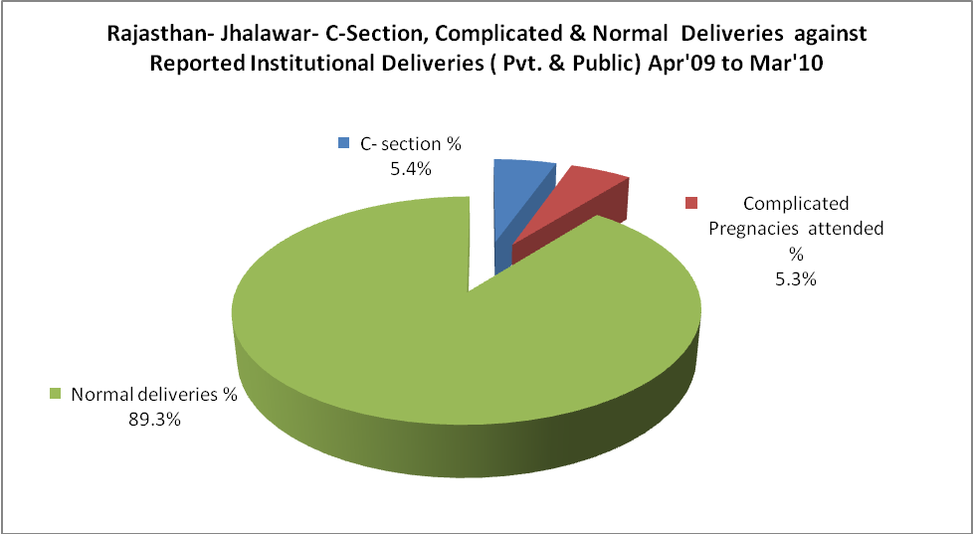

Rajasthan- Jhalawar- Complicated Pregnancies & Deliveries Treated - Apr'09 to Mar'10
Reported Deliveries |  |  | Reported ANC Reigtration
28,764 |  |  | 39,649
Complicated Pregnancies attended | Complicated Pregnancies Rate | C - Section Deliveries | PNC Maternal Complications | Abortions | Still Births
1,340 | 3% | 1,363 | 543 | 848 | 622
Complicated Deliveries Treated with |  |  |  | No Of Eclampsia cases Treated | No Of severe anemia cases treated
IV Antibiotics | IV antihypertensive/Magsulph injection | IV Oxytocis | Blood Transfusion | No Of Eclampsia cases Treated | No Of severe anemia cases treated
1,758 | 352 | 2,488 | 1,514 | 82 | 600

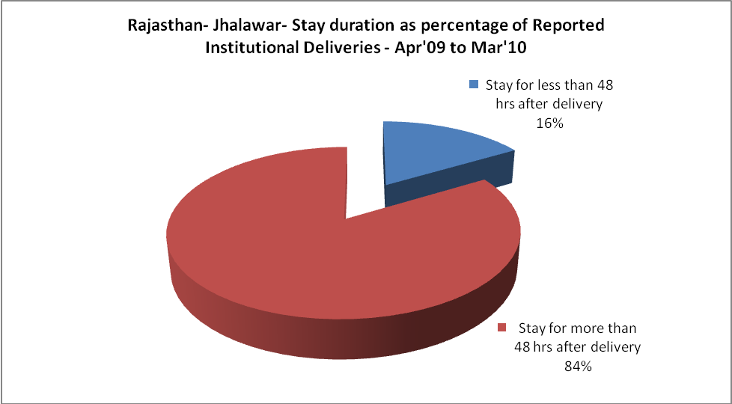

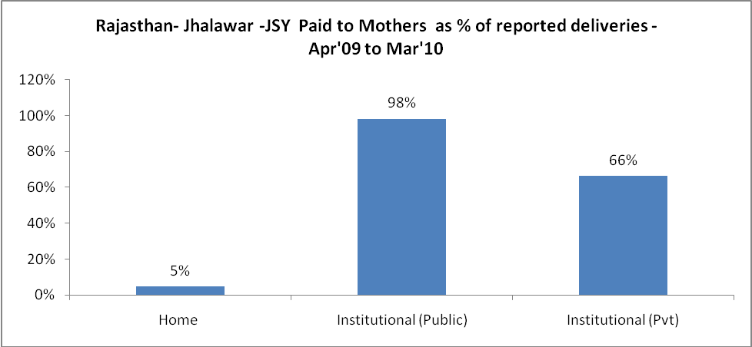

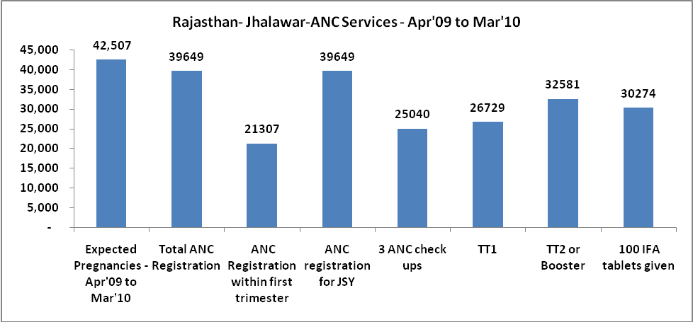

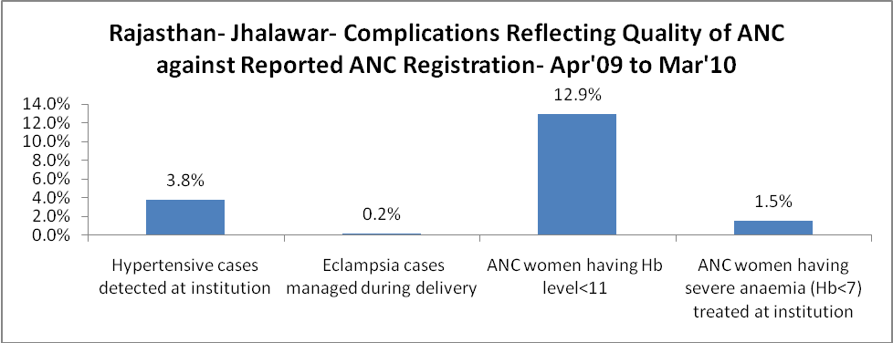

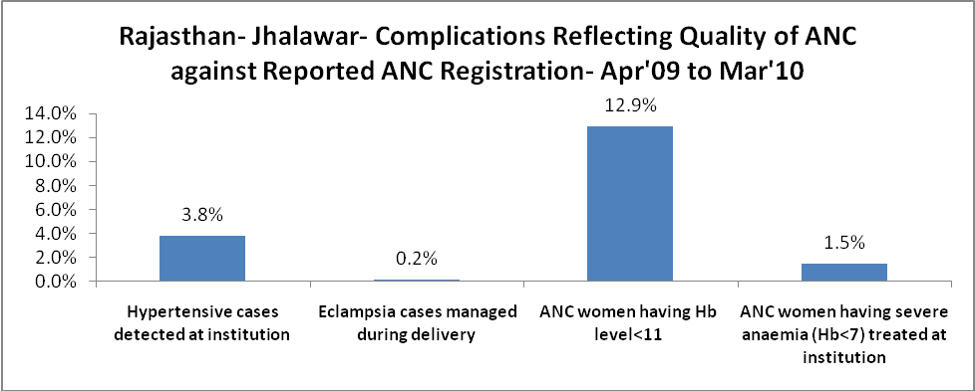

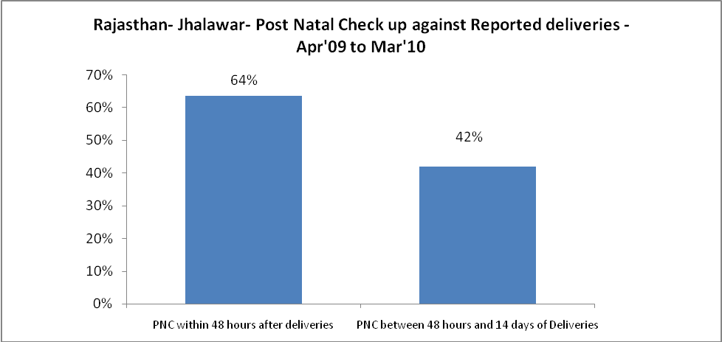

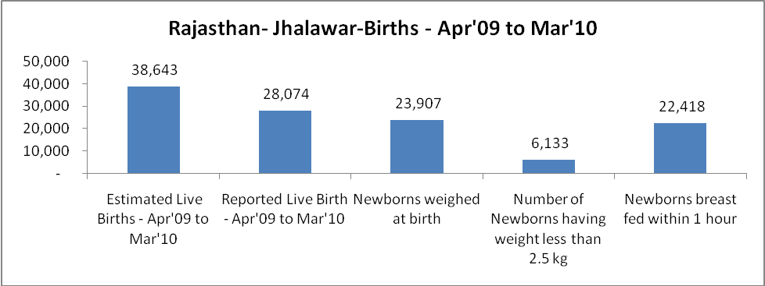

Rajasthan- Jhalawar - Births - Apr'09 to Mar'10
Live Birth - Males | Live Birth - females | Live Birth - Total | Sex Ratio at birth | Still Birth | Abortion( Induced/Spontaneous
14,714 | 13,360 | 28,074 | 908 | 622 | 848

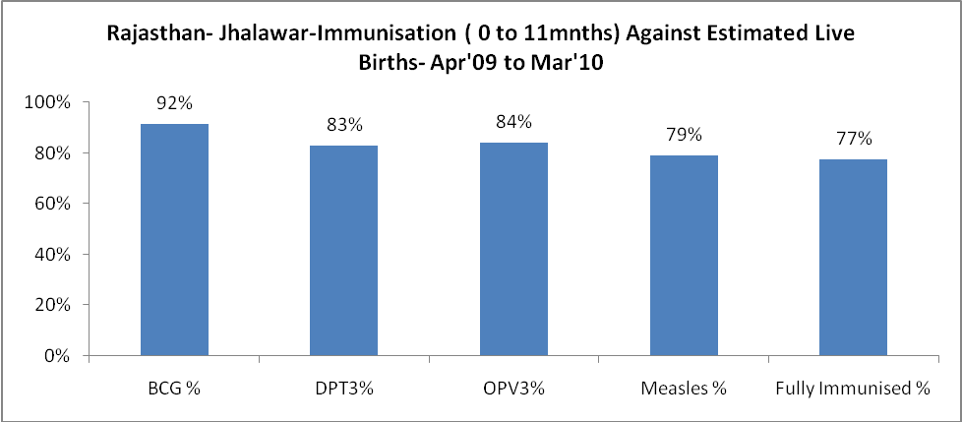

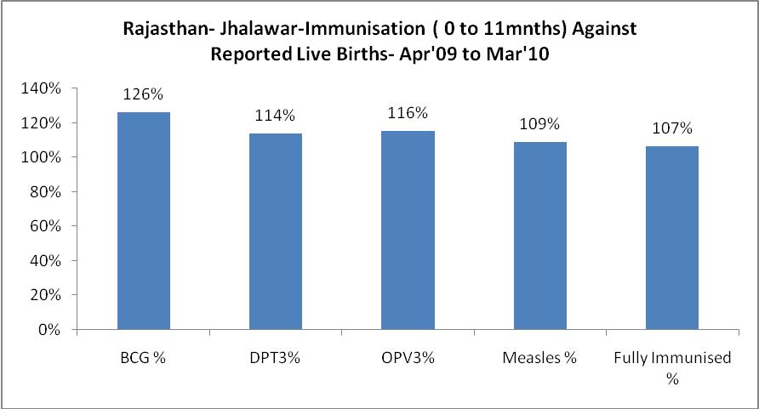

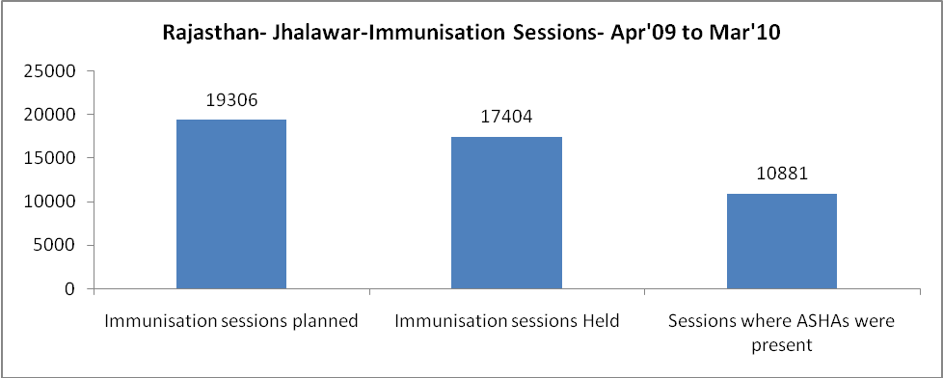

Rajasthan- Jhalawar- Apr'09 to Mar'10
Total Abortions | Abortion Rate
1,103 | 2.6%

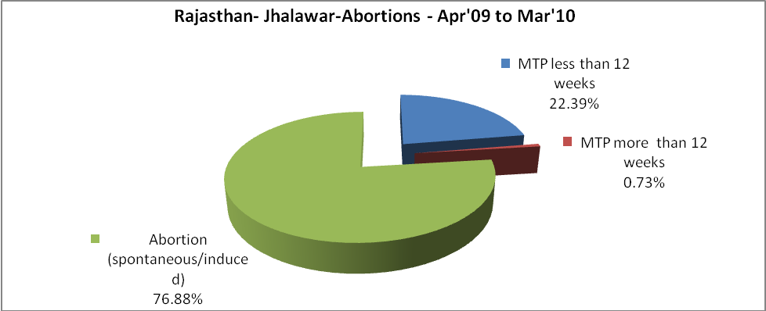

Rajasthan- Jhalawar- Apr'09 to Mar'10
Total OPD | Total RTI/STI cases
781,207 | 3,736

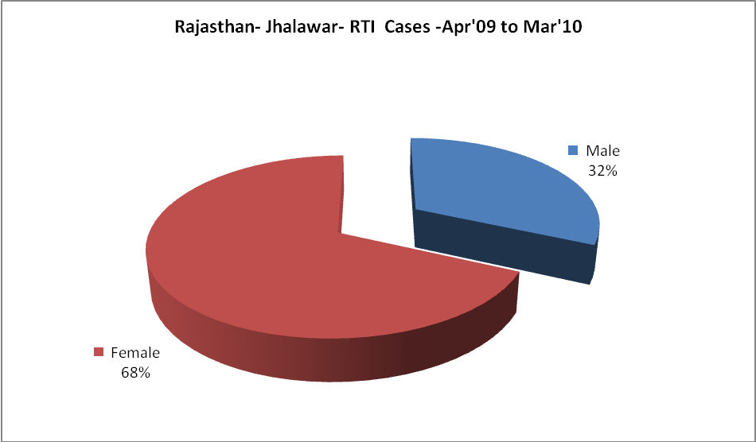

Rajasthan- Jhalawar-Sterilisations - Apr'09 to Mar'10
 | Reported | %age of Reported Sterilisation
Total Sterilisation | 7,240 | -
NSV | 78 | 1%
Laproscopic | 6,970 | 96%
MiniLap | - | 0%
Post Partum | 192 | 3%
Male Sterilisation | 78 | 1%
Female Sterilisation | 7,162 | 99%

Rajasthan- Jhalawar-FP Methods - Apr'09 to Mar'10
 | Reported | %age of All Reported FP Methods
Total Reported FP Methodd (All types) Users | 95,083 | -
Sterilisations | 7,240 | 8%
IUD | 10,137 | 11%
Condom Users | 58,833 | 62%
OCP Users | 18,873 | 20%
Limiting Methods | 7,240 | 8%
Spacing Methods | 87,843 | 92%

Rajasthan- Jhalawar- Service Delivery - Apr'09 to Mar'10
Operation major (General and spinal anaesthesia) | Operation minor (No or local anaesthesia) | AYUSH | Dental Procedures | Adolescent counselling services | Total OPD | Total IPD
1,086 | 1,073 | 44,144 | 1,332 | 3,364 | 781,207 | 62,505
Operation major (General and spinal anaesthesia) as %ge of OPD | Operation minor (No or local anaesthesia)as %ge of OPD | AYUSH as %ge of OPD | Dental Procedures as %ge of OPD | Adolescent counselling services as %ge of OPD | IPD as percentage of OPD
0.1% | 0.1% | 5.7% | 0.2% | 0.4% | 8%

Rajasthan- Jhalawar- Lab Services - Apr'09 to Mar'10
Total OPD | Total HB tested | Total HIV Tested | Total Population
781,207 | 10,520 | 4,400 | 1,405,200
HB test conducted as %age of OPD | HB<7gm as %age of HB tested | HIV test conducted as %age of OPD | HIV positive as %age of HIV tested | Blood Smear Examined as % of Population
1.3% | 5.5% | 0.6% | 0.9% | 7.1%

Rajasthan- Jhalawar- Childhood Disease - Vaccine Preventable -Apr'09 to Mar'10
Diphtheria | Pertussis | Tetanus Neonatorum | Tetanus others | Polio | Measles
5 | 4 | 1 | 9 | 0 | 127
Rajasthan- Jhalawar-Childhood Disease - Others - Apr'09 to Mar'10
Diarrhoea and dehydration | Malaria | Number admitted with Respiratory Infections
2,437 | 188 | 1,325

Rajasthan- Jhalawar- Infant & Child Deaths - Apr'09 to Mar'10
Infant Deaths within 24 hrs of birth | Infant Deaths between 24hrs & under 1 week | Infant Deaths between 1 week & under 1 month | Child Deaths between 1 month & under 1 year | Child Deaths between 1yr under 5years | Total Deaths
0 | 177 | 56 | 84 | 73 | 390

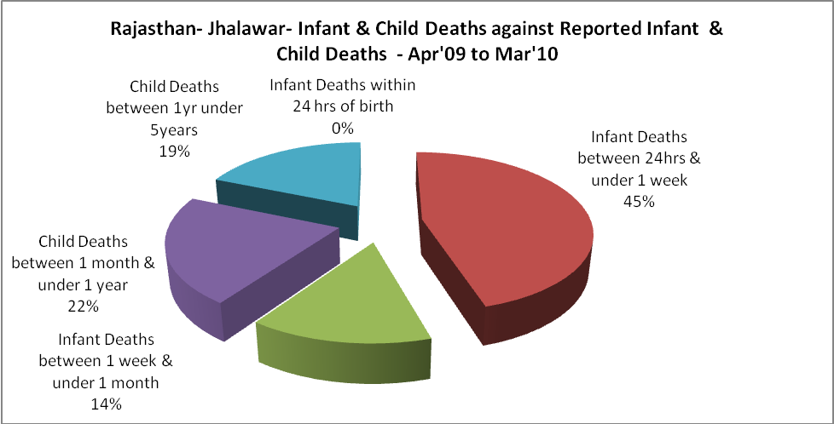

Rajasthan- Jhalawar- Causes of Infant & Child Deaths - Apr'09 to Mar'10
Sepsis |  |  | Asphyxia |  |  | LBW
Up to 1 Weeks of Birth | Between 1 week & 4 weeks of birth | Total | Up to 1 Weeks of Birth | Between 1 week & 4 weeks of birth | Total | Up to 1 Weeks of Birth | Between 1 week & 4 weeks of birth | Total
33 | 18 | 51 | 57 | 3 | 60 | 44 | 12 | 56
Pneumonia |  |  | Diarrhoea |  |  | Fever related
Between 1 month and 11 months | Between 1 year & 5 years | Total | Between 1 month and 11 months | Between 1 year & 5 years | Total | Between 1 month and 11 months | Between 1 year & 5 years | Total
42 | 12 | 54 | 4 | 6 | 10 | 8 | 14 | 22
Others |  |  | Measles |  |  | Others
Up to 1 Weeks of Birth | Between 1 week & 4 weeks of birth | Total | Between 1 month and 11 months | Between 1 year & 5 years | Total | Between 1 month and 11 months | Between 1 year & 5 years | Total
43 | 23 | 66 | 0 | 0 | 0 | 30 | 41 | 71

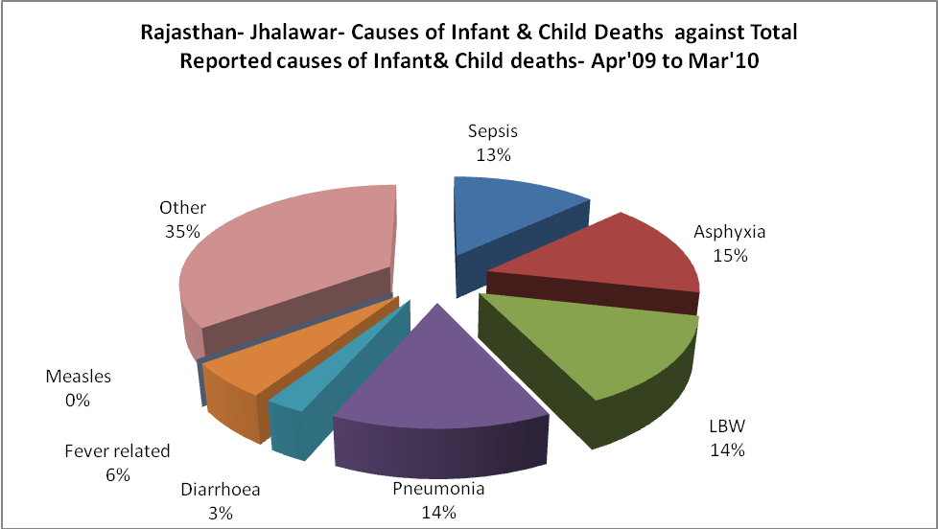

Rajasthan- Jhalawar- Maternal Deaths & Causes - Apr'09 to Mar'10
Abortion |  |  | Obstructed/prolonged labour |  |  | Severe hypertesnion/fits
6-14 yrs | 15-55 yrs. | Total | 6-14 yrs | 15-55 yrs. | Total | 6-14 yrs | 15-55 yrs. | Total
1 | 0 | 1 | 0 | 0 | 0 | 0 | 0 | 0
Bleeding |  |  | High Fever |  |  | Other Causes
6-14 yrs | 15-55 yrs. | Total | 6-14 yrs | 15-55 yrs. | Total | 6-14 yrs | 15-55 yrs. | Total
0 | 1 | 1 | 0 | 1 | 1 | 4 | 2 | 6

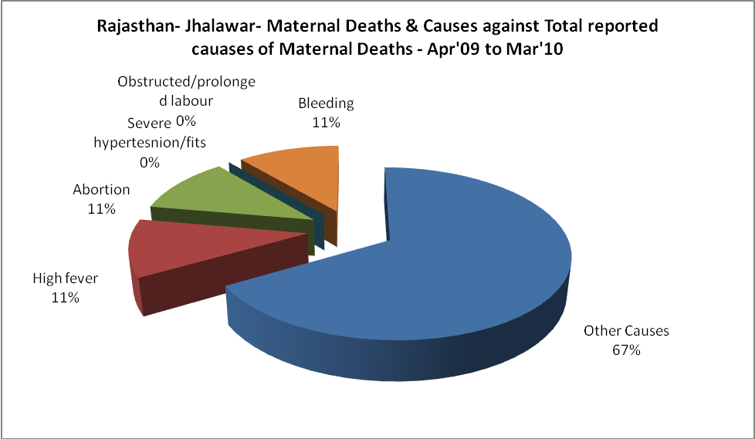

Rajasthan- Jhalawar-Causes of Deaths in 6 to 55yrs age group - Apr'09 to Mar'10
Diarrhoel Diseases |  |  |  | Tuberculosis |  |  |  | Respiratory Diseases( Other than TB)
6-14 yrs | 15-55 yrs. | Above 55yrs | Total | 6-14 yrs | 15-55 yrs. | Above 55yrs | Total | 6-14 yrs | 15-55 yrs. | Above 55yrs | Total
8 | 11 | 5 | 24 | 0 | 21 | 10 | 31 | 6 | 3 | 29 | 38
Malaria |  |  |  | Other fever Related |  |  |  | HIV/Aids
6-14 yrs | 15-55 yrs. | Above 55yrs | Total | 6-14 yrs | 15-55 yrs. | Above 55yrs | Total | 6-14 yrs | 15-55 yrs. | Above 55yrs | Total
4 | 0 | 0 | 4 | 2 | 6 | 5 | 13 | 0 | 0 | 2 | 2
Heart Disease/Hypertenion related |  |  |  | Neurological Disease including strokes |  |  |  | Trauma/Accidents/ Burn Cases
6-14 yrs | 15-55 yrs. | Above 55yrs | Total | 6-14 yrs | 15-55 yrs. | Above 55yrs | Total | 6-14 yrs | 15-55 yrs. | Above 55yrs | Total
6 | 13 | 30 | 49 | 33 | 5 | 11 | 49 | 8 | 31 | 15 | 54
Suicide |  |  |  | Animal Bites & Stings
6-14 yrs | 15-55 yrs. | Above 55yrs | Total | 6-14 yrs | 15-55 yrs. | Above 55yrs | Total
5 | 22 | 3 | 30 | 11 | 16 | 9 | 36

