NHSRC
Himachal Pradesh-Chamba District
Analysis-2009-10

7/22/2010

Kangra Dist.- Summary-Apr'09 to Mar'10
ANC
ANC Registration against Expected Pregnancies | 108% | TT1 given to Pregnant women against ANC Registration | 57%
3 ANC Check ups against ANC Registrations | 78% | 100 IFA Tablets given to Pregnant women against ANC Registration | 62%
Deliveries
Unreported Deliveries against Estimated Deliveries | 31.6% | HOME Deliveries( SBA& Non SBA) against Estimated Deliveries | 39.9%
Institutional Deliveries against Estimated Deliveries | 28.5% | HOME Deliveries( SBA& Non SBA) against Reported Deliveries | 58.3%
Institutional Deliveries against Reported Deliveries | 41.7% | C Section Deliveries against Institutional Deliveries( Pvt & Pub) | 20%
Births & Neonates Care
Live Births Reported against Estimated Live Births | 71% | New borns weighed against Reported Live Births | 99%
Still Births (Reported) | 205 | New borns weighed less than 2.5 kgs against newborns weighed | 7%
Sex Ratio at Birth | 880 | New borns breastfed within one hr of Birth against Reported live Births | 90%
Child Immunization( 0 to 11 months)
BCG given against Expected Live Births | 102% | Measles given against Expected Live Births | 103%
OPV3 given against Expected Live Births | 105% | Fully Immunized Children against Expected Live Births | 102%
DPT3 given against Expected Live Births | 105%
Family Planning
Family Planning Methods Users ( Sterilizations(Male &Female)+IUD+ Condom pieces/72 + OCP Cycles/13) | 29,823 | IUD Insertions against reported FP Methods | 11%
Sterilization against reported FP Methods | 18% | Condom Users against reported FP Methods | 55%
 |  | OCP Users against reported FP Methods | 16%
Other Services
OPD | 1,272,577 | Major Operations | 549
IPD | 18,050 | Minor Operations | 2,878

Kangra Dist.- Deliveries Apr'09 to Mar'10
Total Population | 1,476,526 | Expected Deliveries |  | 26,709
Home SBA | Home Non SBA | Institutional | Total Deliveries Reported | Unreported Deliveries
804 | 9,851 | 7,617 | 18,272 | 8,437
Home SBA % | Home Non SBA% | Institutional % | Total Deliveries Reported % | Unreported Deliveries %
3% | 37% | 29% | 68% | 32%

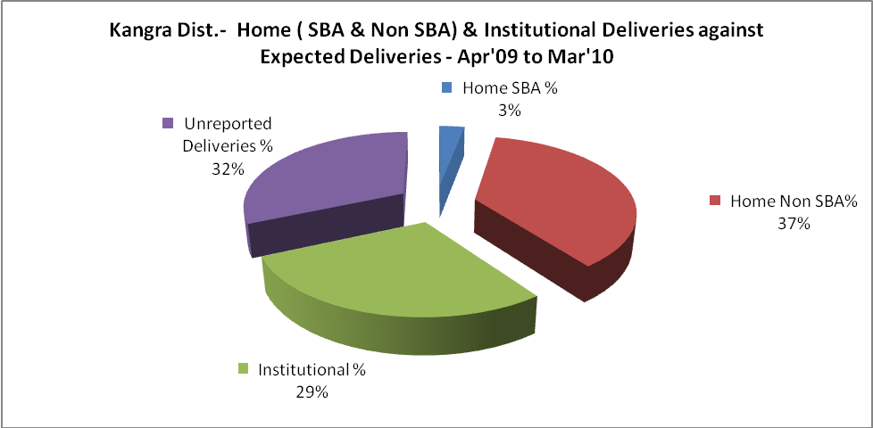

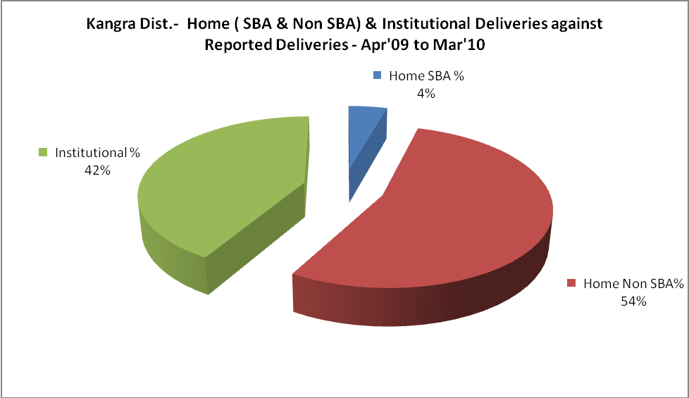

Kangra Dist.- C sections & Complicated Deliveries Apr'09 to Mar'10
 | Institutional Deliveries (Public) | Institutional Deliveries (Pvt)
 | 4,961 | 2,656
C Section | 340 | 362
C Section% | 7% | 14%
Complicated Pregnancies attended | 166 | 132
Complicated Pregnancies attended % | 3% | 5%

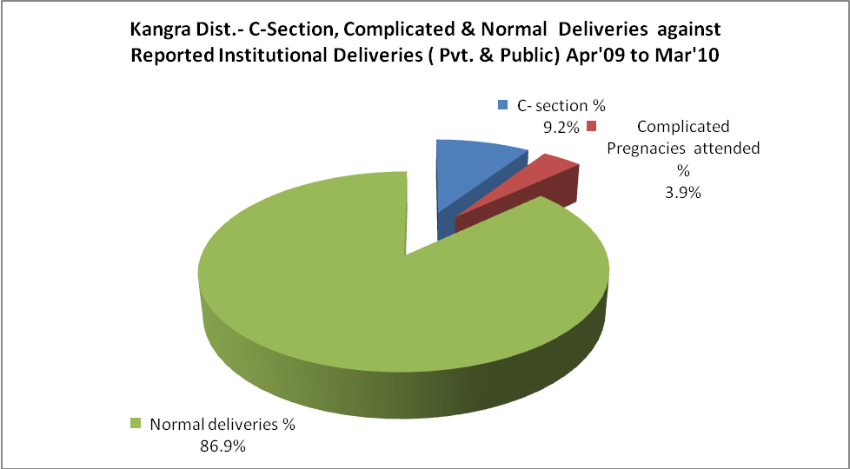
Kangra Dist.- Complicated Pregnancies & Deliveries Treated - Apr'09 to Mar'10
Reported Deliveries |  |  | Reported ANC Registration
18,272 |  |  | 31,124
Complicated Pregnancies attended | Complicated Pregnancies Rate | C - Section Deliveries | PNC Maternal Complications | Abortions | Still Births
298 | 1% | 702 | 3 | 715 | 205
Complicated Deliveries Treated with |  |  |  | No Of Eclampsia cases Treated | No Of severe anemia cases treated
IV Antibiotics | IV antihypertensive/Magsulph injection | IV Oxytocis | Blood Transfusion | No Of Eclampsia cases Treated | No Of severe anemia cases treated
480 | 35 | 1,143 | 13 | - | 666

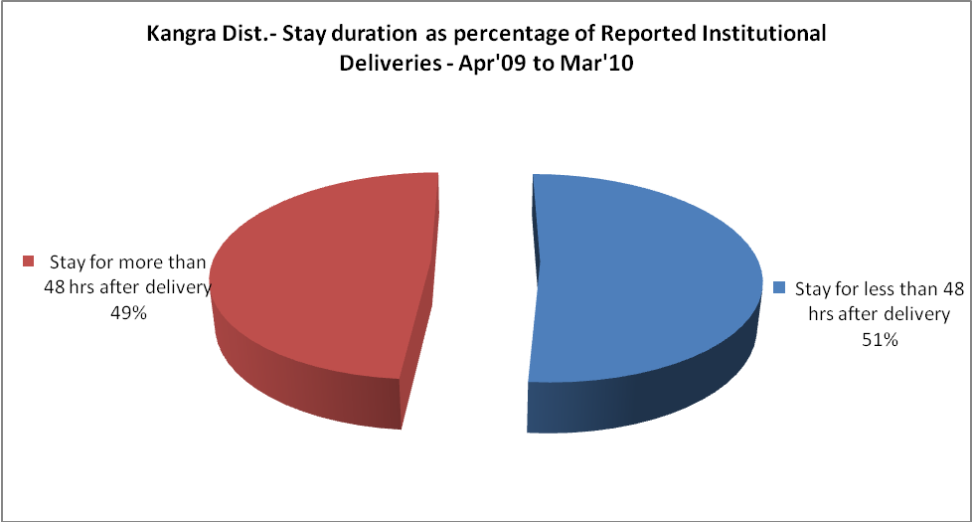

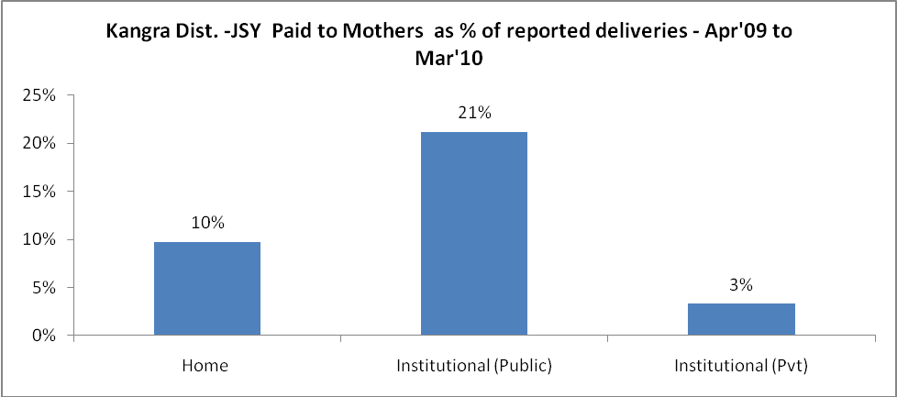
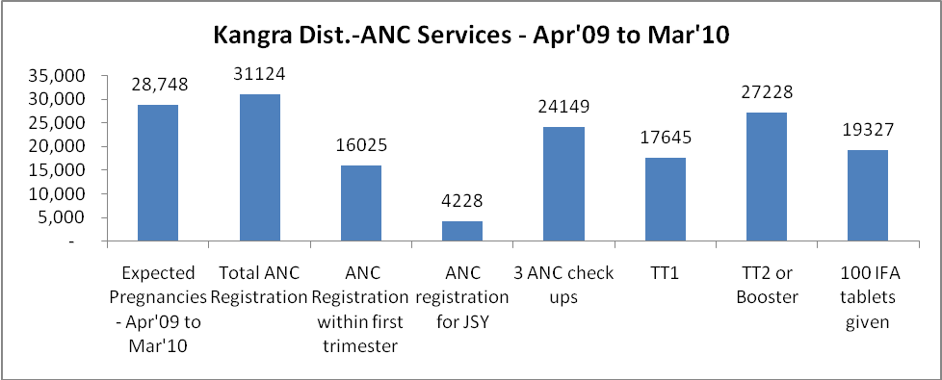

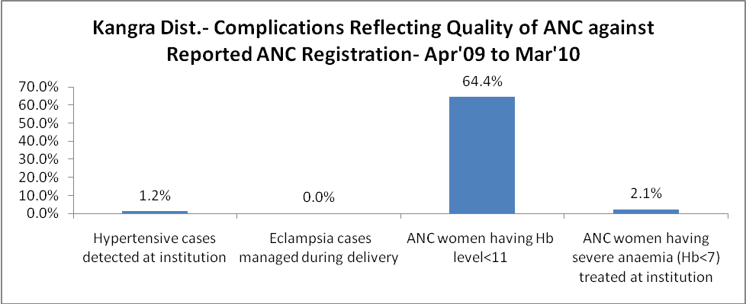

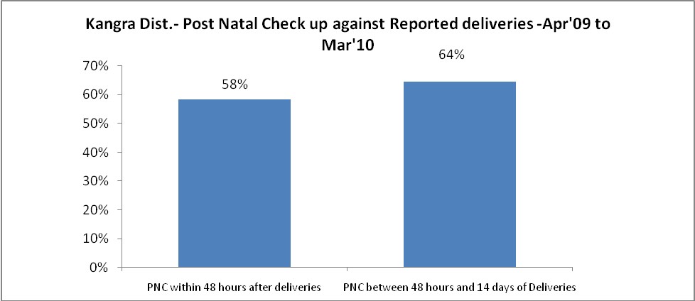

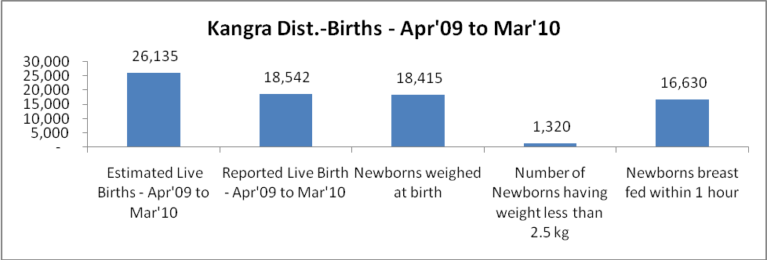

Kangra Dist. - Births - Apr'09 to Mar'10
Live Birth - Males | Live Birth - females | Live Birth - Total | Sex Ratio at birth | Still Birth | Abortion( Induced/Spontaneous
9,865 | 8,677 | 18,542 | 880 | 205 | 715

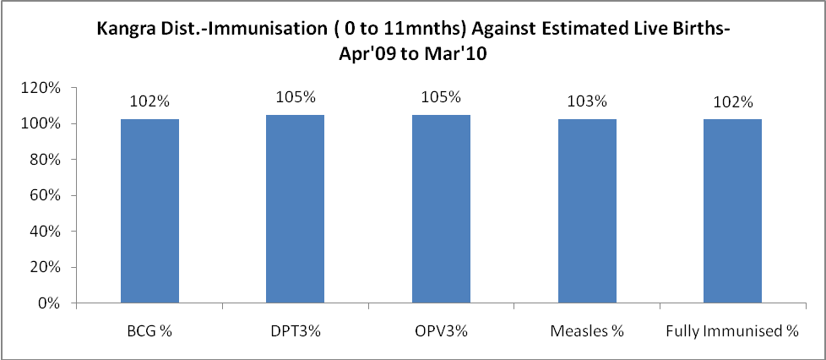
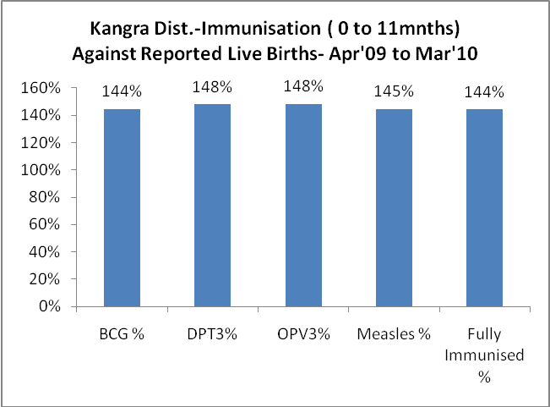
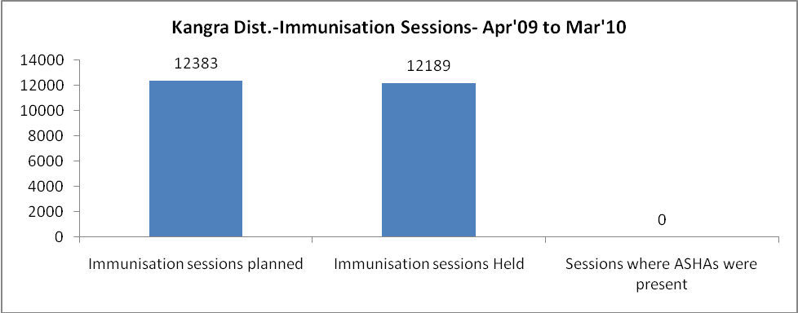

Kangra Dist.- Apr'09 to Mar'10
Total Abortions | Abortion Rate
1,127 | 3.9%

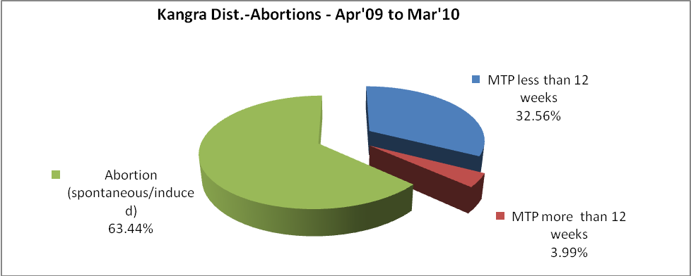
Kangra Dist.- Apr'09 to Mar'10
Total OPD | Total RTI/STI cases
1,272,577 | 7,164

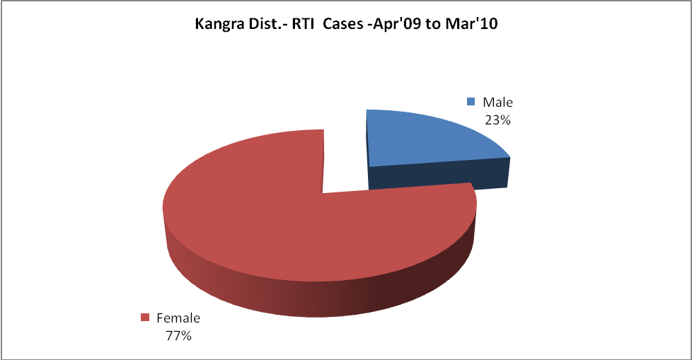

Kangra Dist.-Sterilizations - Apr'09 to Mar'10
 | Reported | %age of Reported Sterilization
Total Sterilization | 5,293 | -
NSV | 72 | 1%
Laproscopic | 4,900 | 93%
MiniLap | 164 | 3%
Post Partum | 157 | 3%
Male Sterilization | 72 | 1%
Female Sterilization | 5,221 | 99%

Kangra Dist.-FP Methods - Apr'09 to Mar'10
 | Reported | %age of All Reported FP Methods
Total Reported FP Method (All types) Users | 29,823 | -
Sterilizations | 5,293 | 18%
IUD | 3,249 | 11%
Condom Users | 16,543 | 55%
OCP Users | 4,738 | 16%
Limiting Methods | 5,293 | 18%
Spacing Methods | 24,530 | 82%

Kangra Dist.- Service Delivery - Apr'09 to Mar'10
Operation major (General and spinal anaesthesia) | Operation minor (No or local anaesthesia) | AYUSH | Dental Procedures | Adolescent counseling services | Total OPD | Total IPD
549 | 2,878 | 273 | 32,545 | 1,866 | 1,272,577 | 18,050
Operation major (General and spinal anaesthesia) as %ge of OPD | Operation minor (No or local anaesthesia)as %ge of OPD | AYUSH as %ge of OPD | Dental Procedures as %ge of OPD | Adolescent counseling services as %ge of OPD | IPD as percentage of OPD
0.0% | 0.2% | 0.0% | 2.6% | 0.1% | 1%

Kangra Dist.- Lab Services - Apr'09 to Mar'10
Total OPD | Total HB tested | Total HIV Tested | Total Population
1,272,577 | 45,562 | 5,347 | 1,476,526
HB test conducted as %age of OPD | HB<7gm as %age of HB tested | HIV test conducted as %age of OPD | HIV positive as %age of HIV tested | Blood Smear Examined as % of Population
3.6% | 6.2% | 0.4% | 2.6% | 2.6%

Kangra Dist.- Childhood Disease - Vaccine Preventable -Apr'09 to Mar'10
Diphtheria | Pertussis | Tetanus Neonatorum |  | Tetanus others | Polio | Measles
0 | 0 | 0 |  | 0 | 0 | 8
Kangra Dist.-Childhood Disease - Others - Apr'09 to Mar'10
Diarrhoea and dehydration | Malaria | Number admitted with Respiratory Infections
6,372 | 243 | 1,952
Kangra Dist.- Infant & Child Deaths - Apr'09 to Mar'10
Infant Deaths within 24 hrs of birth | Infant Deaths under 1 week | Infant Deaths under 1 month | Child Deaths under 1 year |  | Child Deaths under 5years | Total Deaths
21 | 41 | 36 | 66 |  | 85 | 249

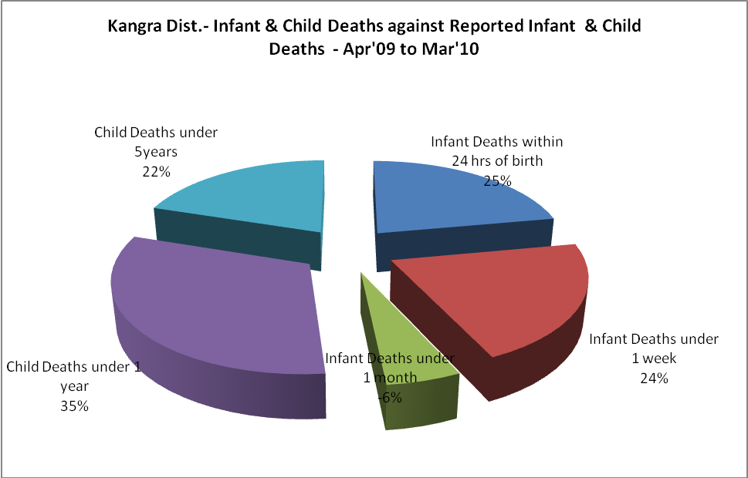

Kangra Dist.- Causes of Infant & Child Deaths - Apr'09 to Mar'10
Sepsis |  |  | Asphyxia |  |  | LBW
Up to 1 Weeks of Birth | Between 1 week & 4 weeks of birth | Total | Up to 1 Weeks of Birth | Between 1 week & 4 weeks of birth | Total | Up to 1 Weeks of Birth | Between 1 week & 4 weeks of birth | Total
0 | 0 | 0 | 3 | 2 | 5 | 7 | 2 | 9
Pneumonia |  |  | Diarrhoea |  |  | Fever related
Between 1 month and 11 months | Between 1 year & 5 years | Total | Between 1 month and 11 months | Between 1 year & 5 years | Total | Between 1 month and 11 months | Between 1 year & 5 years | Total
4 | 8 | 12 | 1 | 0 | 1 | 6 | 2 | 8
Others |  |  | Measles |  |  | Others
Up to 1 Weeks of Birth | Between 1 week & 4 weeks of birth | Total | Between 1 month and 11 months | Between 1 year & 5 years | Total | Between 1 month and 11 months | Between 1 year & 5 years | Total
10 | 12 | 22 | 0 | 0 | 0 | 19 | 9 | 28

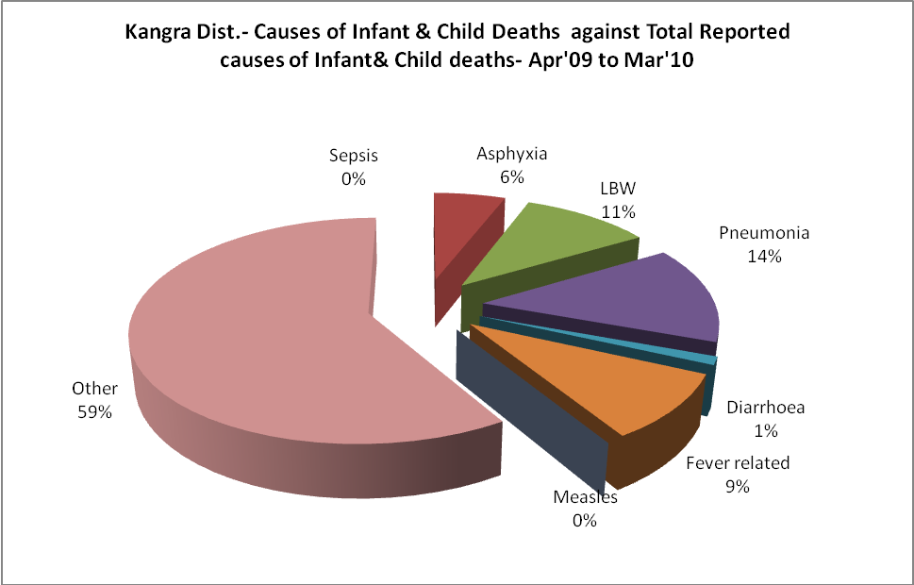

Kangra Dist.- Maternal Deaths & Causes - Apr'09 to Mar'10
Abortion |  |  | Obstructed/prolonged labour |  |  | Severe hypertension/fits
6-14 yrs | 15-55 yrs. | Total | 6-14 yrs | 15-55 yrs. | Total | 6-14 yrs | 15-55 yrs. | Total
0 | 0 | 0 | 0 | 0 | 0 | 0 | 0 | 0
Bleeding |  |  | High Fever |  |  | Other Causes
6-14 yrs | 15-55 yrs. | Total | 6-14 yrs | 15-55 yrs. | Total | 6-14 yrs | 15-55 yrs. | Total
0 | 0 | 0 | 0 | 0 | 0 | 0 | 9 | 9

Kangra Dist.-Causes of Deaths in 6 to 55yrs age group - Apr'09 to Mar'10
Diarrhoel Diseases |  |  |  | Tuberculosis |  |  |  | Respiratory Diseases( Other than TB)
6-14 yrs | 15-55 yrs. | Above 55yrs | Total | 6-14 yrs | 15-55 yrs. | Above 55yrs | Total | 6-14 yrs | 15-55 yrs. | Above 55yrs | Total
0 | 1 | 1 | 2 | 0 | 20 | 11 | 31 | 1 | 45 | 53 | 99
Malaria |  |  |  | Other fever Related |  |  |  | HIV/Aids
6-14 yrs | 15-55 yrs. | Above 55yrs | Total | 6-14 yrs | 15-55 yrs. | Above 55yrs | Total | 6-14 yrs | 15-55 yrs. | Above 55yrs | Total
0 | 0 | 0 | 0 | 1 | 16 | 11 | 28 | 1 | 5 | 1 | 7
Heart Disease/Hypertenion related |  |  |  | Neurological Disease including strokes |  |  |  | Trauma/Accidents/ Burn Cases
6-14 yrs | 15-55 yrs. | Above 55yrs | Total | 6-14 yrs | 15-55 yrs. | Above 55yrs | Total | 6-14 yrs | 15-55 yrs. | Above 55yrs | Total
0 | 141 | 176 | 317 | 0 | 23 | 11 | 34 | 9 | 107 | 32 | 148
Suicide |  |  |  | Animal Bites & Stings
6-14 yrs | 15-55 yrs. | Above 55yrs | Total | 6-14 yrs | 15-55 yrs. | Above 55yrs | Total
0 | 36 | 3 | 39 | 1 | 14 | 2 | 17

