NHSRC
Rajasthan-Karauli
Analysis: Apr 2009 – Mar 2010

Rajasthan- Karauli- Summary-Apr'09 to Mar'10
ANC
ANC Registration against Expected Pregnancies | 98% | TT1 given to Pregnant women against ANC Registration | 70%
3 ANC Checkups against ANC Registrations | 70% | 100 IFA Tablets given to Pregnant women against ANC Registration | 86%
Deliveries
Unreported Deliveries against Estimated Deliveries | 21.9% | HOME Deliveries( SBA& Non SBA) against Estimated Deliveries | 7.7%
Institutional Deliveries against Estimated Deliveries | 70.4% | HOME Deliveries( SBA& Non SBA) against Reported Deliveries | 9.8%
Institutional Deliveries against Reported Deliveries | 90.2% | C Section Deliveries against Institutional Deliveries( Pvt & Pub) | 1%
Births & Neonates Care
Live Births Reported against Estimated Live Births | 79% | New borns weighed against Reported Live Births | 89%
Still Births (Reported) | 379 | New borns weighed less than 2.5 kgs against newborns weighed | 11%
Sex Ratio at Birh | 875 | New borns breastfed within one hr of Birth against Reported live Births | 84%
Child Immunisation( 0 to 11 mnths)
BCG given against Expected Live Births | 92% | Measles given against Expected Live Births | 87%
OPV3 given against Expected Live Births | 91% | Fully Immunised Children against Expected Live Births | 86%
DPT3 given against Expected Live Births | 91%
Family Planning
Family Plannig Methods Users ( Sterilisations(Male &Female)+IUD+ Condom pieces/72 + OCP Cycles/13) | 68,969 | IUD Insertions against reported FP Methods | 15%
Sterilisation against reported FP Methods | 12% | Condom Users against reported FP Methods | 50%
 |  | OCP Users against reported FP Methods | 23%
Other Services
OPD | 790,745 | Major Operations | 174
IPD | 77,680 | Minor Operations | 2,964

Rajasthan- Karauli- Deliveries Apr'09 to Mar'10
Total Population | 1,438,300 | Expected Deliveries |  | 40,799
Home SBA | Home Non SBA | Institutional | Total Deliveries Reported | Unreported Deliveries
1,211 | 1,921 | 28,723 | 31,855 | 8,944
Home SBA % | Home Non SBA% | Institutional % | Total Deliveries Reported % | Unreported Deliveries %
3% | 5% | 70% | 78% | 22%
`

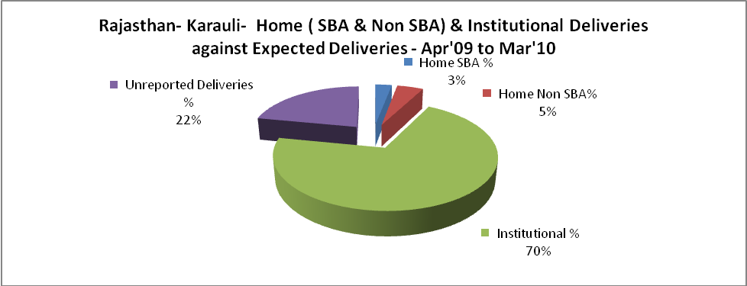

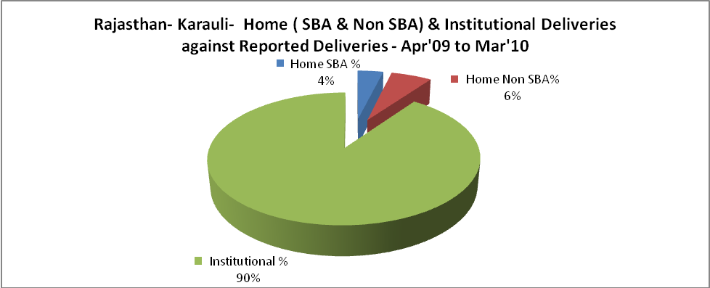

Rajasthan- Karauli- C sections & Complicated Deliveries Apr'09 to Mar'10
 | Institutional Deliveries (Public) | Institutional Deliveries (Pvt)
 | 24,447 | 4,276
C Section | 143 | 209
C Section% | 1% | 5%
Complicated Pregnacies attended | 665 | 213
Complicated Pregnacies attended % | 3% | 5%

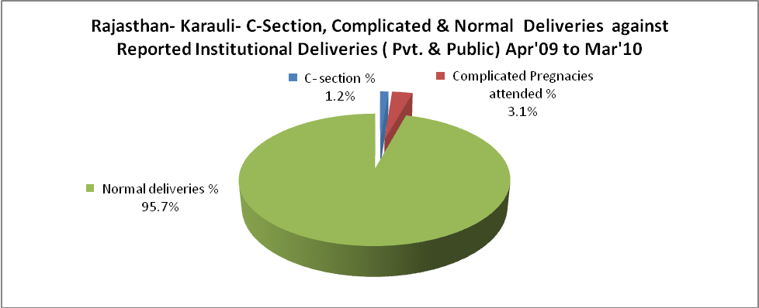

Rajasthan- Karauli- Complicated Pregnancies & Deliveries Treated - Apr'09 to Mar'10
Reported Deliveries |  |  | Reported ANC Reigtration
31,855 |  |  | 42,775
Complicated Pregnancies attended | Complicated Pregnancies Rate | C - Section Deliveries | PNC Maternal Complications | Abortions | Still Births
878 | 2% | 352 | 290 | 213 | 379
Complicated Deliveries Treated with |  |  |  | No Of Eclampsia cases Treated | No Of severe anemia cases treated
IV Antibiotics | IV antihypertensive/Magsulph injection | IV Oxytocis | Blood Transfusion | No Of Eclampsia cases Treated | No Of severe anemia cases treated
304 | 198 | 274 | 243 | 119 | 481

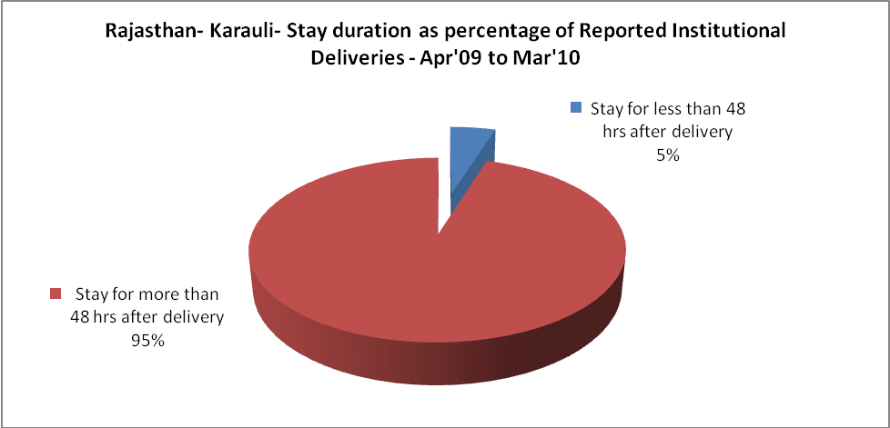

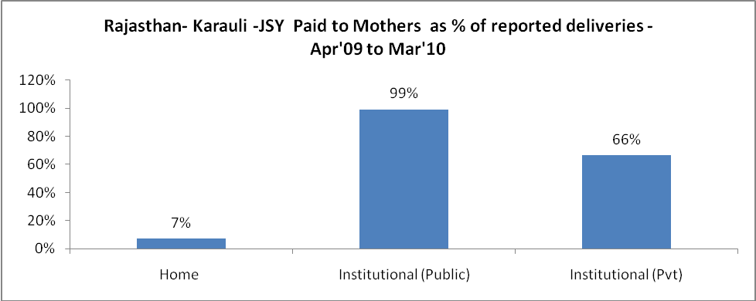

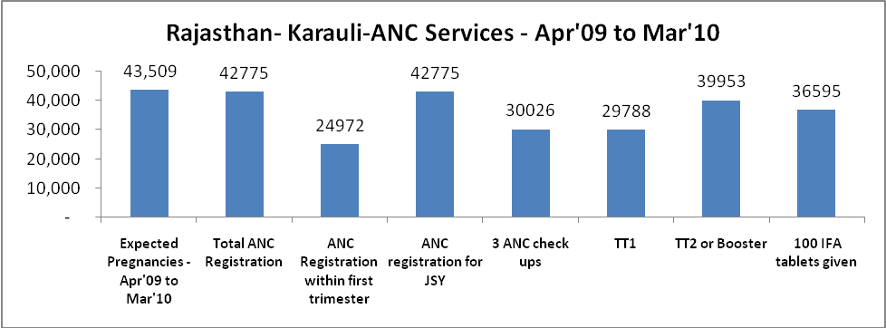
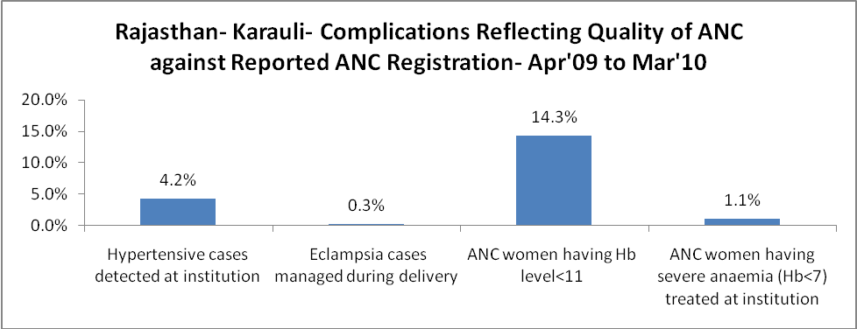
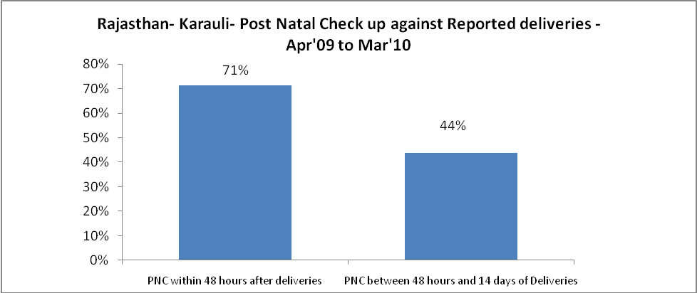

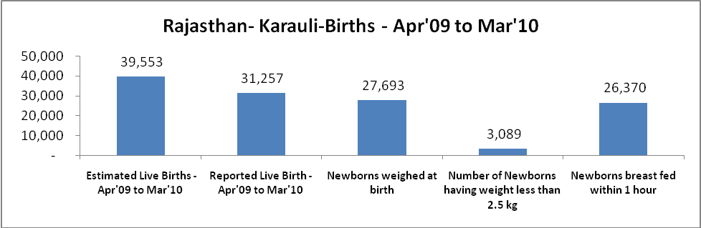

Rajasthan- Karauli - Births - Apr'09 to Mar'10
Live Birth - Males | Live Birth - females | Live Birth - Total | Sex Ratio at birth | Still Birth | Abortion( Induced/Spontaneous
16,674 | 14,583 | 31,257 | 875 | 379 | 213

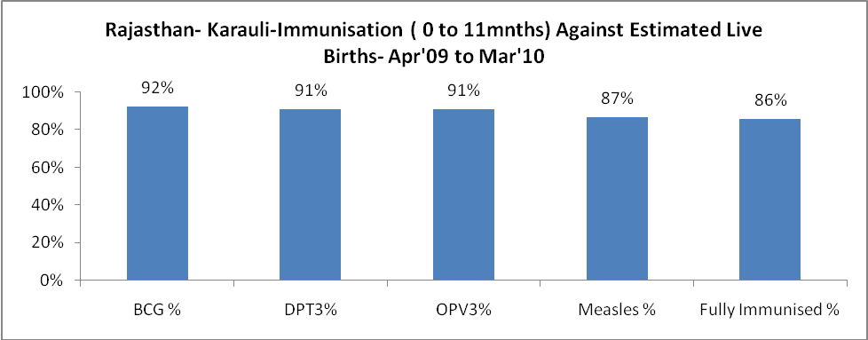

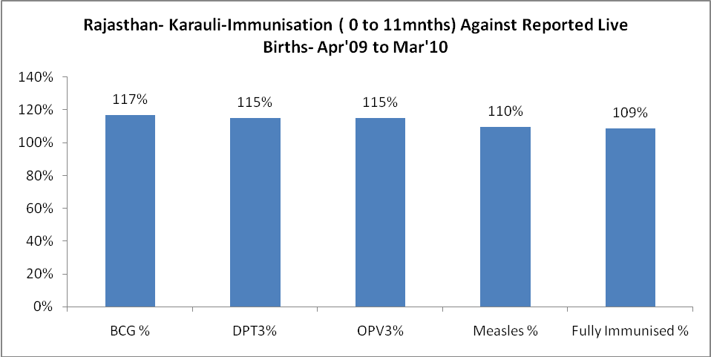

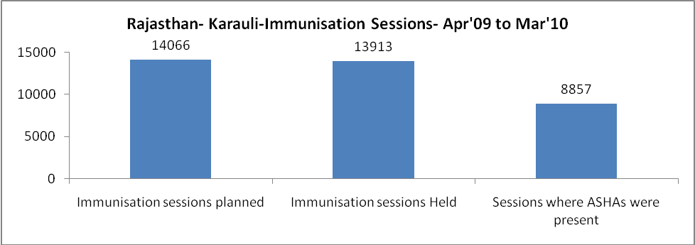

Rajasthan- Karauli- Apr'09 to Mar'10
Total Abortions | Abortion Rate
306 | 0.7%

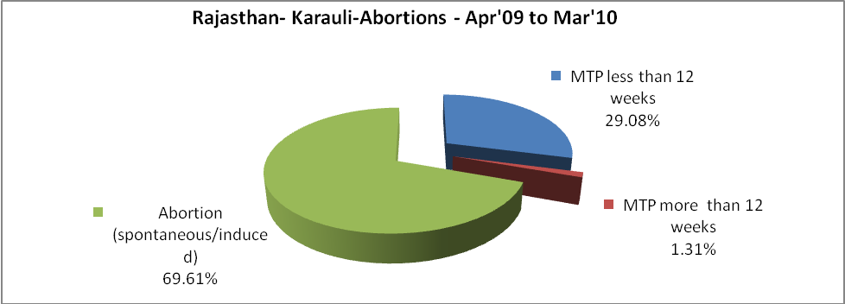

Rajasthan- Karauli- Apr'09 to Mar'10
Total OPD | Total RTI/STI cases
790,745 | 2,622

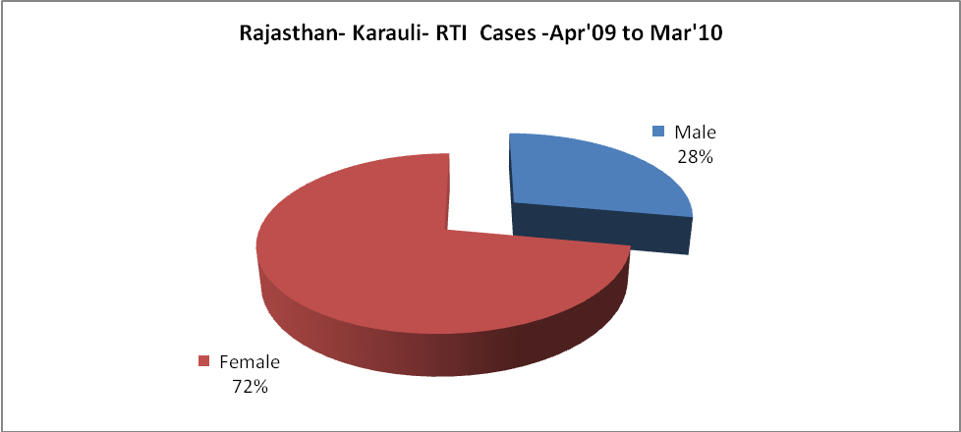

Rajasthan- Karauli-Sterilisations - Apr'09 to Mar'10
 | Reported | %age of Reported Sterilisation
Total Sterilisation | 8,094 | -
NSV | 108 | 1%
Laproscopic | 7,923 | 98%
MiniLap | - | 0%
Post Partum | 63 | 1%
Male Sterilisation | 108 | 1%
Female Sterilisation | 7,986 | 99%

Rajasthan- Karauli-FP Methods - Apr'09 to Mar'10
 | Reported | %age of All Reported FP Methods
Total Reported FP Methodd (All types) Users | 68,969 | -
Sterilisations | 8,094 | 12%
IUD | 10,662 | 15%
Condom Users | 34,198 | 50%
OCP Users | 16,016 | 23%
Limiting Methods | 8,094 | 12%
Spacing Methods | 60,875 | 88%

Rajasthan- Karauli- Service Delivery - Apr'09 to Mar'10
Operation major (General and spinal anaesthesia) | Operation minor (No or local anaesthesia) | AYUSH | Dental Procedures | Adolescent counselling services | Total OPD | Total IPD
174 | 2,964 | 33,449 | 4,366 | 1,738 | 790,745 | 77,680
Operation major (General and spinal anaesthesia) as %ge of OPD | Operation minor (No or local anaesthesia)as %ge of OPD | AYUSH as %ge of OPD | Dental Procedures as %ge of OPD | Adolescent counselling services as %ge of OPD | IPD as percentage of OPD
0.0% | 0.4% | 4.2% | 0.6% | 0.2% | 10%

Rajasthan- Karauli- Lab Services - Apr'09 to Mar'10
Total OPD | Total HB tested | Total HIV Tested | Total Population
790,745 | 12,321 | 4,978 | 1,438,300
HB test conducted as %age of OPD | HB<7gm as %age of HB tested | HIV test conducted as %age of OPD | HIV positive as %age of HIV tested | Blood Smear Examined as % of Population
1.6% | 5.9% | 0.6% | 0.2% | 10.6%

Rajasthan- Karauli- Childhood Disease - Vaccine Preventable -Apr'09 to Mar'10
Diphtheria | Pertussis | Tetanus Neonatorum | Tetanus others | Polio | Measles
1 | 0 | 5 | 5 | 0 | 5
Rajasthan- Karauli-Childhood Disease - Others - Apr'09 to Mar'10
Diarrhoea and dehydration | Malaria | Number admitted with Respiratory Infections
3,517 | 301 | 5,615

Rajasthan- Karauli- Infant & Child Deaths - Apr'09 to Mar'10
Infant Deaths within 24 hrs of birth | Infant Deaths between 24hrs & under 1 week | Infant Deaths between 1 week & under 1 month | Child Deaths between 1 month & under 1 year | Child Deaths between 1yr under 5years | Total Deaths
85 | 98 | 60 | 100 | 63 | 406

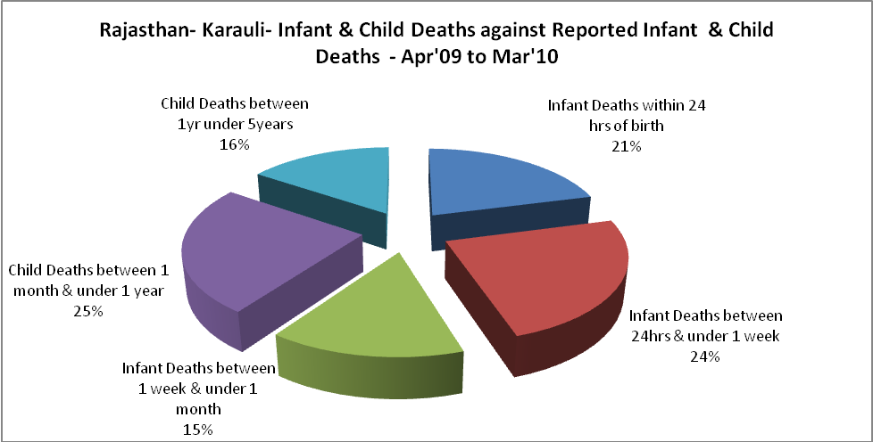

Rajasthan- Karauli- Causes of Infant & Child Deaths - Apr'09 to Mar'10
Sepsis |  |  | Asphyxia |  |  | LBW
Up to 1 Weeks of Birth | Between 1 week & 4 weeks of birth | Total | Up to 1 Weeks of Birth | Between 1 week & 4 weeks of birth | Total | Up to 1 Weeks of Birth | Between 1 week & 4 weeks of birth | Total
9 | 11 | 20 | 23 | 8 | 31 | 29 | 16 | 45
Pneumonia |  |  | Diarrhoea |  |  | Fever related
Between 1 month and 11 months | Between 1 year & 5 years | Total | Between 1 month and 11 months | Between 1 year & 5 years | Total | Between 1 month and 11 months | Between 1 year & 5 years | Total
23 | 12 | 35 | 6 | 2 | 8 | 5 | 3 | 8
Others |  |  | Measles |  |  | Others
Up to 1 Weeks of Birth | Between 1 week & 4 weeks of birth | Total | Between 1 month and 11 months | Between 1 year & 5 years | Total | Between 1 month and 11 months | Between 1 year & 5 years | Total
37 | 25 | 62 | 0 | 0 | 0 | 66 | 46 | 112

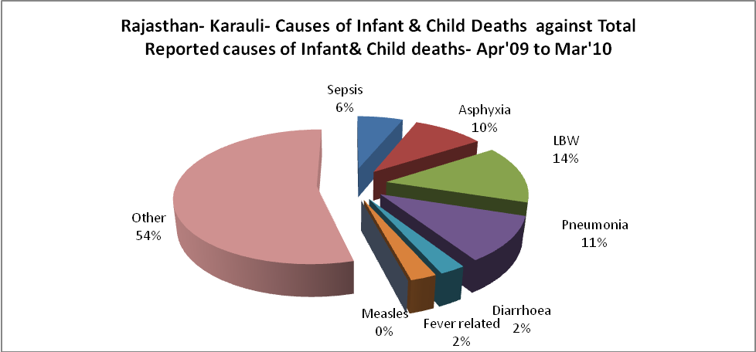

Rajasthan- Karauli- Maternal Deaths & Causes - Apr'09 to Mar'10
Abortion |  |  | Obstructed/prolonged labour |  |  | Severe hypertesnion/fits
6-14 yrs | 15-55 yrs. | Total | 6-14 yrs | 15-55 yrs. | Total | 6-14 yrs | 15-55 yrs. | Total
0 | 1 | 1 | 1 | 0 | 1 | 0 | 0 | 0
Bleeding |  |  | High Fever |  |  | Other Causes
6-14 yrs | 15-55 yrs. | Total | 6-14 yrs | 15-55 yrs. | Total | 6-14 yrs | 15-55 yrs. | Total
0 | 2 | 2 | 0 | 0 | 0 | 0 | 5 | 5

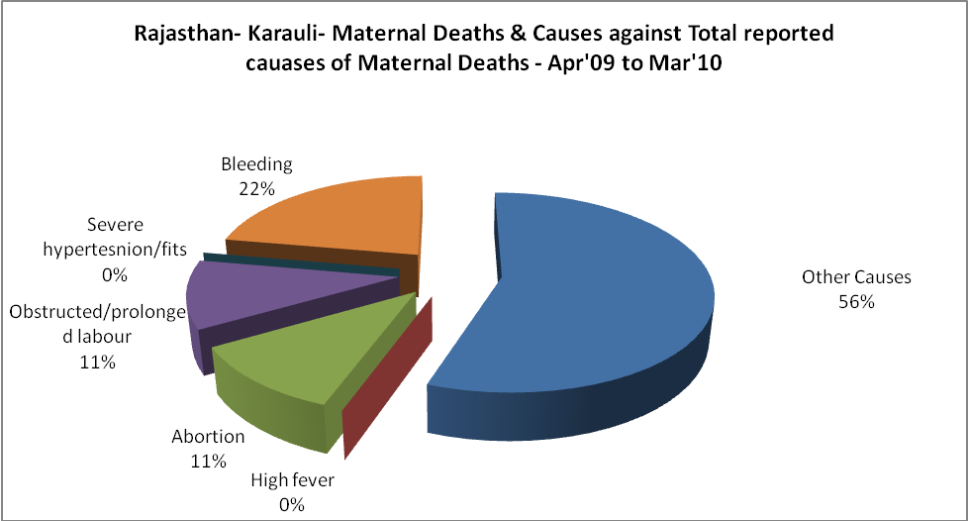

Rajasthan- Karauli-Causes of Deaths in 6 to 55yrs age group - Apr'09 to Mar'10
Diarrhoel Diseases |  |  |  | Tuberculosis |  |  |  | Respiratory Diseases( Other than TB)
6-14 yrs | 15-55 yrs. | Above 55yrs | Total | 6-14 yrs | 15-55 yrs. | Above 55yrs | Total | 6-14 yrs | 15-55 yrs. | Above 55yrs | Total
16 | 6 | 1 | 23 | 2 | 18 | 13 | 33 | 14 | 33 | 51 | 98
Malaria |  |  |  | Other fever Related |  |  |  | HIV/Aids
6-14 yrs | 15-55 yrs. | Above 55yrs | Total | 6-14 yrs | 15-55 yrs. | Above 55yrs | Total | 6-14 yrs | 15-55 yrs. | Above 55yrs | Total
0 | 0 | 1 | 1 | 3 | 5 | 6 | 14 | 0 | 0 | 0 | 0
Heart Disease/Hypertenion related |  |  |  | Neurological Disease including strokes |  |  |  | Trauma/Accidents/ Burn Cases
6-14 yrs | 15-55 yrs. | Above 55yrs | Total | 6-14 yrs | 15-55 yrs. | Above 55yrs | Total | 6-14 yrs | 15-55 yrs. | Above 55yrs | Total
3 | 15 | 16 | 34 | 24 | 6 | 5 | 35 | 3 | 23 | 10 | 36
Suicide |  |  |  | Animal Bites & Stings
6-14 yrs | 15-55 yrs. | Above 55yrs | Total | 6-14 yrs | 15-55 yrs. | Above 55yrs | Total
1 | 11 | 2 | 14 | 9 | 8 | 8 | 25

