NHSRC
Himachal Pradesh-Kinnaur District
Analysis 2009-10

7/22/2010

Kinnaur Dist.- Summary-Apr'09 to Mar'10
ANC
ANC Registration against Expected Pregnancies | 94% | TT1 given to Pregnant women against ANC Registration | 69%
3 ANC Check ups against ANC Registrations | 73% | 100 IFA Tablets given to Pregnant women against ANC Registration | 88%
Deliveries
Unreported Deliveries against Estimated Deliveries | 34.8% | HOME Deliveries( SBA& Non SBA) against Estimated Deliveries | 38.9%
Institutional Deliveries against Estimated Deliveries | 26.3% | HOME Deliveries( SBA& Non SBA) against Reported Deliveries | 59.7%
Institutional Deliveries against Reported Deliveries | 40.3% | C Section Deliveries against Institutional Deliveries( Pvt & Pub) | 14%
Births & Neonates Care
Live Births Reported against Estimated Live Births | 67% | New borns weighed against Reported Live Births | 90%
Still Births (Reported) | 8 | New borns weighed less than 2.5 kgs against newborns weighed | 5%
Sex Ratio at Birth | 1,040 | New borns breastfed within one hr of Birth against Reported live Births | 54%
Child Immunization( 0 to 11 months)
BCG given against Expected Live Births | 93% | Measles given against Expected Live Births | 99%
OPV3 given against Expected Live Births | 106% | Fully Immunized Children against Expected Live Births | 99%
DPT3 given against Expected Live Births | 106%
Family Planning
Family Planning Methods Users ( Sterilizations’(Male &Female)+IUD+ Condom pieces/72 + OCP Cycles/13) | 2,658 | IUD Insertions against reported FP Methods | 5%
Sterilization against reported FP Methods | 10% | Condom Users against reported FP Methods | 55%
 |  | OCP Users against reported FP Methods | 29%
Other Services
OPD | 107,343 | Major Operations | 341
IPD | 3,870 | Minor Operations | 423

Kinnaur Dist.- Deliveries Apr'09 to Mar'10
Total Population | 86,378 | Expected Deliveries |  | 1,563
Home SBA | Home Non SBA | Institutional | Total Deliveries Reported | Unreported Deliveries
326 | 282 | 411 | 1,019 | 544
Home SBA % | Home Non SBA% | Institutional % | Total Deliveries Reported % | Unreported Deliveries %
21% | 18% | 26% | 65% | 35%

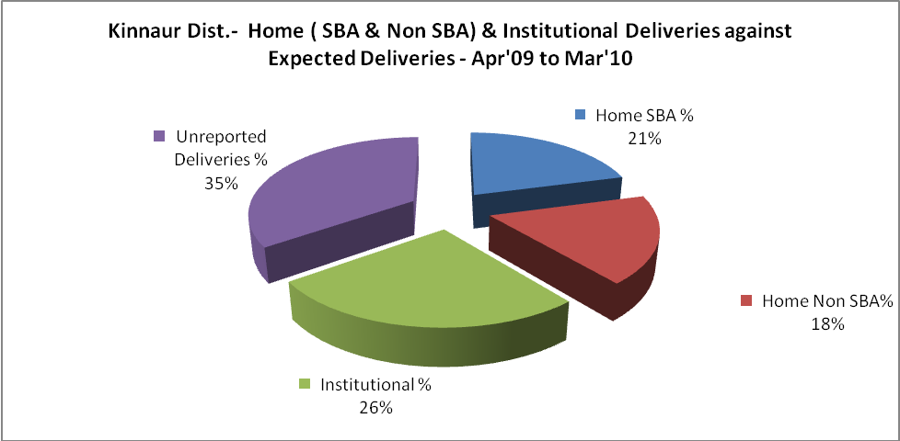
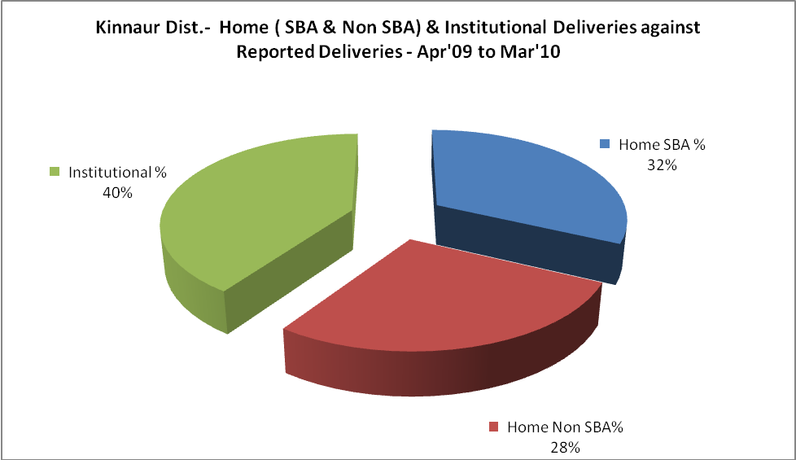

Kinnaur Dist.- C sections & Complicated Deliveries Apr'09 to Mar'10
 | Institutional Deliveries (Public) | Institutional Deliveries (Pvt)
 | 375 | 36
C Section | 10 | 4
C Section% | 3% | 11%
Complicated Pregnancies attended | 2 | -
Complicated Pregnancies attended % | 1% | 0%

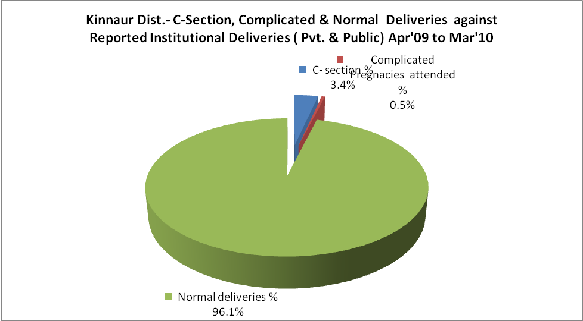

Kinnaur Dist.- Complicated Pregnancies & Deliveries Treated - Apr'09 to Mar'10
Reported Deliveries |  |  | Reported ANC Registration
1,019 |  |  | 1,576
Complicated Pregnancies attended | Complicated Pregnancies Rate | C - Section Deliveries | PNC Maternal Complications | Abortions | Still Births
2 | 0% | 14 | 3 | 4 | 8
Complicated Deliveries Treated with |  |  |  | No Of Eclampsia cases Treated | No Of severe anemia cases treated
IV Antibiotics | IV antihypertensive/Magsulph injection | IV Oxytocis | Blood Transfusion | No Of Eclampsia cases Treated | No Of severe anemia cases treated
- | - | 2 | - | - | 11

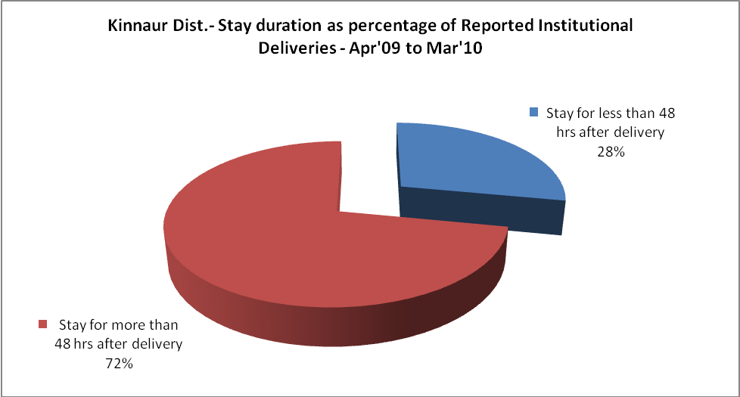

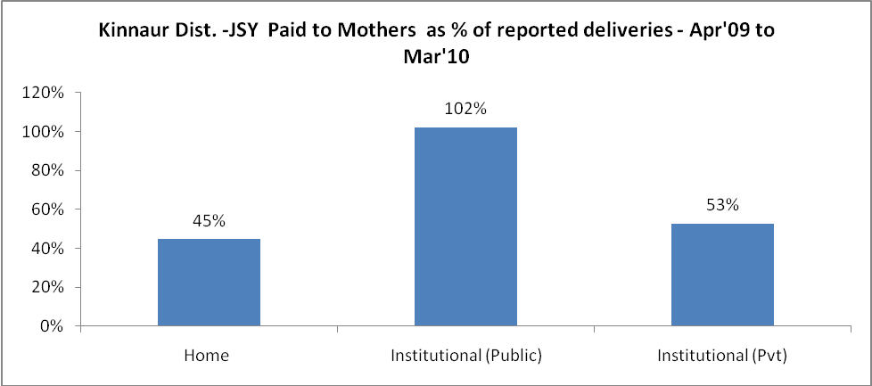
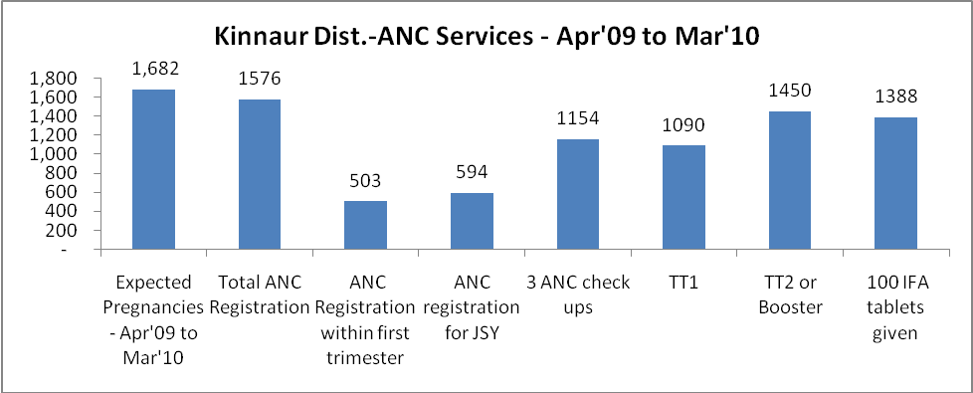

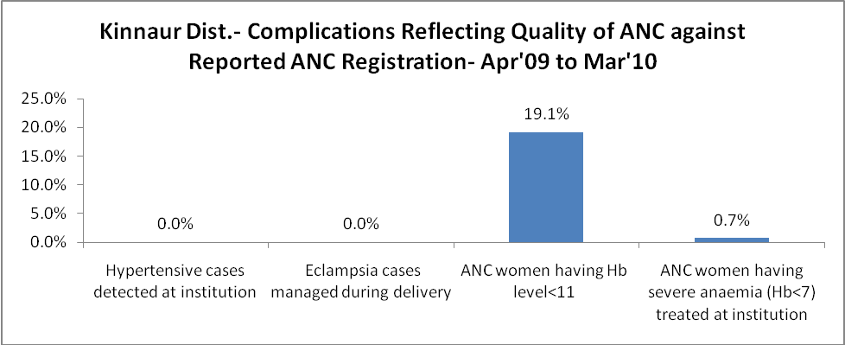

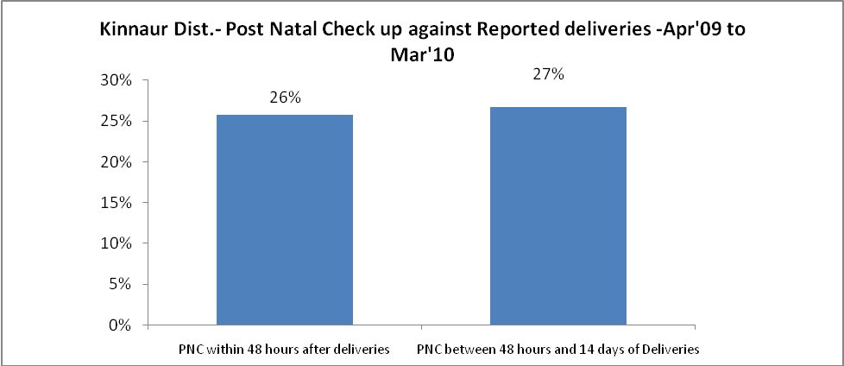

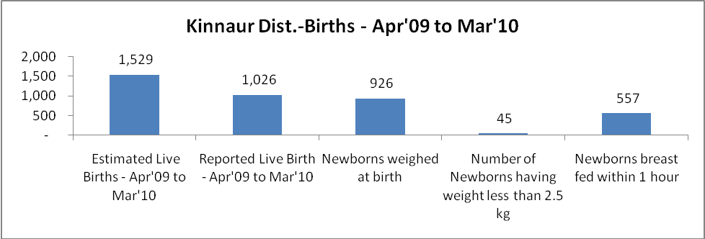

Kinnaur Dist. - Births - Apr'09 to Mar'10
Live Birth - Males | Live Birth - females | Live Birth - Total | Sex Ratio at birth | Still Birth | Abortion( Induced/Spontaneous
503 | 523 | 1,026 | 1,040 | 8 | 4

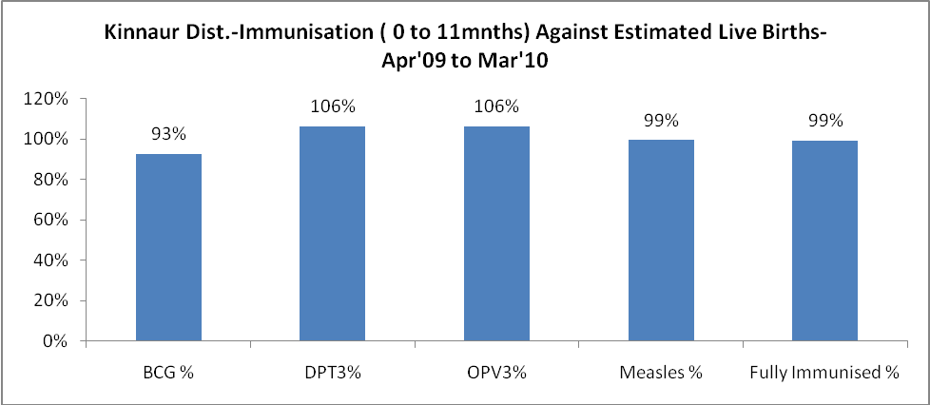
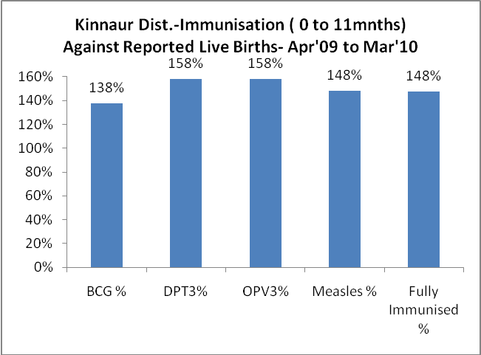
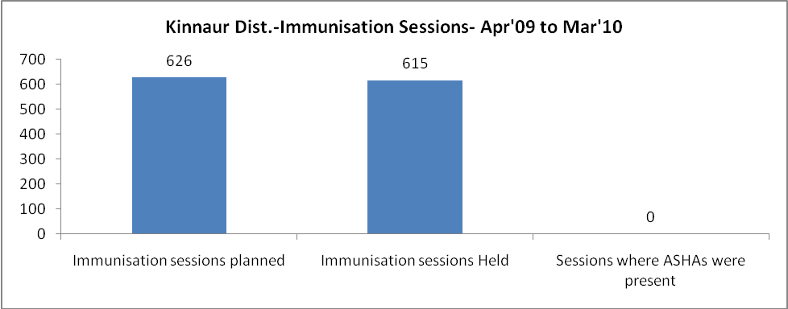
Kinnaur Dist.- Apr'09 to Mar'10
Total Abortions | Abortion Rate
5 | 0.3%

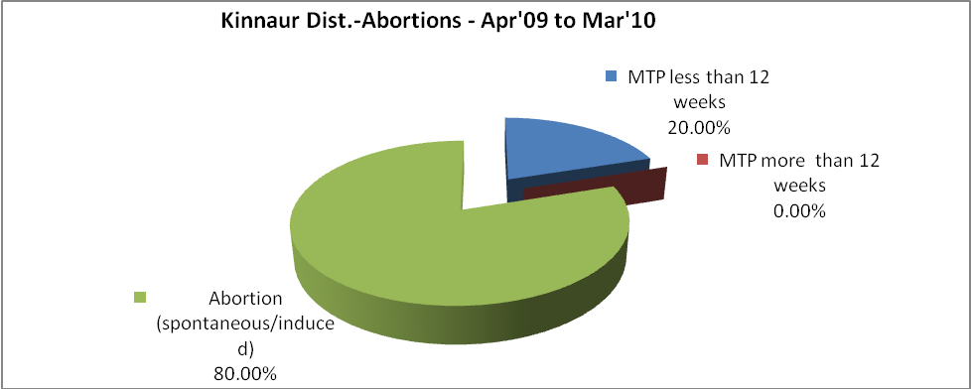
Kinnaur Dist.- Apr'09 to Mar'10
Total OPD | Total RTI/STI cases
107,343 | 1,317

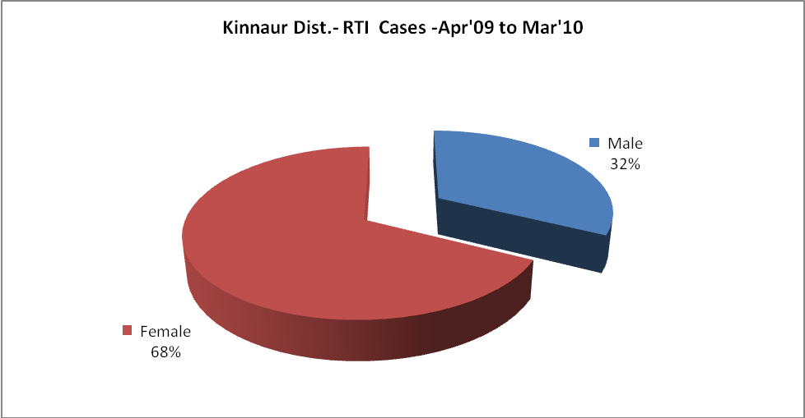
Kinnaur Dist.-Sterilizations - Apr'09 to Mar'10
 | Reported | %age of Reported Sterilization
Total Sterilization | 274 | -
NSV | 152 | 55%
Laproscopic | 119 | 43%
MiniLap | 3 | 1%
Post Partum | - | 0%
Male Sterilization | 152 | 55%
Female Sterilization | 122 | 45%

Kinnaur Dist.-FP Methods - Apr'09 to Mar'10
 | Reported | %age of All Reported FP Methods
Total Reported FP Method (All types) Users | 2,658 | -
Sterilizations | 274 | 10%
IUD | 146 | 5%
Condom Users | 1,469 | 55%
OCP Users | 770 | 29%
Limiting Methods | 274 | 10%
Spacing Methods | 2,384 | 90%

Kinnaur Dist.- Service Delivery - Apr'09 to Mar'10
Operation major (General and spinal anaesthesia) | Operation minor (No or local anaesthesia) | AYUSH | Dental Procedures | Adolescent counseling services | Total OPD | Total IPD
341 | 423 | - | 2,324 | 10 | 107,343 | 3,870
Operation major (General and spinal anaesthesia) as %ge of OPD | Operation minor (No or local anaesthesia)as %ge of OPD | AYUSH as %ge of OPD | Dental Procedures as %ge of OPD | Adolescent counseling services as %ge of OPD | IPD as percentage of OPD
0.3% | 0.4% | 0.0% | 2.2% | 0.0% | 4%

Kinnaur Dist.- Lab Services - Apr'09 to Mar'10
Total OPD | Total HB tested | Total HIV Tested | Total Population
107,343 | 4,526 | 855 | 86,378
HB test conducted as %age of OPD | HB<7gm as %age of HB tested | HIV test conducted as %age of OPD | HIV positive as %age of HIV tested | Blood Smear Examined as % of Population
4.2% | 1.7% | 0.8% | 0.0% | 0.0%

Kinnaur Dist.- Childhood Disease - Vaccine Preventable -Apr'09 to Mar'10
Diphtheria | Pertussis | Tetanus Neonatorum | Tetanus others | Polio | Measles
5 | 0 | 0 | 0 | 0 | 0
Kinnaur Dist.-Childhood Disease - Others - Apr'09 to Mar'10
Diarrhoea and dehydration | Malaria | Number admitted with Respiratory Infections
208 | 2 | 30
Kinnaur Dist.- Infant & Child Deaths - Apr'09 to Mar'10
Infant Deaths within 24 hrs of birth | Infant Deaths under 1 week | Infant Deaths under 1 month | Child Deaths under 1 year | Child Deaths under 5years | Total Deaths
0 | 1 | 4 | 6 | 7 | 18

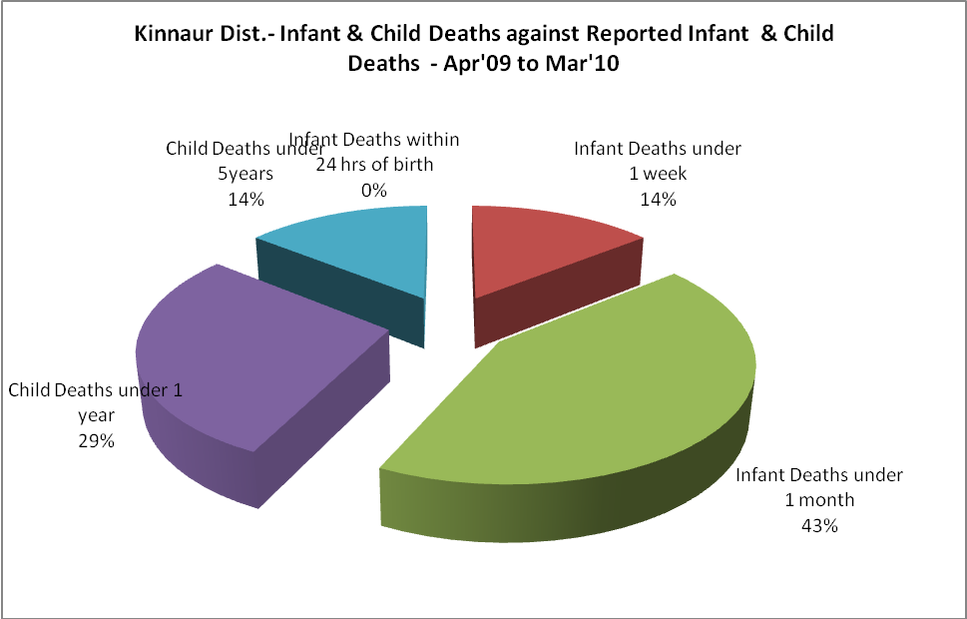

Kinnaur Dist.- Causes of Infant & Child Deaths - Apr'09 to Mar'10
Sepsis |  |  | Asphyxia |  |  | LBW
Up to 1 Weeks of Birth | Between 1 week & 4 weeks of birth | Total | Up to 1 Weeks of Birth | Between 1 week & 4 weeks of birth | Total | Up to 1 Weeks of Birth | Between 1 week & 4 weeks of birth | Total
0 | 0 | 0 | 0 | 0 | 0 | 1 | 2 | 3
Pneumonia |  |  | Diarrhoea |  |  | Fever related
Between 1 month and 11 months | Between 1 year & 5 years | Total | Between 1 month and 11 months | Between 1 year & 5 years | Total | Between 1 month and 11 months | Between 1 year & 5 years | Total
0 | 0 | 0 | 0 | 0 | 0 | 0 | 0 | 0
Others |  |  | Measles |  |  | Others
Up to 1 Weeks of Birth | Between 1 week & 4 weeks of birth | Total | Between 1 month and 11 months | Between 1 year & 5 years | Total | Between 1 month and 11 months | Between 1 year & 5 years | Total
0 | 1 | 1 | 0 | 0 | 0 | 2 | 1 | 3

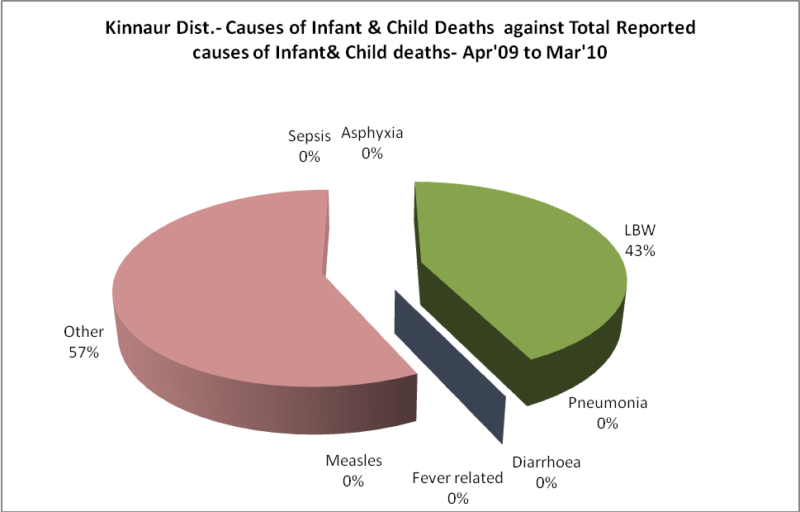

Kinnaur Dist.- Maternal Deaths & Causes - Apr'09 to Mar'10
Abortion |  |  | Obstructed/prolonged labour |  |  | Severe hypertension/fits
6-14 yrs | 15-55 yrs. | Total | 6-14 yrs | 15-55 yrs. | Total | 6-14 yrs | 15-55 yrs. | Total
0 | 0 | 0 | 0 | 0 | 0 | 0 | 0 | 0
Bleeding |  |  | High Fever |  |  | Other Causes
6-14 yrs | 15-55 yrs. | Total | 6-14 yrs | 15-55 yrs. | Total | 6-14 yrs | 15-55 yrs. | Total
0 | 0 | 0 | 0 | 0 | 0 | 0 | 15 | 15

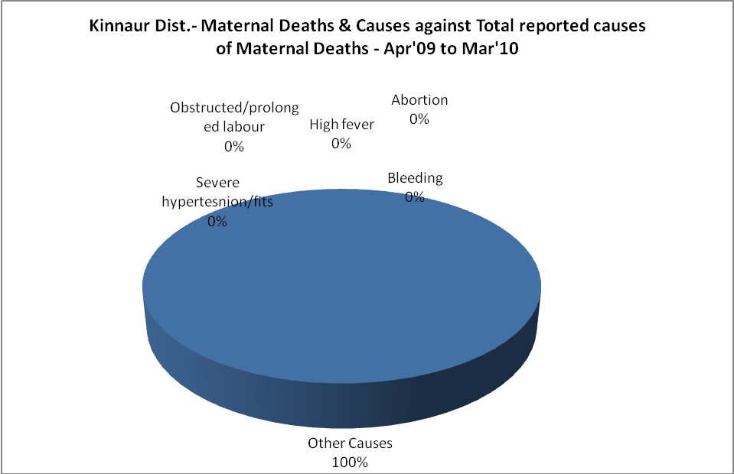

Kinnaur Dist.-Causes of Deaths in 6 to 55yrs age group - Apr'09 to Mar'10
Diarrhoel Diseases |  |  |  | Tuberculosis |  |  |  | Respiratory Diseases( Other than TB)
6-14 yrs | 15-55 yrs. | Above 55yrs | Total | 6-14 yrs | 15-55 yrs. | Above 55yrs | Total | 6-14 yrs | 15-55 yrs. | Above 55yrs | Total
0 | 0 | 0 | 0 | 0 | 0 | 0 | 0 | 0 | 0 | 2 | 2
Malaria |  |  |  | Other fever Related |  |  |  | HIV/Aids
6-14 yrs | 15-55 yrs. | Above 55yrs | Total | 6-14 yrs | 15-55 yrs. | Above 55yrs | Total | 6-14 yrs | 15-55 yrs. | Above 55yrs | Total
0 | 0 | 0 | 0 | 0 | 0 | 0 | 0 | 0 | 0 | 0 | 0
Heart Disease/Hypertension related |  |  |  | Neurological Disease including strokes |  |  |  | Trauma/Accidents/ Burn Cases
6-14 yrs | 15-55 yrs. | Above 55yrs | Total | 6-14 yrs | 15-55 yrs. | Above 55yrs | Total | 6-14 yrs | 15-55 yrs. | Above 55yrs | Total
0 | 2 | 3 | 5 | 0 | 1 | 0 | 1 | 0 | 3 | 1 | 4
Suicide |  |  |  | Animal Bites & Stings
6-14 yrs | 15-55 yrs. | Above 55yrs | Total | 6-14 yrs | 15-55 yrs. | Above 55yrs | Total
0 | 2 | 1 | 3 | 0 | 0 | 0 | 0

