NHSRC
Rajasthan-Kota
Analysis: Apr 2009 – Mar 2010

Rajasthan- Kota- Summary-Apr'09 to Mar'10
ANC
ANC Registration against Expected Pregnancies | 95% | TT1 given to Pregnant women against ANC Registration | 61%
3 ANC Check ups against ANC Registrations | 83% | 100 IFA Tablets given to Pregnant women against ANC Registration | 65%
Deliveries
Unreported Deliveries against Estimated Deliveries | 36.2% | HOME Deliveries( SBA& Non SBA) against Estimated Deliveries | 5.5%
Institutional Deliveries against Estimated Deliveries | 58.3% | HOME Deliveries( SBA& Non SBA) against Reported Deliveries | 8.6%
Institutional Deliveries against Reported Deliveries | 91.4% | C Section Deliveries against Institutional Deliveries( Pvt & Pub) | 10%
Births & Neonates Care
Live Births Reported against Estimated Live Births | 64% | New borns weighed against Reported Live Births | 71%
Still Births (Reported) | 625 | New borns weighed less than 2.5 kgs against newborns weighed | 18%
Sex Ratio at Birth | 897 | New borns breastfed within one hr of Birth against Reported live Births | 63%
Child Immunisation( 0 to 11 months)
BCG given against Expected Live Births | 83% | Measles given against Expected Live Births | 79%
OPV3 given against Expected Live Births | 80% | Fully Immunised Children against Expected Live Births | 74%
DPT3 given against Expected Live Births | 80%
Family Planning
Family Plannig Methods Users ( Sterilisations(Male &Female)+IUD+ Condom pieces/72 + OCP Cycles/13) | 101,731 | IUD Insertions against reported FP Methods | 10%
Sterilisation against reported FP Methods | 7% | Condom Users against reported FP Methods | 60%
 |  | OCP Users against reported FP Methods | 24%
Other Services
OPD | 826,979 | Major Operations | 1,401
IPD | 72,822 | Minor Operations | 1,132

Rajasthan- Kota- Deliveries Apr'09 to Mar'10
Total Population | 1,875,300 | Expected Deliveries |  | 53,195
Home SBA | Home Non SBA | Institutional | Total Deliveries Reported | Unreported Deliveries
2,326 | 609 | 31,003 | 33,938 | 19,257
Home SBA % | Home Non SBA% | Institutional % | Total Deliveries Reported % | Unreported Deliveries %
4% | 1% | 58% | 64% | 36%
`

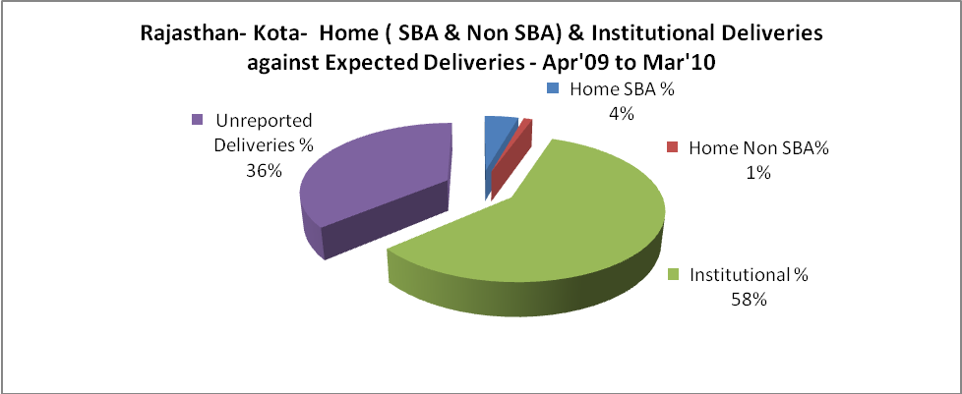

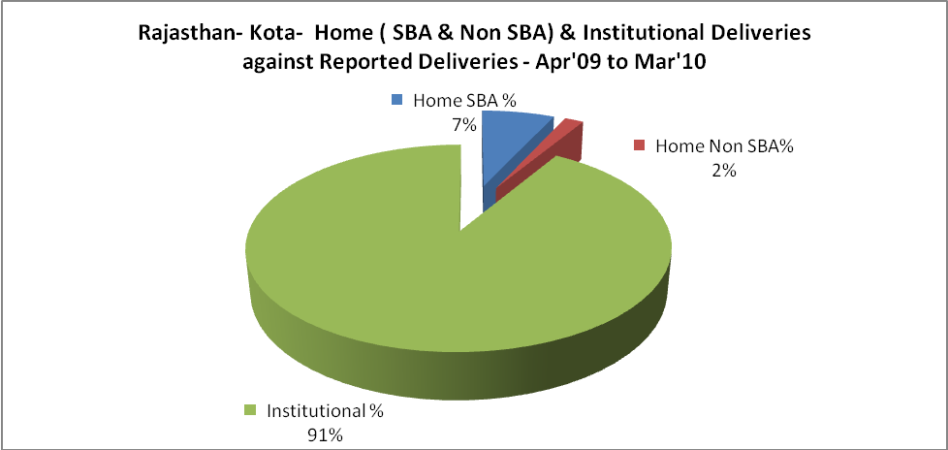

Rajasthan- Kota- C sections & Complicated Deliveries Apr'09 to Mar'10
 | Institutional Deliveries (Public) | Institutional Deliveries (Pvt)
 | 20,572 | 10,431
C Section | 1,328 | 1,732
C Section% | 6% | 17%
Complicated Pregnacies attended | 485 | 156
Complicated Pregnacies attended % | 2% | 1%

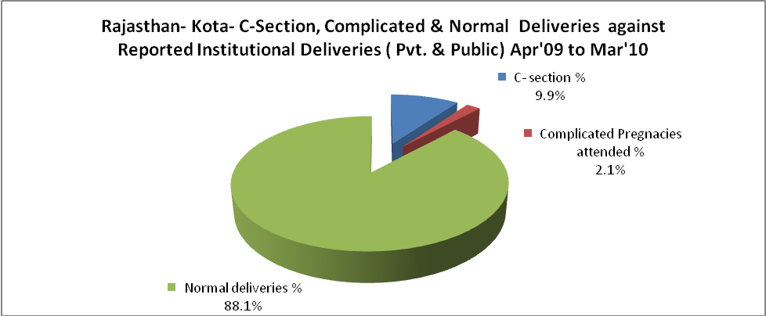

Rajasthan- Kota- Complicated Pregnancies & Deliveries Treated - Apr'09 to Mar'10
Reported Deliveries |  |  | Reported ANC Reigtration
33,938 |  |  | 54,077
Complicated Pregnancies attended | Complicated Pregnancies Rate | C - Section Deliveries | PNC Maternal Complications | Abortions | Still Births
641 | 1% | 3,060 | 333 | 573 | 625
Complicated Deliveries Treated with |  |  |  | No Of Eclampsia cases Treated | No Of severe anemia cases treated
IV Antibiotics | IV antihypertensive/Magsulph injection | IV Oxytocis | Blood Transfusion | No Of Eclampsia cases Treated | No Of severe anemia cases treated
2,091 | 354 | 1,366 | 317 | 248 | 544

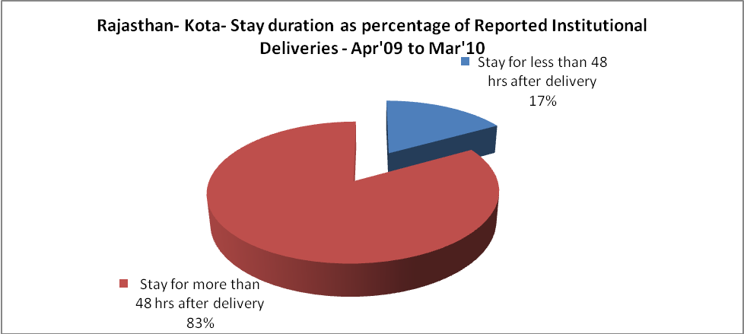

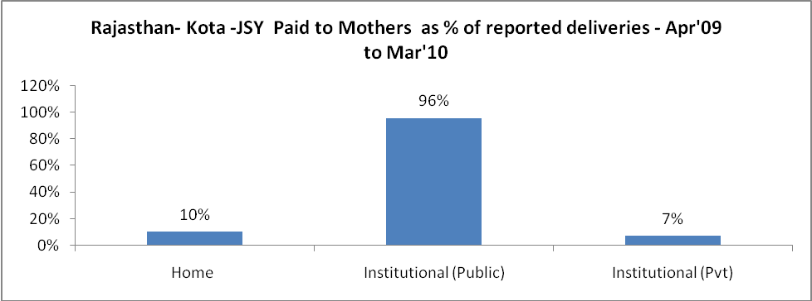

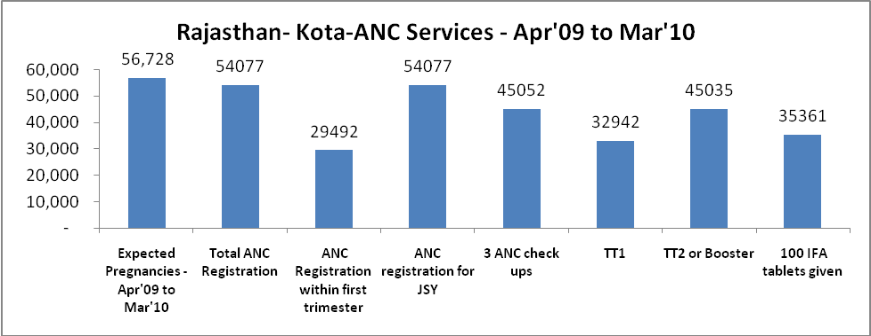

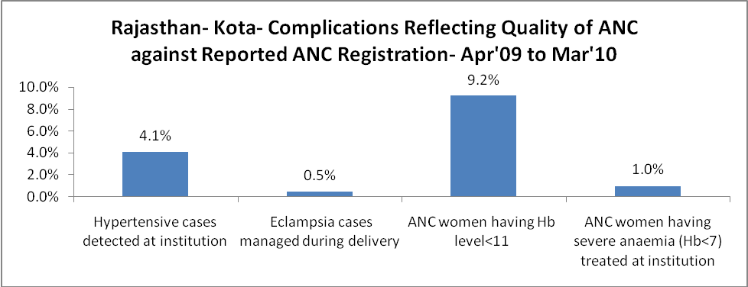

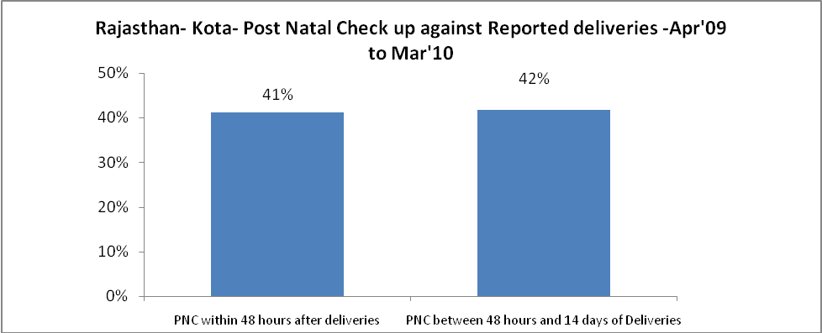
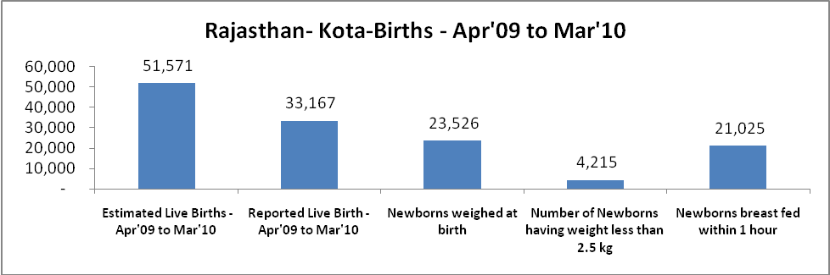

Rajasthan- Kota - Births - Apr'09 to Mar'10
Live Birth - Males | Live Birth - females | Live Birth - Total | Sex Ratio at birth | Still Birth | Abortion( Induced/Spontaneous
17,488 | 15,679 | 33,167 | 897 | 625 | 573

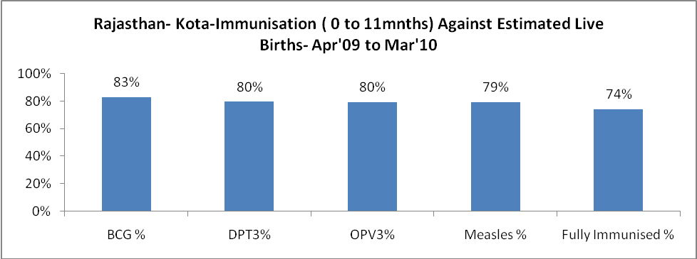

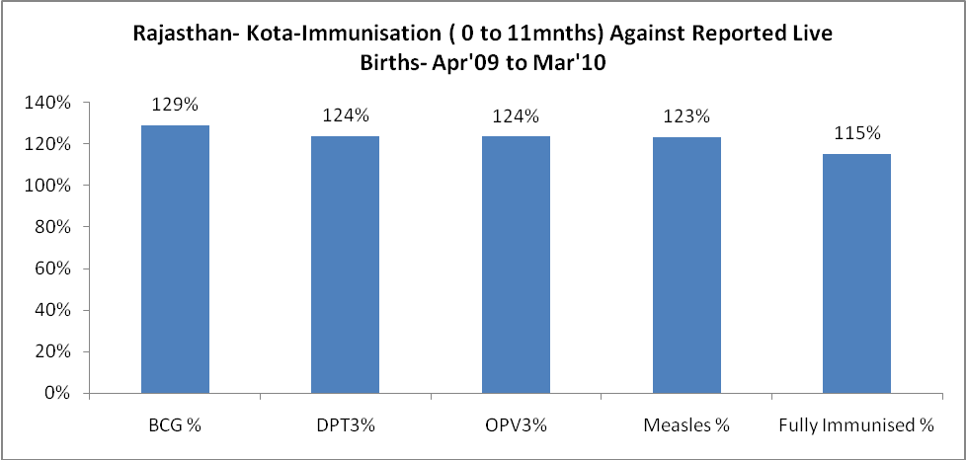

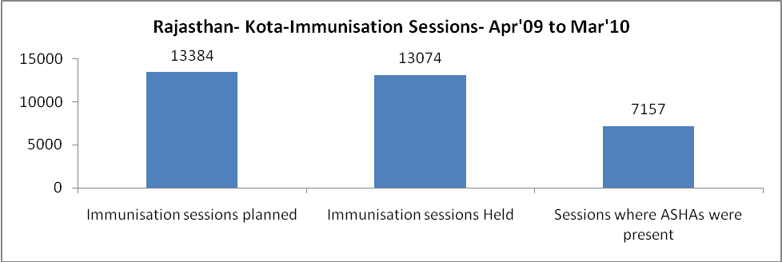

Rajasthan- Kota- Apr'09 to Mar'10
Total Abortions | Abortion Rate
788 | 1.4%

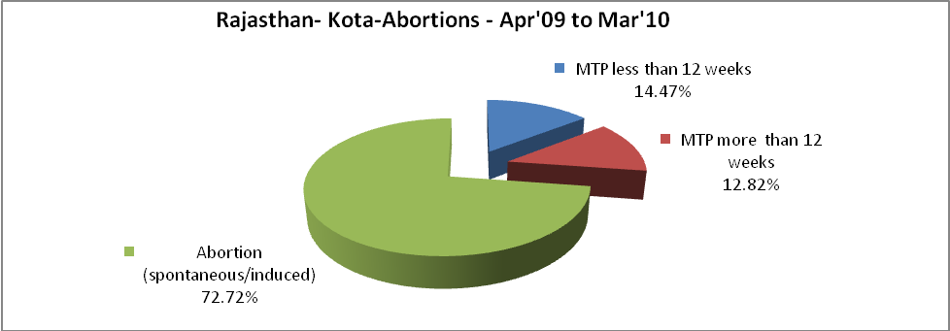

Rajasthan- Kota- Apr'09 to Mar'10
Total OPD | Total RTI/STI cases
826,979 | 5,219

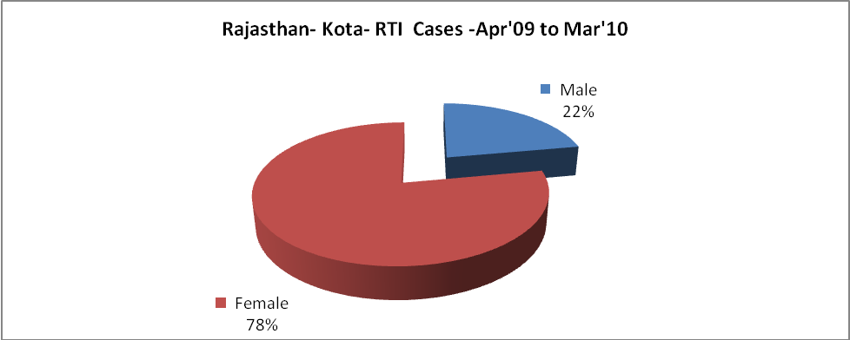

Rajasthan- Kota-Sterilisations - Apr'09 to Mar'10
 | Reported | %age of Reported Sterilisation
Total Sterilisation | 6,870 | -
NSV | 306 | 4%
Laproscopic | 5,985 | 87%
MiniLap | 6 | 0%
Post Partum | 573 | 8%
Male Sterilisation | 306 | 4%
Female Sterilisation | 6,564 | 96%

Rajasthan- Kota-FP Methods - Apr'09 to Mar'10
 | Reported | %age of All Reported FP Methods
Total Reported FP Methodd (All types) Users | 101,731 | -
Sterilisations | 6,870 | 7%
IUD | 9,870 | 10%
Condom Users | 60,850 | 60%
OCP Users | 24,141 | 24%
Limiting Methods | 6,870 | 7%
Spacing Methods | 94,861 | 93%

Rajasthan- Kota- Service Delivery - Apr'09 to Mar'10
Operation major (General and spinal anaesthesia) | Operation minor (No or local anaesthesia) | AYUSH | Dental Procedures | Adolescent counselling services | Total OPD | Total IPD
1,401 | 1,132 | 29,970 | 190 | 588 | 826,979 | 72,822
Operation major (General and spinal anaesthesia) as %ge of OPD | Operation minor (No or local anaesthesia)as %ge of OPD | AYUSH as %ge of OPD | Dental Procedures as %ge of OPD | Adolescent counselling services as %ge of OPD | IPD as percentage of OPD
0.2% | 0.1% | 3.6% | 0.0% | 0.1% | 9%

Rajasthan- Kota- Lab Services - Apr'09 to Mar'10
Total OPD | Total HB tested | Total HIV Tested | Total Population
826,979 | 15,196 | 4,977 | 1,875,300
HB test conducted as %age of OPD | HB<7gm as %age of HB tested | HIV test conducted as %age of OPD | HIV positive as %age of HIV tested | Blood Smear Examined as % of Population
1.8% | 6.9% | 0.6% | 0.0% | 5.4%

Rajasthan- Kota- Childhood Disease - Vaccine Preventable -Apr'09 to Mar'10
Diphtheria | Pertussis | Tetanus Neonatorum | Tetanus others | Polio | Measles
0 | 0 | 0 | 2 | 0 | 48
Rajasthan- Kota-Childhood Disease - Others - Apr'09 to Mar'10
Diarrhoea and dehydration | Malaria | Number admitted with Respiratory Infections
1,268 | 425 | 807

Rajasthan- Kota- Infant & Child Deaths - Apr'09 to Mar'10
Infant Deaths within 24 hrs of birth | Infant Deaths between 24hrs & under 1 week | Infant Deaths between 1 week & under 1 month | Child Deaths between 1 month & under 1 year | Child Deaths between 1yr under 5years | Total Deaths
50 | 78 | 23 | 72 | 99 | 322

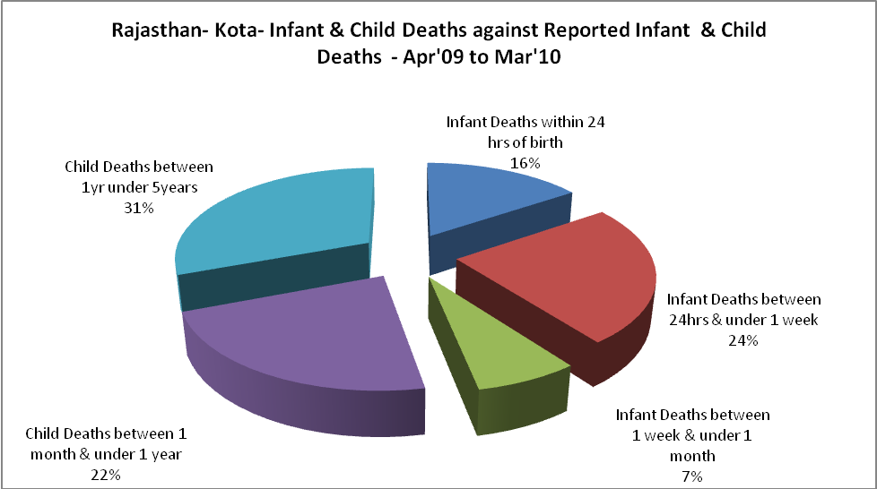

Rajasthan- Kota- Causes of Infant & Child Deaths - Apr'09 to Mar'10
Sepsis |  |  | Asphyxia |  |  | LBW
Up to 1 Weeks of Birth | Between 1 week & 4 weeks of birth | Total | Up to 1 Weeks of Birth | Between 1 week & 4 weeks of birth | Total | Up to 1 Weeks of Birth | Between 1 week & 4 weeks of birth | Total
5 | 0 | 5 | 10 | 2 | 12 | 30 | 15 | 45
Pneumonia |  |  | Diarrhoea |  |  | Fever related
Between 1 month and 11 months | Between 1 year & 5 years | Total | Between 1 month and 11 months | Between 1 year & 5 years | Total | Between 1 month and 11 months | Between 1 year & 5 years | Total
15 | 16 | 31 | 11 | 17 | 28 | 16 | 27 | 43
Others |  |  | Measles |  |  | Others
Up to 1 Weeks of Birth | Between 1 week & 4 weeks of birth | Total | Between 1 month and 11 months | Between 1 year & 5 years | Total | Between 1 month and 11 months | Between 1 year & 5 years | Total
33 | 6 | 39 | 0 | 0 | 0 | 30 | 39 | 69

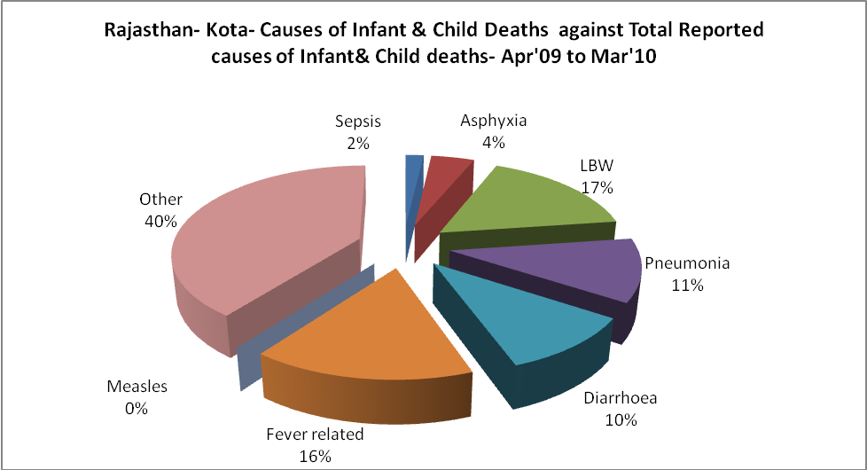

Rajasthan- Kota- Maternal Deaths & Causes - Apr'09 to Mar'10
Abortion |  |  | Obstructed/prolonged labour |  |  | Severe hypertesnion/fits
6-14 yrs | 15-55 yrs. | Total | 6-14 yrs | 15-55 yrs. | Total | 6-14 yrs | 15-55 yrs. | Total
1 | 3 | 4 | 1 | 0 | 1 | 0 | 0 | 0
Bleeding |  |  | High Fever |  |  | Other Causes
6-14 yrs | 15-55 yrs. | Total | 6-14 yrs | 15-55 yrs. | Total | 6-14 yrs | 15-55 yrs. | Total
1 | 0 | 1 | 1 | 3 | 4 | 3 | 6 | 9

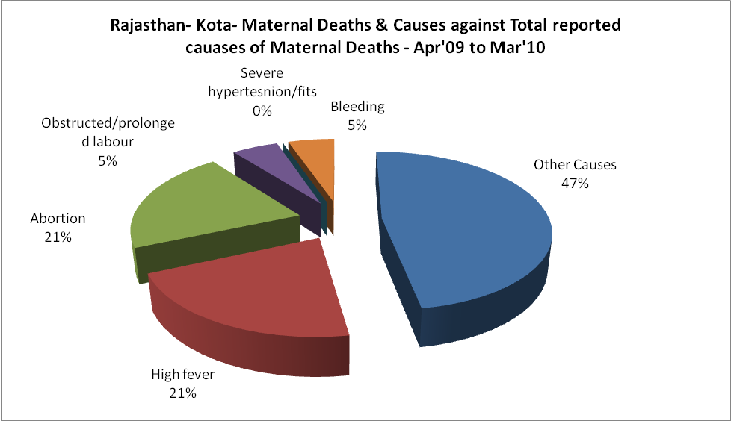

Rajasthan- Kota-Causes of Deaths in 6 to 55yrs age group - Apr'09 to Mar'10
Diarrhoel Diseases |  |  |  | Tuberculosis |  |  |  | Respiratory Diseases( Other than TB)
6-14 yrs | 15-55 yrs. | Above 55yrs | Total | 6-14 yrs | 15-55 yrs. | Above 55yrs | Total | 6-14 yrs | 15-55 yrs. | Above 55yrs | Total
2 | 5 | 4 | 11 | 5 | 8 | 5 | 18 | 4 | 22 | 52 | 78
Malaria |  |  |  | Other fever Related |  |  |  | HIV/Aids
6-14 yrs | 15-55 yrs. | Above 55yrs | Total | 6-14 yrs | 15-55 yrs. | Above 55yrs | Total | 6-14 yrs | 15-55 yrs. | Above 55yrs | Total
3 | 3 | 0 | 6 | 7 | 15 | 1 | 23 | 0 | 0 | 0 | 0
Heart Disease/Hypertenion related |  |  |  | Neurological Disease including strokes |  |  |  | Trauma/Accidents/ Burn Cases
6-14 yrs | 15-55 yrs. | Above 55yrs | Total | 6-14 yrs | 15-55 yrs. | Above 55yrs | Total | 6-14 yrs | 15-55 yrs. | Above 55yrs | Total
1 | 15 | 14 | 30 | 16 | 16 | 9 | 41 | 2 | 15 | 4 | 21
Suicide |  |  |  | Animal Bites & Stings
6-14 yrs | 15-55 yrs. | Above 55yrs | Total | 6-14 yrs | 15-55 yrs. | Above 55yrs | Total
0 | 9 | 5 | 14 | 12 | 16 | 8 | 36

