NHSRC
Himachal Pradesh- Kullu District
Analysis 2009-10

7/22/2010

Kullu Dist.- Summary-Apr'09 to Mar'10
ANC
ANC Registration against Expected Pregnancies | 113% | TT1 given to Pregnant women against ANC Registration | 62%
3 ANC Check ups against ANC Registrations | 71% | 100 IFA Tablets given to Pregnant women against ANC Registration | 80%
Deliveries
Unreported Deliveries against Estimated Deliveries | -0.8% | HOME Deliveries( SBA& Non SBA) against Estimated Deliveries | 53.0%
Institutional Deliveries against Estimated Deliveries | 47.8% | HOME Deliveries( SBA& Non SBA) against Reported Deliveries | 52.6%
Institutional Deliveries against Reported Deliveries | 47.4% | C Section Deliveries against Institutional Deliveries( Pvt & Pub) | 29%
Births & Neonates Care
Live Births Reported against Estimated Live Births | 104% | New borns weighed against Reported Live Births | 97%
Still Births (Reported) | 33 | New borns weighed less than 2.5 kgs against newborns weighed | 11%
Sex Ratio at Birth | 973 | New borns breastfed within one hr of Birth against Reported live Births | 88%
Child Immunization( 0 to 11 months)
BCG given against Expected Live Births | 119% | Measles given against Expected Live Births | 108%
OPV3 given against Expected Live Births | 111% | Fully Immunized Children against Expected Live Births | 103%
DPT3 given against Expected Live Births | 111%
Family Planning
Family Planning Methods Users ( Sterilizations(Male &Female)+IUD+ Condom pieces/72 + OCP Cycles/13) | 16,799 | IUD Insertions against reported FP Methods | 18%
Sterilization against reported FP Methods | 13% | Condom Users against reported FP Methods | 55%
 |  | OCP Users against reported FP Methods | 14%
Other Services
OPD | 584,783 | Major Operations | 672
IPD | 44,791 | Minor Operations | 3,259

Kullu Dist.- Deliveries Apr'09 to Mar'10
Total Population | 420,752 | Expected Deliveries |  | 7,611
Home SBA | Home Non SBA | Institutional | Total Deliveries Reported | Unreported Deliveries
278 | 3,756 | 3,641 | 7,675 | (64)
Home SBA % | Home Non SBA% | Institutional % | Total Deliveries Reported % | Unreported Deliveries %
4% | 49% | 48% | 101% | -1%

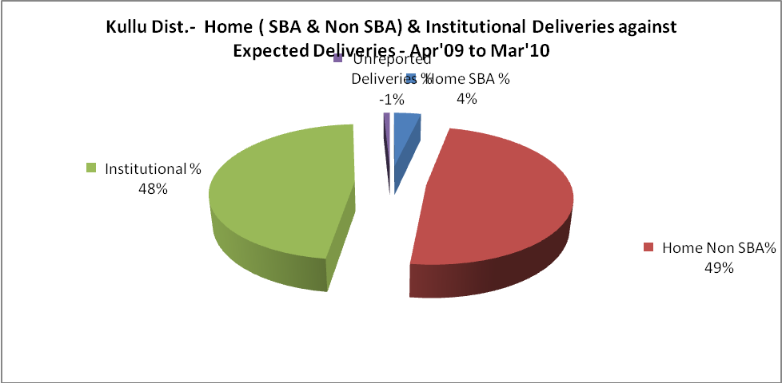
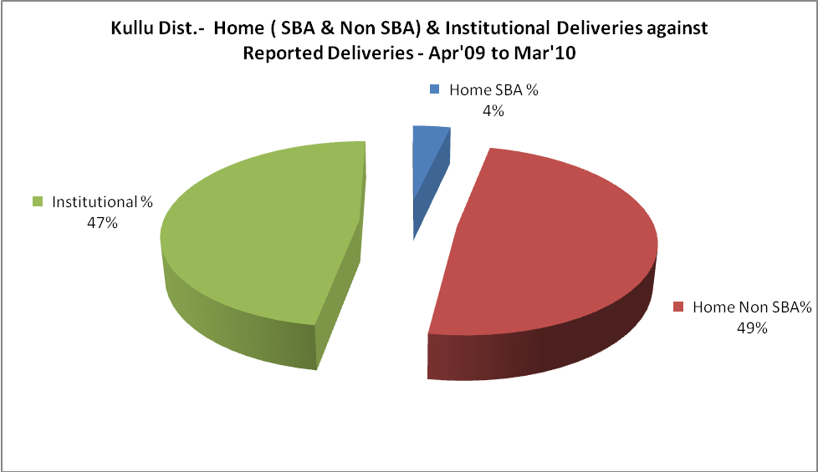

Kullu Dist.- C sections & Complicated Deliveries Apr'09 to Mar'10
 | Institutional Deliveries (Public) | Institutional Deliveries (Pvt)
 | 2,553 | 1,088
C Section | 154 | 247
C Section% | 6% | 23%
Complicated Pregnancies attended | 20 | 86
Complicated Pregnancies attended % | 1% | 8%

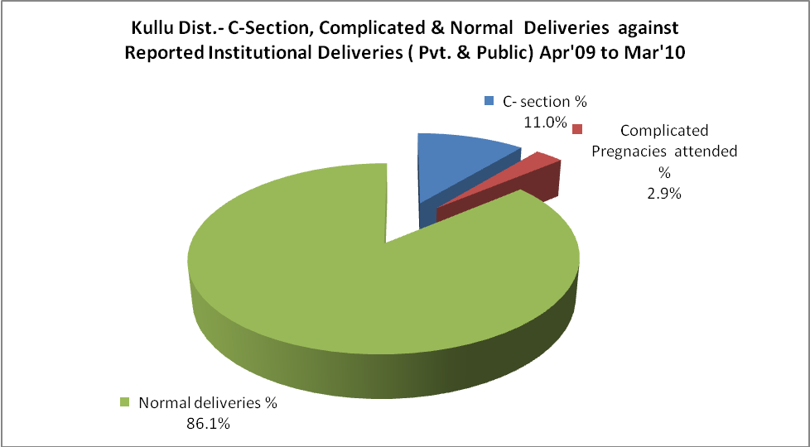

Kullu Dist.- Complicated Pregnancies & Deliveries Treated - Apr'09 to Mar'10
Reported Deliveries |  |  | Reported ANC Registration
7,675 |  |  | 9,266
Complicated Pregnancies attended | Complicated Pregnancies Rate | C - Section Deliveries | PNC Maternal Complications | Abortions | Still Births
106 | 1% | 401 | 1 | 16 | 33
Complicated Deliveries Treated with |  |  |  | No Of Eclampsia cases Treated | No Of severe anemia cases treated
IV Antibiotics | IV antihypertensive/Magsulph injection | IV Oxytocis | Blood Transfusion | No Of Eclampsia cases Treated | No Of severe anemia cases treated
64 | - | - | - | - | 93

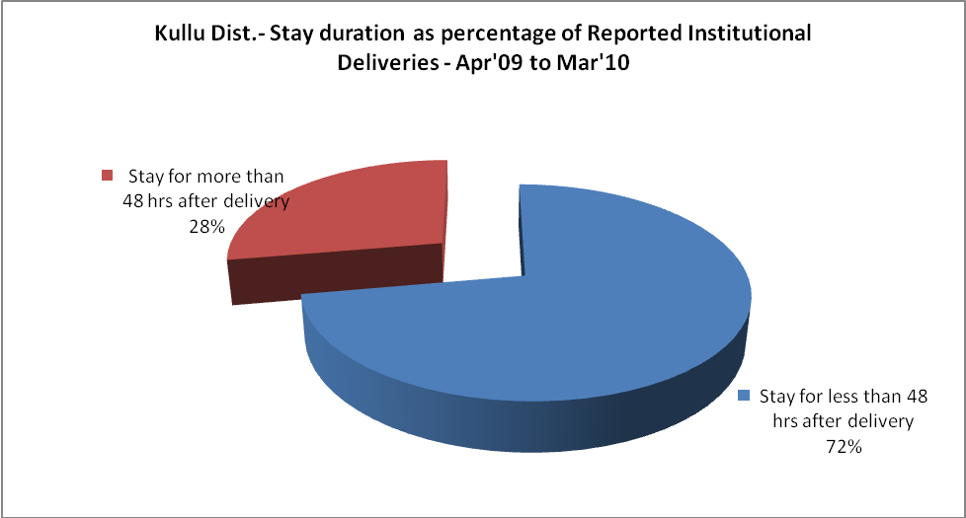

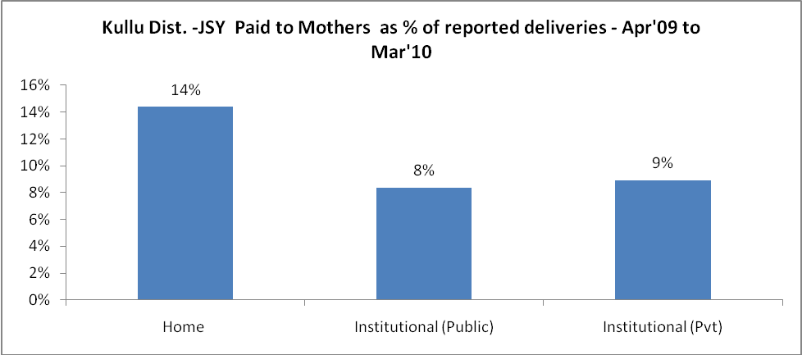
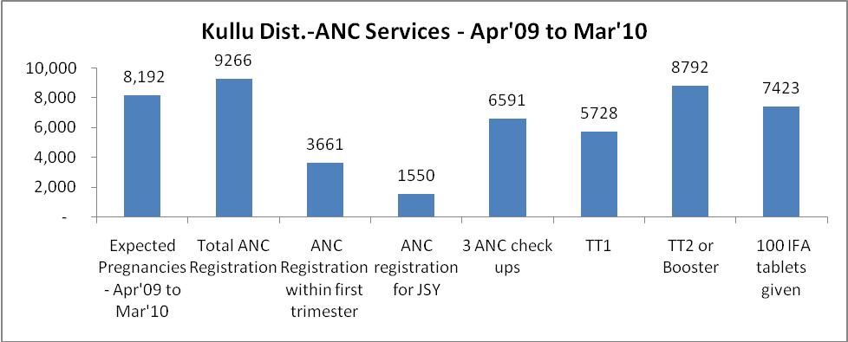

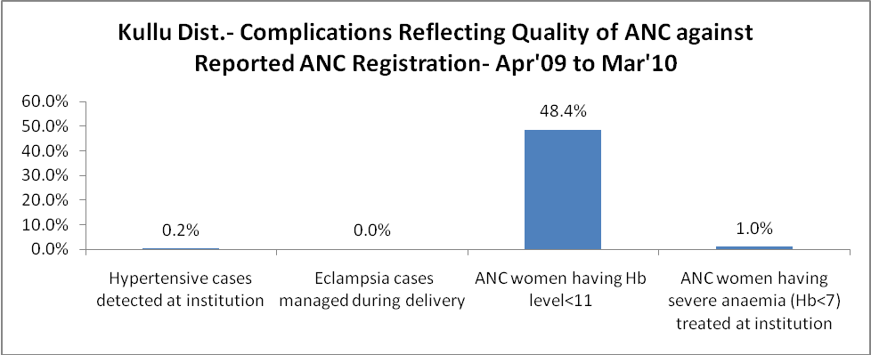
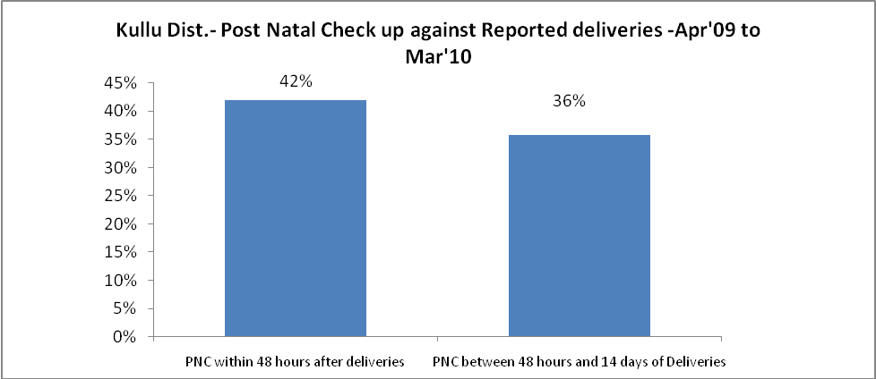

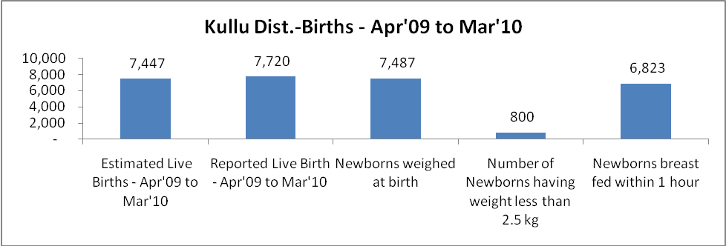

Kullu Dist. - Births - Apr'09 to Mar'10
Live Birth - Males | Live Birth - females | Live Birth - Total | Sex Ratio at birth | Still Birth | Abortion( Induced/Spontaneous
3,912 | 3,808 | 7,720 | 973 | 33 | 16

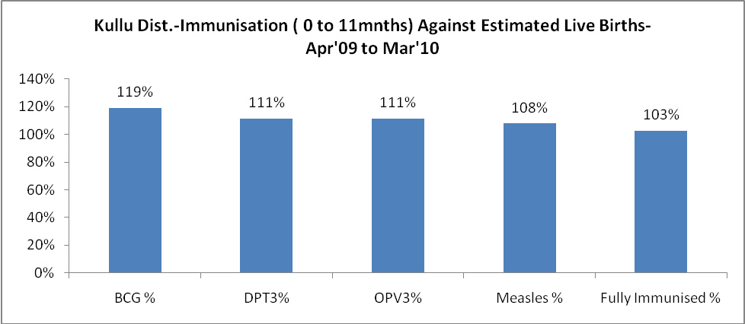
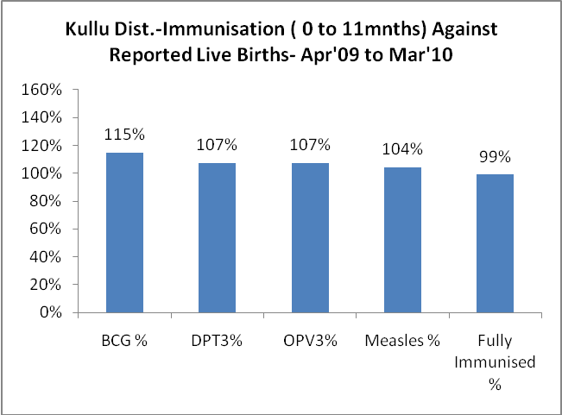
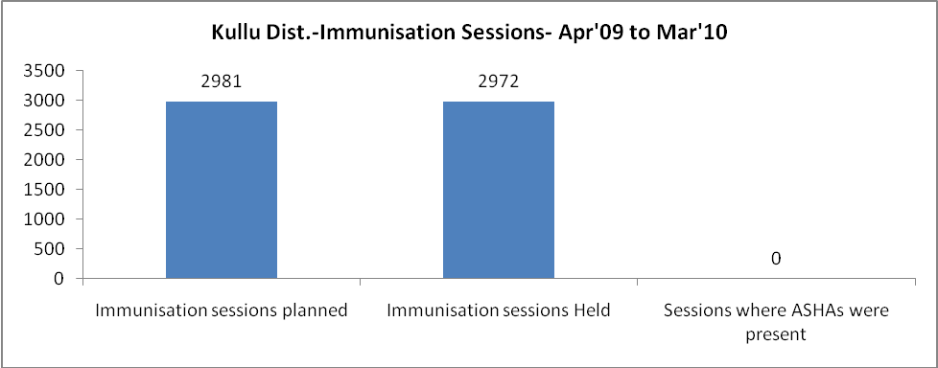
Kullu Dist.- Apr'09 to Mar'10
Total Abortions | Abortion Rate
157 | 1.9%

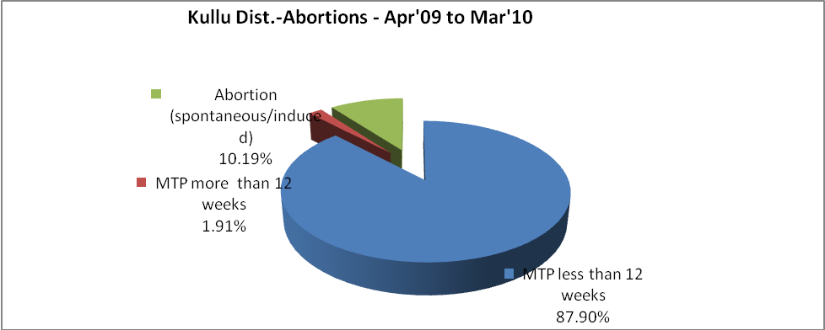
Kullu Dist.- Apr'09 to Mar'10
Total OPD | Total RTI/STI cases
584,783 | 4,186

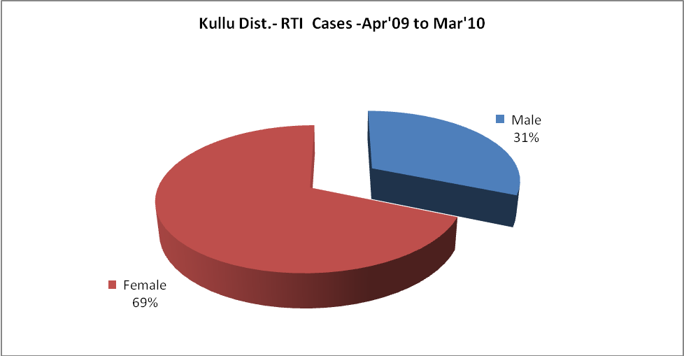
Kullu Dist.-Sterilizations - Apr'09 to Mar'10
 | Reported | %age of Reported Sterilization
Total Sterilization | 2,109 | -
NSV | 848 | 40%
Laproscopic | 1,226 | 58%
MiniLap | 14 | 1%
Post Partum | 21 | 1%
Male Sterilization | 848 | 40%
Female Sterilization | 1,261 | 60%

Kullu Dist.-FP Methods - Apr'09 to Mar'10
 | Reported | %age of All Reported FP Methods
Total Reported FP Method (All types) Users | 16,799 | -
Sterilizations | 2,109 | 13%
IUD | 3,036 | 18%
Condom Users | 9,297 | 55%
OCP Users | 2,357 | 14%
Limiting Methods | 2,109 | 13%
Spacing Methods | 14,690 | 87%

Kullu Dist.- Service Delivery - Apr'09 to Mar'10
Operation major (General and spinal anaesthesia) | Operation minor (No or local anaesthesia) | AYUSH | Dental Procedures | Adolescent counseling services | Total OPD | Total IPD
672 | 3,259 | - | 13,835 | 1,056 | 584,783 | 44,791
Operation major (General and spinal anaesthesia) as %ge of OPD | Operation minor (No or local anaesthesia)as %ge of OPD | AYUSH as %ge of OPD | Dental Procedures as %ge of OPD | Adolescent counseling services as %ge of OPD | IPD as percentage of OPD
0.1% | 0.6% | 0.0% | 2.4% | 0.2% | 8%

Kullu Dist.- Lab Services - Apr'09 to Mar'10
Total OPD | Total HB tested | Total HIV Tested | Total Population
584,783 | 14,678 | 4,576 | 420,752
HB test conducted as %age of OPD | HB<7gm as %age of HB tested | HIV test conducted as %age of OPD | HIV positive as %age of HIV tested | Blood Smear Examined as % of Population
2.5% | 2.8% | 0.8% | 0.4% | 2.8%

Kullu Dist.- Childhood Disease - Vaccine Preventable -Apr'09 to Mar'10
Diphtheria | Pertussis | Tetanus Neonatorum | Tetanus others | Polio | Measles
0 | 0 | 0 | 0 | 0 | 0
Kullu Dist.-Childhood Disease - Others - Apr'09 to Mar'10
Diarrhoea and dehydration | Malaria | Number admitted with Respiratory Infections
2,261 | 4 | 905
Kullu Dist.- Infant & Child Deaths - Apr'09 to Mar'10
Infant Deaths within 24 hrs of birth | Infant Deaths under 1 week | Infant Deaths under 1 month | Child Deaths under 1 year | Child Deaths under 5years | Total Deaths
0 | 2 | 6 | 6 | 6 | 20

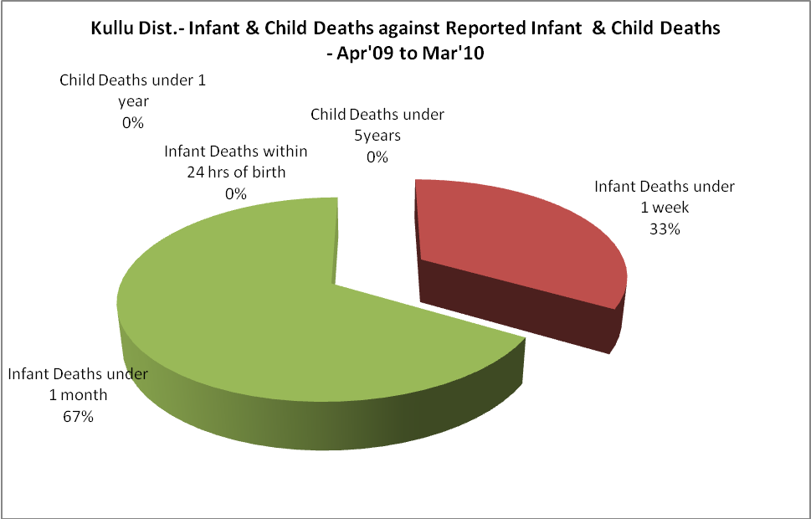

Kullu Dist.- Causes of Infant & Child Deaths - Apr'09 to Mar'10
Sepsis |  |  | Asphyxia |  |  | LBW
Up to 1 Weeks of Birth | Between 1 week & 4 weeks of birth | Total | Up to 1 Weeks of Birth | Between 1 week & 4 weeks of birth | Total | Up to 1 Weeks of Birth | Between 1 week & 4 weeks of birth | Total
0 | 0 | 0 | 0 | 1 | 1 | 0 | 2 | 2
Pneumonia |  |  | Diarrhoea |  |  | Fever related
Between 1 month and 11 months | Between 1 year & 5 years | Total | Between 1 month and 11 months | Between 1 year & 5 years | Total | Between 1 month and 11 months | Between 1 year & 5 years | Total
0 | 0 | 0 | 0 | 0 | 0 | 0 | 0 | 0
Others |  |  | Measles |  |  | Others
Up to 1 Weeks of Birth | Between 1 week & 4 weeks of birth | Total | Between 1 month and 11 months | Between 1 year & 5 years | Total | Between 1 month and 11 months | Between 1 year & 5 years | Total
2 | 1 | 3 | 0 | 0 | 0 | 0 | 0 | 0

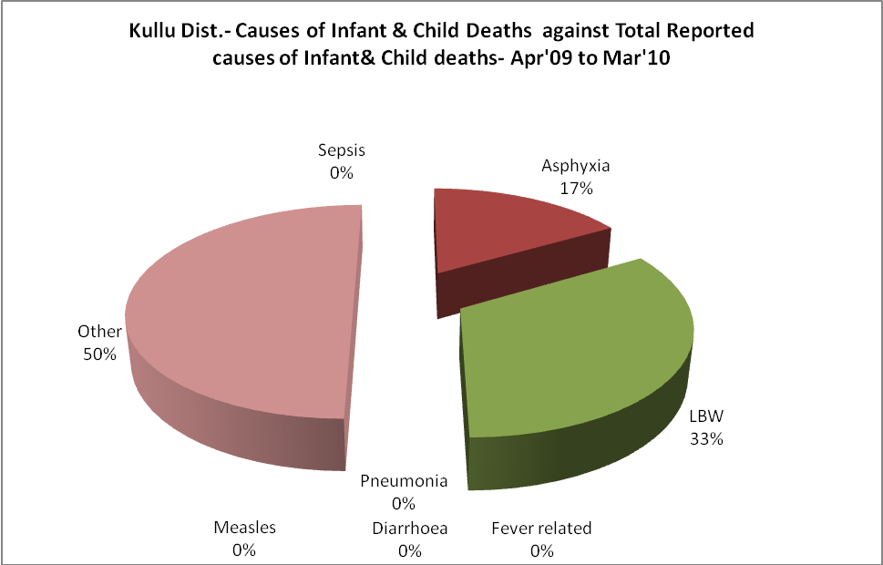

Kullu Dist.- Maternal Deaths & Causes - Apr'09 to Mar'10
Abortion |  |  | Obstructed/prolonged labour |  |  | Severe hypertension/fits
6-14 yrs | 15-55 yrs. | Total | 6-14 yrs | 15-55 yrs. | Total | 6-14 yrs | 15-55 yrs. | Total
0 | 0 | 0 | 0 | 0 | 0 | 0 | 0 | 0
Bleeding |  |  | High Fever |  |  | Other Causes
6-14 yrs | 15-55 yrs. | Total | 6-14 yrs | 15-55 yrs. | Total | 6-14 yrs | 15-55 yrs. | Total
0 | 0 | 0 | 0 | 0 | 0 | 0 | 0 | 0

Kullu Dist.-Causes of Deaths in 6 to 55yrs age group - Apr'09 to Mar'10
Diarrhoel Diseases |  |  |  | Tuberculosis |  |  |  | Respiratory Diseases( Other than TB)
6-14 yrs | 15-55 yrs. | Above 55yrs | Total | 6-14 yrs | 15-55 yrs. | Above 55yrs | Total | 6-14 yrs | 15-55 yrs. | Above 55yrs | Total
0 | 0 | 0 | 0 | 0 | 1 | 0 | 1 | 0 | 7 | 0 | 7
Malaria |  |  |  | Other fever Related |  |  |  | HIV/Aids
6-14 yrs | 15-55 yrs. | Above 55yrs | Total | 6-14 yrs | 15-55 yrs. | Above 55yrs | Total | 6-14 yrs | 15-55 yrs. | Above 55yrs | Total
0 | 0 | 0 | 0 | 0 | 2 | 0 | 2 | 0 | 0 | 0 | 0
Heart Disease/Hypertension related |  |  |  | Neurological Disease including strokes |  |  |  | Trauma/Accidents/ Burn Cases
6-14 yrs | 15-55 yrs. | Above 55yrs | Total | 6-14 yrs | 15-55 yrs. | Above 55yrs | Total | 6-14 yrs | 15-55 yrs. | Above 55yrs | Total
1 | 1 | 1 | 3 | 0 | 0 | 0 | 0 | 0 | 0 | 0 | 0
Suicide |  |  |  | Animal Bites & Stings
6-14 yrs | 15-55 yrs. | Above 55yrs | Total | 6-14 yrs | 15-55 yrs. | Above 55yrs | Total
0 | 0 | 0 | 0 | 0 | 0 | 0 | 0

