NHSRC
Himachal Pradesh- L_Spiti District
Analysis 2009-10

7/22/2010

L_Spiti Dist.- Summary-Apr'09 to Mar'10
ANC
ANC Registration against Expected Pregnancies | 65% | TT1 given to Pregnant women against ANC Registration | 56%
3 ANC Check ups against ANC Registrations | 56% | 100 IFA Tablets given to Pregnant women against ANC Registration | 86%
Deliveries
Unreported Deliveries against Estimated Deliveries | 66.2% | HOME Deliveries( SBA& Non SBA) against Estimated Deliveries | 11.3%
Institutional Deliveries against Estimated Deliveries | 22.5% | HOME Deliveries( SBA& Non SBA) against Reported Deliveries | 33.5%
Institutional Deliveries against Reported Deliveries | 66.5% | C Section Deliveries against Institutional Deliveries( Pvt & Pub) | -
Births & Neonates Care
Live Births Reported against Estimated Live Births | 35% | New borns weighed against Reported Live Births | 92%
Still Births (Reported) | - | New borns weighed less than 2.5 kgs against newborns weighed | 5%
Sex Ratio at Birth | 982 | New borns breastfed within one hr of Birth against Reported live Births | 84%
Child Immunization( 0 to 11 months)
BCG given against Expected Live Births | 53% | Measles given against Expected Live Births | 75%
OPV3 given against Expected Live Births | 62% | Fully Immunized Children against Expected Live Births | 69%
DPT3 given against Expected Live Births | 57%
Family Planning
Family Planning Methods Users ( Sterilizations(Male &Female)+IUD+ Condom pieces/72 + OCP Cycles/13) | 996 | IUD Insertions against reported FP Methods | 9%
Sterilization against reported FP Methods | 12% | Condom Users against reported FP Methods | 50%
 |  | OCP Users against reported FP Methods | 28%
Other Services
OPD | 85,626 | Major Operations | 7
IPD | 1,126 | Minor Operations | 212

L_Spiti Dist.- Deliveries Apr'09 to Mar'10
Total Population | 36,636 | Expected Deliveries |  | 663
Home SBA | Home Non SBA | Institutional | Total Deliveries Reported | Unreported Deliveries
19 | 56 | 149 | 224 | 439
Home SBA % | Home Non SBA% | Institutional % | Total Deliveries Reported % | Unreported Deliveries %
3% | 8% | 22% | 34% | 66%

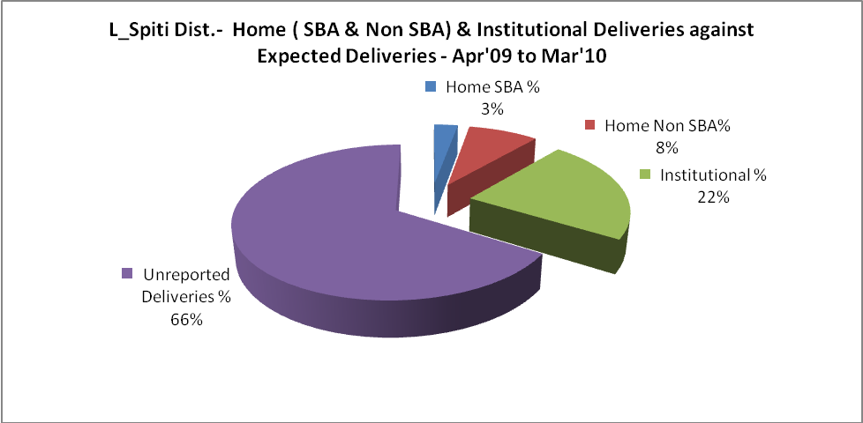
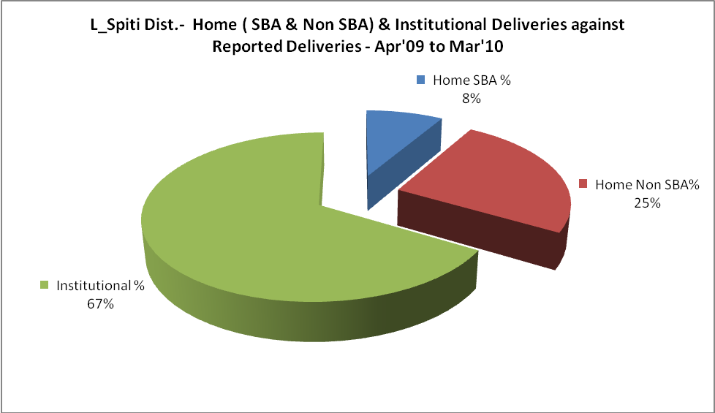

L_Spiti Dist.- C sections & Complicated Deliveries Apr'09 to Mar'10
 | Institutional Deliveries (Public) | Institutional Deliveries (Pvt)
 | 149 | -
C Section | - | -
C Section% | 0% | -
Complicated Pregnancies attended | - | -
Complicated Pregnancies attended % | 0% | -

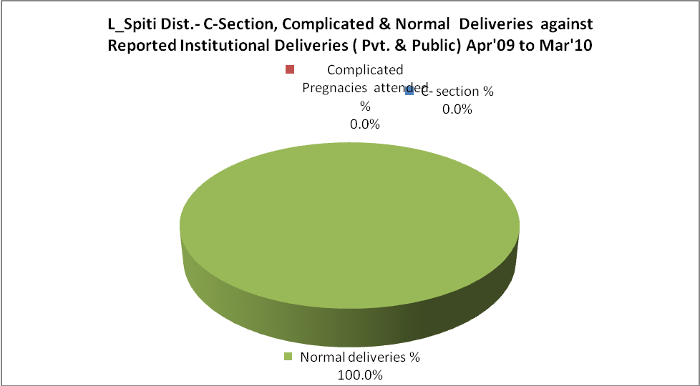
L_Spiti Dist.- Complicated Pregnancies & Deliveries Treated - Apr'09 to Mar'10
Reported Deliveries |  |  | Reported ANC Registration
224 |  |  | 465
Complicated Pregnancies attended | Complicated Pregnancies Rate | C - Section Deliveries | PNC Maternal Complications | Abortions | Still Births
- | 0% | - | - | 3 | -
Complicated Deliveries Treated with |  |  |  | No Of Eclampsia cases Treated | No Of severe anemia cases treated
IV Antibiotics | IV antihypertensive/Magsulph injection | IV Oxytocis | Blood Transfusion | No Of Eclampsia cases Treated | No Of severe anemia cases treated
1 | - | 2 | - | - | 4

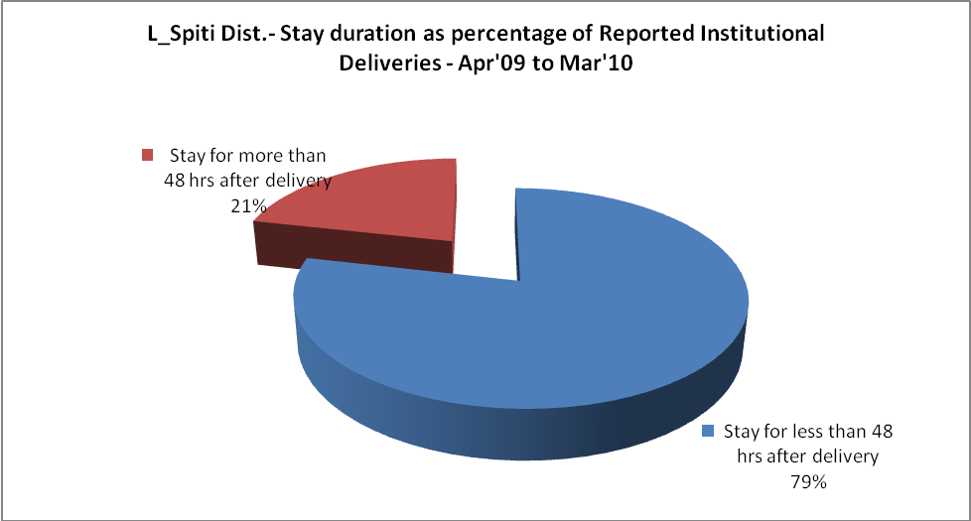

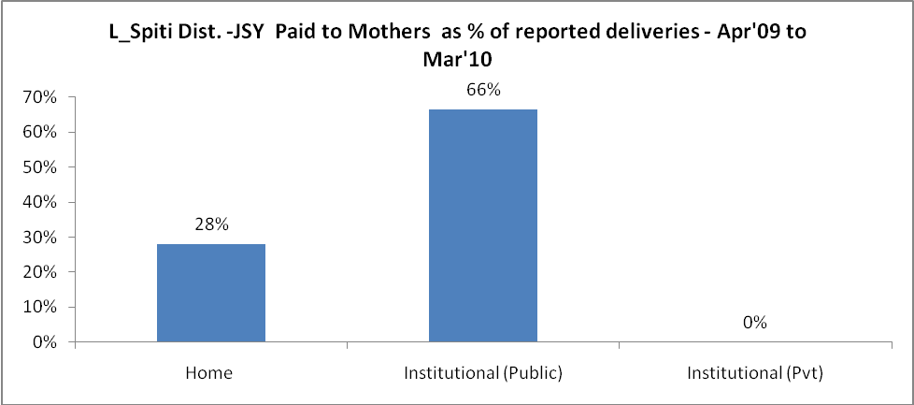
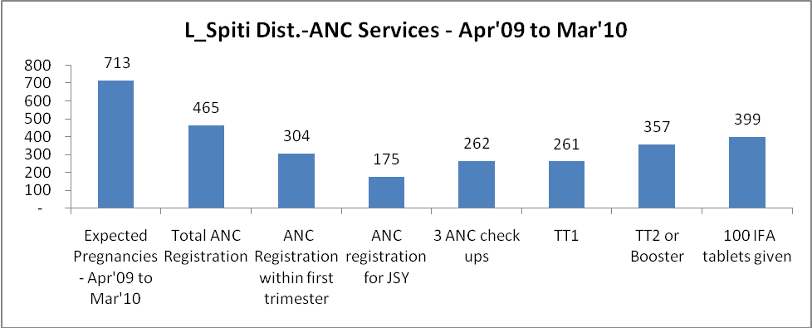

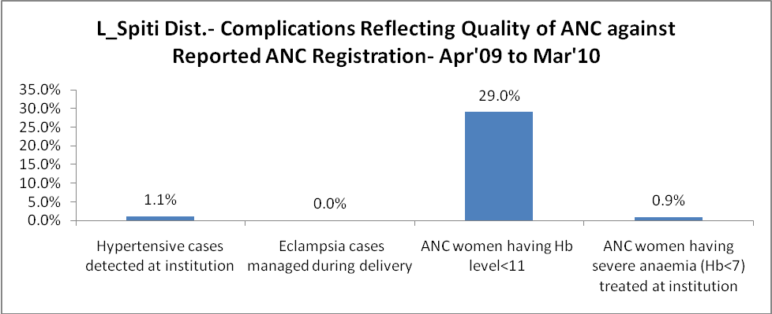
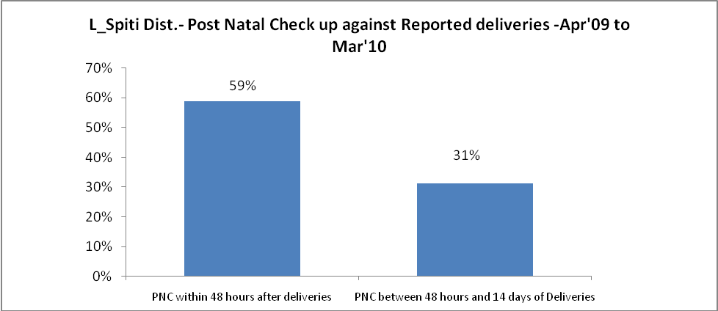

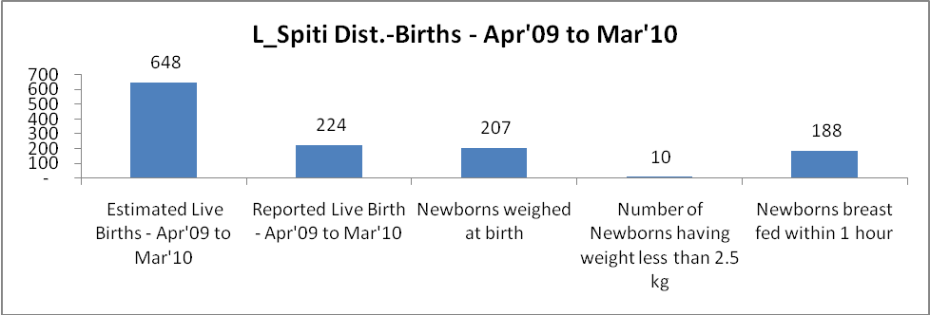

L_Spiti Dist. - Births - Apr'09 to Mar'10
Live Birth - Males | Live Birth - females | Live Birth - Total | Sex Ratio at birth | Still Birth | Abortion( Induced/Spontaneous
113 | 111 | 224 | 982 | - | 3

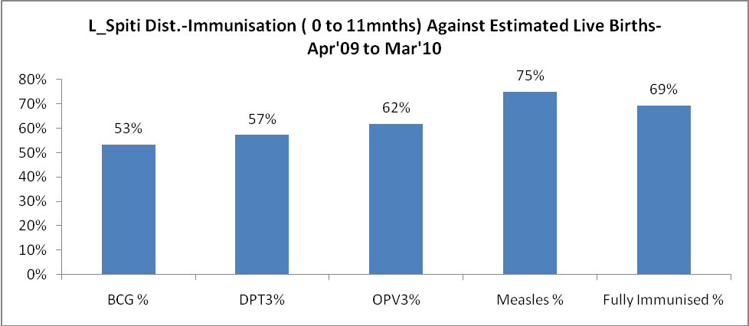
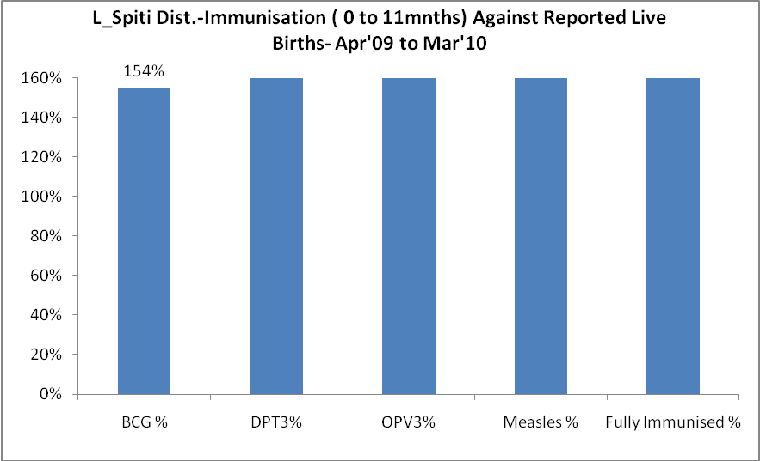
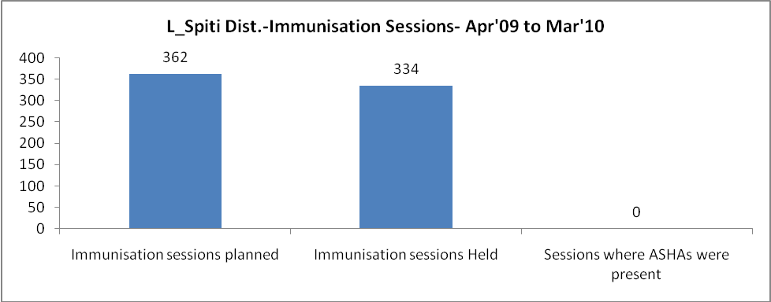
L_Spiti Dist.- Apr'09 to Mar'10
Total Abortions | Abortion Rate
8 | 1.1%

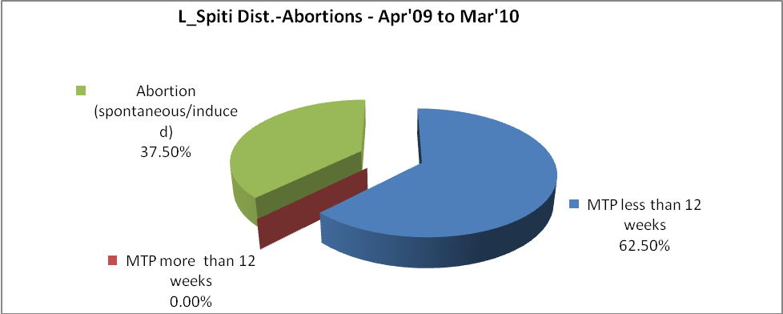
L_Spiti Dist.- Apr'09 to Mar'10
Total OPD | Total RTI/STI cases
85,626 | 551

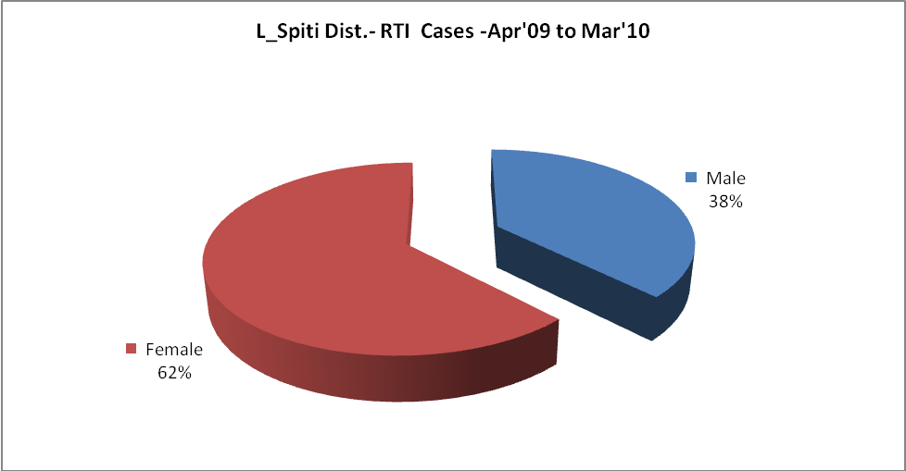
L_Spiti Dist.-Sterilizations - Apr'09 to Mar'10
 | Reported | %age of Reported Sterilization
Total Sterilization | 121 | -
NSV | 40 | 33%
Laproscopic | 81 | 67%
MiniLap | - | 0%
Post Partum | - | 0%
Male Sterilization | 40 | 33%
Female Sterilization | 81 | 67%

L_Spiti Dist.-FP Methods - Apr'09 to Mar'10
 | Reported | %age of All Reported FP Methods
Total Reported FP Method (All types) Users | 996 | -
Sterilizations | 121 | 12%
IUD | 94 | 9%
Condom Users | 500 | 50%
OCP Users | 281 | 28%
Limiting Methods | 121 | 12%
Spacing Methods | 875 | 88%

L_Spiti Dist.- Service Delivery - Apr'09 to Mar'10
Operation major (General and spinal anaesthesia) | Operation minor (No or local anaesthesia) | AYUSH | Dental Procedures | Adolescent counseling services | Total OPD | Total IPD
7 | 212 | - | 1,736 | 16 | 85,626 | 1,126
Operation major (General and spinal anaesthesia) as %ge of OPD | Operation minor (No or local anaesthesia)as %ge of OPD | AYUSH as %ge of OPD | Dental Procedures as %ge of OPD | Adolescent counseling services as %ge of OPD | IPD as percentage of OPD
0.0% | 0.2% | 0.0% | 2.0% | 0.0% | 1%

L_Spiti Dist.- Lab Services - Apr'09 to Mar'10
Total OPD | Total HB tested | Total HIV Tested | Total Population
85,626 | 881 | 437 | 36,636
HB test conducted as %age of OPD | HB<7gm as %age of HB tested | HIV test conducted as %age of OPD | HIV positive as %age of HIV tested | Blood Smear Examined as % of Population
1.0% | 3.5% | 0.5% | 0.0% | 0.1%

L_Spiti Dist.- Childhood Disease - Vaccine Preventable -Apr'09 to Mar'10
Diphtheria | Pertussis | Tetanus Neonatorum | Tetanus others | Polio | Measles
0 | 0 | 0 | 0 | 0 | 1
L_Spiti Dist.-Childhood Disease - Others - Apr'09 to Mar'10
Diarrhoea and dehydration | Malaria | Number admitted with Respiratory Infections
1,065 | - | 67

L_Spiti Dist.- Infant & Child Deaths - Apr'09 to Mar'10
Infant Deaths within 24 hrs of birth | Infant Deaths under 1 week | Infant Deaths under 1 month | Child Deaths under 1 year | Child Deaths under 5years | Total Deaths
2 | 3 | 2 | 2 | 2 | 11

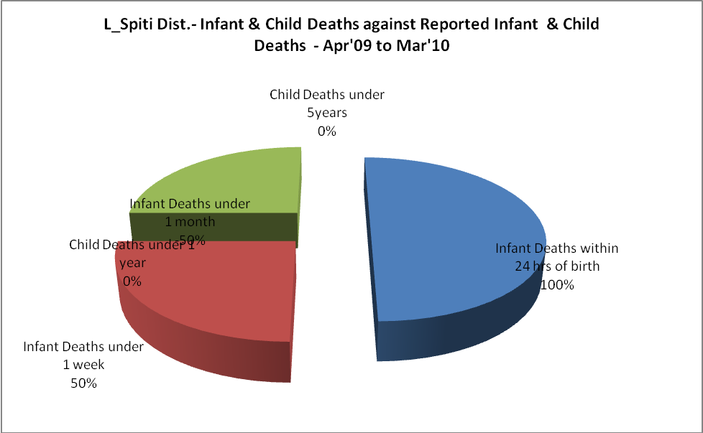

L_Spiti Dist.- Causes of Infant & Child Deaths - Apr'09 to Mar'10
Sepsis |  |  | Asphyxia |  |  | LBW
Up to 1 Weeks of Birth | Between 1 week & 4 weeks of birth | Total | Up to 1 Weeks of Birth | Between 1 week & 4 weeks of birth | Total | Up to 1 Weeks of Birth | Between 1 week & 4 weeks of birth | Total
0 | 0 | 0 | 0 | 0 | 0 | 0 | 1 | 1
Pneumonia |  |  | Diarrhoea |  |  | Fever related
Between 1 month and 11 months | Between 1 year & 5 years | Total | Between 1 month and 11 months | Between 1 year & 5 years | Total | Between 1 month and 11 months | Between 1 year & 5 years | Total
0 | 0 | 0 | 0 | 0 | 0 | 0 | 0 | 0
Others |  |  | Measles |  |  | Others
Up to 1 Weeks of Birth | Between 1 week & 4 weeks of birth | Total | Between 1 month and 11 months | Between 1 year & 5 years | Total | Between 1 month and 11 months | Between 1 year & 5 years | Total
1 | 0 | 1 | 0 | 0 | 0 | 0 | 0 | 0

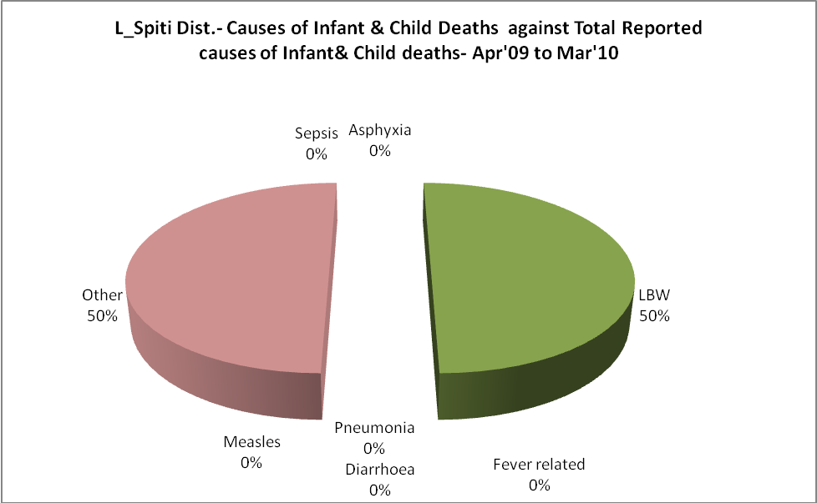

L_Spiti Dist.- Maternal Deaths & Causes - Apr'09 to Mar'10
Abortion |  |  | Obstructed/prolonged labour |  |  | Severe hypertension/fits
6-14 yrs | 15-55 yrs. | Total | 6-14 yrs | 15-55 yrs. | Total | 6-14 yrs | 15-55 yrs. | Total
0 | 0 | 0 | 0 | 0 | 0 | 0 | 0 | 0
Bleeding |  |  | High Fever |  |  | Other Causes
6-14 yrs | 15-55 yrs. | Total | 6-14 yrs | 15-55 yrs. | Total | 6-14 yrs | 15-55 yrs. | Total
0 | 0 | 0 | 0 | 0 | 0 | 0 | 0 | 0

L_Spiti Dist.-Causes of Deaths in 6 to 55yrs age group - Apr'09 to Mar'10
Diarrhoel Diseases |  |  |  | Tuberculosis |  |  |  | Respiratory Diseases( Other than TB)
6-14 yrs | 15-55 yrs. | Above 55yrs | Total | 6-14 yrs | 15-55 yrs. | Above 55yrs | Total | 6-14 yrs | 15-55 yrs. | Above 55yrs | Total
0 | 0 | 0 | 0 | 0 | 0 | 0 | 0 | 0 | 0 | 0 | 0
Malaria |  |  |  | Other fever Related |  |  |  | HIV/Aids
6-14 yrs | 15-55 yrs. | Above 55yrs | Total | 6-14 yrs | 15-55 yrs. | Above 55yrs | Total | 6-14 yrs | 15-55 yrs. | Above 55yrs | Total
0 | 0 | 0 | 0 | 0 | 0 | 0 | 0 | 0 | 0 | 0 | 0
Heart Disease/Hypertension related |  |  |  | Neurological Disease including strokes |  |  |  | Trauma/Accidents/ Burn Cases
6-14 yrs | 15-55 yrs. | Above 55yrs | Total | 6-14 yrs | 15-55 yrs. | Above 55yrs | Total | 6-14 yrs | 15-55 yrs. | Above 55yrs | Total
0 | 0 | 0 | 0 | 0 | 0 | 0 | 0 | 1 | 0 | 0 | 1
Suicide |  |  |  | Animal Bites & Stings
6-14 yrs | 15-55 yrs. | Above 55yrs | Total | 6-14 yrs | 15-55 yrs. | Above 55yrs | Total
0 | 0 | 0 | 0 | 0 | 0 | 0 | 0

