NHSRC
MANIPUR- Churchandpur District
HMIS Data Analysis 2009-10

Amit
8/5/2010

MANIPUR- CHURCHANDPUR- Summary-Apr'09 to Mar'10
ANC
ANC Registration against Expected Pregnancies | 197% | TT1 given to Pregnant women against ANC Registraion | 30%
3 ANC Check ups against ANC Reigtrations | 27% | 100 IFA Tablets given to Pregnant women against ANC Registraion | 35%
Deliveries
Unreported Deliveries against Estimated Deliveries | 33.7% | HOME Deliveries( SBA& Non SBA) against Estimated Deliveries | 12.1%
Institutional Deliveries against Estimated Deliveries | 54.2% | HOME Deliveries( SBA& Non SBA) against Reported Deliveries | 18.2%
Institutional Deliveries against Reported Deliveries | 81.8% | C Section Deliveries against Institutional Deliveries( Pvt & Pub) | 10%
Births & Neonates Care
Live Births Reported against Estimated Live Births | 68% | New borns weighed against Reported Live Births | 91%
Still Births (Reported) | 6 | New borns weighed less than 2.5 kgs against newborns weighed | 2%
Sex Ratio at Birh | 981 | New borns breastfed within one hr of Birth against Reported live Births | 84%
Child Immunisation( 0 to 11 months)
BCG given against Expected Live Births | 96% | Measles given against Expected Live Births | 80%
OPV3 given against Expected Live Births | 88% | Fully Immunised Children against Expected Live Births | 77%
DPT3 given against Expected Live Births | 88%
Family Planning
Family Plannig Methods Users ( Sterilisations(Male &Female)+IUD+ Condom pieces/72 + OCP Cycles/13) | 1,197 | IUD Insertions against reported FP Methods | 25%
Sterilisation against reported FP Methods | 42% | Condom Users against reported FP Methods | 17%
 |  | OCP Users against reported FP Methods | 16%
Other Services
OPD | 79,648 | Major Operations | 412
IPD | 7,191 | Minor Operations | 784

MANIPUR- CHURCHANDPUR- Deliveries Apr'09 to Mar'10
Total Population | 313,409 | Expected Deliveries |  | 4,987
Home SBA | Home Non SBA | Institutional | Total Deliveries Reported | Unreported Deliveries
404 | 199 | 2,704 | 3,307 | 1,680
Home SBA % | Home Non SBA% | Institutional % | Total Deliveries Reported % | Unreported Deliveries %
8% | 4% | 54% | 66% | 34%

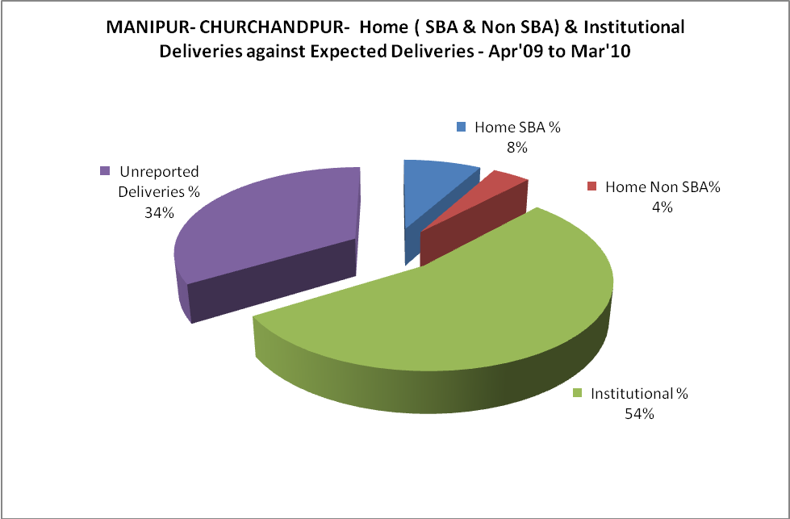

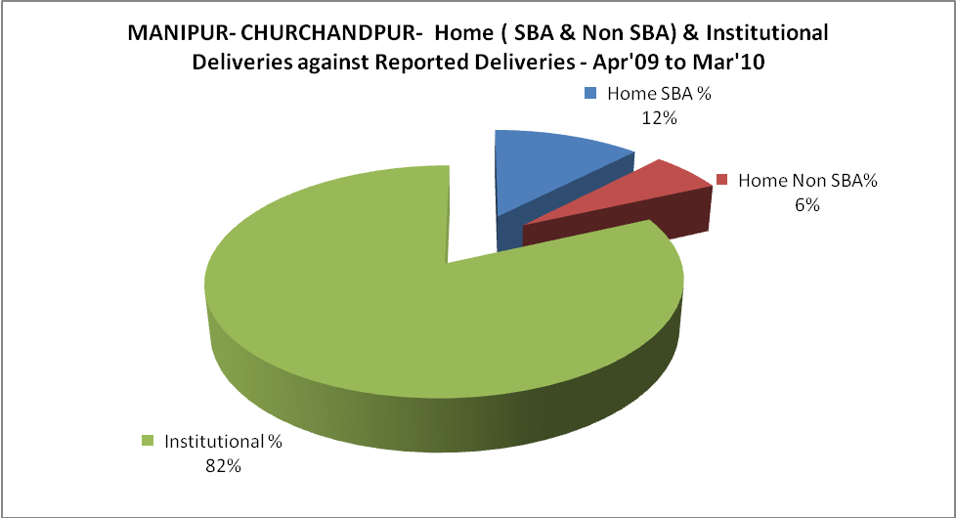

MANIPUR- CHURCHANDPUR- C sections & Complicated Deliveries Apr'09 to Mar'10
 | Institutional Deliveries (Public) | Institutional Deliveries (Pvt)
 | 1,821 | 883
C Section | 124 | 156
C Section% | 7% | 18%
Complicated Pregnacies attended | 26 | 32
Complicated Pregnacies attended % | 1% | 4%

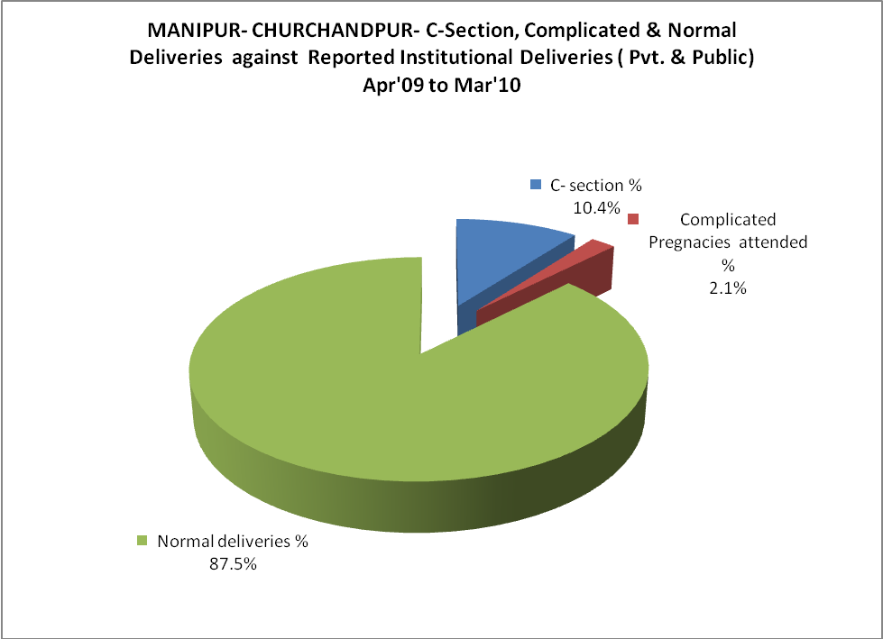
MANIPUR- CHURCHANDPUR- Complicated Pregnancies & Deliveries Treated - Apr'09 to Mar'10
Reported Deliveries |  |  | Reported ANC Reigtration
3,307 |  |  | 10,726
Complicated Pregnancies attended | Complicated Pregnancies Rate | C - Section Deliveries | PNC Maternal Complications | Abortions | Still Births
58 | 1% | 280 | 50 | 225 | 6
Complicated Deliveries Treated with |  |  |  | No Of Eclampsia cases Treated | No Of severe anemia cases treated
IV Antibiotics | IV antihypertensive/Magsulph injection | IV Oxytocis | Blood Transfusion | No Of Eclampsia cases Treated | No Of severe anemia cases treated
1,530 | 140 | 1,472 | 28 | 26 | 17
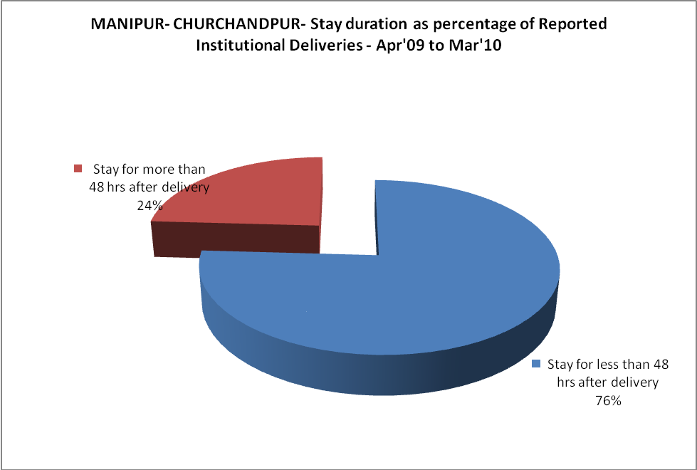
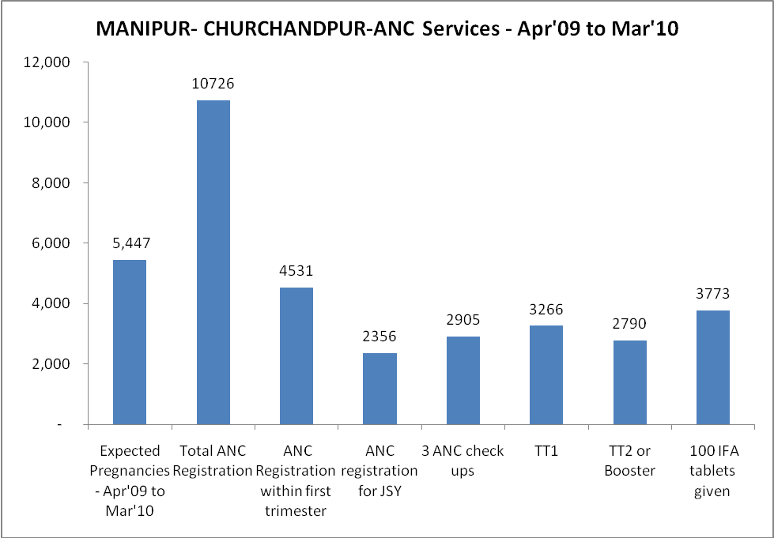
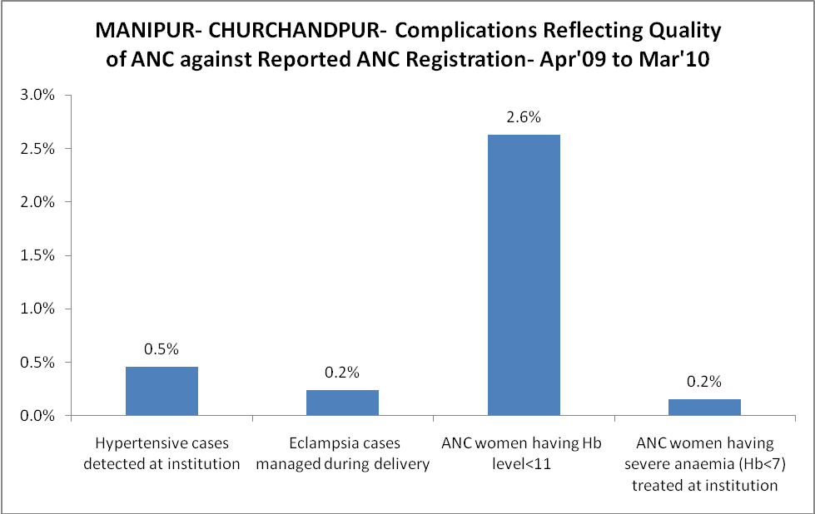
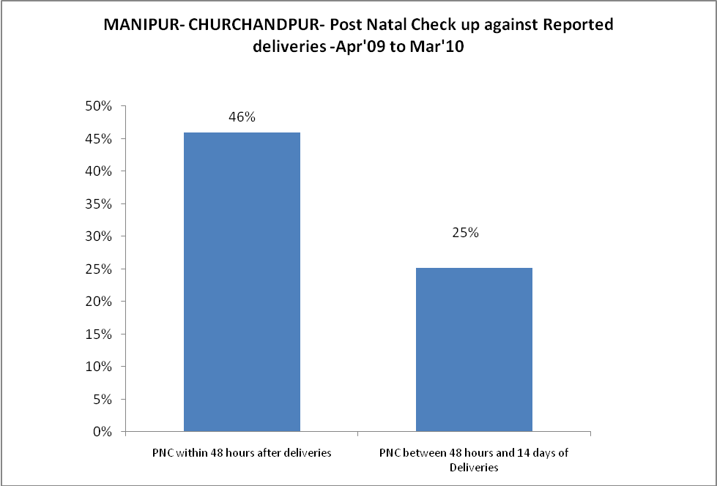
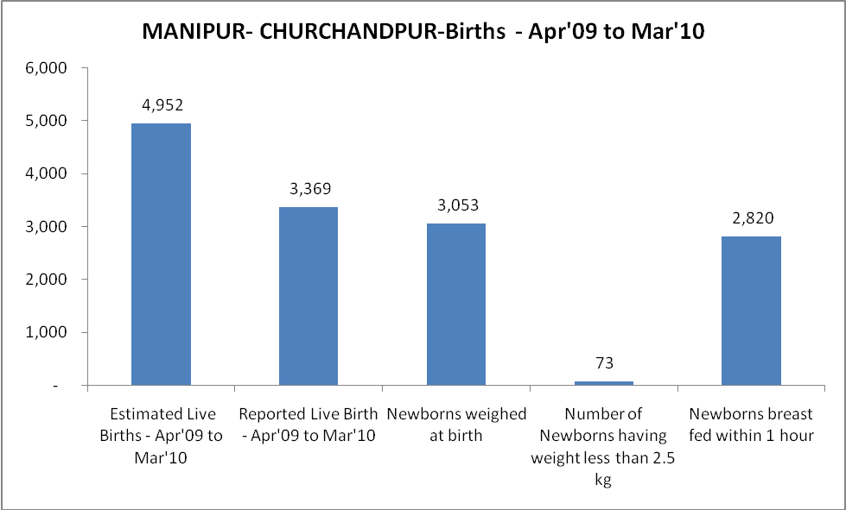

MANIPUR- CHURCHANDPUR - Births - Apr'09 to Mar'10
Live Birth - Males | Live Birth - females | Live Birth - Total | Sex Ratio at birth | Still Birth | Abortion( Induced/Spontaneous
1,701 | 1,668 | 3,369 | 981 | 6 | 225

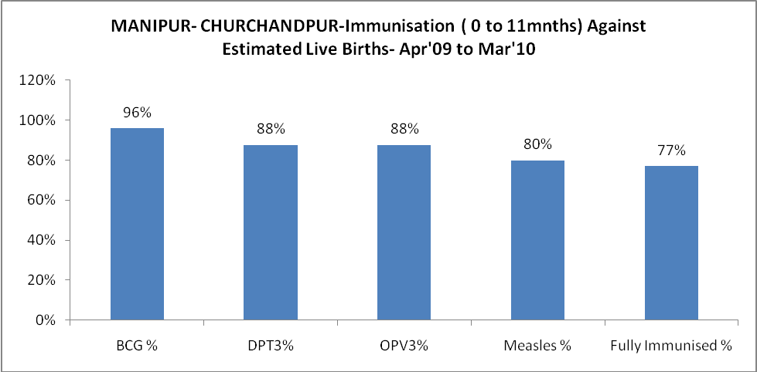

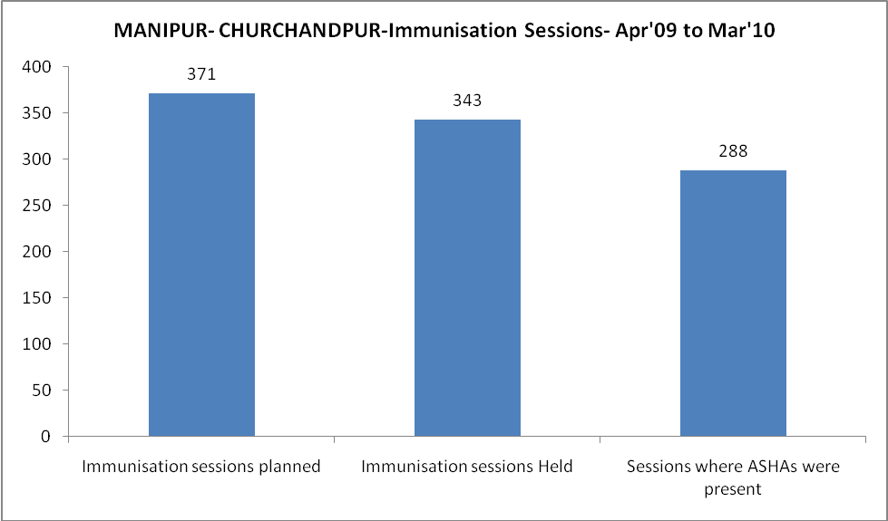
MANIPUR- CHURCHANDPUR- Apr'09 to Mar'10
Total Abortions | Abortion Rate
524 | 9.6%

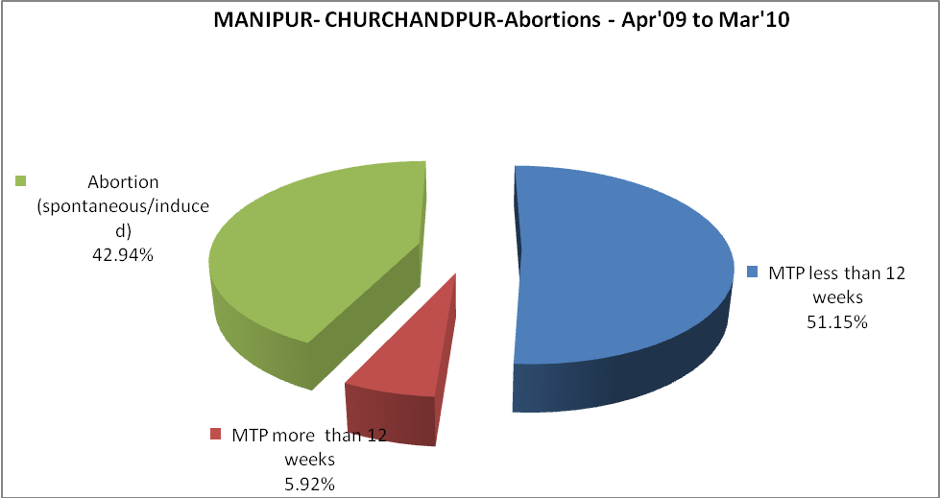
MANIPUR- CHURCHANDPUR- Apr'09 to Mar'10
Total OPD | Total RTI/STI cases
79,648 | 638
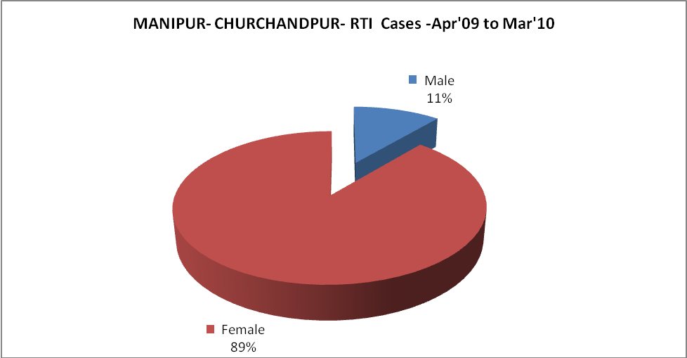

MANIPUR- CHURCHANDPUR-FP Methods - Apr'09 to Mar'10
 | Reported | %age of All Reported FP Methods
Total Reported FP Methodd (All types) Users | 1,197 | -
Sterilisations | 507 | 42%
IUD | 297 | 25%
Condom Users | 202 | 17%
OCP Users | 191 | 16%
Limiting Methods | 507 | 42%
Spacing Methods | 690 | 58%

MANIPUR- CHURCHANDPUR- Service Delivery - Apr'09 to Mar'10
Operation major (General and spinal anaesthesia) | Operation minor (No or local anaesthesia) | AYUSH | Dental Procedures | Adolescent counselling services | Total OPD | Total IPD
412 | 784 | 966 | 995 | - | 79,648 | 7,191
Operation major (General and spinal anaesthesia) as %ge of OPD | Operation minor (No or local anaesthesia)as %ge of OPD | AYUSH as %ge of OPD | Dental Procedures as %ge of OPD | Adolescent counselling services as %ge of OPD | IPD as percentage of OPD
0.5% | 1.0% | 1.2% | 1.2% | 0.0% | 9%

MANIPUR- CHURCHANDPUR- Lab Services - Apr'09 to Mar'10
Total OPD | Total HB tested | Total HIV Tested | Total Population
79,648 | 2,053 | 4,513 | 313,409
HB test conducted as %age of OPD | HB<7gm as %age of HB tested | HIV test conducted as %age of OPD | HIV positive as %age of HIV tested | Blood Smear Examined as % of Population
2.6% | 2.0% | 5.7% | 2.9% | 5.4%

MANIPUR- CHURCHANDPUR- Childhood Disease - Vaccine Preventable -Apr'09 to Mar'10
Diphtheria | Pertussis | Tetanus Neonatorum | Tetanus others |  | Polio | Measles
0 | 0 | 0 | 0 |  | 0 | 148
MANIPUR- CHURCHANDPUR-Childhood Disease - Others - Apr'09 to Mar'10

Diarrhoea and dehydration | Malaria | Number admitted with Respiratory Infections
1,402 | 31 | 163

MANIPUR- CHURCHANDPUR- Infant & Child Deaths - Apr'09 to Mar'10
Infant Deaths within 24 hrs of birth | Infant Deaths between 24hrs & under 1 week | Infant Deaths between 1 week & under 1 month | Child Deaths between 1 month & under 1 year | Child Deaths between 1yr under 5years | Total Deaths
0 | 5 | 1 | 3 | 0 | 9

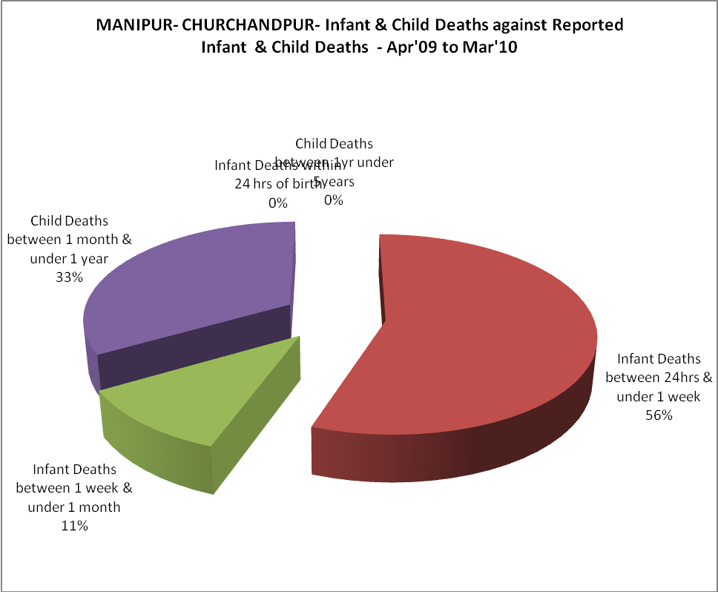
MANIPUR- CHURCHANDPUR- Causes of Infant & Child Deaths - Apr'09 to Mar'10
Sepsis |  |  | Asphyxia |  |  | LBW
Up to 1 Weeks of Birth | Between 1 week & 4 weeks of birth | Total | Up to 1 Weeks of Birth | Between 1 week & 4 weeks of birth | Total | Up to 1 Weeks of Birth | Between 1 week & 4 weeks of birth | Total
3 | 1 | 4 | 0 | 0 | 0 | 2 | 0 | 2
Pneumonia |  |  | Diarrhoea |  |  | Fever related
Between 1 month and 11 months | Between 1 year & 5 years | Total | Between 1 month and 11 months | Between 1 year & 5 years | Total | Between 1 month and 11 months | Between 1 year & 5 years | Total
2 | 0 | 2 | 0 | 0 | 0 | 1 | 0 | 1
Others |  |  | Measles |  |  | Others
Up to 1 Weeks of Birth | Between 1 week & 4 weeks of birth | Total | Between 1 month and 11 months | Between 1 year & 5 years | Total | Between 1 month and 11 months | Between 1 year & 5 years | Total
0 | 0 | 0 | 0 | 0 | 0 | 0 | 0 | 0

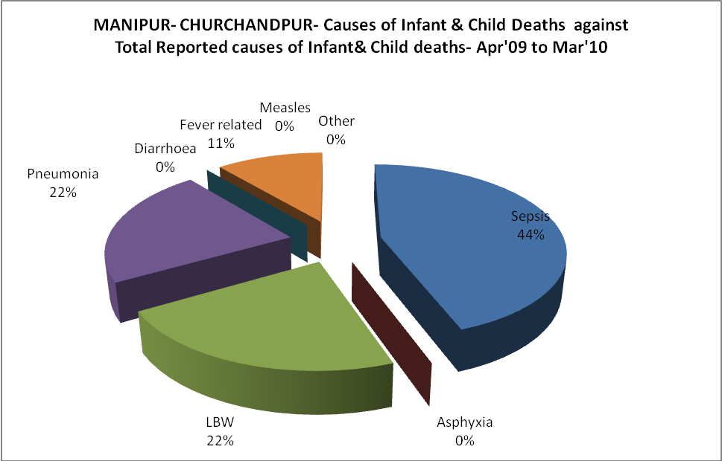
MANIPUR- CHURCHANDPUR- Maternal Deaths & Causes - Apr'09 to Mar'10
Abortion |  |  | Obstructed/prolonged labour |  |  | Severe hypertesnion/fits
6-14 yrs | 15-55 yrs. | Total | 6-14 yrs | 15-55 yrs. | Total | 6-14 yrs | 15-55 yrs. | Total
0 | 0 | 0 | 0 | 0 | 0 | 0 | 0 | 0
Bleeding |  |  | High Fever |  |  | Other Causes
6-14 yrs | 15-55 yrs. | Total | 6-14 yrs | 15-55 yrs. | Total | 6-14 yrs | 15-55 yrs. | Total
0 | 0 | 0 | 0 | 0 | 0 | 0 | 0 | 0

MANIPUR- CHURCHANDPUR-Causes of Deaths in 6 to 55yrs age group - Apr'09 to Mar'10
Diarrhoel Diseases |  |  |  | Tuberculosis |  |  |  | Respiratory Diseases( Other than TB)
6-14 yrs | 15-55 yrs. | Above 55yrs | Total | 6-14 yrs | 15-55 yrs. | Above 55yrs | Total | 6-14 yrs | 15-55 yrs. | Above 55yrs | Total
0 | 0 | 0 | 0 | 0 | 0 | 0 | 0 | 0 | 1 | 0 | 1
Malaria |  |  |  | Other fever Related |  |  |  | HIV/Aids
6-14 yrs | 15-55 yrs. | Above 55yrs | Total | 6-14 yrs | 15-55 yrs. | Above 55yrs | Total | 6-14 yrs | 15-55 yrs. | Above 55yrs | Total
2 | 2 | 5 | 9 | 1 | 0 | 0 | 1 | 0 | 0 | 0 | 0
Heart Disease/Hypertenion related |  |  |  | Neurological Disease including strokes |  |  |  | Trauma/Accidents/ Burn Cases
6-14 yrs | 15-55 yrs. | Above 55yrs | Total | 6-14 yrs | 15-55 yrs. | Above 55yrs | Total | 6-14 yrs | 15-55 yrs. | Above 55yrs | Total
0 | 2 | 1 | 3 | 0 | 1 | 0 | 1 | 1 | 2 | 0 | 3
Suicide |  |  |  | Animal Bites & Stings
6-14 yrs | 15-55 yrs. | Above 55yrs | Total | 6-14 yrs | 15-55 yrs. | Above 55yrs | Total
0 | 0 | 0 | 0 | 0 | 0 | 0 | 0

