NHSRC
MANIPUR- Imphal East
HMIS Data Analysis 2009-10

Amit
8/6/2010

MANIPUR- Imphal East- Summary-Apr'09 to Mar'10
ANC
ANC Registration against Expected Pregnancies | 128% | TT1 given to Pregnant women against ANC Registraion | 53%
3 ANC Check ups against ANC Reigtrations | 36% | 100 IFA Tablets given to Pregnant women against ANC Registraion | 79%
Deliveries
Unreported Deliveries against Estimated Deliveries | 68.3% | HOME Deliveries( SBA& Non SBA) against Estimated Deliveries | 4.8%
Institutional Deliveries against Estimated Deliveries | 26.9% | HOME Deliveries( SBA& Non SBA) against Reported Deliveries | 15.2%
Institutional Deliveries against Reported Deliveries | 84.8% | C Section Deliveries against Institutional Deliveries( Pvt & Pub) | 7%
Births & Neonates Care
Live Births Reported against Estimated Live Births | 32% | New borns weighed against Reported Live Births | 90%
Still Births (Reported) | - | New borns weighed less than 2.5 kgs against newborns weighed | 8%
Sex Ratio at Birh | 916 | New borns breastfed within one hr of Birth against Reported live Births | 83%
Child Immunisation( 0 to 11 months)
BCG given against Expected Live Births | 98% | Measles given against Expected Live Births | 88%
OPV3 given against Expected Live Births | 95% | Fully Immunised Children against Expected Live Births | 86%
DPT3 given against Expected Live Births | 95%
Family Planning
Family Plannig Methods Users ( Sterilisations(Male &Female)+IUD+ Condom pieces/72 + OCP Cycles/13) | 1,838 | IUD Insertions against reported FP Methods | 47%
Sterilisation against reported FP Methods | 0% | Condom Users against reported FP Methods | 24%
 |  | OCP Users against reported FP Methods | 30%
Other Services
OPD | 109,941 | Major Operations | 220
IPD | 6,868 | Minor Operations | 999

MANIPUR- Imphal East- Deliveries Apr'09 to Mar'10
Total Population | 543,511 | Expected Deliveries |  | 8,648
Home SBA | Home Non SBA | Institutional | Total Deliveries Reported | Unreported Deliveries
277 | 140 | 2,324 | 2,741 | 5,907
Home SBA % | Home Non SBA% | Institutional % | Total Deliveries Reported % | Unreported Deliveries %
3% | 2% | 27% | 32% | 68%

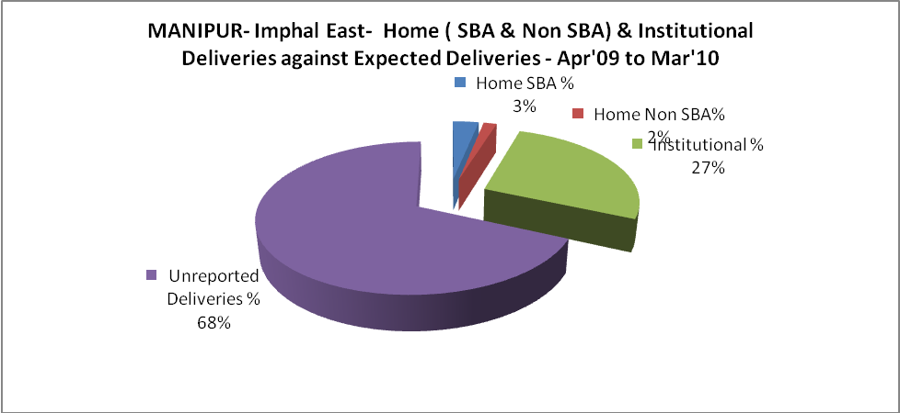
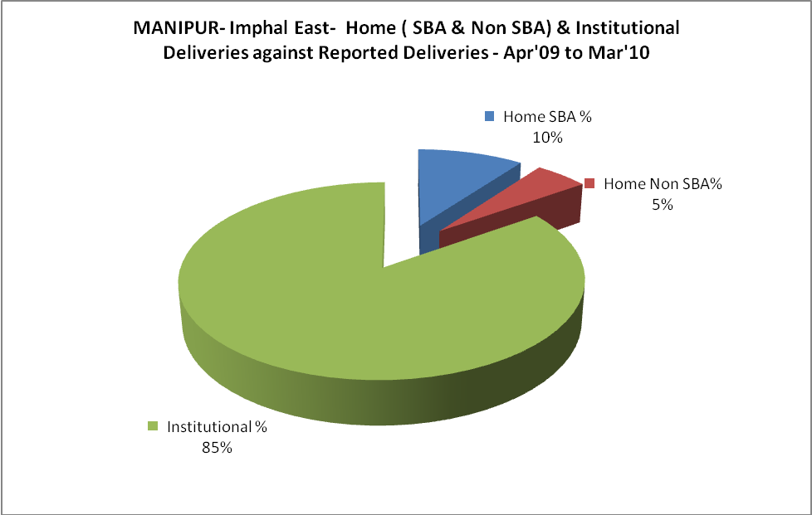
MANIPUR- Imphal East- C sections & Complicated Deliveries Apr'09 to Mar'10
 | Institutional Deliveries (Public) | Institutional Deliveries (Pvt)
 | 2,148 | 176
C Section | 139 | 16
C Section% | 6% | -
Complicated Pregnacies attended | 3 | -
Complicated Pregnacies attended % | 0% | -

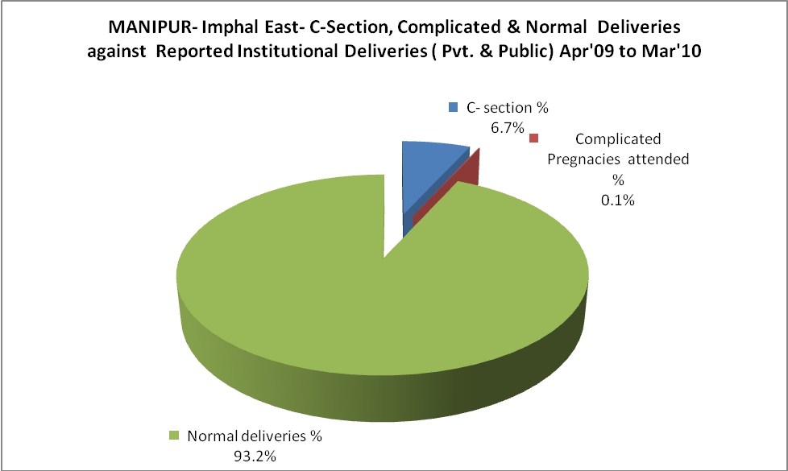

MANIPUR- Imphal East- Complicated Pregnancies & Deliveries Treated - Apr'09 to Mar'10
Reported Deliveries |  |  | Reported ANC Registration
2,741 |  |  | 12,092
Complicated Pregnancies attended | Complicated Pregnancies Rate | C - Section Deliveries | PNC Maternal Complications | Abortions | Still Births
3 | 0% | 155 | 25 | 85 | -
Complicated Deliveries Treated with |  |  |  | No Of Eclampsia cases Treated | No Of severe anemia cases treated
IV Antibiotics | IV antihypertensive/Magsulph injection | IV Oxytocis | Blood Transfusion | No Of Eclampsia cases Treated | No Of severe anemia cases treated
150 | 2 | - | 7 | 6 | 120

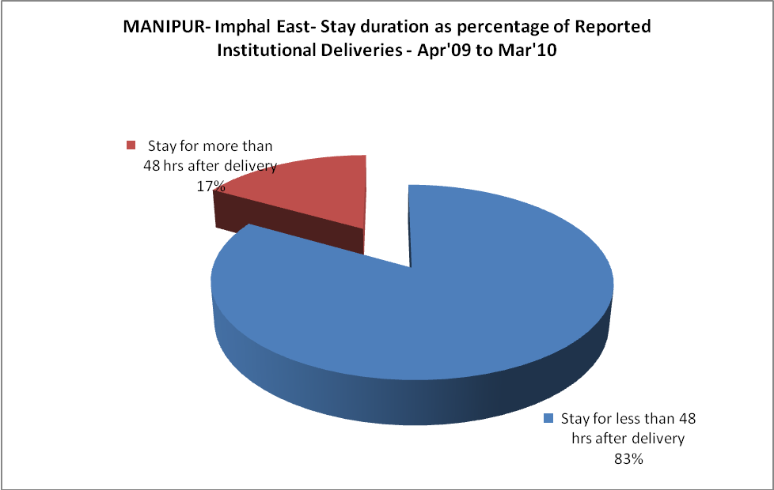
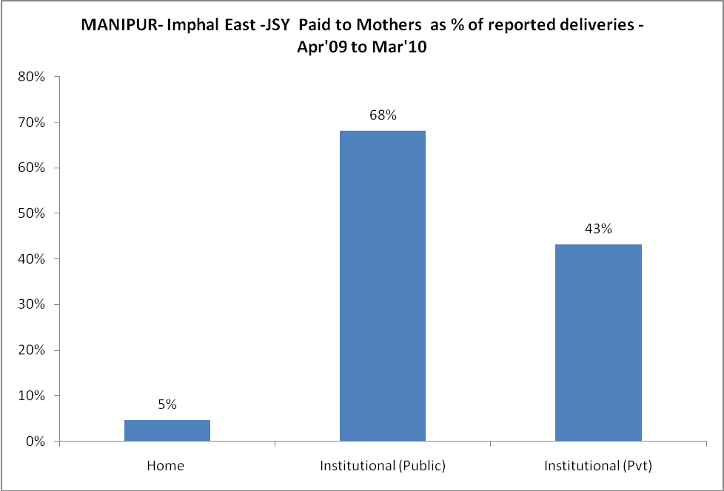
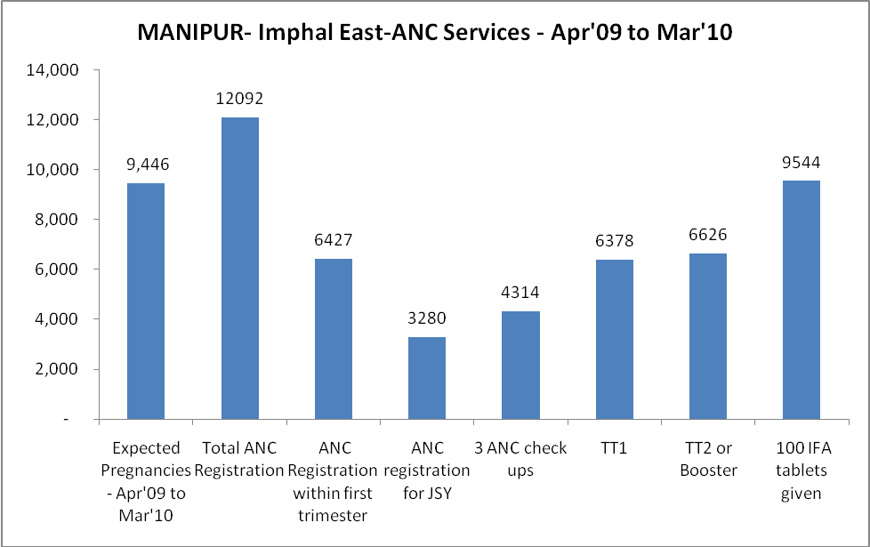
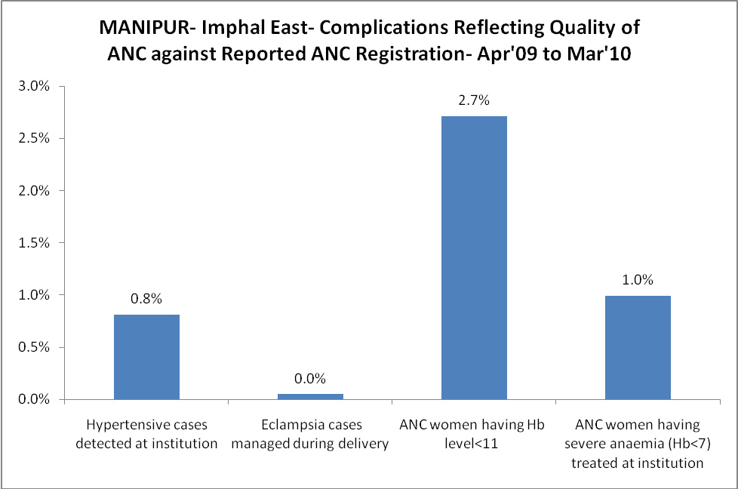

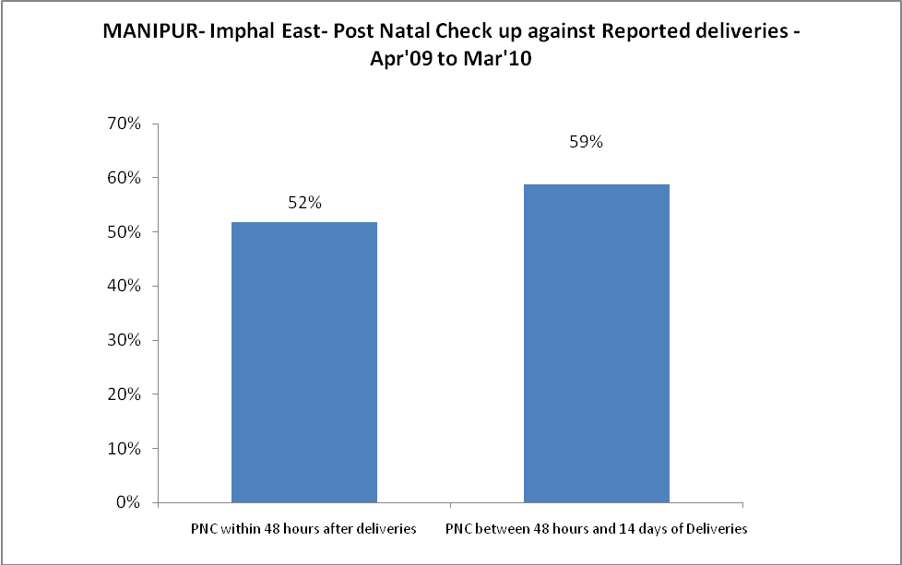
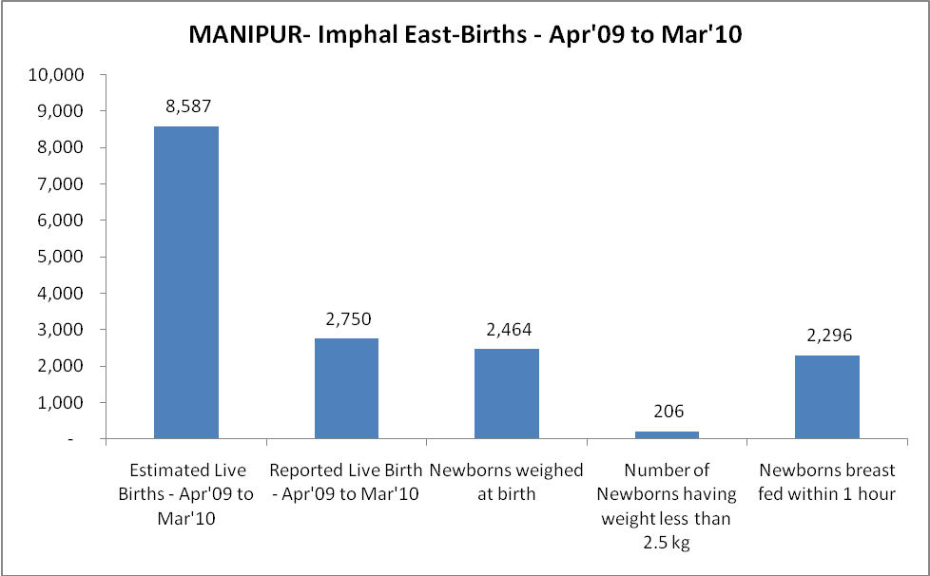

MANIPUR- Imphal East - Births - Apr'09 to Mar'10
Live Birth - Males | Live Birth - females | Live Birth - Total | Sex Ratio at birth | Still Birth | Abortion( Induced/Spontaneous
1,435 | 1,315 | 2,750 | 916 | - | 85

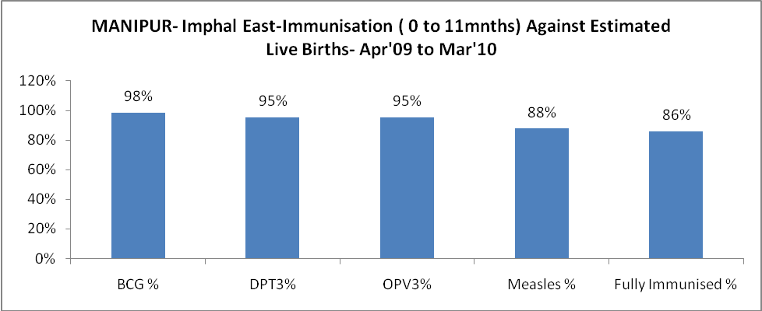
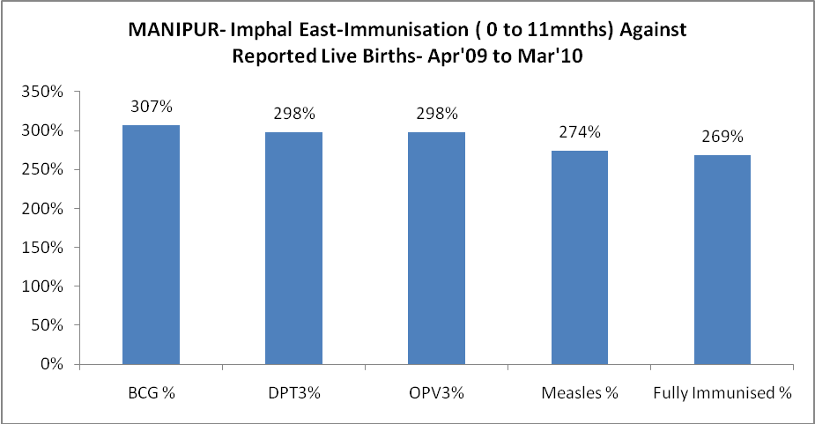

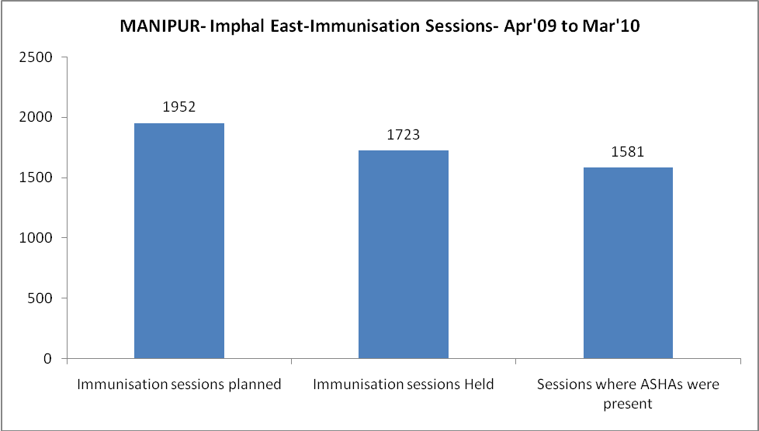
MANIPUR- Imphal East- Apr'09 to Mar'10
Total Abortions | Abortion Rate
1,239 | 13.1%

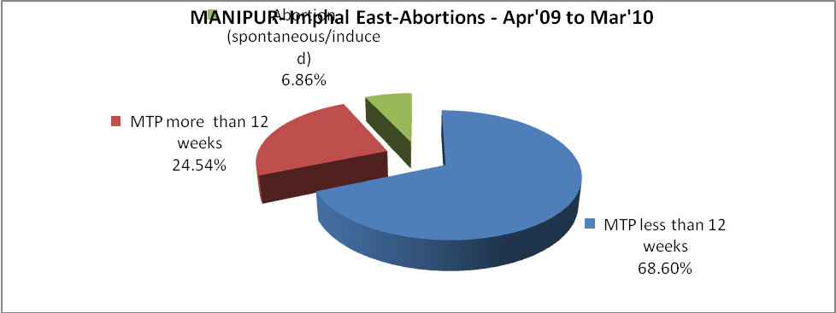

MANIPUR- Imphal East- Apr'09 to Mar'10
Total OPD | Total RTI/STI cases
109,941 | 997
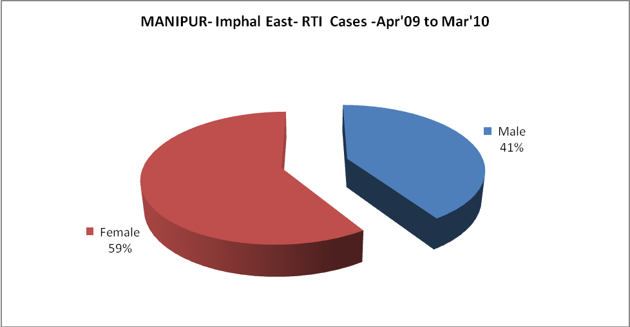
MANIPUR- Imphal East-FP Methods - Apr'09 to Mar'10
 | Reported | %age of All Reported FP Methods
Total Reported FP Methodd (All types) Users | 1,838 | -
Sterilisations | - | 0%
IUD | 863 | 47%
Condom Users | 432 | 24%
OCP Users | 542 | 30%
Limiting Methods | - | 0%
Spacing Methods | 1,838 | 100%

MANIPUR- Imphal East- Service Delivery - Apr'09 to Mar'10
Operation major (General and spinal anaesthesia) | Operation minor (No or local anaesthesia) | AYUSH | Dental Procedures | Adolescent counselling services | Total OPD | Total IPD
220 | 999 | 6,691 | 1,558 | - | 109,941 | 6,868
Operation major (General and spinal anaesthesia) as %ge of OPD | Operation minor (No or local anaesthesia)as %ge of OPD | AYUSH as %ge of OPD | Dental Procedures as %ge of OPD | Adolescent counselling services as %ge of OPD | IPD as percentage of OPD
0.2% | 0.9% | 6.1% | 1.4% | 0.0% | 6%

MANIPUR- Imphal East- Lab Services - Apr'09 to Mar'10
Total OPD | Total HB tested | Total HIV Tested | Total Population
109,941 | 2,058 | 1,577 | 543,511
HB test conducted as %age of OPD | HB<7gm as %age of HB tested | HIV test conducted as %age of OPD | HIV positive as %age of HIV tested | Blood Smear Examined as % of Population
1.9% | 0.1% | 1.4% | 3.2% | 0.9%

MANIPUR- Imphal East- Childhood Disease - Vaccine Preventable -Apr'09 to Mar'10
Diphtheria | Pertussis | Tetanus Neonatorum | Tetanus others | Polio | Measles
0 | 0 | 0 | 0 | 0 | 96
MANIPUR- Imphal East-Childhood Disease - Others - Apr'09 to Mar'10
Diarrhoea and dehydration | Malaria | Number admitted with Respiratory Infections
1,739 | 11 | 543

MANIPUR- Imphal East- Infant & Child Deaths - Apr'09 to Mar'10
Infant Deaths within 24 hrs of birth | Infant Deaths between 24hrs & under 1 week | Infant Deaths between 1 week & under 1 month | Child Deaths between 1 month & under 1 year | Child Deaths between 1yr under 5years | Total Deaths
1 | 0 | 0 | 1 | 4 | 6

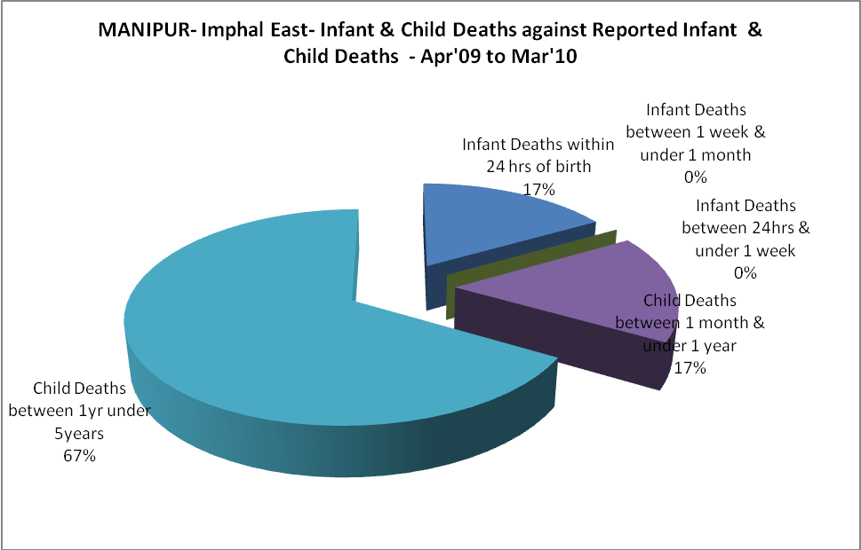

MANIPUR- Imphal East- Causes of Infant & Child Deaths - Apr'09 to Mar'10
Sepsis |  |  | Asphyxia |  |  | LBW
Up to 1 Weeks of Birth | Between 1 week & 4 weeks of birth | Total | Up to 1 Weeks of Birth | Between 1 week & 4 weeks of birth | Total | Up to 1 Weeks of Birth | Between 1 week & 4 weeks of birth | Total
0 | 0 | 0 | 0 | 0 | 0 | 0 | 0 | 0
Pneumonia |  |  | Diarrhoea |  |  | Fever related
Between 1 month and 11 months | Between 1 year & 5 years | Total | Between 1 month and 11 months | Between 1 year & 5 years | Total | Between 1 month and 11 months | Between 1 year & 5 years | Total
1 | 0 | 1 | 0 | 0 | 0 | 0 | 0 | 0
Others |  |  | Measles |  |  | Others
Up to 1 Weeks of Birth | Between 1 week & 4 weeks of birth | Total | Between 1 month and 11 months | Between 1 year & 5 years | Total | Between 1 month and 11 months | Between 1 year & 5 years | Total
0 | 0 | 0 | 0 | 0 | 0 | 0 | 4 | 4

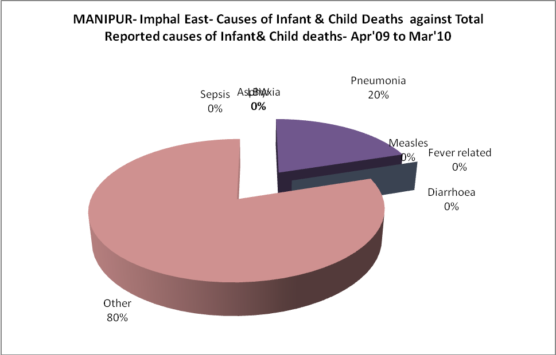
MANIPUR- Imphal East- Maternal Deaths & Causes - Apr'09 to Mar'10
Abortion |  |  | Obstructed/prolonged labour |  |  | Severe hypertesnion/fits
6-14 yrs | 15-55 yrs. | Total | 6-14 yrs | 15-55 yrs. | Total | 6-14 yrs | 15-55 yrs. | Total
0 | 0 | 0 | 0 | 0 | 0 | 0 | 0 | 0
Bleeding |  |  | High Fever |  |  | Other Causes
6-14 yrs | 15-55 yrs. | Total | 6-14 yrs | 15-55 yrs. | Total | 6-14 yrs | 15-55 yrs. | Total
0 | 0 | 0 | 0 | 0 | 0 | 0 | 0 | 0

MANIPUR- Imphal East-Causes of Deaths in 6 to 55yrs age group - Apr'09 to Mar'10
Diarrhoel Diseases |  |  |  | Tuberculosis |  |  |  | Respiratory Diseases( Other than TB)
6-14 yrs | 15-55 yrs. | Above 55yrs | Total | 6-14 yrs | 15-55 yrs. | Above 55yrs | Total | 6-14 yrs | 15-55 yrs. | Above 55yrs | Total
0 | 0 | 0 | 0 | 0 | 0 | 1 | 1 | 0 | 0 | 0 | 0
Malaria |  |  |  | Other fever Related |  |  |  | HIV/Aids
6-14 yrs | 15-55 yrs. | Above 55yrs | Total | 6-14 yrs | 15-55 yrs. | Above 55yrs | Total | 6-14 yrs | 15-55 yrs. | Above 55yrs | Total
0 | 0 | 0 | 0 | 0 | 0 | 1 | 1 | 0 | 0 | 0 | 0
Heart Disease/Hypertenion related |  |  |  | Neurological Disease including strokes |  |  |  | Trauma/Accidents/ Burn Cases
6-14 yrs | 15-55 yrs. | Above 55yrs | Total | 6-14 yrs | 15-55 yrs. | Above 55yrs | Total | 6-14 yrs | 15-55 yrs. | Above 55yrs | Total
0 | 5 | 6 | 11 | 0 | 2 | 3 | 5 | 1 | 5 | 0 | 6
Suicide |  |  |  | Animal Bites & Stings
6-14 yrs | 15-55 yrs. | Above 55yrs | Total | 6-14 yrs | 15-55 yrs. | Above 55yrs | Total
0 | 2 | 0 | 2 | 0 | 0 | 0 | 0

