NHSRC
MANIPUR- Imphal West
HMIS Data Analysis 2009-10

Amit
8/6/2010

MANIPUR- Imphal West- Summary-Apr'09 to Mar'10
ANC
ANC Registration against Expected Pregnancies |  |  | 475% | TT1 given to Pregnant women against ANC Registraion |  |  | 19%
3 ANC Check ups against ANC Reigtrations |  |  | 46% | 100 IFA Tablets given to Pregnant women against ANC Registraion |  |  | 5%
Deliveries
Unreported Deliveries against Estimated Deliveries |  |  | -51.1% | HOME Deliveries( SBA& Non SBA) against Estimated Deliveries |  |  | 4.7%
Institutional Deliveries against Estimated Deliveries |  |  | 146.3% | HOME Deliveries( SBA& Non SBA) against Reported Deliveries |  |  | 3.1%
Institutional Deliveries against Reported Deliveries |  |  | 96.9% | C Section Deliveries against Institutional Deliveries( Pvt & Pub) |  |  | 35%
Births & Neonates Care
Live Births Reported against Estimated Live Births |  |  | 155% | New borns weighed against Reported Live Births |  |  | 99%
Still Births (Reported) |  |  | 159 | New borns weighed less than 2.5 kgs against newborns weighed |  |  | 8%
Sex Ratio at Birh |  |  | 951 | New borns breastfed within one hr of Birth against Reported live Births |  |  | 78%
Child Immunisation( 0 to 11 months)
BCG given against Expected Live Births |  |  | 115% | Measles given against Expected Live Births |  |  | 89%
OPV3 given against Expected Live Births |  |  | 99% | Fully Immunised Children against Expected Live Births |  |  | 86%
DPT3 given against Expected Live Births |  |  | 99%
Family Planning
Family Plannig Methods Users ( Sterilisations(Male &Female)+IUD+ Condom pieces/72 + OCP Cycles/13) |  |  | 2,707 | IUD Insertions against reported FP Methods |  |  | 38%
Sterilisation against reported FP Methods |  |  | 19% | Condom Users against reported FP Methods |  |  | 27%
 |  |  |  | OCP Users against reported FP Methods |  |  | 16%
Other Services
OPD |  |  | 131,932 | Major Operations |  |  | 5,349
IPD |  |  | 14,170 | Minor Operations |  |  | 2,253
MANIPUR- Imphal West- Deliveries Apr'09 to Mar'10
Total Population | 612,368 | Expected Deliveries |  |  |  | 9,743
Home SBA | Home Non SBA | Institutional |  |  | Total Deliveries Reported | Unreported Deliveries
293 | 166 | 14,259 |  |  | 14,718 | (4,975)
Home SBA % | Home Non SBA% | Institutional % |  |  | Total Deliveries Reported % | Unreported Deliveries %
3% | 2% | 146% |  |  | 151% | -51%

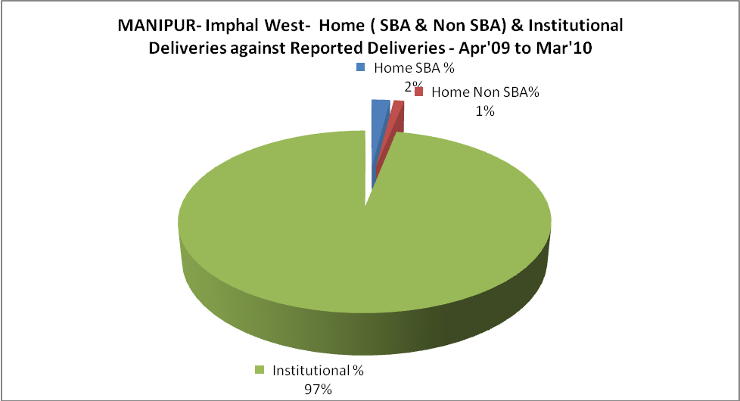

MANIPUR- Imphal West- C sections & Complicated Deliveries Apr'09 to Mar'10
 | Institutional Deliveries (Public) | Institutional Deliveries (Pvt)
 | 10,138 | 4,121
C Section | 2,808 | 2,213
C Section% | 28% | -
Complicated Pregnacies attended | - | 2
Complicated Pregnacies attended % | 0% | -

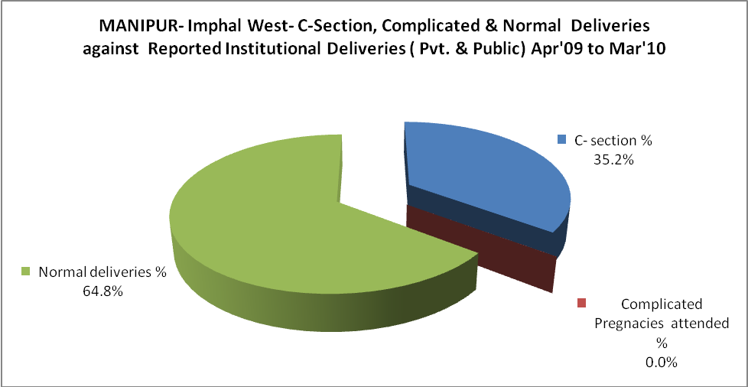

MANIPUR- Imphal West- Complicated Pregnancies & Deliveries Treated - Apr'09 to Mar'10
Reported Deliveries |  |  | Reported ANC Registration
14,718 |  |  | 50,599
Complicated Pregnancies attended | Complicated Pregnancies Rate | C - Section Deliveries | PNC Maternal Complications | Abortions | Still Births
2 | 0% | 5,021 | 5 | 697 | 159
Complicated Deliveries Treated with |  |  |  | No Of Eclampsia cases Treated | No Of severe anemia cases treated
IV Antibiotics | IV antihypertensive/Magsulph injection | IV Oxytocis | Blood Transfusion | No Of Eclampsia cases Treated | No Of severe anemia cases treated
11 | 8 | 109 | - | 2 | 59

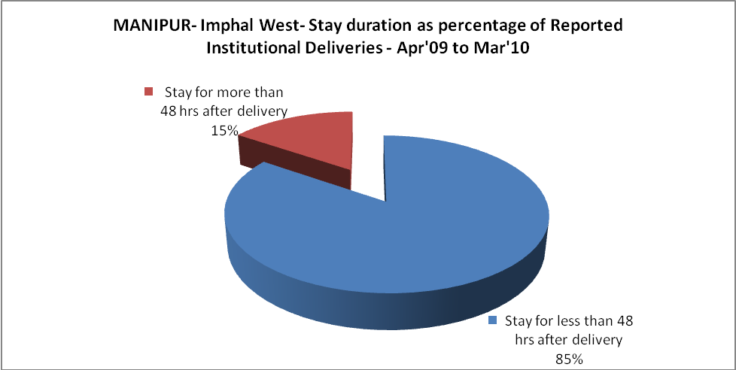
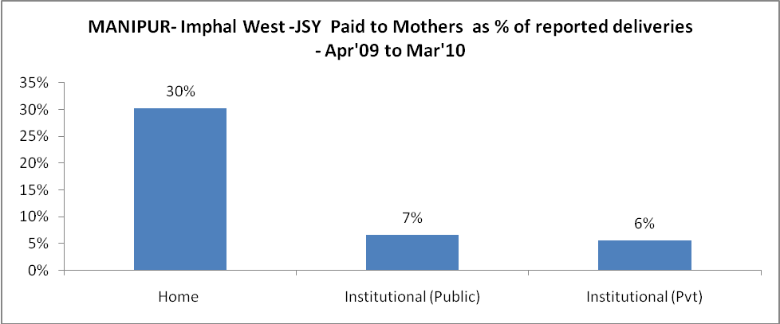

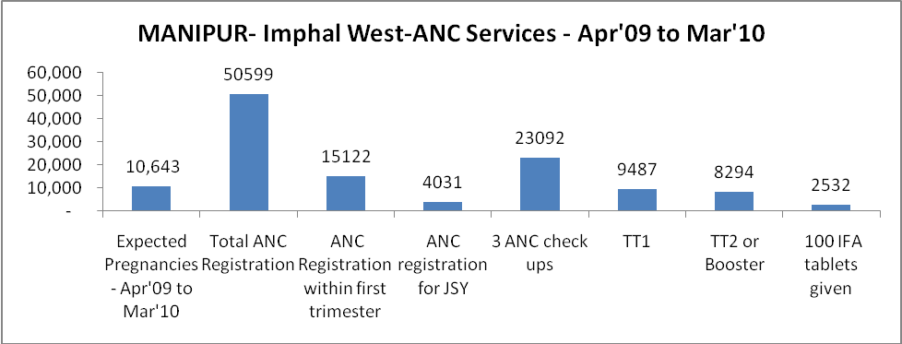
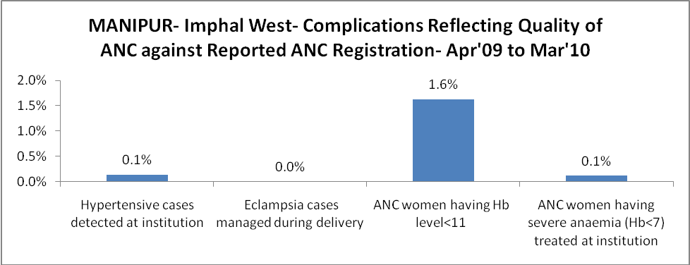

MANIPUR- Imphal West - Births - Apr'09 to Mar'10
Live Birth - Males | Live Birth - females | Live Birth - Total | Sex Ratio at birth | Still Birth | Abortion( Induced/Spontaneous
7,688 | 7,311 | 14,999 | 951 | 159 | 697

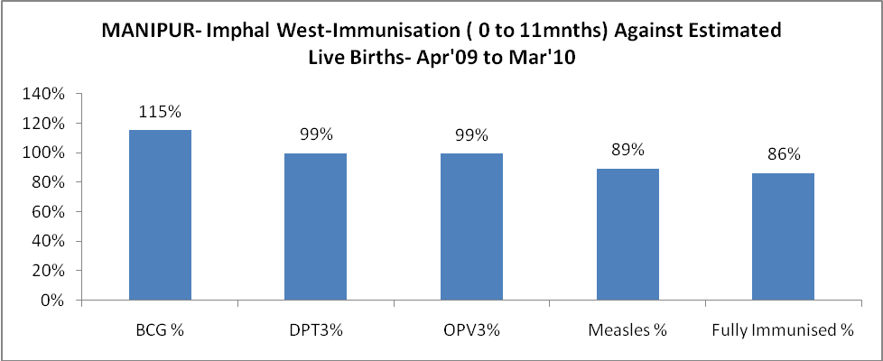
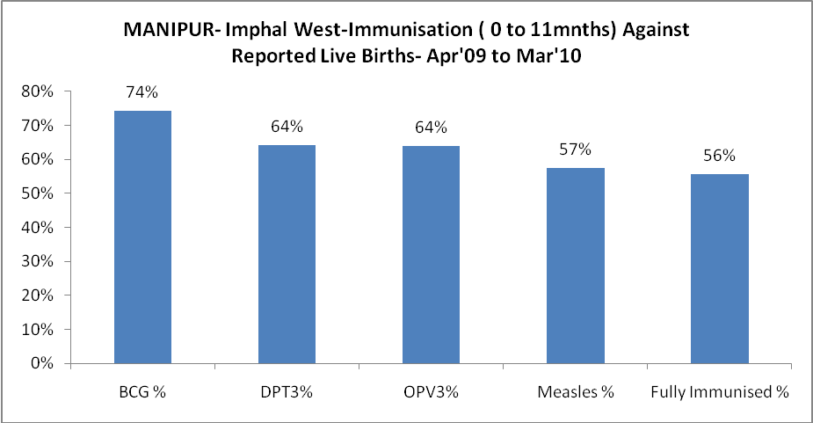

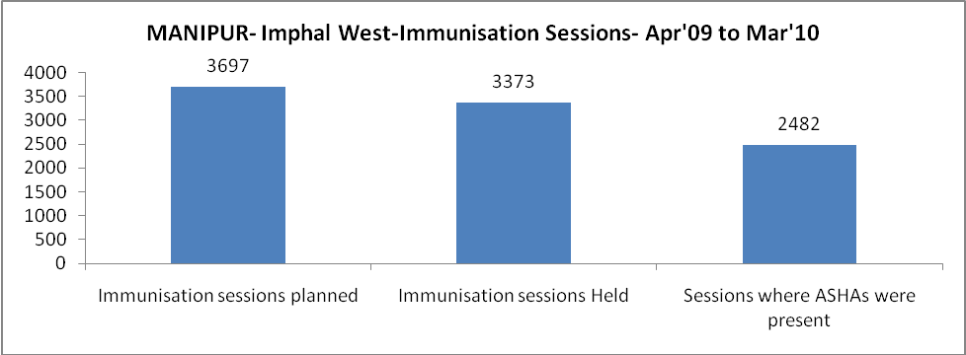
MANIPUR- Imphal West- Apr'09 to Mar'10
Total Abortions | Abortion Rate
2,226 | 20.9%

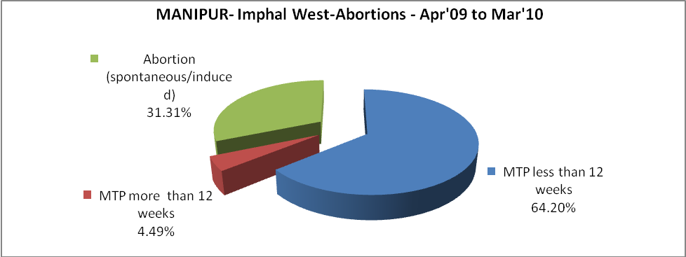
MANIPUR- Imphal West- Apr'09 to Mar'10
Total OPD | Total RTI/STI cases
131,932 | 837
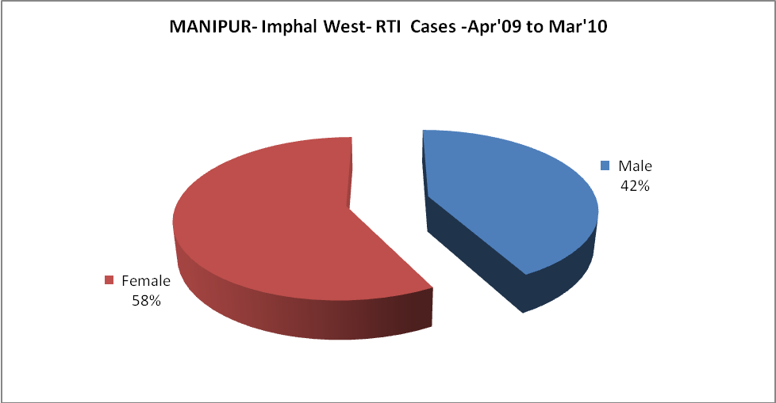
MANIPUR- Imphal West-Sterilisations - Apr'09 to Mar'10
 | Reported | %age of Reported Sterilisation
Total Sterilisation | 516 | -
NSV | 67 | 13%
Laproscopic | 52 | 10%
MiniLap | 19 | 4%
Post Partum | 378 | 73%
Male Sterilisation | 67 | 13%
Female Sterilisation | 449 | 87%

MANIPUR- Imphal West-FP Methods - Apr'09 to Mar'10
 | Reported | %age of All Reported FP Methods
Total Reported FP Methodd (All types) Users | 2,707 | -
Sterilisations | 516 | 19%
IUD | 1,018 | 38%
Condom Users | 744 | 27%
OCP Users | 429 | 16%
Limiting Methods | 516 | 19%
Spacing Methods | 2,191 | 81%

MANIPUR- Imphal West- Service Delivery - Apr'09 to Mar'10
Operation major (General and spinal anaesthesia) | Operation minor (No or local anaesthesia) | AYUSH | Dental Procedures | Adolescent counselling services | Total OPD | Total IPD
5,349 | 2,253 | 9,915 | 319 | 7 | 131,932 | 14,170
Operation major (General and spinal anaesthesia) as %ge of OPD | Operation minor (No or local anaesthesia)as %ge of OPD | AYUSH as %ge of OPD | Dental Procedures as %ge of OPD | Adolescent counselling services as %ge of OPD | IPD as percentage of OPD
4.1% | 1.7% | 7.5% | 0.2% | 0.0% | 11%

MANIPUR- Imphal West- Lab Services - Apr'09 to Mar'10
Total OPD | Total HB tested | Total HIV Tested | Total Population
131,932 | 3,571 | 3,721 | 612,368
HB test conducted as %age of OPD | HB<7gm as %age of HB tested | HIV test conducted as %age of OPD | HIV positive as %age of HIV tested | Blood Smear Examined as % of Population
2.7% | 4.6% | 2.8% | 3.0% | 0.4%

MANIPUR- Imphal West- Childhood Disease - Vaccine Preventable -Apr'09 to Mar'10
Diphtheria | Pertussis | Tetanus Neonatorum | Tetanus others | Polio | Measles
0 | 0 | 0 | 0 | 0 | 126
MANIPUR- Imphal West-Childhood Disease - Others - Apr'09 to Mar'10
Diarrhoea and dehydration | Malaria | Number admitted with Respiratory Infections
2,373 | 114 | 632

MANIPUR- Imphal West- Infant & Child Deaths - Apr'09 to Mar'10
Infant Deaths within 24 hrs of birth | Infant Deaths between 24hrs & under 1 week | Infant Deaths between 1 week & under 1 month | Child Deaths between 1 month & under 1 year | Child Deaths between 1yr under 5years | Total Deaths
0 | 0 | 0 | 0 | 1 | 1

MANIPUR- Imphal West- Causes of Infant & Child Deaths - Apr'09 to Mar'10
Sepsis |  |  | Asphyxia |  |  | LBW
Up to 1 Weeks of Birth | Between 1 week & 4 weeks of birth | Total | Up to 1 Weeks of Birth | Between 1 week & 4 weeks of birth | Total | Up to 1 Weeks of Birth | Between 1 week & 4 weeks of birth | Total
0 | 0 | 0 | 0 | 0 | 0 | 0 | 0 | 0
Pneumonia |  |  | Diarrhoea |  |  | Fever related
Between 1 month and 11 months | Between 1 year & 5 years | Total | Between 1 month and 11 months | Between 1 year & 5 years | Total | Between 1 month and 11 months | Between 1 year & 5 years | Total
0 | 0 | 0 | 0 | 0 | 0 | 0 | 0 | 0
Others |  |  | Measles |  |  | Others
Up to 1 Weeks of Birth | Between 1 week & 4 weeks of birth | Total | Between 1 month and 11 months | Between 1 year & 5 years | Total | Between 1 month and 11 months | Between 1 year & 5 years | Total
0 | 0 | 0 | 0 | 0 | 0 | 0 | 1 | 1

MANIPUR- Imphal West- Maternal Deaths & Causes - Apr'09 to Mar'10
Abortion |  |  | Obstructed/prolonged labour |  |  | Severe hypertesnion/fits
6-14 yrs | 15-55 yrs. | Total | 6-14 yrs | 15-55 yrs. | Total | 6-14 yrs | 15-55 yrs. | Total
0 | 0 | 0 | 0 | 0 | 0 | 0 | 2 | 2
Bleeding |  |  | High Fever |  |  | Other Causes
6-14 yrs | 15-55 yrs. | Total | 6-14 yrs | 15-55 yrs. | Total | 6-14 yrs | 15-55 yrs. | Total
0 | 0 | 0 | 0 | 0 | 0 | 0 | 1 | 1

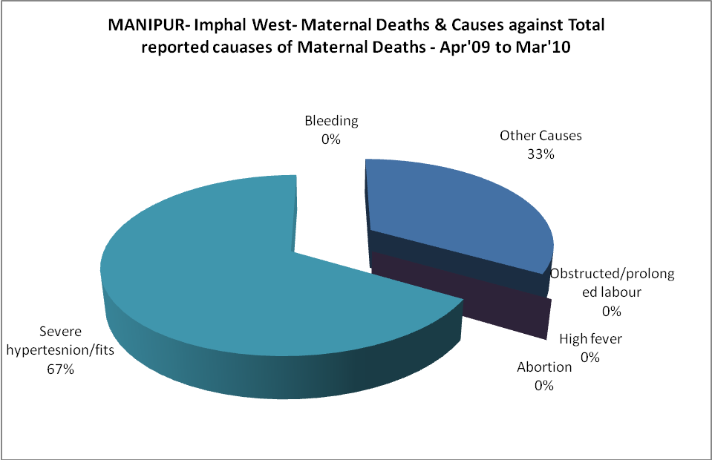
MANIPUR- Imphal West-Causes of Deaths in 6 to 55yrs age group - Apr'09 to Mar'10
Diarrhoel Diseases |  |  |  | Tuberculosis |  |  |  | Respiratory Diseases( Other than TB)
6-14 yrs | 15-55 yrs. | Above 55yrs | Total | 6-14 yrs | 15-55 yrs. | Above 55yrs | Total | 6-14 yrs | 15-55 yrs. | Above 55yrs | Total
0 | 0 | 0 | 0 | 0 | 1 | 1 | 2 | 0 | 0 | 2 | 2
Malaria |  |  |  | Other fever Related |  |  |  | HIV/Aids
6-14 yrs | 15-55 yrs. | Above 55yrs | Total | 6-14 yrs | 15-55 yrs. | Above 55yrs | Total | 6-14 yrs | 15-55 yrs. | Above 55yrs | Total
0 | 0 | 0 | 0 | 0 | 0 | 0 | 0 | 0 | 0 | 0 | 0
Heart Disease/Hypertenion related |  |  |  | Neurological Disease including strokes |  |  |  | Trauma/Accidents/ Burn Cases
6-14 yrs | 15-55 yrs. | Above 55yrs | Total | 6-14 yrs | 15-55 yrs. | Above 55yrs | Total | 6-14 yrs | 15-55 yrs. | Above 55yrs | Total
0 | 3 | 12 | 15 | 0 | 3 | 2 | 5 | 2 | 7 | 19 | 28
Suicide |  |  |  | Animal Bites & Stings
6-14 yrs | 15-55 yrs. | Above 55yrs | Total | 6-14 yrs | 15-55 yrs. | Above 55yrs | Total
0 | 2 | 4 | 6 | 0 | 0 | 1 | 1
