NHSRC
MANIPUR- Tamenglong District
HMIS Data Analysis 2009-10

Amit
8/6/2010

MANIPUR- Tamenglong- Summary-Apr'09 to Mar'10
ANC
ANC Registration against Expected Pregnancies | 104% | TT1 given to Pregnant women against ANC Registraion | 58%
3 ANC Check ups against ANC Reigtrations | 38% | 100 IFA Tablets given to Pregnant women against ANC Registraion | 43%
Deliveries
Unreported Deliveries against Estimated Deliveries | 57.8% | HOME Deliveries( SBA& Non SBA) against Estimated Deliveries | 23.0%
Institutional Deliveries against Estimated Deliveries | 19.1% | HOME Deliveries( SBA& Non SBA) against Reported Deliveries | 54.6%
Institutional Deliveries against Reported Deliveries | 45.4% | C Section Deliveries against Institutional Deliveries( Pvt & Pub) | 0%
Births & Neonates Care
Live Births Reported against Estimated Live Births | 42% | New borns weighed against Reported Live Births | 58%
Still Births (Reported) | 3 | New borns weighed less than 2.5 kgs against newborns weighed | 3%
Sex Ratio at Birh | 964 | New borns breastfed within one hr of Birth against Reported live Births | 95%
Child Immunisation( 0 to 11 months)
BCG given against Expected Live Births | 108% | Measles given against Expected Live Births | 77%
OPV3 given against Expected Live Births | 80% | Fully Immunised Children against Expected Live Births | 67%
DPT3 given against Expected Live Births | 80%
Family Planning
Family Plannig Methods Users ( Sterilisations(Male &Female)+IUD+ Condom pieces/72 + OCP Cycles/13) | 786 | IUD Insertions against reported FP Methods | 57%
Sterilisation against reported FP Methods | 0% | Condom Users against reported FP Methods | 41%
 |  | OCP Users against reported FP Methods | 2%
Other Services
OPD | 24,594 | Major Operations | -
IPD | 2,313 | Minor Operations | 155

MANIPUR- Tamenglong- Deliveries Apr'09 to Mar'10
Total Population | 153,409 | Expected Deliveries |  | 2,441
Home SBA | Home Non SBA | Institutional | Total Deliveries Reported | Unreported Deliveries
248 | 314 | 467 | 1,029 | 1,412
Home SBA % | Home Non SBA% | Institutional % | Total Deliveries Reported % | Unreported Deliveries %
10% | 13% | 19% | 42% | 58%

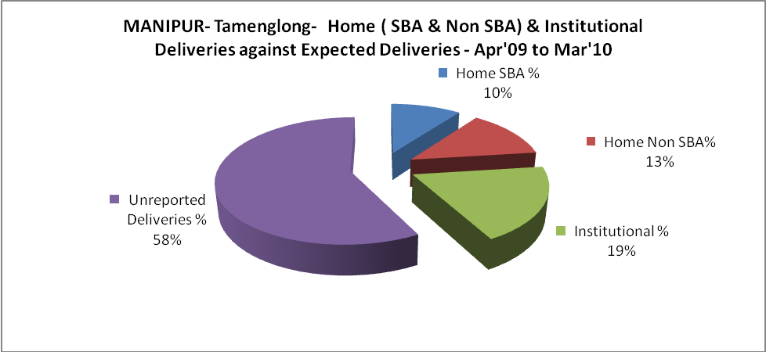
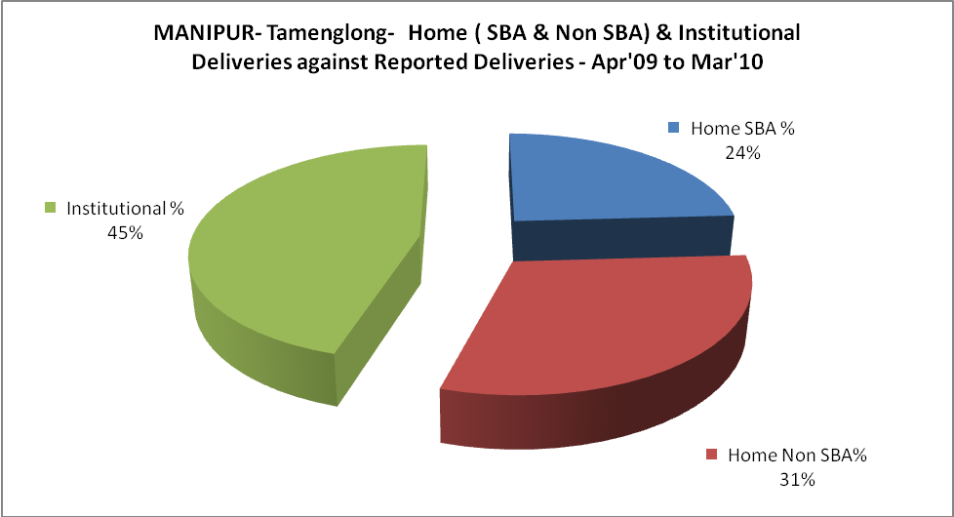
MANIPUR- Tamenglong- C sections & Complicated Deliveries Apr'09 to Mar'10
 | Institutional Deliveries (Public) | Institutional Deliveries (Pvt)
 | 467 | -
C Section | - | -
C Section% | 0% | -
Complicated Pregnacies attended | 1 | -
Complicated Pregnacies attended % | 0% | -

MANIPUR- Tamenglong- Complicated Pregnancies & Deliveries Treated - Apr'09 to Mar'10
Reported Deliveries |  |  | Reported ANC Reigtration
1,029 |  |  | 2,767
Complicated Pregnancies attended | Complicated Pregnancies Rate | C - Section Deliveries | PNC Maternal Complications | Abortions | Still Births
1 | 0% | - | 61 | 18 | 3
Complicated Deliveries Treated with |  |  |  | No Of Eclampsia cases Treated | No Of severe anemia cases treated
IV Antibiotics | IV antihypertensive/Magsulph injection | IV Oxytocis | Blood Transfusion | No Of Eclampsia cases Treated | No Of severe anemia cases treated
23 | - | 241 | - | - | 6

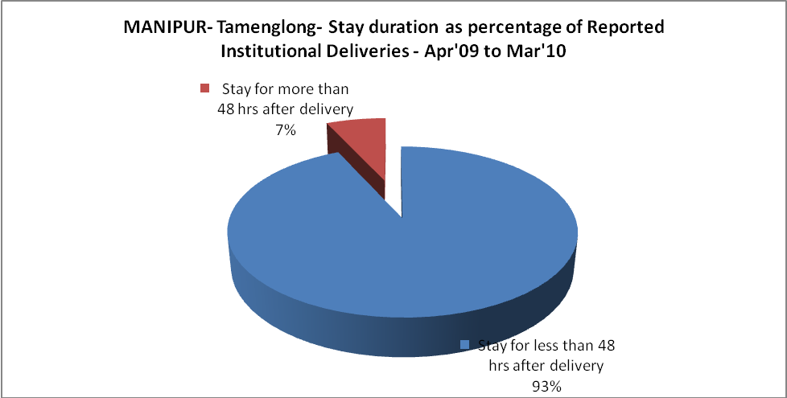
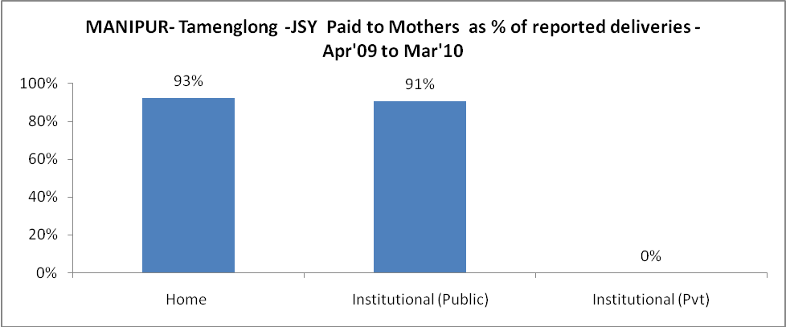

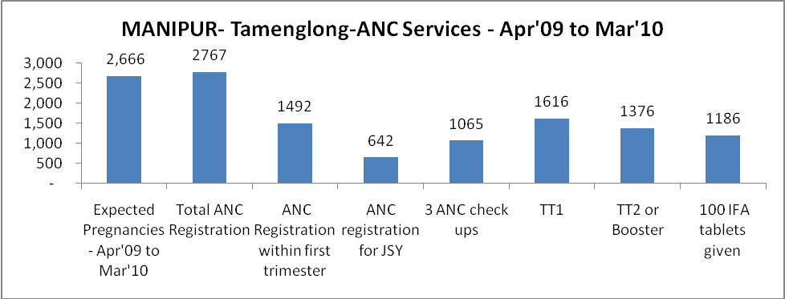
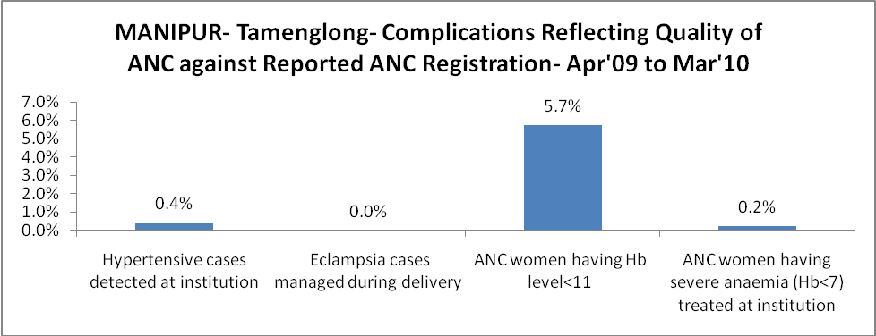

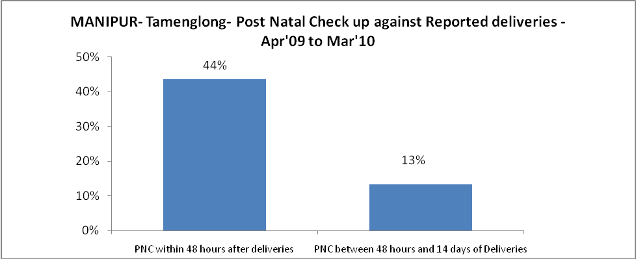
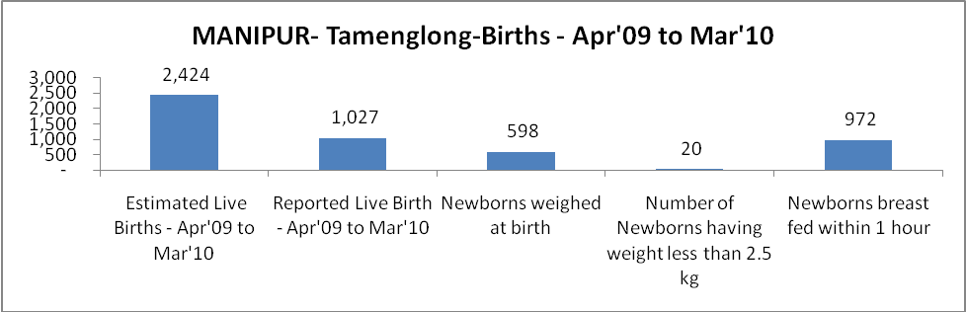
MANIPUR- Tamenglong - Births - Apr'09 to Mar'10
Live Birth - Males | Live Birth - females | Live Birth - Total | Sex Ratio at birth | Still Birth | Abortion( Induced/Spontaneous
523 | 504 | 1,027 | 964 | 3 | 18
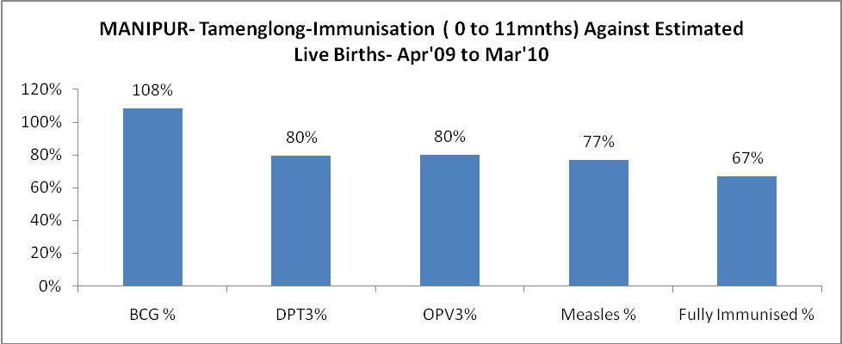
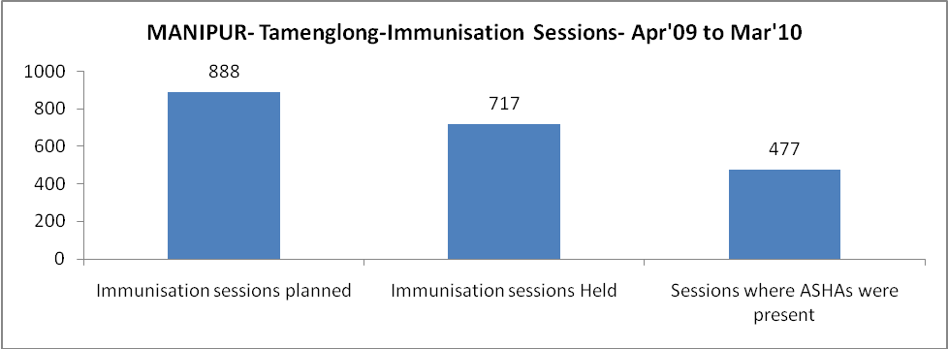
MANIPUR- Tamenglong- Apr'09 to Mar'10
Total Abortions | Abortion Rate
40 | 1.5%
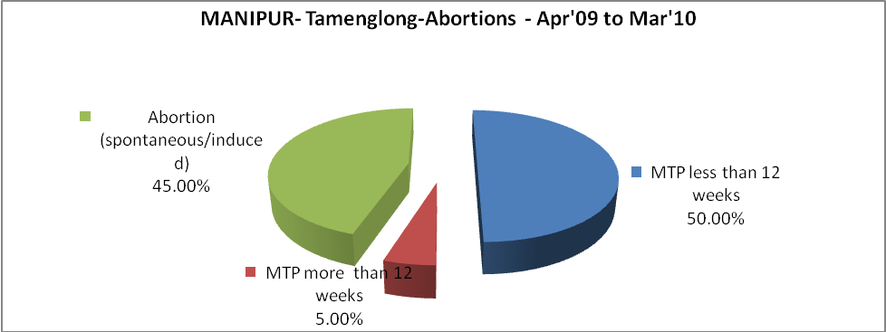
MANIPUR- Tamenglong- Apr'09 to Mar'10
Total OPD | Total RTI/STI cases
24,594 | 156
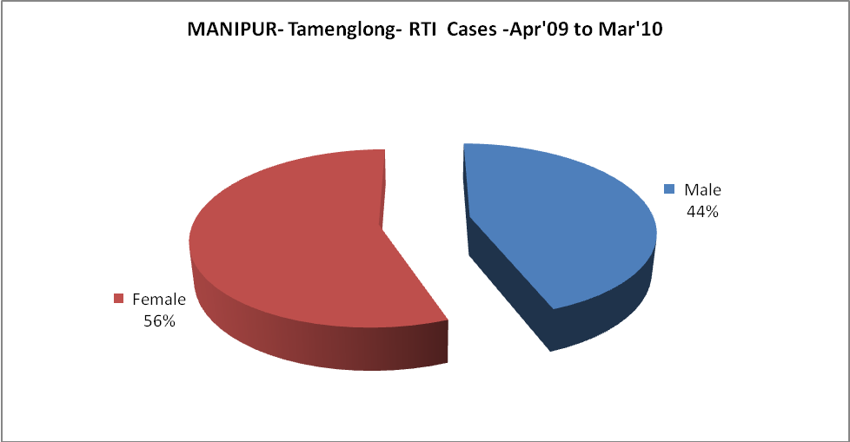

MANIPUR- Tamenglong-FP Methods - Apr'09 to Mar'10
 | Reported | %age of All Reported FP Methods
Total Reported FP Methodd (All types) Users | 786 | -
Sterilisations | - | 0%
IUD | 450 | 57%
Condom Users | 324 | 41%
OCP Users | 12 | 2%
Limiting Methods | - | 0%
Spacing Methods | 786 | 100%

MANIPUR- Tamenglong- Service Delivery - Apr'09 to Mar'10
Operation major (General and spinal anaesthesia) | Operation minor (No or local anaesthesia) | AYUSH | Dental Procedures | Adolescent counselling services | Total OPD | Total IPD
- | 155 | 1,220 | 207 | 55 | 24,594 | 2,313
Operation major (General and spinal anaesthesia) as %ge of OPD | Operation minor (No or local anaesthesia)as %ge of OPD | AYUSH as %ge of OPD | Dental Procedures as %ge of OPD | Adolescent counselling services as %ge of OPD | IPD as percentage of OPD
0.0% | 0.6% | 5.0% | 0.8% | 0.2% | 9%

MANIPUR- Tamenglong- Lab Services - Apr'09 to Mar'10
Total OPD | Total HB tested | Total HIV Tested | Total Population
24,594 | 568 | 1,413 | 153,409
HB test conducted as %age of OPD | HB<7gm as %age of HB tested | HIV test conducted as %age of OPD | HIV positive as %age of HIV tested | Blood Smear Examined as % of Population
2.3% | 3.2% | 5.7% | 0.3% | 2.3%

MANIPUR- Tamenglong- Childhood Disease - Vaccine Preventable -Apr'09 to Mar'10
Diphtheria | Pertussis | Tetanus Neonatorum | Tetanus others | Polio | Measles
0 | 0 | 0 | 0 | 0 | 28
MANIPUR- Tamenglong-Childhood Disease - Others - Apr'09 to Mar'10
Diarrhoea and dehydration | Malaria | Number admitted with Respiratory Infections
612 | 114 | 134

MANIPUR- Tamenglong- Infant & Child Deaths - Apr'09 to Mar'10
Infant Deaths within 24 hrs of birth | Infant Deaths between 24hrs & under 1 week | Infant Deaths between 1 week & under 1 month | Child Deaths between 1 month & under 1 year | Child Deaths between 1yr under 5years | Total Deaths
0 | 0 | 0 | 0 | 0 | 0

MANIPUR- Tamenglong- Causes of Infant & Child Deaths - Apr'09 to Mar'10
Sepsis |  |  | Asphyxia |  |  | LBW
Up to 1 Weeks of Birth | Between 1 week & 4 weeks of birth | Total | Up to 1 Weeks of Birth | Between 1 week & 4 weeks of birth | Total | Up to 1 Weeks of Birth | Between 1 week & 4 weeks of birth | Total
0 | 0 | 0 | 0 | 0 | 0 | 0 | 0 | 0
Pneumonia |  |  | Diarrhoea |  |  | Fever related
Between 1 month and 11 months | Between 1 year & 5 years | Total | Between 1 month and 11 months | Between 1 year & 5 years | Total | Between 1 month and 11 months | Between 1 year & 5 years | Total
0 | 0 | 0 | 0 | 0 | 0 | 0 | 0 | 0
Others |  |  | Measles |  |  | Others
Up to 1 Weeks of Birth | Between 1 week & 4 weeks of birth | Total | Between 1 month and 11 months | Between 1 year & 5 years | Total | Between 1 month and 11 months | Between 1 year & 5 years | Total
0 | 0 | 0 | 0 | 0 | 0 | 0 | 0 | 0

 | MANIPUR- Tamenglong- Maternal Deaths & Causes - Apr'09 to Mar'10
 | Abortion |  |  |  |  |  |  | Obstructed/prolonged labour |  |  |  |  |  |  | Severe hypertesnion/fits
 | 6-14 yrs |  | 15-55 yrs. |  | Total |  |  | 6-14 yrs |  | 15-55 yrs. |  | Total |  |  | 6-14 yrs |  | 15-55 yrs. |  | Total
 | 0 |  | 0 |  | 0 |  |  | 0 |  | 0 |  | 0 |  |  | 0 |  | 0 |  | 0
 | Bleeding |  |  |  |  |  |  | High Fever |  |  |  |  |  |  | Other Causes
 | 6-14 yrs |  | 15-55 yrs. |  | Total |  |  | 6-14 yrs |  | 15-55 yrs. |  | Total |  |  | 6-14 yrs |  | 15-55 yrs. |  | Total
 | 0 |  | 0 |  | 0 |  |  | 0 |  | 0 |  | 0 |  |  | 0 |  | 0 |  | 0
MANIPUR- Tamenglong-Causes of Deaths in 6 to 55yrs age group - Apr'09 to Mar'10
Diarrhoel Diseases |  |  |  |  |  |  | Tuberculosis |  |  |  |  |  |  | Respiratory Diseases( Other than TB)
6-14 yrs |  | 15-55 yrs. |  | Above 55yrs |  | Total | 6-14 yrs |  | 15-55 yrs. |  | Above 55yrs |  | Total | 6-14 yrs |  | 15-55 yrs. |  | Above 55yrs |  | Total
0 |  | 0 |  | 0 |  | 0 | 0 |  | 1 |  | 0 |  | 1 | 0 |  | 0 |  | 0 |  | 0
Malaria |  |  |  |  |  |  | Other fever Related |  |  |  |  |  |  | HIV/Aids
6-14 yrs |  | 15-55 yrs. |  | Above 55yrs |  | Total | 6-14 yrs |  | 15-55 yrs. |  | Above 55yrs |  | Total | 6-14 yrs |  | 15-55 yrs. |  | Above 55yrs |  | Total
0 |  | 0 |  | 0 |  | 0 | 0 |  | 0 |  | 0 |  | 0 | 0 |  | 0 |  | 0 |  | 0
Heart Disease/Hypertenion related |  |  |  |  |  |  | Neurological Disease including strokes |  |  |  |  |  |  | Trauma/Accidents/ Burn Cases
6-14 yrs |  | 15-55 yrs. |  | Above 55yrs |  | Total | 6-14 yrs |  | 15-55 yrs. |  | Above 55yrs |  | Total | 6-14 yrs |  | 15-55 yrs. |  | Above 55yrs |  | Total
0 |  | 0 |  | 0 |  | 0 | 0 |  | 0 |  | 0 |  | 0 | 0 |  | 0 |  | 0 |  | 0
Suicide |  |  |  |  |  |  | Animal Bites & Stings
6-14 yrs |  | 15-55 yrs. |  | Above 55yrs |  | Total | 6-14 yrs |  | 15-55 yrs. |  | Above 55yrs |  | Total
0 |  | 0 |  | 0 |  | 0 | 0 |  | 0 |  | 0 |  | 0

