NHSRC
MANIPUR- Thoubal District
HMIS Data Analysis 2009-10

Amit
8/6/2010

MANIPUR- Thoubal- Summary-Apr'09 to Mar'10
ANC
ANC Registration against Expected Pregnancies | 115% | TT1 given to Pregnant women against ANC Registraion | 49%
3 ANC Check ups against ANC Reigtrations | 31% | 100 IFA Tablets given to Pregnant women against ANC Registraion | 54%
Deliveries
Unreported Deliveries against Estimated Deliveries | 81.9% | HOME Deliveries( SBA& Non SBA) against Estimated Deliveries | 8.1%
Institutional Deliveries against Estimated Deliveries | 10.0% | HOME Deliveries( SBA& Non SBA) against Reported Deliveries | 44.7%
Institutional Deliveries against Reported Deliveries | 55.3% | C Section Deliveries against Institutional Deliveries( Pvt & Pub) | 0%
Births & Neonates Care
Live Births Reported against Estimated Live Births | 18% | New borns weighed against Reported Live Births | 99%
Still Births (Reported) | 9 | New borns weighed less than 2.5 kgs against newborns weighed | 3%
Sex Ratio at Birh | 962 | New borns breastfed within one hr of Birth against Reported live Births | 97%
Child Immunisation( 0 to 11 months)
BCG given against Expected Live Births | 86% | Measles given against Expected Live Births | 67%
OPV3 given against Expected Live Births | 74% | Fully Immunised Children against Expected Live Births | 67%
DPT3 given against Expected Live Births | 74%
Family Planning
Family Plannig Methods Users ( Sterilisations(Male &Female)+IUD+ Condom pieces/72 + OCP Cycles/13) | 1,400 | IUD Insertions against reported FP Methods | 54%
Sterilisation against reported FP Methods | 7% | Condom Users against reported FP Methods | 21%
 |  | OCP Users against reported FP Methods | 18%
Other Services
OPD | 105,077 | Major Operations | -
IPD | 2,928 | Minor Operations | 3,534

MANIPUR- Thoubal- Deliveries Apr'09 to Mar'10
Total Population | 500,576 | Expected Deliveries |  | 7,964
Home SBA | Home Non SBA | Institutional | Total Deliveries Reported | Unreported Deliveries
516 | 127 | 796 | 1,439 | 6,525
Home SBA % | Home Non SBA% | Institutional % | Total Deliveries Reported % | Unreported Deliveries %
6% | 2% | 10% | 18% | 82%

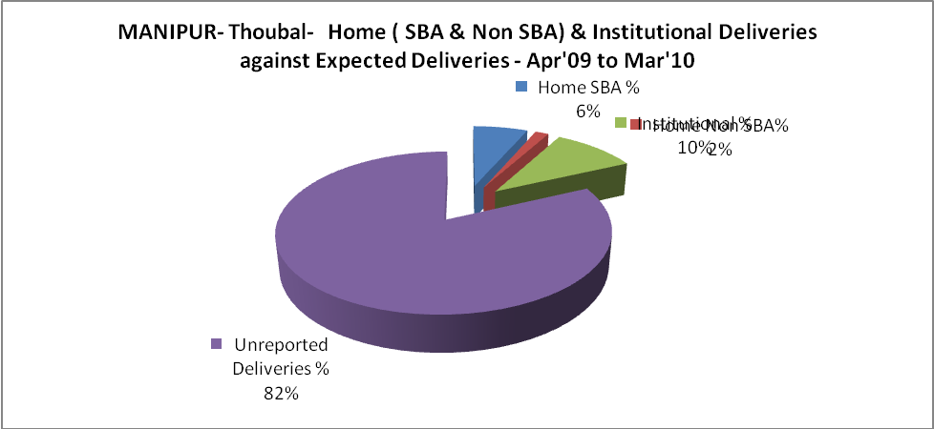
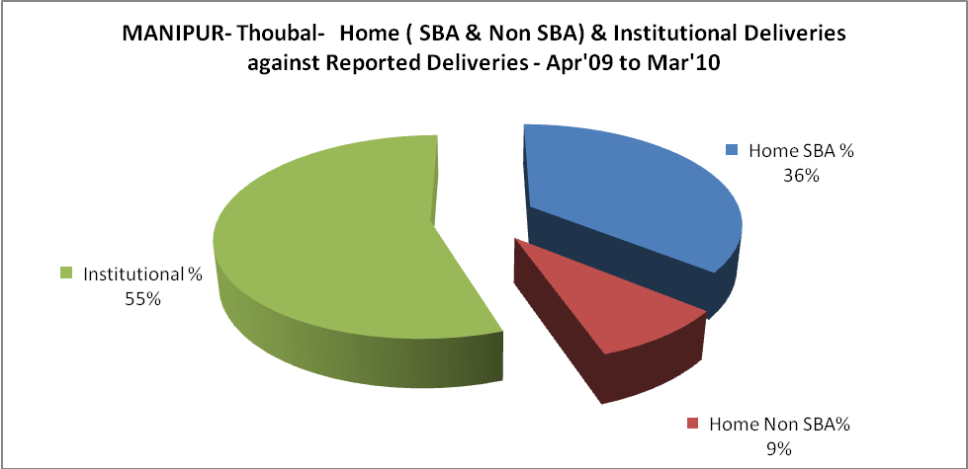
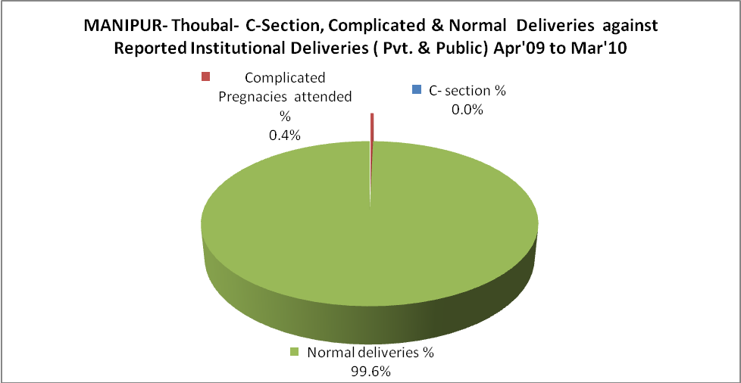
MANIPUR- Thoubal- Complicated Pregnancies & Deliveries Treated - Apr'09 to Mar'10
Reported Deliveries |  |  | Reported ANC Reigtration
1,439 |  |  | 9,996
Complicated Pregnancies attended | Complicated Pregnancies Rate | C - Section Deliveries | PNC Maternal Complications | Abortions | Still Births
3 | 0% | - | 13 | 39 | 9
Complicated Deliveries Treated with |  |  |  | No Of Eclampsia cases Treated | No Of severe anemia cases treated
IV Antibiotics | IV antihypertensive/Magsulph injection | IV Oxytocis | Blood Transfusion | No Of Eclampsia cases Treated | No Of severe anemia cases treated
99 | - | 129 | - | 1 | 2

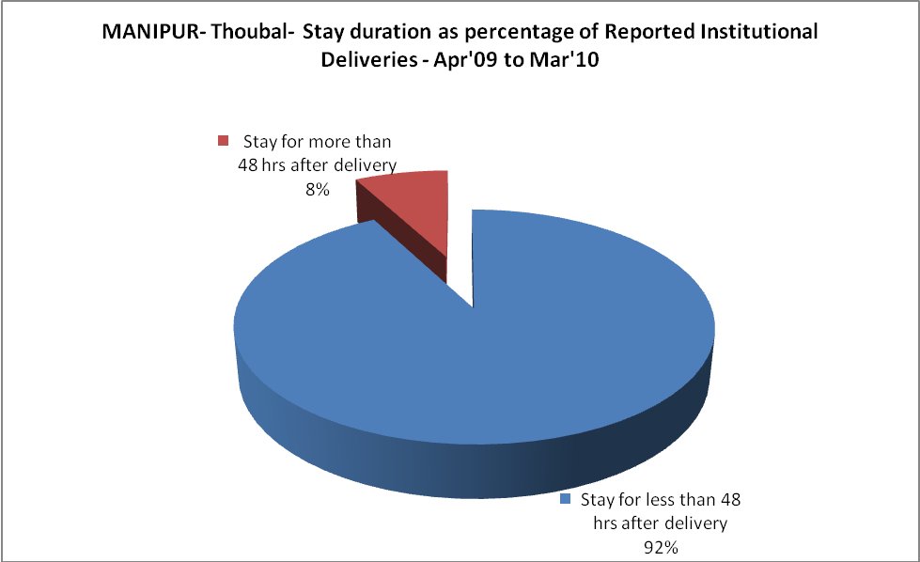

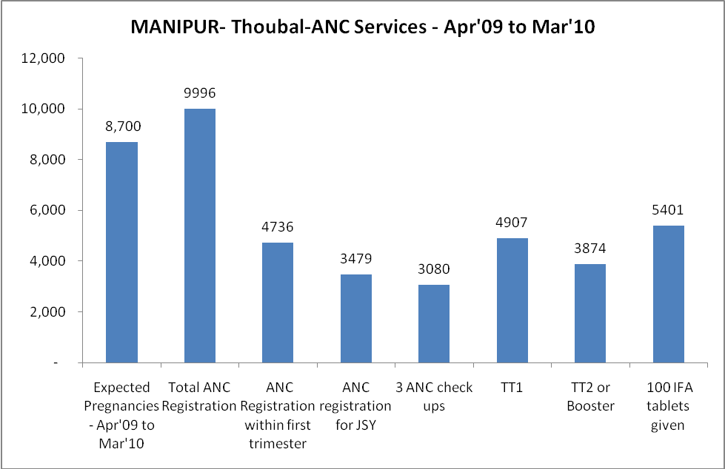
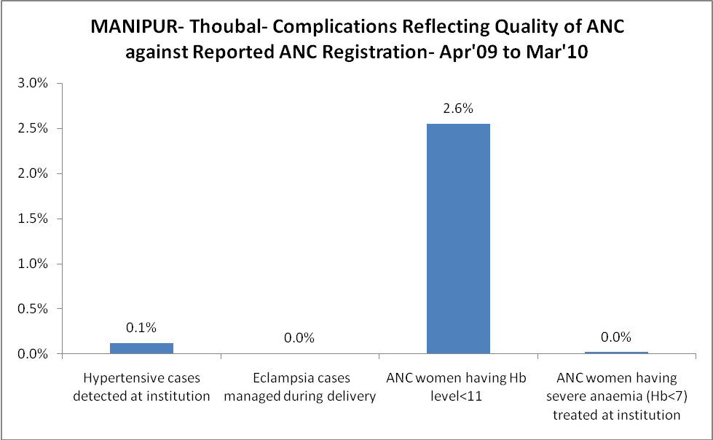

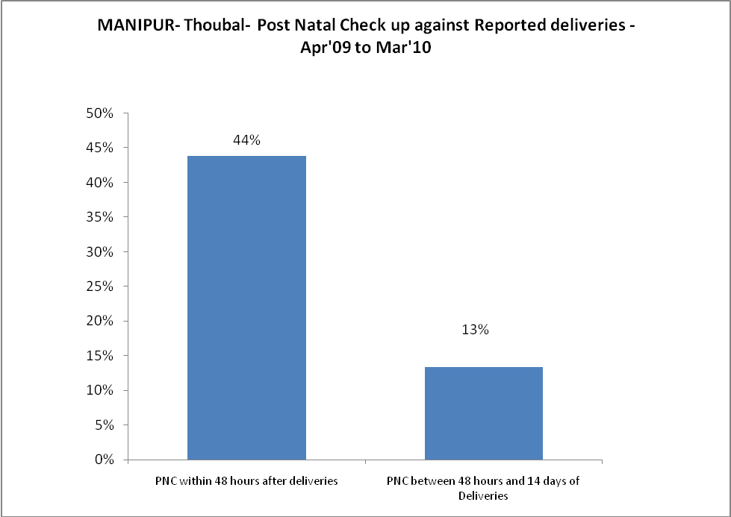
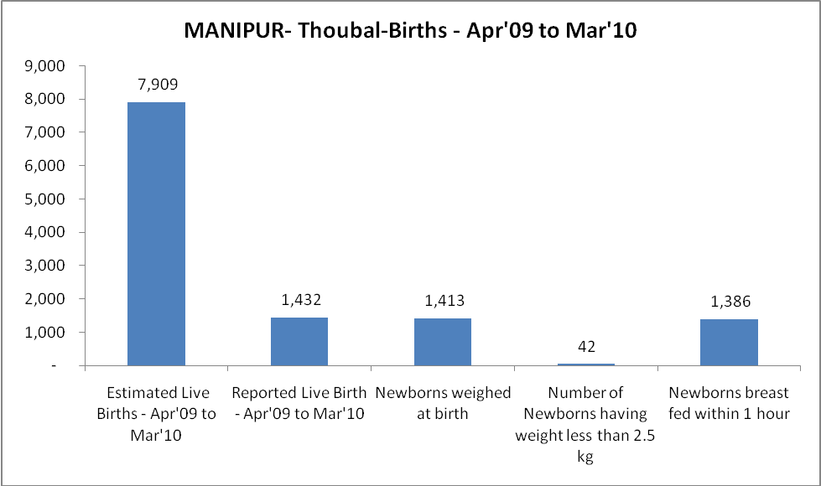
MANIPUR- Thoubal - Births - Apr'09 to Mar'10
Live Birth - Males | Live Birth - females | Live Birth - Total | Sex Ratio at birth | Still Birth | Abortion( Induced/Spontaneous
730 | 702 | 1,432 | 962 | 9 | 39

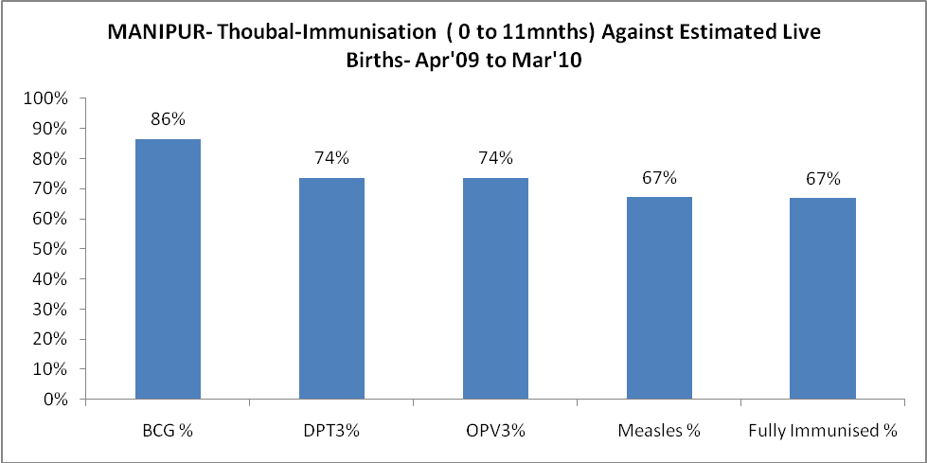
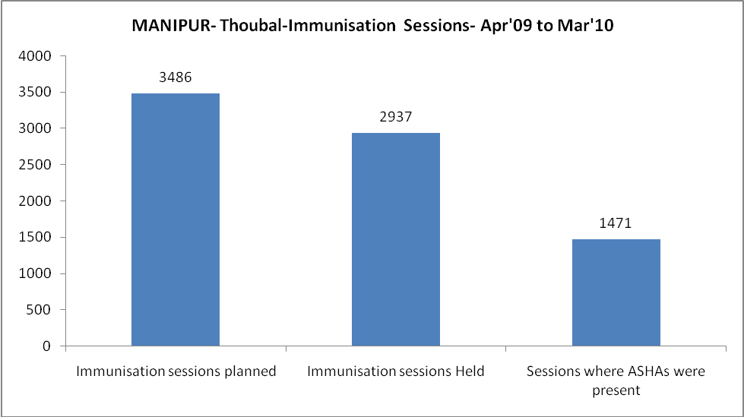
MANIPUR- Thoubal- Apr'09 to Mar'10
Total Abortions | Abortion Rate
1,009 | 11.6%

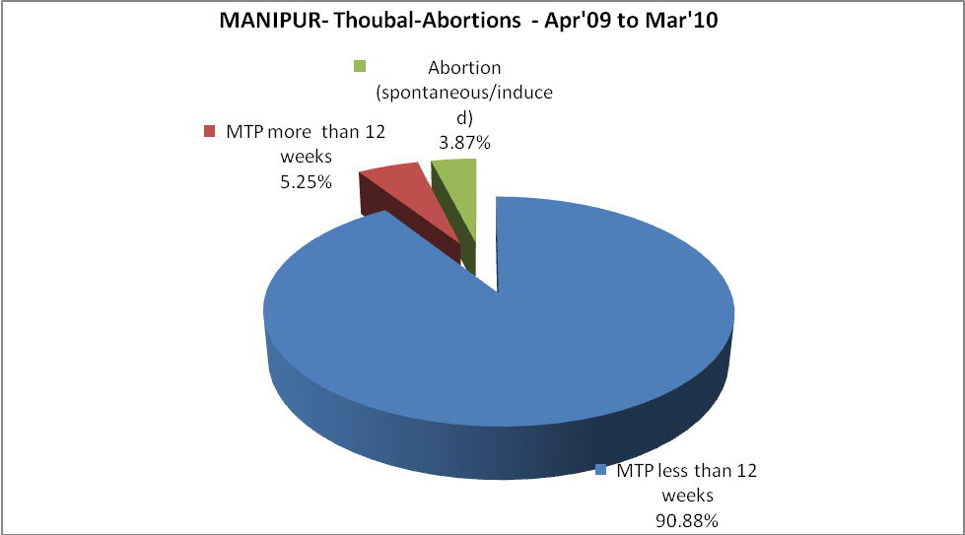
MANIPUR- Thoubal- Apr'09 to Mar'10
Total OPD | Total RTI/STI cases
105,077 | 1,265

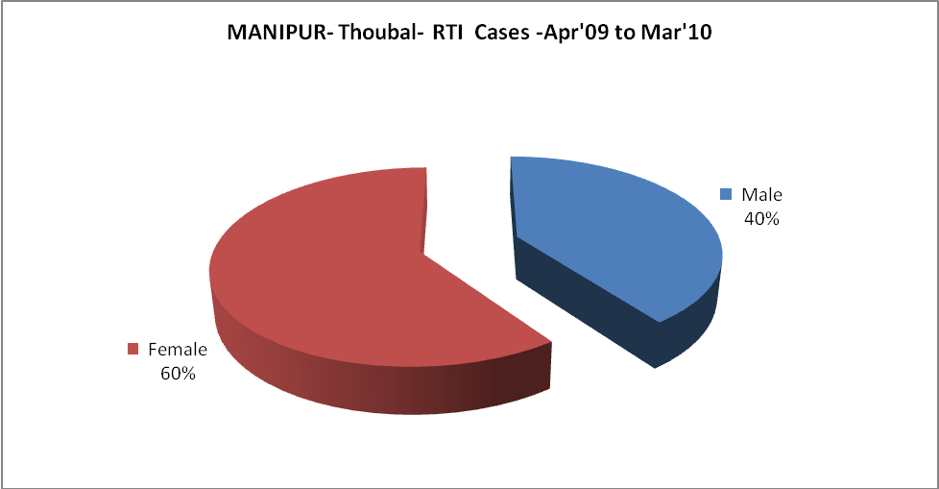
MANIPUR- Thoubal-FP Methods - Apr'09 to Mar'10
 | Reported | %age of All Reported FP Methods
Total Reported FP Methodd (All types) Users | 1,400 | -
Sterilisations | 100 | 7%
IUD | 756 | 54%
Condom Users | 293 | 21%
OCP Users | 250 | 18%
Limiting Methods | 100 | 7%
Spacing Methods | 1,300 | 93%

MANIPUR- Thoubal- Service Delivery - Apr'09 to Mar'10
Operation major (General and spinal anaesthesia) | Operation minor (No or local anaesthesia) | AYUSH | Dental Procedures | Adolescent counselling services | Total OPD | Total IPD
- | 3,534 | 13,280 | 695 | 874 | 105,077 | 2,928
Operation major (General and spinal anaesthesia) as %ge of OPD | Operation minor (No or local anaesthesia)as %ge of OPD | AYUSH as %ge of OPD | Dental Procedures as %ge of OPD | Adolescent counselling services as %ge of OPD | IPD as percentage of OPD
0.0% | 3.4% | 12.6% | 0.7% | 0.8% | 3%

MANIPUR- Thoubal- Lab Services - Apr'09 to Mar'10
Total OPD | Total HB tested | Total HIV Tested | Total Population
105,077 | 1,563 | 6,267 | 500,576
HB test conducted as %age of OPD | HB<7gm as %age of HB tested | HIV test conducted as %age of OPD | HIV positive as %age of HIV tested | Blood Smear Examined as % of Population
1.5% | 3.1% | 6.0% | 2.2% | 0.7%

MANIPUR- Thoubal- Childhood Disease - Vaccine Preventable -Apr'09 to Mar'10
Diphtheria | Pertussis | Tetanus Neonatorum | Tetanus others | Polio | Measles
0 | 0 | 0 | 0 | 0 | 91
MANIPUR- Thoubal-Childhood Disease - Others - Apr'09 to Mar'10
Diarrhoea and dehydration | Malaria | Number admitted with Respiratory Infections
2,116 | 27 | 163

MANIPUR- Thoubal- Infant & Child Deaths - Apr'09 to Mar'10
Infant Deaths within 24 hrs of birth | Infant Deaths between 24hrs & under 1 week | Infant Deaths between 1 week & under 1 month | Child Deaths between 1 month & under 1 year | Child Deaths between 1yr under 5years | Total Deaths
0 | 1 | 1 | 1 | 0 | 3

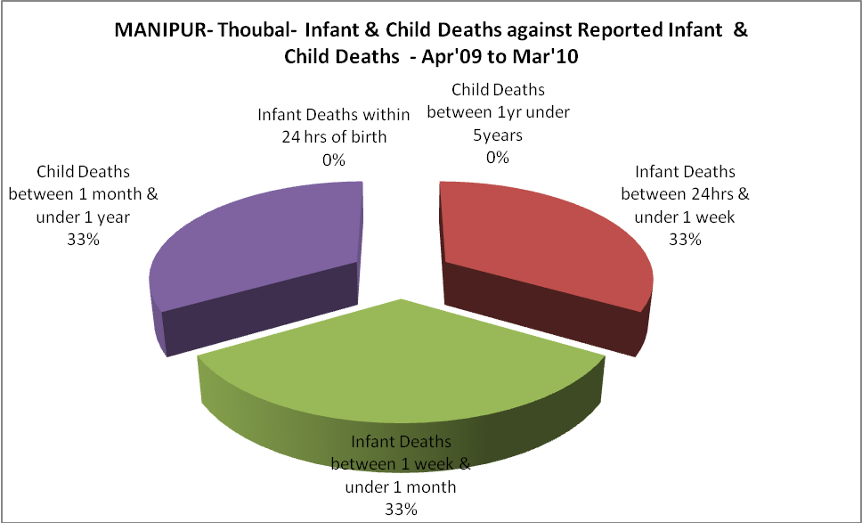

MANIPUR- Thoubal- Causes of Infant & Child Deaths - Apr'09 to Mar'10
Sepsis |  |  | Asphyxia |  |  | LBW
Up to 1 Weeks of Birth | Between 1 week & 4 weeks of birth | Total | Up to 1 Weeks of Birth | Between 1 week & 4 weeks of birth | Total | Up to 1 Weeks of Birth | Between 1 week & 4 weeks of birth | Total
0 | 0 | 0 | 0 | 0 | 0 | 1 | 0 | 1
Pneumonia |  |  | Diarrhoea |  |  | Fever related
Between 1 month and 11 months | Between 1 year & 5 years | Total | Between 1 month and 11 months | Between 1 year & 5 years | Total | Between 1 month and 11 months | Between 1 year & 5 years | Total
0 | 0 | 0 | 0 | 0 | 0 | 0 | 0 | 0
Others |  |  | Measles |  |  | Others
Up to 1 Weeks of Birth | Between 1 week & 4 weeks of birth | Total | Between 1 month and 11 months | Between 1 year & 5 years | Total | Between 1 month and 11 months | Between 1 year & 5 years | Total
0 | 1 | 1 | 0 | 0 | 0 | 1 | 0 | 1

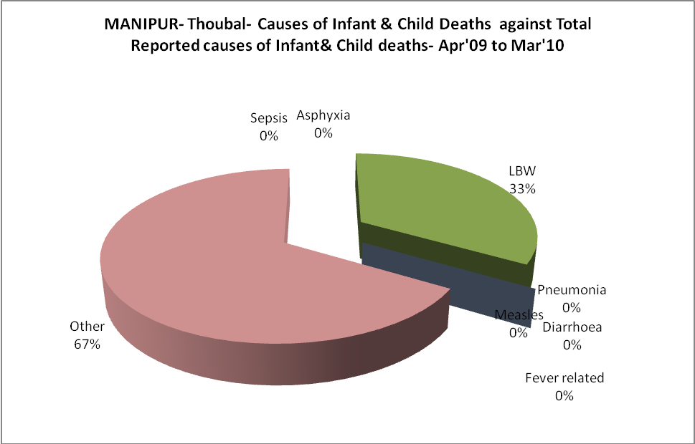
MANIPUR- Thoubal- Maternal Deaths & Causes - Apr'09 to Mar'10
Abortion |  |  | Obstructed/prolonged labour |  |  | Severe hypertesnion/fits
6-14 yrs | 15-55 yrs. | Total | 6-14 yrs | 15-55 yrs. | Total | 6-14 yrs | 15-55 yrs. | Total
0 | 0 | 0 | 0 | 0 | 0 | 0 | 0 | 0
Bleeding |  |  | High Fever |  |  | Other Causes
6-14 yrs | 15-55 yrs. | Total | 6-14 yrs | 15-55 yrs. | Total | 6-14 yrs | 15-55 yrs. | Total
0 | 0 | 0 | 0 | 0 | 0 | 0 | 3 | 3

MANIPUR- Thoubal-Causes of Deaths in 6 to 55yrs age group - Apr'09 to Mar'10
Diarrhoel Diseases |  |  |  | Tuberculosis |  |  |  | Respiratory Diseases( Other than TB)
6-14 yrs | 15-55 yrs. | Above 55yrs | Total | 6-14 yrs | 15-55 yrs. | Above 55yrs | Total | 6-14 yrs | 15-55 yrs. | Above 55yrs | Total
0 | 0 | 2 | 2 | 0 | 0 | 2 | 2 | 0 | 0 | 1 | 1
Malaria |  |  |  | Other fever Related |  |  |  | HIV/Aids
6-14 yrs | 15-55 yrs. | Above 55yrs | Total | 6-14 yrs | 15-55 yrs. | Above 55yrs | Total | 6-14 yrs | 15-55 yrs. | Above 55yrs | Total
0 | 0 | 0 | 0 | 0 | 2 | 2 | 4 | 0 | 1 | 1 | 2
Heart Disease/Hypertenion related |  |  |  | Neurological Disease including strokes |  |  |  | Trauma/Accidents/ Burn Cases
6-14 yrs | 15-55 yrs. | Above 55yrs | Total | 6-14 yrs | 15-55 yrs. | Above 55yrs | Total | 6-14 yrs | 15-55 yrs. | Above 55yrs | Total
0 | 3 | 5 | 8 | 1 | 0 | 1 | 2 | 0 | 6 | 1 | 7
Suicide |  |  |  | Animal Bites & Stings
6-14 yrs | 15-55 yrs. | Above 55yrs | Total | 6-14 yrs | 15-55 yrs. | Above 55yrs | Total
0 | 3 | 0 | 3 | 0 | 0 | 0 | 0

