NHSRC
MANIPUR- UKHRUL District
HMIS Data Analysis 2009-10

Amit
05-08-2010

MANIPUR- UKHRUL- Summary-Apr'09 to Mar'10
ANC
ANC Registration against Expected Pregnancies | 95% | TT1 given to Pregnant women against ANC Registraion | 53%
3 ANC Check ups against ANC Reigtrations | 29% | 100 IFA Tablets given to Pregnant women against ANC Registraion | 21%
Deliveries
Unreported Deliveries against Estimated Deliveries | 53.0% | HOME Deliveries( SBA& Non SBA) against Estimated Deliveries | 21.5%
Institutional Deliveries against Estimated Deliveries | 25.4% | HOME Deliveries( SBA& Non SBA) against Reported Deliveries | 45.8%
Institutional Deliveries against Reported Deliveries | 54.2% | C Section Deliveries against Institutional Deliveries( Pvt & Pub) | 11%
Births & Neonates Care
Live Births Reported against Estimated Live Births | 46% | New borns weighed against Reported Live Births | 76%
Still Births (Reported) | 38 | New borns weighed less than 2.5 kgs against newborns weighed | 4%
Sex Ratio at Birh | 968 | New borns breastfed within one hr of Birth against Reported live Births | 47%
Child Immunisation( 0 to 11 months)
BCG given against Expected Live Births | 86% | Measles given against Expected Live Births | 58%
OPV3 given against Expected Live Births | 73% | Fully Immunised Children against Expected Live Births | 57%
DPT3 given against Expected Live Births | 76%
Family Planning
Family Plannig Methods Users ( Sterilisations(Male &Female)+IUD+ Condom pieces/72 + OCP Cycles/13) | 160 | IUD Insertions against reported FP Methods | 61%
Sterilisation against reported FP Methods | 4% | Condom Users against reported FP Methods | 21%
 |  | OCP Users against reported FP Methods | 14%
Other Services
OPD | 39,696 | Major Operations | 149
IPD | 1,739 | Minor Operations | 1,306

MANIPUR- UKHRUL- Deliveries Apr'09 to Mar'10
Total Population | 193,658 | Expected Deliveries |  | 3,081
Home SBA | Home Non SBA | Institutional | Total Deliveries Reported | Unreported Deliveries
244 | 419 | 784 | 1,447 | 1,634
Home SBA % | Home Non SBA% | Institutional % | Total Deliveries Reported % | Unreported Deliveries %
8% | 14% | 25% | 47% | 53%

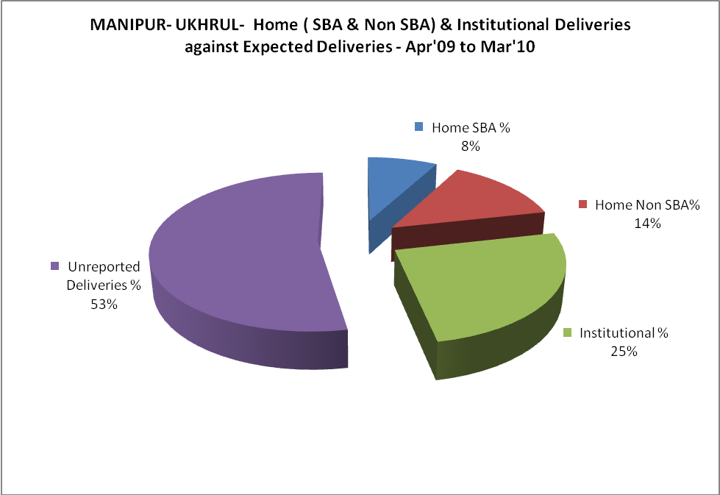

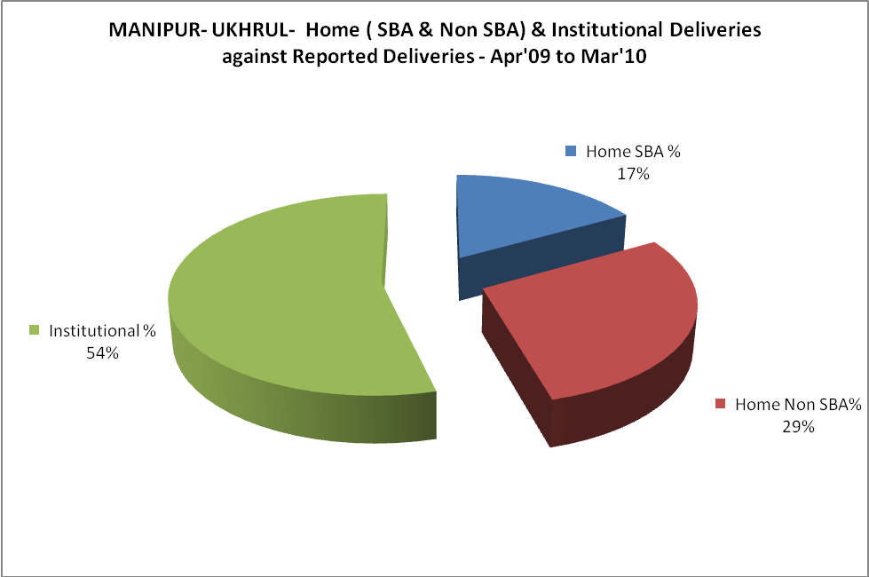
MANIPUR- UKHRUL- C sections & Complicated Deliveries Apr'09 to Mar'10
 | Institutional Deliveries (Public) | Institutional Deliveries (Pvt)
 | 263 | 521
C Section | - | 87
C Section% | 0% | 17%
Complicated Pregnacies attended | - | 57
Complicated Pregnacies attended % | 0% | 11%

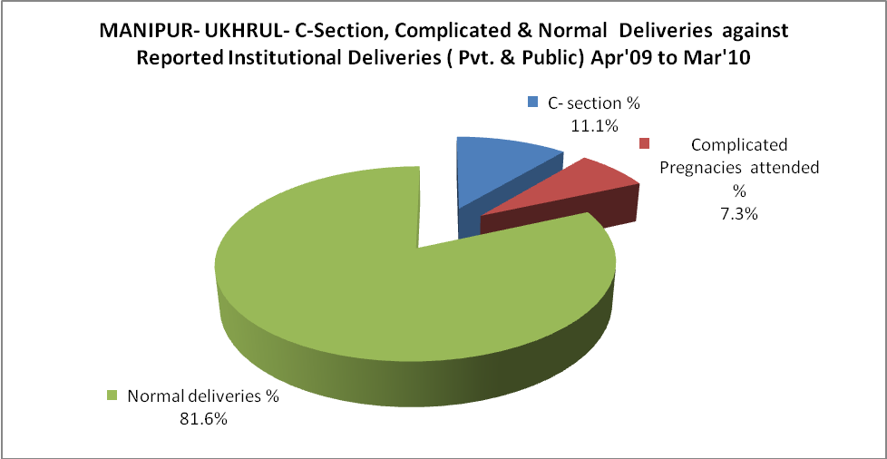

MANIPUR- UKHRUL- Complicated Pregnancies & Deliveries Treated - Apr'09 to Mar'10
Reported Deliveries |  |  | Reported ANC Reigtration
1,447 |  |  | 3,212
Complicated Pregnancies attended | Complicated Pregnancies Rate | C - Section Deliveries | PNC Maternal Complications | Abortions | Still Births
57 | 2% | 87 | - | 15 | 38
Complicated Deliveries Treated with |  |  |  | No Of Eclampsia cases Treated | No Of severe anemia cases treated
IV Antibiotics | IV antihypertensive/Magsulph injection | IV Oxytocis | Blood Transfusion | No Of Eclampsia cases Treated | No Of severe anemia cases treated
69 | 22 | 315 | - | 4 | 8

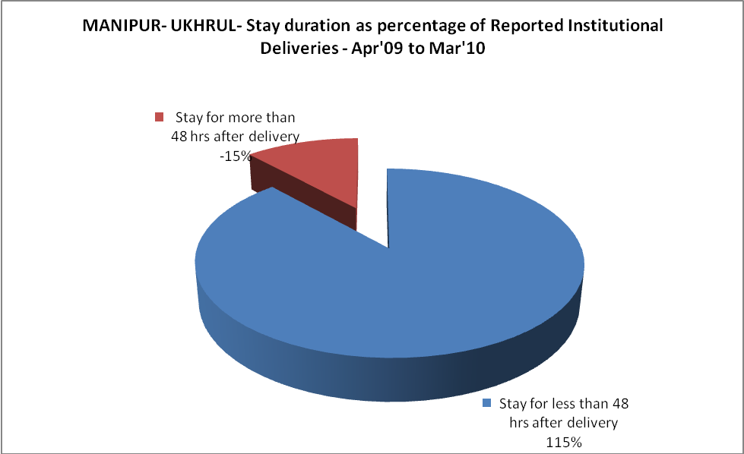

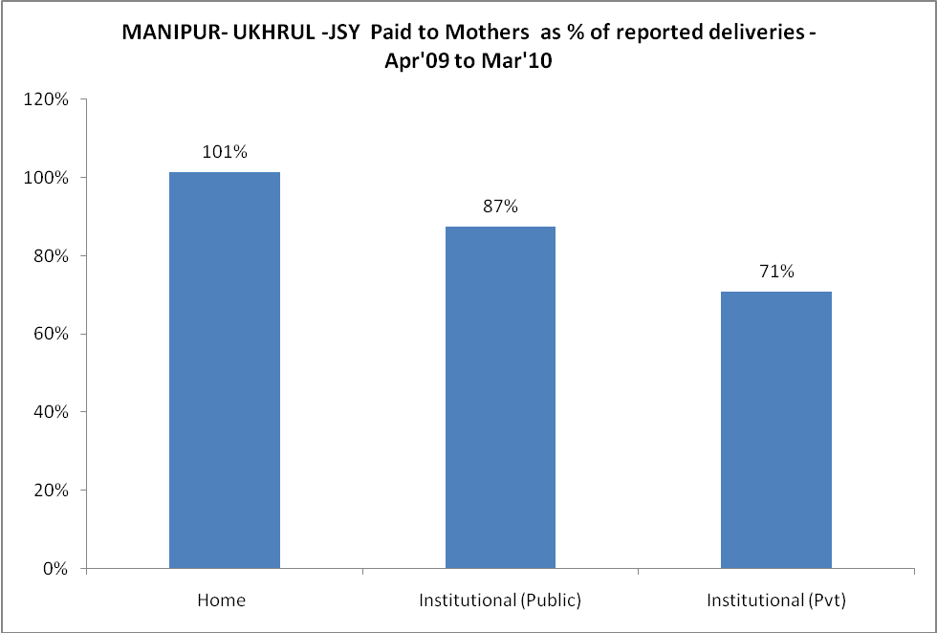
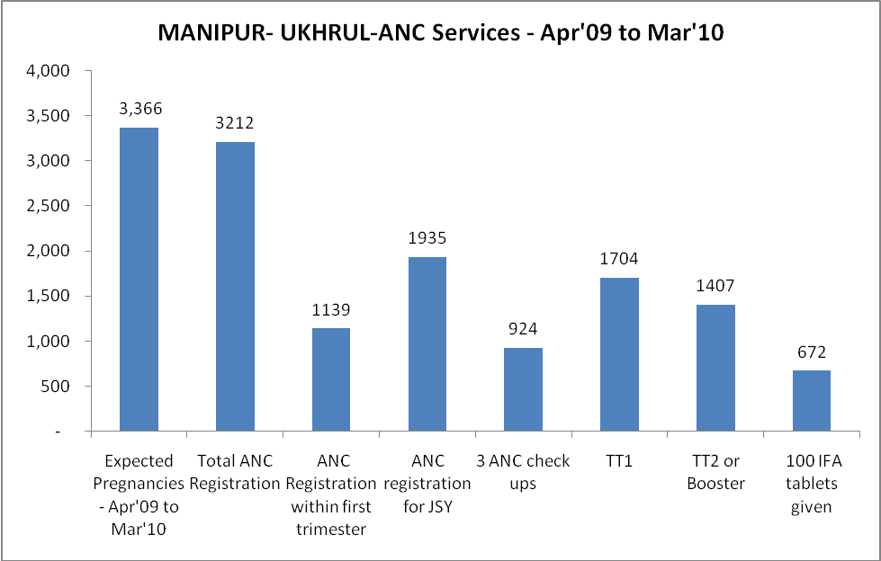
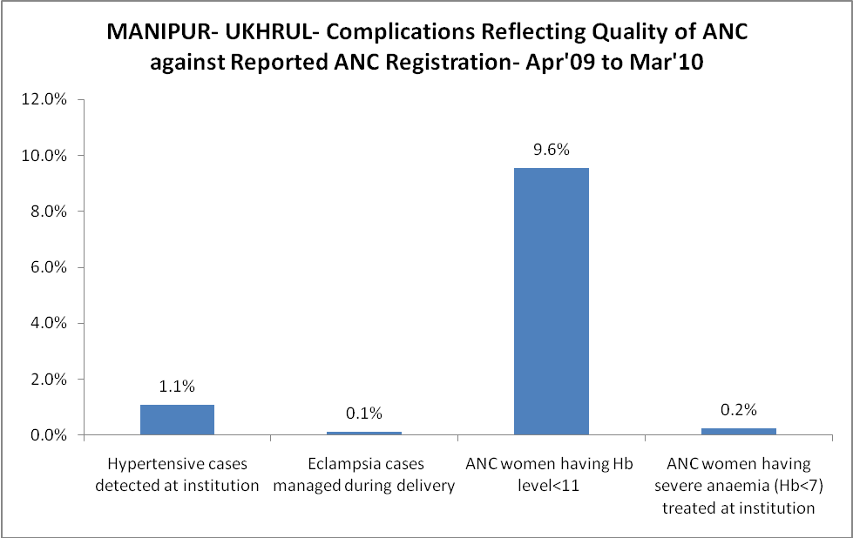

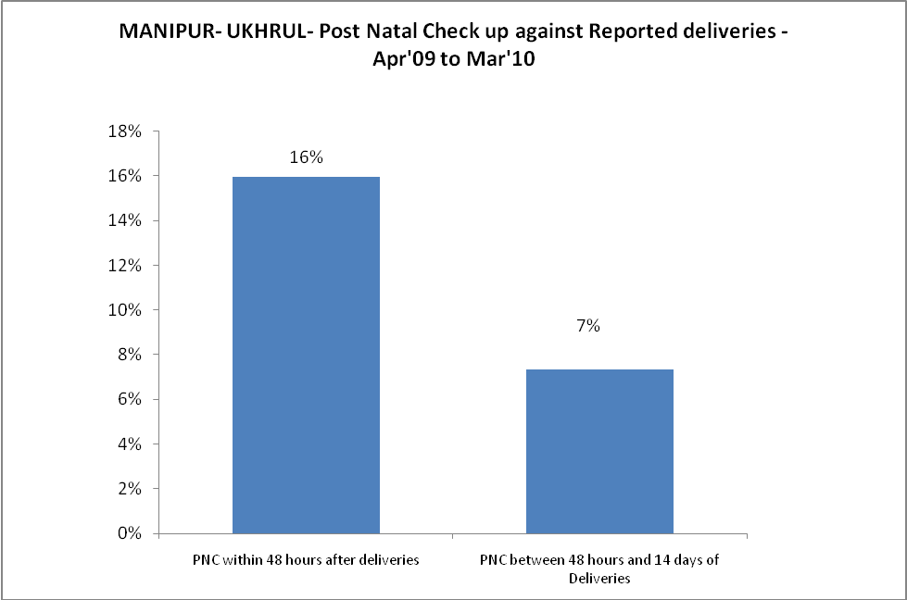
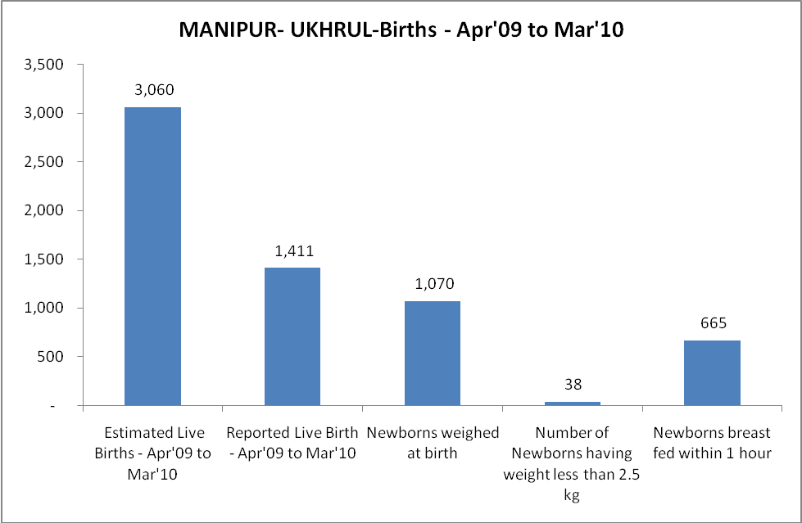
MANIPUR- UKHRUL - Births - Apr'09 to Mar'10
Live Birth - Males | Live Birth - females | Live Birth - Total | Sex Ratio at birth | Still Birth | Abortion( Induced/Spontaneous
717 | 694 | 1,411 | 968 | 38 | 15

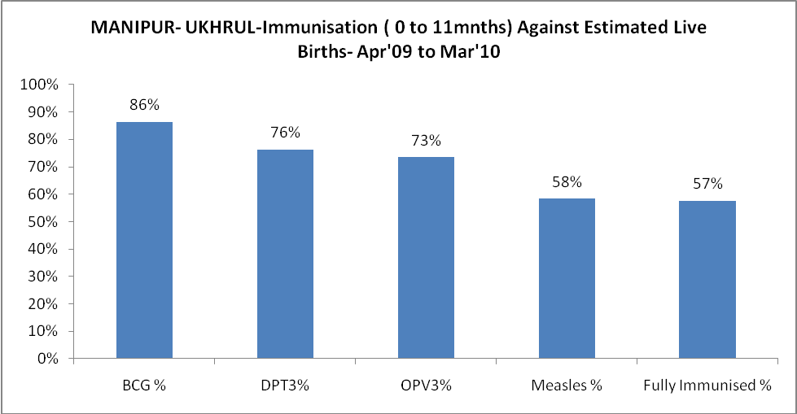
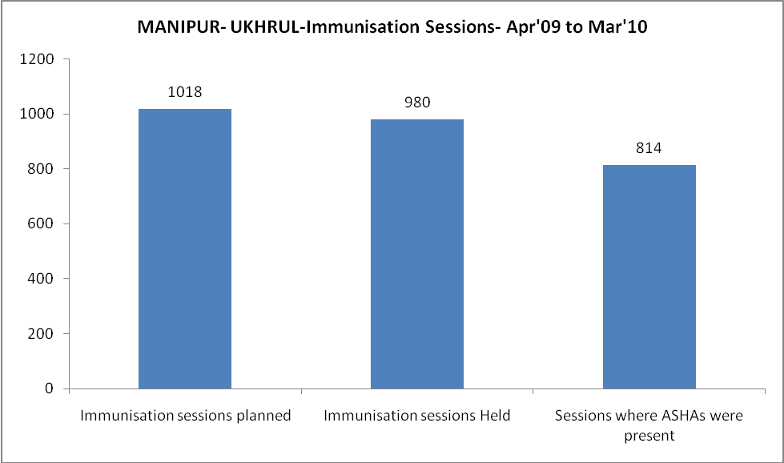
MANIPUR- UKHRUL- Apr'09 to Mar'10
Total Abortions | Abortion Rate
15 | 0.4%

MANIPUR- UKHRUL- Apr'09 to Mar'10
Total OPD | Total RTI/STI cases
39,696 | 80

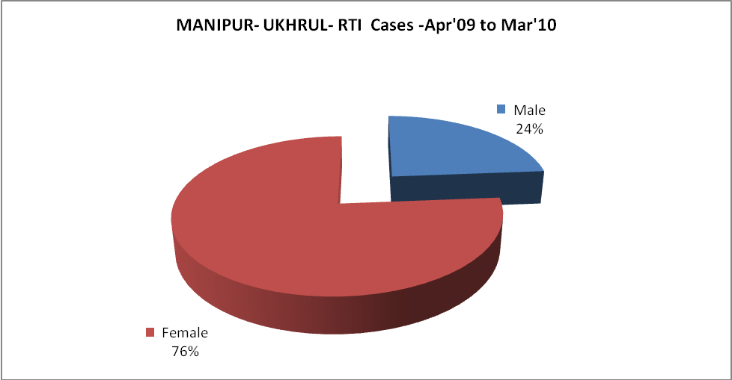

MANIPUR- UKHRUL-Sterilisations - Apr'09 to Mar'10
 | Reported | %age of Reported Sterilisation
Total Sterilisation | 6 | -
NSV | 1 | 17%
Laproscopic | - | 0%
MiniLap | 5 | 83%
Post Partum | - | 0%
Male Sterilisation | 1 | 17%
Female Sterilisation | 5 | 83%

MANIPUR- UKHRUL-FP Methods - Apr'09 to Mar'10
 | Reported | %age of All Reported FP Methods
Total Reported FP Methodd (All types) Users | 160 | -
Sterilisations | 6 | 4%
IUD | 97 | 61%
Condom Users | 34 | 21%
OCP Users | 23 | 14%
Limiting Methods | 6 | 4%
Spacing Methods | 154 | 96%

MANIPUR- UKHRUL- Service Delivery - Apr'09 to Mar'10
Operation major (General and spinal anaesthesia) | Operation minor (No or local anaesthesia) | AYUSH | Dental Procedures | Adolescent counselling services | Total OPD | Total IPD
149 | 1,306 | 1,318 | 11 | 10 | 39,696 | 1,739
Operation major (General and spinal anaesthesia) as %ge of OPD | Operation minor (No or local anaesthesia)as %ge of OPD | AYUSH as %ge of OPD | Dental Procedures as %ge of OPD | Adolescent counselling services as %ge of OPD | IPD as percentage of OPD
0.4% | 3.3% | 3.3% | 0.0% | 0.0% | 4%

MANIPUR- UKHRUL- Lab Services - Apr'09 to Mar'10
Total OPD | Total HB tested | Total HIV Tested | Total Population
39,696 | 3,072 | 1,631 | 193,658
HB test conducted as %age of OPD | HB<7gm as %age of HB tested | HIV test conducted as %age of OPD | HIV positive as %age of HIV tested | Blood Smear Examined as % of Population
7.7% | 0.7% | 4.1% | 8.3% | 1.8%

MANIPUR- UKHRUL- Childhood Disease - Vaccine Preventable -Apr'09 to Mar'10
Diphtheria | Pertussis | Tetanus Neonatorum | Tetanus others | Polio | Measles
0 | 0 | 0 | 0 | 0 | 69
MANIPUR- UKHRUL-Childhood Disease - Others - Apr'09 to Mar'10
Diarrhoea and dehydration | Malaria | Number admitted with Respiratory Infections
1,205 | 29 | 76

MANIPUR- UKHRUL- Infant & Child Deaths - Apr'09 to Mar'10
Infant Deaths within 24 hrs of birth | Infant Deaths between 24hrs & under 1 week | Infant Deaths between 1 week & under 1 month | Child Deaths between 1 month & under 1 year | Child Deaths between 1yr under 5years | Total Deaths
5 | 5 | 0 | 2 | 2 | 14

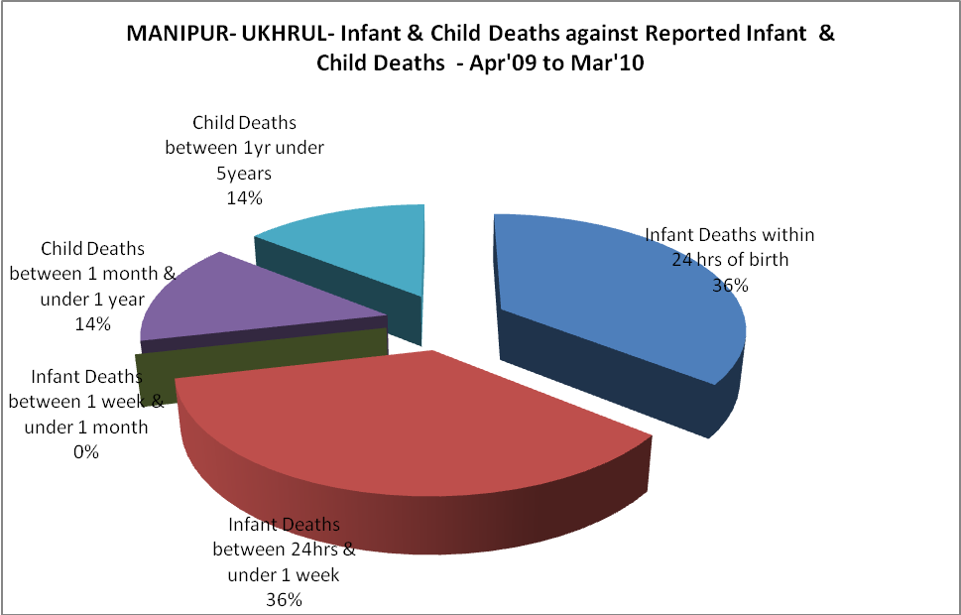

MANIPUR- UKHRUL- Causes of Infant & Child Deaths - Apr'09 to Mar'10
Sepsis |  |  | Asphyxia |  |  | LBW
Up to 1 Weeks of Birth | Between 1 week & 4 weeks of birth | Total | Up to 1 Weeks of Birth | Between 1 week & 4 weeks of birth | Total | Up to 1 Weeks of Birth | Between 1 week & 4 weeks of birth | Total
0 | 0 | 0 | 2 | 0 | 2 | 1 | 0 | 1
Pneumonia |  |  | Diarrhoea |  |  | Fever related
Between 1 month and 11 months | Between 1 year & 5 years | Total | Between 1 month and 11 months | Between 1 year & 5 years | Total | Between 1 month and 11 months | Between 1 year & 5 years | Total
0 | 0 | 0 | 2 | 0 | 2 | 0 | 1 | 1
Others |  |  | Measles |  |  | Others
Up to 1 Weeks of Birth | Between 1 week & 4 weeks of birth | Total | Between 1 month and 11 months | Between 1 year & 5 years | Total | Between 1 month and 11 months | Between 1 year & 5 years | Total
2 | 0 | 2 | 0 | 0 | 0 | 0 | 1 | 1

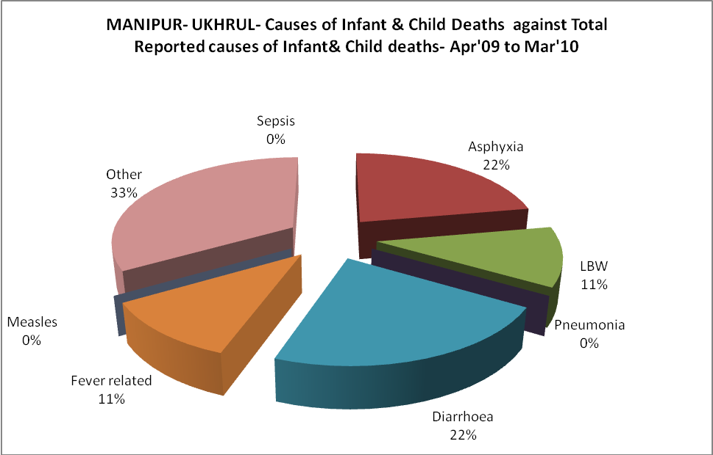
MANIPUR- UKHRUL- Maternal Deaths & Causes - Apr'09 to Mar'10
Abortion |  |  | Obstructed/prolonged labour |  |  | Severe hypertesnion/fits
6-14 yrs | 15-55 yrs. | Total | 6-14 yrs | 15-55 yrs. | Total | 6-14 yrs | 15-55 yrs. | Total
0 | 0 | 0 | 0 | 0 | 0 | 0 | 0 | 0
Bleeding |  |  | High Fever |  |  | Other Causes
6-14 yrs | 15-55 yrs. | Total | 6-14 yrs | 15-55 yrs. | Total | 6-14 yrs | 15-55 yrs. | Total
0 | 0 | 0 | 0 | 0 | 0 | 0 | 0 | 0

MANIPUR- UKHRUL-Causes of Deaths in 6 to 55yrs age group - Apr'09 to Mar'10
Diarrhoel Diseases |  |  |  | Tuberculosis |  |  |  | Respiratory Diseases( Other than TB)
6-14 yrs | 15-55 yrs. | Above 55yrs | Total | 6-14 yrs | 15-55 yrs. | Above 55yrs | Total | 6-14 yrs | 15-55 yrs. | Above 55yrs | Total
0 | 0 | 1 | 1 | 0 | 2 | 0 | 2 | 0 | 0 | 0 | 0
Malaria |  |  |  | Other fever Related |  |  |  | HIV/Aids
6-14 yrs | 15-55 yrs. | Above 55yrs | Total | 6-14 yrs | 15-55 yrs. | Above 55yrs | Total | 6-14 yrs | 15-55 yrs. | Above 55yrs | Total
0 | 1 | 0 | 1 | 0 | 0 | 0 | 0 | 0 | 3 | 0 | 3
Heart Disease/Hypertenion related |  |  |  | Neurological Disease including strokes |  |  |  | Trauma/Accidents/ Burn Cases
6-14 yrs | 15-55 yrs. | Above 55yrs | Total | 6-14 yrs | 15-55 yrs. | Above 55yrs | Total | 6-14 yrs | 15-55 yrs. | Above 55yrs | Total
0 | 1 | 5 | 6 | 1 | 1 | 2 | 4 | 0 | 3 | 0 | 3
Suicide |  |  |  | Animal Bites & Stings
6-14 yrs | 15-55 yrs. | Above 55yrs | Total | 6-14 yrs | 15-55 yrs. | Above 55yrs | Total
0 | 0 | 0 | 0 | 1 | 2 | 0 | 3

