NHSRC
MANIPUR- Senapati District
HMIS Data Analysis 2009-10

Amit
8/6/2010

MANIPUR- SENAPATI- Summary-Apr'09 to Mar'10
ANC
ANC Registration against Expected Pregnancies |  |  | 313% | TT1 given to Pregnant women against ANC Registraion |  |  | 47%
3 ANC Check ups against ANC Reigtrations |  |  | 27% | 100 IFA Tablets given to Pregnant women against ANC Registraion |  |  | 36%
Deliveries
Unreported Deliveries against Estimated Deliveries |  |  | -25.7% | HOME Deliveries( SBA& Non SBA) against Estimated Deliveries |  |  | 84.9%
Institutional Deliveries against Estimated Deliveries |  |  | 40.8% | HOME Deliveries( SBA& Non SBA) against Reported Deliveries |  |  | 67.5%
Institutional Deliveries against Reported Deliveries |  |  | 32.5% | C Section Deliveries against Institutional Deliveries( Pvt & Pub) |  |  | 0%
Births & Neonates Care
Live Births Reported against Estimated Live Births |  |  | 123% | New borns weighed against Reported Live Births |  |  | 100%
Still Births (Reported) |  |  | 22 | New borns weighed less than 2.5 kgs against newborns weighed |  |  | 1%
Sex Ratio at Birh |  |  | 992 | New borns breastfed within one hr of Birth against Reported live Births |  |  | 84%
Child Immunisation( 0 to 11 months)
BCG given against Expected Live Births |  |  | 236% | Measles given against Expected Live Births |  |  | 220%
OPV3 given against Expected Live Births |  |  | 237% | Fully Immunised Children against Expected Live Births |  |  | 218%
DPT3 given against Expected Live Births |  |  | 238%
Family Planning
Family Plannig Methods Users ( Sterilisations(Male &Female)+IUD+ Condom pieces/72 + OCP Cycles/13) |  |  | 1,146 | IUD Insertions against reported FP Methods |  |  | 49%
Sterilisation against reported FP Methods |  |  | 0% | Condom Users against reported FP Methods |  |  | 26%
 |  |  |  | OCP Users against reported FP Methods |  |  | 24%
Other Services
OPD |  |  | 72,455 | Major Operations |  |  | 34
IPD |  |  | 3,222 | Minor Operations |  |  | 681
MANIPUR- SENAPATI- Deliveries Apr'09 to Mar'10
Total Population | 189,767 | Expected Deliveries |  |  |  | 3,019
Home SBA | Home Non SBA | Institutional |  |  | Total Deliveries Reported | Unreported Deliveries
1,280 | 1,283 | 1,232 |  |  | 3,795 | (776)
Home SBA % | Home Non SBA% | Institutional % |  |  | Total Deliveries Reported % | Unreported Deliveries %
42% | 42% | 41% |  |  | 126% | -26%

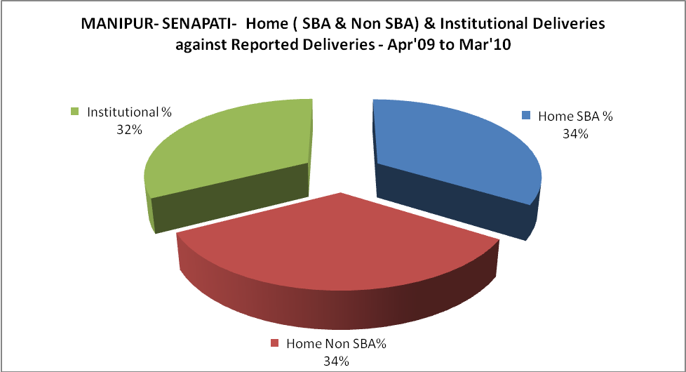

MANIPUR- SENAPATI- C sections & Complicated Deliveries Apr'09 to Mar'10
 | Institutional Deliveries (Public) | Institutional Deliveries (Pvt)
 | 1,225 | 7
C Section | - | -
C Section% | 0% | 0%
Complicated Pregnacies attended | 28 | -
Complicated Pregnacies attended % | 2% | 0%

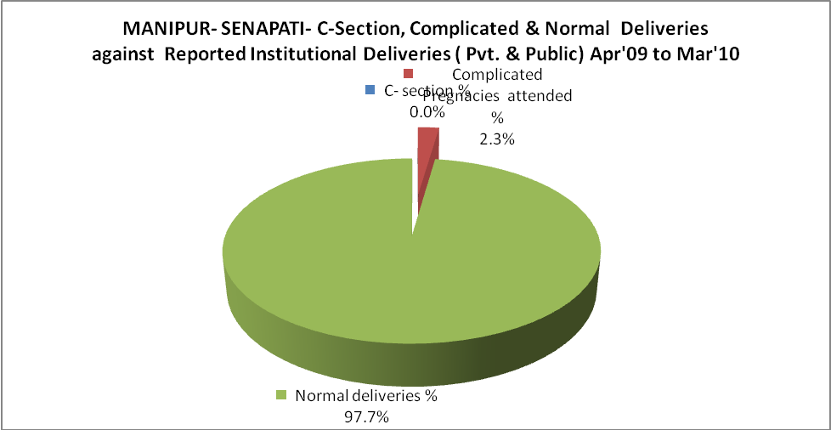

MANIPUR- SENAPATI- Complicated Pregnancies & Deliveries Treated - Apr'09 to Mar'10
Reported Deliveries |  |  | Reported ANC Reigtration
3,795 |  |  | 10,326
Complicated Pregnancies attended | Complicated Pregnancies Rate | C - Section Deliveries | PNC Maternal Complications | Abortions | Still Births
28 | 1% | - | 3 | 43 | 22
Complicated Deliveries Treated with |  |  |  | No Of Eclampsia cases Treated | No Of severe anemia cases treated
IV Antibiotics | IV antihypertensive/Magsulph injection | IV Oxytocis | Blood Transfusion | No Of Eclampsia cases Treated | No Of severe anemia cases treated
32 | - | 35 | - | 1 | 26

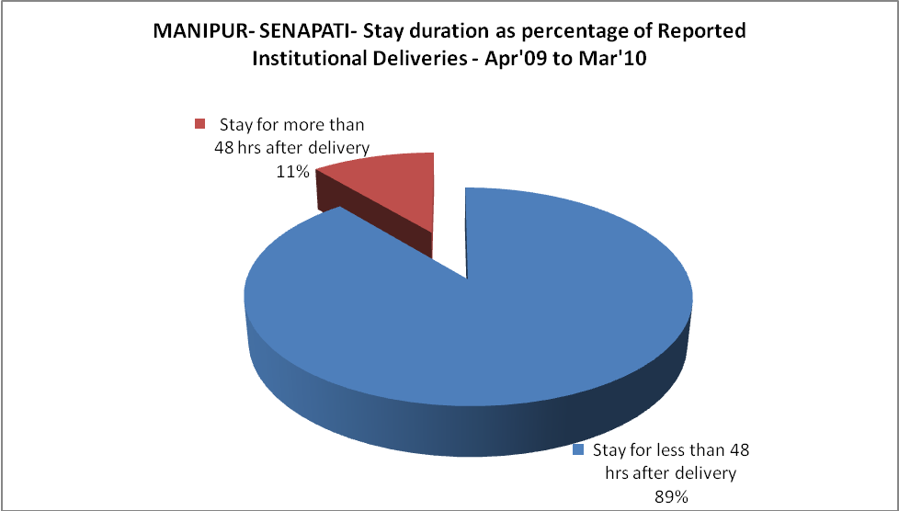
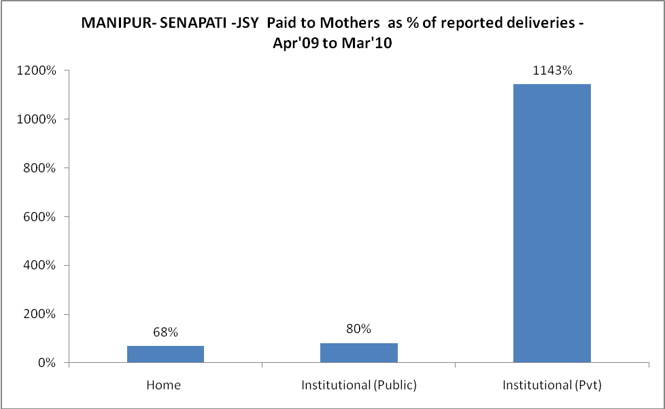
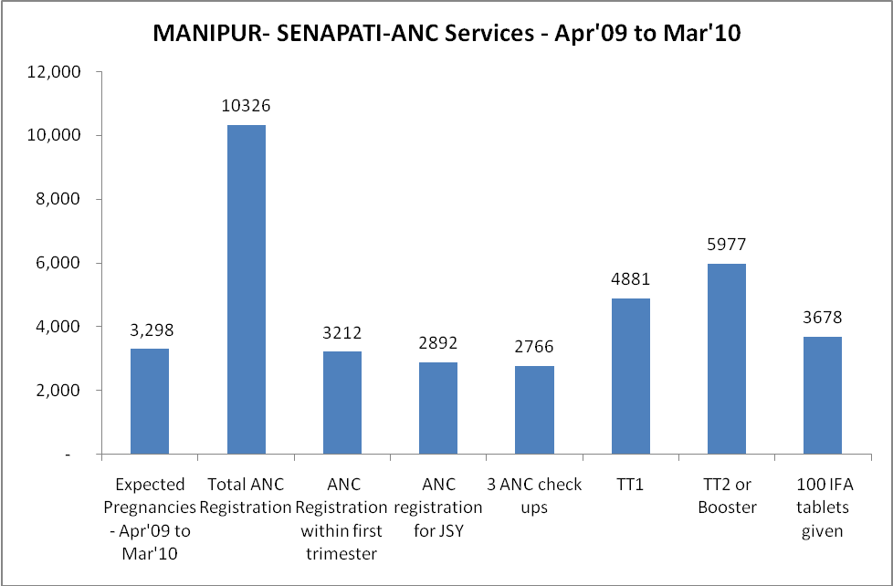
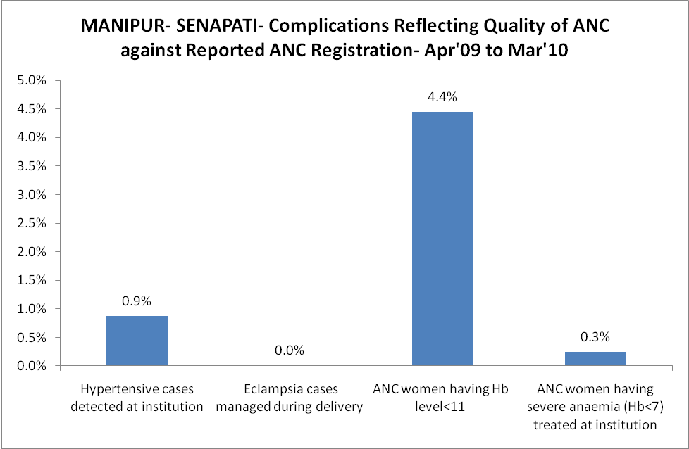
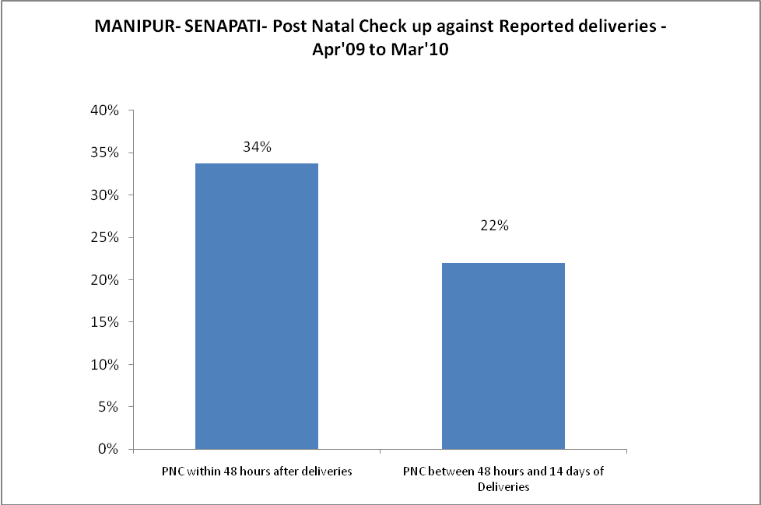
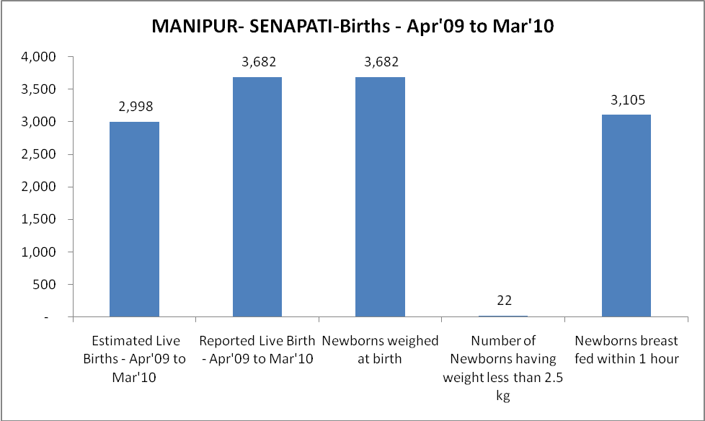
MANIPUR- SENAPATI - Births - Apr'09 to Mar'10
Live Birth - Males | Live Birth - females | Live Birth - Total | Sex Ratio at birth | Still Birth | Abortion( Induced/Spontaneous
1,848 | 1,834 | 3,682 | 992 | 22 | 43

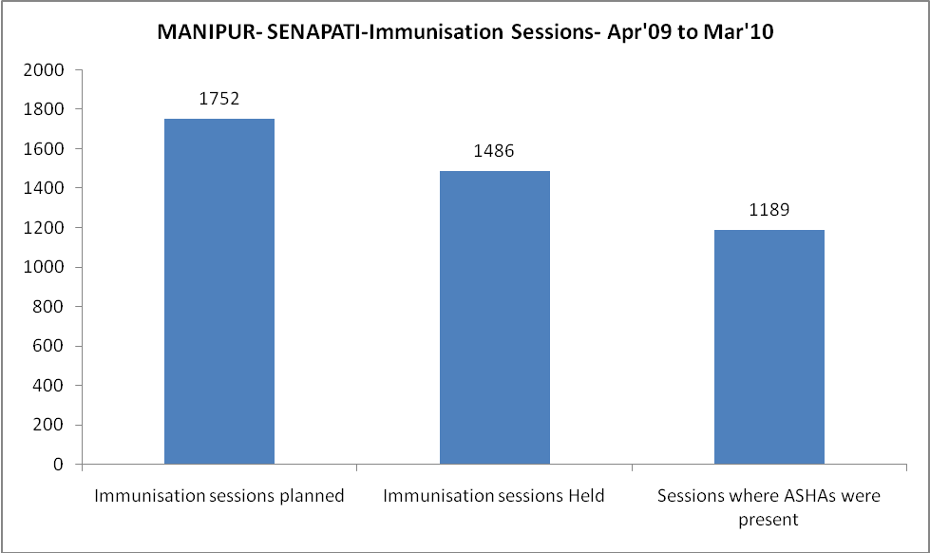
MANIPUR- SENAPATI- Apr'09 to Mar'10
Total Abortions | Abortion Rate
295 | 8.9%

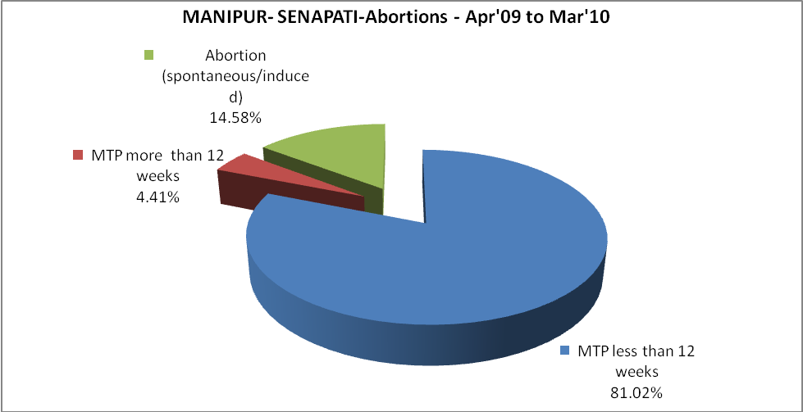
MANIPUR- SENAPATI- Apr'09 to Mar'10
Total OPD | Total RTI/STI cases
72,455 | 829

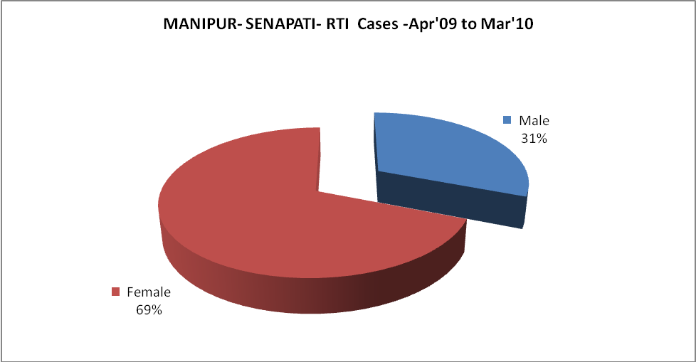
MANIPUR- SENAPATI-FP Methods - Apr'09 to Mar'10
 | Reported | %age of All Reported FP Methods
Total Reported FP Methodd (All types) Users | 1,146 | -
Sterilisations | - | 0%
IUD | 564 | 49%
Condom Users | 302 | 26%
OCP Users | 280 | 24%
Limiting Methods | - | 0%
Spacing Methods | 1,146 | 100%

MANIPUR- SENAPATI- Service Delivery - Apr'09 to Mar'10
Operation major (General and spinal anaesthesia) | Operation minor (No or local anaesthesia) | AYUSH | Dental Procedures | Adolescent counselling services | Total OPD | Total IPD
34 | 681 | 5,341 | 754 | 741 | 72,455 | 3,222
Operation major (General and spinal anaesthesia) as %ge of OPD | Operation minor (No or local anaesthesia)as %ge of OPD | AYUSH as %ge of OPD | Dental Procedures as %ge of OPD | Adolescent counselling services as %ge of OPD | IPD as percentage of OPD
0.0% | 0.9% | 7.4% | 1.0% | 1.0% | 4%

MANIPUR- SENAPATI- Lab Services - Apr'09 to Mar'10
Total OPD | Total HB tested | Total HIV Tested | Total Population
72,455 | 836 | 3,809 | 189,767
HB test conducted as %age of OPD | HB<7gm as %age of HB tested | HIV test conducted as %age of OPD | HIV positive as %age of HIV tested | Blood Smear Examined as % of Population
1.2% | 3.3% | 5.3% | 1.4% | 2.6%

MANIPUR- SENAPATI- Childhood Disease - Vaccine Preventable -Apr'09 to Mar'10
Diphtheria | Pertussis | Tetanus Neonatorum | Tetanus others | Polio | Measles
0 | 0 | 1 | 0 | 0 | 116
MANIPUR- SENAPATI-Childhood Disease - Others - Apr'09 to Mar'10
Diarrhoea and dehydration | Malaria | Number admitted with Respiratory Infections
4,218 | 62 | 754

MANIPUR- SENAPATI- Infant & Child Deaths - Apr'09 to Mar'10
Infant Deaths within 24 hrs of birth | Infant Deaths between 24hrs & under 1 week | Infant Deaths between 1 week & under 1 month | Child Deaths between 1 month & under 1 year | Child Deaths between 1yr under 5years | Total Deaths
3 | 1 | 1 | 3 | 12 | 20

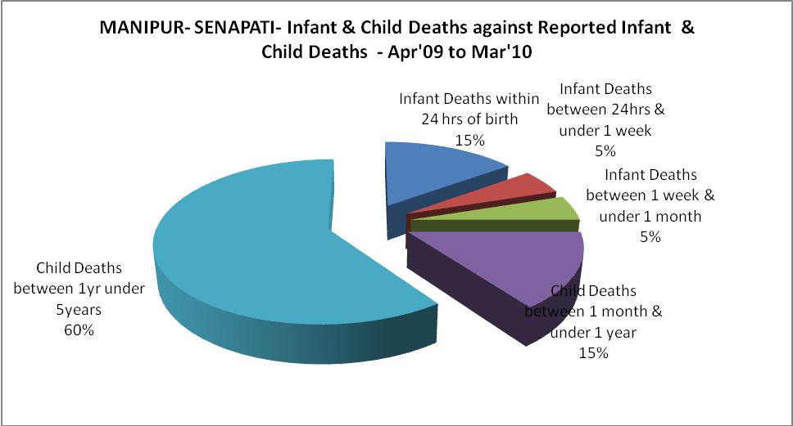

MANIPUR- SENAPATI- Causes of Infant & Child Deaths - Apr'09 to Mar'10
Sepsis |  |  | Asphyxia |  |  | LBW
Up to 1 Weeks of Birth | Between 1 week & 4 weeks of birth | Total | Up to 1 Weeks of Birth | Between 1 week & 4 weeks of birth | Total | Up to 1 Weeks of Birth | Between 1 week & 4 weeks of birth | Total
0 | 0 | 0 | 0 | 0 | 0 | 0 | 0 | 0
Pneumonia |  |  | Diarrhoea |  |  | Fever related
Between 1 month and 11 months | Between 1 year & 5 years | Total | Between 1 month and 11 months | Between 1 year & 5 years | Total | Between 1 month and 11 months | Between 1 year & 5 years | Total
1 | 1 | 2 | 1 | 5 | 6 | 0 | 2 | 2
Others |  |  | Measles |  |  | Others
Up to 1 Weeks of Birth | Between 1 week & 4 weeks of birth | Total | Between 1 month and 11 months | Between 1 year & 5 years | Total | Between 1 month and 11 months | Between 1 year & 5 years | Total
1 | 1 | 2 | 0 | 0 | 0 | 1 | 4 | 5

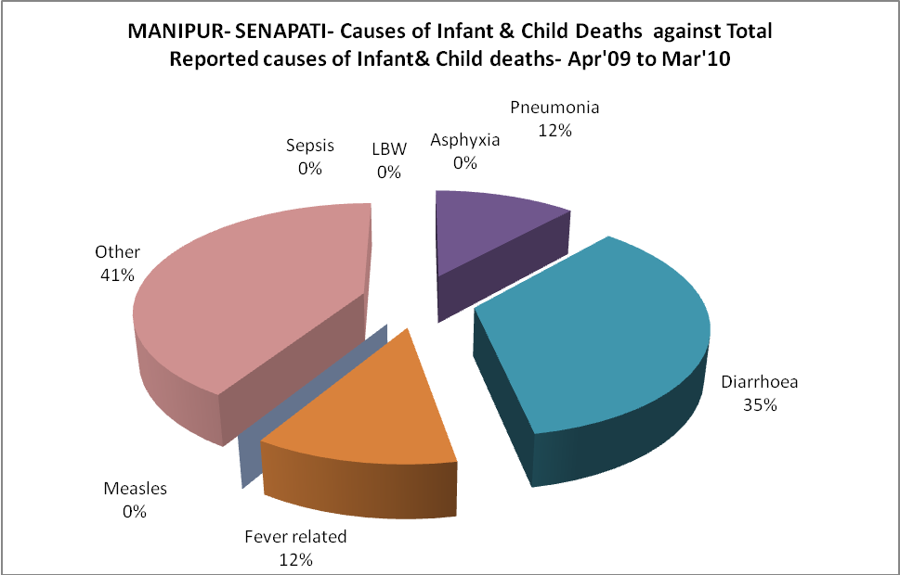
MANIPUR- SENAPATI- Maternal Deaths & Causes - Apr'09 to Mar'10
Abortion |  |  | Obstructed/prolonged labour |  |  | Severe hypertesnion/fits
6-14 yrs | 15-55 yrs. | Total | 6-14 yrs | 15-55 yrs. | Total | 6-14 yrs | 15-55 yrs. | Total
0 | 0 | 0 | 0 | 0 | 0 | 0 | 0 | 0
Bleeding |  |  | High Fever |  |  | Other Causes
6-14 yrs | 15-55 yrs. | Total | 6-14 yrs | 15-55 yrs. | Total | 6-14 yrs | 15-55 yrs. | Total
0 | 0 | 0 | 0 | 0 | 0 | 0 | 0 | 0

MANIPUR- SENAPATI-Causes of Deaths in 6 to 55yrs age group - Apr'09 to Mar'10
Diarrhoel Diseases |  |  |  | Tuberculosis |  |  |  | Respiratory Diseases( Other than TB)
6-14 yrs | 15-55 yrs. | Above 55yrs | Total | 6-14 yrs | 15-55 yrs. | Above 55yrs | Total | 6-14 yrs | 15-55 yrs. | Above 55yrs | Total
0 | 1 | 4 | 5 | 0 | 1 | 4 | 5 | 0 | 3 | 1 | 4
Malaria |  |  |  | Other fever Related |  |  |  | HIV/Aids
6-14 yrs | 15-55 yrs. | Above 55yrs | Total | 6-14 yrs | 15-55 yrs. | Above 55yrs | Total | 6-14 yrs | 15-55 yrs. | Above 55yrs | Total
0 | 1 | 0 | 1 | 0 | 3 | 0 | 3 | 0 | 2 | 0 | 2
Heart Disease/Hypertenion related |  |  |  | Neurological Disease including strokes |  |  |  | Trauma/Accidents/ Burn Cases
6-14 yrs | 15-55 yrs. | Above 55yrs | Total | 6-14 yrs | 15-55 yrs. | Above 55yrs | Total | 6-14 yrs | 15-55 yrs. | Above 55yrs | Total
3 | 8 | 4 | 15 | 0 | 2 | 0 | 2 | 0 | 1 | 1 | 2
Suicide |  |  |  | Animal Bites & Stings
6-14 yrs | 15-55 yrs. | Above 55yrs | Total | 6-14 yrs | 15-55 yrs. | Above 55yrs | Total
0 | 4 | 0 | 4 | 0 | 2 | 0 | 2

