NHSRC
MEGHALAYA STATE ANALYSIS
HMIS DATA ANALYSIS 2009-10

NHSRC
8/25/2010

Fact Sheet - Meghalaya
Indicators
A - General
A.1 | Total Population (NHSRC Inhouse estimation for March 2008) |  |  |  |  |  | 2,836,145
A.2 | Eligible Couples ((NHSRC Inhouse estimation for March 2008) |  |  |  |  |  | 624741
A.3 | TFR {Source: NFHSIII} |  |  |  |  |  | 3.80
A.4 | MMR ( per 100,000 live births){Source: Registrar General of India (RGI), Ministry of Home Affairs., May 2009}
A.5 | IMR (SRS Bulletin - Oct 2009) |  |  |  |  |  | 58
A.6 | CBR ( per 1000 population)(SRS Bulletin - Oct 2009) |  |  |  |  |  | 25.2
A.7 | CDR ( per 1000 population)(SRS Bulletin - Oct 2009) |  |  |  |  |  | 7.9
A.8 | Sex Ratio ( per thousand males)(census 2001) |  |  |  |  |  | 973.00
 | B - Child Health |  |  | HMIS - 2009-10 | Surveys | Source
B.1 | Expected Live Births |  |  | 71,471 | - | NFHSIII
B.2 | New born breastfed in less than 1 hr of birth against Expected Live Births |  |  | 65% | 58.6% | NFHSIII
B.3 | Newborn weighed % against Expected Live Births |  |  | 63% | 33.5% | NFHSIII
B.4 | Newborn weighed less than 2.5 kgs % as percentage of B.3 |  |  | 12% | 18.0% | NFHSIII
 | C - Child Immunisation |  |  | HMIS - 2009-10 | Surveys | Source
C.1 | Fully Immunised Children % ( of Expected Live Births) |  |  | 74% | 32.8% | NFHSIII
C.2 | Children given BCG % ( of Expected Live Births) |  |  | 107% | 65.9% | NFHSIII
C.3 | Children given 3 doses of OPV % ( of Expected Live Births) |  |  | 86% | 56.6% | NFHSIII
C.4 | Children given 3 doses of DPT % ( of Expected Live Births) |  |  | 87% | 47.3% | NFHSIII
C.5 | Children given Measles % ( of Expected Live Births) |  |  | 76% | 43.8% | NFHSIII
 | D - Maternal Health |  |  | HMIS - 2009-10 | Surveys | Source
D.1 | Pregnant women registered for ANC% ( as percentage of expected pregnancies) |  |  | 130% | _ | _
D.2 | ANC registered in First Trimester % ( as percentage of expected pregnancies) |  |  | 35% | 24.8% | DLHSIII
D.3 | Antenatal Care 3 check ups % ( as percentage of expected pregnancies) |  |  | 54% | 39.4% | DLHSIII
D.8 | Home Deliveries % ( as percentage of expected deliveries) |  |  | 51% | 74.9% | DLHSIII
D.9 | Home Deliveries assisted by SBA % ( as percentage of expected deliveries) |  |  | 6% | 5.9% | DLHSIII
D.10 | Institutional Deliveries % ( as percentage of expected deliveries) |  |  | 39% | 24.4% | DLHSIII
D.11 | Post natal check up within 48 hrs of delivery % ( as percentage ofreported deliveries) |  |  | 36% | _ | _
D.12 | Deliveries with post natal check up within two days and 14 days of birth % ( as percentage ofreported deliveries) |  |  | 34% | 32.5% | DLHSIII

Meghalaya- Deliveries Apr'09 to Mar'10
Total Population | 2,836,145 | Expected Deliveries |  | 73,544
Home SBA | Home Non SBA | Institutional | Total Deliveries Reported | Unreported Deliveries
4,771 | 33,053 | 28,441 | 66,265 | 7,279
Home SBA % | Home Non SBA% | Institutional % | Total Deliveries Reported % | Unreported Deliveries %
6% | 45% | 39% | 90% | 10%

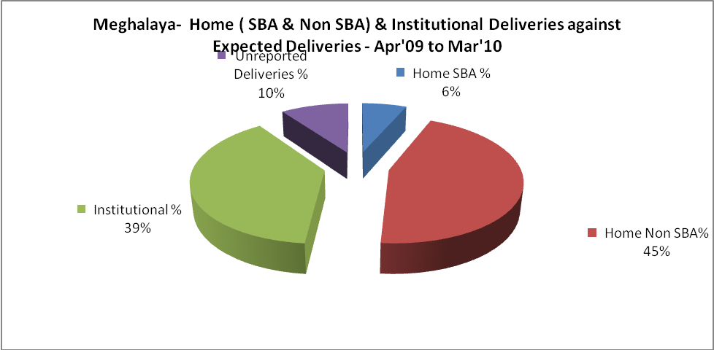

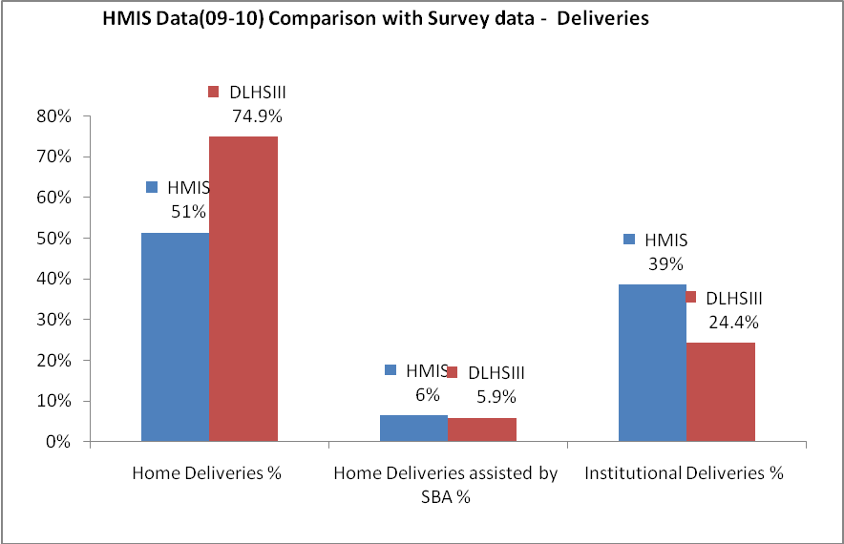

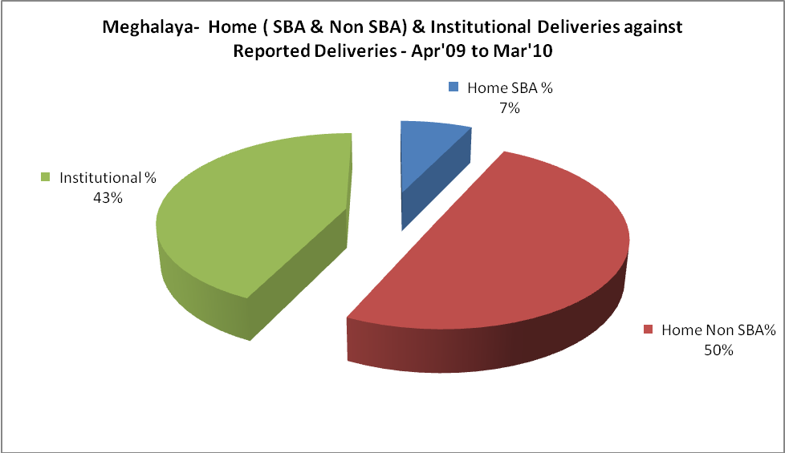

Meghalaya- C sections & Complicated Deliveries Apr'09 to Mar'10
 | Institutional Deliveries (Public) | Institutional Deliveries (Pvt)
 | 21,512 | 6,929
C Section | 2,045 | 2,287
C Section% | 10% | 33%
Complicated Pregnacies attended | 2,059 | 371
Complicated Pregnacies attended % | 10% | 5%

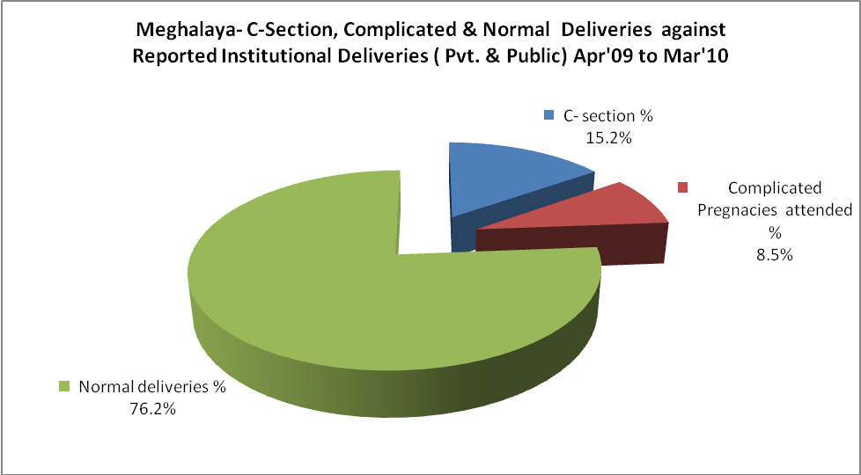

Meghalaya- Complicated Pregnancies & Deliveries Treated - Apr'09 to Mar'10
Reported Deliveries |  |  | Reported ANC Reigtration
66,265 |  |  | 102,540
Complicated Pregnancies attended | Complicated Pregnancies Rate | C - Section Deliveries | PNC Maternal Complications | Abortions | Still Births
2,430 | 3% | 4,332 | 2,008 | 2,131 | 1,556
Complicated Deliveries Treated with |  |  |  | No Of Eclampsia cases Treated | No Of severe anemia cases treated
IV Antibiotics | IV antihypertensive/Magsulph injection | IV Oxytocis | Blood Transfusion | No Of Eclampsia cases Treated | No Of severe anemia cases treated
3,302 | 379 | 1,635 | 311 | 1,238 | 1,724

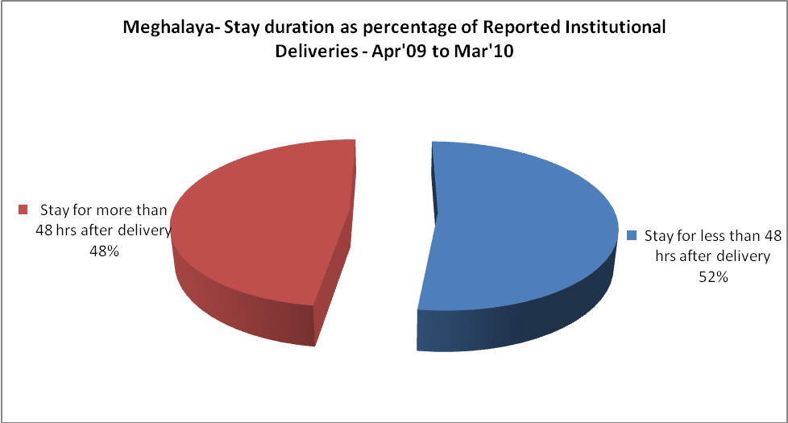
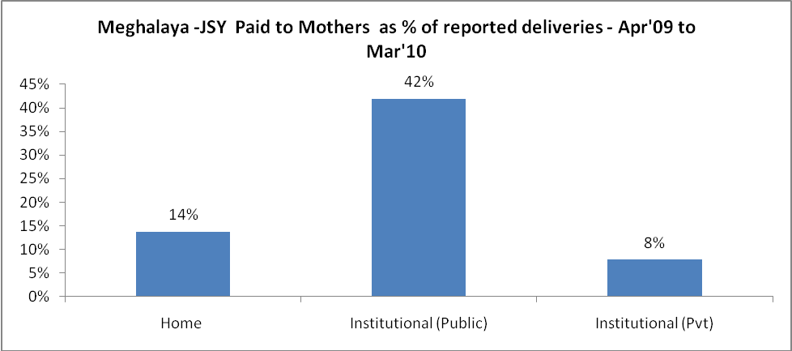

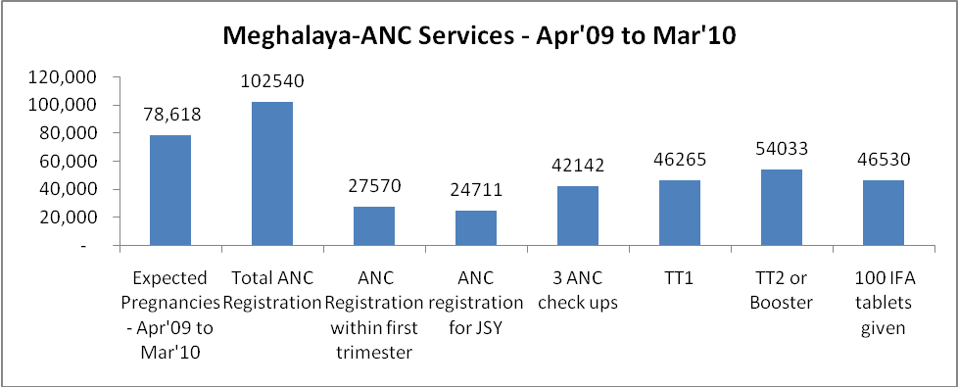

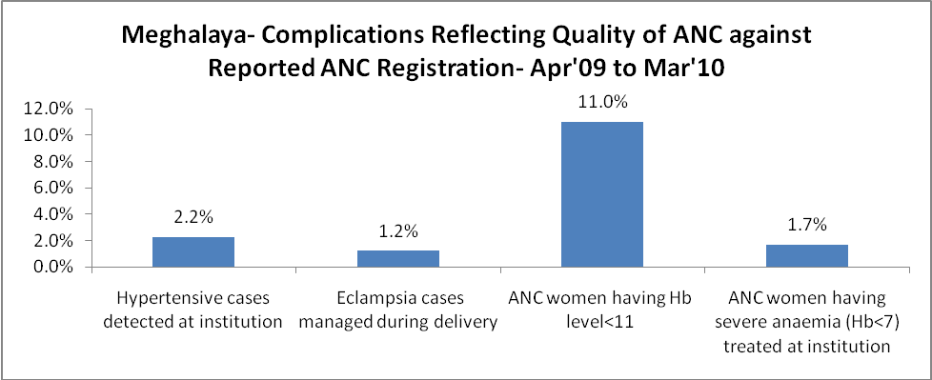

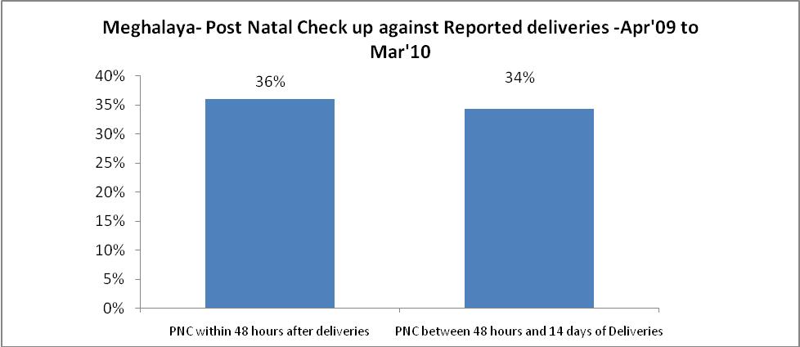

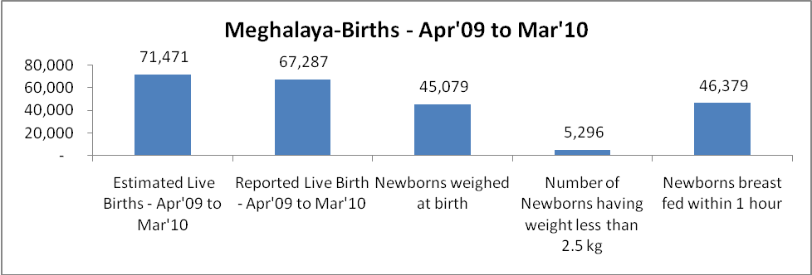

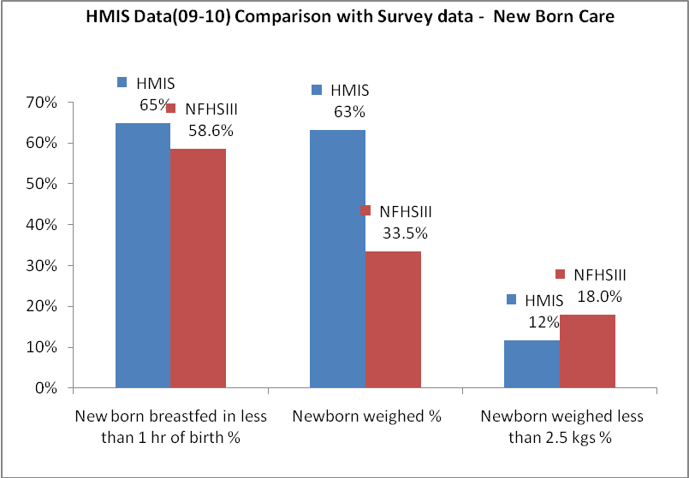

Meghalaya - Births - Apr'09 to Mar'10
Live Birth - Males | Live Birth - females | Live Birth - Total | Sex Ratio at birth | Still Birth | Abortion( Induced/Spontaneous
34,627 | 32,660 | 67,287 | 943 | 1,556 | 2,131

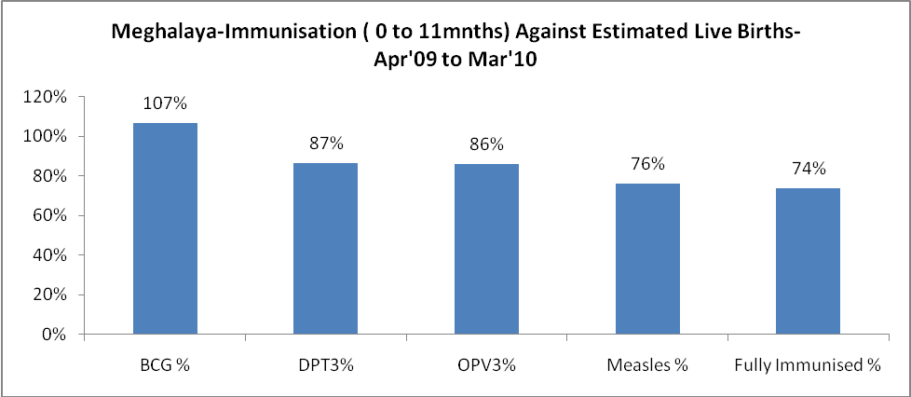

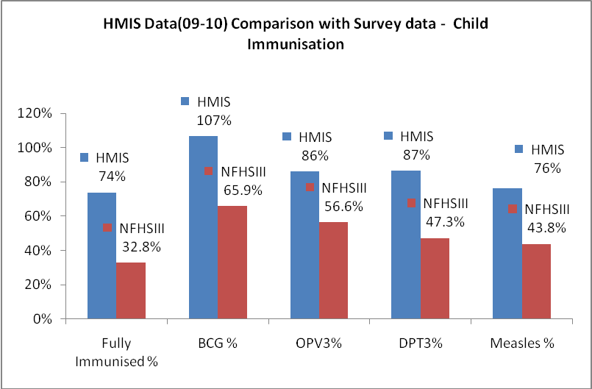

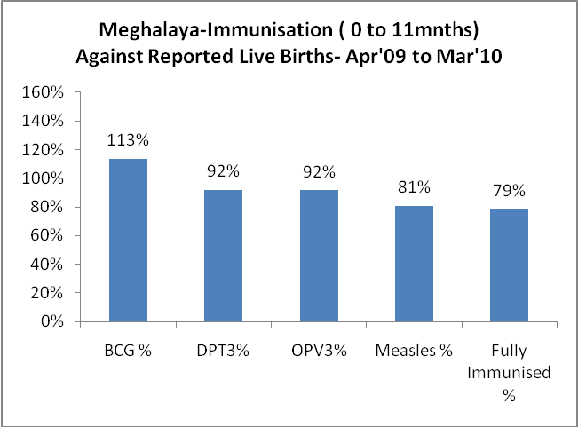

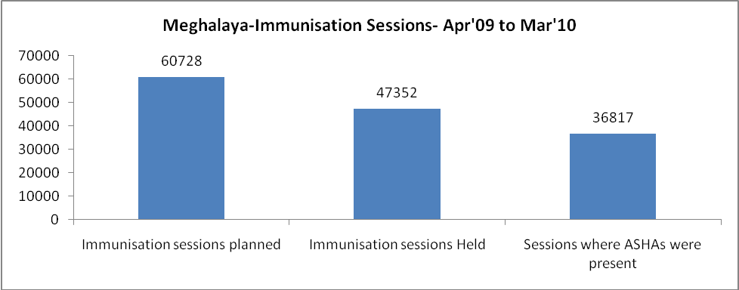

Meghalaya- Apr'09 to Mar'10
Total Abortions | Abortion Rate
2,535 | 3.2%

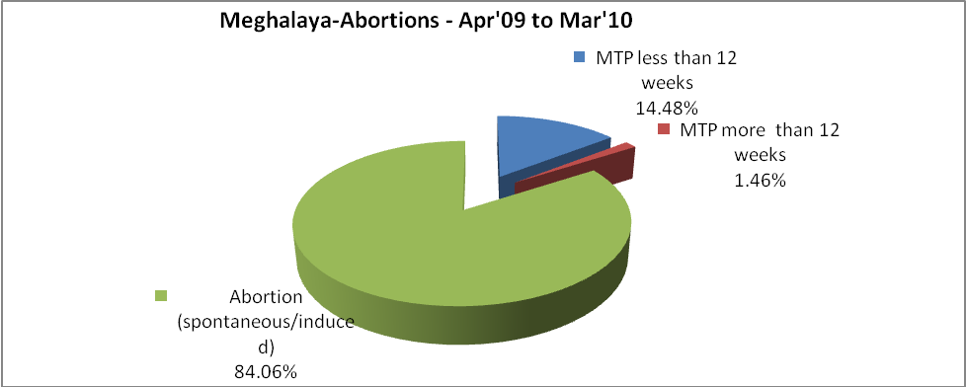

Meghalaya- Apr'09 to Mar'10
Total OPD | Total RTI/STI cases
2,514,500 | 6,425

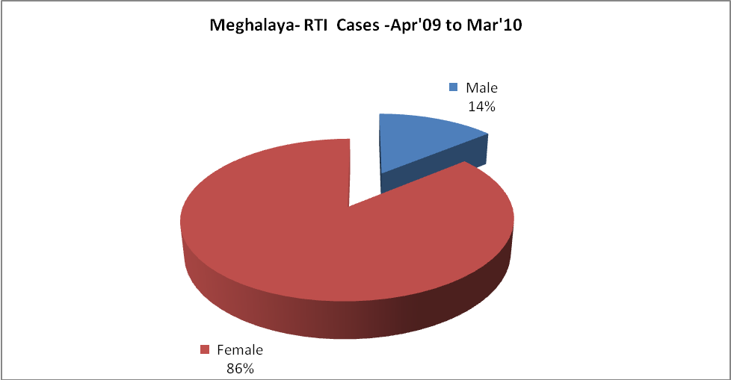

Meghalaya-Sterilisations - Apr'09 to Mar'10
 | Reported | %age of Reported Sterilisation
Total Sterilisation | 1,820 | -
NSV | 25 | 1%
Laproscopic | 39 | 2%
MiniLap | 380 | 21%
Post Partum | 1,376 | 76%
Male Sterilisation | 25 | 1%
Female Sterilisation | 1,795 | 99%

Meghalaya-FP Methods - Apr'09 to Mar'10
 | Reported | %age of All Reported FP Methods
Total Reported FP Methodd (All types) Users | 12,807 | -
Sterilisations | 1,820 | 14%
IUD | 2,591 | 20%
Condom Users | 3,555 | 28%
OCP Users | 4,842 | 38%
Limiting Methods | 1,820 | 14%
Spacing Methods | 10,987 | 86%

Meghalaya- Service Delivery - Apr'09 to Mar'10
Operation major (General and spinal anaesthesia) | Operation minor (No or local anaesthesia) | AYUSH | Dental Procedures | Adolescent counselling services | Total OPD | Total IPD
20,634 | 4,030 | 96,717 | 27,351 | 2,673 | 2,514,500 | 144,786
Operation major (General and spinal anaesthesia) as %ge of OPD | Operation minor (No or local anaesthesia)as %ge of OPD | AYUSH as %ge of OPD | Dental Procedures as %ge of OPD | Adolescent counselling services as %ge of OPD | IPD as percentage of OPD
0.8% | 0.2% | 3.8% | 1.1% | 0.1% | 6%

Meghalaya- Lab Services - Apr'09 to Mar'10
Total OPD | Total HB tested | Total HIV Tested | Total Population
2,514,500 | 89,975 | 13,044 | 2,836,145
HB test conducted as %age of OPD | HB<7gm as %age of HB tested | HIV test conducted as %age of OPD | HIV positive as %age of HIV tested | Blood Smear Examined as % of Population
3.6% | 6.9% | 0.5% | 0.5% | 11.1%

Meghalaya- Childhood Disease - Vaccine Preventable -Apr'09 to Mar'10
Diphtheria | Pertussis | Tetanus Neonatorum | Tetanus others | Polio | Measles
9 | 4 | 1 | 1 | 0 | 2549
Meghalaya-Childhood Disease - Others - Apr'09 to Mar'10
Diarrhoea and dehydration | Malaria | Number admitted with Respiratory Infections
86,027 | 24,858 | 11,851

Meghalaya- Infant & Child Deaths - Apr'09 to Mar'10
Infant Deaths within 24 hrs of birth | Infant Deaths between 24hrs & under 1 week | Infant Deaths between 1 week & under 1 month | Child Deaths between 1 month & under 1 year | Child Deaths between 1yr under 5years | Total Deaths
246 | 428 | 212 | 878 | 999 | 2763

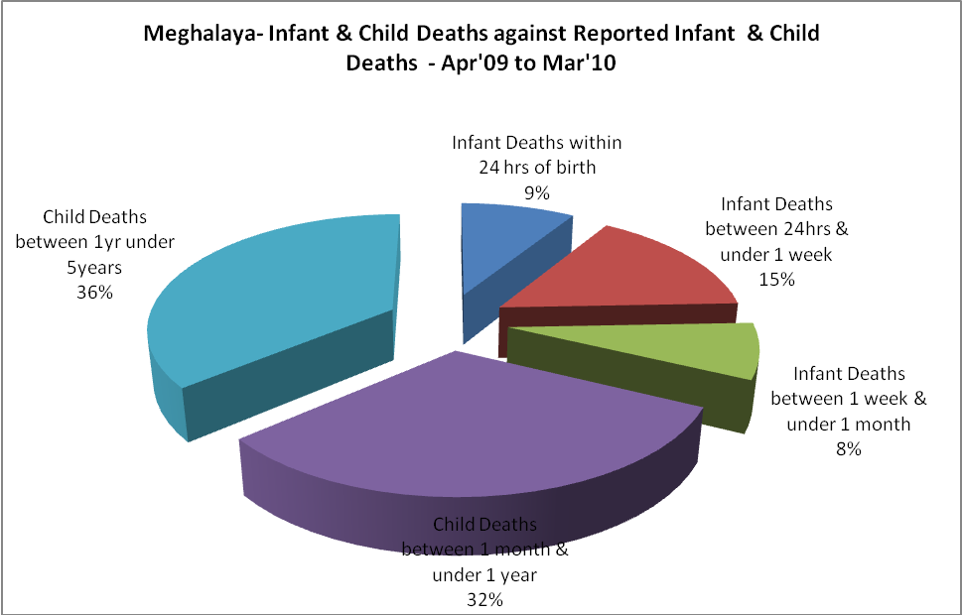

Meghalaya- Causes of Infant & Child Deaths - Apr'09 to Mar'10
Sepsis |  |  | Asphyxia |  |  | LBW
Up to 1 Weeks of Birth | Between 1 week & 4 weeks of birth | Total | Up to 1 Weeks of Birth | Between 1 week & 4 weeks of birth | Total | Up to 1 Weeks of Birth | Between 1 week & 4 weeks of birth | Total
43 | 18 | 61 | 77 | 30 | 107 | 79 | 26 | 105
Pneumonia |  |  | Diarrhoea |  |  | Fever related
Between 1 month and 11 months | Between 1 year & 5 years | Total | Between 1 month and 11 months | Between 1 year & 5 years | Total | Between 1 month and 11 months | Between 1 year & 5 years | Total
135 | 83 | 218 | 42 | 51 | 93 | 234 | 276 | 510
Others |  |  | Measles |  |  | Others
Up to 1 Weeks of Birth | Between 1 week & 4 weeks of birth | Total | Between 1 month and 11 months | Between 1 year & 5 years | Total | Between 1 month and 11 months | Between 1 year & 5 years | Total
229 | 138 | 367 | 14 | 44 | 58 | 453 | 545 | 998

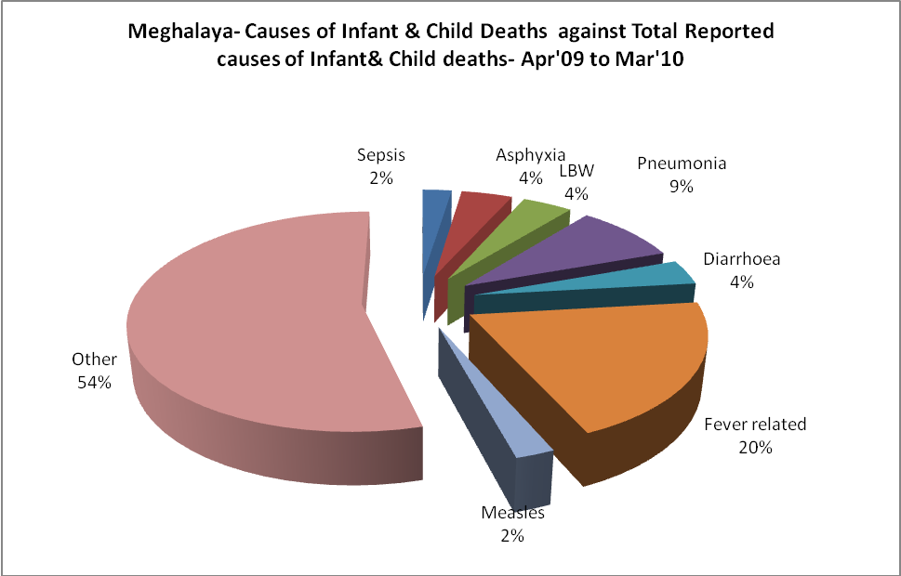

Meghalaya- Maternal Deaths & Causes - Apr'09 to Mar'10
Abortion |  |  | Obstructed/prolonged labour |  |  | Severe hypertesnion/fits
6-14 yrs | 15-55 yrs. | Total | 6-14 yrs | 15-55 yrs. | Total | 6-14 yrs | 15-55 yrs. | Total
2 | 2 | 4 | 2 | 15 | 17 | 0 | 6 | 6
Bleeding |  |  | High Fever |  |  | Other Causes
6-14 yrs | 15-55 yrs. | Total | 6-14 yrs | 15-55 yrs. | Total | 6-14 yrs | 15-55 yrs. | Total
0 | 26 | 26 | 6 | 13 | 19 | 27 | 74 | 101

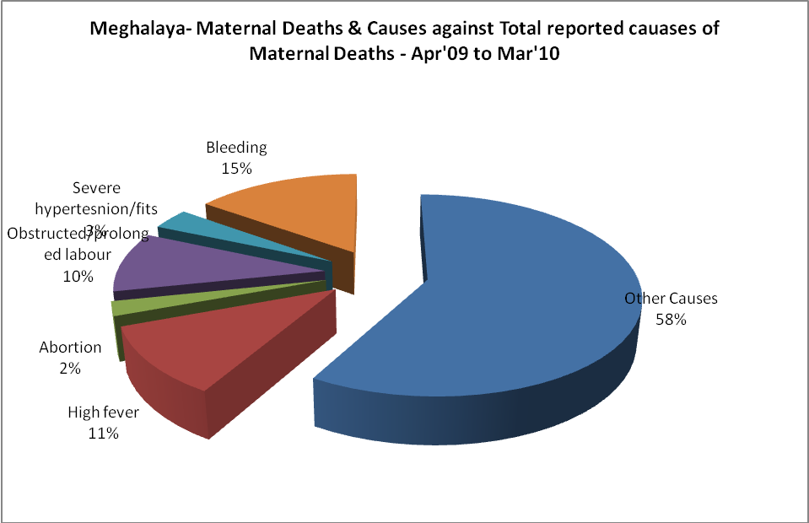
‘

Meghalaya-Causes of Deaths in 6 to 55yrs age group - Apr'09 to Mar'10
Diarrhoel Diseases |  |  |  | Tuberculosis |  |  |  | Respiratory Diseases( Other than TB)
6-14 yrs | 15-55 yrs. | Above 55yrs | Total | 6-14 yrs | 15-55 yrs. | Above 55yrs | Total | 6-14 yrs | 15-55 yrs. | Above 55yrs | Total
41 | 52 | 34 | 127 | 11 | 83 | 32 | 126 | 42 | 78 | 86 | 206
Malaria |  |  |  | Other fever Related |  |  |  | HIV/Aids
6-14 yrs | 15-55 yrs. | Above 55yrs | Total | 6-14 yrs | 15-55 yrs. | Above 55yrs | Total | 6-14 yrs | 15-55 yrs. | Above 55yrs | Total
96 | 147 | 27 | 270 | 176 | 284 | 257 | 717 | 0 | 0 | 0 | 0
Heart Disease/Hypertenion related |  |  |  | Neurological Disease including strokes |  |  |  | Trauma/Accidents/ Burn Cases
6-14 yrs | 15-55 yrs. | Above 55yrs | Total | 6-14 yrs | 15-55 yrs. | Above 55yrs | Total | 6-14 yrs | 15-55 yrs. | Above 55yrs | Total
10 | 74 | 83 | 167 | 5 | 29 | 71 | 105 | 40 | 88 | 21 | 149
Suicide |  |  |  | Animal Bites & Stings
6-14 yrs | 15-55 yrs. | Above 55yrs | Total | 6-14 yrs | 15-55 yrs. | Above 55yrs | Total
7 | 40 | 6 | 53 | 4 | 12 | 2 | 18

