NHSRC
Rajasthan-Nagaur
Analysis: Apr 2009 – Mar 2010

Rajasthan- Nagaur- Summary-Apr'09 to Mar'10
ANC
ANC Registration against Expected Pregnancies | 91% | TT1 given to Pregnant women against ANC Registration | 68%
3 ANC Checkups against ANC Registrations | 63% | 100 IFA Tablets given to Pregnant women against ANC Registration | 57%
Deliveries
Unreported Deliveries against Estimated Deliveries | 36.9% | HOME Deliveries( SBA& Non SBA) against Estimated Deliveries | 10.8%
Institutional Deliveries against Estimated Deliveries | 52.3% | HOME Deliveries( SBA& Non SBA) against Reported Deliveries | 17.1%
Institutional Deliveries against Reported Deliveries | 82.9% | C Section Deliveries against Institutional Deliveries( Pvt & Pub) | 3%
Births & Neonates Care
Live Births Reported against Estimated Live Births | 63% | New borns weighed against Reported Live Births | 70%
Still Births (Reported) | 938 | New borns weighed less than 2.5 kgs against newborns weighed | 27%
Sex Ratio at Birth | 923 | New borns breastfed within one hr of Birth against Reported live Births | 56%
Child Immunisation( 0 to 11 months)
BCG given against Expected Live Births | 91% | Measles given against Expected Live Births | 86%
OPV3 given against Expected Live Births | 86% | Fully Immunised Children against Expected Live Births | 83%
DPT3 given against Expected Live Births | 86%
Family Planning
Family Plannig Methods Users ( Sterilisations(Male &Female)+IUD+ Condom pieces/72 + OCP Cycles/13) | 100,411 | IUD Insertions against reported FP Methods | 14%
Sterilisation against reported FP Methods | 13% | Condom Users against reported FP Methods | 46%
 |  | OCP Users against reported FP Methods | 27%
Other Services
OPD | 1,507,194 | Major Operations | 1,684
IPD | 53,862 | Minor Operations | 2,292

Rajasthan- Nagaur- Deliveries Apr'09 to Mar'10
Total Population | 3,339,600 | Expected Deliveries |  | 94,732
Home SBA | Home Non SBA | Institutional | Total Deliveries Reported | Unreported Deliveries
6,611 | 3,615 | 49,516 | 59,742 | 34,990
Home SBA % | Home Non SBA% | Institutional % | Total Deliveries Reported % | Unreported Deliveries %
7% | 4% | 52% | 63% | 37%
`

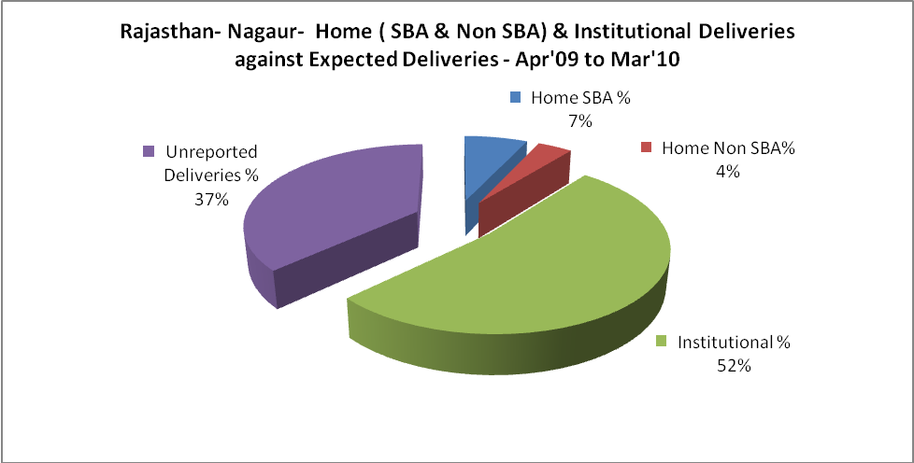

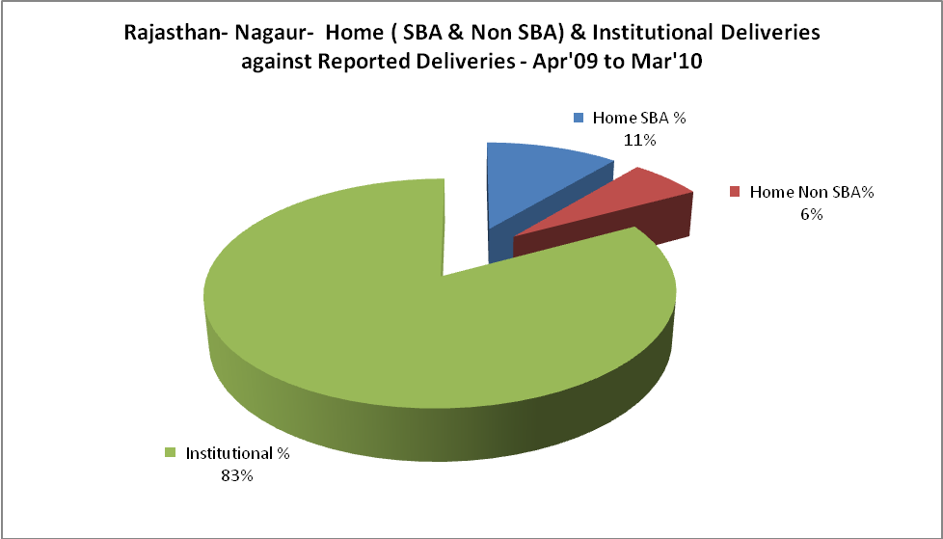

Rajasthan- Nagaur- C sections & Complicated Deliveries Apr'09 to Mar'10
 | Institutional Deliveries (Public) | Institutional Deliveries (Pvt)
 | 41,607 | 7,909
C Section | 665 | 585
C Section% | 2% | 7%
Complicated Pregnacies attended | 824 | -
Complicated Pregnacies attended % | 2% | 0%

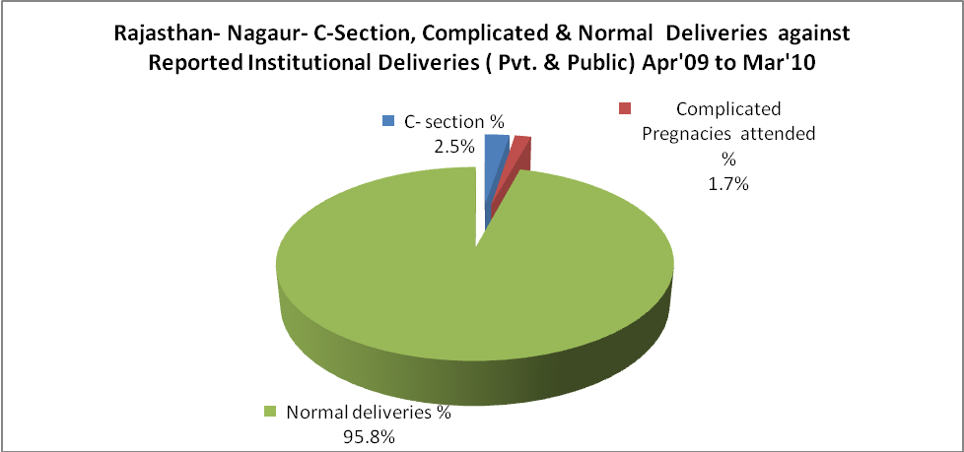

Rajasthan- Nagaur- Complicated Pregnancies & Deliveries Treated - Apr'09 to Mar'10
Reported Deliveries |  |  | Reported ANC Reigtration
59,742 |  |  | 92,061
Complicated Pregnancies attended | Complicated Pregnancies Rate | C - Section Deliveries | PNC Maternal Complications | Abortions | Still Births
824 | 1% | 1,250 | 292 | 1,502 | 938
Complicated Deliveries Treated with |  |  |  | No Of Eclampsia cases Treated | No Of severe anemia cases treated
IV Antibiotics | IV antihypertensive/Magsulph injection | IV Oxytocis | Blood Transfusion | No Of Eclampsia cases Treated | No Of severe anemia cases treated
864 | 127 | 799 | - | 195 | 1,226

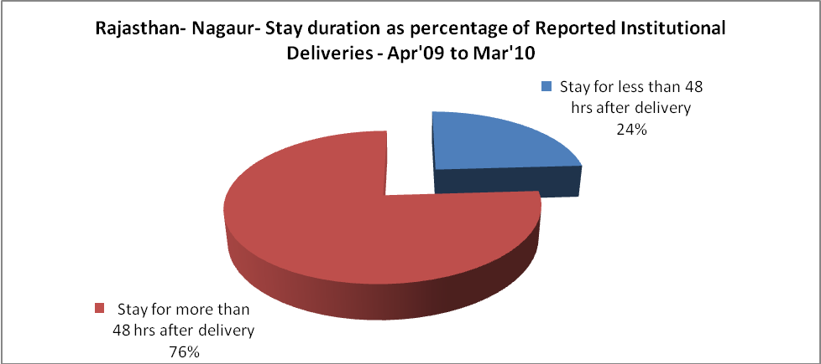

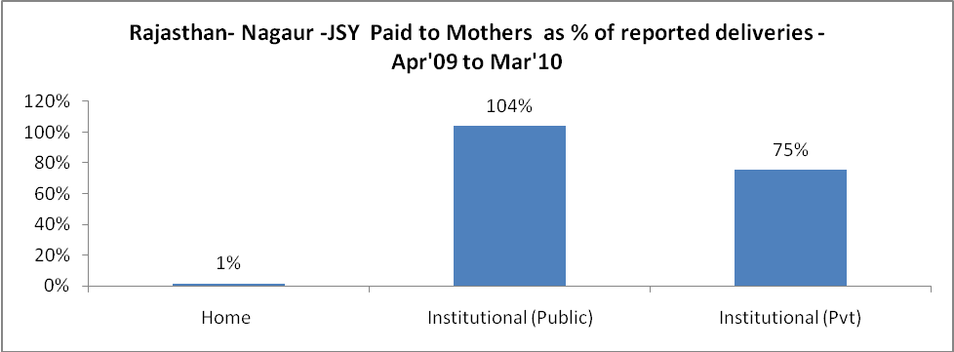

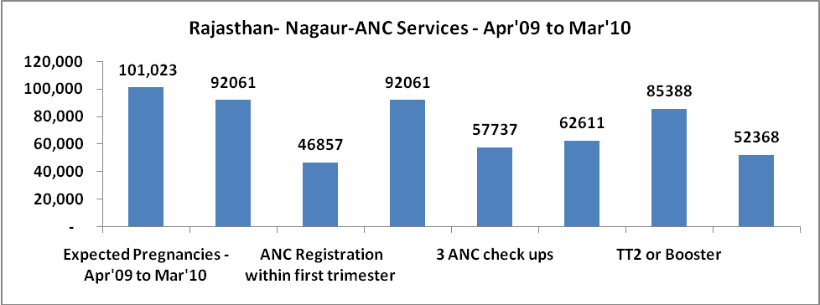

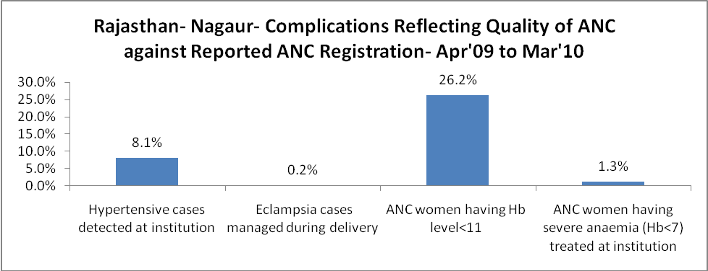

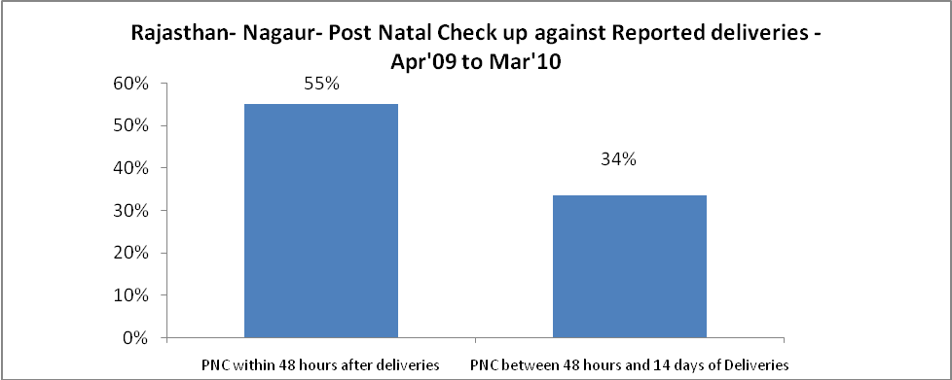
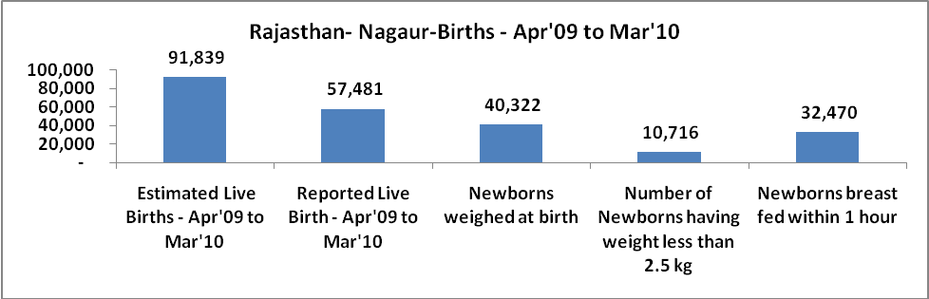

Rajasthan- Nagaur - Births - Apr'09 to Mar'10
Live Birth - Males | Live Birth - females | Live Birth - Total | Sex Ratio at birth | Still Birth | Abortion( Induced/Spontaneous
29,891 | 27,590 | 57,481 | 923 | 938 | 1,502

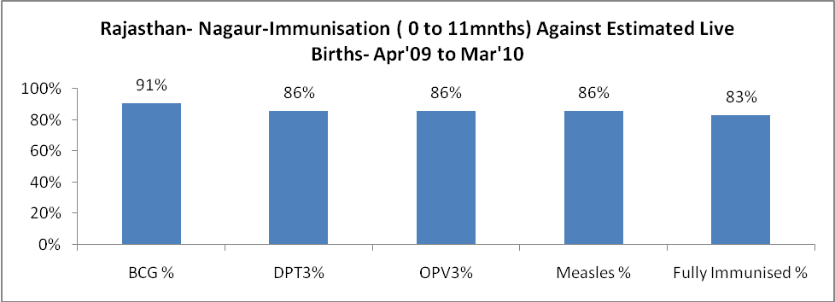

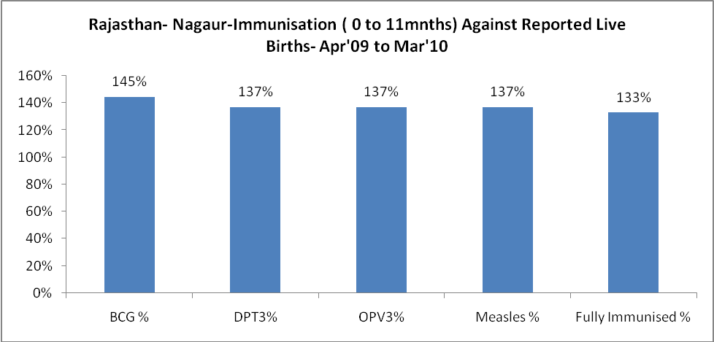

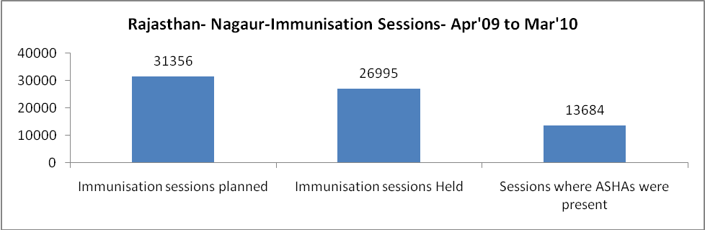

Rajasthan- Nagaur- Apr'09 to Mar'10
Total Abortions | Abortion Rate
1,651 | 1.6%

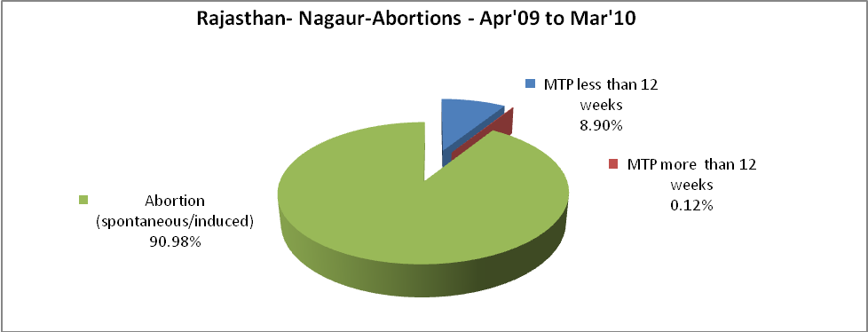

Rajasthan- Nagaur- Apr'09 to Mar'10
Total OPD | Total RTI/STI cases
1,507,194 | 2,630

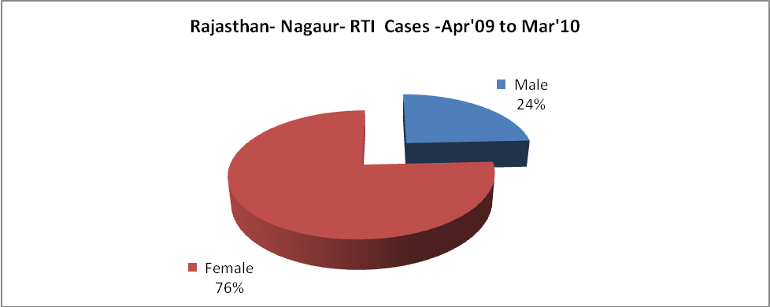

Rajasthan- Nagaur-Sterilisations - Apr'09 to Mar'10
 | Reported | %age of Reported Sterilisation
Total Sterilisation | 13,086 | -
NSV | 350 | 3%
Laproscopic | 12,390 | 95%
MiniLap | - | 0%
Post Partum | 346 | 3%
Male Sterilisation | 350 | 3%
Female Sterilisation | 12,736 | 97%

Rajasthan- Nagaur-FP Methods - Apr'09 to Mar'10
 | Reported | %age of All Reported FP Methods
Total Reported FP Methodd (All types) Users | 100,411 | -
Sterilisations | 13,086 | 13%
IUD | 13,802 | 14%
Condom Users | 46,185 | 46%
OCP Users | 27,338 | 27%
Limiting Methods | 13,086 | 13%
Spacing Methods | 87,325 | 87%

Rajasthan- Nagaur- Service Delivery - Apr'09 to Mar'10
Operation major (General and spinal anaesthesia) | Operation minor (No or local anaesthesia) | AYUSH | Dental Procedures | Adolescent counselling services | Total OPD | Total IPD
1,684 | 2,292 | 45,860 | 1,548 | 3,226 | 1,507,194 | 53,862
Operation major (General and spinal anaesthesia) as %ge of OPD | Operation minor (No or local anaesthesia)as %ge of OPD | AYUSH as %ge of OPD | Dental Procedures as %ge of OPD | Adolescent counselling services as %ge of OPD | IPD as percentage of OPD
0.1% | 0.2% | 3.0% | 0.1% | 0.2% | 4%

Rajasthan- Nagaur- Lab Services - Apr'09 to Mar'10
Total OPD | Total HB tested | Total HIV Tested | Total Population
1,507,194 | 54,581 | 643 | 3,339,600
HB test conducted as %age of OPD | HB<7gm as %age of HB tested | HIV test conducted as %age of OPD | HIV positive as %age of HIV tested | Blood Smear Examined as % of Population
3.6% | 4.1% | 0.0% | 0.0% | 10.9%

Rajasthan- Nagaur- Childhood Disease - Vaccine Preventable -Apr'09 to Mar'10
Diphtheria | Pertussis | Tetanus Neonatorum | Tetanus others | Polio | Measles
0 | 0 | 0 | 0 | 0 | 3
Rajasthan- Nagaur-Childhood Disease - Others - Apr'09 to Mar'10
Diarrhoea and dehydration | Malaria | Number admitted with Respiratory Infections
12,593 | 43 | 5,731

Rajasthan- Nagaur- Infant & Child Deaths - Apr'09 to Mar'10
Infant Deaths within 24 hrs of birth | Infant Deaths between 24hrs & under 1 week | Infant Deaths between 1 week & under 1 month | Child Deaths between 1 month & under 1 year | Child Deaths between 1yr under 5years | Total Deaths
128 | 159 | 59 | 80 | 119 | 545

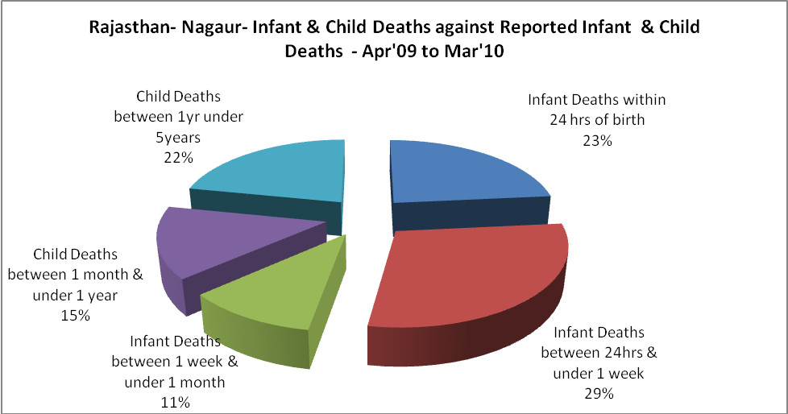

Rajasthan- Nagaur- Causes of Infant & Child Deaths - Apr'09 to Mar'10
Sepsis |  |  | Asphyxia |  |  | LBW
Up to 1 Weeks of Birth | Between 1 week & 4 weeks of birth | Total | Up to 1 Weeks of Birth | Between 1 week & 4 weeks of birth | Total | Up to 1 Weeks of Birth | Between 1 week & 4 weeks of birth | Total
27 | 8 | 35 | 40 | 15 | 55 | 51 | 19 | 70
Pneumonia |  |  | Diarrhoea |  |  | Fever related
Between 1 month and 11 months | Between 1 year & 5 years | Total | Between 1 month and 11 months | Between 1 year & 5 years | Total | Between 1 month and 11 months | Between 1 year & 5 years | Total
12 | 20 | 32 | 14 | 29 | 43 | 18 | 31 | 49
Others |  |  | Measles |  |  | Others
Up to 1 Weeks of Birth | Between 1 week & 4 weeks of birth | Total | Between 1 month and 11 months | Between 1 year & 5 years | Total | Between 1 month and 11 months | Between 1 year & 5 years | Total
41 | 17 | 58 | 0 | 0 | 0 | 36 | 39 | 75

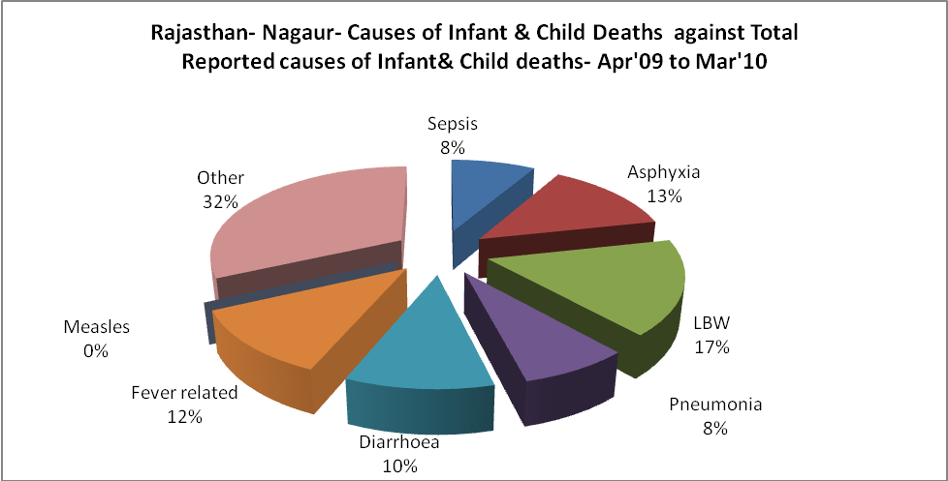

Rajasthan- Nagaur- Maternal Deaths & Causes - Apr'09 to Mar'10
Abortion |  |  | Obstructed/prolonged labour |  |  | Severe hypertesnion/fits
6-14 yrs | 15-55 yrs. | Total | 6-14 yrs | 15-55 yrs. | Total | 6-14 yrs | 15-55 yrs. | Total
0 | 4 | 4 | 0 | 0 | 0 | 0 | 0 | 0
Bleeding |  |  | High Fever |  |  | Other Causes
6-14 yrs | 15-55 yrs. | Total | 6-14 yrs | 15-55 yrs. | Total | 6-14 yrs | 15-55 yrs. | Total
1 | 12 | 13 | 2 | 8 | 10 | 2 | 10 | 12

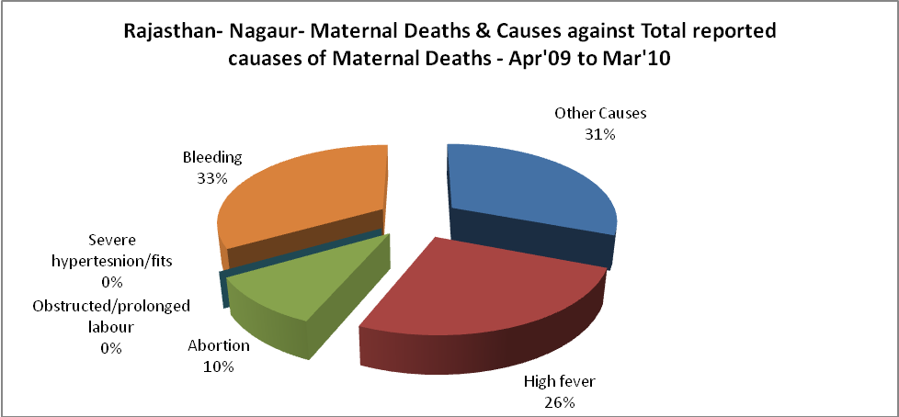

Rajasthan- Nagaur-Causes of Deaths in 6 to 55yrs age group - Apr'09 to Mar'10
Diarrhoel Diseases |  |  |  | Tuberculosis |  |  |  | Respiratory Diseases( Other than TB)
6-14 yrs | 15-55 yrs. | Above 55yrs | Total | 6-14 yrs | 15-55 yrs. | Above 55yrs | Total | 6-14 yrs | 15-55 yrs. | Above 55yrs | Total
48 | 32 | 15 | 95 | 8 | 23 | 8 | 39 | 6 | 54 | 71 | 131
Malaria |  |  |  | Other fever Related |  |  |  | HIV/Aids
6-14 yrs | 15-55 yrs. | Above 55yrs | Total | 6-14 yrs | 15-55 yrs. | Above 55yrs | Total | 6-14 yrs | 15-55 yrs. | Above 55yrs | Total
0 | 14 | 3 | 17 | 55 | 44 | 27 | 126 | 0 | 0 | 0 | 0
Heart Disease/Hypertenion related |  |  |  | Neurological Disease including strokes |  |  |  | Trauma/Accidents/ Burn Cases
6-14 yrs | 15-55 yrs. | Above 55yrs | Total | 6-14 yrs | 15-55 yrs. | Above 55yrs | Total | 6-14 yrs | 15-55 yrs. | Above 55yrs | Total
2 | 122 | 151 | 275 | 31 | 10 | 10 | 51 | 34 | 44 | 17 | 95
Suicide |  |  |  | Animal Bites & Stings
6-14 yrs | 15-55 yrs. | Above 55yrs | Total | 6-14 yrs | 15-55 yrs. | Above 55yrs | Total
0 | 12 | 2 | 14 | 1 | 9 | 9 | 19

