NHSRC
Maharashtra – Nashik
Analysis: Apr 2009 – Mar 2010

Maharashtra-Nashik- Summary-Apr'09 to Mar'10
ANC
ANC Registration against Expected Pregnancies | 104% | TT1 given to Pregnant women against ANC Registration | 74%
3 ANC Check ups against ANC Registrations | 77% | 100 IFA Tablets given to Pregnant women against ANC Registration | 70%
Deliveries
Unreported Deliveries against Estimated Deliveries | 7.3% | HOME Deliveries( SBA& Non SBA) against Estimated Deliveries | 19.3%
Institutional Deliveries against Estimated Deliveries | 73.4% | HOME Deliveries( SBA& Non SBA) against Reported Deliveries | 20.9%
Institutional Deliveries against Reported Deliveries | 79.1% | C Section Deliveries against Institutional Deliveries( Pvt & Pub) | 6%
Births & Neonates Care
Live Births Reported against Estimated Live Births | 92% | New borns weighed against Reported Live Births | 93%
Still Births (Reported) | 1,350 | New borns weighed less than 2.5 kgs against newborns weighed | 13%
Sex Ratio at Birth | 907 | New borns breastfed within one hr of Birth against Reported live Births | 0%
Child Immunization( 0 to 11 months)
BCG given against Expected Live Births | 109% | Measles given against Expected Live Births | 101%
OPV3 given against Expected Live Births | 106% | Fully Immunized Children against Expected Live Births | 101%
DPT3 given against Expected Live Births | 104%
Family Planning
Family Planning Methods Users ( Sterilizations(Male &Female)+IUD+ Condom pieces/72 + OCP Cycles/13) | 82,344 | IUD Insertions against reported FP Methods | 19%
Sterilization against reported FP Methods | 44% | Condom Users against reported FP Methods | 20%
 |  | OCP Users against reported FP Methods | 17%
Other Services
OPD | 457,595 | Major Operations | 626
IPD | - | Minor Operations | 1,049
`
Maharashtra-Nashik- Deliveries Apr'09 to Mar'10
Total Population | 5,861,645 | Expected Deliveries |  | 106,655
Home SBA | Home Non SBA | Institutional | Total Deliveries Reported | Unreported Deliveries
8,162 | 12,475 | 78,276 | 98,913 | 7,742
Home SBA % | Home Non SBA% | Institutional % | Total Deliveries Reported % | Unreported Deliveries %
8% | 12% | 73% | 93% | 7%

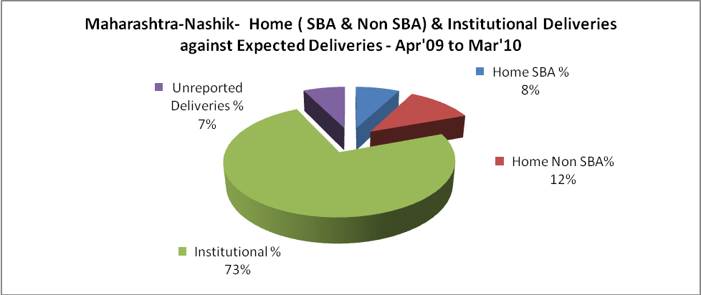

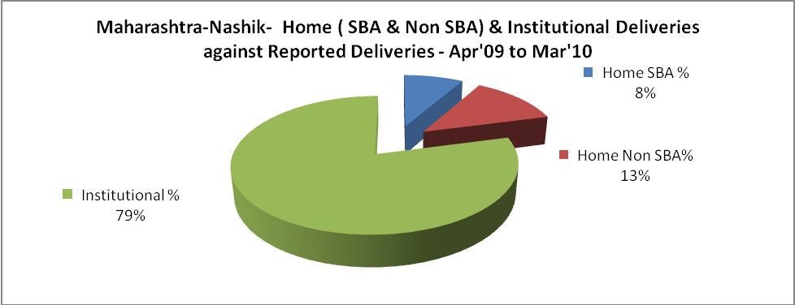

Maharashtra-Nashik- C sections & Complicated Deliveries Apr'09 to Mar'10
 | Institutional Deliveries (Public) | Institutional Deliveries (Pvt)
 | 56,849 | 21,427
C Section | 2,560 | 1,833
C Section% | 5% | 9%
Complicated Pregnancies attended | 2,283 | 377
Complicated Pregnancies attended % | 4% | 2%

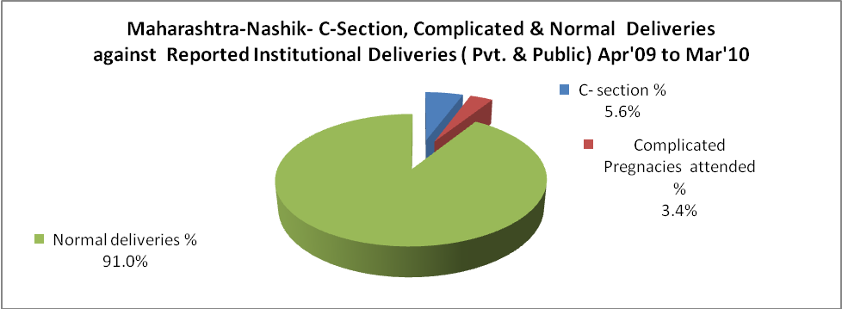

Maharashtra-Nashik- Complicated Pregnancies & Deliveries Treated - Apr'09 to Mar'10
Reported Deliveries |  |  | Reported ANC Registration
98,913 |  |  | 120,108
Complicated Pregnancies attended | Complicated Pregnancies Rate | C - Section Deliveries | PNC Maternal Complications | Abortions | Still Births
2,660 | 2% | 4,393 | - | 5,002 | 1,350
Complicated Deliveries Treated with |  |  |  | No Of Eclampsia cases Treated | No Of severe anemia cases treated
IV Antibiotics | IV antihypertensive/Magsulph injection | IV Oxytocis | Blood Transfusion | No Of Eclampsia cases Treated | No Of severe anemia cases treated
- | - | - | - | - | -

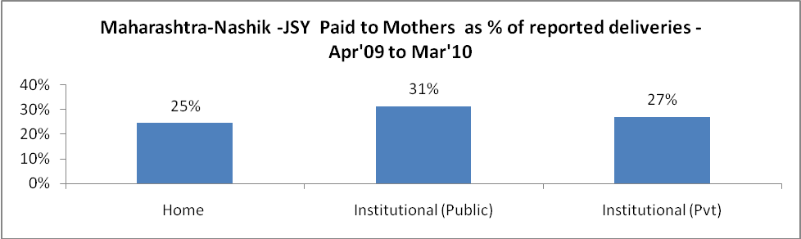

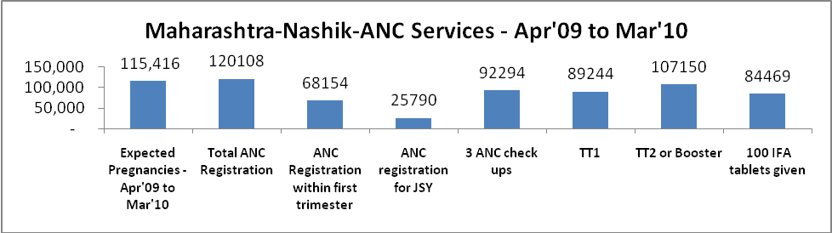

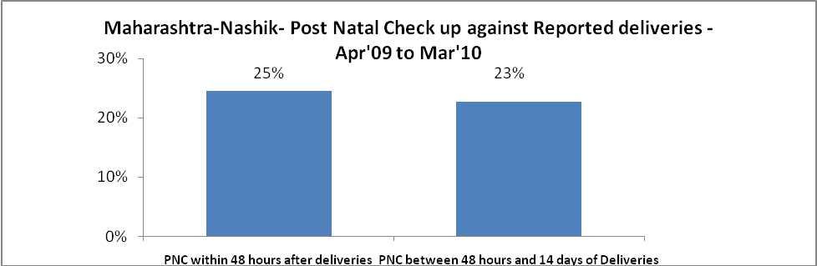

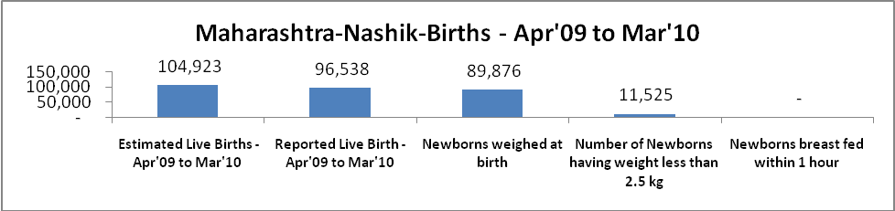

Maharashtra-Nashik - Births - Apr'09 to Mar'10
Live Birth - Males | Live Birth - females | Live Birth - Total | Sex Ratio at birth | Still Birth | Abortion( Induced/Spontaneous
50,615 | 45,923 | 96,538 | 907 | 1,350 | 5,002

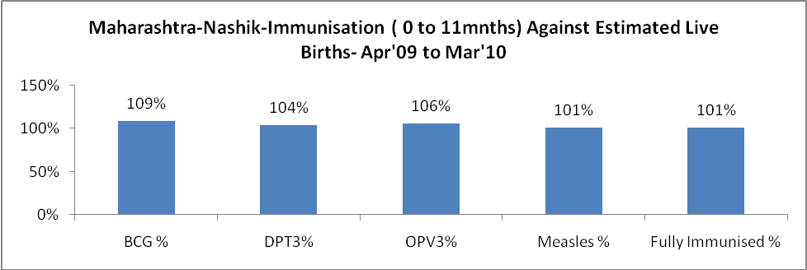

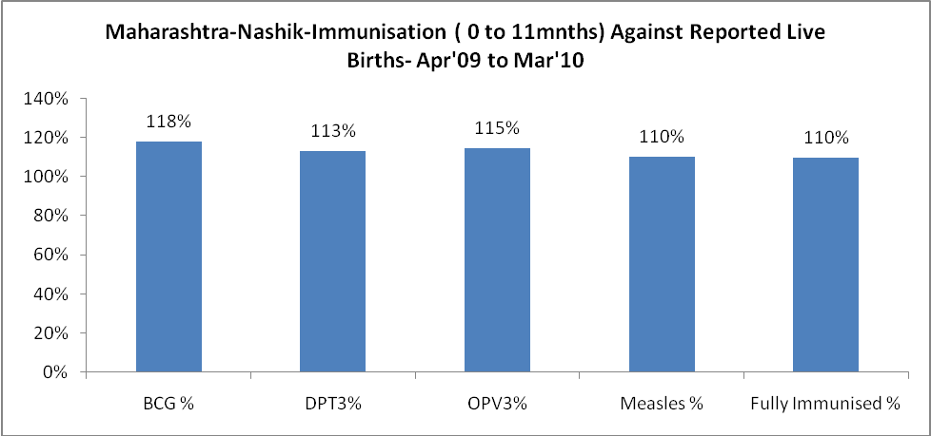

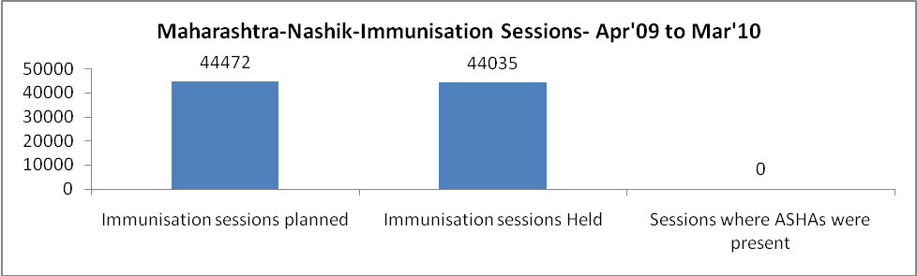

Maharashtra-Nashik- Apr'09 to Mar'10
Total Abortions | Abortion Rate
7,732 | 6.7%

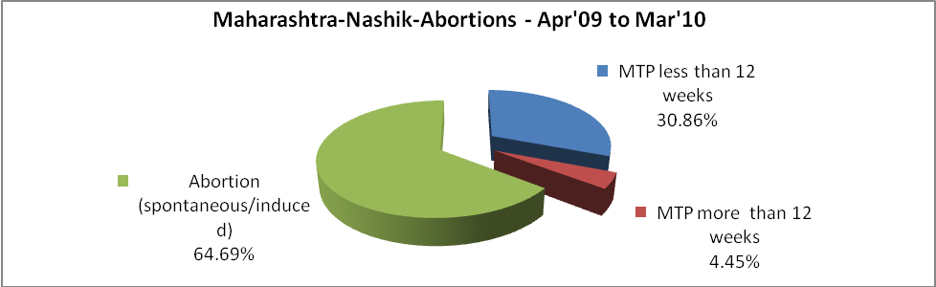

Maharashtra-Nashik- Apr'09 to Mar'10
Total OPD | Total RTI/STI cases
457,595 | 11,412
.

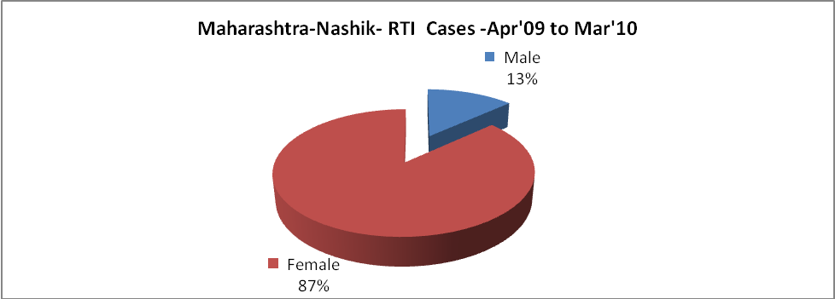

Maharashtra-Nashik-Sterilisations - Apr'09 to Mar'10
 | Reported | %age of Reported Sterilization
Total Sterilization | 35,932 | -
NSV | 2,889 | 8%
Laparoscopic | 1,810 | 5%
MiniLap | 23,021 | 64%
Post Partum | 8,212 | 23%
Male Sterilization | 2,889 | 8%
Female Sterilization | 33,043 | 92%

Maharashtra-Nashik-FP Methods - Apr'09 to Mar'10
 | Reported | %age of All Reported FP Methods
Total Reported FP Method (All types) Users | 82,344 | -
Sterilizations | 35,932 | 44%
IUD | 15,963 | 19%
Condom Users | 16,580 | 20%
OCP Users | 13,869 | 17%
Limiting Methods | 35,932 | 44%
Spacing Methods | 46,412 | 56%

Maharashtra-Nashik- Service Delivery - Apr'09 to Mar'10
Operation major (General and spinal anaesthesia) | Operation minor (No or local anaesthesia) | AYUSH | Dental Procedures | Adolescent counselling services | Total OPD | Total IPD
626 | 1,049 | - | - | - | 457,595 | -
Operation major (General and spinal anaesthesia) as %ge of OPD | Operation minor (No or local anaesthesia)as %ge of OPD | AYUSH as %ge of OPD | Dental Procedures as %ge of OPD | Adolescent counselling services as %ge of OPD | IPD as percentage of OPD
0.1% | 0.2% | 0.0% | 0.0% | 0.0% | 0%

Maharashtra-Nashik- Lab Services - Apr'09 to Mar'10
Total OPD | Total HB tested | Total HIV Tested | Total Population
457,595 | 21,937 | - | 5,861,645
HB test conducted as %age of OPD | HB<7gm as %age of HB tested | HIV test conducted as %age of OPD | HIV positive as %age of HIV tested | Blood Smear Examined as % of Population
4.8% | 0.0% | 0.0% | 0.0% | 8.5%

Maharashtra-Nashik- Childhood Disease - Vaccine Preventable -Apr'09 to Mar'10
Diphtheria | Pertussis | Tetanus Neonatorum | Tetanus others | Polio | Measles
16 | 10 | 0 | 0 | 0 | 13019
Maharashtra-Nashik-Childhood Disease - Others - Apr'09 to Mar'10
Diarrhoea and dehydration | Malaria | Number admitted with Respiratory Infections
2,057 | 9 | 384

Maharashtra-Nashik- Infant & Child Deaths - Apr'09 to Mar'10
Infant Deaths within 24 hrs of birth | Infant Deaths between 24hrs & under 1 week | Infant Deaths between 1 week & under 1 month | Child Deaths between 1 month & under 1 year | Child Deaths between 1yr under 5years | Total Deaths
120 | 351 | 191 | 580 | 543 | 1785

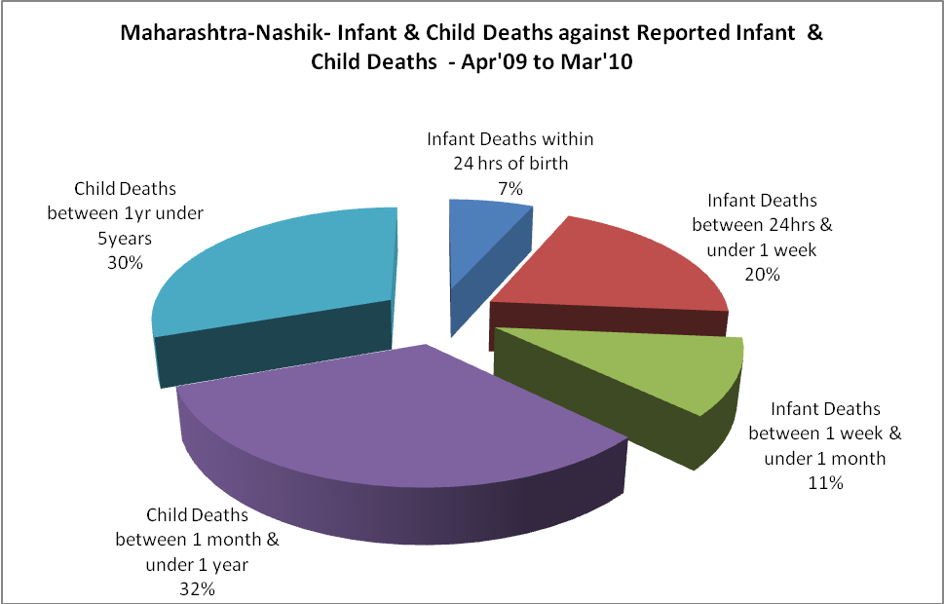

Maharashtra-Nashik- Causes of Infant & Child Deaths - Apr'09 to Mar'10
Sepsis |  |  | Asphyxia |  |  | LBW
Up to 1 Weeks of Birth | Between 1 week & 4 weeks of birth | Total | Up to 1 Weeks of Birth | Between 1 week & 4 weeks of birth | Total | Up to 1 Weeks of Birth | Between 1 week & 4 weeks of birth | Total
0 | 0 | 0 | 0 | 0 | 0 | 0 | 0 | 0
Pneumonia |  |  | Diarrhoea |  |  | Fever related
Between 1 month and 11 months | Between 1 syear & 5 years | Total | Between 1 month and 11 months | Between 1 year & 5 years | Total | Between 1 month and 11 months | Between 1 year & 5 years | Total
0 | 0 | 0 | 0 | 0 | 0 | 0 | 0 | 0
Others |  |  | Measles |  |  | Others
Up to 1 Weeks of Birth | Between 1 week & 4 weeks of birth | Total | Between 1 month and 11 months | Between 1 year & 5 years | Total | Between 1 month and 11 months | Between 1 year & 5 years | Total
351 | 191 | 542 | 0 | 0 | 0 | 580 | 543 | 1123

Maharashtra-Nashik- Maternal Deaths & Causes - Apr'09 to Mar'10
Abortion |  |  | Obstructed/prolonged labour |  |  | Severe hypertension/fits
6-14 yrs | 15-55 yrs. | Total | 6-14 yrs | 15-55 yrs. | Total | 6-14 yrs | 15-55 yrs. | Total
0 | 0 | 0 | 0 | 5 | 5 | 0 | 13 | 13
Bleeding |  |  | High Fever |  |  | Other Causes
6-14 yrs | 15-55 yrs. | Total | 6-14 yrs | 15-55 yrs. | Total | 6-14 yrs | 15-55 yrs. | Total
0 | 19 | 19 | 0 | 12 | 12 | 0 | 0 | 0

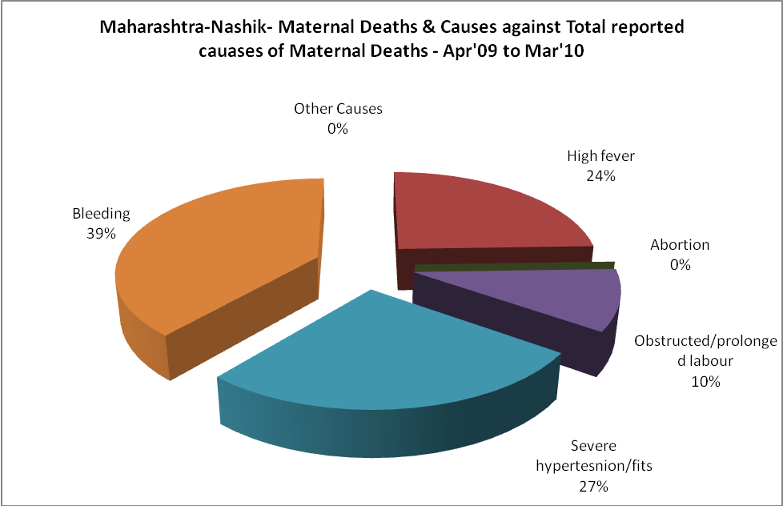

Maharashtra-Nashik-Causes of Deaths in 6 to 55yrs age group - Apr'09 to Mar'10
Diarrhoel Diseases |  |  |  | Tuberculosis |  |  |  | Respiratory Diseases( Other than TB)
6-14 yrs | 15-55 yrs. | Above 55yrs | Total | 6-14 yrs | 15-55 yrs. | Above 55yrs | Total | 6-14 yrs | 15-55 yrs. | Above 55yrs | Total
0 | 0 | 0 | 0 | 0 | 0 | 0 | 0 | 0 | 0 | 0 | 0
Malaria |  |  |  | Other fever Related |  |  |  | HIV/Aids
6-14 yrs | 15-55 yrs. | Above 55yrs | Total | 6-14 yrs | 15-55 yrs. | Above 55yrs | Total | 6-14 yrs | 15-55 yrs. | Above 55yrs | Total
0 | 0 | 0 | 0 | 0 | 0 | 0 | 0 | 0 | 0 | 0 | 0
Heart Disease/Hypertension related |  |  |  | Neurological Disease including strokes |  |  |  | Trauma/Accidents/ Burn Cases
6-14 yrs | 15-55 yrs. | Above 55yrs | Total | 6-14 yrs | 15-55 yrs. | Above 55yrs | Total | 6-14 yrs | 15-55 yrs. | Above 55yrs | Total
0 | 0 | 0 | 0 | 0 | 0 | 0 | 0 | 0 | 0 | 0 | 0
Suicide |  |  |  | Animal Bites & Stings
6-14 yrs | 15-55 yrs. | Above 55yrs | Total | 6-14 yrs | 15-55 yrs. | Above 55yrs | Total
0 | 0 | 0 | 0 | 0 | 0 | 0 | 0

