NHSRC
Rajasthan-Pali
Analysis: Apr 2009 – Mar 2010

Rajasthan- Pali- Summary-Apr'09 to Mar'10
ANC
ANC Registration against Expected Pregnancies | 92% | TT1 given to Pregnant women against ANC Registration | 59%
3 ANC Checkups against ANC Registrations | 66% | 100 IFA Tablets given to Pregnant women against ANC Registration | 108%
Deliveries
Unreported Deliveries against Estimated Deliveries | 31.4% | HOME Deliveries( SBA& Non SBA) against Estimated Deliveries | 7.0%
Institutional Deliveries against Estimated Deliveries | 61.6% | HOME Deliveries( SBA& Non SBA) against Reported Deliveries | 10.2%
Institutional Deliveries against Reported Deliveries | 89.8% | C Section Deliveries against Institutional Deliveries( Pvt & Pub) | 3%
Births & Neonates Care
Live Births Reported against Estimated Live Births | 69% | New borns weighed against Reported Live Births | 91%
Still Births (Reported) | 565 | New borns weighed less than 2.5 kgs against newborns weighed | 10%
Sex Ratio at Birth | 959 | New borns breastfed within one hr of Birth against Reported live Births | 84%
Child Immunisation( 0 to 11 mnths)
BCG given against Expected Live Births | 86% | Measles given against Expected Live Births | 84%
OPV3 given against Expected Live Births | 85% | Fully Immunised Children against Expected Live Births | 82%
DPT3 given against Expected Live Births | 85%
Family Plannng
Family Plannig Methods Users ( Sterilisations(Male &Female)+IUD+ Condom pieces/72 + OCP Cycles/13) | 144,985 | IUD Insertions against reported FP Methods | 12%
Sterilisation against reported FP Methods | 13% | Condom Users against reported FP Methods | 44%
 |  | OCP Users against reported FP Methods | 31%
Other Services
OPD | 1,211,609 | Major Operations | 2,525
IPD | 44,794 | Minor Operations | 3,388

`
Rajasthan- Pali- Deliveries Apr'09 to Mar'10
Total Population | 2,171,700 | Expected Deliveries |  | 61,603
Home SBA | Home Non SBA | Institutional | Total Deliveries Reported | Unreported Deliveries
2,473 | 1,846 | 37,941 | 42,260 | 19,343
Home SBA % | Home Non SBA% | Institutional % | Total Deliveries Reported % | Unreported Deliveries %
4% | 3% | 62% | 69% | 31%

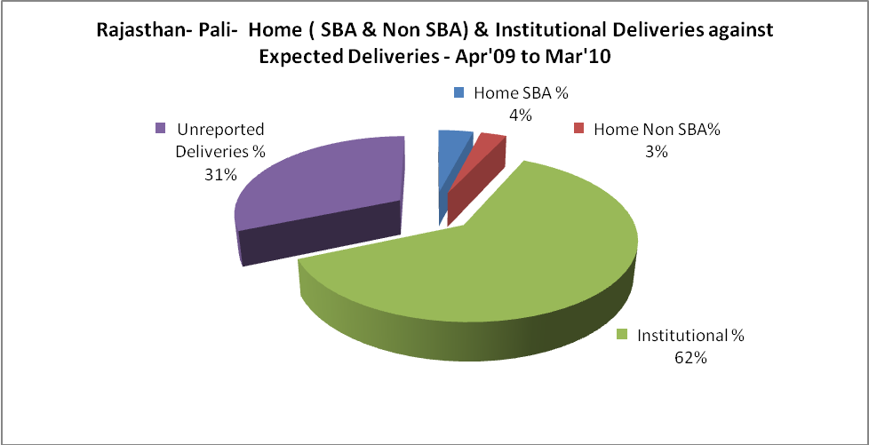

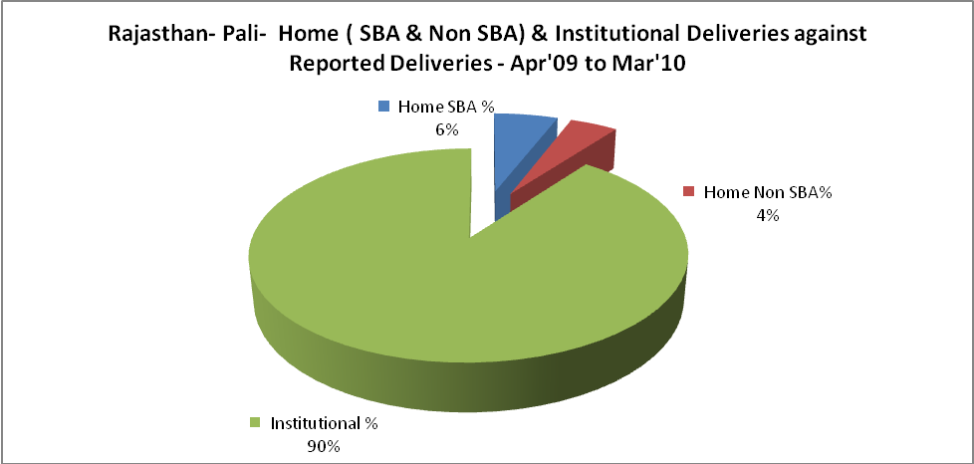

Rajasthan- Pali- C sections & Complicated Deliveries Apr'09 to Mar'10
 | Institutional Deliveries (Public) | Institutional Deliveries (Pvt)
 | 31,575 | 6,366
C Section | 1,230 | -
C Section% | 4% | 0%
Complicated Pregnacies attended | 2,360 | 199
Complicated Pregnacies attended % | 7% | 3%

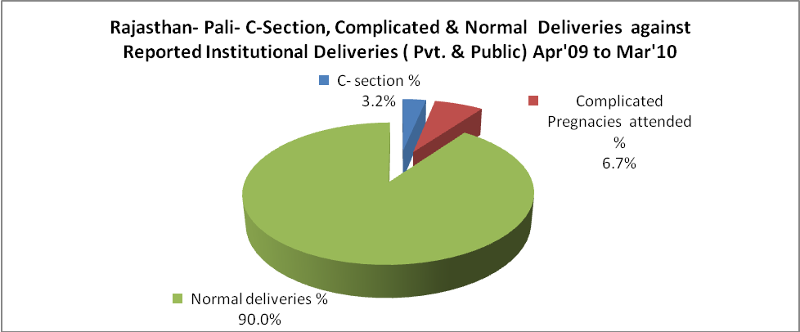

Rajasthan- Pali- Complicated Pregnancies & Deliveries Treated - Apr'09 to Mar'10
Reported Deliveries |  |  | Reported ANC Reigtration
42,260 |  |  | 60,746
Complicated Pregnancies attended | Complicated Pregnancies Rate | C - Section Deliveries | PNC Maternal Complications | Abortions | Still Births
2,559 | 4% | 1,230 | 251 | 259 | 565
Complicated Deliveries Treated with |  |  |  | No Of Eclampsia cases Treated | No Of severe anemia cases treated
IV Antibiotics | IV antihypertensive/Magsulph injection | IV Oxytocis | Blood Transfusion | No Of Eclampsia cases Treated | No Of severe anemia cases treated
1,737 | 197 | 1,661 | 156 | 283 | 1,973

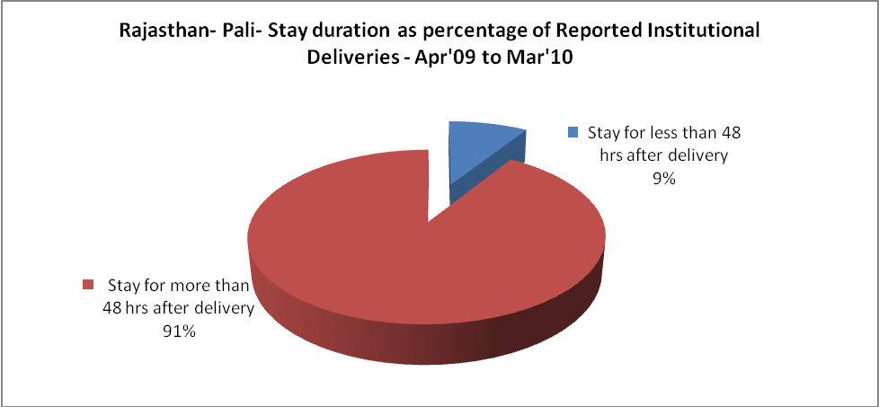

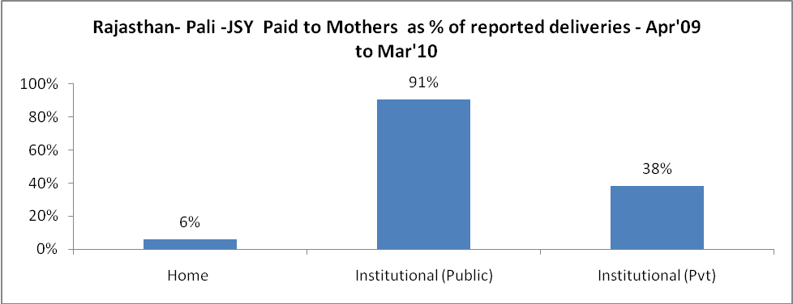

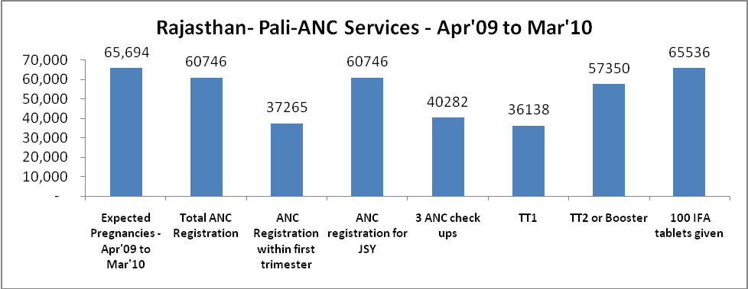

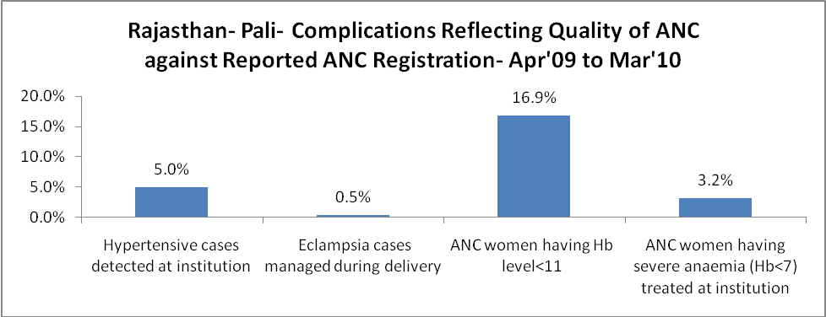

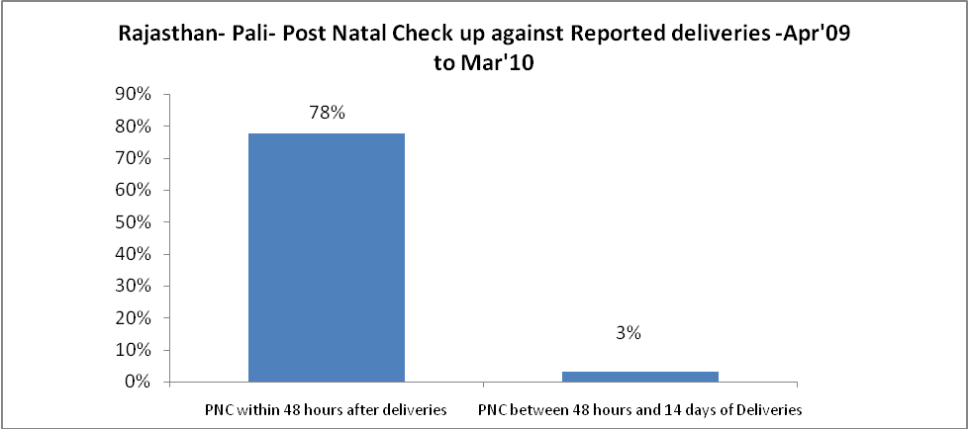

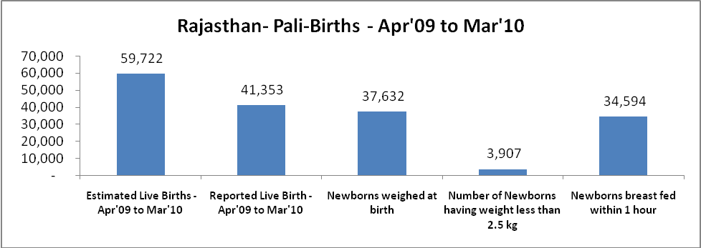

Rajasthan- Pali - Births - Apr'09 to Mar'10
Live Birth - Males | Live Birth - females | Live Birth - Total | Sex Ratio at birth | Still Birth | Abortion( Induced/Spontaneous
21,113 | 20,240 | 41,353 | 959 | 565 | 259

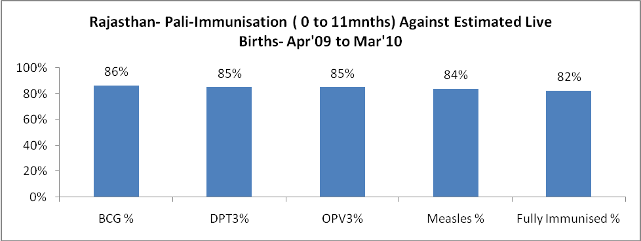

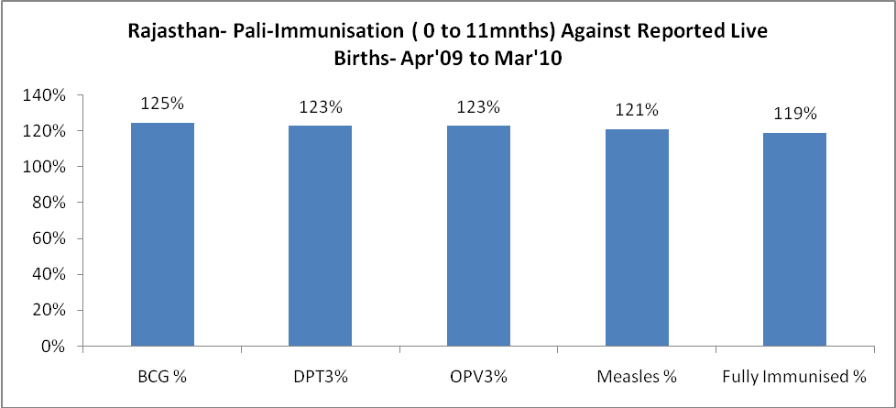

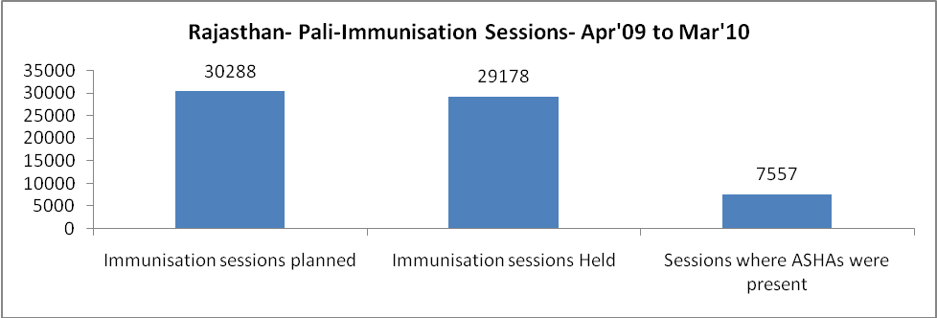

Rajasthan- Pali- Apr'09 to Mar'10
Total Abortions | Abortion Rate
1,232 | 1.9%

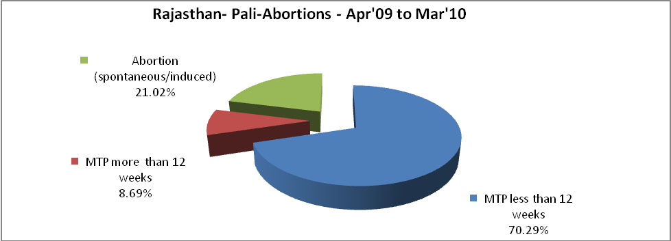

Rajasthan- Pali- Apr'09 to Mar'10
Total OPD | Total RTI/STI cases
1,211,609 | 5,320

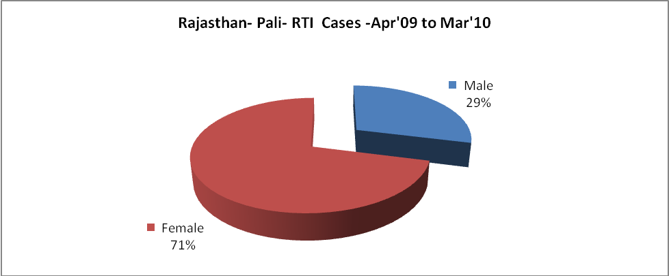

Rajasthan- Pali-Sterilisations - Apr'09 to Mar'10
 | Reported | %age of Reported Sterilisation
Total Sterilisation | 18,286 | -
NSV | 145 | 1%
Laproscopic | 16,896 | 92%
MiniLap | - | 0%
Post Partum | 1,245 | 7%
Male Sterilisation | 145 | 1%
Female Sterilisation | 18,141 | 99%

Rajasthan- Pali-FP Methods - Apr'09 to Mar'10
 | Reported | %age of All Reported FP Methods
Total Reported FP Methodd (All types) Users | 144,985 | -
Sterilisations | 18,286 | 13%
IUD | 17,644 | 12%
Condom Users | 63,926 | 44%
OCP Users | 45,129 | 31%
Limiting Methods | 18,286 | 13%
Spacing Methods | 126,699 | 87%

Rajasthan- Pali- Service Delivery - Apr'09 to Mar'10
Operation major (General and spinal anaesthesia) | Operation minor (No or local anaesthesia) | AYUSH | Dental Procedures | Adolescent counselling services | Total OPD | Total IPD
2,525 | 3,388 | 21,064 | 4,083 | 995 | 1,211,609 | 44,794
Operation major (General and spinal anaesthesia) as %ge of OPD | Operation minor (No or local anaesthesia)as %ge of OPD | AYUSH as %ge of OPD | Dental Procedures as %ge of OPD | Adolescent counselling services as %ge of OPD | IPD as percentage of OPD
0.2% | 0.3% | 1.7% | 0.3% | 0.1% | 4%

Rajasthan- Pali- Lab Services - Apr'09 to Mar'10
Total OPD | Total HB tested | Total HIV Tested | Total Population
1,211,609 | 31,679 | 3,377 | 2,171,700
HB test conducted as %age of OPD | HB<7gm as %age of HB tested | HIV test conducted as %age of OPD | HIV positive as %age of HIV tested | Blood Smear Examined as % of Population
2.6% | 11.9% | 0.3% | 1.2% | 4.3%

Rajasthan- Pali- Childhood Disease - Vaccine Preventable -Apr'09 to Mar'10
Diphtheria | Pertussis | Tetanus Neonatorum | Tetanus others | Polio | Measles
0 | 0 | 8 | 0 | 0 | 41
Rajasthan- Pali-Childhood Disease - Others - Apr'09 to Mar'10
Diarrhoea and dehydration | Malaria | Number admitted with Respiratory Infections
2,713 | 87 | 3,608

Rajasthan- Pali- Infant & Child Deaths - Apr'09 to Mar'10
Infant Deaths within 24 hrs of birth | Infant Deaths between 24hrs & under 1 week | Infant Deaths between 1 week & under 1 month | Child Deaths between 1 month & under 1 year | Child Deaths between 1yr under 5years | Total Deaths
30 | 64 | 18 | 38 | 32 | 182

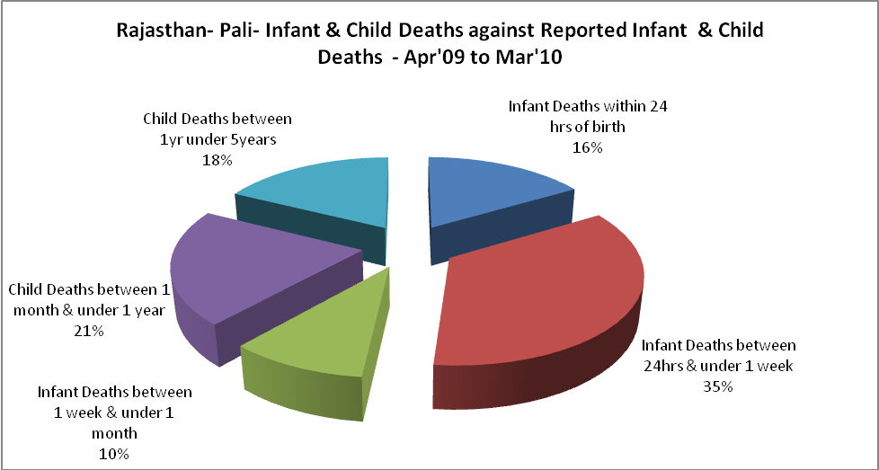

Rajasthan- Pali- Causes of Infant & Child Deaths - Apr'09 to Mar'10
Sepsis |  |  | Asphyxia |  |  | LBW
Up to 1 Weeks of Birth | Between 1 week & 4 weeks of birth | Total | Up to 1 Weeks of Birth | Between 1 week & 4 weeks of birth | Total | Up to 1 Weeks of Birth | Between 1 week & 4 weeks of birth | Total
5 | 3 | 8 | 6 | 1 | 7 | 16 | 4 | 20
Pneumonia |  |  | Diarrhoea |  |  | Fever related
Between 1 month and 11 months | Between 1 year & 5 years | Total | Between 1 month and 11 months | Between 1 year & 5 years | Total | Between 1 month and 11 months | Between 1 year & 5 years | Total
9 | 4 | 13 | 5 | 4 | 9 | 1 | 7 | 8
Others |  |  | Measles |  |  | Others
Up to 1 Weeks of Birth | Between 1 week & 4 weeks of birth | Total | Between 1 month and 11 months | Between 1 year & 5 years | Total | Between 1 month and 11 months | Between 1 year & 5 years | Total
37 | 10 | 47 | 0 | 0 | 0 | 23 | 17 | 40

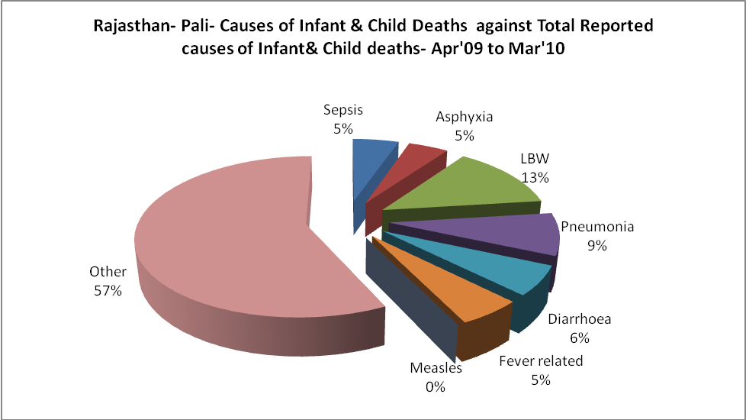

Rajasthan- Pali- Maternal Deaths & Causes - Apr'09 to Mar'10
Abortion |  |  | Obstructed/prolonged labour |  |  | Severe hypertesnion/fits
6-14 yrs | 15-55 yrs. | Total | 6-14 yrs | 15-55 yrs. | Total | 6-14 yrs | 15-55 yrs. | Total
0 | 1 | 1 | 0 | 1 | 1 | 0 | 0 | 0
Bleeding |  |  | High Fever |  |  | Other Causes
6-14 yrs | 15-55 yrs. | Total | 6-14 yrs | 15-55 yrs. | Total | 6-14 yrs | 15-55 yrs. | Total
0 | 3 | 3 | 0 | 1 | 1 | 0 | 11 | 11

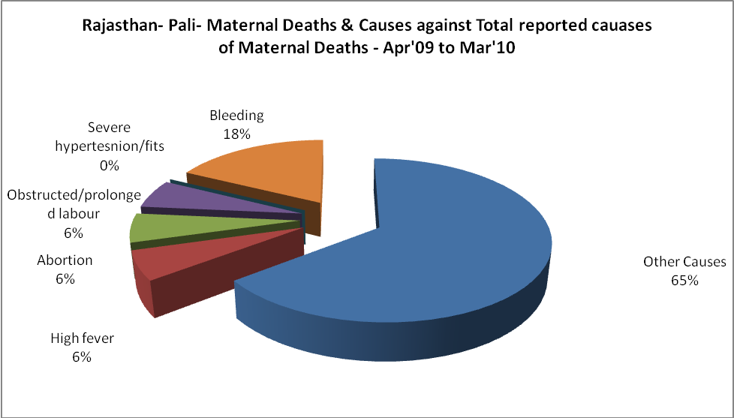

Rajasthan- Pali-Causes of Deaths in 6 to 55yrs age group - Apr'09 to Mar'10
Diarrhoel Diseases |  |  |  | Tuberculosis |  |  |  | Respiratory Diseases( Other than TB)
6-14 yrs | 15-55 yrs. | Above 55yrs | Total | 6-14 yrs | 15-55 yrs. | Above 55yrs | Total | 6-14 yrs | 15-55 yrs. | Above 55yrs | Total
2 | 5 | 5 | 12 | 0 | 10 | 13 | 23 | 2 | 32 | 46 | 80
Malaria |  |  |  | Other fever Related |  |  |  | HIV/Aids
6-14 yrs | 15-55 yrs. | Above 55yrs | Total | 6-14 yrs | 15-55 yrs. | Above 55yrs | Total | 6-14 yrs | 15-55 yrs. | Above 55yrs | Total
0 | 0 | 0 | 0 | 6 | 15 | 13 | 34 | 3 | 4 | 0 | 7
Heart Disease/Hypertenion related |  |  |  | Neurological Disease including strokes |  |  |  | Trauma/Accidents/ Burn Cases
6-14 yrs | 15-55 yrs. | Above 55yrs | Total | 6-14 yrs | 15-55 yrs. | Above 55yrs | Total | 6-14 yrs | 15-55 yrs. | Above 55yrs | Total
0 | 32 | 45 | 77 | 33 | 6 | 6 | 45 | 5 | 46 | 25 | 76
Suicide |  |  |  | Animal Bites & Stings
6-14 yrs | 15-55 yrs. | Above 55yrs | Total | 6-14 yrs | 15-55 yrs. | Above 55yrs | Total
2 | 13 | 3 | 18 | 1 | 4 | 3 | 8

