NHSRC
Rajasthan-Pratapgarh
Analysis: Apr 2009 – Mar 2010

Rajasthan- Pratapgarh- Summary-Apr'09 to Mar'10
ANC
ANC Registration against Expected Pregnancies | 83% | TT1 given to Pregnant women against ANC Registration | 67%
3 ANC Checkups against ANC Registrations | 73% | 100 IFA Tablets given to Pregnant women against ANC Registration | 93%
Deliveries
Unreported Deliveries against Estimated Deliveries | 28.0% | HOME Deliveries( SBA& Non SBA) against Estimated Deliveries | 8.2%
Institutional Deliveries against Estimated Deliveries | 63.7% | HOME Deliveries( SBA& Non SBA) against Reported Deliveries | 11.5%
Institutional Deliveries against Reported Deliveries | 88.5% | C Section Deliveries against Institutional Deliveries( Pvt & Pub) | 0%
Births & Neonates Care
Live Births Reported against Estimated Live Births | 73% | New borns weighed against Reported Live Births | 92%
Still Births (Reported) | 532 | New borns weighed less than 2.5 kgs against newborns weighed | 24%
Sex Ratio at Birth | 901 | New borns breastfed within one hr of Birth against Reported live Births | 86%
Child Immunisation( 0 to 11 mpnths)
BCG given against Expected Live Births | 95% | Measles given against Expected Live Births | 79%
OPV3 given against Expected Live Births | 81% | Fully Immunised Children against Expected Live Births | 76%
DPT3 given against Expected Live Births | 81%
Family Planning
Family Plannig Methods Users ( Sterilisations(Male &Female)+IUD+ Condom pieces/72 + OCP Cycles/13) | 46,900 | IUD Insertions against reported FP Methods | 11%
Sterilisation against reported FP Methods | 7% | Condom Users against reported FP Methods | 53%
 |  | OCP Users against reported FP Methods | 28%
Other Services
OPD | 395,704 | Major Operations | 1,190
IPD | 43,582 | Minor Operations | 445

Rajasthan- Pratapgarh- Deliveries Apr'09 to Mar'10
Total Population | 827,200 | Expected Deliveries |  | 23,465
Home SBA | Home Non SBA | Institutional | Total Deliveries Reported | Unreported Deliveries
1,056 | 878 | 14,955 | 16,889 | 6,576
Home SBA % | Home Non SBA% | Institutional % | Total Deliveries Reported % | Unreported Deliveries %
5% | 4% | 64% | 72% | 28%
`

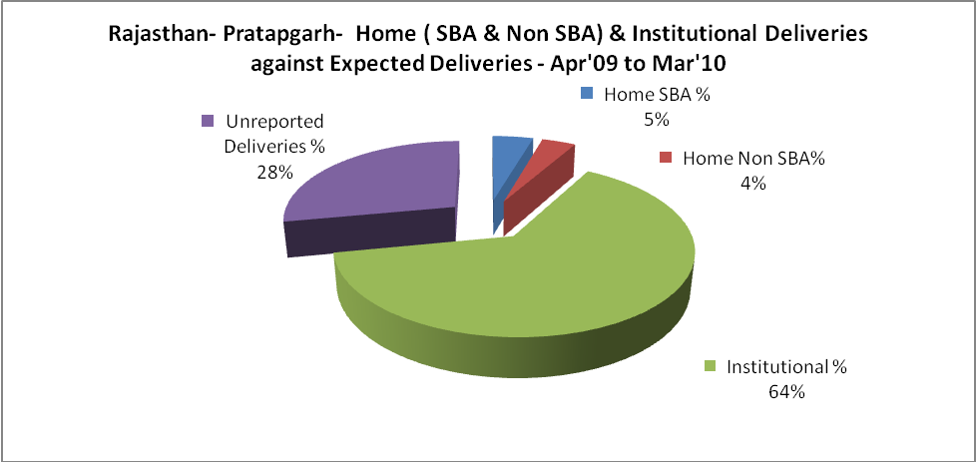c

Rajasthan- Pratapgarh- Deliveries Apr'09 to Mar'10
Total Population | 827,200 | Expected Deliveries |  | 23,465
Home SBA | Home Non SBA | Institutional | Total Deliveries Reported | Unreported Deliveries
1,056 | 878 | 14,955 | 16,889 | 6,576
Home SBA % | Home Non SBA% | Institutional % | Total Deliveries Reported % | Unreported Deliveries %
5% | 4% | 64% | 72% | 28%

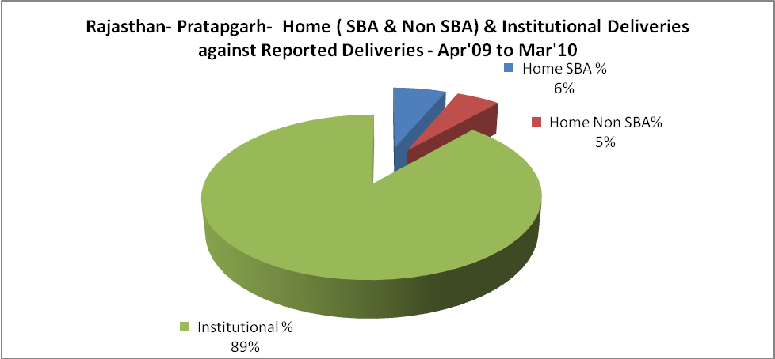

Rajasthan- Pratapgarh- C sections & Complicated Deliveries Apr'09 to Mar'10
 | Institutional Deliveries (Public) | Institutional Deliveries (Pvt)
 | 14,955 | -
C Section | 72 | -
C Section% | 0% | #DIV/0!
Complicated Pregnacies attended | 230 | -
Complicated Pregnacies attended % | 2% | #DIV/0!

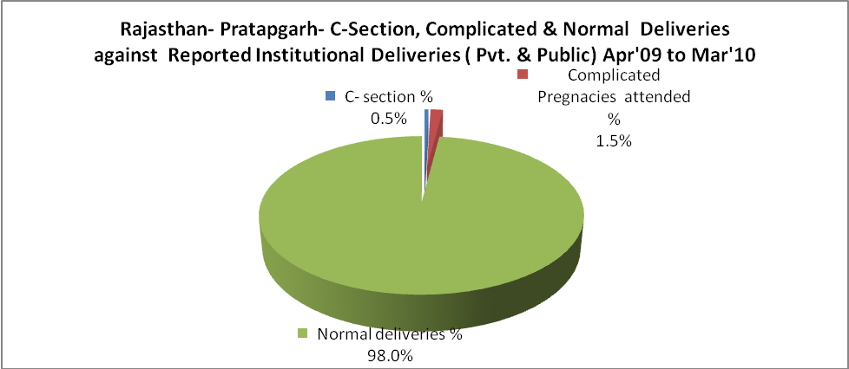

Rajasthan- Pratapgarh- Complicated Pregnancies & Deliveries Treated - Apr'09 to Mar'10
Reported Deliveries |  |  | Reported ANC Reigtration
16,889 |  |  | 20,686
Complicated Pregnancies attended | Complicated Pregnancies Rate | C - Section Deliveries | PNC Maternal Complications | Abortions | Still Births
230 | 1% | 72 | 190 | 457 | 532
Complicated Deliveries Treated with |  |  |  | No Of Eclampsia cases Treated | No Of severe anemia cases treated
IV Antibiotics | IV antihypertensive/Magsulph injection | IV Oxytocis | Blood Transfusion | No Of Eclampsia cases Treated | No Of severe anemia cases treated
126 | 58 | 156 | 137 | 95 | 323
.

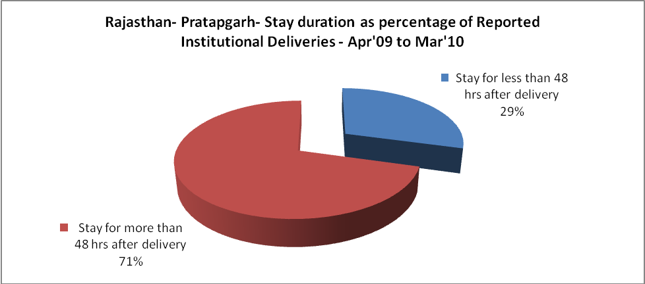

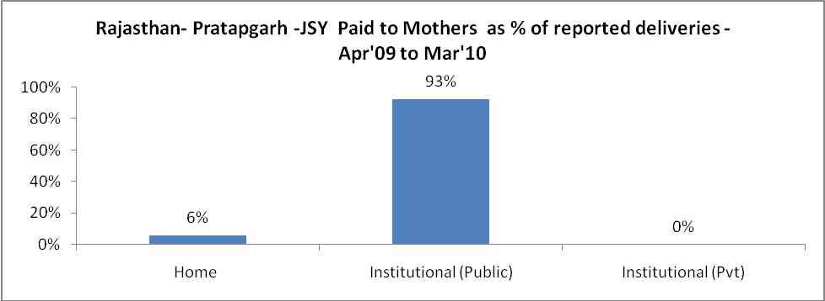

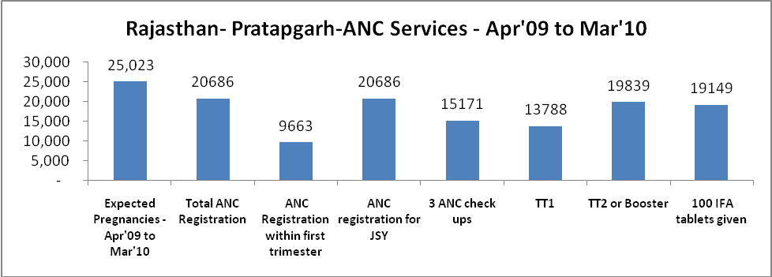
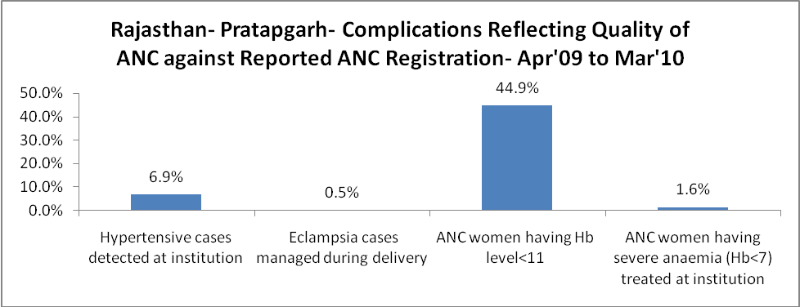

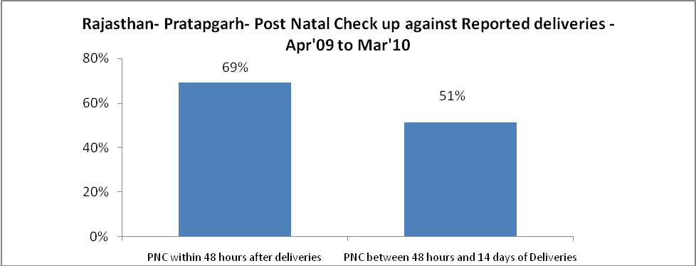

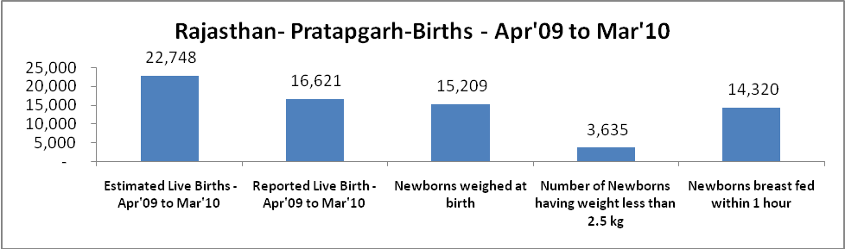

Rajasthan- Pratapgarh - Births - Apr'09 to Mar'10
Live Birth - Males | Live Birth - females | Live Birth - Total | Sex Ratio at birth | Still Birth | Abortion( Induced/Spontaneous
8,743 | 7,878 | 16,621 | 901 | 532 | 457

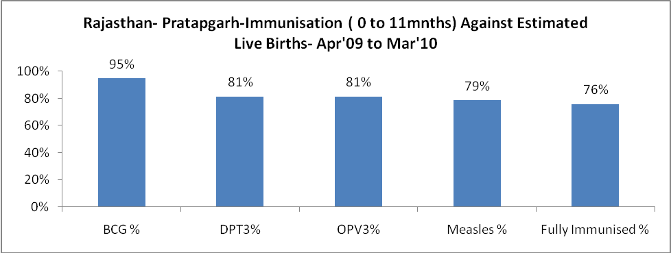

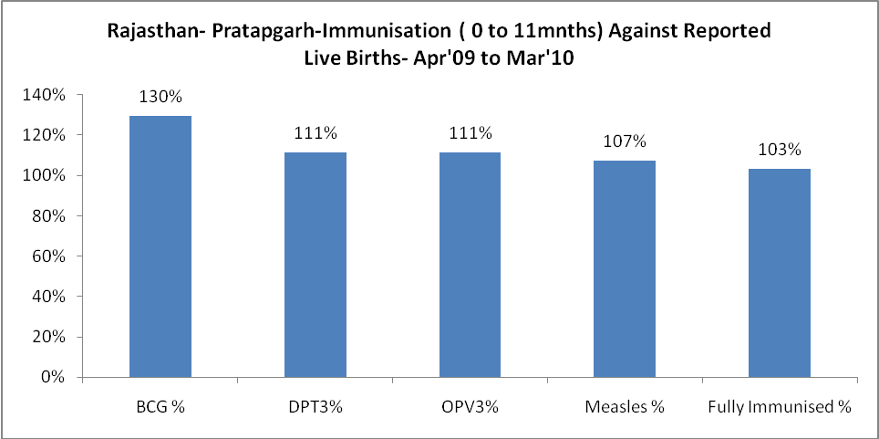

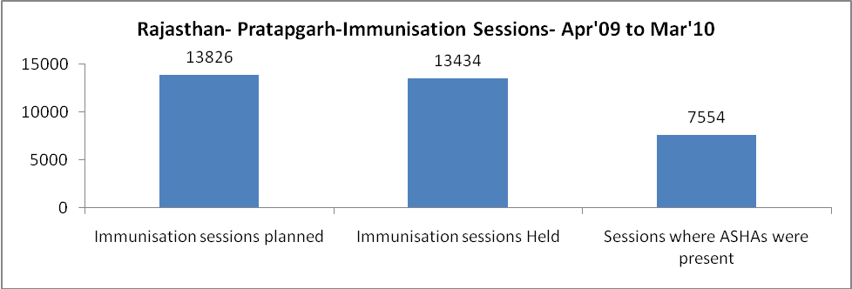

Rajasthan- Pratapgarh- Apr'09 to Mar'10
Total Abortions | Abortion Rate
626 | 2.5%

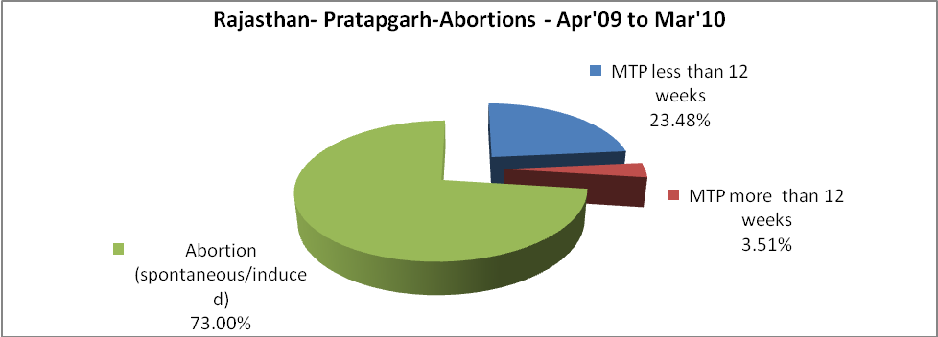

Rajasthan- Pratapgarh- Apr'09 to Mar'10
Total OPD | Total RTI/STI cases
395,704 | 3,648

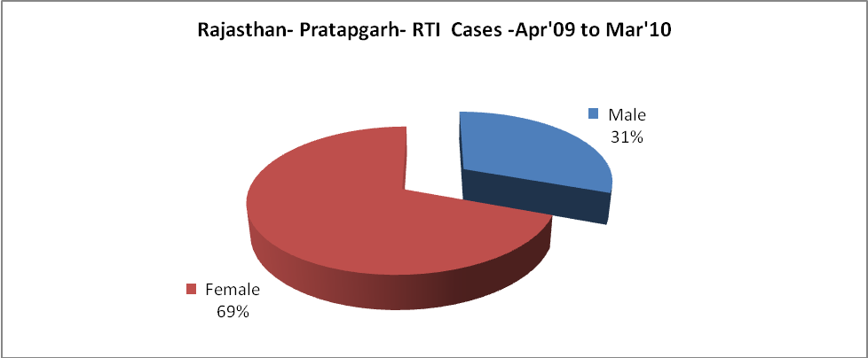

Rajasthan- Pratapgarh-Sterilisations - Apr'09 to Mar'10
 | Reported | %age of Reported Sterilisation
Total Sterilisation | 3,367 | -
NSV | 15 | 0%
Laproscopic | 3 | 0%
MiniLap | 18 | 1%
Post Partum | 3,331 | 99%
Male Sterilisation | 15 | 0%
Female Sterilisation | 3,352 | 100%

Rajasthan- Pratapgarh-FP Methods - Apr'09 to Mar'10
 | Reported | %age of All Reported FP Methods
Total Reported FP Methodd (All types) Users | 46,900 | -
Sterilisations | 3,367 | 7%
IUD | 5,354 | 11%
Condom Users | 24,820 | 53%
OCP Users | 13,359 | 28%
Limiting Methods | 3,367 | 7%
Spacing Methods | 43,533 | 93%

Rajasthan- Pratapgarh- Service Delivery - Apr'09 to Mar'10
Operation major (General and spinal anaesthesia) | Operation minor (No or local anaesthesia) | AYUSH | Dental Procedures | Adolescent counselling services | Total OPD | Total IPD
1,190 | 445 | 5,537 | 3,094 | 992 | 395,704 | 43,582
Operation major (General and spinal anaesthesia) as %ge of OPD | Operation minor (No or local anaesthesia)as %ge of OPD | AYUSH as %ge of OPD | Dental Procedures as %ge of OPD | Adolescent counselling services as %ge of OPD | IPD as percentage of OPD
0.3% | 0.1% | 1.4% | 0.8% | 0.3% | 11%

Rajasthan- Pratapgarh- Service Delivery - Apr'09 to Mar'10
Operation major (General and spinal anaesthesia) | Operation minor (No or local anaesthesia) | AYUSH | Dental Procedures | Adolescent counselling services | Total OPD | Total IPD
1,190 | 445 | 5,537 | 3,094 | 992 | 395,704 | 43,582
Operation major (General and spinal anaesthesia) as %ge of OPD | Operation minor (No or local anaesthesia)as %ge of OPD | AYUSH as %ge of OPD | Dental Procedures as %ge of OPD | Adolescent counselling services as %ge of OPD | IPD as percentage of OPD
0.3% | 0.1% | 1.4% | 0.8% | 0.3% | 11%

Rajasthan- Pratapgarh- Childhood Disease - Vaccine Preventable -Apr'09 to Mar'10
Diphtheria | Pertussis | Tetanus Neonatorum | Tetanus others | Polio | Measles
0 | 0 | 0 | 1 | 1 | 15
Rajasthan- Pratapgarh-Childhood Disease - Others - Apr'09 to Mar'10
Diarrhoea and dehydration | Malaria | Number admitted with Respiratory Infections
4,127 | 624 | 2,136

Rajasthan- Pratapgarh- Infant & Child Deaths - Apr'09 to Mar'10
Infant Deaths within 24 hrs of birth | Infant Deaths between 24hrs & under 1 week | Infant Deaths between 1 week & under 1 month | Child Deaths between 1 month & under 1 year | Child Deaths between 1yr under 5years | Total Deaths
34 | 70 | 37 | 64 | 124 | 329

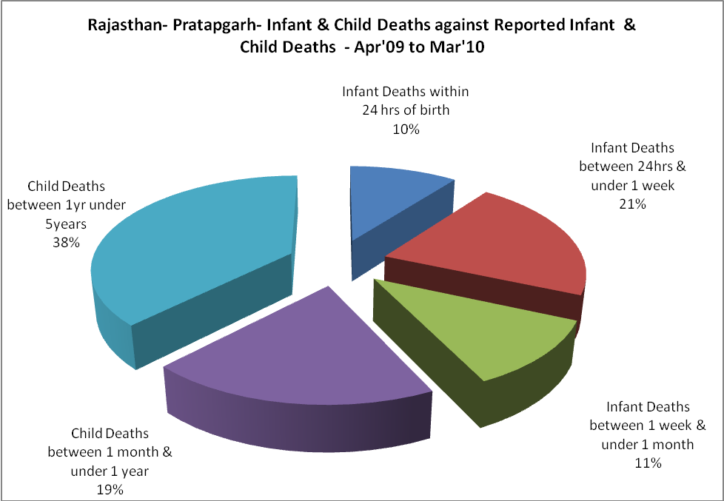

Rajasthan- Pratapgarh- Causes of Infant & Child Deaths - Apr'09 to Mar'10
Sepsis |  |  | Asphyxia |  |  | LBW
Up to 1 Weeks of Birth | Between 1 week & 4 weeks of birth | Total | Up to 1 Weeks of Birth | Between 1 week & 4 weeks of birth | Total | Up to 1 Weeks of Birth | Between 1 week & 4 weeks of birth | Total
3 | 10 | 13 | 6 | 6 | 12 | 39 | 12 | 51
Pneumonia |  |  | Diarrhoea |  |  | Fever related
Between 1 month and 11 months | Between 1 year & 5 years | Total | Between 1 month and 11 months | Between 1 year & 5 years | Total | Between 1 month and 11 months | Between 1 year & 5 years | Total
14 | 20 | 34 | 10 | 17 | 27 | 5 | 6 | 11
Others |  |  | Measles |  |  | Others
Up to 1 Weeks of Birth | Between 1 week & 4 weeks of birth | Total | Between 1 month and 11 months | Between 1 year & 5 years | Total | Between 1 month and 11 months | Between 1 year & 5 years | Total
22 | 9 | 31 | 0 | 0 | 0 | 35 | 81 | 116

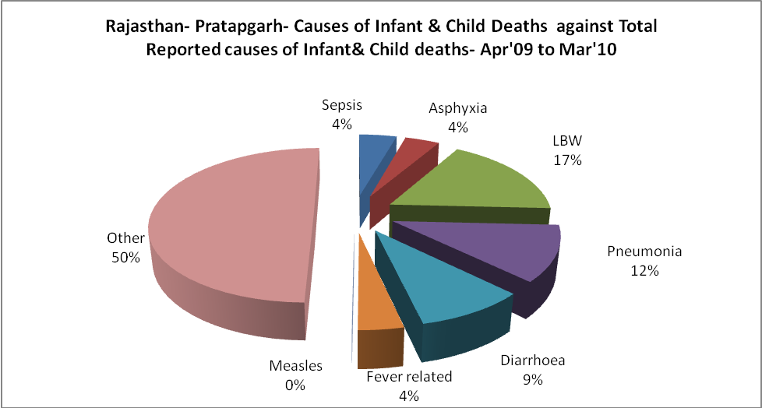

Rajasthan- Pratapgarh- Maternal Deaths & Causes - Apr'09 to Mar'10
Abortion |  |  | Obstructed/prolonged labour |  |  | Severe hypertesnion/fits
6-14 yrs | 15-55 yrs. | Total | 6-14 yrs | 15-55 yrs. | Total | 6-14 yrs | 15-55 yrs. | Total
0 | 3 | 3 | 0 | 1 | 1 | 0 | 4 | 4
Bleeding |  |  | High Fever |  |  | Other Causes
6-14 yrs | 15-55 yrs. | Total | 6-14 yrs | 15-55 yrs. | Total | 6-14 yrs | 15-55 yrs. | Total
0 | 5 | 5 | 0 | 0 | 0 | 1 | 8 | 9

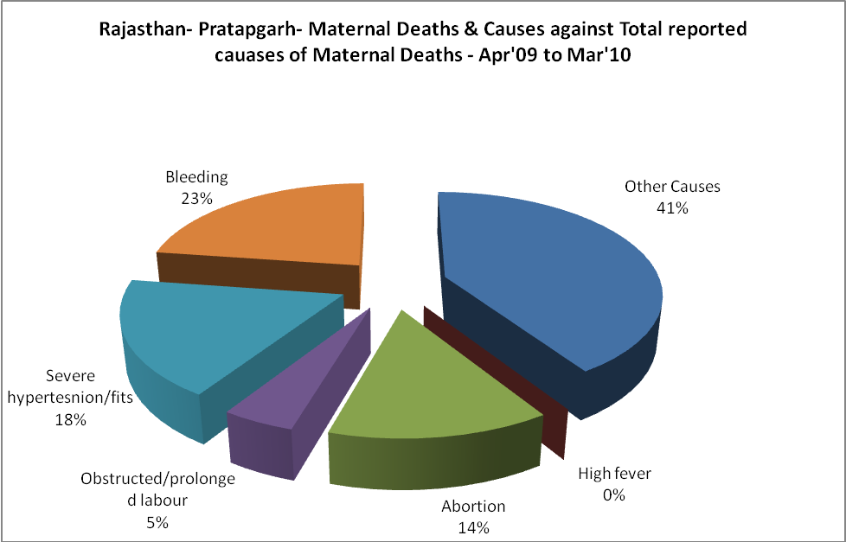

Rajasthan- Pratapgarh-Causes of Deaths in 6 to 55yrs age group - Apr'09 to Mar'10
Diarrhoel Diseases |  |  |  | Tuberculosis |  |  |  | Respiratory Diseases( Other than TB)
6-14 yrs | 15-55 yrs. | Above 55yrs | Total | 6-14 yrs | 15-55 yrs. | Above 55yrs | Total | 6-14 yrs | 15-55 yrs. | Above 55yrs | Total
14 | 3 | 4 | 21 | 4 | 39 | 27 | 70 | 8 | 27 | 50 | 85
Malaria |  |  |  | Other fever Related |  |  |  | HIV/Aids
6-14 yrs | 15-55 yrs. | Above 55yrs | Total | 6-14 yrs | 15-55 yrs. | Above 55yrs | Total | 6-14 yrs | 15-55 yrs. | Above 55yrs | Total
2 | 3 | 1 | 6 | 6 | 17 | 16 | 39 | 0 | 1 | 0 | 1
Heart Disease/Hypertenion related |  |  |  | Neurological Disease including strokes |  |  |  | Trauma/Accidents/ Burn Cases
6-14 yrs | 15-55 yrs. | Above 55yrs | Total | 6-14 yrs | 15-55 yrs. | Above 55yrs | Total | 6-14 yrs | 15-55 yrs. | Above 55yrs | Total
1 | 50 | 63 | 114 | 41 | 25 | 12 | 78 | 14 | 54 | 10 | 78
Suicide |  |  |  | Animal Bites & Stings
6-14 yrs | 15-55 yrs. | Above 55yrs | Total | 6-14 yrs | 15-55 yrs. | Above 55yrs | Total
5 | 56 | 6 | 67 | 10 | 18 | 22 | 50

